Mid-Term Notes – Delcorde

Lecture 1:

Business can affect, also be affected by:
- Government
- Civil society

Forms of “For Profit” business ownership
- Corporations
- Partnerships
- Proprietorships

Forms of Government:
- Municipal
- Federal
- Provincial

The Modified Boulding Triangle: A Way to Depict the Canadian Macroenvironment

Business

Civil Society Government

The modified boulding triangle depicts the three segments of the domestic macroenvironment – business, government, and civil society. At the corners, it represents all three in their purest form: Pure reciprocity (civil society), pure exchange (business), and pure coercion (government). All the inner territory represents organizations embodying different mixes of the three – a variety of socioeconomic and governance relationships. The lines between each segment are not rigid, but in fact represent interaction between the three.

Lecture 2:

The economic system in Canada is a private enterprise system
Basic rights of a private enterprise system include:
- Private property
- Freedom of Choice
- Profits
- Competition

Modern Workforce of Today:
- Aging population (Baby boomer generation)
- Increasing diversity with immigration
- Outsourcing and the changing nature of work
- Flexibility and Mobility
- Innovation through collaboration

Managers must be culturally sensitive in the Canadian environment, especially since multiculturalism has become a social norm. The Canadian Workplace will continue to diversify culturally, but also through age. Multi-ages in the workplace will not become uncommon; people of all ages and cultures will come together in the workplace.

Forms of Business Ownership:
- Sole Proprietorship
- Partnership (General and limited)
- Corporation
- Cooperative
- Franchises – A specialized form of Business Ownership
Sole Proprietorship:
- Is the simplest form of business organization
- Falls under provincial and municipal jurisdiction
- Filing a name declaration is not required provided the business operates under the owners name
- Owned and operated by one person

Pro’s | Con’s
- Easy and cheap to start  - Secrecy  - Flexibility and control  - Pride of ownership  - Distribution and use of profit  - No special taxes  - No government regulation | - Unlimited liability  - Limited skills pool  - Overwhelming time commitment  - Few fringe benefits  - Limited growth  - Limited life span

Partnership (General and Limited)
- An arrangement whereby two or more persons combine some or all of their resources in a business undertaking with a view to sharing profits among partners
- You must register a partnership agreement, everything will be split.
- Two types: General, and Limited (Silent, secret, nominal, and dormant partners)

Silent partners:
Known to the public, no active management role

Secret partners:
Unknown to the public, but take an active role in management

Nominal partners:
Lend their name for public relations, but are actually not involved

Dormant partners:
Neither known to the public nor active in management

Pro’s | Con’s
- More financial resources  - Shared management  - Combined knowledge and skill  - Faster decision making  - Few regulatory controls  - Ease of organization | - Unlimited liability  - Partners are responsible for the business activities of all others  - Division of profits  - Disagreements among partners  - Life of a partnership

Corporation (Private and public)
- A corporation is recognized as a separate legal entity under the law
- A corporation can be incorporated federally or provincially
- A federal company cannot be prevented by a provincial government from exercising the powers that have been validly conferred on the company by federal authority (example: doing business in a province)

Private Corporation:.
- The right to transfer shares is restricted
- Number of shareholders is limited to 50
- May not sell shares or debentures (bonds of debt instruments) to the public

Public Corporation:
- Sells shares to the public on a stock exchange
- Is subject to stricter regulations for filing financial reports, must follow certain audit procedures
- Must file a prospectus if shares are being sold to the investing public

Pro’s | Con’s
- More money for investment  - Limited liability  - Separation of ownership from management  - Ease of ownership change  - Perpetual life  - Size  - Perceived legitimacy | - Initial cost  - Paperwork  - Two tax returns  - Termination difficult  - Double taxation  - Greater expectations for social responsibility an ethical conduct from stakeholders

Things to think about: Under what circumstance would certain forms of business ownership be preferred?
- Test of concept
- Personal privacy/property rights/something you don’t want to share
- When the person themselves is the business

Cooperatives:
An organization that emphasizes working together as a way of building community involvement by supplying needed goods and services at a lower cost (example: producer co-op, housing co-op, financial co-op)

Franchises:
A business established or operated under an authorization to sell or distribute a company’s goods or services in a particular area

Corporate Governance:
The processes, structures, and relationships through which the shareholders, as represented by a board of directors, oversee the activities of the business enterprise

Corporate Governance key players:
- Shareholders: Interested in return on investment
- Board of directors: Elected by shareholders to represent them, responsible for governance
- Officers/senior employees

OECD:
Governance…the full set of relationships between a company’s management, its board, its shareholders and its other stakeholders such as its employees and the community in which it is located

Board of Directors Role
- To make decisions in the best interest of the company (not always the best interest of shareholders, no preferential treatment)
- Consider other stakeholders
- Equal consideration to shareholders
- No personal profits

Officers Role
- Senior employees who oversee daily operations
- CEO’s, President, Senior management

Corporate Social Responsibility
The way a corporation achieves a balance among it economic, social, and environmental responsibilities in its operations so as to address shareholder and other stakeholder expectations.

What are the arguments for and against CSR? Is it necessary?

Pro’s | Con’s
- Public image  - Business must satisfy society’s needs  - Addressing problems can become financial opportunities  - Prevents criticism | - Social policy is a role for government not business  - Lacks training in social issues  - Profit maximization should be the main focus of business  - CSR would give too much power to business

1) Amoral View: Traditional view of business as merely profit making entity

2) Personal View: Corporations are like people and can therefore be held accountable for their actions

3) Social View: Corporations are social institutions with social responsibilities

Standard Environmentalism
Occurs when government regulation/intervention is required to remedy the market’s failure to provide sufficient environmental protection

Market Environmentalism
Occurs when economic incentives created by the market are more effective at protecting the environment than government intervention

Lecture 3: to be typed

Federal government

Canada governs through the “Westminster Model” of Government
Three Branches of Government:
  - Legislative -- The House of Commons & The Senate
  - Executive -- Prime Minister, Cabinet and the Public Service
  - Judicial -- independent of Cabinet, Parliament or of any other state institution

The Canadian Federal Government
Legislative Branch -- House of Commons
    - 308 seats
    - Elections at least every 5 years
    - The Speech from the Throne (intended work plan for the government)
    - Question Period (Opposition’s chance to challenge government actions)
    - Legislation and Debates (draft bills are tabled and debated before becoming law)
    - all proceedings of the House of Commons are recorded in a parliamentary publication called Hansard

Private Bills
- Matters of particular interest or benefit to a person or persons, including corporations
- Only a minister can introduce a bill for the appropriation of public monies or taxation and only in the House of Commons
- 2 types

Government Bills: Introduced and sponsored by a minister

Private members public bills: sponsored by a private member

Parliamentary Committees
Standing Committees: Focus on a substantive sphere of government policy
Special committees: Examine specific issues (pensions, child care)
Legislative committees: Examine specific government bills after they have passed second reading
Committee of the whole: All members from either the Commons or the Senate

The Public Policy
- Problem identification/definition
- Setting the agenda
- Formulating the policy
- Implementing the policy
- Evaluating the policy

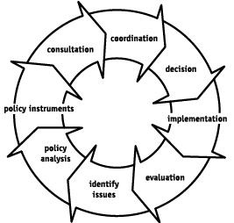

Lecture 4:

Civil Society
The elements in society that make up a democratic society:
- Community
- Reciprocity-based value system
- Trust and collaboration
- Social capital (social capital is not human capital)

Examples of social capital: parent teacher association, a national organization, a labor union.

Five Roles of Civil Society
- Monitoring: Through which policy is kept “honest”
- Advocacy: Through which policy options can be supported or not supported
- Innovator: Through which different ways of doing things are developed
- Service Provider: Through which a particular need is fulfilled
- Capacity builder: Through which support is provided to other civil society organization

Civil Society: What characterizes the segment?
“Good Neighborliness”
- Less emphasis on private accumulation and minimizing cost, more emphasis on public good and maximizing participation
- Activities are labor intensive

What is the relationship between civil society and business?
- They need each other
- They compliment each other to be more effective

Civil Society has 3 complex issues:
- Segment Fragmentation
- Funding
- Attracting and retaining volunteers

Boudieu: Four types of Personal Capital
- Social Capital (Who you know)
- Economic Capital (what you have)
- Cultural Capital (legit knowledge)
- Symbolic Capital (Your status in the eyes of others)

Lecture 5:

Stakeholders:
Individuals and groups with a multitude of interests, expectations, and demands as to what business should provide to society

Who exactly are stakeholders?
Any group or individual who is affected by or can affect the achievement of an organization’s objectives (Freeman: 1984)

Primary stakeholders:
Are those that have a direct interest in the organization and its success

Secondary stakeholders:
Are those that have a public or special interest in the organization

Core stakeholders:
Are essential to the firm’s survival

Strategic stakeholders:
Are directly affected by threats and opportunities the organization faces

Environmental stakeholders:
Are all others in the organization's environment

Shareholder Viewpoint:
  - A business exists to make money – greatest efficiency is achieved through profit maximization

Stakeholder Viewpoint:
  - Business has a responsibility to do more than maximize profits
  - Business has caused several problems so it has a responsibility to fix them
  - Social institution theory (society provides the very existence of business through legal frameworks)

A key Stakeholder:
One who can exert and sustain a positive or negative affect on the organization
Those stakeholders having high interest and high power to influence would be perceived as key

Pluralism:
A condition in which there is diffusion of power among society’s many groups and organizations – a wide decentralization and diversity of power concentration

Diffusion Of Power – Pluralism

Strengths | Weaknesses
- Prevents concentration of power  - Maximizes freedom  - Disperses individual allegiances  - Creates diversified loyalties  - Provides safeguards | - Pursuit of self-interest  - Proliferates organizations  - Forces conflicts  - Promotes inefficiency

Shareholder Typology
* This will be on the midterm %100

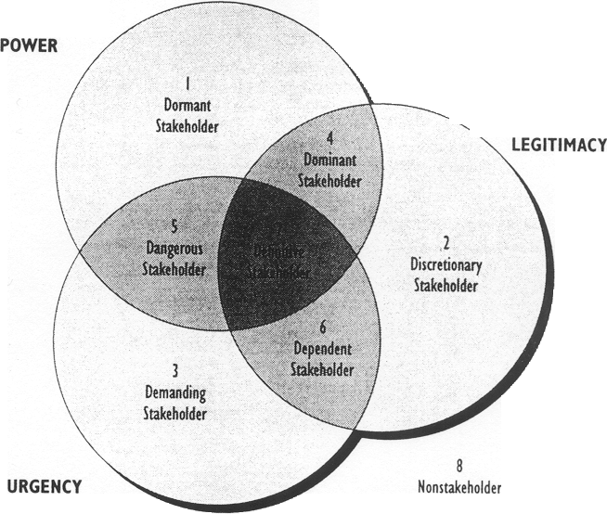

Lecture 6
Globalization: a term used to describe the growing interdependance of people around the world with regard to societal influence, economies, and cultural exchange, refers to the increasing economic integration.

Types of Globalization
Globalization: a process of decreasing constraints on the interactions among the nations and peoples of the world.

Economic globalization: The integration of fragmented markets into a global economy.

Political globalization: The process by which world sovereignty by the state.

Social or cultural globalization: The emergence of the worldwide cultural system

Globalization Key Drivers
- Market
- Cost
- Competition
- Government
- Technology

Market Key Drivers
- New Markets
- Strategic alliances
- Demand for products

Cost Drivers
- Source of Inexpensive labour
- Cheaper raw materials
- New Sources of capital

Competition Drivers
- Competition is producing similar gods of equal or better quality for lower cost
- Competition can come from anywhere

Government Drivers
- Trade liberalization policies
- Industry deregulation
- Privatization
- Participation in globalization institutions

*The government’s job is to make sure that trade agreements are in place to make business functional.

Technology Drivers
- Advances in technology
- Homogenization of many technologies

Globalization: Good or bad?

Pro’s | Con’s
-Increases economic growth rate  - Private corporations and open markets benefit society with their goods  -Leads to lower prices, higher employment in developing countries  -Promotes technology, capital, skilled labor  -Increases civil liberties and reduces inequalities  - Rising standard of living in developing countries | - Increases wealth of giant corporations which leave countries poorer  - Harms environment  - Increases unemployment in developed countries  - Reduces standards  - Periodic financial crisis arise  - Homogenizes cultures  - Promotes “haves” and “have nots”  - Causes problems that cannot be solves by single nations

Midterm Question: what evidence is there arguments for and against globalization in this video?

What is culture?
The collection of values, beliefs, customers, and attitudes that distinguish a society.

Culture is:
Value: something explicitly or implicitly desirable to an individual group reflecting preferences that defines right and wrong

Attitude: an expression of values disposing a person to act or react in a certain way towards something

Behavior: any for of human action

Videos:
Banks beer: Popular beer in the Caribbean but now being licensed in Canada by two women.
- They don’t want to pay shipping fees for the business, so they are allowing it but they will charge the other business in full next time.
- They ran out of labels for their own bottles
- Machines started acting up multiple times
- Sales ended up better than expected
- Advertised their product at Caribana festival in central Toronto.

TedX Digital Humanitarian:
http://www.ted.com/talks/paul_conneally_digital_humanitarianism#t-6579

Food Fads:
- The food industry is beneficial because food is always in demand
- Society can change what they eat, demand is diverse
- Competitive advantage is gained when working with civil society

The Cost of Cloth: Ethical Textiles:
- Globalization usually means someone else is paying the full price of the bargain
- They pay 1/50th of Euro/American counterparts
- Video shows 3rd biggest textile company (Bangladesh)
- They produce approximately 20,000 items per day
- Examples of third world countries who are involved in our globalization: China, India, Bangladesh, Vietnam
- Poor working conditions, Illegal actions and poverty is common in these countries

