Lecture 3 – September 18

LAST WEEK
In Class Assignment Answers
- NUMBER 3
  - M-wave represents activation of the motor neuron without going to the spinal cord
  - Signal is sent directly to the muscle
  - Tells us the intensity of the stimulus
- NUMBER 4
  - As the stimulus strength increases we see an increase in the m-wave
  - More output more neurotransmitters reaching the neuron
  - At lower stimulus strengths may not get an m-wave
  - Initially you see an increase in H-wave until drop-off
  - Only in this artificial situation in extreme case with external electrical stimulus you can get an anti-dromic motor response
  - Signal is carried in opposite way that it’s suppose to
  - Motor neuron sends signal one way and sensory neuron sends signal the other way, signals collide
  - Over stimulation of the nerve
- SECOND LAST QUESTION
  - AT 60V you would see no M-wave and a high H-wave
  - At 100V you would have a large M-wave and a small H-wave
- LAST QUESTION
  - Only one reflexive circuit shown, need more than one trial
  - Different trial where the M-waves are the same but different H-waves. The response to the stimulus changes

The Role of the Spinal Cord in Locomotion
- Without input from higher structures (brain stem, cortex) can still produce rhythmic locomotion
- Cat experiment

OBJECTIVES OF THE LECTURE
- What areas make up the brain stem?
- What are these different areas responsible for with respect to movement?
- What is the Reticulospinal tract?
- How fast can a movement be initiated?
- What is an experimental manipulation that has been used to look at (advanced) response preparation?

OUTLINE
- Central nervous system: The brain stem
- The role of the brain stem (midbrain) in movement
  - Startle
- Can prepared movements be stored subcortically?

CENTRAL NERVOUS SYSTEM: THE BRAIN STEM

The Brain Stem
Functions
- Gets information on the muscles
- Sensation from head, neck, face/motor control of head neck and face
- Receives a lot of sensory information
- Sensory input about orientation and send output as feedback to head, neck and face
- Hearing, balance, taste enter brain stem
- Also have control of autonomic functions
- Heart rate, digestion etc.
- Carries information to higher areas in the brain and send information out to the spinal cord as well
- Sort of like a relay
Reticulospinal Formation
- A diffuse network of neurons
- Receives summary of sensory information entering the spinal cord and brain stem
- One of the oldest pathways evolutionarily
- Receives a summary of information, neurons from this area go directly from spinal cord and connect with motor neurons
- Affects arousal level of the organism
- Can influence motor output
- Enervates with trunk and shoulder area muscles, also proximal muscles
Divisions
- Medulla
  - Regulates blood pressure and respiration
  - Receives input regarding taste, hearing and balance
  - Also responsible for control of facial muscles
- Pons
  - Relays information about movement and sensation from the cerebral cortex to the cerebellum
  - Strong connection to the cerebellum (know as the little brain)
  - Involved in autonomic function such as taste and sleep
- Midbrain
  - Forms linkage between parts of the motor system the cerebellum, basal ganglia and cerebral hemispheres
  - Substantia nigra is the nucleus of the midbrain = turns on and off the basal ganglia
  - Involved with processing of auditory and visual information
    - Control of eye movements

THE ROLE OF THE BRAIN STEM (MIDBRAIN) IN MOVEMENT

Sprinters
- Have a background reading with a standard deviation
- If sprinter has a motor response prior to 100ms conclusion is he/she is not reacting to the stimulus (gun shot)
- Can be the presence of EMG activity, increase in force or an overt movement
- 100ms is the baseline because researchers have looked at the timing of different processes
- Determined that the fastest an auditory stimulus can enter brain is 35ms
- To send motor output from brain to spinal cord to muscle is a minimum of 25ms
- Not just these 2 processes going on however and so researchers believe its more than 100ms
- Researchers have suggested that maybe we can react faster
- Proposed using this idea of startle

Startle Response
- STARTLE RESPONSE = Diffuse protective response consisting of a characteristic set of muscle actions
- Startle response elicited by 100dB< auditory stimulus
- A protective gesture
- Starts with a blink of the eye and works it’s way down
- Tension in the neck, tensing body
- Tends to be a reflexive response
- The REFLEX is mediated by neurons in the reticular formation (run through the brain stem)
- Initial response can vary quickly – at 40ms
Startle experiment
- Associated with a tri-phastic pattern
- Muscle activity starts just before the movement output

Fractioning Reaction Time with Electromyography
- RED = agonist, PURPLE = antagonist
- Premotor time starts from go signal to when we first see the output response
- Once muscle turns on we need enough activation to build up in order to overcome the inertia in the muscle
- Smaller muscle means you don’t need as much activation
- Must be less than 100ms to be sure you’re responding to a go-signal

Tri-phasic muscle activation
- 3 muscle burst
- First agonist
  - Turns on before the movement
  - Amplitude and duration depends on how far we have to move
  - Larger the distance we have to move the more force we have to put into the movement
- Antagonist
  - Depends on what the movement looks like
  - Short movement requires antagonist to activate quicker
  - Represents this breaking action
- Second agonist burst
  - Makes sure the limb is directly at the target
  - Narrow in on the target
  - Not as big of a burst
Graph
- Trial with startle results in a faster initiation
- The movement remains the same and a tri-phasic pattern is also present
- Movement is produced quickly with startle
- Comparing the length of the boxes are the same
- The duration the muscles are on for and the time between them
- Initiation is faster but the timing of the whole movement is the same
- Still a voluntary movement even with startle
- Suggestion is that subjects are preparing the movement in advance in subcortical and specifically brain stem areas
- Therefore what happens is prepare the movement in advance stored somewhere in the brain stem and startle activates the reticular response and preplanned response
- Startle response + kick out of the voluntary movement
- Bypass the other processes
- Response is too fast to be affected by stimulus intensity

CAN PREPARED MOVEMENTS BE SUBCORTICALLY STORED

Can a prepared response by stored subcortically?
- Involves Hicks’ law as a background
- Suggested that response selection and programming is stored in advance for 1-choice RT tasks
- For Choice-RT you would not be able to store the information prior to stimulus
- In experiment, for the control RT increased based on Hicks’ law
- To determine which hypothesis is correct we examine each type for the startle reaction
- Findings
  - Startle has a much earlier movement onset at 60-70ms
  - Simple RT was speeded by startle
  - Choice RT was not speeded by startle
  - No difference between the control and startle group for the 2-choice and 4-choice RT
- Conclusion
  - We can prepare and store our movements ahead of time
- Take into consideration:
  - How well the movement is learned
  - For sprinters, does the gun act as a startle on the athletes
  - We don’t have evidence that anything is going on in the brain stem
  - No neural observations

Questions to Consider
- Why wrist extension movement?
  - Reflexive response tends to be flexion
  - By doing something that’s not natural we can really see that it’s a voluntary movement
- Why include only startle trials in which subjects show a startle response?
  - If there was no startle it could be something different going on
  - Reticular formation not activated
  - Could be anticipation
- Is this stimulus intensity effect?
  - If it was then all 1-choice, 2-choice and 4-choice RT’s would show a decrease in startle trials
- What kind of errors was made? What trials were these made in?
  - Only in the choice task
  - Startled and didn’t make a response or made the wrong response
- Who else has looked at response programming
  - Henry and Rogers
  - They manipulated response complexity
  - Looked at reaction time, RT increased the more complex the response was

OBJECTIVES OF THE LECTURE
- What groups of nuclei make up the Basal Ganglia?
  - What are the connections between these nuclei and other (motor) areas of the CNS?
- What is the role of Basal Ganglia in movement?
- What happens when something goes wrong?
  - Know the signs and symptoms of PD
  - How/Why does PD arise?
  - Treatment options for PD?
    - What should be considered when thinking about a form of treatment?

OUTLINE
- Basal Ganglia
- Anatomy and Function
- Parkinson’s Disease

The Central Nervous System (CNS)
- Major structures include:
  - Brain
    - Cerebrum
      - Cerebral cortex
      - Basal Ganglia
    - Diencephalon
      - Thalamus
      - Hypothalamus
    - Brain stem
      - Midbrain
      - Pons
      - Medulla
    - Cerebellum
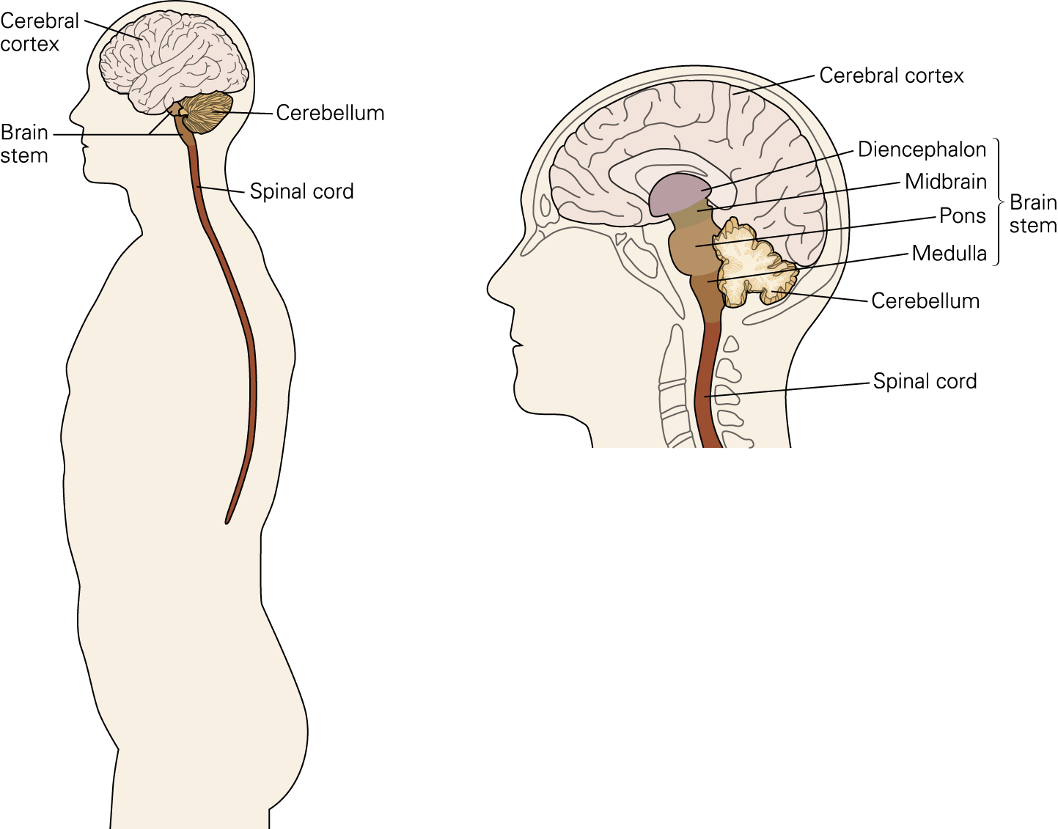
  - Spinal Cord

BASAL GANGLIA

Function
- Strong interconnection with the brain stem, cerebral cortex and the thalamus
- Involved in action selection
- Regulates activities of the motor and premotor areas so that voluntary movements may be executed smoothly
- Exert inhibitory influence on various motor systems
Structures
- Striatum
  - Caudate nucleus
  - Putamen
- Globus pallidus
- Nucleus accumbens
- Subthalamic nucleus
- Substantia nigra

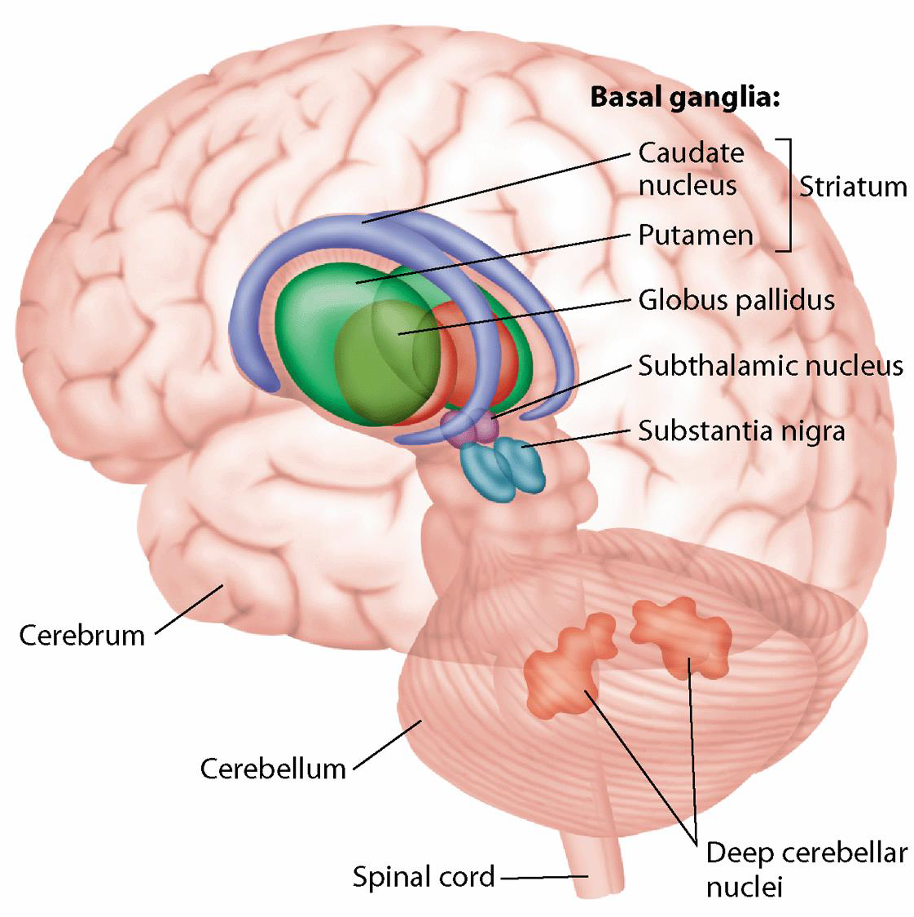

Diencephalon
- Thalamus
  - Involved in hormone production
  - Keeping body in equilibrium
- Hypothalamus
  - Big point of entry for motor sensory information
  - Comes in and is sent out

Basal Ganglia
- 5 different types of neurons
  - Substantia nigra in the mid-brain
  - Subthalamic nucleus
  - Globus pallidus
    - Internal and external
  - Striatum formed by:
  - Putamen
  - Caudate

Basal Ganglia and Motor Circuits
- Connects to thalamus which then send messages to higher areas of brain know as cerebral cortex
- Also sends output to brain stem which then activates neurons that send messages down to the spinal cord
- Indirect movement, Thalamus and brain stem connections

Circuitry of Basal Ganglia
- Two inhibitory circuits cancel each other out
- I.e. 2 red inhibitory circuits together
- If Caudate/Putamen inhibits the Globus pallidus it cannot inhibit Thalamus
- That way Thalamus can continue circuit
- By having 2 inhibition arrows it can reduce motor output
- Can suppress movements we don't want and activate movements we do want
- Globus pallidus inhibition = thalamus activation
- Globus pallidus activation = thalamus inhibition
- Direct pathways and indirect pathways are operating simultaneously/parallel to each other
- Dopamine turns on the direct and turns off the indirect
- For example, people with Parkinsons don’t have dopamine they have trouble initiatating movement
- Substantia nigra pars compacta releases the neurotransmitters that inhibits
- The 3 inhibitory ciricuits in a row causes the inhibition of the Substantia nigra

ANATOMY AND FUNCTION

Direct Pathways facilitate movement
- Striatum
- Globus Pallidus Internal
- Thalamus
- Cortex

Indirect Pathways inhibit movement
- Striatum
- Globus Pallidus External
- STN
- Globus Pallidus Internal
- Thalamus
- Cortex

Basal Ganglia
- Turns on movements purposeful movements and inhibits unwanted movements
- Fine tunes movements, makes them nice and smooth
- Parkinson’s patients have very jerky movements
- Automatic movements that are well learned are assisted by Basal Ganglia
- Correcting posture (PD patients often bent over)

PARKINSON’S DISEASE

What does the Basal Ganglia do
- Activates wanted movements and inhibits unwanted movements
- Does not initiate movement directly but once their initiated can carry them out
- Has a role in posture, monitor sensory feedback

What happens when something goes wrong with the circuit?
- Not getting movements you do want while getting the movement you don't want

Parkinson’s Disease
- Movement disorder starting in the brain
- Specifically substantia nigra
- Cells lose their ability to create dopamine
- Important for balance and movement
- Commonly seen is resting tremor in hands, arms, legs and even the jaw
- Gait is effected, bent over and walk with a shuffle
- Problem with transitioning between gaits, going from running to walking for example
- Parkinson’s rating scale, the more symptoms you have the more likely you will be a patient

Basal Ganglia Disorder: Parkinson’s Disease
- Great rate of decline in death or neurons in people with Parkinsons
- Can’t turn on the direct pathway to get less inhibition in Globus pallidus and more inhibition in thalamus
- Also it means we can’t inhibit
- Damage of the circuitry, example is turrets

PD: Neuron Loss
- By the time people are showing symptoms of PD, most of the neurons are gone

PD: Symptoms
- Hypokinetic = loss of voluntary movements
- Akinesia = initiating movement
- Bradykinesia = carrying out movement
- More likely to fall
- Walk with shuffling phase
- Problems with integrated sensory information with what their motor system is doing
- Some individuals also suffer from dementia, depression and motor slowing
- Idea od rigidity, agonist and antagonist acting at the same time
- Problem is putting out the right amount f power
- PD patient have to mask continual movements

Parkinson’s Treatment
- Can’t put dopamine in itself because it wont cross the blood brain barrier
- L-Dopa however is the precursor and therefore can be used
- Patients often experience depression and other symptoms
- Surgical intervention, go into basal ganglia and kill the globus pallidus neurons more likely to be able to initiate continuous movement but unable to grade the force you need or turn on/off undesired movement
- After operation movements are faster
- Exercise intervention
  - Exercise like yoga can help Parkinson’s patients but there’s no evidence as to which works best

PD: Treatment
- Deep brain stimulus
- Drop needle into brain structure into basal ganglia/which changes the way the neuron fire

Study
- No difference in reaction time either way
- RT for reaction times are the same on and off meds
- No problem with programming movement
- Movements executed faster, behave more like a typical healthy individual

