Fragile Systems - Chapter 1

A) What is density and how does it relate to stratification?
Density is mass per unit volume. Describes how much mass fits into a space. Written in kg/m3
Less dense material will float above dense materials in the presence of gravity. Most dense sinks onto floor, least dense is on top, and the other materials layer in the middle so that density increases as you go downward. The materials are stratified into layers. This is even seen in the earth. Least dense (air) floats, most dense (rocks) sink.

The atmosphere:
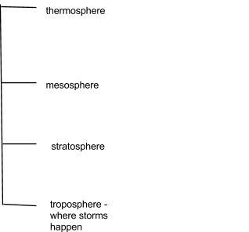

B) Explain why disaster scales are based on the Order-of-Magnitude concept and interpret graphs with logarithmic scales.
Intensity → Order of magnitude is when something is multiplied by 10. For example, the number of students at UBC Vancouver (40,000) is an order of magnitude greater than the number of students at UBC Okanagan (4,000). Similarly, we could say the number of students at UBCO is an order of magnitude smaller than the number of students at UBC Vancouver.

Logarithm → how many 0’s are in the number. Log of 10 is 1, log of 100 is 2, and so on

Exponential curve → starts of rising very slowly for the first few values, then increases dramatically

Logarithmic graph → the ordinate (vertical axis) steps by powers of 10, the abscissa (horizontal axis) states the magnitude. The number 2 means 100, 3 means 1000, 4 means 10,000, etc
C) Relate natural-disaster risk and intensity to frequency, return period, and consequences (costs).

More intense disasters happen much less frequently. A way to quantify how often a disaster has occurred in the past is the return period.

Return period → The average number of years between disaster events of the same magnitude

Calculating return period - time span / number of cases. This can help determine whether or not a disaster will occur during your lifetime (consequences)

D) Explain how recent disasters were associated with the concentration or dilution of energy.

Concentration of energy
Most energy sources are diffuse (weak but cover a wide area), natural disasters need a concentration of a lot of energy into a small area
Some energy sources are gradual (weak but spanning a long time). natural disasters need a constant build up and a quick release

E) Get the disaster info you need from reliable sources.
1. Infrastructure sensitivity and resilience
2. Disaster prediction
3. Increasing sensitivity to natural disasters - evacuate people successfully, etc

F) List the 1st and 2nd most common elements in the Earth, ocean, and atmosphere.
Earth’s crust - oxygen, silicon
Ocean - oxygen, hydrogen
Atmosphere - nitrogen, oxygen
Earth’s core - iron, oxygen

G) Describe how viscosity and compressibility relate to the phase of matter.
Viscosity is a measure of how much fluids resist flowing or changing their shape. The greater the viscosity, the more it resists change.
Depends on temperature and chemical structure. High - magma, med - water, low - air

Compressibility is the ability for a material to be squeezed or expanded so it fills less or more space. Compression leads to a change in density

Solids - least compressible, gases - most compressible

Gas (condense) → Liquid
Sold (sublimate) → Gas
Gas (deposit) → Solid

H) Be able to diagnose the type of strain by the way a material deforms.
Strain → The change in shape or size (deformation) of a solid object.
Elastic → The ability of an object to change shape when pressure is applied but then go right back to it’s original shape
Plastic → the ability to permanently change shape when forced
Ductile → very plastic
Brittle → breaks instead of bending

I) Explain why gravity affects motion and energy.
Gravity is a force that attracts matter together.

J) List the 5 types of energy, and describe what causes them to vary.
1. Work energy → Force x Distance (depends on the force that pushes/pulls over a distance)
2. Potential energy → The work needed to raise an object of mass a distance over the pull of gravity
3. Kinetic energy → a moving object possesses this
4. Sensible heat → the heat we can feel is measurable by sensible heat
5. Latent heat → stored when matters change from solid to liquid or liquid to gas. it is released when changed from gas to liquid or liquid to solid
When solids melt or liquids evaporate, sensible heat is taken from the surroundings and stored as sensible heat. For the opposite, latent heat is released back as sensible heat

K) Explain (with examples) how energy conservation applies to natural disasters.
Energy can easily change from one form to another. Energy is conserved when it changes form. All disasters studied involve motion and impacts from space.
Potential - kinetic energy → landslide

L) Describe relationships between force, pressure, stress, strain, energy, and power.
Power → the rate of doing work/ consuming energy
Pressure → the force per unit surface area, applied to a perpendicular force
Stress → the force per unit surface area, applied to a parallel force

M) Describe population growth and explain why it is important for natural disasters.
Over the past 8000 years, the population has been growing exponentially
Doubling time → the amount of time it’ll take for the population to double

N) Explain how Earth's carrying capacity and overpopulation are related to the fate of the human race, and anticipate your role in it.

Carrying capacity → the population that can be sustainably supported within a given domain

Extra:

Waves - regular oscillations that propagate a shift in space.
Longitudinal and transverse waves

Longitudinal waves → the displacement of the particles of a wave are parallel to the direction of the wave. Eg primary waves (seismic waves) , slinky/spring waves

Transverse waves → the displacement of the particles of a wave are perpendicular to the direction of the wave

Wave metrics:

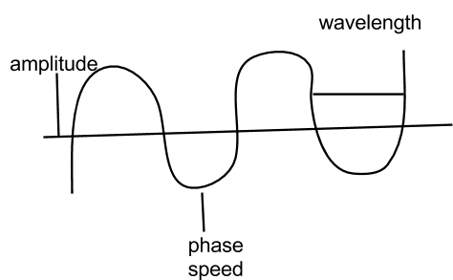

topmost point of a wave - crest
trough - the lowest point of a wave

frequency → how many wave crests pass a stationary point during a fixed time , measured in cycles per second (1 cycle = 1 hertz)

period → the passage of one wave crest to the next wave crest

turbulence → random motions in a fluid - transports both energy and matter

waves → transport only energy

Energy propagates, not matter

Group velocity → speed of energy propagation (the speed that energy moves due to waves)

Earthquakes - Chapter 2

A) Describe the global distribution of earthquakes and how often quakes of various magnitudes occur
The vast majority of earthquakes occur at margins of Earth’s tectonic plates (where continents meet oceans)
Majority of earthquakes have a magnitude that is less than 4
The largest earthquakes occur at collision zones

B. Understand the different types of faulting at different plate boundaries, and which plate boundaries produce the largest quakes

There are 9 major plates, but the 2 main ones are oceanic and continental. Oceanic plates are fast, young, formed at mid-ocean ridges and destroyed at subduction zones. Continental plates are old, slow moving, and do not get subducted because they are more buoyant.

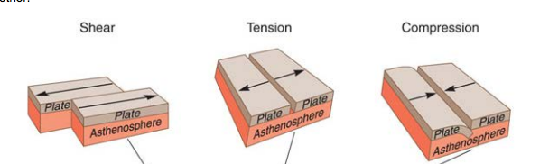

Different types of boundaries:

1. Divergent → plates moving apart, leading to tension or stretching, rocks break, small earthquakes occur. Happens at mid-ocean ridges

2. Transform → plates move past each other, leading to shearing forces between plates. Many earthquakes occur here, but not as large as the ones in the next two types

3. Convergent 1 → plates move toward each other and slide, leading to compression. One plate is less dense, leading to subduction zones. Many large earthquakes occur here

4. Convergent 2 → same as type 1 but neither of the plates subduct, they crumple. Small to large earthquakes occur here

C) Describe how the Earth builds, stores, and releases energy in earthquakes (elastic rebound)
D) Understand concepts of (1) stress causing strain and (2) plastic versus brittle deformation

1. Elastic deformation → the forces acting on a rock are relatively small. The rock goes back to normal after the force has been removed. There’s no evidence of the force ever being there. It is usually not a problem, as long as the waves being transmitted do not cause any damage before it’s gone.

2. Plastic deformation → permanently changes the shape of the rock without breaking it.

3. Brittle deformation → as force applied to the material increases, the material stores the energy. When the stress exceeds the materials strength, it breaks and the energy is released as heat, motion and sound. The resulting motion is an earthquake. Energy is dissipated as waves, away from the location of the breakage

Faults - where rocks are broken. The different types of faults are:

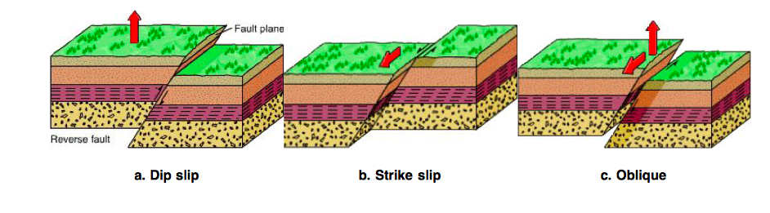

1. Dip slip faults are the direction of motion in which side leans over the neighbor. Reverse faults are when the side leaning on the neighbor moves up, and normal faults are when the side leaning on the neighbor drops down.

2. Strike slip faults involve horizontal motion.

3. Oblique faults are a combination of horizontal and vertical movement.

E) Describe how the rupture propagates from the focus and why shaking and damage are not necessarily greatest at the epicenter
Motions along faults are not uniform and do not fall in a single jolt. No earthquake is a single isolated event. There are usually many earthquakes associated with the main event. There are foreshocks, the main event and then aftershocks. The largest aftershock is usually 1 magnitude smaller than the main event

What factors affect the magnitude of an earthquake?
1. Area of broken zone
2. Strength of rocks being broken
3. Amount of motion
Measuring the ground motion of many locations, over what area the motion occurred, and the type of rocks involved (tougher rocks take more energy to break). → seismic moment

moment magnitude

magnitude 7 eq releases 32 x as much energy as a magnitude 6 eq

Forces at plates :
Compressional forces → those that cause squeezing
Tensional forces → those that cause pulling apart of material
Shear forces → those that cause twisting or shearing

Stress → force per unit area, Strain → how materials change when caused by stress

F) Describe the different types of seismic waves and how they move through the Earth
When faults slip, all the released energy is converted to wave energy
Two main types of seismic waves:
Body waves → those that travel through the interior of materials
Surface waves → those that travel only along surfaces

Different types of body waves:
1. Particles move back and forth in line with the direction the waves are traveling → pressure/primary waves (p waves) Travel faster than S waves
2. Particles move side to side, perpendicular to the direction that waves are traveling → shear/secondary waves (s waves)

Different types of surface waves (generated when p and s waves arrive at the earth’s surface, the energy cannot continue onto air so it is reflected back as these waves)
1. Rayleigh wave → particles experience a backward rotating motion that is in line with the wave’s direction. Cause the most damage, are the largest, and most felt.
2. Love wave → particles experience side to side motion that is perpendicular to the waves direction

G. Understand the principle behind early warning systems (such as the one in Japan) and how much warning time they can give
There are indicators of imminent earthquakes. Some of these are:
Lights in the sky
Changing electrical resistivity
Spontaneous radio noise
Ground behavior
Animal behavior
Radon emission

Not possible to PREDICT earthquakes and when exactly they’ll come

Possible to know that there were EQs before prediction was possible because of :
Tree rings
Sediment deposition
A tsunami in the Japanese coastal communities

H. Describe how an earthquake is recorded and how to locate the epicenter
Detecting ground motion through a seismogram, the time ground motion is recorded at 3 or more locations and we use what's known of the energy travel times to find the source

I) Understand how local ground conditions can affect the duration and amplitude of shaking
Eyewitnesses are a good way to know about ground shaking. Short oscillations. An accelerograph is used to measure the change in speed of the ground. The most reliable way of determining the magnitude is the careful records of ground motions in many locations. How much the ground moved at the epicentre and over what area it occurred.

J) Compare and contrast the meanings and uses of earthquake magnitude and intensity scales
Oldest method of estimating earthquake magnitude → Richter scale, not used very often because it only works with a certain type of seismometer and only if it happened in Southern California

Seismic moment / moment magnitude → most accurate way of prediction
Each step up the richter scale means 32 x as much energy and 10 x as much shaking

K. Explain the different magnitude scales, which one is best for large quakes, and why
Moment magnitude scale is best for large earthquakes because this estimate is not based on any assumptions about how energy traveled through the ground, and hence is a more reliable estimate for earthquake magnitude.

L) Explain factors that determine earthquake intensity
Earthquake magnitude → the larger it is (especially when around humans) the more catastrophic it can be
duration of shaking → longer shaking = more damage
distance from epicentre → “the felt zone”, closer to epicentre = more intensity
ground type → harder rocks are stiffer and experience smaller motions, all frequencies of a seismic signal pass more easily in hard rocks
building characteristics → stronger buildings will suffer less & resonance

M. Be aware of how earthquakes can be the cause of other natural disasters (e.g., tsunamis, liquefaction, landslides)

N. Understand the basics of how buildings can be designed or retrofitted to better resist earthquakes (and reduce casualties)
1. Static methods
Add structure to make the building stronger such as cross braces, shear walls and cores

2. Dynamic methods
Absorbing energy if shear motion occurs
Changing the resonant frequency by adding mass
Allowing the earth to move without bringing structure with it - adding huge rubber blocks
The dam foundation is being re-built by dynamic compaction (blasting and dropping large weights). Such "blast densification" is a relatively new process in British Columbia. The method involves setting off explosions, which cause soil layers to settle and become dense. Dense layers will not flow when the Earth shakes.

O) Identify fault zones that could produce an earthquake damaging to Vancouver
Nootka, cascadia , queen elizabeth

P. Explain what we can and cannot predict about large earthquakes
Q. Know the difference between forecasting and prediction
R. Make informed decisions about earthquake safety - how to act, how to prepare

