MARK 305 – COURSE NOTES
FALL 2014

CHAPTER 1 : INTRODUCTION TO CONSUMER BEHAVIOUR

INTRO:

The field of consumer behaviour is the study of the process involved when individuals or groups select, purchase, use or dispose of products, services, ideas or experience to satisfy their needs and desires.

Segmentation.
- Demographic are statistic that measure observable aspects of the population : Age, sex, income, occupation, family structure, life stage, ethnicity, geography,
- Psychographic : Lifestyle, interests, attitude, values, personality

Using market segmentation strategies means targeting a brand only to a specific group of consumer rather than to everybody.
Helps marketers to define the market for a product or deciding upon the appropriate techniques to employ when targeting a certain group of consumers.

Consumption:

• Our purchase decisions are influenced by the opinions and behaviours of our friends and people next to us.
• Our values are shared by members of subcultures or smaller groups within our culture.
• The web has created online consumption communities that are more influential than ads.
• Brands have strong images and personalities (packaging, advertising, marketing strategy) to define the position of a product in a certain way.
• People evaluate a product through the appearance, taste, texture or smell.
• Relationship marketing : building bonds with consumers that will last a lifetime in order to create a brand or product loyalty.
• Popular culture : music, movies, sports, books, celebrities… They’re both a product of and an inspiration for marketers.
• Consumer-generated content : consumers themselves voice their opinion about products, brands and companies on bogs, social networks etc.

Global consumer :

The majority of people on Earth live in urban centres.

Global consumer culture: people around the world are united by their common devotion to brand, goods, movies, stars etc.

Virtual consumption:
• People can shop 24/7 from their home.
• The Web permit consumers from around the world to exchange information about their experiences
• Horizontal revolution : information flows across people through social media.
• Social media enable a culture of participation : the ability to freely interact with other people, companies, organization. It allows users to share content.
Ex: Facebook offers synchronous interaction (ones that occur in the real time) and asynchronous interactions (one that don’t require all participants to respond immediately – ex : message)

CHAPTER 2 : PERCEPTION

• Sensation is the immediate response of our sensory receptors (eyes, ears, nose, mouth and skin) to basic stimuli as light, colour, smell and sounds.

• Perception is the process by which these sensations are selected, organized and interpreted. Most marketers agree that perception can be more influential than sensation in determining consumer preferences.

Marketers contribute to the wild array of stimulation though ads, radio, billboards, packaging ect.

Sensory system :

External stimuli (sensory inputs) are interpreted by every one in a different way because influenced by our own unique biases, experience and needs.
The process of perception : exposure, attention and interpretation.

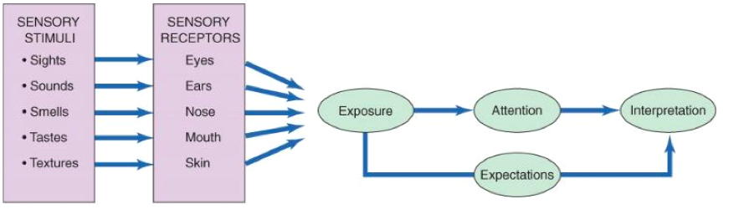

I - SENSORY MARKETING.

Marketers use our sensory to create a competitive advantage.

- Vision
• Our vision play tricks on us. Our eyes often have more to say than our stomachs.
• We ate more in larger boxes or plates
• with packaging, multiple smaller packages make people eat more
• Assortment of food or buffet in abundance suggest that its appropriate to eat more

• Colours influence our emotion directly. Red create feelings of arousal and stimulate appetite // blue is relaxing // white is safe.
• They are rich in symbolic values and cultural meanings (red = good luck for Chinese people)
• The choice of color is frequently a key issue in packaging design.
• Some colour combinations come to be associate with a corporation : company’s trade dress (white & red : coca cola)

- Smell
• Odours can stir emotions or create a calming feeling
• There is a link between smell, memory and mood
• Pleasant scents can recall of brand names, particularly when combined with a visual image.
• We process fragrance cues in the limbic system, the most primitive part of the brain and the place where experience immediate emotions.
• Clean scents can lead people to engage in morally virtuous acts (volunteering, reciprocating)
• Vanilla smell in women’s clothes shop and spicy , honey smell in men’s clothing store almost doubled sales.

- Hearing
• Advertising jingle maintain brand awareness
• Background music create desired moods
• Functional music is played in stores, shopping malls and offices to either relax or stimulate consumers.
• Aging ear: a loss of the ability to hear higher frequency sounds.

- Touch
• Haptic senses: touch is the most basic of senses; we learn this before vision and smell
• Touch has even been shown to be a factor in sales interactions. Study: diners who were touched by waiters gave bigger tips
• Haptic sense appear to moderate the relationship between product experience and judgment confidence People are more sure about what they perceive when they touch it.
• Touching an item forms a relationship with the product

- Taste
• Flavour houses develop new concoctions for consumer palates
• Cultural changes determine desirable tastes
• Color of a product can influence the actual taste of the product.

II – EXPOSURE.

Exposure is the process by which the consumer comes onto contact with the stimulus and has the potential to notice it.
Consumers can focus on the stimulus, or ignore the information

Sensory thresholds :
There are some stimuli people cannot perceive. Some people are better able to pick up sensory information than others.

Psychophysics: the science that focused on how the physical environment is integrated into our personal and subjective world.

- The absolute Threshold
It refers to the minimum amount of stimulation that can be detected in a sensory channel.
Ex: The sound emitted by a dog whistle is too high to be detected by human ears this stimulus is beyond out auditory absolute threshold.

- Differential Threshold
The ability of a sensory system to detect changes, or differences between 2 stimuli.
Just noticeable difference (JDN) : The minimum difference between two stimuli

Sometimes a marketer may want to ensure that a change is noticed (discount) and some other times, they’ll make everything so that consumer don’t notice the change (size of the product, increase of the price).

Weber’s law :
The amount of change necessary to be noticed is systematically related to the original intensity of the stimulus.
It is the ration (not the absolute difference) that are important in describing the least perceptible difference in sensory discrimination. (ex: market down should be at least 20% to make an impact on shoppers. So socks at $10 will be sale at $8 and coat at $100 : $80)
The weber’s law is used for two reasons:
• So reductions are not readily discernible to the public (ex: reduction of the size)
• So the product improvements are perceived by the public

Subliminal perception:

• Subliminal perception occur when the perception of a stimuli is below the level of consumer consciousness. Subliminal messages can be sent on both visual and aural channels.
• If you can see it or hear it then it is not subliminal.
• fear of unconscious manipulation began with the experience and projection of a movie called “panic”. They inserted messages that said “drink coca-cola”. People didn’t noticed but sells of coca increased by 60%
• Subliminal techniques such as an embed (often of sexual nature)

III – ATTENTION.

• Attention refers to the extent to which the brain’s processing activity is devoted to a particular stimulus.
• We are often in a state of sensory overload : we are exposed to more information then we are able or wiling to process (nb : 3,500 ad info pieces daily)
• Younger consumers can multi-task: process multiple media
• Marketers need to break through the confusion: guerrilla marketing and message that go viral.
• Perceptual selectivity : people pay attention only to stimuli to which they are exposed. They select among the stimuli to avoid being overwhelmed.

Personal selection factors:

• Perceptual filters : based on past experiences and influence what they decide to process
• Perceptual vigilance : it is a factor in selective exposure. Consumer are aware of stimuli that relate to their current needs (conscious or unconscious)
• Perceptual defence : people see what they want to see and ignore what they don’t.
want to see
• Adaptation : the degree to which consumers continue to notice a stimulus over time. The process of adaptation occurs when consumer no longer pay attention to a stimulus because it is so familiar. Several factors can lead to adaption :
- Intensity (stimuli with less sensory impact ex: soft sounds)
- Duration (if a stimuli require to be confuse on it for a long time to understand it)
- Discrimination (they do not require attention to details)
- Exposure (the more often you see it the less you see it)
- Relevance (stimuli unimportant, they don’t catch your attention)

Stimulus selection factors:
In addition to the receiver mindset, characteristics of the stimulus itself play an important role in determining what gets noticed and what gets ignored.
We are more likely to notice stimuli that differ from others around them:
• Size
• Colour
• Position
• Novelty (communication that use new stimuli or appear in unexpected places tend to grab our attention)
IV – INTERPRETATION.

• Interpretation refers to the meanings that people assign to sensory stimuli. Two people can see or hear the same event, but their interpretations of it can be like night and day.
• Consumers assign meaning to stimuli based in the schema : set of beliefs to which stimulus is assigned.
• A schema provides a cognitive framework that helps organize and interpret information that surrounds a particular stimulus.

Stimulus organization

• People don’t perceive a single stimulus in isolation, they tend to view it in terms if relationships with other events, sensations or images.
• Gestalt psychology: people derive meaning from the totality of a set of stimuli rather tgab from any individual stimulus. “The whole is greater than the sum of its parts” (Une perspective fragmentaire qui analysent chaque composant du stimulus séparément ne sera pas en mesure de saisir l'effet total.)

The gestalt perspective provide three explanation of how stimuli are organized:
- Closure: people perceive an incomplete picture as complete
- Similarity: consumers tend to group together objects that share similar physical characteristics
- Figure Ground: one part of the stimulus will dominate the figure, while other parts recede into the background

V – INTERPRETATION BIASES.

• It is up to us to determine the meaning based on our past experience, expectations and needs.
• Consumers tend to project their own desires or assumptions onto products and advertisements.

Perceptual positioning
• perception of a brand compromise both its functional attribute (features, price etc.) and it symbolic attributes (its image and what we think it is say about us)
• Our percdeption of a product is typically the result of what it mean rather than what it does.
• The meaning, as perceived by consumer, constitutes the product’s market position.
• A position strategy : the way marketers want to brand to be viewed by consumer.
Use of mix marketing (product design, price, distribution and marketing communication) to influence the consumer’s interpretation of the brand’s meaning.

• Brand’s position as a function of:
- Lifestyle
- price leadership
- attributes
- product class
- competitors
- occasions
- users
- design

CHAPTER 3 : LEARNING AND MEMORY

THE LEARNING PROCESS

Learning refers to a relatively permanent change in behaviour that is caused by experience.
The experience does not have to affect us directly. We can also learn vicariously by observing events that affect others.
Incidental learning refers to an unintentional acquisition of knowledge.
Learning is an ongoing process (processus discontinue)

Behavioural learning theory

• Behavioural learning theory assume that learning takes place as the result of responses to external events, as opposed to internal though processes.
• The mind is approached as a “black box” that cannot directly investigate
• The stimuli or event perceive from the outside world go inside that box and responses or reaction of these stimuli come out of the box (ex: a Big Mac as the stimuli and salivation as a response).

- Classical conditioning

Classical conditioning occurs when a stimulus that elicit a response is associate with an other stimulus that initially does not elicit a response on it own. Over time, this second stimulus causes a similar response because it is associated with the first stimulus (ex: Pavlov using meat power, bell and dog )
• The powder was an unconditioned stimulus (UCS) because it was naturally capable of causing a response.
• The bell became a conditioned stimulus (CS) because it did not initially cause salvation.
• The sound cause by the bell now linked to the feeding time was a conditioning response (CR).

Classical conditioning is a form of associative learning in which consumers learn associations between stimuli without really thinking about it (no complex memory or cognitive learning).

- Repetition
Associative learning : when a conditioned stimulus and an unconditioned stimulus have been paired a number of time.
- Repetition increases learning
- More exposure results in greater brand awareness
- Less exposure can result in decay
- When exposure decreases extinction results
- But….too much exposure leads to advertising wear out

- Stimulus generalization
When a stimuli similar to a conditioned stimulus evokes similar conditioned response.
Ex : with the dog of Pavlov, the dog start salivating when he hears keys jangling.
people react to other stimuli in the same way as they respond to an original stimulus.
- Family branding
- Product line extensions
- Licensing
- Look-alike packaging (“me too” product)

- Stimulus discrimination
Stimulus discrimination occurs when a stimulus similar to a CS is not followed by a UCS. Part of the learning process involves learning to respond to some stimuli but not to other similar stimuli.
Only buy the brand names

- Transferred meaning can be conditioned by fairly simple associations
- Goal is to create brand equity
  - Repetition (H&R Block)
  - Product Associations
  - Backward Conditioning
  - Advertising wear-out (change media/message)

- Instrumental conditioning

Instrumental conditioning (operant conditioning) occurs as the individual learns to perform behaviours that produce positive outcomes and to avoid behaviours that yield negative outcomes.
• Under instrumental conditioning, people perform more complex behaviours and associate these behaviours with either rewards or punishments.
• Shaping occurs when consumers are rewarded for successive steps taken toward the desired response. It is the desired behaviour learned over time.
In instrumental learning, the response is performed because it is instrumental to gaining a reward or avoiding a punishment.
- Positive reinforcement in the form of reward = learning of the appropriate behaviour (ex : Frequency marketing, thank you letters, rebates, follow-up phone calls)
- Negative reinforcement : removing something negative to increase the change of getting a desired response
- Punishment : used to decrease undesired behaviour. Punishment occurs when a response is followed by an unpleasant event. With punishment, we learn not to repeat these behaviour.
Nb : for both positive and negative reinforcement, when a positive outcome is no longer received, extinction of the behaviour is likely to occur.

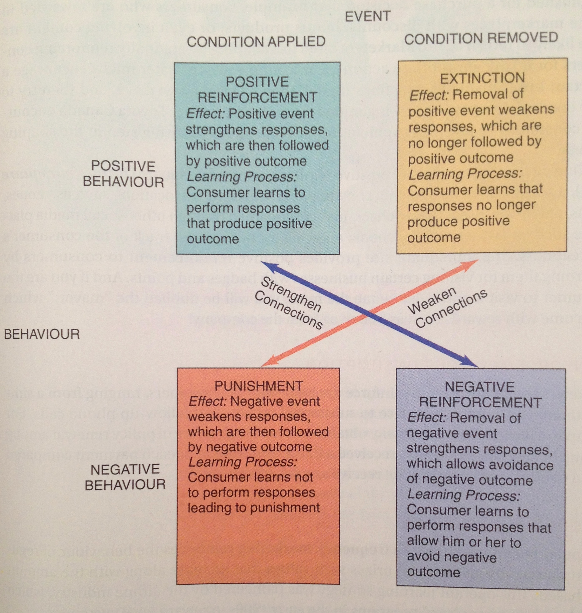
Four types of schedules learning.

Two general way in which consumers are reinforced for desired behavior :
Ratio schedules reinforce the learner based on the number of responses that have been completed.
Interval schedules reinforce the learner after a certain amount of time passes since the appropriate response.

- Fixed ratio reinforcement : reinforcement occur after a fixed number of responses : buy 9 get 1 free
- Variable ratio reinforcement : slot machine
- Fixed interval reinforcement : After a specified time period has passed (ex: seasonal sales )
- Variable interval reinforcement : unknown amount of time that must pass before reinforcement is delivered. `

Application of instrumental conditioning on marketing :

To be done

COGNITIVE LEARNING THEORY

In contrast to the behavioural theories of learning, cognitive learning theory stresses the importance of internal mental process.
This perspective views people as problem solvers who actively use information from the world around them to master their environment.
• Mindless : the fact that people process some information in an automatic, passive way. Our reaction are activated by a trigger feature (stimulus that change our behaviour without being aware of doing so)

Observational learning

Observational learning occurs when people watch the action of others and note the reinforcement they receive for their behaviours.
Learning occurs as a result of vicarious rather than direct experience.

• Modelling : the process of imitating the behaviour of others. It is a powerful form of learning but it can be dangerous (ex : TV violence on children). Socially desirable models/celebrities who use or do not use their products. 4 conditions must be met for modelling learning :
- The consumer attention must be focus on the model (attractiveness, status, competences..)
- The consumer must remember what the model says or does
- The consumer must convert this information into actions
- The consumer must be motivated to perform these actions
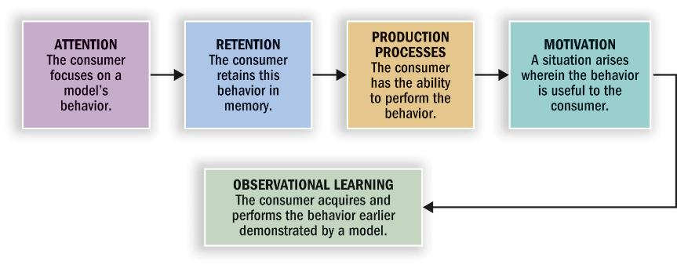
Marketers use modelling. They can show what happens to models who use or not use their products, in the knowledge that consumers will often be motivated to imitate these action later.
The degree to which model will be imitate depends on his or her social attractiveness.

THE ROLE OF MEMORY IN LEARNING

Memory : acquiring information and storing it over time so that it will be available when needed.
• Information-processing approach : the mind is like a computer, data are input, processed and output for later use in revised form.
In the encoding stage, information is entered in a way the system will recognize. In the storage stage, this knowledge is integrated with what is already in memory. During retrieval the mind access the desired information
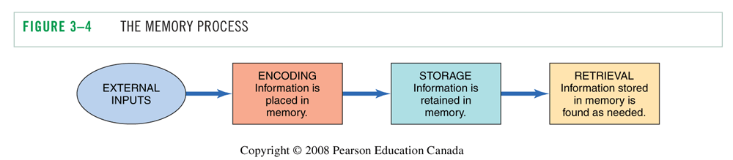

• Decision-making process : this internal memory is combined with external memory (all of the product details on packaging, in shopping lists, and through other marketing stimuli).
It permit brand alternatives to be identified and evaluated.

Encoding :
Encoding involves linking new information to exhibiting knowledge in order to make the new information more meaningful.

• Types of meaning
We encode information to help us retain it later
- Sensory meaning - colors, shapes
- Semantic meaning - symbolic associations (rich people drinking champagne)

• Personal relevance
- Episodic (or flashbulb) memories : reminds of events that are personally relevant (ex: a song for a couple)
Conveying product information through a narrative or a story so people construct a mental representation of the information they are viewing. Brand are more likely to be positively evaluate.
Low-involvement products tend to have descriptive, snappy names

Memory system :

There are three distinct memory system:
- Sensory memory :it permits storage of the information we receive from our senses. This storage is temporary.
- Short-term memory : also store information for a limited period of time. It hold the information we are currently processing (cf: working memory, RAM)
- Long-term memory : It allows us to retain information for a long period of time. For information to enter long-term memory from short-term memory, elaborative rehearsal is required (thinking about the meaning of the stimulus to keep it in mind)
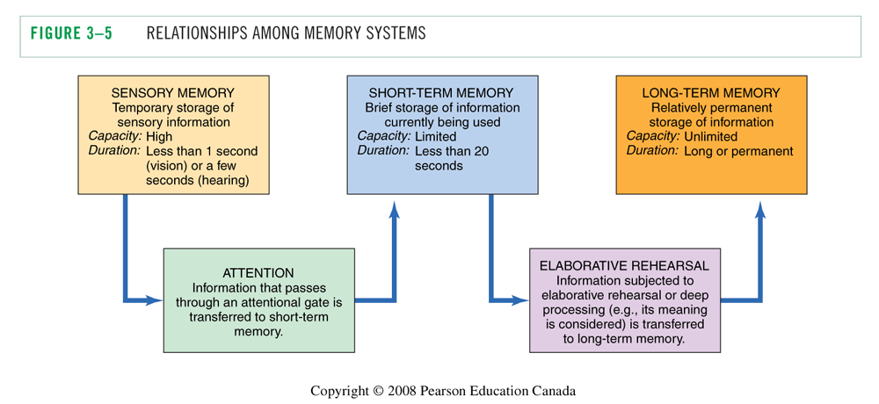

Storing information in memory:

• Activation models of memory : depending on the nature of the processing task, different levels of processing occur that activate some aspect of memory rather than others. (The more effort it takes to process the info the more likely it will end in the long term memory)

• Associative network of related information: it is the association that form in consumer’s minds that lead to learning about brands and products.
• These storage unit is known as Knowledge structures of interconnected nodes which are connected by associative links in these structure.
• Hierarchical processing model: a message or ad is processing in a bottom-up fashion (de bas en haut) Processing start at a basis level. If processing at one level fails to evoke the next level, processing od the ad is terminated and our capacity will be allocated to something else.

• Spreading association : A meaning can be activated indirectly. As one node is activated, other nodes associated with it also begin to be triggered
Meaning types of associated nodes:
Brand-specific : claims made for the brand
Ad-specific : content of the ad itself
Brand identification: brand name
Product category: how the product works, experience and use of the product
Evaluative reactions: “that looks like fun” or not

Example :

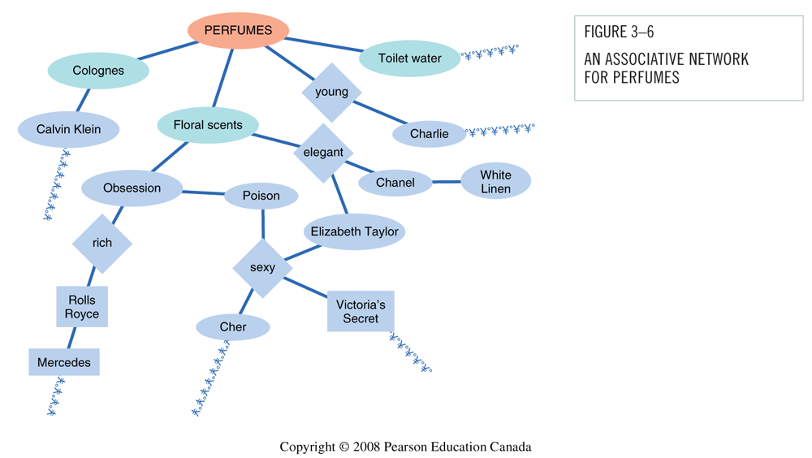

• Level of knowledge : Individual nodes = meaning concepts. Two (or more) connected nodes = proposition or belief (complex meaning, ex: Chanel is a perfume for elegant woman). Two or more propositions = schema (cognitive framework developed through experience). We more readily encode info that is consistent with an existing schema.
One schema that is relevant to consumer behaviour is a script (little scenarios that happen in our mind. We associate an idea with a scenario)

Analogical learning:
• To introduce new product or innovation, marketers can educate and inform consumers by drawing an analogy (highlighting similarities) between the new product and an existing one.
• In analogical learning, the existing product is called the base and the new one is called the target. It is effective because the consumer can integrate knowledge about the base into the schema for the target product

• Analogical learning can takes two forms :
- Attributes : identifiable features or proprieties of the product.
- Relations : refers to how the product relates to a desired outcome.

Collecting information for purchase decisions
Retrieval is the process of accessing information from long-term memory.
• Situational factors : relating to the environment in which the message is delivered.
- Pioneer-brand are more likely to be recall as the were the first to enter the market
- Low involvement products with descriptive brand names are more likely to be recalled.
• The viewing environment of a marketing message also affect recall.
- Ads shows during continuous activities (stories or drama) are easily to recall than in a context of stop-and-go activities (talk show).
- Commercials shown first in a series of ads are recalled better than those shown last.
• Post experience advertising effects : imagery from the ad can become confused with our own experience. When consumer were exposed to ads after they had experience the product, the ad altered their recollections of the experience.

Appropriate factors

• Familiarity and recall : Familiarity with an item enhance its recall. Marketers try to create and maintain awareness of their products. Attention: to much familiarity : inferior learning and recall !
• Salience and recall : salience : prominence of the brand in our memory. Stimuli that stand out are more likely to command attention (unusual ads or distinctive p ackaging)
• Pictorial versus verbal cues : superiority of visual memory over verbal memory. Information presented in picture form is more likely to be recognized later. Pictorial ads enhance recall but do not improve comprehension.

Factors influencing forgetting:
• Memory fade because of passage of time : decay
• Forgetting occur because of interference : as additional information id learned, it displaces earlier information.
- Retroactive interference : new response replace older ones.
- Proactive interference : prior learning interfere with new learning

Products as memory markers :
Products and ads can serve as powerful retrieval cue.
- Furniture, visual art and photos call forth memories of the past
- Autobiographical memories on buying behaviour
- Power of nostalgia “the good old days”
- Retro brands : updated version of a brand from a prior historical period. It trigger nostaligia
- Nostalgia Index: people’s tastes in products like movies and clothing are influenced by what was popular during certain period of their past.

Measuring memory for marketing stimuli:
A good ad is one which have a good impact (impression) on consumer. Two basic measures of impact are :
• Recognition : people are shown ads one at a time and asked if they have seen them before. It is more likely to be an important factor in a store where consumer are confronted with thousands of product option and information.

• Recall: free recall, people have to think of what they have seen without being prompted for it. Recall are more important in situation in which consumers do not have product data at their disposal.

recognition score are almost always better than recall scores because recognition is simpler process and more retrieval cue are available to the consumer.

• Problem with memory measurement:
- Response biases : People tend to say ‘yes’ regardless of what is being asked and they want to be “good subject” to please the experimenter.

- Memory lapses: people forget information = omitting, averaging (normalize things), telescoping (inaccurate recall of time)

- Memory or facts vs. feelings : measurement do not adequately tap the impact of feeling ads (ads that convey strong emotion instead of concrete product benefits).

CHAPTER 4 : MOTIVATION AND AFFECT

INTRODUCTION

The motivation process :
Motivation refers to the processes lead people to behave as they do. It occurs when a need is aroused that the consumer wishes to satisfy. Once a need is activated, a state of tension : unpleasant state that exists if a person’s consumption needs are not fulfilled.
• This need can be utilitarian (functional or practical benefits) or hedonic (experimental need that involve emotion).
• The forces that drive us to buy/use products :
- Goal: Consumer’s desired end-state
- Want: Manifestation of consumer need

MOTIVATIONAL STRENGTH.

Motivational strength: Degree of willingness to expend energy to reach a goal

Drive theory :
Biological needs that produce unpleasant states of arousal (e.g., hunger, people can be grumpy if they haven’t eaten). This state activates goal-oriented behaviour that attempts to reduce or eliminate this unpleasant state and return to balanced one called Homeostasis.
Drive theory runs into difficulties when it tries to explain some facets if humain behaviour that run counter to its predictions.

Expectancy theory:
Behaviour is pulled by expectations of achieving desirable outcomes (positive incentives like money or social status). We choose one product over another because we expect this choice to have more positive consequence for us.

MOTIVATIONAL DIRECTION.

Motives have direction and strength. They are goal-oriented to satisfy a need.

Needs vs. Wants
The specific way a need is satisfied depends on the person’s unique history, learning experience and culture.
A “want” is the way a need is going to be satisfy (ex: two people are hungry, one is going to satisfy his hunger with a burger and one want a soup to satisfy his hunger).

Types of Needs:
• Biogenic need : food, water, air, shelter innate, necessary to maintain life.
• Psychogenic needs : acquired in the process of becoming member of a culture need of status, power, affiliation…
• Utilitarian needs : need for tangible attributes to achieve the objective (kilometers, calories..)
• Hedonic needs: they are subjective and experimental. Need for excitement, self-confidence, fantasy..

Motivational conflicts :
A goal has valence : it can be positive or negative.
- Positive valued goal : approach the goal
- Negative valued goal : avoid a negative outcome. People avoid rejection and product associate with social disapproval. Positive and negative motives often conflict with one another. Three different kind of conflicts can occur:

- Approach-approach: a person must choose between two desirable alternatives
The theory of cognitive dissonance : people have a need of consistency in their lives. A state of tension is created when beliefs and behavior conflict with another. Conflict that arises when choosing between two alternatives may be resolved through a process of cognitive dissonance reduction : people convincing themselves they made the good choice to eliminate unpleasant tension

- Approach-avoidance: products and services we desire have negative consequences attached to them as well as positive consequences. This conflict occurs when we desire a goal but wish to avoid it at the same time.
solution : fake furs to eliminate guilt about harming animals while allowing you to make a fashion statement. // diet coke, hybrid vehicle …

- Avoidance-avoidance: People face a choice between two undesirable alternatives.

Specific needs and buying behavior:
• Need for achievement: People will value personal accomplishment and will place a premium on products and services that signify success.
• Need for affiliation: : (to be in company of other people) Need for products and services that relieve from loneliness (bars, shopping malls, athletic venues…)
• Need for power : (to control one’s environment) Focus on products that have mastery over surroundings (ex: hotels and resorts that promise to respond to the consumer’s every caprice)
• Need for uniqueness : To assert one’s individual identity

Maslow hierarchy of needs:

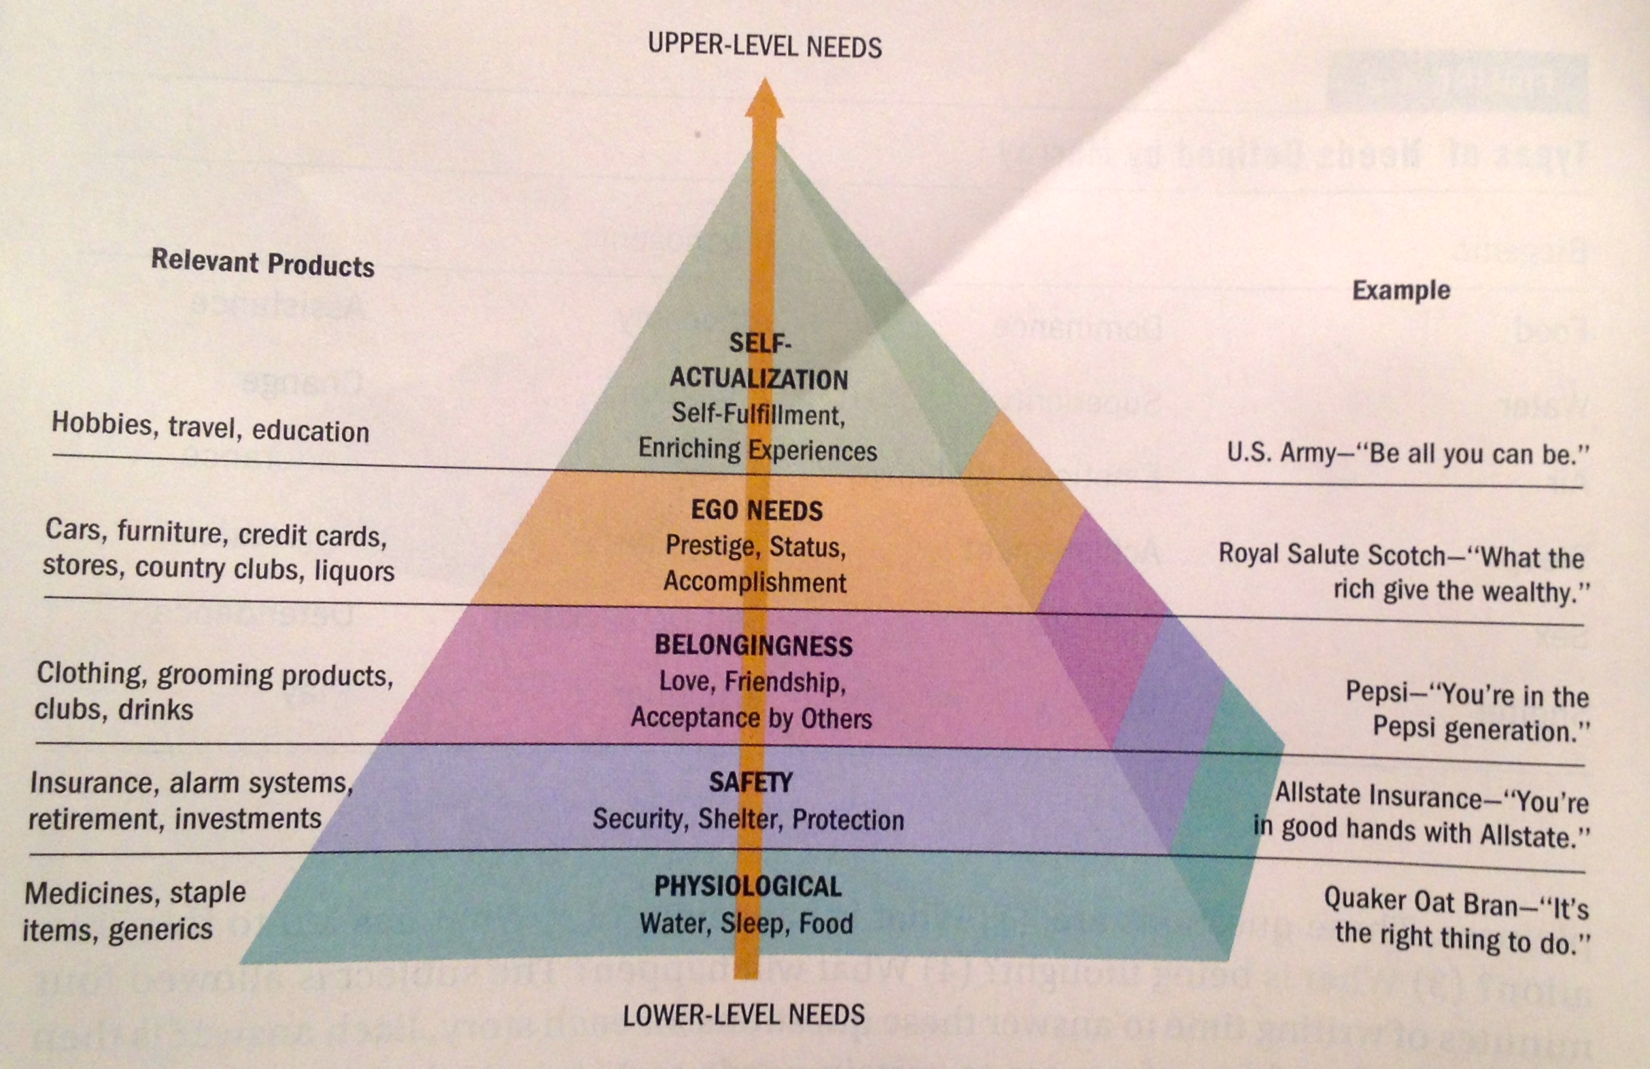

Maslow’s need hierarchy predicts that higher-order needs become the driving force behind human behavior as the consumer’s lower-level needs are satisfied.
NB: Satisfaction doesn’t motivate behavior, dissatisfaction does.

Motivation and Goal Fulfillment:
• Goal Setting that is SMART (Specific, Measurable, Attainable, Realistic and Time-bound) can help consumers to reach their goals. Ex: Nike and the Running Room
• Sometimes consumers decrease effort when they get closer to the goal.
• Goal progress dos not have to be real, and can simply be perceived to have strong effects on behavior.
Goals can be unconsciously activated: The Apple brand name activates the need to be unique and different (we are not aware of it).

CONSUMER INVOLVEMENT.

A consumer motivation to attain a goal influences his or her desire to extend the effort necessary to attain the objective.
Involvement : relevance of a product or brand that is perceived by a person, based on his inherent needs, valued and interest. How much are you wiling to do to get a product ?
It is the motivation to process information.

Level of involvement:
• Inertia: Consumption at the low end of involvement. We make decisions out of habit (lack of motivation to consider alternatives)
• Flow state: Consumption at the high end of involvement. True involvement with a product, ad or website. Flow is an optimal experience characterized by the following:
- A sense of Playfulness
- A feeling of being in control
- Concentration and high focused attention
- Mental enjoyment of activity for its own sake
- Distorted sense of time
- Match between challenge at hand and one’s skills

• Involvement can be cognitive or emotional. There are 3 broad types of involvement that relate to the product, to the message and to the situation.

- Product involvement: Consumer’s level of interest in a product.
- Many sales promotions attempt to increase product involvement.
- Mass customization enhances product involvement by permitting consumers to play a role in designing or personalizing what they buy.

- Message-response involvement : Television is considered as a low-involvement medium (passive viewer) // Print media demand high involvement.
- Consumer’s interest in processing marketing communications (question and answer on Pringles’ snack chip. Or creating spectacle and performance to deliver the message)
- Marketers experiment with novel ways to increase consumers’ involvement, such as games on Web sites, texting to vote on Canadian Idol interactive mobile marketing

- Purchase situation involvement: Differences that may occur when buying the same object for different contexts.
Example: wedding gift For your boss: purchase expensive vase to show that you want to impress boss. For your cousin you don’t like: purchase inexpensive vase to show you’re indifferent
Scale to Measure Involvement:

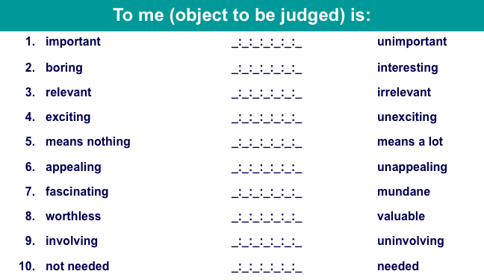

Dimensions of Involvement

The amount of consumer involvement depends on:
- Personal interest in product category
- Risk importance (consequences)
- Probability of bad purchase
- Pleasure value of product category
- Sign value of product category (self-concept relevance)

Strategies to increase involvement :

• Appeal to consumers’ hedonic needs (ads with sensory appeal generate higher level of attention)
• Use novel stimuli (unexpected movements in commercial, silence etc)
• Use prominent stimuli (loud music and fast action)
• Include celebrity endorsers to generate higher interest in commercials.
• Build a bond with consumer by maintaining an ongoing relationship with them.
• Push Consumer generated content

AFFECT

Types of Affective Responses
Affect refers to the experience of emotionally-laden states, which can range from evaluations, to moods, to full-blown emotions.

• Evaluations involve valenced (i.e., positive or negative) reactions to events and objects, that are not accompanied by high levels of arousal (éveil) ex: when someone evaluate a movie.

• Moods involve temporary positive or negative affective states accompanied by moderate levels of arousal.

• Emotions tend to be more intense and are often related to a specific triggering event.

How Do Marketers Use Affective States?

• Positive moods and emotions are highlighted as a product benefits. Ex: Viagra use humour and music to convey the positive affective quality of the product.
Ex: alcohol, Tabaco fragrance, caffeinated beverages are consumed for their mood-altering qualities.

• Negative moods Negative state relief occur when helping can relieve negative moods.
Ex: a picture of a starving child will activate a negative mood. By donating to the cause, it will resolve this negative mood.

• Mood congruency effect : our judgemnt are often consistent with our existing mood state.
Positive moods lead to more positive evaluations.

Social Media and Emotions
People are express their mood and reaction about a product on twitter and Facebook + use emoticon. It is a treasure for marketers who wants to learn more about how their offering make people feel.

- Sentiment analysis (opinion mining) : a process that scours the social media to collect and analyze feeling of people about a product. People use certain words that relate to their emotions.
- Word phrase dictionary (library) : researchers use these words to create word-phrase dictionary to code data.

Discrete Emotions

• Happiness is a mental state of well-being characterized by positive emotions.
- Experimental purchases brought more happiness than material purchases.
- Spending money on others increase happiness as opposed to on the self
- Happiness does not involve moment at all, it involve time (one possibility)
- What makes us happy vary throughout the lifespan.

• Envy is a negative associated with the desire to reduce the gap between one-self and someone who is superior on some dimension.
- Benign envy occurs when the individual believes that the superior other deserves his/her status (when consumer experience benign envy on a product they are wiling to pay more for it)
- Malicious envy occurs when the consumer believes that the superior other does not deserve his status. Is can result to negative word of mouth an d sabotage of a product + wiling to pay more for a product of the same category (ex: the other have an Iphone, I’ll get a phone more expensive but not apple)

• Guilt is defined as an individual unpleasant state associated with possible objections to his/her actions, inaction, circumstances or intention.
- Guilt appeal are very efficient when other people are present because it activates a sense of consumer social responsibility.
- Guilt appeal can backfire if too extreme
• Embarrassment is a social emotion driven by a concern for what others are thinking about us.
- Unwanted events communicate undesired information about oneself to others
- Sometimes dependent on product category : condom, adult diapers, Viagra ..
- It can arise between consumers when a social norm is violated (ex : rejection of one’s credit card during a date)

CHAPTER 5: THE SELF

PERSPECTIVES ON THE SELF

• We buy products to highlight/hide aspects of the self.
• Western culture stress on the separateness of each individual // Eastern culture focus on an interdependent self, whereby a person’s identity is defined by the relationship he has with others.
• Eastern and Western cultures see the self as an inner private self and the outer public self.
• In the era of Facebook and Twitter everyone is able to share their thoughts with millions of friends and strangers.
• Each of us is a separate, unique individual

Self-Concept:
The self-concept refers to the beliefs a person holds about his or her own attributes and how he or she evaluates theses qualities.
Attribute dimensions:
- Content (facial attractiveness versus mental aptitudes)
- Positivity or negativity (self-esteem)
- Intensity
- Stability over time
- Accuracy (the degree to which one’s self-assessment corresponds to reality)

Self-Esteem:
Self-esteem refers to the positivity of your attitude toward yourself.
• Low self-esteem: People think they will not perform well and will try to avoid embarrassment.
• High self-esteem: People think they will be successful and will take more risks. They are lore wiling to be the center of attention.
• Exposure to ads can trigger a process of social comparison : people will try to evaluate themselves by comparing to the image they in ads.
- Marketer use attractive models using products
- Young women’s perception of their body and physical appearance can be altered after watching TV (30min)

Real and Ideal Selves:
Ideal self: Conception of how we would like to be. It is partly moulded by elements of our culture and models.
Actual self: More realistic appraisal of the qualities we do and don’t have.
Impression management : we work hard to “manage” what others think of us. We strategically engage in products and behaviours to impress.
• Products are purchase because :
- They help us reach ideal self
- They are consistent with our actual self
• We are constantly faced with images of the “ideal” person in media
• Each of us has more than one self concept - one for attractiveness, work ethic, friend etc.

Multiple Selves:
• Each consumer is really a number of different people.
• We have as many selves as we have different social roles.
• Marketers promote products needed to facilitate active role identities (husband, boss, student // dancer, stamp collector, advocate for the homeless…)

Virtual Identity:
• Interactive virtual worlds allow people assuming virtual identities in cyberspace
• Avatars represent visual identity (ranged from realistic version of us to trigger-out versions with exaggerated characteristics)
How do online “selves” affect consumer behaviour?

Symbolic Interactionism:
when and how do we decide which self to “activate” at any point of time ?
Symbolic interactionism: Relationships with others play a large part in forming the self.
We exist in a symbolic environment in which the meaning of situation or object is determined by the interpretation of this symbol.
• As member of a society we share meaning (and interpretation) ex: red light means stop.
• “Who am I in this situation?” // “Who do other people think I am?” We pattern our behaviour on the perceived expectation of others.
• Self-fulfilling prophecy : we acting the way we assume others expect us to act.

Looking Glass Self
In the “looking glass self” view, a process of reflexive evaluation occur when an individual attempt to define the self. We’re taking the role of the other and trying to project the impression they have of us.
• It Can vary depending on…
…Whose perspective we are taking
…How accurate our predictions are of their evaluations of us
• It leads to Self-fulfilling prophecy

Self-Consciousness:
• Sometimes people can be painfully aware of themselves (you coming late in a lecture and everyone is looking at to : you feeling self-conscious)
• Public self-consciousness: concern of public image (people with high public self-consciousness consume more cosmetic and clothes)
• Self-monitoring : people will focus on how they present themselves in their social environment.
- High self monitors : consume more products that make good impressions on other (plus notion of vanity, fixation on physical appearance..)
- Low self-monitors: People don’t evaluate products consumed in public in terms of impressions they will make on others.

Consumption and Self-Concept:
• Identity marketing: Consumers alter aspects of their selves to advertise a branded product
• Consumption of products and services consumption contribute to the definition of the self
• Product can be viewed as extended of the self

You Are What You Consume
• Reflected self: People see themselves as the image others see them.
• Product (car, jewellery, clothing…) help to determine the perceived self.
• Social identity as individual consumption behaviours
Question: Who am I now? Answer: To some extent, your possessions!
• Inference of personality based on consumption patterns
• Consumers get attachment to an objet because it is used by that person to maintain her self-concept.
•Symbolic self-completion theory: People who have an incomplete self-definition complete identity by acquiring and displaying associated symbols (cars, cigarette, high heels ….)
• People victims of a burglary, fire or natural disaster reports feelings of alienation, as if they were being violated/ raped. Basic reaction is “What I’m buying now won’t be as important to me”.

Self/Product Congruence (compatibility) :
• Consumers demonstrate consistency between their values and attitudes and the things they buy.
• Self-image congruence models: We choose products when their attributes matches with ourselves. Process of cognitive matching between these attributes and the consumer’s self-image.
Product Usage
Self-Image

=

Problem of the “chicken and egg” : Do people buy product because they are seen as similar to the self OR do they assume that the product is similar because they bought it ?

The Extended Self:
Extended self: We consider external objects as a part of us. There are 4 levels of the extended self. These range from very personal objects to places and things that allow us to feel as if we were rooted their environment.
• Levels of extended self:
- Individual: Consumer include personal possessions in self definition (cars, clothing)
- Family: the consumer’s residence and furnishings in it. (House = symbol of the body for the family)
- Community: neighbourhood or town where you live
- Group: attachment to certain social or other groups that are considered as part of the self.

Gender Differences:
• Gender identity is an important component of consumer’s self concept.
• The roles of genders vary by culture and are changing over time.
• Many societies still expect traditional roles:
- Agentic roles: Men are expected to be assertive and have certain skills
- Communal roles: Women are taught to foster harmonious relationships

Gender versus Sexual Identity:
Sex-typed traits: characteristics we stereotypically associate with one gender or the other.
• Unlike maleness or femaleness, masculinity and femininity are NOT biological characteristics. Each society determines what “real” men and women should and shouldn’t do.

Sex-types products: Products take on masculine or feminine attributes and consumers often associate them with one gender or another.
Ex: Pink Princess telephones for girls and Jack Daniels Whisky for men.

Androgyny:
Androgyny refers to the possession of both masculine and feminine traits.
• Difference in gender-role orientation can influence responses to marketing stimuli.
• Androgynous people function well in a variety of social situations
• Sex-typed people: stereotypically masculine or feminine
- Females are more detail oriented and appear to be more sensitive to gender-role relationship than man.
- Men are more influenced overall themes when writing a letter or forming a judgement.

Gender Benders:
Marketer –s try to think about new markets for their products.
• Gender-bending products: Selling a sex-typed item adapted to the opposite sex
- Rubbermaid introduced grooming tools such as tweezers and clippers for men
- Harley Davidson backed a world record attempt for female motorcycle riders
- Sarah Palin and her hunting adventures could catch on with other women

Female roles :
Sex roles constantly evolve.
The study named “Contemporary Young Female Achievers” (CYMFA) identified different roles women play in different context : highly feminine role as a mother or partner / masculine roles as businesswomen / both of them as a friend.

Male roles:
Like women, men receive mixed message about how they are supposed to behave and feel.
Notion of metrosexual : a straight urbane male who exhibits strong interest and knowledge regarding product such as fashion, home deign, gourmet cooking and personal care.
our definition of masculinity is evolving. Men redefine sex roles while they stay in a “safe zone” of acceptance behaviour.

GLBT Consumers:
• They represent between 4% to 8% of U.S. population
• Spend $250–$350 billion a year
• Segments within the GLBT community
- Super Gays
- Habitaters
- Gay Mainstream
- Party People
- Closeted

BODY IMAGE

Body image: Consumer’s subjective evaluation of his/her physical self. The image is not necessarily accurate.

• Body cathexis: person’s feelings about his or her own body. Cathexis refers to the emotional significance of some object or idea to a person, and some parts of the body are more central to self-concept than others.
Strong body cathexis = frequent purchases of “preening” products (as air conditioner, facial bronzer…)

Ideals of Beauty:
Ideal of beauty is a particular model or exemplar of appearance. It include physical features (blue eyes, pale vs. tan, lips..) aspects of clothing and body type (small, thin, athletic..)
“What is beautiful is good” is an stereotype that assume that the more attractive people are smarter.

Favourable physical features
Attractive faces
Good health and youth
Balance/symmetry
Feminine curves/hourglass body shape

Western ideals of beauty :
• Skin color and eye shape = status, sophistication, and social desirability
• Less powerful cultures adopt standards of beauty in dominant cultures
• Many Asian cultures associate light skin with wealth and status and associate dark skins with labour class.
• Use of plastic surgery to obtain big round eyes, tiny waists, large breasts, blond hair, and blue eyes

Ideal of beauty over time:
Specific “looks”/ideals of beauty
- Early 1800s: delicate/looking ill appearance, 18-inch waistline (use of corsets)
- 1890s: voluptuous, lusty woman
- Bad economy: mature features vs. good economy: babyish features 1990s: “waif” look
- Modern women: high heels, body waxing, eyelifts, liposuction

Male Ideals of Beauty:
A recent national survey asked both women and men to define male aspects of appearance :
- Strongly masculine, muscled body according to men but women prefer less muscle mass.
- Fashion designers and magazines are using models who look like “regular guys”
- Men and women “work on the body” from exercise to cosmetic surgery

Working on the Body:

To match up to some ideal of appearance, people work hard to change their physical aspects :
- Cosmetics
- Sports
- Plastic surgery
- Tanning salon
- …

Fattism :
• “You can never be too thin or too rich” how realistic are this appearance standards ?
• Healthy body image is the ideal : weight-conscious
• Dove has banned the size “0” in their ads

Body Image Distortions:
• For many people, body quality reflects self-worth (particularly among women). Rich = thin, Poor= fat.
• Distorted body image is linked to eating disorders among females : anorexia, bulimia …
• Body dysmorphic disorder (obsession with perceived flaws in appearance) becoming more common among young men
- Steroid scandals : use of dangerous product to reach the ideal body

Cosmetic Surgery:
• Cosmetic surgery is now commonplace and accepted among many segments of consumers.
• Changing a poor body image or to enhance appearance
• Men account for 20% of surgeries
• Breast Augmentation is the most common surgery for women.
• Perception that breast size = sex appeal

Body Decoration and Mutilation:
The body is adorned or altered in some way in every culture. Body decoration serve a number of purpose :
- Separate group members from non-members (Chinook Indians of North America)
- Place the individual in the social organization (puberty rites to illustrate a boy becoming a man)
- Place the individual in a gender category
- Enhance gender role identification (high heels for women / foot binding in china)
- To provide a sense of security (amulet against the evil eyes)
- To indicate desired social conduct (gay man wear an hearing in the left or right to signal what role they have in a relationship)
- To indicate status or rank (Indians wear feather ornament to indicate how many people they have killed)

CHAPTER 6: PERSONALITY, LIFESTYLES AND VALUES

- PERSONALITY:
    - Definition: Person’s unique psychological makeup and how it consistently influences the way a person responds to his/her environment.
    - Debated cause people are not reacting consistently the same way in front of the same situation

  - Freudian Systems:
    - Freud personality’s definition: conflict between gratification and responsibility
    - Symbolize by 3 components of the self systems:
      - ID: pleasure principle (the party animal) / maximize pleasure and avoid pain
      - Superego: the person’s conscience / society rules and work
      - (≠ ID)
      - Ego: mediates between superego and ID / balance between virtue and temptation

    - Marketing Implications:
      - Unconscious Motives:
        - the Ego possibly relies on the symbolism in product to compromise the ID and the Superego

  - Motivational Research:
      - Freudian ideas unlock deeper product and advertisement meanings
      - Consumers and in-depth interviews
      - Latent motives for purchases
    - Criticisms:
      - Invalid cause gives the advertisers to manipulate consumers
      - Lacked of rigor and validity (subjective and indirect)
      - Too sexually based cause influenced by orthodox Freudian theory

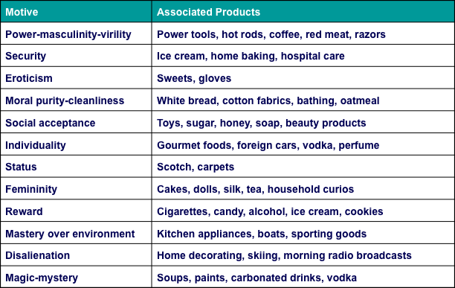
    - Appeal (attract by)
      - Cheaper than surveys
      - Powerful hook for promotional strategy and good first experience
      - Intuitively plausible findings (after the fact)
      - Enhanced validity when combines with other technics

    - Neo-Freudian Theories
      - Karen Horney
        - People can be described as moving towards others (Compliant), away from others (detached), or against others (aggressive)
      - Alfred Adler
        - Motivation to overcome inferiority
      - Harry Stack Sullivan
        - Personality evolves to reduce anxiety
      - Carl Jung
        - Developed his own method the “analytical psychology”
        - Established concept of collective unconscious, which is the storehouse memories inherited from our ancestral past.
        - Explained the creation of archetypes, universally shared ides and behavior patterns.

  - Trait Theory
    - Personality traits: Identifiable characteristics that define a person
    - Traits relevant to consumer behavior:
      - Innovativeness (like trying new things)
      - Materialism ( the importance people attach to wordly possession)
      - Public self-consciousness (person who monitors and controls his/her image seen by others)
      - Need for cognition (degree of a person who likes to think)
      - Need for uniqueness (need for showing his/her difference)

- BRAND PERSONALITY
    - Set of traits people attribute to a product as if it were a person
    - Brand equity (the extent to which consumers hold strong, favorable and unique associations with a brand)
    - Outsourcing production to focus on brand
    - Extensive consumer research goes into brand campaigns
    - Distinctive brand personality = brand loyalty
      - Animism (human qualities attributed to products)
        - Level 1: brand = spokespersons and loved ones
        - Level 2: anthropomorphized brands (given human characteristics)

  - Personality of positioning
    - Brand personality is a statement of brand positioning
    - Some brands re-position to gain new interest in their products

- LIFESTYLE AND PSYCHOGRAPHYICS
    - Consumption patterns reflecting a person’s choices of how one spends time and money

  - Who we are and what we do?
    - Lifestyle marketing perspective:
      - People sort themselves into groups on the basis of the things they like to do, spend time and money
      - Create market segmentation strategies based on type of product and brand choice

  - Lifestyles and Group Identities
    - Forms of expressive symbolism
    - Self-definition of group members = common symbol system
      - Terms include lifestyle, taste public, consumer group, symbolic community, status culture
      - Each person provides a unique “twist” to be an “individual”
    - Tastes/preferences evolve over time

  - Products Building blocks of Lifestyles
    - Brand focuses on Product usage in desirable social settings = Consumption style
    - Patterns of behavior:
      - Co-branding strategies: Brands team up with other companies to promote products, to make sense
      - Product complementarity: Symbolic meanings of different products relate to one another
      - Consumption constellations: Define, communicate, and perform social roles

  - Psychographics
    - Use of psychological, sociological, and anthropological factors to:
      - Determine market segments
      - Determine their reasons for choosing products
      - Fine-tune offerings to meet needs of different segments

    - Consumers can share the same demographics and still be very different!

  - Psychographic Analysis
    - Grouping consumers according to (AIO):
      - (A) ctivities
      - (I) nterests
      - (O) pinions
    - Identifying heavy, moderate, and light users
      - Targeting heavy users and the benefits they derive from product
        - Ex: walk for fun and walk to go to work
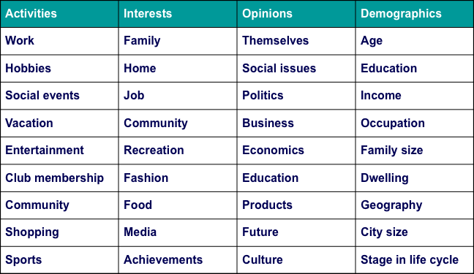
  - Psychographic Segmentation Uses
    - To define target market:
    - To create new view of market
    - To position product
    - To better communicate product attributes
    - To develop overall strategy
    - To market social/political issues

  - Geodemography
    - Consumer expenditures/socioeconomic factors + geographic information
      - “Birds of a feature flock together”
      - Can be reached more economically (by city and postal code)
        - People with similar needs and tastes tend to live near one

- VALUES
  - A value is a belief that some condition is preferable to its opposite
    - Values have a central influence in their consumption and in society
      - Ex: Two people can believe in the same behavior (e.g., vegetarianism), but their underlying belief systems may be quite different (e.g., animal activism versus health concerns).

  - Core Values
    - Every culture has a set of values that it imparts to its members.
      - Many values vary by country and culture and change over time
      - Core values define a culture and are taught to us by socialization agents (parents, friends, teachers) through enculturation
      - Differences in values explain why marketing campaigns may be a hit in one country and flop in another
        - Ex: Cosmopolitan Mag, sex articles in Sweden, China and India are different
    - Some Values are universal – health, wisdom etc

  - Classifying Values
    - Specific value scale for different use:
      - Cultural Values
      - Consumption Specific Value
      - Product Specific values

  - New Core Values
    - Conscientious consumerism
      - Health conscious consumers
      - Growing green market an
      - BUT, if people don’t have enough money, they won’t want buy the “green” products

    - LOHAS = “lifestyles of health and sustainability”
      - People worry about they environment, sustainable product
      - Green is spreading to the mass market

  - Materialism
    - Materialism refers to the importance people attach to worldly possessions - “He who dies with most toys, wins”
    - Modern Living – expectation of “the good life” a world of material comforts, like cell phones, ipads etc.
    - Materialism = unhappiness?
    - Materialistic tendencies = dislike of school, poor grades

