Quiz 1





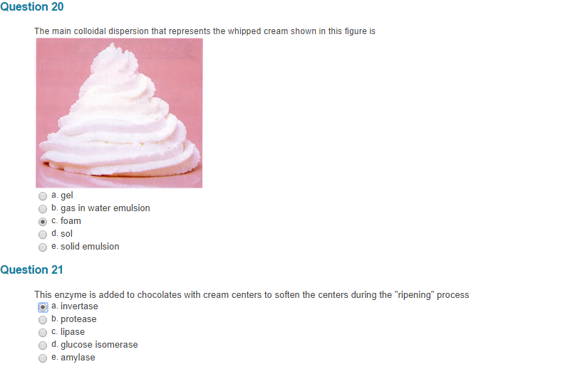


Quiz 3
- The class of microorganism cannot grow unless there is oxygen present
- Viruses
- Bacteria
- Mould
- Yeast
- Larvae
- Based on temperature requirements for growth, this class of microorganism is the major cause of spoilage of refrigerated foods.
- Psychrophiles
- Psychrotrophs
- Mesophiles
- Thermophiles
- Pathogen
- This term described the dormant form of microbial cells which can be very resistant to processing or environmental conditions
- Mould
- Spores
- Yeast
- Virus
- Vegetative cells
- If a thermal death time curve shows that in order to shorten the D-value from 80 min to 8 min, you need to increase the temperature of your thermal process from 140º to 160ºC
- 20ºC
- 72 mins
- 80 mins
- 140ºC
- 160ºC
- The D-value or decimal reduction time is
- Characteristic for each type of microorganism under the specified conditions
- Dependent on the starting number of microorganisms
- Independent of the temperature of heating
- Determined from a thermal death time curve
- Described by all of the above
- The quality of frozen foods can be maximized by
- Freezing the food slowly
- Allowing the temperature to constantly fluctuate
- Storing at a temperature close to the freezing point of water
- Allowing cold air to circulate slowly
- Forming and maintaining small ice crystals
- Modified atmosphere packaging
- Maintains pre-set gas compositions within vacuum-packaged food products
- Prevents growth of spoilage-causing microorganisms
- Allows products to be stored at room temperature
- Is used for some fresh pasta products, cured meats, cheeses and ready-to-eat salads
- Involves all of the above
- Cool or refrigerated storage refers to storage at temperatures in the following range ºC
- 4 to 20
- 0 to 16
- 0 to 20
- -2 to 20
- -2 to 16
- In the IQF process, the food product
- Such as ice cream is frozen
- Is frozen in individual flat packages
- Is in directed contact with a plate freezer
- Immersed quickly in a cryogenic fluid
- Frozen quickly as individual entities
- Preservation of food by refrigeration is based on
- Inhibited of psychrotrophic microorganisms
- Destroying enzymes present in the food
- Killing of disease-causing microorganisms
- Killing of spoilage-causing microorganisms
- Slowing down microbial growth and rate of senescence
- The packaging material used for frozen foods should
- Be impermeable to light and moisture
- Be impermeable to light and oxygen
- Be impermeable to oxygen only
- Be impermeable to light, moisture, and oxygen
- Be impermeable to moisture only
- The rate of freezing can be affected by
- The food composition
- The product/food thickness
- The air velocity
- All of the above
- None of the above
- A commercially sterile food product
- Is completely free from all forms of microorganisms
- Is obtained after boiling the food at 100ºC for at least 15 minutes
- May contain small numbers of heat-resistant bacterial spores which will not germinate under normal conditions
- May contain small numbers of vegetative cells which may grow under normal conditions
- Can be stored for 90 days or less
- Blanching is a thermal process that is
- Usually applied to meat products
- Used to inactive microorganisms
- Used to inactive enzymes in plant tissue
- Described by all of the above
- Described by none of the above
- Shelf-stable milk that is to be stored at room temperature must have been processed using
- A pre-sterilized packaging material
- Commercial sterilization with ultra-high temperature
- Aspetic packaging conditions
- All of the above
- None of the above
- What is the primary heat transfer mechanism during thermal processing to tomato juice?
- Steaming
- Retort
- Conduction
- Convection
- Microwave heating
- This is the number of survivors after application of a 5D thermal process to a food containing a starting 1,000,000
- 20,000
- 5,000
- 1,000
- 100
- 10
- Freezer burn is popular name for a phenomenon observed on some frozen foods that is mainly due to:
- Enzymatic browning that occurs in the food during frozen storage
- Scorching that occurs during rapid thawing of frozen foods
- Surface dehydration of the food during frozen storage
- Maillard browning that occurs in the food during frozen storage
- Textural hardness caused by the growth of large ice crystals
- This enzyme causes development of brown colour in apples when they are cut
- Polyphenol oxidase
- Glucose isomerase
- Pectinase
- Invertase
- Lipase
- Changes that can occur in foods during frozen storage include
- Freezer burn
- Oxidative rancidity
- Lipolytic rancidity
- Textural changes
- All of the above
- In the video on corn processing, we learned that
- A corn is packaged in ‘tetrapacks” for longer shelf life
- Blanching is performed at 100ºC for 3 minutes
- Corn kernels are frozen using a still air freezer
- Processing of corn is conducted year round
- Corn starch is added is added to the water used for washing the corn kernel
- For low-acid food, the recommended margin of safety in terms of number of decimal reduction times is
- 1 D
- 3 D
- 5D
- 10 D
- 12D
- This term means “impervious to water vapour, air, and other gases”
- Aseptic
- Hermetic
- Hygroscopic
- Sterile
- Porous
- In the dairy processing video, we learned that egg nog
- Is pasteurized using the same thermal processing conditions as milk
- Contains ingredients that are added after pasteurization of the milk and does not need re-pasteurization
- Does not require pasteurization since the added ingredients are sterile
- Needs a more severe thermal process than milk
- Is processed by commercial sterilization
- In the video for lesson 5, we learned that microorganisms can be inactivated or slowed down by
- Heating or thermal processing
- Ionizing radiation or irradiation
- Dehydration to lower the water activity
- Freezing or low temperature processing
- All of the above

Quiz 4
- Irradiation is currently approved to reduce the microbial load of the following food/ingredients in Canada
- Strawberries
- Ground beef
- Spices and dried seasonings
- Sliced mangos
- Shell eggs
- This term described commercial sterilization using irradiation
- Radicidation
- Radurization
- Radappertization
- Irradiating sterilization
- Sterile irradiation
- Which of the following may be used as a source of ionizing energy for food irradiation
- Ultraviolet rays
- Infrared radiation
- Microwave radiation
- Gamma radiation from cobalt 60
- All of the above
- In making decisions about the safety and wholesomeness of irradiated foods, the principle of radiological safety refers to the determination of
- Whether radioactivity will be induced in the food
- Whether radioactivity is emitted from the source of ionizing energy
- The safety of personnel in the irradiation facilities
- All of the above
- None of the above
- In the context of cheese production, the term biotechnology refers to
- Addition of starter cultures to milk
- Fermentation by lactic acid bacteria
- Milk clotting by microbial produced chymosin
- Research on genetically engineered starter cultures
- All of the above
- The purified form of the milk-clotting enzyme used for cheese production is called
- Lactase
- Chymosin
- Rennet
- Amylase
- Invertase
- Changes that can occur in foods as a result of irradiation include
- Induction of radioactivity
- Emission of fluorescence
- Increase in temperature
- Formation of the free radical
- All of the above
- The term describing the suppression of spoilage- and disease-causing microorganisms by desirable microorganisms in fermented food is
- Microbial synergy
- Microbial antagonism
- Pasteurization
- Commercial sterilization
- Survival of the fittest
- The ability of dehydration to result in preservation of food is attributed to
- Killing of pathogenic microorganism
- Killing of spoilage-causing microorganisms
- Physical removing microorganisms from the surface of the food
- A decrease in water activity resulting in inhibition of microbial growth
- All of the above
- The raisin sampled in class gave an immediate sweet sensation when they were placed on the tongue because
- Sugars migrate to the outer surface of the grape during the dehydration process, where they are deposited as the water evaporates
- Starch in the grape is converted to sugar when the grape id dried
- Sugar is manually coated on the surface of raisins, making them sweeter
- The sulphites added to the raisins enhance the sweet taste
- Sugar is manually coated on the grapes prior to drying thus making the raisins sweeter
- Sublimation is the basis for dehydration that occurs during
- Drum drying
- Spray drying
- Freeze drying
- Tunnel drying
- Tray drying
- The term “biotechnology” includes
- Fermentation
- Genetic engineering
- Application of microorganisms for production of food ingredients
- All of the above
- None of the above
- The characteristic holes or “eyes” in Swiss cheese arise from
- Release of carbon dioxide during fermentation by lactic acid bacteria
- Release of carbon dioxide during fermentation by propionic acid bacteria
- Production of acids during fermentation by bacteria
- High cooking temperatures that release water vapour
- None of the above
- In the cheese-making video we learned that
- Milk is pasteurized before the starter culture is added
- Milk is pasteurized after the starter culture is added
- Milk is coagulated with the aid of gums and starches
- Starter cultures used are naturally present in milk
- The whey portion is used for making the cheese
- Foods that have been air/tray dried
- Have excellent re-hydration properties due to the voids/channels in them
- Do not require any special packaging
- May appear shrunken and have poor rehydration properties
- May have higher water activity than the original food before dehydration
- Are also known as concentrated foods
- The process which involves exposing droplets of lipid skim milk into a stream of heated air is called
- Drum dry
- Freeze dry
- Spray dry
- Tray dry
- Vacuum microwave drying
- Moulds are involved in production of which of the following cheese
- Roquefort cheese
- Camembert cheese
- Blue cheese
- All of the above
- None of the above
- The following term describes the tendency of dehydrated foods to pick up moisture
- Humid
- Hygroscopic
- Hydroscopic
- Water activity
- Case hardening
- The samples of dehydrated “instant mashed potatoes” shown in class had been dried by the following dehydration process
- Freeze drying
- Spray drying
- Deep fat drying
- Vacuum microwave drying
- Drum drying
- In Canada, the following federal agency is responsible for aspects related to wholesomeness and safety of irradiated foods
- The Canadian Nuclear Safety Commission (CNSC)
- Atomic Energy Control Board (AECB)
- The Radiation Protection Bureau (RPB)
- The Canadian Food Inspection Agency
- The Health Products and Food Branch of Health Canada
- The term “cheddaring” refers to
- Acid formation by lactic acid bacteria fermentation
- Coagulation of protein by rennet enzyme
- The orange colour of Cheddar cheese curd
- Cutting of the matted curd and piling the blocks on one another
- All of the above
- Labelling of irradiated foods in Canada is
- Mandatory for all irradiated foods and for foods containing more than 10% irradiated ingredients
- Voluntary for foods containing less than 10% irradiated ingredients
- Completely voluntary
- Not regulated
- Only required when the food may become radioactive
- The rate of dehydration or removal of water from foods depends on
- The temperature, humidity and velocity of the drying air
- The composition of the food to be dried
- The relative amounts of free and bound water in the food
- The surface area of food to be dried
- All of the above
- Preservation of foods through fermentation is a direct result of
- Microorganisms producing acids that increase the pH of the food
- Mould growth that lowers water activity
- Enzyme action that breaks down cellulose to glucose
- All of the above
- None of the above
- The following may be used to minimize indirect effects of food irradiation
- Irradiation in a frozen state
- Irradiation in a vacuum
- Removal of oxygen
- Addition of ascorbic acid
- All of the above

