- Geology
  - Study of Earth

Why study Geology?
  - Important for energy and natural resources, solving environmental problems, building cities and highways, predicting and protecting against natural disasters like earthquakes, volcanic eruptions, landslides, floods

- Uniformitarianism: fundamental principle “the present is the key to the past”
  - What we see now has probably been going on throughout the history of our planet, only the rates have changed.

- How long? geologic time is measured in billions of years

- Where and How? After the Big Bang (~14 billion years ago) Earth may have formed by the nebular theory:
  - ~5 billion years ago a solar nebula of hydrogen and helium gravitationally contracted into a rotating disc with our Sun at the centre, and the planets and moons revolving around it

Solar Nebula Earth

  - Within the disc, Earth evolved through many collisions of rocky and metallic fragments into a rocky sphere divided into a dense core, large mantle (very hot, almost melting), and lighter crust.
  - Heavy stuff to the inside (core) and light stuff to the outside (crust)

- Plate Tectonics:

- crust

- uppermost mantle lithosphere (brittle)

- asthenosphere (soft) CCW movement

- convection

- lower mantle

  - Crust and uppermost mantle eventually split into rigid plates of lithosphere (sphere of rock) that move over Earth’s surface above the soft, convecting asthenosphere (weak sphere) by Continental Drift, based on... Plate tectonics ~140years ago
    - fit of the continents - e.g. South America, Africa and other continents fit well together at 900 m depth which coincides with the edge of their continental shelves
    - fossil evidence - same type and age found on continents separated by ocean basins (species that can’t usually swim that far)
    - rock types and structural similarities - match when continents are fit back together across ocean basins. Newfoundland and Greenland across the Atlantic ocean.
    - Paleo (ancient) climates - evidence of ancient glaciations (glacial rocks damaged rocks) in warm areas of today (south India, Antarctica and Greenland have ice sheets)- show the pattern of a single ice sheet if continents are refitted back together; all attached to Antarctica.
      - Also, ancient coal fields that formed in tropical swamps now occur in areas of cold climate and polar areas (Canadian arctic)
    - Dismissed because lithospheric plates “cannot move”

Convergent plate boundary

- 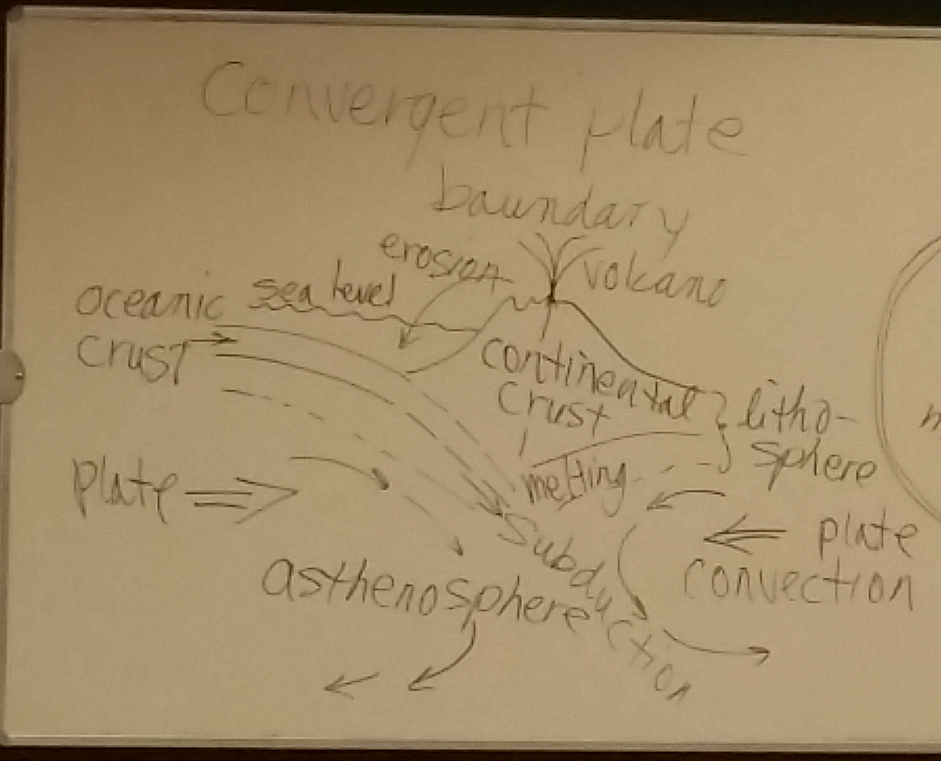

- • most Geologic activity (e.g. earthquakes, volcanoes) occurs at plate boundaries; especially at convergent boundaries where denser oceanic lithosphere descends beneath lighter continental lithosphere; at depth it melts to produce magma which rises to the surface and erupts as volcanoes which in turn are eventually eroded and the sediment carried by streams to the ocean again

- Earth System and Rock Cycle:
  - Earth is a dynamic planet (system) of interacting hydrosphere, atmosphere, biosphere, and geosphere (solid earth); matter (molecules) is recycled with changing conditions of depth (pressure), temperature, and rock type within Earth’s crust (e.g. convergent boundaries)
  - the rock cycle and plate tectonics together produce many different types of rocks that are made up of different minerals

- 4700 natural minerals are known, only about 20 dominate the Earth’s crust
- Common minerals are natural solid compounds
  - Silicates: made of silicon-oxygen tetrahedron (silica, (SiO4)^-4)

Si-O tetrahedron
Si^4+
Cation
Oxygen O^2-

- formulas are not
- necessary to know

  - Ferromagnesian (dark) silicates contains Fe^+2, Mg^+2
    - Olivine: single tetrahedral bonded to Fe^+2, Mg^+2 ions
Si-O tetrahedral

- Fe^2+
- Mg^2+

- individual tetrahedral

    - Pyroxene: single chains of tetrahedral, ~90° cleavage
One line shows
Single chain

Strong covalent bonding within chains

Ionic (weaker) between chains

    - Amphibolde: double chains, ~120° cleavage
      - Similar to pyroxene, but two lines
    - Biotite: (black mica) tetrahedral sheets (sheets = “infinite” chains) with perfect (basal) cleavage
Double tetrahedral sheet
Weak bonding
Al Fe Mg

  - Nonferromagnesian (light) silicates
    - Muscovite: tetrahedral sheets with perfect platy cleavage
    - Feldspar: strongly bonded 3-D network of silica tetrahedral
      - K variety is called orthoclase
      - Ca-Na group is called plagioclase
    - Quartz: made entirely of silica tetrahedral (SiO2) covalently bonded, hard (7 out of 10), has no cleavage

  - Nonsilicate materials
    - Carbonates: metals bonded to (CO3)^-2 group
      - Calcite: CaCO3 limestone
      - Dolomite: CaMg(CO3)2 (magnesium!)
    - Minerals formed by evaporation:
      - Halite: NaCl, common salf (also chlorine, baking soda)
      - Gypsum: CaSo4 * 2H2O, use to make plaster and drywall
    - Ores of metal (extracted, mined for money)
      - Hematite: Fe, O (iron ore)
      - Sphalerite: Zn, S (zinc ore)
      - Galena: Pb, S (lead ore: used for soldering)
      - Native gold (Au), silver (Ag)

  - Igneous rocks crystallize from molten silicate material called magma that forms at high temperatures and pressures deep in the Earth
  - Magma rises through the crust and either reaches the surface by
    - Volcanoes (extrusive) or
    - Cools below surface (intrusive)
  - How magamas evolve:
    - Discontinuous series (different structures) of olivine (single tetrahedra), pyroxene (single chains), amphibole (double chains), biotite (sheets)
    - Continuous series (plagioclase structure)
    - Bowen’s Reaction Series: crystals settle in a magma chamber resulting in the melt crystallizing through a series of minearsl according to their decreasing melting temperatures
      - Remaining crystals react with the melt that is enriched in lighter elements (magmatic differentiation)
      - Dark crystals form early, settle, and take heavy elements with them, then light crystals form from the remaining light elements, eventually to quarts
        - Granite can ultimately evolve from an original magma having a basaltic composition

        - Magnetic Differentiation
Mineral crystal

Crystal settling

Magma chamber
Settled crystals with heavy element

- Crystal settling is the key

    - Assimilation: magma composition can also change through pieces of host rock falling into the magma and melt
      - Magma mixing where one body of magma invades another, producing a composition intermediate between the two

- Igneous compositions:
  - Colour (content differs)
    - Dark (Fe, Mg) mafic
    - Light (more silica) felsic
  - Texture (size, shape, arrangement of mineral crystals)
    - Aplanatic (fast cooling magma, small crystals) cools very quickly with contact with cool air or rock, so crystals are very small (fine grain), aphanitic (crystals are too small to view with eye).
    - Phaneritic (slow cooling magma, large crystals, coarse) formed by slow cooling below the surfaces
    - Porphyritic (large crystals surrounded by smaller ones) magma crystalizing in a vent or offshoot, solidified from volcano
    - Glassy (quenched, no crystals) in cold air, etc. formed so fast that crystals don’t have time to form
    - Pyroclastic (fragmental) created by airborned pieces of magma falling to the ground, ejected violently into the air

- Naming igneous rocks using rock textures and mineral compositions (dark / light)
  - Felsic (~70% silica)
    - Granite (in cores of mountains)
    - Rhyolite (volcanic)
  - Intermediate (~60% silica)
    - Andesite (from volcanoes above subduction zones)
    - Diorite (in intrusive rocks above subduction zones)
  - Mafic (~50% silica) basaltic
    - Basalt (most abundant rock, forms oceanic crust; upper oceanic curst and volcanic islands)
    - Gabbro (in lower oceanic crust)
  - Ultramafic (~40%)
    - Peridotite (in upper mantle, might be the main rock in the upper mantle, as seen in certain areas of the world)

- Intrusive igneous bodes: forms plutons by magma crystalizing at depth
  - Discordant (dykes): cuts across host rocks where magma intrudes fractures, squeezes along layers of rock.
  - Concordant (sills): parallel to layers of rocks that is being squeezed through.
  - Laccoliths: concordant, bulge

Dyke
Laccoliths

Bulge
Sills
Host rock
- Volcanoes erupt from gas buildup carbon dioxide, sulfuric acid
Gas, pyroclastics – viscous, felsic composition
                - Runny mafic composition

Lava flow
  - Runny mafic composition

sx

pipes
                - pipe

                - magma
magma

- Materials extruded
  - Lava tends to flow quietly downhill while cooler, :
    - Hotter, runny pahoehoe (ropy, coils of rope looking) mafic
    - Cooler, viscous aa (blocky, hard to walk on) jagged
    - Pillow lavas form under water and builds lava tubes that stack on top of each other (underwater volcanism, stacked pillows) look like rocks
    - Pyroclastic ranges from fine ash to large bombs and large blocks (created by eruption)
    - Nuée ardentes (pyroclastic flows) very hot glowing cloud of ash & gas
    - Lahars: wet ash flow mixed with rain, ice, snow

- Volcanic structures

crater
                - crater

Caldera > 1 km across

Pipe, vent
                - Pipes, vent

  - Caldera- sides and roof cave in

- Types of volcanoes:
  - Shield (broad dome of lava flows): large and successive flows (top of base (under sea level) is higher than mt. Everest
  - Cinder cone (small, pyroclastic materials)
  - Composite (classic cone shape, mixed materials of lava flows and pyroclastic materials)

10’s ms
Few kms
Mix of lava & pyroclastics
composite
Pyroclastic material
Cinder cone
All lava flows
100s kms
Shield

Mt. St. Helen’s eruption was huge

  - fissure eruptions pour lava onto land to build up lava plateaus from fissures in the crust. Builds up thick piles of lava flows (plateaus) on continents (eg. NW USA) basalt plateau

- Plate tectonics and Volcanic activity
  - Pacific ring of fire
    - Plate boundaries and convergent boundaries have lots of volcanic activity
    - Oceanic crust is denser so it descends under the continental crust (lighter minerals), taking sea water, lowering melting point of mantle rocks, causing melting and volcanism in mountain ranges atop
  - Seamounts- submarine volcanoes where basaltic lava flows out from the sea floor
  - Mantle plumes at boundary between the core and the mantle (under the middle of lithospheric plates) due to movement of pacific plates, creating intraplate volcanoes (eg. Hawaii)
- Rocks are formed, then weathered when exposed at the surface
  - Prepares material for transport by erosion processes in rock cycle
  - Type of weathering: mechanical (disintegration) and chemical (decomposition) act together and enhance the effectiveness of each other
    - Mechanical: reduction of rocks to smaller pieces
      - Frost wedging: water freezes in rock fractures and expands 9%, prying rock apart
rock
water

Water freezes, spreads rock apart

      - Sheeting: rock surface expands after stuff on top is removed, slabs break off

Pressure released after
Curb slabs slide downward

ground
pluton

    - Chemical
      - Dissolution: CO2 dissolves in water to make weak carbonic acid that dissolves rock minerals
        - Easily attacks minerals, sodium
      - Oxidation: dark silicates react with oxygen; form Fe, Mg oxides, clays
      - Hydrolysis: feldspar in igneous rocks. Orthoclase in granite switches from K+ to tiny H+ ions, turns to clay

Hydrolysis - hydrogen replacing some other
Silicone 4+
Oxygen
Aluminum 3+
Potassium 1+

- Rates of weathering
  - Rock characteristics
    - Light silicates form closer to weathering conditions, more stable; marble is soluble, unstable
    - Dark silicates form under higher P, T conditions, unstable under weathering conditions
    - Climate: weathering is greater in warm, wet climates
      - Moisture and water

- Soil: biologic activity combined with
  - Parent material: rock or sediment on which soil forms
  - Time: longer, more soil formation
  - Climate: slow in cold, dry areas
  - Plants, animals: provide hummus
  - Topography: erosion, water retention (gentle slope / flat slope)

Soil profile develops donward from the ground surface as layered horizons

O: horizon: humus (like compost)

A: humus

E: removal of soluble ions

B: accumulation of oxides, clays

C: regolith (weathered parent material)

Unaltered parent material

- Soil Erosion

Riles

Gullies

streams
- “To settle” = settlement that settles
  - produced from weathering
  - 7% of rocks on the continent
  - streams deposit sediments, glaciers transform sediments as well
  - ocean basin has sedimentary rocks

  - Lithification
    - Compaction: sediment compressed into smaller volume, thinner
compaction
opens
Oepns
compaction

    - cementation: minerals precipitate
  - detrital sedimentary rocks
    - mainly settled rock fragments clay from weathering of plutonic rocks, and quartz
    - clay metals settle into sedimentary rocks
    - ferromagnisium oxides, quartz gets concentrated into sediment
    - 3 main types…
      - shale: from settling of ifne particles in quiet water
        - mud carried through ponds and sea
        - good cap rock for oil and gas
        - abundant in ocean basins, standing water
        - fine material settles
        - water cannot permeate, good for oil and gas
        - water has been transporting at a certain velocity
          - let go of smaller stuff, concentrate similar sizes
        - colliding causes corners and edges to be worn down
        - might have feldspar and feramagnesium
        - feldspar heavy = arkose (S14)
        - shale has fossils, bedded
        - silica and iron oxide
        - S7
      - sandstone: well sorted if grains of similar size; poorly sorted if a mix of different sizes
        - mainly quartz grains; called arkose if it has lots of feldspar
        - S11
      - Conglomerate: from muddy gravel deposited down slopes or by currents, waves
        - Particles travelled far, rounded
        - Formed by possible: streams down a mountain, fast flowing stream, beach due to wave activity
        - S9
      - Breccia: particles deposited close to source, still angular
        - Quickly deposited from the source
        - Particles that are broken haven’t travelled a distance
      - Chemical sedimentary rocks: lake or sea
        - Ions from chemical weathering precipitate in sea or ponds
        - Shells of organism form biochemicsal sedimentary rocks
          - Animals etc
        - 5 main types
          - limestone (calcite) (turns into rocks due to)
            - micrite (sea water) S10
            - fossiliferous limestone (coral reefs) S
            - coquina (shells on a beach) shell hashes cemented by calcium carbonate
            - chalk (plankton on sea floor) S8 extracted from sea water, packed and cemented over a million years
            - travertine (caves) S1 CO2
          - dolostone: Ca+2 partly replaced by Mg+2 calcite of limestone
          - chert: mainly remains of plankton with skeletons of silica; used for arrowheads, spears S15
          - evaporates: rock salt, rock gypsum (S5), potash in shallow seas, salt flats
          - coal: plant matter in swamps
            - turns to lignite (produced lots of CO2) and andesite (highest grade of coal)
              - andesite is rare
              - main type of coal burned is: pancetta
        - Classification
          - Clastic: fragments of rocks and minerals in detrital sed rocks
          - Nonclastic: interlocking crystals in chemical sed rocks (eg. halite)

Interlocking
inet
nonclastic
Clastic
detrital

  - basic layering is one layer stacked upon another in sedimentary rock (cross bedding)
    - graded bedding: heavier stuff falls lower, settles lower
    - mudcracks: related to sea water or rain water that dried up
    - ripple marks: ancient ripples formed either by a stream or wave ripples on the underside of wave rock (oil, gas)
    - fossil fish: preservations of ancient life

- Metamorphism
  - “Changed” by heat, pressure and fluids (water with ions)
  - Solid state
  - Sedimentary rock can be buried by more sediments, invaded by magma
- Controlling factors
  - Parent rock: controls chemical composition (made of different minerals with different elements) resulting from cooking parent
  - Heat: most important, drives chemical reactions and recrystallization of host rock (magma bodies)
    - Cooking causes tighter locking, no cement anymore, larger than original (recrystallization, increase in size)
  - Pressure: increases with depth
    - Confining pressure (from all around)
    - Directed pressure (from say, above)
  - Chemical activity: ions in solution exchange with ions in minerals of the parent rock to form new minerals (minerals recrystallize, line up perpendicular to each other)
Directed
Pressure
confining

Metamorphic grade
  - increases in temperature
  - index minerals from low grade to high grade
  - Contact metamorphism
    - Local effect by magma intruding host rocks
    - Metamorphic aureoles form
    - Minerals recrystallize but are not reoriented
Cooling

magma
Contact metam

- nonfoliated metamorphic rocks
  - marble: coarse interlocking crystals of calcite
  - quartzite: coarse interlocking crystals of quartz (spherical, equi-dimensional)

  - Regional Metamorphism
    - Larger scale in the cores of mountains built by colliding plates
    - Directed pressures orient (align)
      - Recrystallized minerals (foliation) contac
    - Most intense in the roots of mountain belts
    - Slate: fine, parallel mica flakes
    - Phyllite: slightly larger flakes
    - Schist: foliation easily visible
    - Gneiss: banded or contorted: light and dark bending

    - Regional metamorphism
gneiss
Schist poliation is easier to see with eyes

Slate fine felite, hard to see
- See what earth is made of, how old it is
  - Ancient clues found in rocks

  - Relative Time
    - Superposition: each bed is older than the one above and younger than the one below
      - Layered rocks
- Superposition

1- oldest
1>2>3>4
3- youngest
2

    - original horizontality: sediment is usually deposited horizontally
    - cross-cutting relations (sometimes magma can fill inbetween as well)
      - a fault is younger than the rock it cuts
      - a rock is younger than the rock it cuts
    - inclusions: inclusions are older than the rock containing them
      - a preexisting rock is picked up and included into a younger rock
      - more deposits of sedimentary rocks cover the broken pieces
Fault- younger than it cuts
Cross cutting relations

Host rock

Dyke
younger than host rock

- unconformities: breaks in the geologic record (something missing either never there or was eroded away)
  - angular unconformity: between flat and tilted, eroded beds
    - boundary between
    - rocks getting crumpled, common in mountain beds (where there is a hump, which gets eroded)
      - land goes down and sea evades so sedimentary rock is found in the sea
  - disconformity: between parallel beds
  - nonconformity: between flat beds on eroded igneous, metamorphic rock
Disconformity
Missing rocks due to erosion
unconformity

Missing rocks nondeposition. Eroded away or never formed

Nonconformity

ig rock

Sedimentary rock

Meta. Aueral eroded away

Correlation: matching rocks features, fossils…
  - fossil succession: organisms evolved along distinct pathways through geologic time, left index fossils
    - fossil: imprint on rock of some organism from “millions” of years ago
Same age because same index fossils
Same index fossil
Index fossils
Same sequence
Outcrop b
Outcrop a
    - if several index fossils, find the shortest time span of fossil

Dating with radioactivity
  - radioactive isotopes (parents) decay to daughters over time (alpha, beta and gamma particles are emitted so element changes to a new element)
  - time it takes to decay to half the amount of parent left is the half life of the isotopes
  - compare parent left with half life, gives time since rock formed
Negative exponential decay curve
Fraction of parent isotope remaining
Half life
Radioactive Decay

Independent dating methods come up with the same age
      - potassium argyle (how much potassium is left?)
      - 5 half lives is about limit
  - oldest rocks on earth are on east of Hudson’s Bay 4.28billion yrs

- Radiocarbon (C14) dating (plants absorb radiocarbon through photosynthesis, we eat plants)
  - In organisms C14 decays to N14 with half life of 5730 years but is replaced by C14 from the air
  - In fossils C14 decays but is not replaced; use C14/12 ratio and
Radiocarbon dating

C14-> N12 is 5730 yrs (half life)

C14, C12 in constant rate
C14 is constantly replenished while alive

Ratio of C14 to C12 is constantly getting smaller and smaller

C14 is still decaying to N14
C14 is not being replenished
C12 stays the same (doesn’t decay)

Death = radiocarbon dating

Not tested on Geologic time scale

Deformation
  - Stress (force) on rocks
    - Compressional- squeezing
    - Tensional- stretching
    - Shear- slipping sideways
  - Strain results from stress- effect on applying stress to rocks
Shear- slipping sideways
Tensional- stretching
Compressional- squeezing

  - Under stress, rocks can exceed the elastic limit before flowing (ductile deformation) or being fractured (brittle deformation)
  - Brittle deformation is common near the surface (cold conditions), ductile deformation is common at depth

- Mapping geologic structure
  - Strike: azimuth of horizontal line on the surface of a piano
  - Dip: angle of indication of the surface from horizontal
    - Measured perpendicular to the strike
  - Structures:
    - Folds: compression forces
      - Anticline (arch)
      - Syncline (trough)
      - Monocline (step)
      - Dome (oldest rock in the middle)
      - Basin (youngest rock in the middle)

Fold ports

surface
younger
oldest
Cross-section view
Dome: map view
youngest
oldest
Symmetrical fold
limb
Fold axis
Axial plane

Cross-section view
Basin: map view
young
oldest

oldest
youngest

  - Joints: fractures but no displacement

Basin: map view

