Econ 101 Review Notes
Chapter 1
Definitions
- Scarcity: the inability to satisfy all of our wants and needs
- Incentive: a reward that encourages an action or a penalty that discourages one
- Economics: the social science that studies the choices that individuals, businesses, governments, and entire societies make as they cope with scarcity and the incentives that influence and reconcile those choices
- Microeconomics: the study of choices that individuals and businesses make, the way these choices interact in markets, and the influence of governments
- Macroeconomics: the study of the performance of the national economy and the global economy

Two Big Economic Questions
- 1. What, How, and For Whom to produce?
  - Goods and services are the objects people value and produce to satisfy human wants
  - What?
    - What we produce changes over time
    - It has moved from manufacturing to services
  - How?
    - Goods and services are produced using the factors of production:
      - Land – natural resources
      - Labour – work time and effort by people (quality depends on human capital)
      - Capital – tools, instruments, machines, buildings
      - Entrepreneurship – the human resource that organizes land, labour, and capital
  - For Whom?
    - It depends on the incomes that people earn
      - Land earns rent
      - Labour earns wages (70% of income)
      - Capital earns interest
      - Entrepreneurship earns profit
- 2. How can the Pursuit of Self-Interest Promote the Social Interest
  - Self-Interest
    - A choice that is the best one available to you
  - Social Interest
    - Self-interested choices promote the social interest if they lead to an outcome that is best for society as a whole – an outcome that uses resources efficiently and distributes goods and services equitably among individuals
    - Resources are used efficiently when:
      - Produced at the lowest possible cost
      - Produced in the quantities that give the greatest possible benefit
  - Self-Interest and the Social Interest
    - Globalization
    - The Information-Age Economy
    - Global Warming
    - Natural Resource Depletion
    - Economic Instability
The Economic Way of Thinking
- Choices and Tradeoffs
  - Tradeoff: giving up one thing to get more of another
- What, How, and For Whom Tradeoffs
  - What Tradeoffs – how to spend income
  - How Tradeoffs – how to produce
  - For Whom Tradeoffs – distribution of buying power
- The Big Tradeoff: Equality vs. Efficiency
- Opportunity Cost: the highest valued alternative given up
- Choosing at the Margin
  - Comparing benefits and costs
  - Marginal Benefit: the benefit that arises from an increase in an activity
  - Marginal Cost: the cost of increasing an activity
- Economics as Social Science and Policy Tool
  - Economics as a Social Science
    - Positive Statements – about what is
      - Economists test them against facts
    - Normative Statements – what ought to be
      - They depend on values and cannot be tested
    - Economic Models: a description of some aspect of the economic world that includes only the features needed
    - Natural Experiments: a situation that arises in the ordinary course of economic life
    - Statistical Investigation: looks for correlation between to variables
    - Economic Experiment: puts people in a decision-making situation and varies the influence of factors to see how they respond
  - Economics as Policy Tool
    - Personal Economic Policy
    - Business Economic Policy
    - Government Economic Policy

Chapter 1 Appendix
- Time Series Graph: measures a variable over time, also reveals trends
- Cross-Section Graphs: shows values of an economic variable for different categories at a point
- Scatter Diagrams: one variable against another
- Positive Relationship (direct relationship): two variables that move up and down together
- Negative Relationship (inverse relationship): two variables that move in opposite directions
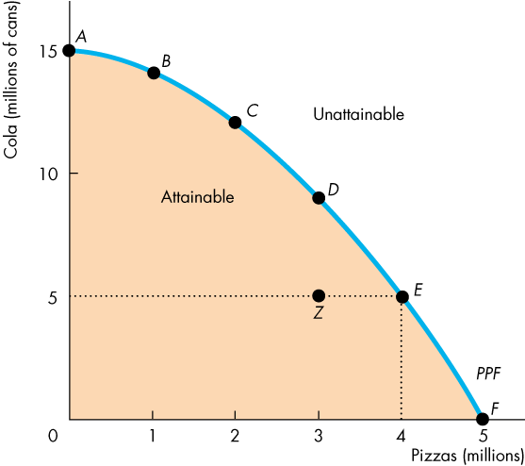
Chapter 2
Production Possibilities and Opportunity Cost
- The production possibilities frontier is the boundary between those combinations of goods and services that can be produced and those that cannot
- It illustrates scarcity because not all points are attainable
- Production Efficiency is achieved is we produce at the lowest possible cost (all points on the PPF)
- Production inefficiency is due to unused or misallocated resources

Opportunity Cost
- As a Ratio: The decrease in the quantity produced of one good divided by the increase in the quantity produced of another
- Opportunity cost increases as more of the x-variable are produced
- The PPF is bowed outward because resources are not all equally productive in all activities

Using Resources Efficiently
- Allocative efficiency: when goods and services are produced at the lowest possible cost and in the quantities that provide the greatest possible benefit
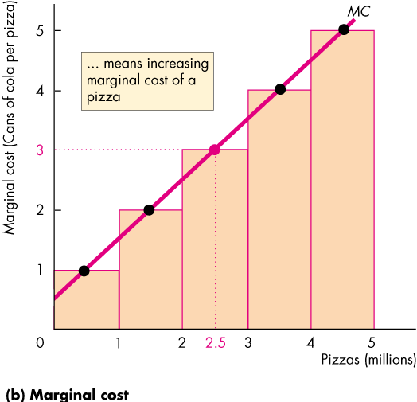
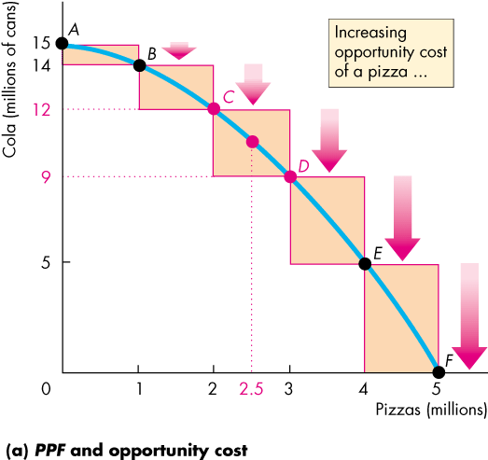
- Marginal Cost: the opportunity cost of producing one more unit (the slope of the PPF)

- Preferences: a description of a person’s likes and dislikes
- Marginal Benefit: the benefit received from consuming one more unit of it (the most that people are willing to pay for an additional unit)
- Illustrate preferences using the marginal benefit curve
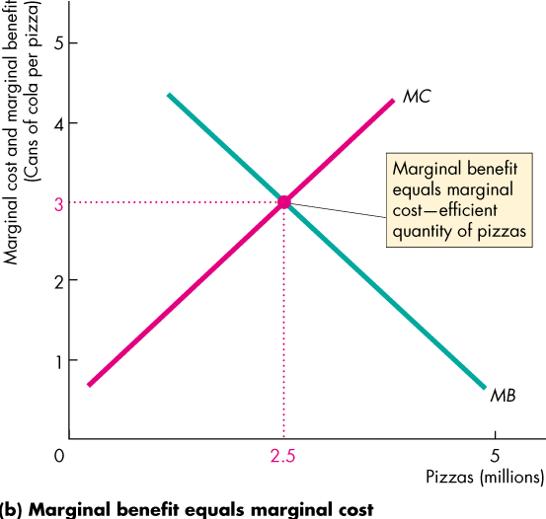
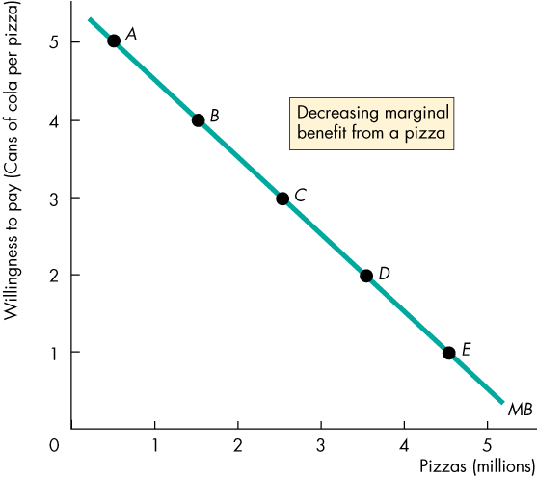
- Allocative Efficiency: MC = MB

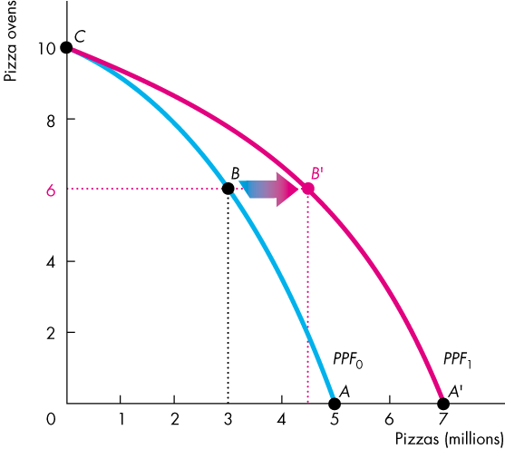
Economic Growth
- Economic growth: expansion of production, increase our standard of living
- The Cost of Economic Growth:
  - Technological Change
  - Capital Accumulation

Gains from Trade
- Comparative Advantage: an activity that a person can perform at a lower opportunity cost than anyone else
- Absolute Advantage: An activity in which the person is more productive than others
- People should specialize in which they have a comparative advantage and then trade
- Dynamic Comparative Advantage: a comparative advantage that has been acquired by learning-by-doing

Economic Coordination
- Firms
  - An economic unit that hires factors of production and organizes those factors to produce and sell goods and services
- Markets
  - Any arrangement that enables buyers and sellers to get information and to do business with each other
- Property Rights
  - The social arrangements that govern the ownership, use, and disposal of anything that people value
    - Real property – land
    - Financial Property – money
    - Intellectual Property – intangible products of creative efforts
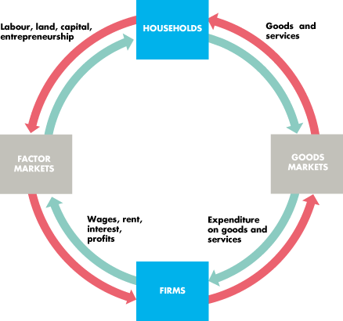
    - Money – any commodity or token that is generally acceptable as a means of payment

Chapter 3
Markets and Prices
- Competitive Market: a market that has many buyers and sellers, so no single buyer or seller can influence price
- Money Price: the amount of dollars given up for a product
- Relative Price: The ratio of one price to another = Opportunity Cost

Demand
- If you demand something:
  - Want it
  - Can afford it
  - Plan to buy it
- Quantity Demanded: the amount that consumers plan to buy during a given time period at a particular price
- The Law of Demand:
  - Other things remaining the same, the higher the price of a good, the smaller is the quantity demanded; and the lower the price of a good, the greater is the quantity demanded
- Substitution Effect
  - As opportunity cost rises, there is incentive to switch to a substitute
- Income Effect
  - As price increases consumers must decrease demand for some products
- Demand: refers to the entire relationship between the price of a good and the quantity demanded of that good
- Change in Demand: when any factor other than the price of the good changes
- Six main factors that change demand:
  - Prices of Related Goods
  - Expected Future Prices
  - Income
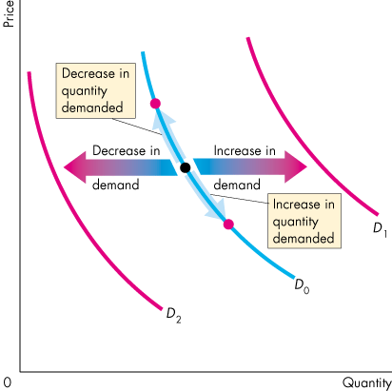
    - Normal Good: demand increases if income increases
    - Inferior Good: demand decreases if income increases
  - Expected Future Income and Credit
  - Population
  - Preferences
- Change in Demand: Shifts the curve
- Change in Quantity Demanded: Move along the curve

Supply
- If a firm supplies a good:
  - They have the resources and technology to produce it
  - Can profit producing it
  - Plans to produce and sell it
- Quantity Supplied: the amount that producers plan to sell during a given time period at a particular price
- The Law of Supply:
  - Other things remaining the same, the higher the price of a good, the greater is the quantity supplied; and the lower the price of a good, the smaller is the quantity supplied
- Price increases because the marginal cost increases
- Supply refers to the entire relationship between the quantity supplied of it.
- It can be interpreted as a minimum-supply-price curve
- A change in Supply: any factor that influences selling plans other than the price of the good changes
- Six main factors that change supply:
  - The prices of factors of production
  - The prices of related goods produced
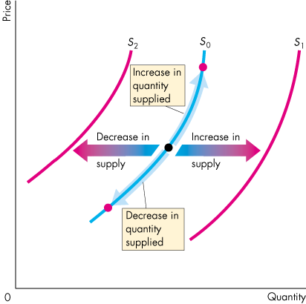
    - Substitutes in production – goods that can be produced by using the same resources
    - Complements in production – goods that must be produced together
  - Expected future prices
  - The number of suppliers
  - Technology
  - The state of nature
- Change in Supply : shifts the curves
- Change in Quantity Supplied: movement along the curve

Market Equilibrium
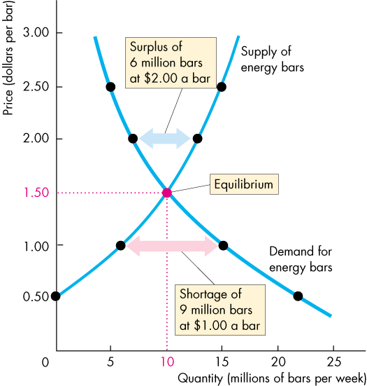
- Equilibrium Price: the price at which the quantity supplied equals quantity demanded
- Equilibrium Quantity: the quantity bought and sold at the equilibrium price
- A market moves towards Equilibrium because of:
  - 1. Price Regulates
  - 2. Price Adjustments
    - Shortage forces prices up
    - Surplus forces the price down

Chapter 4
Price Elasticity of Demand
- Price Elasticity of Demand: a units free measure of the responsiveness of the quantity demanded of a good to a change in its price when all other influences on buying plans remain the same
- Price Elasticity of Demand = % Change in Quantity Demanded/%Change in Price
- Price Elasticity of Demand = (Change in Q. Demanded/Average Q.)/(Change in P./Average P.)
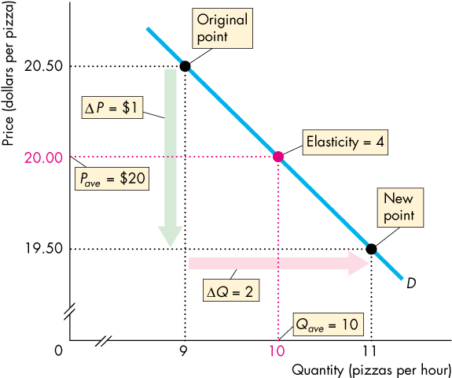

- The calculation always results in a negative value because as the price rises, the quantity demanded decreases.
- Perfectly Inelastic Demand: quantity demanded stays constant when the price changes, PED = 0
- Unit Elastic Demand: the change in quantity demanded equals the change in price, PED = 1
- Inelastic Demand: the change in quantity demanded is less than the change in price,0 < PED < 1
- Perfectly Elastic Demand: the quantity demanded changes by an infinitely large percentage in response to a tiny price change
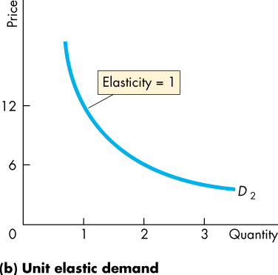
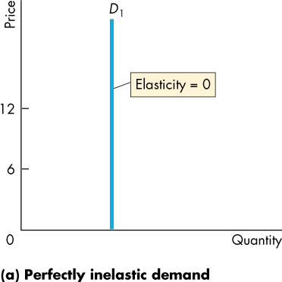
- Elastic Demand: PED > 1
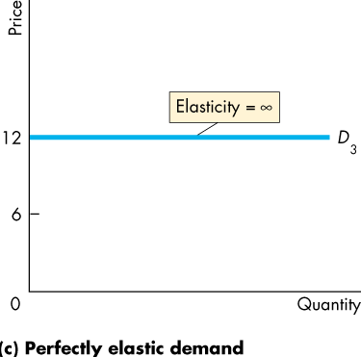

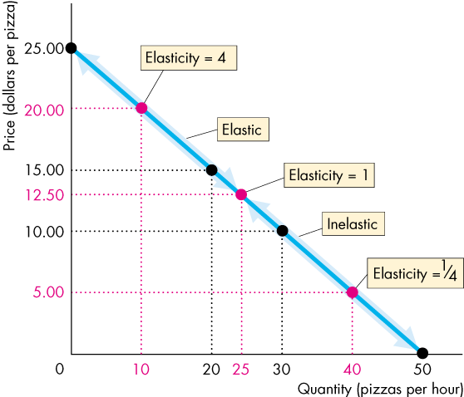

Total Revenue and Elasticity
- Total Revenue: price of a good multiplied by the quantity sold
- Elastic Demand: ↓P increases the quantity sold by more than that change = ↑TR
- Inelastic Demand: ↓P increases the quantity sold by less than that change = ↓TR
- Unit Elastic Demand: ↓P increases the quantity sold by the same amount = No change in TR
- Total Revenue Test: a method of estimating the PED by observing the change in Total Revenue
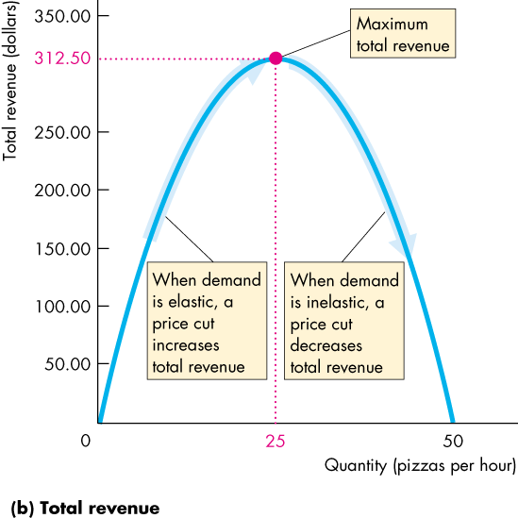
  - Elastic Demand: ↓P = ↑TR
  - Inelastic Demand: ↓P = ↓TR
  - Unit Elastic Demand: ↓P = No Change
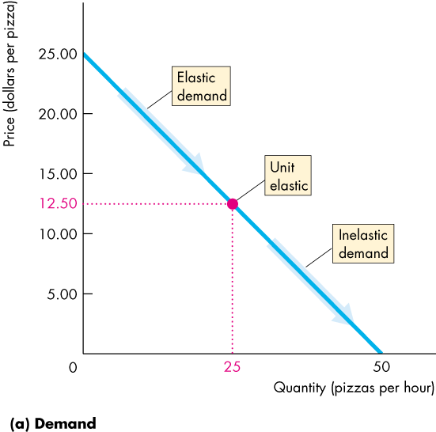

- Expenditure And Elasticity
  - Elastic Demand: Expenditure Increases
  - Inelastic Demand: Expenditure Decreases
  - Unit Elastic: Expenditure does not change
- Factors the Influence the Elasticity of Demand:
  - Closeness of Substitutes
  - Proportion of Income Spent on the Good
  - Time Elapsed Since Price Change – More time more elastic
More Elasticities of Demand
- Cross Elasticity of Demand: a measure of the responsiveness of the demand for a good to a change in the price of a substitute or complement, other things remaining the same
  - CED = % Change in Quantity Demanded/% Change in Price of a Substitute or Complement
    - Substitute: +
    - Complement: -
- Income Elasticity of Demand: a measure of the responsiveness of the demand for a good or service to a change in income, other things remaining the same
  - IED = % Change in Quantity Demanded/% Change in Income
    - IED > 1 = Normal Good/Income Elastic
    - 0 < IED < 1 = Normal Good/Income Inelastic
    - Negative = Inferior Good
Elasticity of Supply
- Elasticity of Supply: measures the responsiveness of the quantity supplied to a change in the price of a good when all other influences on selling plans remain the same
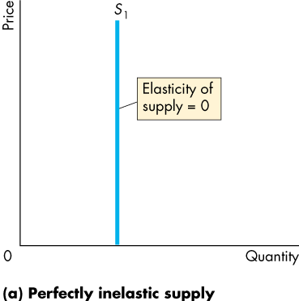
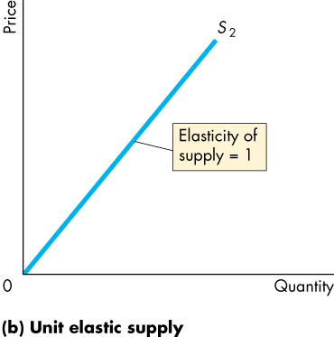
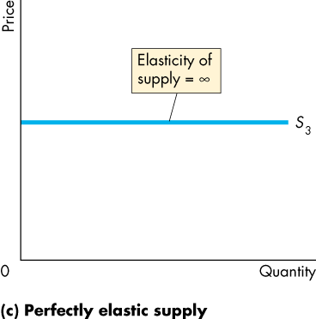
  - Elasticity of Supply = % Change in Quantity Supplied/ % Change in Price
- Factors that Influence the Elasticity of Supply
  - Resource Substitution Possibilities
  - Time Frame for the Supply Decision
    - Momentary Supply
      - Quantity supplied immediately following the price change
    - Long-run Supply
      - All technological adjustments have been made
    - Short-run Supply
      - Only some of the technological adjustments have been made
Chapter 8
Maximizing Utility
- Utility: is the benefit or satisfaction that a person gets from the consumption of goods and services
- Total Utility: the total benefit that a person gets from the consumption of all the different goods and services
- Marginal Utility: the change in total utility that results from a one-unit increase in the quantity of the good consumed
  - Diminishing Marginal Utility: MU decreases as the consumption of the good increases
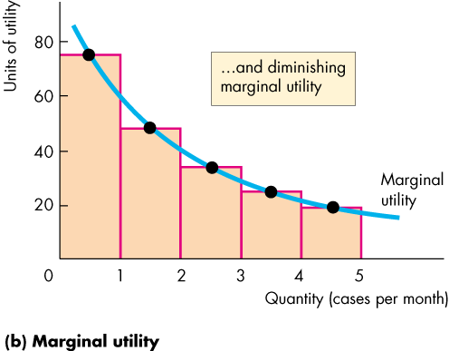
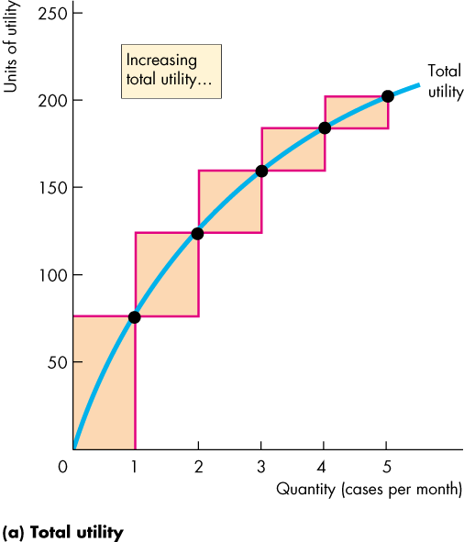

- The Utility Maximizing Choice
  - Consumer Equilibrium: a situation in which the consumer has allocated all of his or her available income in the way that maximizes his or her total utility
- Choosing at the Margin
  - Spend All the Available Income
  - Equalize Marginal Utility per Dollar
    - Marginal Utility Per Dollar: the marginal utility from a good obtained by spending one more dollar on that good

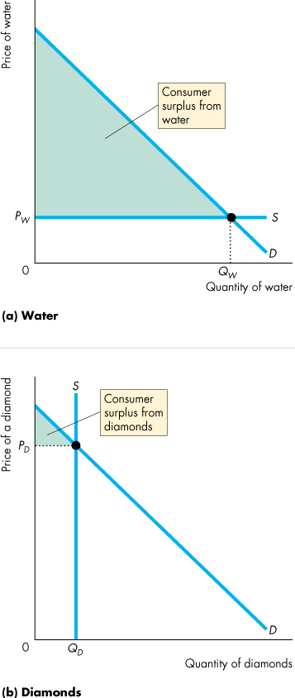
Predictions of Marginal Utility Theory
- The Paradox of Value
  - Water vs. Diamonds
  - Water = Low Marginal Utility, High Total Utility
  - Diamonds = High Marginal Utility, Low Total Utility

New Ways of Explaining Consumer Choices
- Behavioural Economics
  - Studies the ways in which limits on the human brain’s ability to compute and implement rational decisions influences economic behaviour
    - Bounded Rationality: We can’t always work out the rational choice
    - Bounded Will-Power: not enough will power to make a rational choice
    - Bounded Self-Interest: Limited self-interest (suppress our own interests to help others
    - The Endowment Effect: a tendency to value something more highly because you own it
- Neuroeconomics
  - The study of the activity of the human brain when a person makes an economic decision
    - Economic Decisions – prefrontal cortex/hippocampus
- Controversy
  - Most believe economics should be about observing the decisions that people make not about what goes on inside their heads
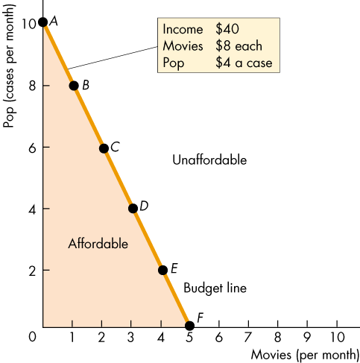
Chapter 9
Consumption Possibilities
- Budget Line: describes the limits to a person’s consumption choices
  - Affordable Quantities: they can consume anywhere on the line or inside of it
- Budget Equation:
  - Y = P*Q + P*Q
  - Real Income: its income expressed as a quantity of goods that the household can afford to buy (where the budget line crosses the y-axis)
  - Relative Price: is the price of one good divided by the price of another good. = Opportunity Cost = Slope of the Budget Line
  - A Change in Prices
    - Lower the price of the good on the x-axis the flatter is the budget line
  - A Change in Income
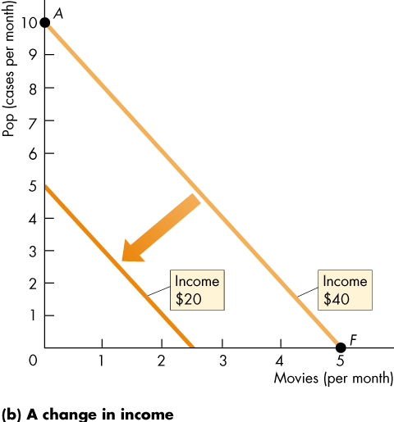
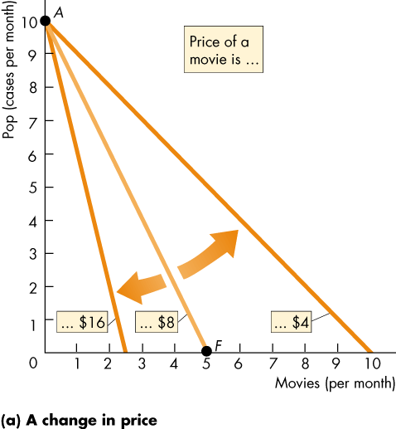
    - Slope remains the same, but the budget line shifts

Preferences and Indifference Curves
- Indifference Curve: is a line that shows combinations of goods among which a consumer is indifferent
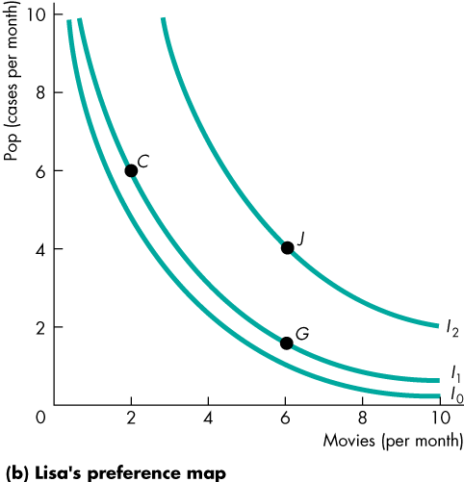
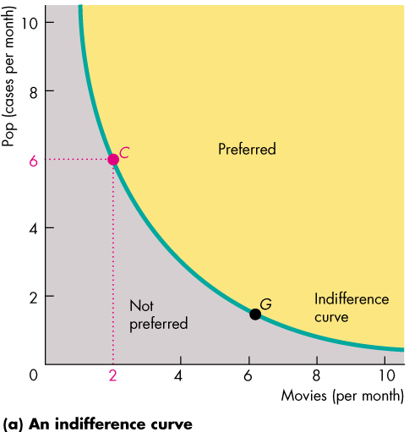
- Preference Map: A series of indifferent curves

- Marginal Rate of Substitution
  - MRS: is the rate at which a person will give up good y to get an additional unit of good x while remaining indifferent
  - MRS = Slope of the Indifference Curve
  - Diminishing MRS: a general tendency for a person to be willing to give up less of good y to get one more unit of good x, as the quantity of good x increases
- Degree of Substitutability
  - Close Substitutes
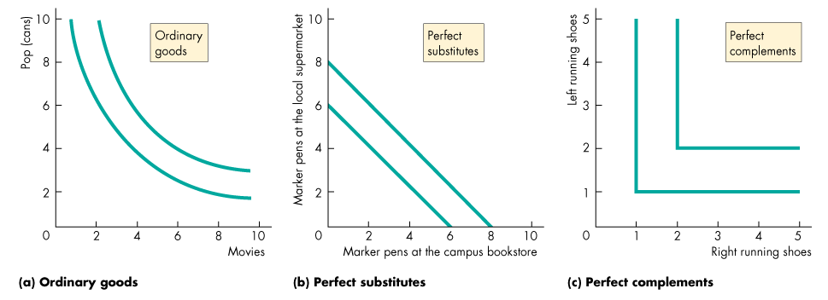
  - Complements
Predicting Consumer Choices
- Best Affordable Choice: Point where the budget line intersects the indifference curve
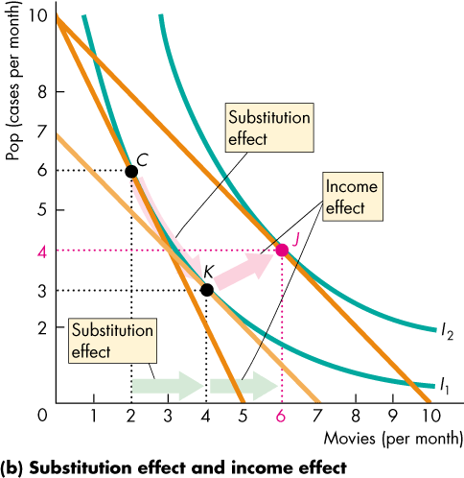
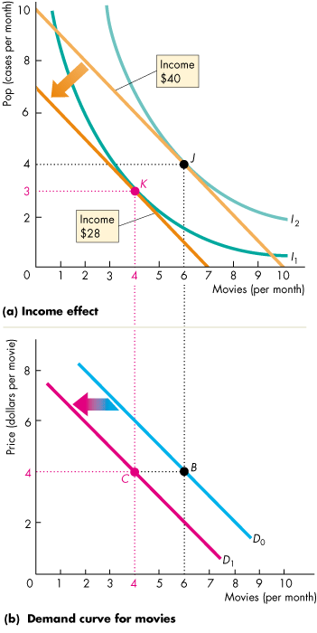
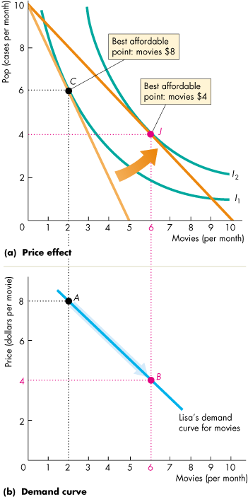
  - MRS = Relative Price

Work Leisure Choices
- More leisure, less income, m = Wage Rate
- Higher wage increases the opportunity cost of leisure which leads to a substitution effect away from leisure
- Higher wage rate increases income and leads to an income effect towards more leisure
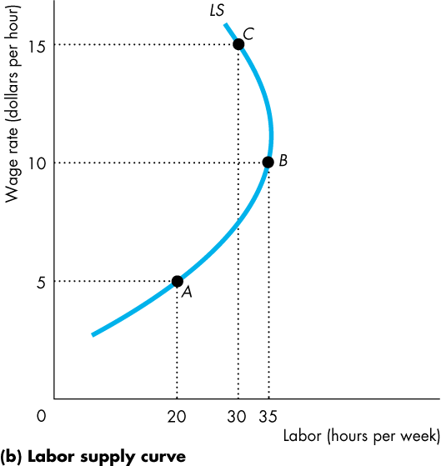
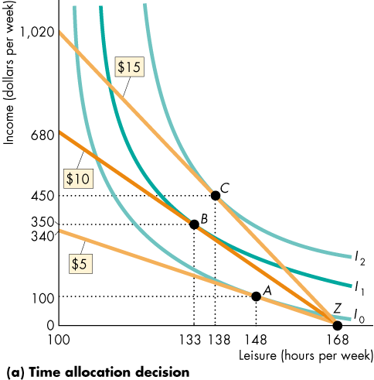

Chapter 10
The Firm and Its Economic Problem
- Firm: an institution that hires factors of production and organizes those factors to produce and sell goods and services
- The Firm’s Goal
  - To maximize economic profit
- Accounting Profit = Revenues – Expenses
- Economic Accounting
  - Economic Profit = Total Revenue – Total Cost (Opportunity Cost of Production)
- Opportunity Cost of Production
  - The value of the best alternative use of the resources that a firm uses in production
    - Resources Bought in the Market
    - Owned by the firm
      - Implicit Rental Rate of Capital
        - Economic Depreciation
          - Fall in the market value of capital
        - Forgone Interest
    - Supplied by the firm’s Owner
      - Entrepreneurship
        - Normal Profit: profit earned on average
      - Owner’s Labour Services
        - Wages forgone
- The Firm’s Constraints
  - Technology Constraints
    - Increase in profit is limited by the technology available
  - Information Constraints
    - We never possess all the information we would like to have to make decisions
    - There is a lack of information about the present and future
  - Market Constraints
    - Prices, marketing efforts of other firms
Technological and Economic Efficiency
- Technological Efficiency: occurs when the firm produces a given output using the least amount of inputs
- Economic Efficiency: occurs when the firm produces a given output at the least cost
- A technologically inefficient method is never economically efficient
- A firm that is not economically efficient does not maximize profit
Information and Organization
- Command Systems: managerial hierarchy – Commands ↓ Information ↑
  - Used when easier to monitor performance
- Incentive Systems: market-like mechanism within a firm – compensation schemes that induce workers to maximize profit
- The Principal-Agent Problem
  - The problem of devising compensation rules that induce an agent to act in the best interests of the principal
- Solutions:
  - Ownership – responsibility, incentive
  - Incentive Pay – pay related to performance
  - Long-term contracts – tie the long-term fortunes to the success of the principal
Markets and the Competitive Environment
- Markets
  - Perfect Competition – many firms, identical product, many buyers (grain, crops)
  - Monopolistic Competition – large number of firms, differentiated products (pizza)
  - Oligopoly – Small number of firms compete, might produce identical products (software)
  - Monopoly – only one firm, product with no close substitutes, protected from entry of new firms (Microsoft)
- Measures of Concentration
  - The Four-Firm Concentration Ratio
    - Percentage of sales accounted for by the 4 biggest firms
    - 0 = Perfect Competition
    - 100 = Monopoly
    - > 60 = Oligopoly
    - <60 = Monopolistic Competition
  - Herfindahl-Hirschman Index: the square of the percentage market share of each firm summed over the largest 50 firms
    - 0 = Perfect Competition
    - 10,000 = Monopoly
    - < 1,000 = Competitive
    - 1,000 < x < 1800 = Monopolistic Competition
    - > 1800 = Oligopoly
  - Limitations of a Concentration Measure
    - Geographical Scope – national/regional/global
    - Barriers to Entry/Firm Turnover – highly concentrated, but easy entry
    - Market and Industry Correspondence – markets are narrower, make several products, switch markets
Markets and Firms
- Firms are more efficient than markets
  - Lower transaction costs – costs that arise from finding someone to do business
  - Economies of Scale – the cost of producing a unit of a good falls as its output rate increases
  - Economies of Scope – when it uses specialized resources to produce a range of goods
  - Economies of Team Production – a production process in which the individuals in a group specialize in mutually supportive tasks
Chapter 11
Decision Time Frames
- The Short Run
  - Fixed Factors: plant
  - The quantity of at least one factor of production is fixed
  - Decisions are easily reversed
  - In increase output in the short-run, they must increase the variable factor of production
- The Long Run
  - Decisions are not easily reversed – Sunk Cost: no resale value
  - The quantities of all factors of production can be varied

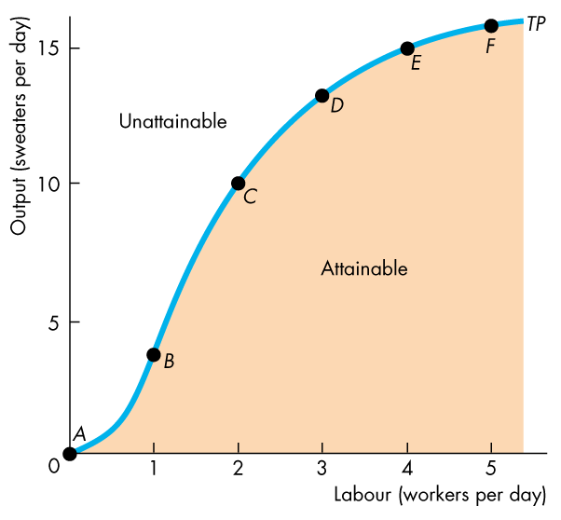
Short-Run Technology Constraint
- Total Product: is the maximum output that a given quantity of labour can produce
  - Only points on the curve are technologically efficient
- Marginal Product: the increase in total product that results from a one-unit increase in the quantity of labour
  - The height of the curve measures the slope of the total product curve at a point
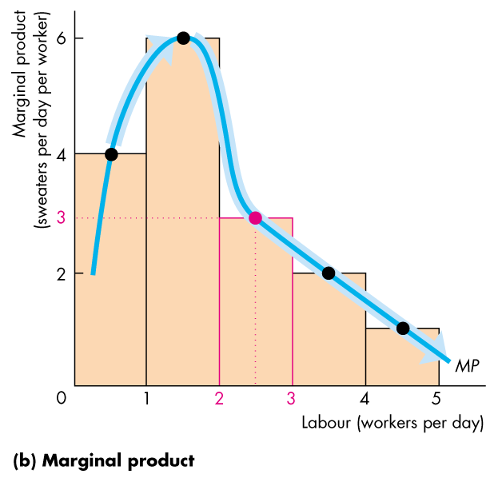
  - Increasing Marginal Returns: MP of an additional unit worker exceeds the MP of the previous worker
    - Increases specializations
    - Division of Labour
  - Diminishing Marginal Returns: MP of an additional is less than the MP of the previous worker
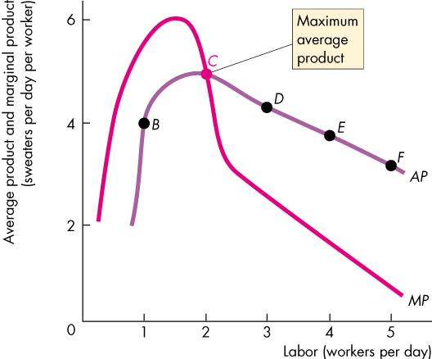
    - More workers using the same capital and space
- Average Product: how productive are workers = Total Product/Quantity of Labour
  - Average product is largest when it equals marginal product
  - Marginal product exceeds average product, average product is increasing
  - Marginal product is less than average product, average product is decreasing
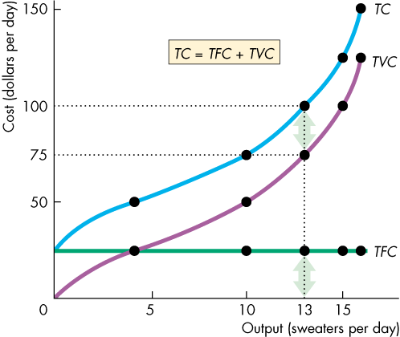
Short Run Cost
- Total Cost: the cost of all the factors of production it uses
  - Total Fixed Cost: cost of the firms fixed factors
  - Total Variable Cost: the cost of variable factors
  - TC = TFC + TVC
- Marginal Cost: the increase in total cost that results from a one-unit increase in output
  - It shape comes from the law of diminishing returns
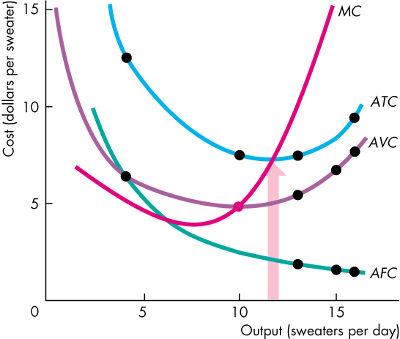
- Average Cost
  - Average Fixed Cost: total fixed cost per unit of output
  - Average Variable Cost: total variable cost per unit
  - Average Total Cost: total cost per unit of output
  - TC/Q = TFC/Q + TVC/Q → ATC = AFC + AVC
- Marginal Cost and Average Cost
  - MC intersects the AVC and ATC at their minimum points
  - When MC is less than ATC, average cost is decreasing

Long-Run Cost
- Depends on the production function
- Diminishing Returns
  - As the firm increases the quantity of labour employed, the marginal product of labour eventually diminishes
- Diminishing Marginal Product of Capital
  - Marginal Product of Capital: the change in total product divided by the change in capital when the quantity of labour remains constant
- Short-Run Cost and Long-Run Cost
  - Each short run ATC curve is U-shaped
  - For each short-run ATC curve, the larger the plant, the greater is the output at which average total cost is at a minimum
  - The economically efficient plant for producing a given output is the one that has the lowest average total cost
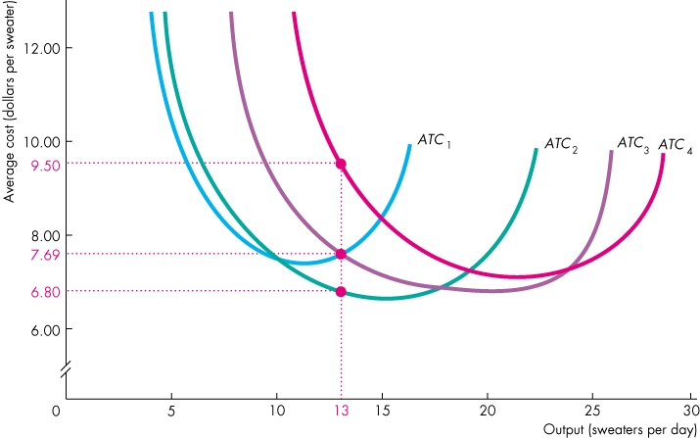
  - The Long-Run Average Cost Curve: is the relationship between the lowest attainable average total cost and output when the firm can change both the plant it uses and the quantity of labour it employs
- Economies of Scale
  - Features of a firm’s technology that make average total cost fall as output increases
- Diseconomies of Scale
  - Features of a firm’s technology that make average total cost rise as output increases
- Constant Returns to Scale
  - Features of a firm’s technology that keep average total cost constant as output increases
- Minimum Efficient Scale
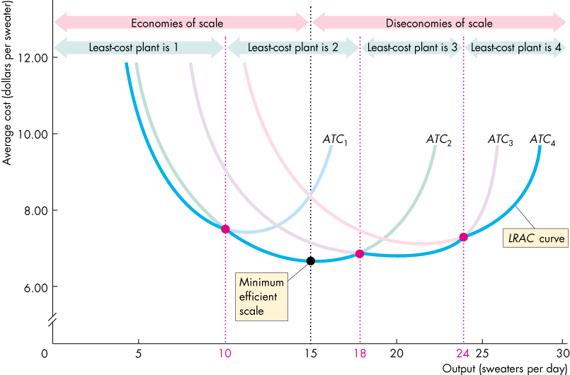
  - The smallest output at which long-run average cost reaches its lowest level

Chapter 6
A Housing Market with a Rent Ceiling
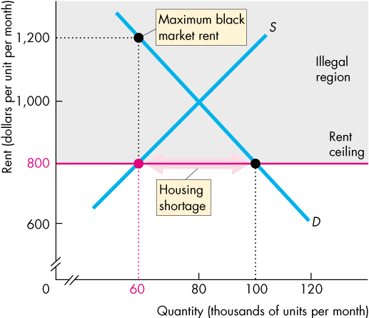
- Price Ceiling (Price Cap): a government regulation that makes it illegal to charge a price higher than the specific level
- Price ceiling above equilibrium price = No effect
- Price ceiling below the equilibrium price = law and market conflict
  - Creates shortage, increased search activity, a black market
- A Housing Shortage
  - The quantity of housing demanded is greater than the quantity supplied
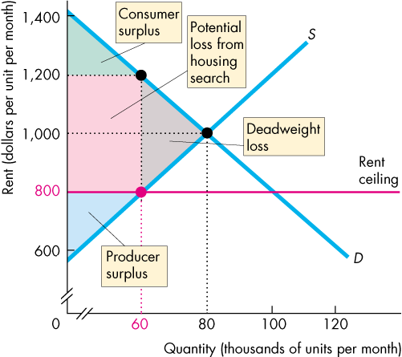
- Increased Search Activity
  - The time spent looking for someone to do business with
- A Black Market
  - An illegal market in which the equilibrium price exceeds the price ceiling
- Inefficiency of a Rent Ceiling
  - Marginal Social Benefit exceeds the Marginal Social Cost
- Are Rent Ceilings Fair?
  - A lottery
  - First-come, first-serve
  - Discrimination
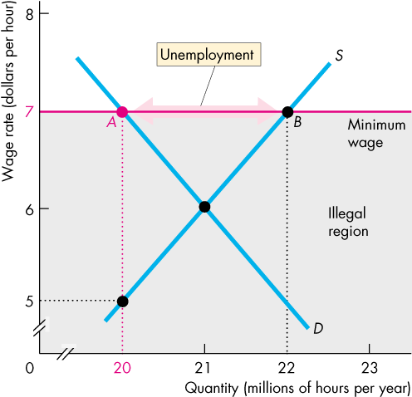
  - NO!
A Labour Market with a Minimum Wage
- Price Floor: a government regulation that makes it illegal to charge a price lower than a specified level
- Price floor set below the equilibrium price = No effect
- Price floor set above the equilibrium price = law and market conflict
- Minimum Wage: A price floor applied to a labour market
- Minimum Wage Brings Unemployment
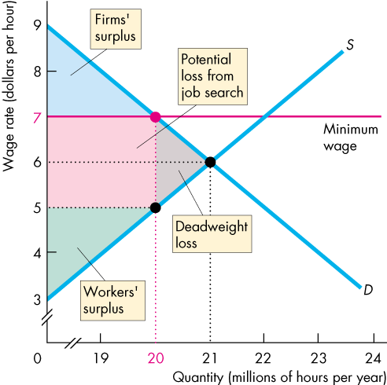
  - Surplus of labour: the quantity of labour available is greater than the quantity demanded
- Inefficiency of a Minimum Wage
  - Marginal Social Benefit Exceeds Marginal Social Cost
Taxes
- Tax Incidence
  - Is the division of the burden of a tax between buyers and sellers
  - Price Rises by the full amount = Buyers pay
  - Price remains the same = Sellers pay
  - Prices by less than the amount = Shared
- A Tax on Sellers
  - Increases cost = decrease in supply
- A Tax on Buyers
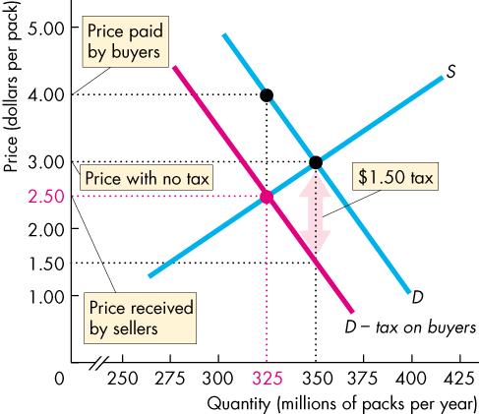
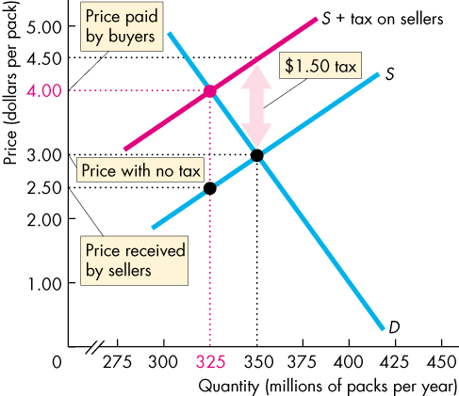
  - Lowers the amount they are willing to pay and demand decreases
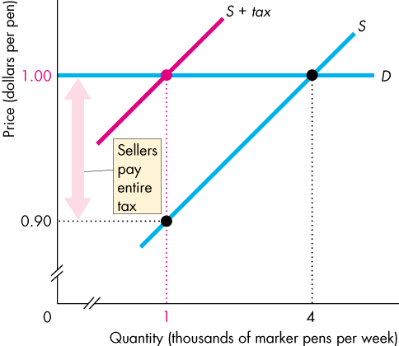
- Tax Incidence and Elasticity of Demand
  - Perfectly Inelastic Demand
  - Perfectly Elastic Demand
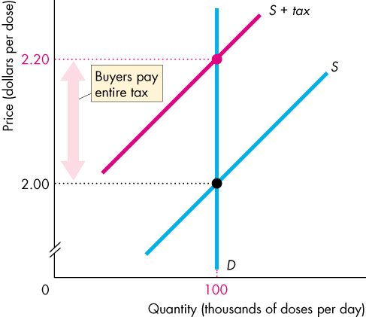
- Tax Incidence and Elasticity of Supply
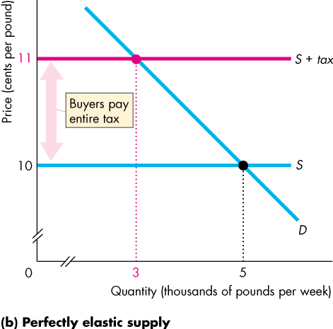
  - Perfectly Inelastic Supply
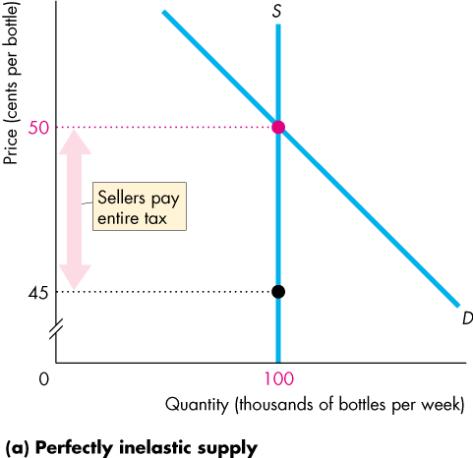
  - Perfectly Elastic Supply

Taxes and Efficiency
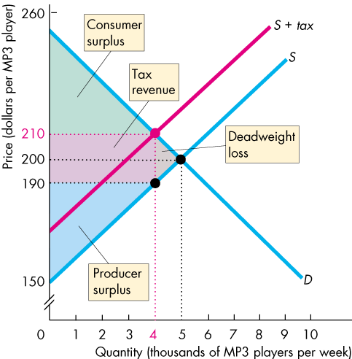

Taxes and Fairness
- The Benefits Principle
  - People should pay taxes equal to the benefits they receive from the services provided by the government
- The Ability-to-Pay Principle
  - People should pay taxes according to how easily they can bear the burden of tax
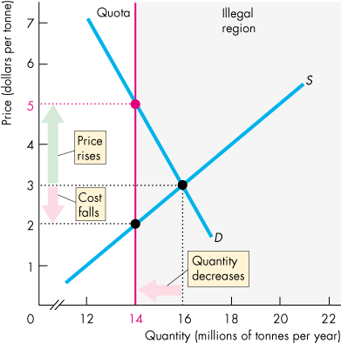
Production Quotas and Subsidies
- Production Quotas
  - An upper limit to the quantity of a good that may be produced in a specific period
  - Production Quota Set Below Equilibrium
    - A decrease in Supply
    - A Rise in Price
    - A Decrease in Marginal Cost
    - Inefficient Underproduction
    - An Incentive to Cheat
- Subsidies
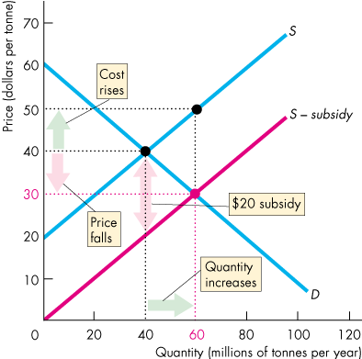
  - A payment made by the government to the producer
    - An Increase in Supply
    - A Fall in Price and Increase in Quantity Produced
    - An Increase in Marginal Cost
    - Payments by Government to Farmers
    - Inefficient Overproduction
Chapter 12
What Is Perfect Competition?
- A market in which:
  - Many firms sell identical products to many buyers
  - There are no restrictions on entry into the market
  - Established firms have no advantage over new ones
  - Sellers and buyers are well informed about prices
- How it Arises
  - If the minimum efficient scale of a single producer is small relative to the market demand for the good or service
- Price Takers
  - Price Taker: is a firm that cannot influence the market price because its production is an insignificant part of the total market
- Economic Profit and Revenue
  - Total Revenue = the price of its output multiplied by the number of units of output sold
  - Marginal Revenue = the change in total revenue that results from a one-unit increase in the quantity sold
    - In perfect competition, the firm’s marginal revenue equals the market price
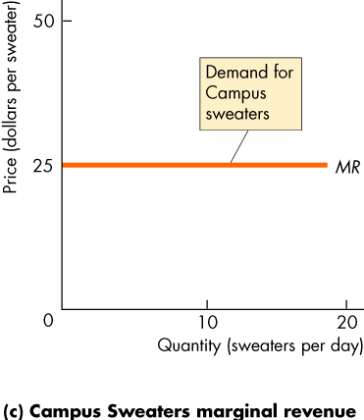
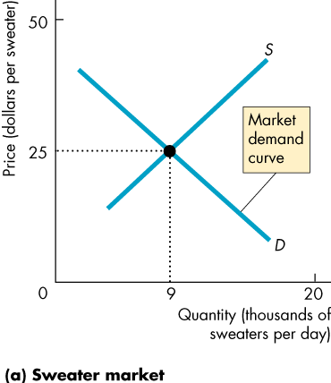
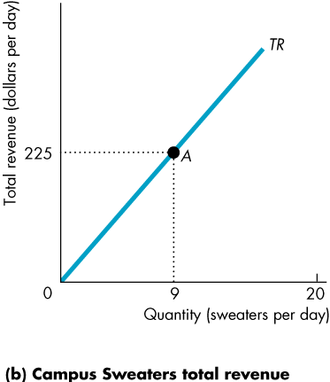
  - The demand curve is perfectly elastic for the firm
- The Firm’s Decisions
  - How to produce at minimum cost
  - What quantity to produce
  - Whether to enter or exit a market

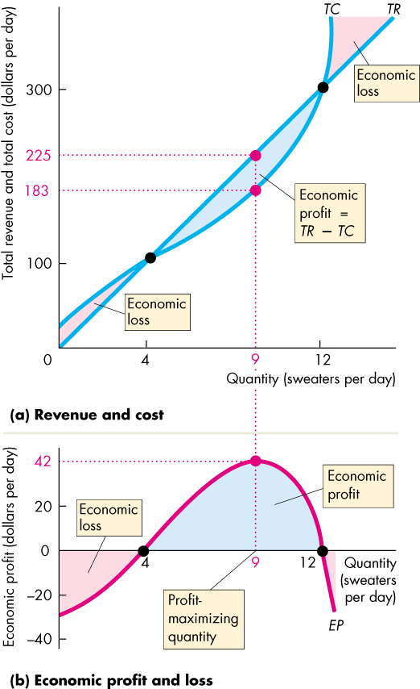
The Firm’s Output Decision
- Marginal Analysis and the Supply Decision
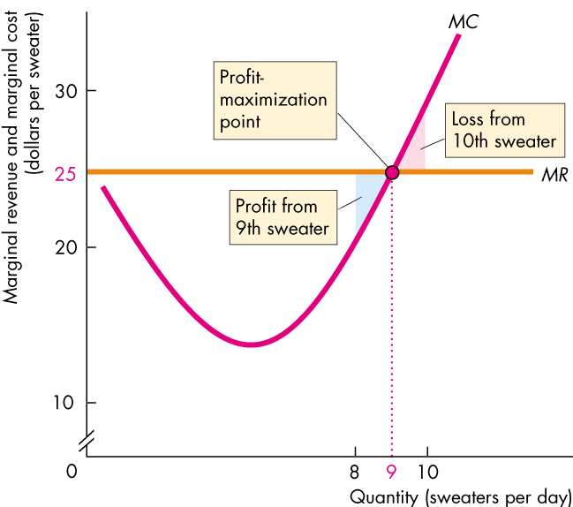
  - MR = MC = Maximized Profit
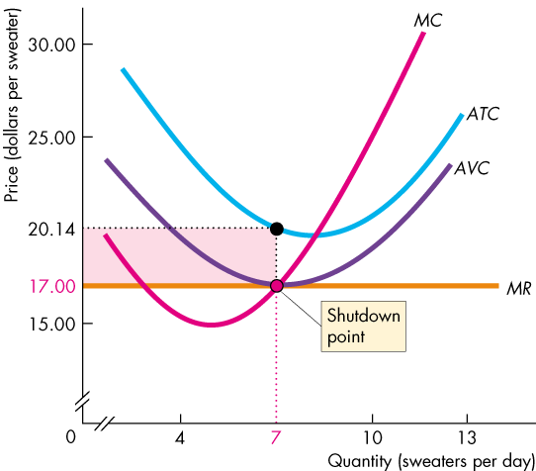
- Temporary Shutdown Decision
  - If price is less than average total cost = economic loss
  - Loss Comparisons
    - Economic Loss = TFC + TVC – TR
    - If it shuts down economic loss = TFC
  - The Shutdown Point: the price and quantity at which it is indifferent between producing and shutting down
    - AVC is a minimum
- The Firm’s Supply Curve
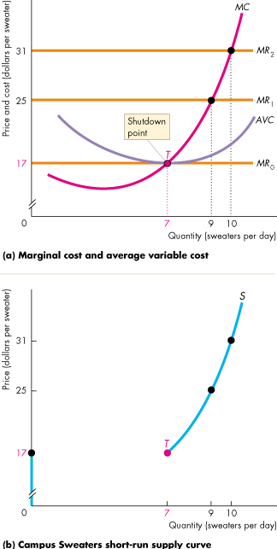
  - When the price exceeds minimum average variable cost, the firm maximizes profit by producing the output at which marginal cost = price

Output, Price, and Profit in the Short Run
- The short run is a situation in which the number of firms is fixed
- Market Supply in the Short Run
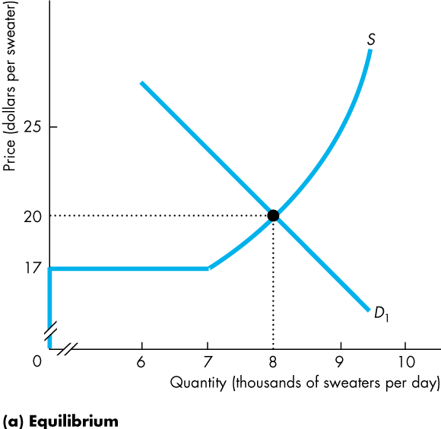
  - Short Run Market Supply Curve: shows the quantity supplied by all firms in the market at each price when each firm’s plant and the number of firms remain the same
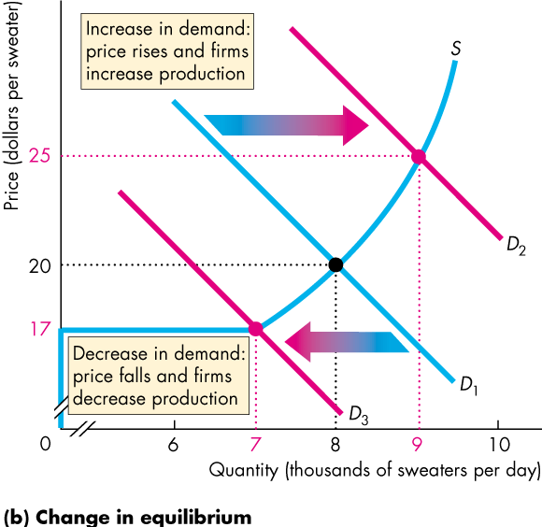

- Profits and Losses in the Short Run
  - Economic Profit (loss) = (Price – ATC) x Q
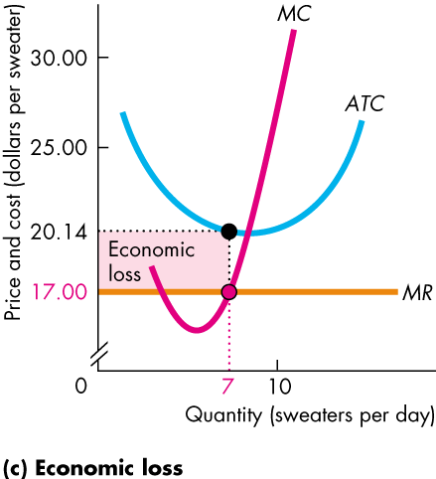
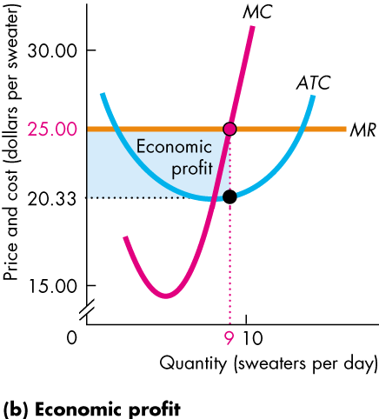
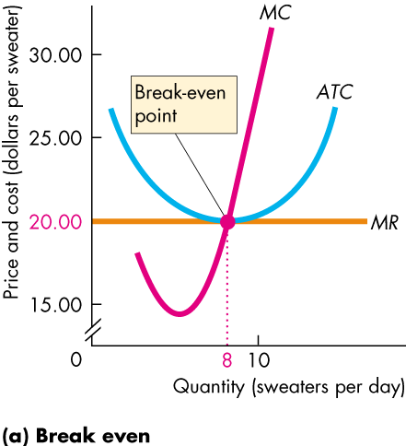
- Three Possible Short-Run Outcomes
Output, Price and Profit in the Long Run
- Entry and Exit
  - Firms enter when there is economic profit
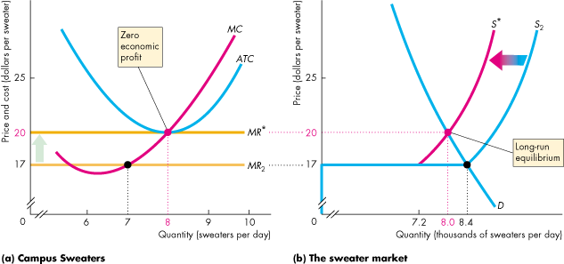
  - Firms exit when they are incurring an economic loss

- Long-Run Equilibrium
  - When economic profit and economic loss have been eliminated and entry and exit have stopped, a competitive market is in long-run equilibrium
  - Rarely is it in a state of equilibrium
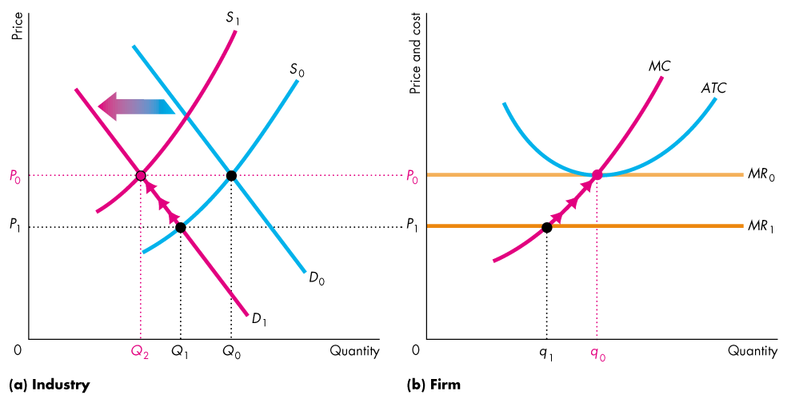
- Decrease in Demand

- External Economies and Diseconomies
  - External Economies: are factors beyond the control of an individual firm that lower the firm’s costs as the market output increases
  - External Diseconomies: are factors outside the control of a firm that raise the firm’s costs as the market output increases
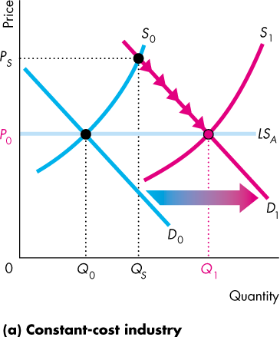
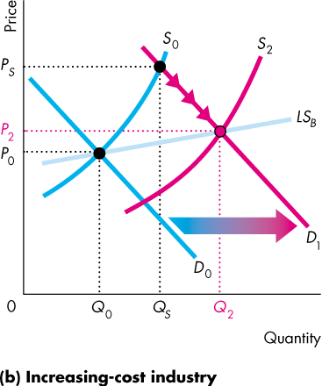
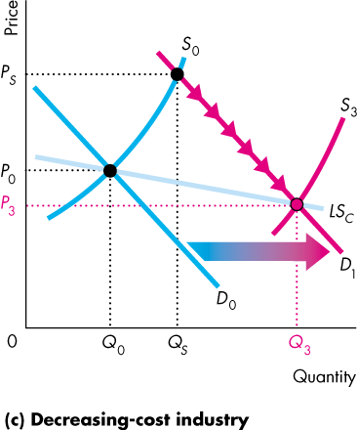
  - Long-Run Market Supply Curve: shows how the quantity supplied in a market varies as the market price varies after all the possible adjustments have been made, including changes in each firm’s plant and the number of firms in the market
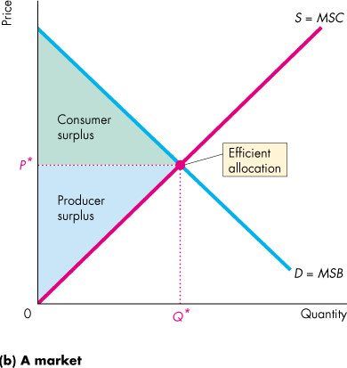
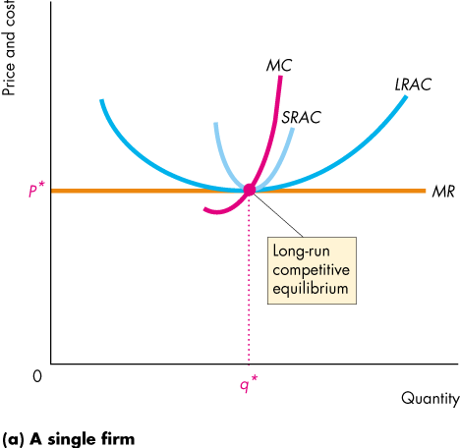
Competition and Efficiency
- Equilibrium and Efficiency
  - Resources are used efficiently when marginal social benefit equals marginal social cost
Chapter 13
Monopoly and How it Arises
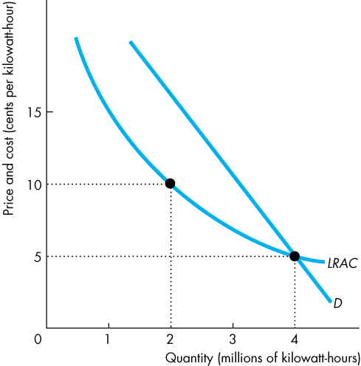
- Monopoly: a market with a single firm that produces a good or service for which no close substitute exists and that is protected by a barrier that prevents other firms from selling that good or service
- How Monopoly Arises
  - No Close Substitutes
  - Barrier to Entry: a constraint that protects a firm from potential competitors
    - Natural Barrier to Entry
      - Creates a Natural Monopoly: an industry in which economies of scale enable one firm to supply the entire market at the lowest possible cost
    - Ownership Barrier to Entry
      - Occurs if one firm owns a significant portion of a key resource
    - Legal Barrier to Entry
      - Creates a Legal Monopoly: a market in which competition and entry are restricted by the granting of:
        - Public Franchises: an exclusive right granted to a firm to supply a good or service
        - Government Licence: controls entry into particular occupations, professions, and industries
        - Patent: is an exclusive right granted to the inventor of a product or service
        - Copyright: is an exclusive right granted to the author or composer of a literary, musical, dramatic, or artistic work
- Monopoly Price-Setting Strategies
  - Single Price
    - Single Price Monopoly: is a firm that must sell each unit of output for the same price to all its customers
  - Price Discrimination
    - It sells different units of a good or service for different prices
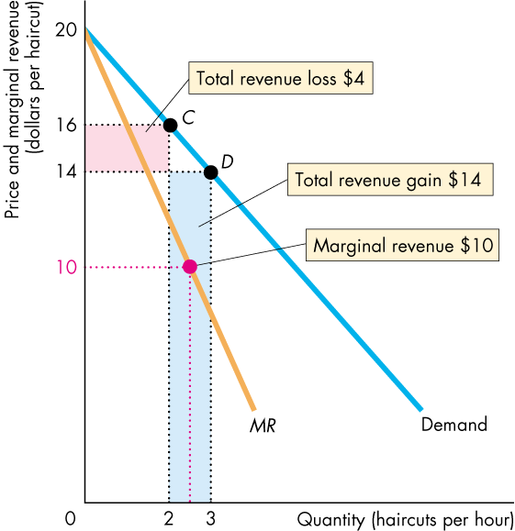
A Single-Price Monopoly’s Output and Price Decision
- Price and Marginal Revenue
  - Why is marginal revenue less than price? It is because when the price is lowered to sell one more unit, two opposing forces affect total revenue. The lower price results in revenue loss, and the increased quantity results in a revenue gain
- Marginal Revenue and Elasticity
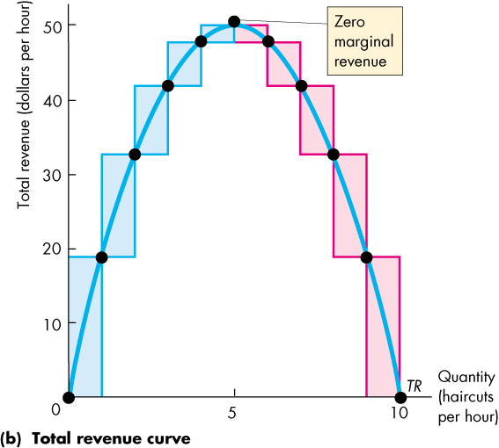
  - In a monopoly, Demand is always elastic
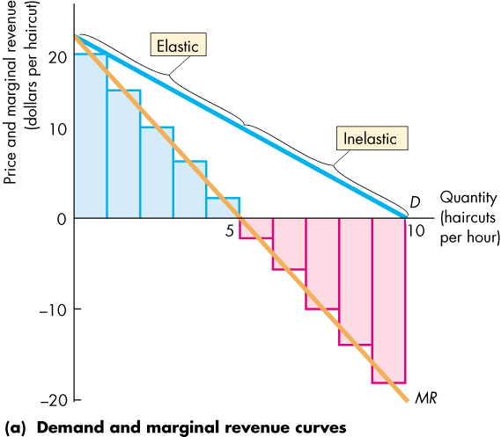
- Price and Output Decision
  - A Monopoly produces the profit maximizing quantity and sells that quantity for the highest price it can get
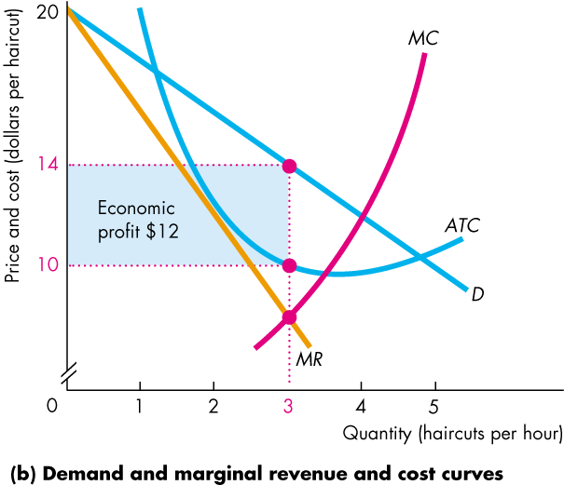
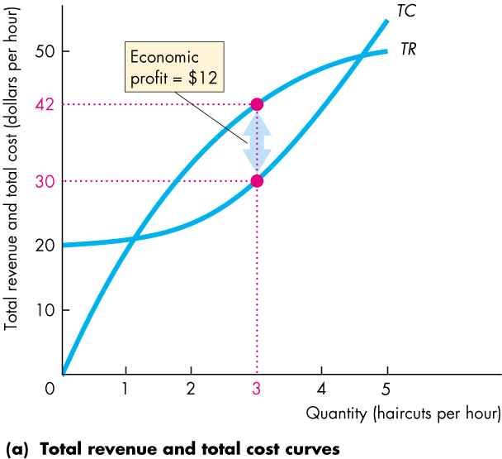
  - For a monopoly, price exceeds marginal revenue and marginal cost

Single-Price Monopoly and Competition Compared
- Comparing Price and Output
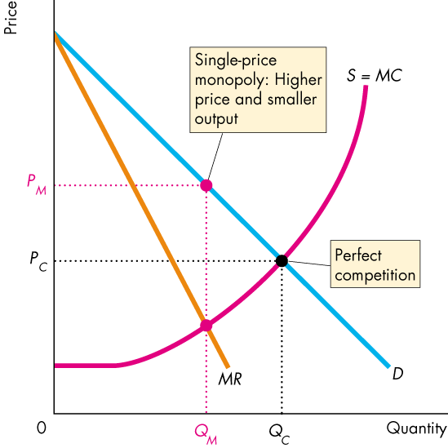
  - Compared to a perfectly competitive industry, a single-price monopoly produces a smaller output and charges a higher price

- Efficiency Comparison
  - At the competitive equilibrium, marginal social benefit equals marginal social cost; the sum of consumer surplus and producer surplus is maximized; firms produce at the lowest possible long-run average cost; and the resource use is efficient
  - Monopoly Consumer Surplus Shrinks
    - Consumers lose by having to pay more for the good
    - Consumers lose by getting less of the good, and this loss is part of the deadweight loss
  - It loses some producer surplus because it producers a smaller output
  - It does not produce at the minimum possible long-run average cost
    - Smaller output and faces no competition
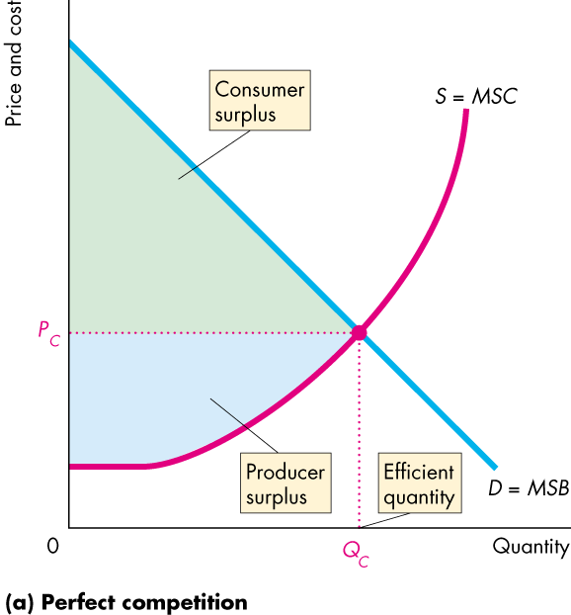
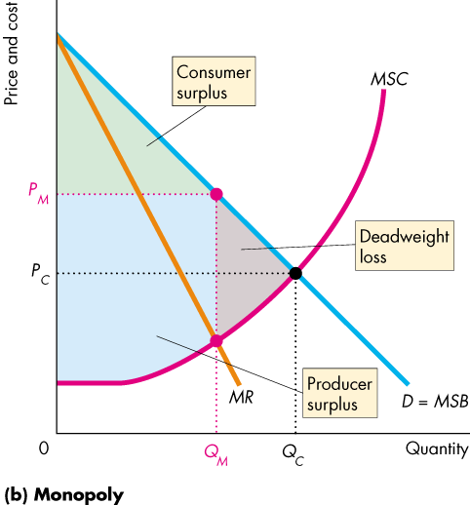
  - A monopoly produces less, increases the cost of production, and raises the price by more than the increased cost of production

- Rent Seeking
  - Economic Rent: any surplus – consumer, producer, or economic profit
  - Rent Seeking: the pursuit of wealth by capturing economic rent
    - Buy a Monopoly: a person searches for a monopoly that is for sale at a lower price than the monopoly’s economic profit
    - Create a Monopoly: mainly a political activity
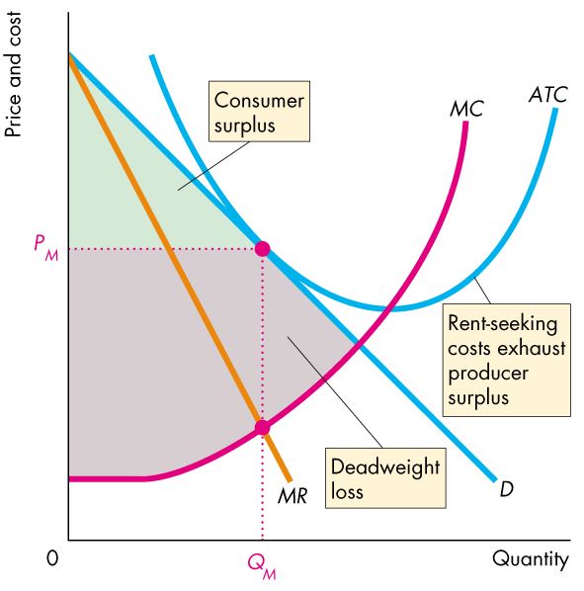
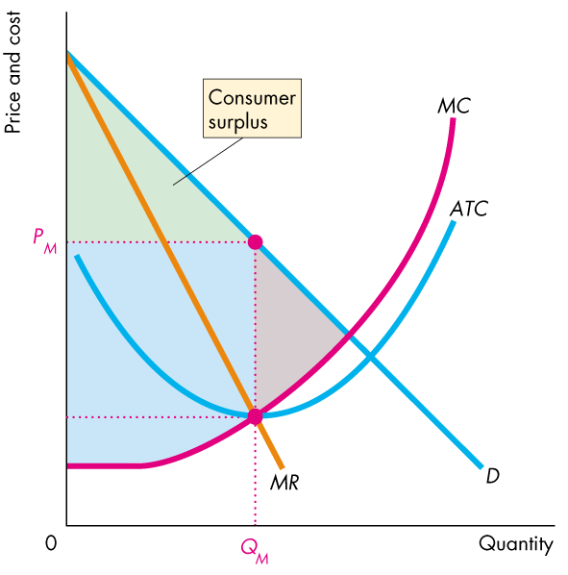
- Rent Seeking Equilibrium

Price Discrimination
- Selling a good or service at a number of different prices
- Capturing Consumer Surplus
  - Price discrimination captures consumer surplus and converts it into economic profit
  - Discriminating Among Groups of Buyers
    - People differ in the values they place on a good – their marginal benefit and willingness to pay
  - Discriminating Among Units of a Good
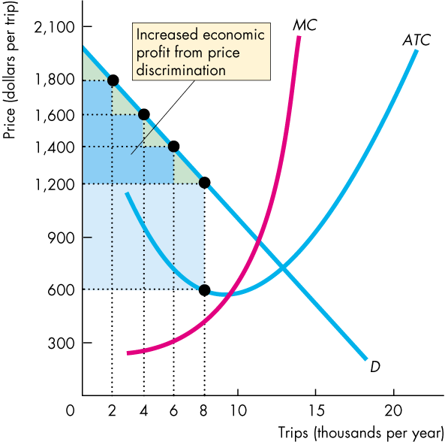
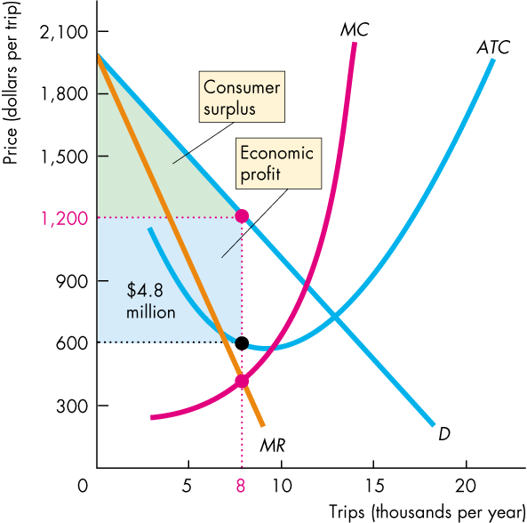
- Profiting by Price Discriminating

- Perfect Price Discrimination
  - Occurs if a firm is able to sell each unit of output for the highest price anyone is willing to pay for it
  - The market demand curve becomes the marginal revenue curve
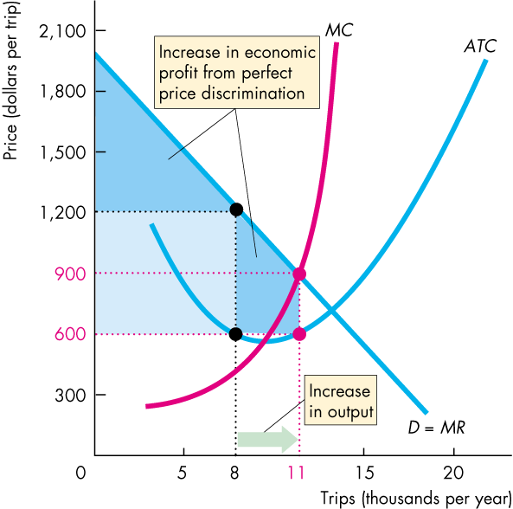
  - For the perfect price discriminator, marginal revenue equals price and the market demand curve becomes the marginal revenue curve

- Efficiency and Rent Seeking with Price Discrimination
  - The more perfectly the monopoly can price discriminate, the closer its output is to the competitive output and the more efficient is the outcome
  - Differences Between Perfect Competition and Perfect Price Discrimination
    - Total Surplus is Different
      - PC: Shared by Consumers and Producers
      - PPD: Producers gets it all
    - Since the producer gets all the surplus, rent seeking becomes profitable

Monopoly Regulation
- Regulation: rules administered by a government agency to influence prices, quantities, entry, and other aspects of economic activity in a firm or industry
- Deregulation: is the process of removing regulation of prices, quantities, entry, and other aspects of economic activity in a firm or industry
- There are two theories about how regulation actually works:
  - The Social Interest Theory: is that the political and regulatory process relentlessly seeks out inefficiency and introduces regulation that eliminates deadweight loss and allocates resources efficiently
  - Capture Theory: is that regulation serves the self-interest of the producer, who captures the regulator and maximizes economic profit
- Efficient Regulation of a Natural Monopoly
  - Marginal Cost Pricing Rule: set price equal to marginal cost
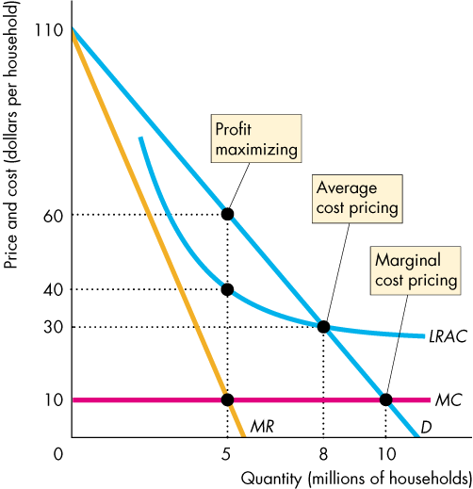
  - The quantity demanded at a price equal to marginal cost is the efficient quantity – the quantity at which marginal benefit equals marginal cost
- Second-Best Regulation of a Natural Monopoly
  - Average Cost Pricing
    - Average Cost Pricing Rule: sets price equal to average total cost
    - The firm produces the quantity at which the average total cost curve cuts the demand curve
    - The firm makes zero economic profit
  - Government Subsidy
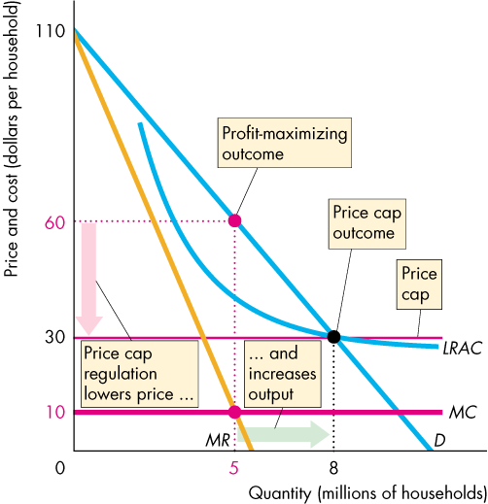
    - A direct payment to a firm equal to its economic loss
  - Rate of Return Regulation
    - Rate of Return Regulation: a firm must justify its price by showing that its return on capital doesn’t exceed a specified target rate
  - Price Cap Regulation
    - Price Cap Regulation: a price ceiling – a rule that specifies the highest price the firm is permitted to set

Chapter 14
What Is Monopolistic Competition
- Monopolistic Competition
  - A large number of firms compete
    - Small Market share
    - Ignore other firms
    - Collusion is impossible
  - Each firm produces a differentiated product
    - Make a product that is slightly different from the products of competing firms
  - Firms compete on product quality, price, and marketing
    - Quality: the physical attributes that make it different
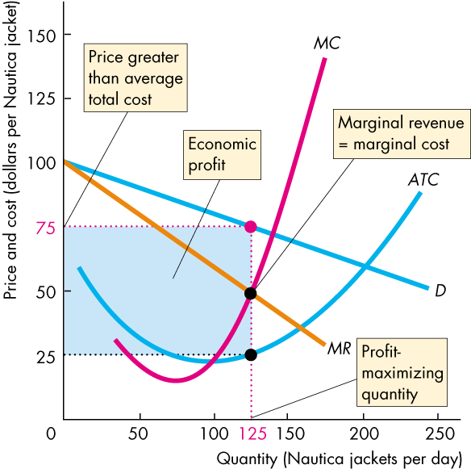
    - Price: they can charge whatever price they want
    - Marketing: advertising and packaging
  - Firms are free to enter and exit the industry
    - No economic profit in the long run

Price and Output in Monopolistic Competition
- The Firm’s Short-Run Output and Price Decision
  - In the short run, a firm in monopolistic competition makes its output and price decision just like a monopoly firm does
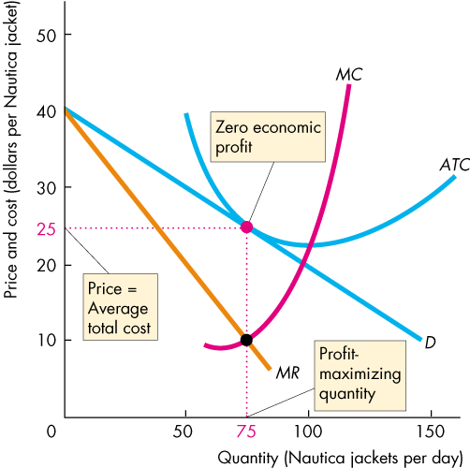
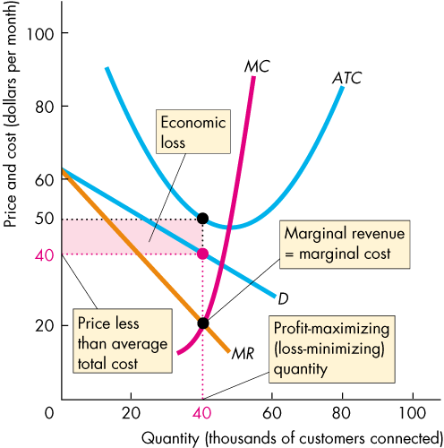
- The key difference between monopoly and monopolistic competition lies in what happens in the long run, whether firms make an economic profit or incur an economic loss
- Long Run = Zero Economic Profit
  - Due to entry and exit

- Monopolistic Competition and Perfect Competition
  - Excess Capacity
    - Has it i fit produces below its efficient scale, which is the quantity at which average total cost is a minimum
    - Average total cost is the lowest possible only in perfect competition
  - Markup
    - The amount by which price exceeds marginal cost
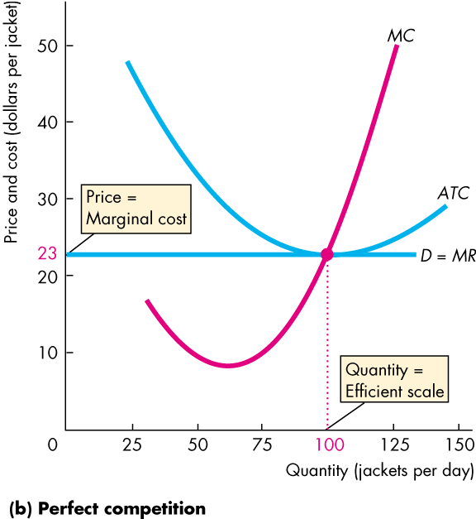
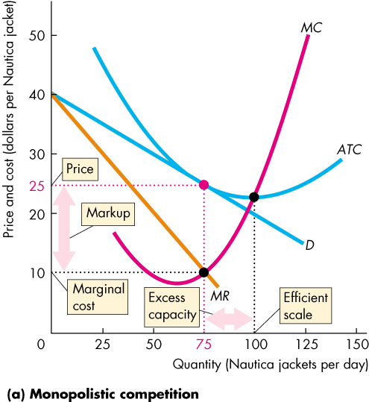

Product Development and Marketing
- Innovation and Product Development
  - One major way of trying to maintain economic profit is for a firm to seek out new products that will provide it with a competitive edge, even if temporary
  - A firm that introduces a new and differentiated product faces a demand that is less elastic and is able to increase its price and make an economic profit
- Advertising
  - A firm needs to ensure that its customers know how its product is different from the competition
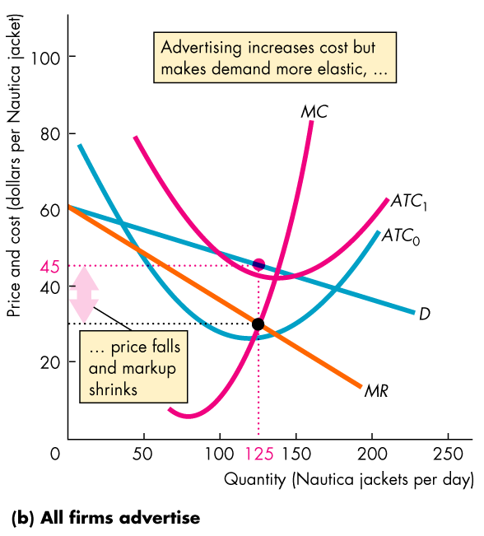
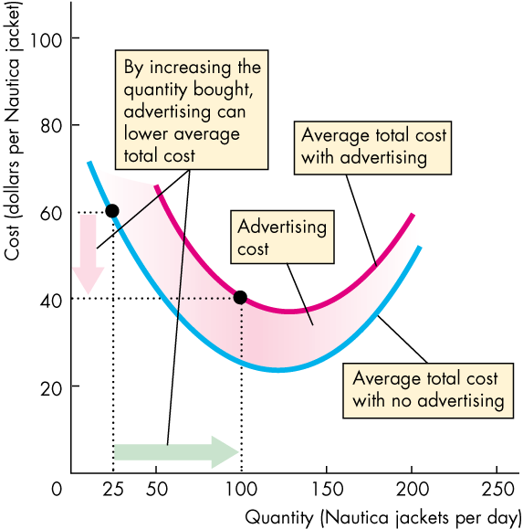
  - A firm also might attempt to create a consumer perception that its product is different from its competitors’ even when that difference is small

- Signal: an action taken by an informed person or firm to send a message to uninformed people

