ACCO 340 CRASHCOURSE NOTES
4 Topics on final exam:
- Capital Gain
- Taxable Income
- Taxes Payable --> Credit
- GST
Template to Memorize:
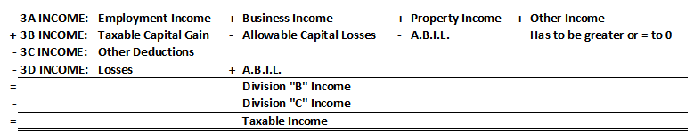
3A INCOME:
Property Income
- Dividends ($125 non-eligible)
- Royalties
- Interest
Other Income
- Death benefits (100K-10k)
- Child support ($0)
- Spousal support (when support is in a lump sum it's not taxable, if support is paid in annuity payments it's taxable.)
- Other allowance (taxable under other income)
3B INCOME:
- T.C.G.= 0.5 (POD-ACB)
- T.C.G. - A.C.L. has to be greater than or equal to 0, if it results in a negative number its remaining its carried forward.
3C OTHER DEDUCTIONS:
- Moving expenses (move 40km closer to work)
- RSP (not part of employment deductions because most employments don't include RSP plans)
- Child support (when you pay child support its not deductible)
- Spousal support (when you pay in a lump sum it's not deductible, if paid in annuity payments its deductible)
- Interest (deductible when its purpose is to produce T.C.G.)
- Medical expenses (you get a credit)
3D LOSSES:
- Rental loss
- Business loss
- A business investment loss (A.B.I.L.)
*The word "allowable" means 50% rate has been applied
Allowable A.B.I.L. (the remainder of the loss from 3B is added to 3D

TAXABLE INCOME:
T.I. x rates = taxes owed
(credits)
Taxes Payable
7 TYPES OF CAPITAL GAINS QUESTIONS:
- Principle Residency
Actual C.G. = C.G. - P.R. exemption
= C.G. - C.G. ( 1+ )
# yrs owned
- Reserves
Actual C.G.= C.G. - reserve
--> lesser of 1. CG X (ACB/POD)
2. 20% x CG (4- # yrs passed)
*Can defer a reserve for a maximum of 5 years*
- Identical Asset
- PUP/LPP
List of LPP:
- Coins
- Jewelry
- Stamps
- Paintings
- Rare books + Manuscripts
Rules:
- POD and ACB must be at least 1,000
- LPP losses can only be applied against LPP gains. If you don't have any gains to apply it to make it 0, and carry forward.
- Your LPP losses carry overs go directly in 3B income. If you have 1,000 capital losses carried forward but only 800 gains then you can only do 800 and you carry forward $200.
- Involuntary/voluntary
- Special rule --> Real Property
- Superficial Losses
Example 1: January 1st Niko bought 1,000 shares @$10/share. --> ACB =10,000 March 1st he sold 1,000 @$4/share.
March 20th re-bought 1,000 shares @$3/share.--> ACB= 3,000 +6,000*=9,000
*POD=4000
ACB=(10,000)
CL=(6,000)
Example 2: January 1st Niko bought 1,000 shares @$10/share. --> ACB =10,000 March 1st he sold 1,000 @$4/share.
March 20th re-bought 250 shares @$3/share.--> ACB= 750 + *1,500= 1,250
*POD=4000
ACB=(10,000)
CL=(6,000) * (250/1,000)
= 1,500
CHILDCARE:
Childcare lesser of:
- actual exp. + (# weeks @ overnight x weekly limit)
- annual limit
- 2/3 of earned income
 | Annual Limit | Weekly Limit (Annual/40)
0-6 | $7,000 | 175
6-16 | $4,000 | 100
Disabled | $10,000 | 250

- Only lower income spouse can claim this deduction or if they are a single parent
- If you are the higher income spouse you can claim deduction if ther lower income spouse is in prison, school or hospital. But they can only claim the weeks they took care of the child. (#weeks x weekly limit)
RRSP:
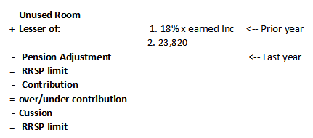
QUESTION 1: CALCULATING T.I.
1. Simon owns a cottage in Gatineau, Quebec that he and his family occupy for several weeks a year. He purchased it in 1988 for $30,000, and sold it in 2008 for $120,000. He also owns a city home in Edmonton, Alberta, which purchased in 1984. Simon wishes to designate that summer cottage as his principal residence for the years 1986 to 1998 inclusive, if allowed under the Income Tax Act. He has never made a principal residence designation in the past.
Note 1:
Simon wants to designate from 1986-1998 but the house was only bought in 1988 so ti can only be designated between 1988-1998.
POD = 120,000
ACB = 30,000
C.G. = 90,000
P.R. = 90,000 (1 + 11*) = 51,428 *1998-1988 inclusive=11
21** ** 2008-1988 inclusive = 21
Actual C.G. = 90,000 - 51,428
= 48,572
T.C.G. --> 48,572 x 50%= 19,286
2. Simon purchased land on the edge of a gold course in Edmonton for $300,000 in 1985. It was a good purchase, as he sold it in 2007 for $1,600,000. Simon paid a $100,000 commission to a real estate broker who handled the sale. Simon received a down payment of $400,000, and accepted a 25 year mortgage for the balance of $1,200,000. The payments on his mortgage begin in 2008 and require the repayment of $48,000 per year in capital. Simon always claims the maximum reserves to defer the payment of taxes on capital gains for as long as possible. (ignore any interest income for purposes of this answer).
Note 2:
POD= 1,600,000
ACB= 300,000 + 100,000 = 400,000
C.G. = 1,200,000
Actual CG 2007 = 1,200,000-900,000 = 300,000
--> lesser of 1. 1,200,000 x (1,200,000/1,600,000)= 900,000
2. 20% x 1,200,000 (4-0)= 960,000
TCG = 150,000

Actual CG 2008 = reserve 2007 - reserve 2008
= 900,000-720,000
--> lesser of 1. 1,200,000 (1,152,000*/1,600,000)=864,000
2. 20% x 1,200,000 (4-1)=720,000
= 180,000
TCG= 90,000
* 1,200,000-48,000=1,152,000
3. On the advice of his friend Mike, Simon bought and sold shares of ABC Oil Ltd. over the last several years, as follows:
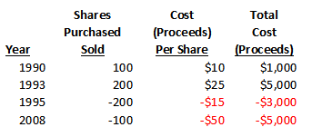
The 2008 sale took place on October 1, 2008. Prior to this sale on June 30, 2008. Simon received a 100 share stock dividend. The fair market value of the shares at the time was $40 per share, and the total amount ($4,000) was credited to the paid up capital of ABC Oil Ltd.
**IMPORTANT**
Public Company --> Eligible --> x1.38
Private Company --> Non-eligible --> 1.25

Note 3: Property Income = 4,000 x 1.38 = 5,520
4. Simon disposed of the following personal assets in 2008, all of which were bought subsequent to 1972:
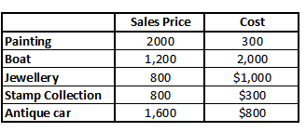
Note 4:
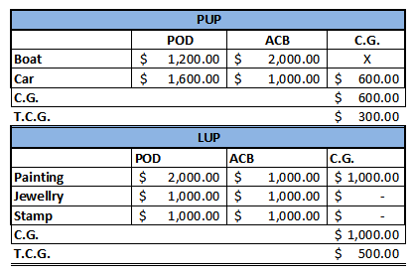
5. Simon owns 1,000 shares of Bell Canada, which he bought in 2004 for $8,000. Wishing to realize a capital loss in order to offset some of his capital gains in 2007, Simon sells the bell Canada shares on November 15, 2008 for $2,000 ($2 per share), which was the current fair market value. On December 10, 2008 he buys back 1000 shares of Bell Canada at $1 per share, as the price seemed to be very attractive.
Note 5:
POD = 2,000
ACB = 8,000
C.L. = -6,000 <-- Superficial because of the 30 day rule. On December 10 he re-bought therefore
ACB= 1,000+6,000= 7,000 <-- Add because he re bought it within 30 days
6. Simon loaned $24,000 to Frontline Resturant Ltd. (an arm's length small business Corporation). The restaurant declared bankruptcy in 2008 after allegations of fraud and misappropriate of funds. Simon received no proceeds nor interest on his loan.
Note 6: 24,000 = A.B.I.L.
12,000 = available B.I.L.
Other Information:
Simon has incurred the following losses, which have not previously been deducted:
LPP LOSSES: 2003: $(600)
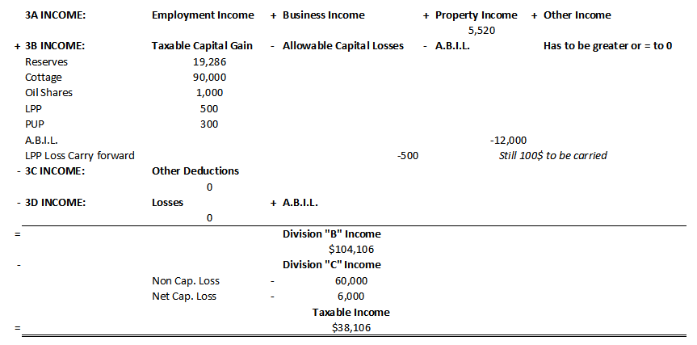
Net Capital losses: 2004: $(6,000)
Non-capital losses: 2005: $(60,000)
Final T.I. Solution: Calculate Simon's taxable income for 2008.

QUESTION 2: MINIMUM NET INCOME & MINIMUM T.I. 2008
As a result of her employer, a public company being taken over by another company, Mrs. Cortez's job was eliminated on May 1, 2008. The company gave her a car, which cost $40,000 in 2000. This was the company's way of thanking her for her long service. The car had a net book value on the company's accounting records on May 1, 2008 of $28,000 and a market value of $32,000 at that time. In early June 2008, Mrs. Cortez's second husband unexpectedly died of a heart attack. Mrs. Cortez decided that she needed a change of life and accepted a new job at a Toronto company and moved directly from Alberta to Toronto on September 1, 2008. She sold the former family home in Alberta on December 20,2008.
Mrs. Cortez has requested your assistance in calculating her 2008 taxable income based on the following information:
- Salary from Alberta employer $96,000

- Salary from Toronto employer 30,000

- Moving allowance received from Toronto employer 5,000
Max Deduction: Salary + moving expenses = (30,000 +5,000)
= 35,000

- Amount received by Mrs. Cortez from Mr. Cortez's 50,000
previous employer due to his death.

- Interest-free loan received on January 1,2008 from 225,000
her Alberta employer to purchase shares under the
stock option plan. (the loan was fully repaid on
December 1,2008)
225,000 x (5%-0%) x 11/12 = 10,313

- Interest-free loan received on September 1, 2008 from 100,000
her new employer to assist her to purchase new home.
100,000 (5%-0%) x 4/12= 1,667

- Interest on foreign bond ( Canadian funds), net of 15% 8,500
withholding taxes.
8,500 / 85% (100%-15%) = 10,000

- Dividends from the TD bank of Canada 1,000
- Moving expenses from Alberta to Toronto paid by Mrs. Cortez:
a) Transportation of her household effects 8,000
b) Travel costs, including meals/lodging for her family 6,500
c) Mortgage interest paid on vacant house in Alberta 7,000
until it was sold in December, 2008
d) Legal fees and real estate commission on the sale 13,000
of her old house
e) Legal fees on purchase of new home 10,000
f) Mrs. Cortez spent $2,200 on airfare and accommodations in October to fly to Toronto to try and find a suitable home to purchase for their family.
g) Mrs. Cortez's new employer reimbursed her for $7,000 of her moving costs.
 | Deductible | Non-Deductible
a) Trans. of household effects | 8,000
b) Travel costs | 6,500
c) Mortgage | 5,000 | 2,000
d) legal fees | 13,000
e) Legal fees | 10,000
f) Airfare/Accommodations |  | 2,200
TOTAL | 42,500 | 4,200

10. Payments made to a babysitter to care for her 6 year-old 8,000
son while Mrs.Cortez works
Lesser of:
1. 8,000
2. 7,000
3. 2/3 x 96m000 + 30,000.....

11. Registered retirement savings plan contributions 20,000

Her 2007 earned income was $120,000 with a pension adjustment of $6,000 and her 2008 earned income was $150,000 with a pension adjustment of $22,000. She has unused room of $0.
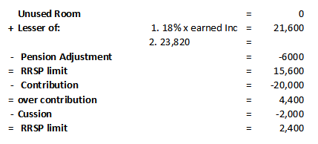
Additional Information:

12. On march 1,2008, Mrs. Cortez's Alberta employer granted her an option to purchase 15,000 common shares at $15/share, which was the FMV at that date.
Stock option price = $15 > or = FMV when option given --> Division "c" stock option deduction available.

13. a. She exercised the option to purchase all 15,000 shares in January of 2008 when the shares were trading at $21. b. She sold 10,000 shares on December 1,2008 at $25/share.
a. Stock option benefit (3A employee income)= 15,000 (21-15)= 90,000
T.C.G.= 45,000
*If it's a public company its dully taxable*

b. Sold 10,000 on December 1 @$25/share
POD=250,000
ACB=210,000
CG= 40,000
TCG=20,000

14. Mr.Bailey, Mrs. Cortez ex-husband from her first marriage, found about Mr. Cortez's death and demanded alimony. After months of negotiations, it was agreed that Mrs. Cortez would pay Bailey a one-time amount of $120,000 on November 20,2008 and $500 per month for 3 years starting November 1,2008. She also paid $10,000 in legal fees in regards to this agreement.
*Lump sums are not deductible*
500 x 2 (November + December) = 1,000

Legal fees not deductible
- only mental and physical counselling or work employment fees are deductible

Mrs. Cortez had incurred a net capital loss $25,000 in 2002, which she had not previously been deducted.
Deduct only 20,000 and then carry forward 5,00 because 3B is only 20,000.

Note: The prescribed interest rate for 2008 is 5%.



