A photosystem:
- Reaction center complex associated with light
- Consists of:
  - Reaction center complex: surrounded by light harvesting complexes. Contains a primary electron acceptor excited the electrons, reduced as a result
  - Light-harvesting complexes: pigment molecule around ^. Acts as antenna, transfer energy of photon to reaction center.
- Transfer of an electron from chlorophyll a to primary electron acceptor (1st step in light reaction)
- Two types of photosystems in the thylakoid membrane:
  - PS II” 1st named because it was discovered first (680nm) reaction center P680
  - PS IP700
- Light reactions: two possible routes for electron flow:
  - Linear: involves both photosystems. Produces ATP and NADPH using light energy
    - PSII:
    - Photon hits pigment transferring energy, p680 transferred to primary electron acceptor
    - P680 is an oxidizing agent
    - H2O is split by enzymes, electrons transferred from H to P680+
    - O2 is released as a by product
    - Electrons falls from PSII to PSI, releasing energy served as creator of proton gradient
    - Diffusion of protons drives ATP synthesis
    - PSI:
    - Light energy excited P700 which loses an electron to an electron acceptor
    - P700+ accepts an electron from PSII
    - Each electron falls from primary electron acceptor of PSI to protein ferredoxin
    - Electrons are transferred to NADP+NADPH
    - NADPH electron available for the Calvin cycle
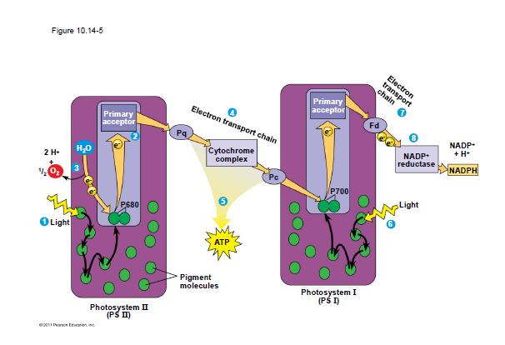
  - Cyclic: involves only PSI. produces only ATP (bacteria)
    - No o2 released
    - Generates surplus ATP
- Calvin cycle: building sugar using ATP and NADPH
  - Carbon enters cycle as CO2, leaves as G3P
  - For 1 G3P the cycle takes place 3 times, using 3 molecules of CO2
  - Three cycles in the Calvin cycle:
    - Carbon fixation
    - Reduction
    - Regeneration of CO2 acceptor (RuBP)
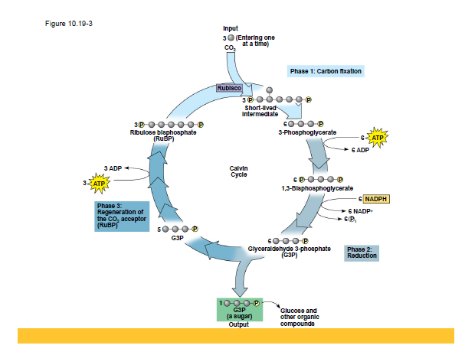Lecture 8:
- Hot arid climates have alternatives for carbon fixation, CLOSING OF STOMATA
- Photorespiration:
  - Most plants, with fixation of CO2 form a three carbon compound (C3 plants)
  - Photorespiration O2 is added instead of CO2 in the Calvin cycle forming a 2 carbon compound
  - This process consumes o2 and produces co2
  - This is bad because it uses a lot of co2 without producing energy
- C4 plants incorporate CO2 into four carbon compound (requires enzyme PEP carboxylase)
- This enzyme can fix CO2 even when there isn’t a lot
- This four carbon compounds are sent to be used as CO2 in the Calvin cycle
- CAM plants:
  - CAM used to fix carbon, open stomata at night only to let CO2 in
- Catabolic pathways:
  - Fermentation (no O2)
  - Aerobic respiration (O2 used)
  - Anaerobic respiration (other than O2)
- Cellular respiration includes aerobic and anaerobic
  - Electrons transferred to NAD+, and passes them to the electron transport chain.
  - O2 pulls electrons down the steps of the chain, yielding energy ATP
- Stages of cellular respiration:
  - Glycolysis (glucose two pyruvate) two major phases
    - Energy investment
    - Energy payoff
  - Pyruvate oxidation and citric acid cycle (pyruvate break down)
  - Electron transport chain and oxidative phosphorylation (90% ATP synthesis)
- The other 10% is formed by substrate level phosphorylation in glycolysis and oxidative phosphorylation
  - Enzyme takes P from substrate and transfers it to ADP forming ATP
- If there is O2 pyruvate then goes in the mitochondria. It must be converted to Acetyl CoA first before the citric acid cycle begins
- Citric acid cycle:
  - Pyruvate CO2
  - Generates:
    - 1 ATP
    - 3 NADH
    - 1 FADH2

  - Step 1: Acetyl group attach to oxaloacetate forming citrate
  - Step 2-7: convert citrate back to oxaloacetate
  - NADH and FADH relay electrons to the electron transport chain, producing ATP (oxidative phosphorylation)
- Electron transport chain is in the inner membrane of mitochondria
- Chemiosmosis: electrons in the electron transport chain cause protein pump H+ from mitochondrial matrix to inter membrane space, and moves back inside the membrane through ATP synthase.
- Energy flow in cellular respiration:
Glucose NADH Electron transport chain proton motive force (H+) ATP
- For each molecule of glucose, 36 ATP is made
Lecture 9:
- If there’s no O2 fermentation or anaerobic respiration occur
- Anaerobic respiration uses electron acceptor other than o2 (SO4-, NO3-, s)
- Fermentation substrate level phosphorylation (glycolysis + reactions that make NAD+)
  - Alcohol fermentation
    - Pyruvate converted to ethanol
      - Two steps:
        - Release CO2
    - Wine, beer, baking
  - Lactic acid fermentation
    - Pyruvate reduced by NADH to lactate
    - Make cheese, yogurt
    - Human muscles
- All three (ferm, aero and anaero) require glycolysis 2ATP
  - NAD+ is the oxidizing agent that accepts e during glycolysis
  - Different final electron acceptor
  - Cell respiration 32 ATP
  - Fermentation 2 ATP
- Obligate anaerobes: fermentation. Cannot like with o2
- Facultative anaerobes: can survive with fermentation or cell respiration (depending if theres o2 or not)
- Glycolysis accepts carbohydrates, catabolic reactions
  - Fat glycerol (glycolysis) and fatty acid (beta oxidation acetyl coa)
- Body uses small molecules to build larger ones
- Feedback mechanism ATP high, respiration slows vice versa
- Based on regulation of activity of enzymes
- Chloroplast and mitochondria both make ATP but use different sources of energy
  - Chloroplast: light
    - Protons pumped to thylakoid membrane/ diffuse back to stroma for ATP
  - Mitochondria: food
    - Protons pumped from inter membrane space/ go back into mitochondria for atp
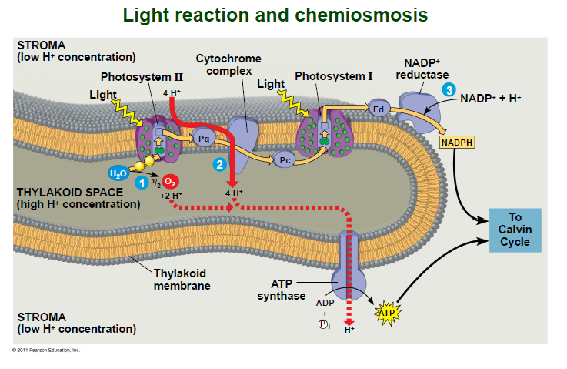

Lecture 10:
- Etiolating: adaptations for growing in darkness (de-etiolation for when there is light after dark)
- Cell signaling process stages (potato reaction to light):
  - Reception
  - Transduction
  - Response
- De-etiolation: activate enzymes for photosynthesis, chlorophyll production, affect hormone for growth
- Plant hormones: chemical signals control physiological processes (growth development)
- Tropism: Curvature of organs towards or away from stimulus
- Darwin and son experiment on phototropism (plant response to light)
- Observation: Grass could bend toward light when the tip was present
- Conclusion: signal transmitted from tip to elongating region
- Plant hormones produced in low concentrations
- Auxin:
  - Chemical that promotes elongation of coleoptiles
  - Indoleacetic acid for ex
  - Produced in shoot tips
  - Proteins transport from basal of one cell to apical of other
  - In cell elongation:
    - Stimulates proton pump in plasma membrane which lower pH in cell wall
    - Low pH expansins (enzyme that loosens wall fabric) activation
  - Practical uses of auxins:
    - IBAcid stimulates adventitious roots and propagation
  - Overdose of auxins kills plant (herbicide example)
- Cytokinins:
  - Stimulate cytokinesis (cell division)
  - Produced in actively growing tissues
  - Work with auxins to control cell division and differentiation
  - They have anti-aging effects. Inhibit breakdown of protein
- Gibberellins:
  - Stem elongation: produced in young roots and leaves, stimulate growth
  - fruit growth,
  - seed germination: release from embryo
- Abscisic acid:
  - Slows growth
  - Seed dormancy: Ensures seed germinate only in optimal conditions (when it rains etc.)
  - Drought tolerance: accumulation causes stomata to close fast
- Ethylene:
  - Produced in response to mechanical stress (drought, flood, infection etc.) ripe
  - Triple response to mechanical stress:
    - Slowing of stem elongation
    - Thickening of stem
    - Horizontal growth
  - Senescence: programmed death of cell or organs (ethylene associated with this)
  - Leaf abscission: when leaf falls in autumn (Auxin and ethylene)
  - Fruit ripening: burst of ethylene more ripening more ethylene
- Photo morphogenesis: effect of light on morphology of plant
- Phytochromes: pigment that regulate plant response to light
- Red light increase germination (far red opposite) phytochrome is receptor responsible for the opposing effects
- Two states of Phytochromes exist
  - Pr (red): increase germination, trigger conversion to pfr
  - Pfr (far red): opposite pr
  - Sunlight increase ration pfr/pr trigger germination
- Photoperiod: length of night and day (used by plants)
- Photoperiodism: physiological response to photoperiod
  - Control flowering: when light day shorter short day plant/long night (opposite when light day is longer)
  - Day neutral plant flowering not controlled by photoperiod
- Researchers discovered that it’s not actually day that controls but night length
- Flash of red long night. Flash of red and far red short night (cancel effect)
- Things that affect plant other than light:
  - Gravity: this is known as gravitropism (root positive, shoot negative)
    - Statoliths detect gravity
  - Mechanical stimuli: thigmomorphogene changes that result from mechanical disturbance
    - Thigmotropism growth in response to touch (vines)
- Defense against herbivores:
  - Physical defense: thorns
  - Chemical: toxic cpds
  - Recruit predatory animals
- Defense against pathogens:
  - Epidermis first line of defense
  - Chemical attack second line (enhanced by ability to recognize certain pathogens)
  - Avirulent pathogen: harms but doesn’t kill
  - Virulent pathogen : plant has little specific defense
- Gene for gene recognition: R protein recognizes molecules made by pathogen Avr gene, r protein activate defenses (signal transduction pathway) include:
  - Hypersensitive response: cell death near infection, production of attacker, confine pathogen
  - Systemic acquired resistance: long lasting response. Salicylic acid synthesized triggers systemic expression of defense genes
Lecture 11:
- Angiosperms(sporophyte is dominant) lure insects with nectar. Mutualistic relationships between plants and other organisms exist
- Three fs in angiosperm life cycle:
  - Flower
  - Double fertilization
  - Fruits
- Angiosperm life cycle: sporophyte (2n) meiosis spore (n)grow gametophyte (n) mitosis gametes (n) fertilization sporophyte (2n)
- Flower: reproductive shoot of angiosperm, attached t receptacle (in stem)
  - Four major organs: sepals, petals, stamens, carpels (last two reproductive organs, the others are sterile)
  - Stamen filament topped by an anther with pollen sacs
  - Carpel style with stigma where pollen lands (one or more carpel: pistil)
  - Style ovary at the base containing ovules
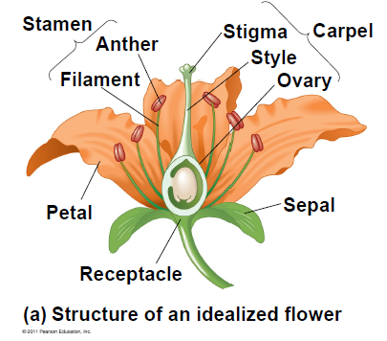
- Complete flowers contain all 4 organs
- Incomplete lack one or more organs
- Cluster of flowers: inflorescences
- Male gametophyte:
- Pollen comes from microspores in the microsporangia (pollen sac)
- Microspores mitosis generative cell (2sperm) and tube cell
- If pollination succeeds: pollen grain produce pollen tube that discharges two sperm cells
- Female:
  - Embryo sac develops in ovule
  - In ovule two integuments surround a mega sporangium
  - One cell in mega sporangium undergoes meiosis making 4 megaspores (only 1 survives)
  - The megaspore divides making a cell with 8 nuclei
- Pollination is transfer of pollen from an anther to a stigma (can be wind, water, animals)
- Win pollinated species: grass
- Double fertilization: after the discharge of two sperms, one fertilizes the egg zygote (2n) the other combines with polar nuclei food storing endosperm (3n)
- Fertilization: after double fertilization. Ovule seed, ovary fruit enclosing seed
- Endosperm development precedes embryo development. Endosperm stores nutrients.
- Fruit form and function: develops from ovary, protects seeds, aids seed dispersal
- Fruit classification by development:
  - Simple one or more fused carpels (pea)
  - Aggregate flower with many separate carpels (raspberry)
  - Multiple group of flower (inflorescence) (pineapple)
  - Accessory fruitother floral parts with ovaries (apple)
Lecture 12:
- Flowering plant can reproduce sexually(different from parent)/ asexually(clone)
- Advantages and disadvantages to both types of reproduction
  - Asexual: good for stable environments but not for changing. Good for ensuring all ovule develop into a seed
  - Sexual: good for evolution, not all seedlings survive
- Types of asexual reproduction in plants:
  - Clones from cutting: plant is cut and callus (mass of dividing cells) form
  - Grafting: closely related species only (cutting a branch and sticking it to another plant) stock (plant) scion (branch)
  - Test tube cloning: callus growing in response to hormones
- Gene modification:
  - Transgenic: GM plants that express gene of another organism
  - Protoplast fusion: used to create hybrid plants (fuse protoplast and plant cells without cell walls)
- Plant breeding:
  - Plants w/ good modifications are crossed with domesticated plants, their progeny with domesticated, etc.
- Plant biotechnology: innovation to make useful products or GM organisms
- Problems in genetic engineering:
  - World hunger
  - Fossil fuel dependency
- Reducing world hunger and malnutrition:
  - GM food increase quality and quantity of food
  - Transgenic crops:
    - Produce protein to defend against insect pests
    - Tolerate herbicides
    - Resist disease
    - Nutrition quality of plant improved (golden rice-more vitamin A)
- Reducing fossil fuel dependency:
  - Oil being depleted bad
  - Biofuels made by fermentation and distillation of plant material (ex, cellulose)
    - Produced rapidly
    - Reduce emission of CO2
    - Problem: requires a lot of energy
- Human health problems: GM transfer allergens to plants and then humans
- Human benefits: less cancer causing toxins, less insect damage
- Problem: transfer of GM genes to weeds creating super weeds resistant to herbicides
  - Solution: male sterility (no pollen)
  - Apomixes ( only asexual reproduction possible)
  - Transgenes into chloroplast DNA (doesn’t transfer by pollen)
  - Strict self-pollination (closed flower)
- DNA technology: used to improve productivity and quality of food, genes can be transferred to a lot of species.
- Ti plasmid: commonly used vector for transferring genes into plant cell
- Genetic engineering used to transfer genes with herbicide, pest, salinity resistance and improve nutritional value of plants
- Cut plasmid where sticky end is and insert gene of interest

