Module 6
Slide 6
- In the cleaning process, the polar end of the surfactant molecule interacts with water (a polar molecule) and the non-polar end is attracted to oil or grease (non-polar molecules)
  - 1. chemical interaction (with soap or detergent) traps the oily and greasy molecules. In aqueous solution, surfactants cluster near the surface
  - 2. the hydrophobic tails are attracted to grease and the hydrophilic heads to the water, thereby forcing the grease away from the soiled surface
  - 3. the grease is then surrounded by the individual surfactant molecules and removed from the soiled surface
  - 4. thermal interaction (with hot water) helps dissolve oil and grease molecules. Mechanical interaction (machine agitation or hand rubbing) releases oily and greasy soil from the fabric.
Slide 13: shampoos, conditioners, styling agents, colorants
- Overview: products are used for variety of purposes such as to wash, condition, color, or to curl hair. Thus the products used include: shampoos, conditioners, styling agents, colorants
- Shampoos:
  - Cleansing agents containing anionic surfactants to remove oil and dirt from hair and scalp
  - Surfactants produce foam, lifting oil and direct from hair
  - In addition, fragrances, thickeners, foam boosters and other agents may be added
- Conditioners: usually contain cationic surfactants. These help in rinsing out any residual shampoo and at the same time provide softer and easy-to-manage hair.
- Styling agents: curling of hair is carried out in 3 steps:
  - Treatment of hair with reducing agent (electron donor) that breaks certain covalent bonds
  - Setting hair in desired shape
  - Treating hair with oxidizing agent (an electron acceptor) such as dilute solution of hydrogen peroxide to reform the previously broken covalent bonds in the new shape
- Colorants: hair coloring is a two-step process involving:
  - Oxidization of natural hair pigments to colorless products using a bleaching agent
  - Application of an organic, synthetic dye to obtain the desired color
- In addition to the dye (or its precursor), the formulations contain ammonia, hydrogen peroxide and a surfactant. In order to reduce the damage to hair during the coloring process and reduce the shell of ammonia, the chemistry has been modified by replacing ammonia with ammonium carbonate.
- Major developments in the field of hair coloring include the availability of:
  - Large variety of colors
  - Improved delivery systems to enhance the adhesion of colors to hair
  - More effective conditioners to neutralize harsh effects of dye chemicals
Slide 14: skin care products can be classified as moisturizers and sunscreens
- Moisturizers: used to increase water content of skin. They perform number of functions such as:
  - Prevent and treat dry skin
  - Protect skin and make it appear smooth by encouraging an orderly shedding process
  - Improve skin tone and texture
  - Protect sensitive skin and mask imperfections
- Moisturizers: active ingredients
  - Humectants: absorb moisture and hold it in the skin
    - Ex: glycerin, urea
  - Emollients: lubricate an smooth skin
    - Ex: lanolin, mineral oil
  - Miscellaneous: antioxidants, fragrances, minerals, plant extracts, vitamins
- Skin care products (creams, lotions, shampoos and sun care products) containing plant-derived chemicals are being developed at a very fast rate)
- Sunscreen (sunblock): used to protect skin against harmful effects of ultraviolet radiation. UV radiation emitted by sun consists of UV-A and UV-B
- Although stratospheric ozone layer destroys most of this radition, UV light that gets through can cause problems. In addition, depletion of ozone layer due to variety of natural and human made chemicals may increase the amount of UV radiation reaching us. It is believed that exposure to UV radiation can cause painful sunburn, damage skin, and lead to skin cancer.
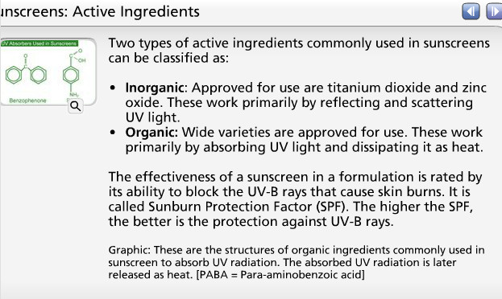
- Sunscreen products (sold as lotions, ointments, creams and gels) are formulated with additional chemical ingredients that absorb UV radiation)


