OFFSHORE OUTSOURCING ON SUSTAINABILITY: AN IN DEPT ANALYSIS

Presented to Professor Philippe Colas
Lecturer

Concordia University John Molson School of Business

Presented by Carine Bedrossian
Bachelor of Commerce

October 30, 2014

TABLE OF CONTENENTS
EXECUTIVE SUMMARY 3
INTRODUCTION 4
Purpose and Scope 5
Sources 5
LITERATURE FINDINGS 5
Long Term Effects of Outsourcing 5
Firm’s perspective 8
Consumer’s Perspective 10
Examples in current economy 11
PROPOSED SOLUTIONS 13
CONCLUSION 16
REFERENCES 17

EXECUTIVE SUMMARY
The phenomenon of offshore outsourcing jobs, mostly in the manufacturing industry, inspired the subject of this study. The purpose of this study was to demonstrate (1) the effects of long-term outsourcing, (2) why businesses continue to outsource manufacturing, and (2) why consumers continue to support businesses that outsource manufacturing.
The secondary data collected suggests that offshore outsourcing is not sustainable for the domestic economy, because it will ultimately increase unemployment. It also shows that outsourcing is unsustainable from an ethical perspective. Another finding was that firms were not so eager to stop outsourcing, because companies like to see immediate results that are measurable, which is not the case for sustainability. An additional finding was that consumers did not really think about the effects outsourcing has on sustainability when purchasing a product. Their decisions are price and convenience driven.
The following suggestions were made in an attempt to provide solutions to the existing offshore outsourcing dilemma:
- Better awareness.
- Better Government incentives
- Laws that protect the domestic country’s work force.
- Laws that protect offshore workers
- Increased seriousness about GNH index

INTRODUCTION
It is scorching hot, back is aching, fingers are covered in blisters, eyes are bloodshot, and there is still 10 hours of work ahead; it’s just a typical Monday morning in a manufacturing sweatshop. In this day and age, most American and Canadian firms outsource the manufacturing of their products. This strategic business move aims to lower production costs and produce at a larger scale. Advances in technology and the expansion of globalization have played a great role in contributing to this phenomenon. However, outsourcing raises certain questions in terms of sustainability.
The US Labor department defines a sweatshop as a factory that violates 2 or more labor laws. The most common among many labor laws broken are unfair wages, poor working conditions and child labor. Although some rare cases have shown up where sweatshops were discovered on North American soil, most manufacturing factories on this side of the content abide by all labor laws. Conversely, instead of staying true to labor laws of their countries, some firms have found a loophole: outsourcing. The true epicenter of sweatshops lies within underdeveloped or developing countries, where labor laws are much more lax.
Yet, one might ask itself how, with all these progresses in technology and medicine, has human kind regressed in terms of social justice? When did capital become the sole driver of our society?
Sustainability is a topic that is widely discussed, and information on it is easily accessibly with just a few taps on our keyboards. It is no secret that large established companies like Nike, Wal-Mart, H&M and The Gap use sweatshops when manufacturing their products. Nonetheless, they are still supported and even celebrated by consumers. Granted, it is not the consumer’s decision whether a company outsources their production process, but they do have the power to decide whether or not to support the company.

Purpose and Scope
The purpose of this paper is to demonstrate why firms continue to outsource the manufacturing of their products and why consumers turn a blind eye to it. Furthermore, it illustrates how outsourcing affects long-term sustainability on a macro-economic level.

Sources
This paper is largely based on secondary sources that come from various academic journals, acclaimed books and reliable newspaper publications.

LITERATURE FINDINGS
Sustainability in the business sense means managing financial, social and environmental risks & obligations. The goal of this research was to show how outsourcing is not sustainable, and find the main factors that influenced the decision to be sustainable. For this, the problematic obstacles in pertain to sustainability were separated into two categories: (1) the firm’s perspective and (2) the consumer’s perspective.

Long Term Effects of Outsourcing
Most economists tell us that offshore outsourcing will have a positive effect on the economy in the long run. (Hira & Hira, 2008, p. 96) They believe that since firms have the ability to offer products at a cheaper price, it will increase the consumer’s purchasing power. However, this theory relies on the “full employment assumption”. In accordance with this assumption, workers who have lost their jobs to outsourcing have moved on to better paying and more skilled jobs. Conversely, if workers are left unemployed, then the theory that offshore outsourcing will be beneficial falls apart. (p. 97)
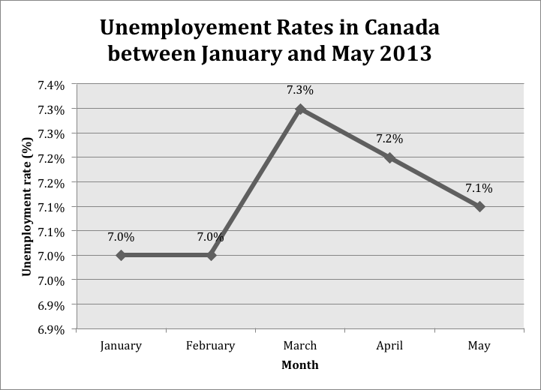
In March of 2013, Canada lost a total of 54,500 jobs in the private sector, among which 24, 200 lost were manufacturing jobs. This reflects the effect of outsourcing manufacturing jobs on unemployment, and supports the theory that outsourcing is not a sustainable practice. (Source: CANSIM, Statistics Canada)
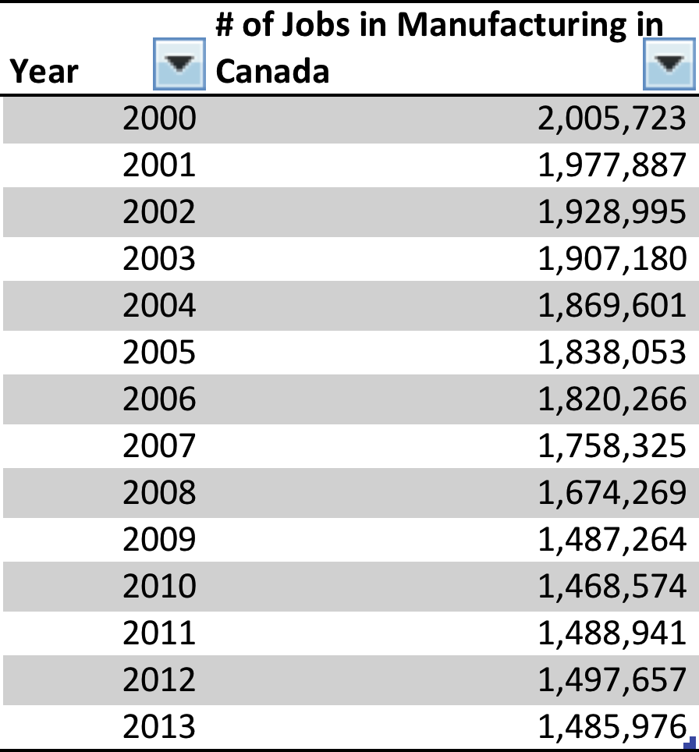
The above table and chart show the number of manufacturing jobs occupied in Canada from 2000 to 2013. We can clearly see a downward trend in this sector. Jobs are moving out of Canada, and being outsourced. Between 2000 and 2013 a total of 519,747 manufacturing jobs have left the market. (Source: CANSIM, Statistics Canada)

Offshore outsourcing also puts a downward pressure on domestic wages. (p.127) Many companies have also stopped given benefits, and even gone to the extent of discontinuing pension plans. (p. 128)
However, some of the impacts of outsourcing are immeasurable. On an emotional level, it impacts many people. Those who lose their jobs deal with a lot of anxiety and stress. (p. 126) Those who end up working in overseas manufacturing factories face very harsh working conditions. This affects the happiness and overall wellbeing of society. Humans are resources, too. We shouldn’t exhaust them.

Firm’s perspective
Firms know that sustainability is important. They also know that outsourcing affects social sustainability gravely, but they are still reluctant to be more sustainable. The Ivey Business Journal (2011) conducted a study where 25 of the world’s leading organization were interviewed with the purpose of determine what were the key reason companies did not engage in sustainable practices. The results showed, for one, that companies believed there were too many metrics that influenced how well sustainability is executed. Each metric serves different purpose and companies fount it hard to determine which were more important that others. They also found it difficult to measure how significant a role their company plays in global sustainability. Businesses like to see very clear results. When their efforts are not recognized, or ranked, businesses are less motivated to take action. There has to be a certain level of measurable competiveness amongst companies to peak their interest. Also, the outcomes of sustainability are not immediate. The study suggests that the idea of waiting to see the rewards sustainability yields is not attractive for businesses. Businesses like knowing what the return on investing in sustainability will exactly be and when it will come.
Another opposing barrier according to the study is that government does not use the tools they have at their disposal such as taxes and market regulations efficiently. Incentives that acknowledge sustainable efforts are poorly measure and so far ineffective. Policies must drive leading firms to achieve long-term sustainability.
One big problem discussed by the organizations was that sustainability is not an aspect consumers take into account every time they purchase a product or service. There is always a “sustainability-related tradeoff” in the decision making process. However, consumers are not always ready to give up something of their own in order to benefit global sustainability. When products are made in Canada and the U.S., employers must pay workers fair wages ⎯ respective to each countries minimum pay per hour, provide employees benefits, and ensure good working conditions. Consequently, product that is produced domestically is relatively more expensive than products that are made offshore in sweatshops. Consumers are not always prepared to pay the extra price; their thinking is short-term. The benefits of sustainable actions are accumulated over time and reaped by society much later on. Consumers seek to have immediate benefit. Firms feel they must outsource in order to stay competitive. This is discussed more in detail in the following section.
In addition, some customers perceive sustainable moves made by businesses as “greenwashing” and that companies are not really genuine with their motives. With this criticism on their work, companies do not know how to deliver their message on sustainability in a believable manner. The risks of being negatively perceived outweigh the social responsibility of the companies. (Ivey Business Journal, 2011)
Furthermore, companies that have tried to push the sustainability envelope have more than often failed. This discourages firms on the market to invest in sustainability. A sustainable model can attract new customers and create a loyal following, but at the same time presents the risk of being outshined by other companies who might come up with better sustainability models, leaving companies back at square one. (Ivey Business Journal, 2011)

Consumer’s Perspective
Recent studies have shown that 89% of American consumers believe it is imperative for business’s to be more “socially responsible” (The Cone Corporate Citizenship Study, 2002) Conversely, studies have shown that when its time to actually make a purchase decision consumers base themselves on 3 factors: price, quality, or convenience. (Webb and Mohr, 1998) Corporate social responsibility (CSR) as defined by Mohr, Webb and Harris (2001) is a companies “commitment to minimizing or eliminating any harmful effect and maximizing its long-run beneficial impact on society.” On a survey conducted by these three scholars (2001), it was interesting to see that consumers rated companies that did not give out any CSR information as positively as companies that gave out very high levels of CSR information. The researchers deducted that this was probably due to the fact that consumers either did not consider CSR on instinct or that they assumed the company was sustainable. This shows that, given the information, consumers are willing and able to make the right decisions. What plays a key role in this case is awareness. Most companies advertise that they are sustainable, or in this case sweatshop-free, but consumers do not fully grasp the significance of each sustainable move. This is a phenomenon that stems from the consumer’s own education. Yes, it is the business’s job to deliver the message of sustainability, but they can only explain issues to certain extents. It is partly the consumer’s responsibility to be sustainable on his/her own and have an idea about what are some sustainability issues, like sweatshops in the textile industry. It is a matter of taking that extra step to be a more socially conscious member of society. If consumers support firms who are socially conscious, firms will be more eager to jump into sustainable models.

Examples in current economy
One of the very few retailers notorious for being sustainable is American Apparel. Like the name and slogan suggests, American Apparel is a vertically integrated and sweat-shop free apparel retailer, the manufactures all of its clothing in the United Stated. In fact, every subdivision of American Apparel, from top management to manufacturing, is situated in one large factory in downtown Los Angeles. Vertical integration means that American Apparel independently foresees the production of everything they sell or use; this includes advertisements as much as it includes apparel. Globally, American Apparel has 10,000 employees (Market Watch, 2014). At the factory, sewers who manufacture the clothing have a 12$/per hour wage, twice the federal minimum, and earn salaries of 30,000$ and up. They also get medical insurance for themselves and their families. American Apparel also offers their workers free massages on Fridays, and since most of the employees are immigrants, they also offer free English lessons to help employees acquire helpful skills. American Apparel also empowers the use of clean energy. Their factory roof is covered by solar panels that help fuel 15% of the company’s total energy consumption.
Despite their sustainable model, American Apparel has faced numerous challenges in the past year. In February 2014, their stock fell below 1.00$ for the first time in over a year and has been struggling to get up ever since (Bloomberg 2014). Since clothing at American Apparel is slightly more costly, consumers are opting to buy from other competitive retailers such as H&M and Forever 21 who outsource the manufacturing of their products. Last year, although they had a revenue of $633.94 million in sales, they’re net income was in the negatives, at $-106.30M (Market Watch 2014). The bellow graph shows the depreciation in percentages on American Apparel stock since it became open for purchase. The red line represents stock trends in the apparel industry. As we can see, although the apparel industry has achieved tremendous growth, American Apparel stock continues to plummet. This kind of market makes it almost impossible for companies with sustainable models to survive.
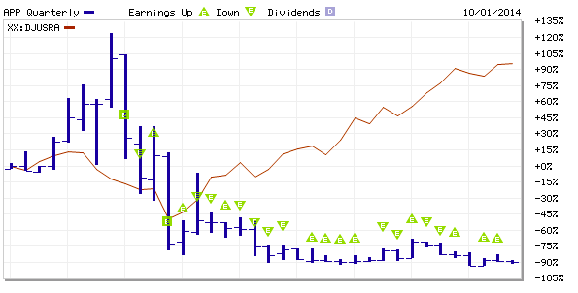
As explained above, this chart shows how the American Apparel (APP) stock has fallen over the years whilst the industry its in experiences tremendous growth. (Source: Market Watch, 2014)

PROPOSED SOLUTIONS
Given the above issues, below is a list of solutions that have been proposed after analyzing different studies:
- Better awareness. The key component of a successful sustainable model is to spread information on the cause the model is trying to support. When talking about outsourcing, it is important to stress how outsourcing impacts the lives of not only those working offshore, but also to demonstrate how outsourcing can effect members of the domestic economy. Ignorance is a core driver of the outsourcing phenomenon. As demonstrate in Webb and Mohr, not knowing what is going on in our society has as much of impact on sustainability as knowing what is going on and not doing anything about it.
- Better Government incentives. The government has to use its resources to their full potential. By having the power to regulate the market, it can encourage firms to produce on domestic ground by offering subsidies to companies who have sustainable models. Businesses often want to be sustainable in their methods, but do not have the means. It is important for government to collaborate with businesses so that they understand what businesses need, and establish policies that meet the needs of both the business and society. (Ivey Business Journal, 2011)
- Laws that protect the domestic country’s work force. Click & Duening, authors of the book Business Process Outsourcing, forecast that over the course of the next few years laws will appear banning the use of offshore labor when there all individual onshore who are equally qualified and skilled to do the required job (p. 219).
- Laws that protect offshore workers. There should be a universal set of laws that protect the employee from being abused. Companies that outsource in third world countries take advantage of a really bad situation. People in these countries are willing to work at any price, including the price of their childhood. Child labor is morally wrong, and destroys the chance of the developing country’s next generation to acquire a more progressive skillset. The poor keep getting poorer, and the rich keep getting richer. It is a vicious cycle. This only fuels more disparity between the classes.
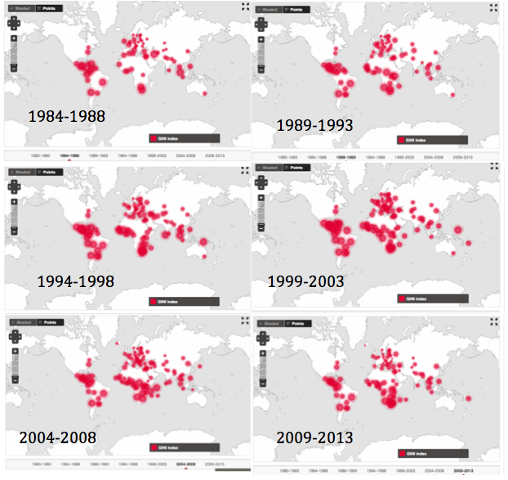
The GINI index is a tool used to measure the equality of income. When the GINI index is at 0, income is at perfect equality. When it is at 100, it represents complete inequality. In the above graph, a bigger circle represents a higher GINI index, meaning a bigger gap between high and low-income earners. Because there is not enough information to assess the GINI index, the GINI index of many countries is unknown. However, there is enough evidence to support the idea that disparity has increased over the years. We can observe the appearance of new disparities, especially in south Africa and Asia. (Source: World Bank)
- Increased seriousness about GNH index. The Gross National Happiness index is a tool that helps measure the nations happiness. (Grossnationalhappiness.org) Humans are considered as resources that are apart of the economy and the eco-system. Being sustainable also means doing our best to keep society happy. This metric is hard to calculate, because it is based on quantitative data. However, it is the only index that takes into account psychological well-being, health, good governance, living standards and community vitality. Leaders of developed countries should invest in research & development teams that focus on calculating this index. From then on, there will be more concrete data showing disparity between countries. This newly found data would aim to entice people to be more sustainable.

CONCLUSION
In the current market, it is almost impossible for firms to be sustainable. If we consider competitive pressures and consumer price expectations, it seems like there is no way to escape outsourcing. Those who have tried have so far failed. The problem lies within the entire system.
If society wants to reach sustainability, for each decision made, members must think on a macroeconomic level; what an individual does must benefit society as whole. Although consumers might have to pay more for products in the short run, supporting firms that produce domestically will encourage competitors to the same. Insourcing does not only create manufacturing jobs. It also creates managerial, accounting, and human relations positions, among various other position. In return, this phenomenon of job creations will increase purchasing power and decrease unemployment in the domestic country. This economic model will also encourage other nations to create businesses of their own, manufacture their own products and become valuable trading partners.
Conclusively, the most important lesson learned from this study should be that all of our actions have consequences. Society needs to recognize there is an issue with the constant outsourcing of jobs, and measures must be taken to correct it. We can no longer keep ignoring something that raises so many ethical and economical concerns. As the infamous Ghandi quote goes, “Be the change that you wish to see in the world.”

REFERENCES
Nisen, M. (2013, May 9). How Nike Solved Its Sweatshop Problem. Retrieved October 30, 2014, from <http://www.businessinsider.com/how-nike-solved-its-sweatshop-problem-2013-5>
Heywood, J. (2001). The outsourcing dilemma the search for competitiveness. London: Financial Times Prentice Hall.
Click, R., & Duening, T. (2005). Business process outsourcing the competitive advantage. Hoboken, N.J.: John Wiley & Sons.
American Apparel Shorts Triple as Sales Growth Stalls. (2014, February 7). Retrieved October 30, 2014, from http://www.bloomberg.com/news/2014-02-07/american-apparel-shorts-triple-as-sales-growth-stalls.html
Mohr, L., & Webb, D. (2005). The effects of corporate social responsibility and price on consumer responses. Journal of Consumer Affairs, 121-147. Retrieved October 30, 2014.
Laughland, P. (2011, February 1). THE TOP TEN REASONS WHY BUSINESSES AREN'T MORE SUSTAINABLE - Ivey Business Journal. Retrieved October 30, 2014, from <http://iveybusinessjournal.com/topics/social-responsibility/the-top-ten-reasons-why-businesses-arent-more-sustainable#.VFHvwIck-nj>
GINI index. (n.d.). Retrieved October 30, 2014, from <http://data.worldbank.org/indicator/SI.POV.GINI/countries/all?display=map>
American Apparel Inc. APP Key Statistics. (n.d.). Retrieved October 30, 2014, from <http://www.marketwatch.com/investing/stock/app/profile?CountryCode=US>

Sweatshops. (n.d.). Green America's Ending Program: Economic action to end sweatshop and forced child labor. Retrieved October 28, 2014, from http://www.greenamerica.org/programs/sw
Nisen, M. (2013, May 9). How Nike Solved Its Sweatshop Problem. Retrieved October 30, 2014.
http://www.huffingtonpost.ca/2013/04/05/unemployment-canada-march-2013_n_3019622.html
Book – the outsourcing dillemma
The information about American Apparel business model can be found on the company’s website, in the “About Us” section, direct link: <http://www.americanapparel.net/aboutus/>
To learn more about the GNH, follow the provided link: http://www.grossnationalhappiness.com/nine-domains/

