Module 7.1 – 7.2
Introduction—Changes to the Sensory System
- The human body has several sensory systems that allow it to detect the external changes rapidly.
These systems include:
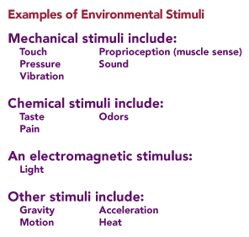
  - the somatosensory (touch) system,
  - the visual system,
  - the auditory and vestibular system,
  - the olfactory (smell) system, and
  - the gustatory (taste) system.
- Transduction of Environmental Information
  - Transduction of environmental information is how information from the external environment is turned into language the brain understands—action potentials.
  - In order for the brain to know what is happening outside the body, environmental stimuli (energy) like light, heat, touch, or sound must first be detected by sensory receptors which then convert the information into action potentials.
- Environmental Stimuli
  - In order for the brain to consciously perceive an environmental stimulus, that stimulus must be detected by a sensory receptor.
  - Environmental stimuli come in different forms and, therefore, will require different receptors to detect the stimulus and then convert it to action potentials.
    - For example, a mechanical stimulus, like touching or vibrating the skin, will stretch sensory receptors in the skin and open ion channels, causing a depolarization of the sensory neuron producing an action potential.
    - A chemical stimulus, like a sour taste on the tongue or an odor in the nose, binds with a receptor, causing a depolarization and then an action potential.
    - Light energy is absorbed by photoreceptors of the eye (rods and cones in the retina) and eventually produces action potentials.
    - Gravity and motion can also be detected by hair cells in the vestibular system, which convert this form of external stimulus to action potentials.
- Adequate Stimulus for the Receptor
  - Although there are many types of stimuli and a corresponding receptor to detect, some receptors can detect more than one type of stimulus.
  - An adequate stimulus is the particular form of environmental stimulus to which the sensory receptor is most sensitive.
  - The adequate stimulus for the rod and cone cells found in the retina of the eye is light. Sensory receptors do respond to other forms of energy but not in an optimal way.
    - For example, the rod and cone cells of the eye also respond to pressure on the eyeball.

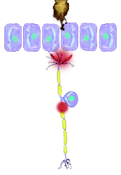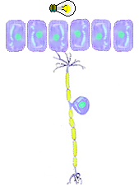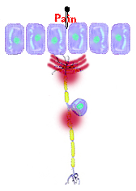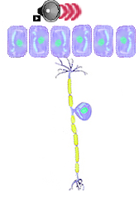
Heat light pain sound
- Receptor (Generator) Potentials
  - Recall that at a chemical synapse an excitatory neurotransmitter first produces an EPSP that, if strong enough, then generates an action potential at the axon hillock.
This is similar to the events that take place at a sensory receptor.
  - Once the sensory receptor is stimulated by an environmental stimulus, it will cause a change in ion permeability, leading to a local depolarization.
    - This local depolarization is called a generator or receptor potential.
  - Since the receptor does not have voltage-gated ion channels necessary to fire an action potential, the receptor potential must spread to an area on the sensory neuron that does contain these channels.
    - This is usually at the first node of Ranvier on the axon.
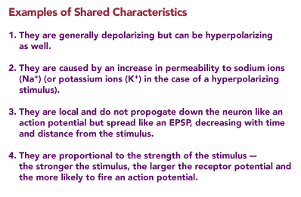
  - The action potential will then be generated and propagated along the axon and into the spinal cord.
  - In receptors with no axons (like the hair cells in the inner ear that we will see later), the depolarization has to spread to the synapse to result in the release of a neurotransmitter.
  - Receptor potentials are similar to EPSPs and IPSPs and share some of the same characteristics. These characteristics include those shown below.
- Receptor Potential and Neural Coding
  - Neural coding informed the brain of the weight of an object in your hand.
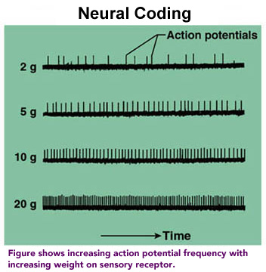
  - The weight of the object was "coded" into the action potentials (the heavier the object, the more action potentials per second).
  - How do you generate a large number of action potentials?
    - The heavier weight will trigger the receptor to produce a large receptor potential.
    - This large receptor potential will trigger many action potentials on the sensory neuron's axon.
    - This burst of high-frequency action potentials will eventually reach the brain where you will become consciously aware of the heavier weight in your hand.
- The Somatosensory System
  - The somatosensory system detects and processes the sensations of touch, vibration, temperature, and pain—the majority of which originate in the skin.
  - Detecting each sensation requires several different sensory receptors within the skin, each developed to detect its adequate stimulus.
  - The receptors in the skin are collectively referred to as cutaneous receptors. They include the following:
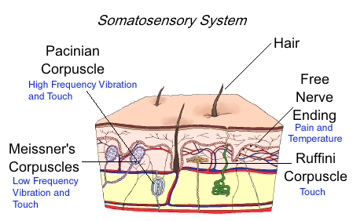
    - Hair follicle receptors that are sensitive to fine touch and vibration
    - Free nerve endings that respond to pain and temperature (hot and cold)
    - Meissner's corpuscles that detect low-frequency vibrations (between 30 and 40 cycles/sec) and touch
    - Ruffini's corpuscles that detect touch
    - Pacinian corpuscles that detect high-frequency vibrations (250 to 300 cycles/sec) and touch
- Receptive Field
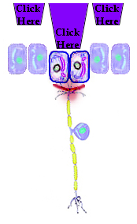
  - Although it would appear from the previous page that our skin is covered with sensory receptors, each receptor will only respond to a stimulus within a certain region on the skin.
  - The receptive field is the area on the surface of the skin where an adequate stimulus will activate a particular receptor to fire an action potential in the neuron.
  - Any stimulus applied outside the receptor field will not generate an action potential.
  - Now that action potentials have been generated in the sensory nerve, they must be propagated to a specific area of the brain so that the individual becomes consciously aware of the stimulus. These action potentials reach the brain via two spinal tracts
- Somatosensory Pathways from the Periphery to the Brain: The Spinothalamic (Anterolateral) Tract
  - The spinothalamic (anterolateral) tract transmits information dealing with very basic sensations like pain, temperature, and crude touch.
  - The information from the sensory neuron (first order neuron) enters the spinal cord where it synapses with a second order neuron.
  - This neuron crosses to the opposite or contralateral side of the spinal cord and ascends to a region of the brain called the thalamus.
  - The thalamus acts as a relay station for almost all sensory information (except smell).
  - A second synapse with a third order neuron occurs here and then travels to the somatosensory cortex.
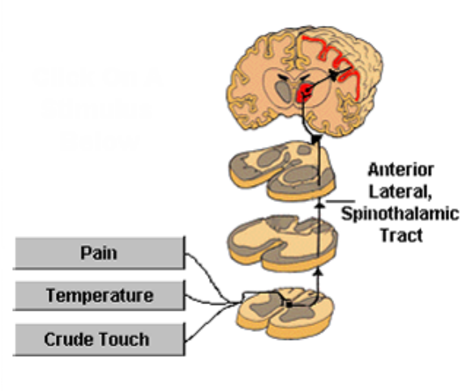
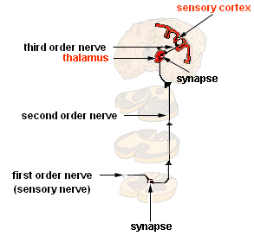
  - Note: sensory information from the right side of the body goes to the left side of the brain
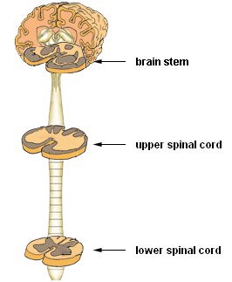
- Somatosensory pathways from the peripheral to the brain: Dorsal column, Medial Lemniscal system
  - The dorsal column, the medial lemniscal system transmits information associated with the more advanced sensation of fine detailed touch, proprioception (muscle sense), and vibration.
  - The information from the sensory neuron (first order neuron) enters the spinal cord and immediately travels up the spinal cord before crossing to the contralateral side (unlike the spinothalamic system)
  - In the upper spinal cord, the sensory neuron synapses with a second order neuron which then crosses to the opposite side of the spinal cord.
  - From here it continues to the thalamus where it synapses again onto a third order neuron that then travels to the somatosensory cortex
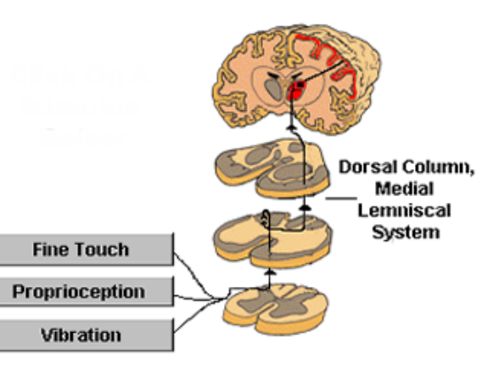
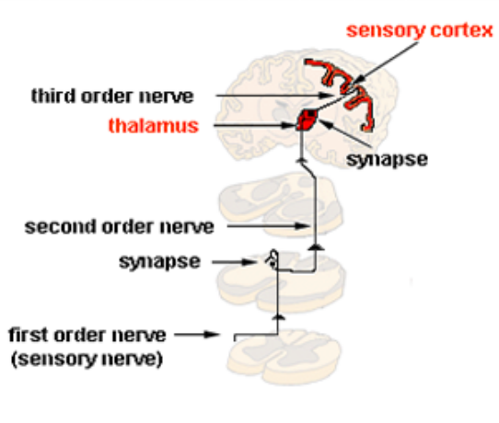
  - Again, sensory information from the right side of the body goes to the left side of the brain and vice versa
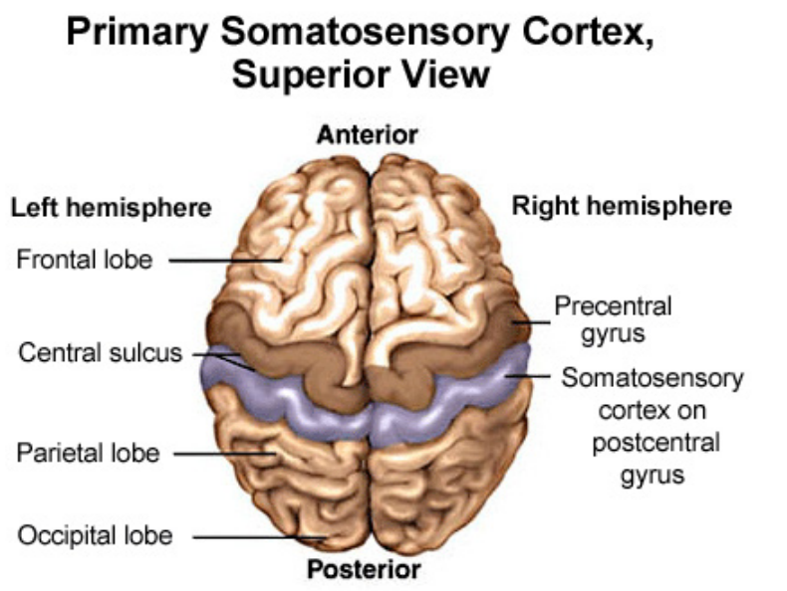
- Primary Somatosensory Cortex
  - Once the sensory information has reached the brain, it travels to the primary somatosensory cortex, which is located in the parietal lobe on the postcentral gyrus behind the central sulcus.
- Primary Somatosensory Cortex—The Somatosensory Homunculus
  - The primary somatosensory cortex is arranged in a very specific manner.
  - The sensory information arriving at this cortex is not randomly scattered around on the surface; rather, it is "geographically preserved."
  - It is as if the entire body were projected onto the surface of the brain like a map.
  - All the sensory information for the foot is located in one area—that of the leg just next to it and the hip next to the leg, and so on—for the entire body.
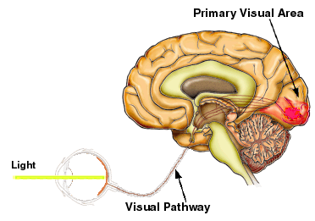
  - This topographical representation of the body on the surface of the cortex is called the somatosensory homunculus
  - You should notice that the "picture" of the human body represented in the homunculus is somewhat out of scale. Some of the representative areas are out of proportion (much larger than they should be).
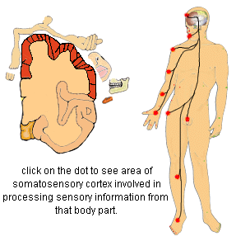
  - This is because some areas on the cortex, like the areas dealing with the hand, tongue, and lips, receive more sensory information and require more of the brain to process that information. The hands, tongue, and lips are the most sensitive parts of the body; they contain many more sensory receptors than any other part. After all, when you really want to experience how something feels, you use your hands (although babies prefer to use their mouths).
- The Visual System
  - The visual system detects light, converts it into action potentials, and sends these to the primary visual areas for processing.
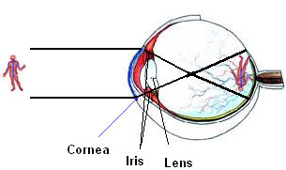
  - Once processed, we become aware of our visual world and are able to distinguish and recognize features in our external environment.
  - The visual system consists of:
    - the eye (which contains photoreceptors that convert the light to action potentials),
    - the visual pathway (which transmits the action potentials), and
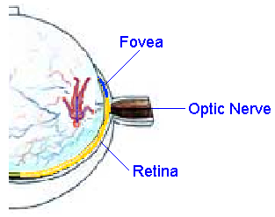
    - the primary visual area in the occipital lobe of the brain (which processes the incoming signals).
- The Eye
  - The eye is very much like any camera.
    - After passing through the cornea, the amount of light is regulated by the iris, which can constrict with bright light or dilate in low light.
    - The lens flips the light (upside down and backwards) and focuses it onto the retina at the back of the eye.
    - The retina contains photoreceptors called rods and cones.
      - The rods and cones actually point toward the back of the head.
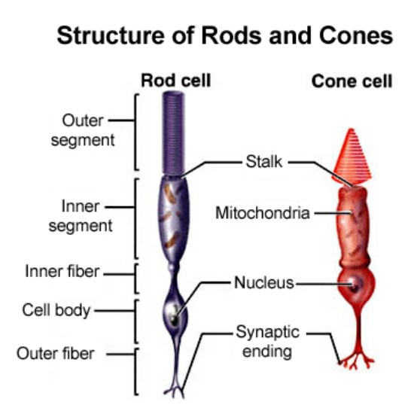
    - The center of your vision is focused onto a part of the retina called the fovea. This area has the highest concentration of cone cells.
- The Photoreceptors of the Eye—Rod Cells and Cone Cells
  - Rods are extremely sensitive to light and, therefore, function best under low light conditions.
    - They contain one type of photopigment (a chemical sensitive to light) and, consequently, do not detect color.
    - Rods are located mostly in the region of the retina outside and around the fovea.
  - Cones, on the other hand, function best under bright light and are ideal for detecting detail.
    - There are three different types of cone cells, each with a different photopigment and each sensitive to one primary color.
    - The cones are principally located in the region of the fovea where they are found in large concentrations.
  - Notice that the rod and cone cells do not have axons and, therefore, do not generate action potentials. However, they do generate receptor potentials that cause the release of an inhibitory neurotransmitter (this is important) from their synaptic ending.
- Other Cells of the Retina
  - The retina contains a pigment layer at the very back of the eye that absorbs excess light.
  - Other cells in the retina include bipolar cells, ganglion cells, horizontal cells, and amacrine cells.
  - As already mentioned, the rod and cone cells do not generate action potentials.
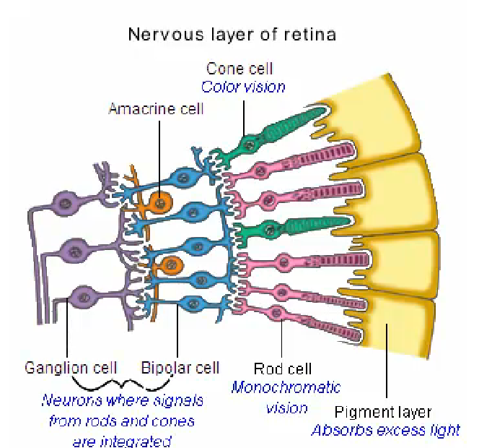
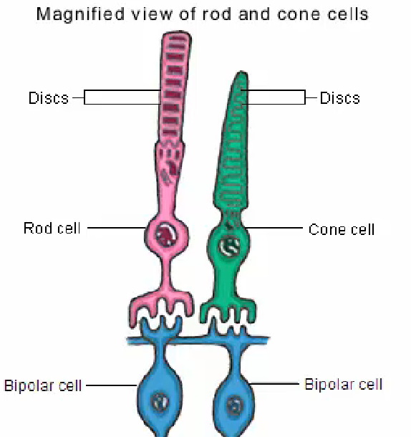
  - These other cells are responsible for the integration of information from the rods and cones and the production of action potentials.
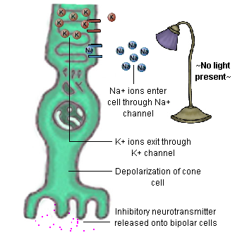
- Transduction of Light to Action Potentials
  - The visual system works "backwards."
  - As you have seen, the light striking the retina has been flipped upside down and backwards due to the lens.
  - When depolarized, the rod and cone cells release an inhibitory neurotransmitter, shutting off the bipolar cells.
  - But, most importantly, when light strikes the retina, it does not excite and depolarize the rod and cone cells. The light actually hyperpolarizes these cells and shuts them off.
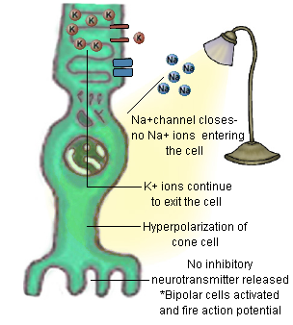
  - Since these cells release an inhibitory neurotransmitter when depolarized in the dark, they inhibit the bipolar cells.
  - When light strikes the photoreceptors, they hyperpolarize, shut off, and stop releasing inhibitory neurotransmitter.
  - The bipolar cells, which can depolarize spontaneously (by themselves), now become activated.
  - Eventually, the depolarization of the bipolar cells may lead to an action potential in the ganglion cells
- How Light is Transformed into Action Potentials
  - In the dark, Na⁺ are flowing into the photoreceptors, producing a depolarization.
  - This leads to the release of the inhibitory neurotransmitter.
  - However, when light strikes the rod and cone cells, it closes these Na⁺ channels.
  - With less Na⁺ coming in and K⁺ leaking out (as they always do in every cell), the cell hyperpolarizes.
  - With the rods and cones hyperpolarized, no inhibitory neurotransmitter is released and the bipolar cell depolarizes.
- Types of Eye Movements
  - In order to be able to focus our attention on a particular object, we must be able to direct our eyes to exactly the correct spot.
  - In this way, the image of interest is focused onto the fovea, which has the highest concentration of cone cells.
  - In order to do this, we must be able to move the eyes in a number of ways, depending on whether the object is stationary or moving.
  - There are four primary eye movements:
      - Saccades are rapid, jerky movements of the eye. Saccades are used to rapidly move the eye to the object of interest
        - ex: gazing around a room while holding your head still or reading these words on your computer
      - Smooth pursuit is a smooth movement of the eyes that is made to keep a moving object of interest focused on the fovea
        - ex: following the flight of a bird through the sky while keeping your head still
      - The vestibular ocular reflex (VOR) is an eye movement made when you focus your attention on an object and then move your head back and forth or shake it up and down
        - Ex: staring at someone with whom you are disagreeing or agreeing.
      - Vergences are eye movements that are made when an object of interest is approaching or moving away from you.
        - When the object is moving away, the eyes diverge;
        - when the object moves closer, the eyes converge
        - ex: staring at a pencil while moving it away from and toward your face

