Nervous System

- Nervous system:
  - Central Nervous system (CNS)
    - Brain
    - Spinal cord
  - Peripheral Nervous System (PNS)
    - Somatomotor = nerves going to skeletal muscles
    - Autonomic= nerves going to other organs
- Facts about the brain
  - The brain contains between 10 billion to 100 billion cells and weights about 1.5 kg (3.5 lbs)
  - If all the cells were laid out end-to-end, they would stretch roughly 1000 km (600 miles)
  - You have more brain cells when you are born than you do right now
  - Action potentials, which are the language of the nervous system, can travel down nerve cells at up to 400 km/hr (240 mph)
- Basic structure of the Brain
  - Brain:
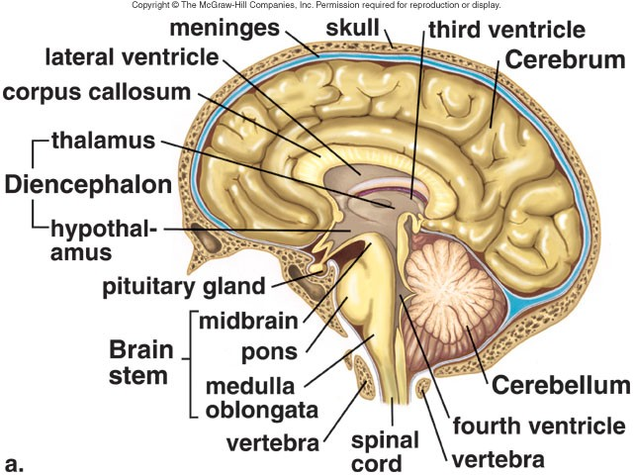
    - Right hemisphere
    - Left hemisphere
      - Left hemisphere sends signals to activate muscles on the right side of the body; similarly, sensory information from the right side of the body travels to the left hemisphere
    - The brain stem: controls some of the most basic functions of the body ex: Heart rate and respiration
      - Midbrain
      - Pons
      - Medulla oblongata
        - Medulla is continuous with the spinal cord
    - Cerebellum:
      - Above the brain stem
      - Coordinated movement
    - Diencephalon:
      - Thalamus
      - Hypothalamus
    - There are many bumps (gyri) and dips (sulci) on the surface of the brain
      - These folds are most prominent in humans and increase the surface area of the brain
      - The locations of the sulci and gyri are quite consistent between individuals (with only minor differences in size and shape)
      - They have specific names
    - Each cerebral hemisphere can be divided up into 4 lobes, which based on these “landmark”
      - Each lobe has very specific function
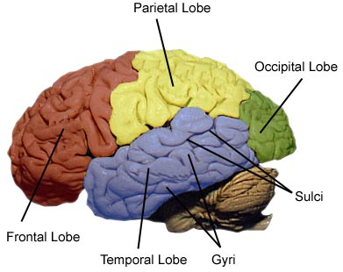
- Functional structure of the brain
  - Lateral:
    - Frontal lobe
    - Temporal lone
    - Parietal obe
    - Occipital lobe
    - Cerebellum
  - Medial
    - Corpus callosum
    - Diencephalon
    - Pituitary gland
    - Midbrain
    - Pons
    - Medulla
    - Cerebellum
  - Ventral
    - Optic nerves
    - Brain stem
    - Cerebellum
  - Dorsal
    - Primary motor cortex
    - Primary somatosensory cortex
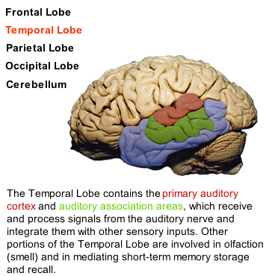
    - Language and mathematical area
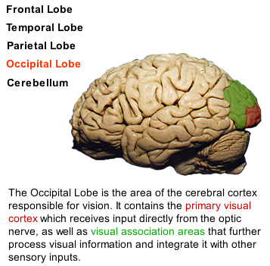
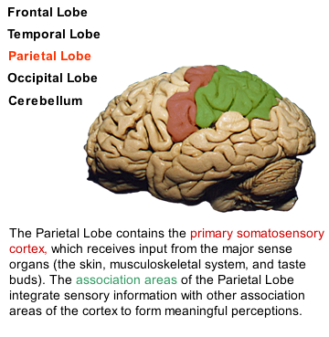
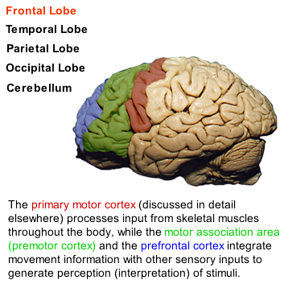

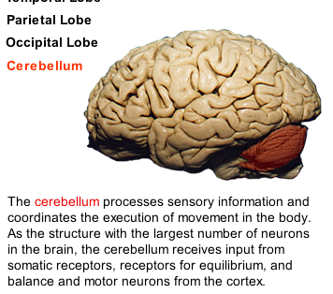

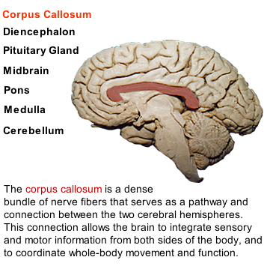
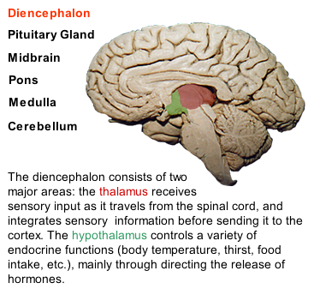

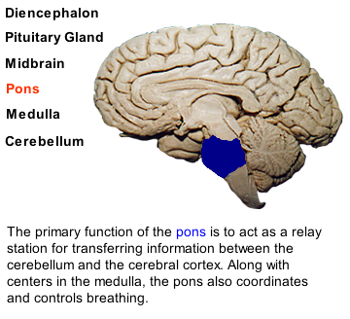
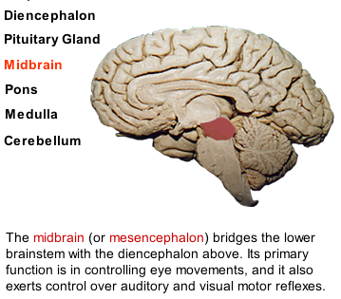

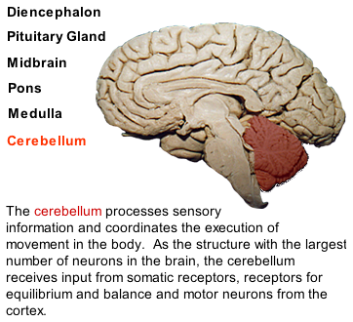
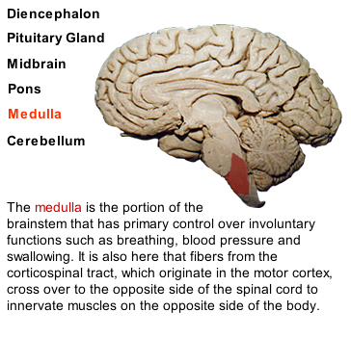
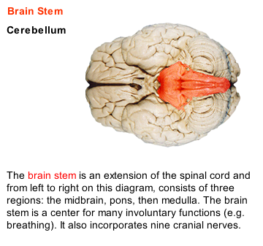
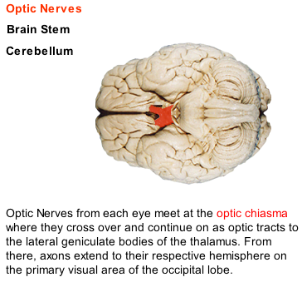

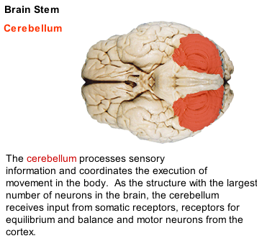

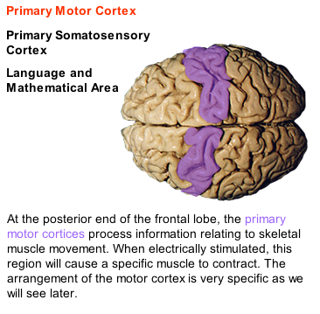
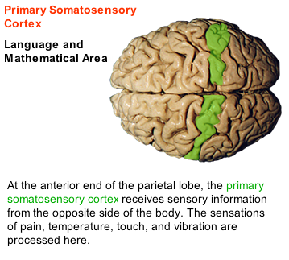

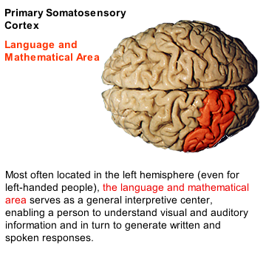

- Neurons and Glial Cells
  - Neurons
    - They are the information transmitting and processing cells of the body, yet they constitute only a small percentage of the entire brain
  - Glial cells
    - Make up about 90% of the brain
    - They provide the necessary environment for the neurons to function properly
  - Neurons:
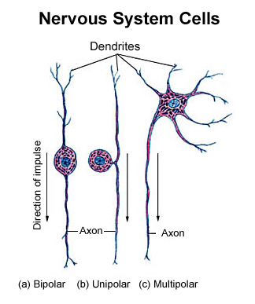
    - Bipolar neurons
      - have two processes extending from the cell body (a form of specialized neurons that can be found in the retina of the eye)
    - Unipolar neurons
      - Have one process extending fro the cell’s body
      - Located in the peripheral nerves outside the CNS and are generally sensory in nature, transmitting signals to and from the spinal cord
      - Their cell body lies in the middle and off to one side of the axon
    - Multipolar neurons
      - Contain many branching dendrites and one axon
      - Are common in the CNS
  - Glial Cells
    - They are the “support” cells of the brain, as they maintain the delicate internal environment of the CNS
    - 5x as many as glial cells as neurons
    - Functions:
      - A structural role (gluing things together)
      - Regulate the nutrients and specific interstitial environment of the brain
        - They regulate by regulating the passage of substances between the blood and the brain’s interstitial space
    - Types:
      - Astrocytes
      - Microglia
      - Oligodendrocytes = produce myelin
- The language of the nervous system and neural coding
  - Information travels down axons in the form of an action potential
  - These action potential are the language of the nervous system
    - Ex: how does your brain know if you have a light object in your hand or a heavy object?
Special receptors detect the pressure on the skin and send action potentials to the brain, the more action potential per second. This is called neural coding
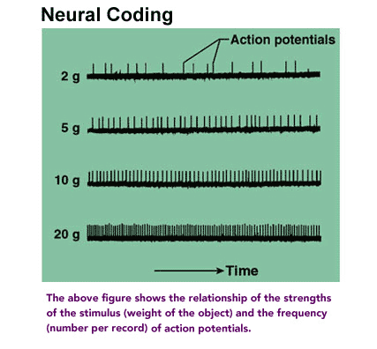
- Synaptic Transmission: the chemical synapse
  - Nerve cells communicate with one another by a chemical synapse
  - At a chemical synapse, a presynaptic nerve will release a chemical called a neurotransmitter that will affect a postsynaptic nerve
- The structure of the chemical synapse
  - The axon terminal of the presynaptic cell containing:
    - Voltage-gated calcium ion (Ca++) channels
    - Synaptic vesicles containing the neurotransmitter
    - Mitochondria
  - Synaptic cleft
  - The postsynaptic cell containing
    - Chemical receptors and
    - Chemically gated ion channels (ligand-gated ion channels)= these open when a chemical (ex: neurotransmitter) attaches to them
- Sequence of events at a chemical synapse:
  - Action potential on presynaptic nerve
  - Action potentials in presynaptic neuron depolarize synaptic terminal
  - Voltage gated Ca++ channel open
  - Ca++ flows into neuron
  - Synaptic vesicles fuse to the wall of synaptic terminal
  - Exocytosis causes the release of neurotransmitter into the synaptic cleft
  - Neurotransmitter diffuses across cleft
  - Neurotransmitter attaches to chemically gated channels
  - Nonspecific ion channels open
  - Lots of Na+ flows in and some K+ flows out
  - The postsynaptic membrane potential changes, causing a depolarization or hyperpolarization depending on the type of neurotransmitter. A depolarization increases the probability of an action potential on the postsynaptic neuron, while a hyperpolarization decreases the likelihood.
- Neurotransmitters
  - Neurotransmitters are chemicals released by neurons at their axon terminals
  - They are synthesized within neurons and are stored in synaptic vesicles to be release when action potential occurs on presynaptic nerve
  - After being released, neurotransmitter diffuses across the synaptic cleft and produces a response in the postsynaptic neuron
  - 2 types of neurotransmitters:
    - Excitatory = leading to a depolarization of the postsynaptic cell
      - If the depolarization is strong enough, it may fire AP
    - Inhibitory= leading to a hyperpolarization of the postsynaptic membrane
      - It makes it harder to generate AP
  - 4 different groups of neurotransmitter (according to their chemical makeup):
    - Acetylcholine
    - Biogenic Amines
      - Catecholamines: dopamine, norepinephrine, epinephrine
    - Amino Acids
      - Excitatory AA: glutamate, aspartate
      - Inhibitory AA: GABA – gamma-amino-butyric acid, glycine
    - Neuropeptides
      - Endogenous opioids: endorphin
      - Vasoactive intestinal peptide (VIP)
  - Difference between NMJ and chemical synapse:
    - They are similar in structure and functions
    - At neuromuscular junction (NMJ), a single AP in the motor neuron produced a single AP in the muscle cell, causing the muscle to contract
    - At chemical synapse, a single AP on a presynaptic neuron will not produce AP on a postsynaptic neuron
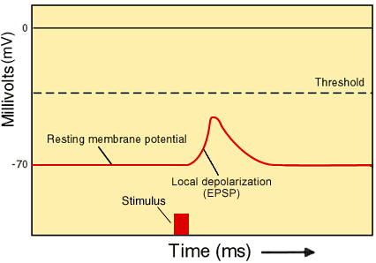
- Ionic basis of the postsynaptic potentials – EPSPs and IPSPs
  - An excitatory NT will cause the opening of chemically gated channels
    - These gates are selective for only positive ions and will allow the influx of Na+ into the cell
    - This will cause a local depolarization of the membrane called EPSP (excitatory postsynaptic potential)
    - EPSP is a very local event that diminished with time and distance from its point of origin (a graded potential)
  - The influx of NA+ will depolarize the region of the dendrite, but it will not fire an AP because there are no voltage-gated channels on the dendrite or cell body of the neurons
    - Voltage-gated channels are essential for the production of an AP, and the AP begins at the axon hillock where there is the highest concentration of voltage-gated channels
    - Thus, to generate AP, EPSP must depolarize the axon hillock.
- EPSPs
  - EPSP gets smaller with distance it has to travel. Therefore, in order to cause a sufficient depolarization to open the voltage-gated sodium channels located at the axon hillock, the positive current of EPSP must be strong enough to spread all the way from the synapse where it originated to the axon hillock.
  - Now you have an action potential (AP)
- Spatial and Temporal summation of Synaptic potentials
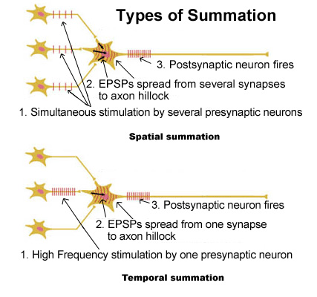
  - The strength of an EPSP can be increased in 2 ways:
    - Spatial summation of EPSPs
      - It is the additive effect produced by many EPSPs that have been generated at many different synapses on the same postsynaptic neuron at the same time
    - Temporal summation of EPSPs
      - It is the additive effect produced by many EPSPs that have been generated at the same synapse by a series of high-frequency APs on the presynaptic neuron
  - Difference between EPSP and AP
    - EPSP = occurs only on the dendrites and cell body, will decrease with time and distance from its point of origin
    - AP = all-or-nothing and is usually only found on the axon
    - EPSPs can be added one on top of the other, while AP cannot
- Spatial summation
  - Since each postsynaptic neuron can receive thousands of synapses from other nerve cells, many EPSPs occurring simultaneously at many different synapses can be added together to produce a large depolarization.
  - When this depolarization reaches the axon hillock, it will open a sufficient number of voltage-gated channels to reach threshold and to fire the AP
- Temporal summation
  - It is the summing of a series of consecutive EPSPs that were generated by a set of high-frequency AP at the same synapse over a short period of time
  - When this depolarization reaches the axon hillock, it will open a sufficient number of voltage-gated channels to reach threshold and to fire the AP
- Inhibitory postsynaptic potential – IPSPs
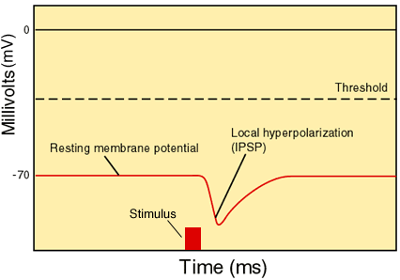
  - Inhibitory neurotransmitters produce a hyperpolarization by opening different chemically gated channels
  - These channels will either let Cl- into the cells (adding negative charge) or let K+ out (removing positive charge).
  - The overall effect is the same – that is to make the membrane potential more negative, creating a hyperpolarization.
  - This local hyperpolarization is called an inhibitory postsynaptic potential (IPSP).
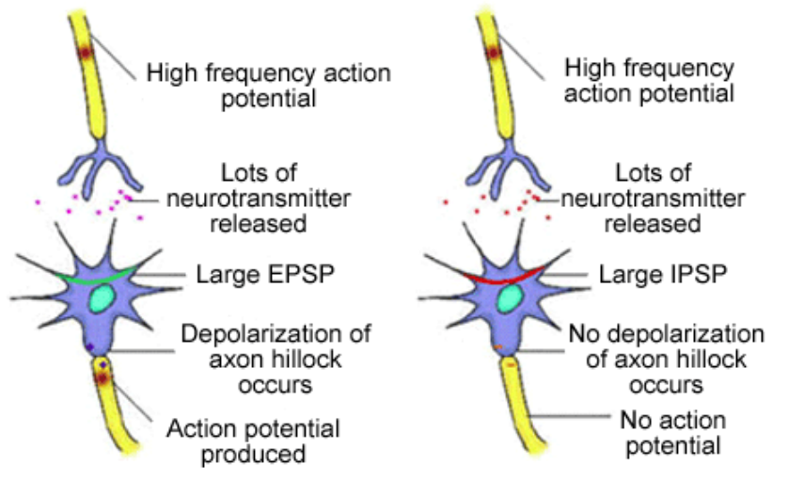
  - The hyperpolarization will move the membrane potential further away from threshold, making it less likely to fire an AP; this will shut off the nerve cell
Spatial and temporal summation can occur with IPSPs as well as EPSPs.
Rather than producing stronger depolarization, however, summation of IPSPs will produce larger hyperpolarization (no depolarization of axon hillock and no AP)
- EPSPs and IPSPs – Synaptic integration
  - Any single postsynaptic nerve cell can receive hundreds of thousands of synapses.
  - Some of these can produce EPSPs and some can produce IPSPs. Therefore, this postsynaptic cell could have EPSPs and IPSPs occurring at the same time.
  - Whether the cell depolarizes and fire AP or hyperpolarize and shut off, it depends on the number of each postsynaptic potential.
    - The cell may fire AP if there are many more EPSPs than IPSPs
    - But if the number of IPSPs outnumbers the EPSPs, the cell will be shut off
    - The “battle” of postsynaptic potential is called synaptic integration.
- QUICK REVIEW
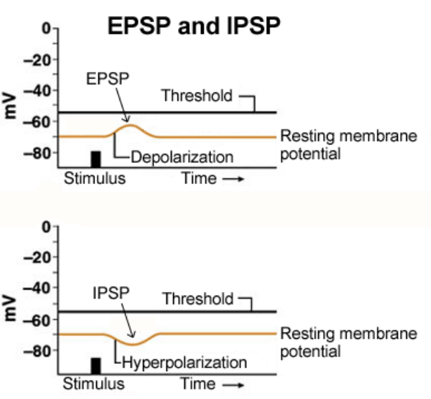
  - APs are the language of the nervous system.
  - They are generated at the axon hillock of a cell by a strong depolarization that opens voltage-gated channels.
  - Once initiated, they travel along the axon and reach the axon terminal
  - Here, the AP triggers the influx of Ca++ into the cell, which in turn, cause the release of a neurotransmitter from synaptic vesicles.
  - An excitatory NT will open Na+ channels, causing a depolarization of the postsynaptic membrane called an EPSP
  - An inhibitory NT will hyperpolarize the cell, producing an inhibitory postsynaptic potential (IPSP)
  - Both EPSP and IPSP can occur on the same neuron and can be spatially and temporally summed
  - Synaptic integration is the interaction of many IPSP and EPSP.
  - Summation of many EPSP is essential for the production of AP at the axon hillock of the post synaptic cell
  - EPSP and IPSP will both decrease in size with time and distance from the point of production. They produce neurotransmitter
- The somatic motor system: basic structure and organization
  - Motor system includes:
    - the supplementary motor area,
    - the premotor area and
    - the primary motor cortex area
    - also, basal ganglia, various spinal pathways, the motor nerves going to the muscles and muscle receptors
  - The premotor cortex
    - Ex: if you want to get a glass of water in front of you,
First thought would be deciding to pick up the glass, which comes from prefrontal cortex.
From there, signals pass to the premotor cortex located in the front lobe, which develops the appropriate strategy for the movements necessary to pick up the cup.
For example, the arm must be extended first before the hand closes around the handle; the other way around (closing the hand then extending the arm) would not work.
    - When people with damage to the premotor cortex were presented with food inside a glass box with a small opening in the side, they did not reach through the opening but aimed directly at the food, bumping their hand into the shield. They were not able to "select" the appropriate strategy to reach the food.
- Structure and Organization of the Motor System—The Supplementary Motor Cortex
  - Now that the premotor cortex has developed the appropriate sequence of muscle contractions, that information travels to the supplementary cortex (also located in the frontal lobe) to program the motor sequences necessary to pick up the cup of coffee.
  - This area is particularly important when it comes to programming the muscles to open and close the hand and for repetitious movements like typing, since these can be quite complex movements.
  - The more complex or repetitious the movement, the more the supplementary motor area is needed.
  - When people with lesions (damage) to the supplementary cortex try to pick up a peanut in a small well, the hand assumes an awkward position as it reaches for the peanut. They are unable to orient their hands and digits appropriately.
- Structure and Organization of the Motor System—The Primary Motor Cortex
  - The program has now been "written" and is sent to the primary motor cortex to activate the neurons that will eventually activate the appropriate muscles.
  - The primary motor cortex is located on the precentral gyrus in the frontal lobe and is arranged in a very specific manner.
  - It is as if the entire body was projected onto the surface of the brain like a map.
  - This topographical representation of the body on the surface of the cortex is called the motor homunculus. A specific area of the motor cortex activates a particular muscle.
  - Moving from medial (midline) to lateral, the arrangement is as follows: foot, ankle, knee, thigh, trunk, shoulder, elbow, wrist, hand, lots of room for fingers, face, lips, jaw, and tongue. Signals from the primary motor cortex will travel down to the spinal cord through the corticospinal tract
- Corticospinal Tract
  - The corticospinal tract is the major motor pathway from the primary motor cortex to the motor neurons that innervate the muscle cells.
  - This tract is made up of millions of axons whose cell bodies lie in the primary motor cortex.
  - The tract begins in the motor cortex and descends down to the brain stem.
  - In the medulla, 80% of all the nerve fibers cross to the contralateral side of the body while 20% remain on the same or ipsilateral side.
  - From the brain stem, the fibers enter the spinal cord and continue their descent.
  - Once they reach the level of the spinal cord where they synapse with the motor neurons, the fibers previously on the ipsilateral side cross to the contralateral side.
  - At this point, the neurons of the cortical spinal tract synapse with the motor neurons, which will directly innervate the muscle.
  - Those nerves that activate the muscles in the arm or upper body will end in the upper spinal cord. Those neurons that activate muscles in the legs and lower body will travel to and end in the lower spinal cord.
- Muscle Receptors
  - You should now have a good understanding of how the central nervous system stimulates muscle to contract. But, this is not enough to generate an accurate movement of the limbs. As we will see, it is important for the brain to be aware of the positions of the limbs and the extent of each muscle contraction at all times. This "muscle sense" is called proprioception.
  - A perfect example of this is the ability to touch your two index fingers together while your eyes are closed and your arms are extended in front of you.
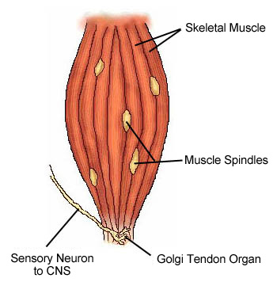
  - In fact, almost all muscle movements are made without consciously following them with your eyes to make sure they are being performed accurately.
  - This ability is possible because of the presence of special receptors in the muscle, which send signals back to the brain. These receptors include the following:
- Muscle spindles, which detect muscle stretch, muscle length, and the rate of change of the muscle length
- Golgi tendon organs, which detect muscle tension
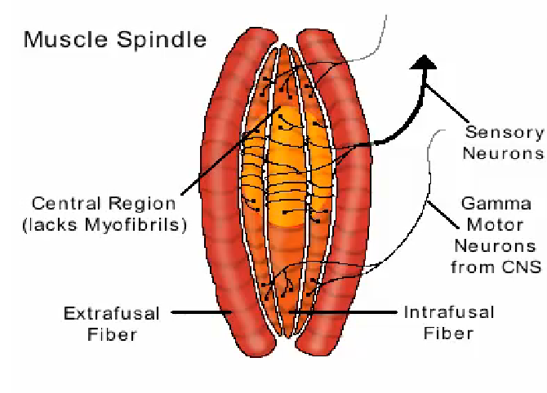
- Muscle Spindles
  - Inside a whole muscle and adjacent to the real contractile muscle cells (called extrafusal fibers here) are sensory organs called muscle spindles.
  - These spindles sense the length and stretch of the muscle.
  - The muscle spindle consists of a series of
    - intrafusal muscle fibers,
    - a central sensory region,
    - two sets of gamma motor neurons that activate the intrafusal fibers, and
    - a sensory neuron that originates in the sensory region.
  - When the whole muscle stretches, the sensory region of the spindles also stretches.
  - This sensory region, which is sensitive to changes in shape, depolarizes and triggers action potentials in the sensory nerve, sending signals back to the brain.
  - The more stretched the muscle, the more stretched the sensory region, the more it is depolarized, and the more action potentials sent back to the CNS.
  - The brain receives this information and can interpret how stretched the muscle is. Since the muscle is attached to a limb, it will also "know" the position of the limb in space. This is proprioception.
- Alpha-Gamma Coactivation
  - Signals sent to a whole muscle (like the biceps) causing it to contract, travel from the spinal cord through alpha motor neurons.
  - When this occurs, only extrafusal muscle fibers would contract.
  - Meanwhile, the intrafusal muscle fibers within the muscle spindles would go slack and information from the muscle spindle would stop.
  - To keep muscle spindles operating (in their sensitive range) during a muscle contraction, commands are simultaneously sent through gamma motorneurons to the intrafusal fibers.
  - This causes the contraction of the intrafusal fibers, which maintains stretch on the central region (where the stretch receptors are located) at the same rate as the whole muscle.
  - Therefore, during a muscle contraction, alpha-gamma coactivation ensures that the muscle spindles continue to send information to the brain about muscle and limb position.
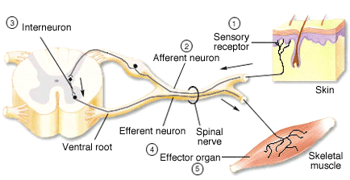
- The Reflex Arc
  - A reflex arc is the most basic type of integrated neural activity.
  - It requires a sensory receptor, a sensory (or afferent) neuron, one or more synapses (generally in the spinal cord), and may contain one or more interneurons.
It also contains a motor (or efferent) neuron, and an effector organ (like muscle).
  - The activity in a reflex arc begins in the receptor with a receptor potential that produces an action potential in the afferent neuron.
  - The action potential enters the spinal cord where it will produce action potentials on the interneurons and, eventually, on the efferent neuron.
  - The efferent neuron will activate an effector (in our example at right, a muscle).
  - Note: A reflex arc does not require any output by the brain to cause the muscle (effector) to contract.
- Stretch Reflex
  - The stretch reflex is one example of a reflex arc.
This is the one you experience when you visit the doctor for a checkup.
  - In the example at right, we are looking at the stretch reflex in the quadriceps muscle, but this reflex can be found in all muscles.
  - The sequence of events is as follows:
    - Hammer strikes knee quadriceps muscle stretches muscle spindles activated muscle spindle trigger AP in afferent neuron to travel to spinal cord activation of motor nerve to quadriceps muscle inhibition of motor nerve to hamstring muscle quadriceps muscle contracts hamstring relaxes lower leg kicks out
  - Again, in this simple reflex the brain is not involved with the contraction of the muscles.
- Cerebellum
  - Cerebellum means "little brain," which is only partly accurate.
  - The cerebellum, although much smaller, actually contains more neurons than the rest of the brain combined.
  - Its functions include contributing to
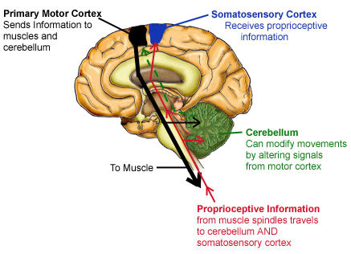
    - the generation of accurate limb movements,
    - correcting ongoing movements, and
    - modifying the strength of some reflexes.
    - involved with classical Pavlovian conditioning, the learning of new muscle movements, and the vestibular occular reflex (VOR)—one of our important eye movements (after viewing this link, right mouse click and click on back to return to original screen.)
  - Let's have a look at how the cerebellum generates accurate movements and corrects ongoing ones.
  - In order for the cerebellum to assist in making accurate limb movements and correcting ongoing movement, it must receive information from two different sources:
    - it must receive the same information from the motor cortex that is traveling out to the muscles being activated and
    - it must receive information dealing with the position of the limbs in space (proprioception).
  - The cerebellum compares the actual signal from the brain with the proprioceptive information from the muscle itself.
  - As a result, it can make sure that the muscle is actually doing what it's supposed to do.
  - If the movement is not what it should be, the cerebellum will modify the signals from the primary motor cortex.
- The Limbic System and the Hypothalamus
  - Stimulation of the hypothalamus and limbic system may elicit rather normal looking behaviors, among which are eating, drinking, locomotion, autonomic responses (including changes to heart rate and blood pressure), attack responses, sexual behaviors, and memory.
  - Both of these regions together coordinate a variety of autonomic, hormonal, and motor effects associated with constant maintenance of the internal environment and coordinating emotional behaviors.
- Limbic System
  - The limbic system is composed of the hypothalamus, amygdala, hippocampus, as well as the cingulate cortex, and septum.
  - Most of these structures are found deep within the brain and form a ring around the brain stem.
  - The key function of the limbic system is to link the higher thought processes of the brain with the more primitive emotional responses of fear, rage, and sexual pleasure.
  - It is also involved with behaviors dealing with feeding, drinking, pain, motivation, and learning.
  - Overall, the limbic system allows us to respond correctly to changes in our environment.
- The Hypothalamus
  - The hypothalamus is located at the base of the brain just anterior to the brain stem.
  - Although it constitutes a relatively small portion of the brain, it is responsible for many important functions.
  - Its major functions include
    - temperature control, body water regulation, regulation of food intake, cardiovascular regulation, regulation of the circadian clock, coordination of emotional behaviors, and control of hormones released from the anterior and posterior pituitary gland.
  - The hypothalamus performs most of these functions through negative feedback control.
  - An example of hypothalamic function is the control of body temperature.
    - If the body temperature (set at 37°C, or 98.6°F) were to rise to 39°C (or 102.2°F), regions in the hypothalamus would detect this change and initiate mechanisms to return the temperature to normal.
    - These mechanisms include diverting blood to the skin and sweating, both of which would lead to cooling of the skin and returning the body temperature back to normal
- The Pituitary Gland
  - In humans, it is roughly the size of a large pea and hangs below the hypothalamus.
  - It is very important in the control and release of hormones and is closely regulated by the hypothalamus.
- The Autonomic Nervous System
  - The autonomic nervous system (ANS), unlike the somatomotor system, is not under voluntary control.
  - The ANS can be considered an "automatic" system.
  - The ANS controls heart rate, the pupils in the eye, smooth muscle in the walls of arteries and veins, glands like the adrenals, and many other organs.
  - The two divisions of the ANS—the sympathetic (SYN) and parasympathetic (PSYN) nervous systems
  - The SYN is responsible for activating body functions involved in fight or flight situations.
    - These situations could include being chased by a dog or even preparing for a big, competitive game.
    - When activated, it will increase your heart rate and blood pressure, dilate your airways (bronchodilation) and blood vessels to the muscles, dilate pupil of the eye and shut down your digestive system.
  - The PSYN, on the other hand, is responsible for storage and conservation of energy—functions associated with rest and relaxation.
    - This system would slow the heart rate and lower blood pressure.
- Pathways of the Autonomic Nervous System
  - SYN and PSYN sends neurons to organs (except the adrenal, which receives input from only the SYN).
    - One division of the ANS will excite the organ while the other will inhibit it.
  - Nerves of the SYN exit the spinal cord in the thoracic and lumbar (central) regions of the cord.
    - These preganglionic neurons will synapse in ganglia onto a second postganglionic nerve that will travel to the effector/target organ of interest.
  - Nerves of the PSYN exit at the brain stem and the very lower sacral region of the spinal cord.
    - These preganglionic nerves will synapse onto a postganglionic nerve very near the effector organ of interest.
    - This nerve will then synapse onto the target organ.
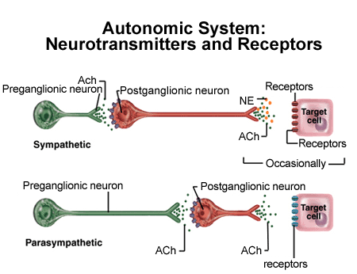
- Neurotransmitters of the ANS
  - The preganglionic neurons that leave the spinal cord in both the SYN and PSYN release the neurotransmitter acetylcholine (ACh).
    - The axons of the PSYN preganglionic fibers are longer since the synapse occurs closer to the effector organ.
    - The ACh will then stimulate the second postganglionic neuron.
  - The neurotransmitter released by the sympathetic postganglionic neuron onto the target organ is usually norepinephrine (NE), but in some cases it is ACh.
    - The neurotransmitter released by the parasympathetic postganglionic neuron is always ACh.
- REVIEW:
  - Different types of potentials, so far:
    - resting membrane potentials are found on all excitable cells
    - equilibrium potentials for each ion (Na, K, Cl) of a resting nerve cell
    - AP occur on the axon of all nerve cells and over muscle cell membranes
    - EPSPs and IPSPs occur on the dendrites of neurons in the CNS

