Lecture 1: January 13, 2012
Forward Genetics versus Reverse Genetics
- Forward genetics: looking at the phenotype (appearance) of the individual and then go looking for the genes that cause it. We look at different phenotypes either occurring naturally or we make them by induced mutations and then sequence the genes to see how they changed.
- Reverse genetics: you have the sequence of the gene BUT, you don't know what that gene does. So you make changes (mutations) in the sequence and then look to see what the appearance (phenotype) of the organism is.
- Simply put, while forward genetics seeks to find the genetic basis of a phenotype or trait, reverse genetics seeks to find what phenotypes arise as a result of particular genes.

Genetics as an Investigative tool
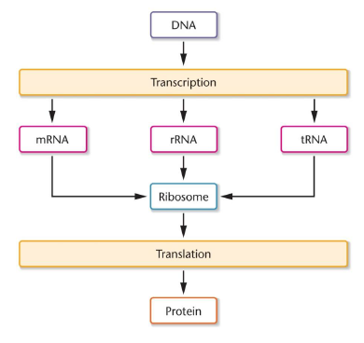
- Everything that is done in genetics will be based on this diagram (central dogma)
- Central Dogma of genetics: DNA is transcribed into mRNA, mRNA is then translated into a protein (see diagram)

How can we use that diagram?
- many different steps to protein production and each of those steps can be used to measure something (for example isolate the DNA and measure it)
- every single step allows us to get into the system and play around with it to see how the system might change
- All these steps let us muck around and see and learn about the system via inhibition and translation splicing, ext.
- We can inhibit or cause mutations..ext. to test or measure it
- We change gene expression!
- If protein changes, it can be detected
- Missing on the diagram is meiosis
- we also look at how the role of meioses has a role on genetics (how it may impact how genes are inherited)

Characteristics of Genetic Material
- DNA is a deoxyribonucleic acid
- RNA is a ribonucleic acid
- DNA is composed of a sugar phosphate backbone and phosphodiester bonds exist between phosphate of one nucleotide and hydroxyl group of another
- Genetics used as research investigative tools.
4 main characteristics of DNA:

- stores information
  - DNA is informational macromolecules used to store hereditary information
  - We know that this information has to be transmitted to next generation
  - DNA is a large sink for information that codes for proteins and other genetic markers
- Replication
  - DNA is replicated, it makes a copy of it to transmit it to next generation
  - meiosis+ mitosis
- Expression of Information
  - made into protein
- Variation by mutation
  - Mutations in the replication of DNA, transcription of mRNA or translation of proteins leads to diversity
  - Variation in population by mutation allows organisms to adapt to different environments.

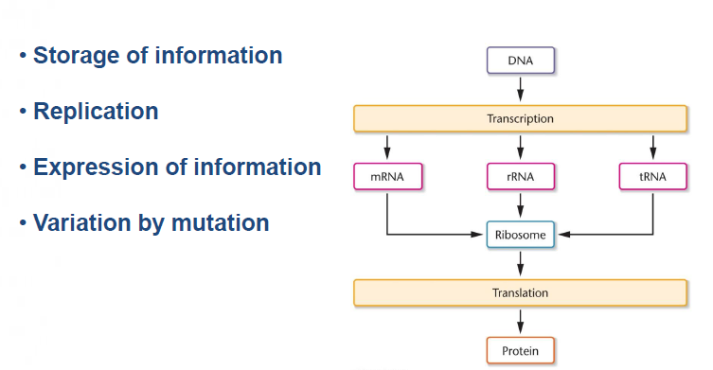
Historical Perspectives
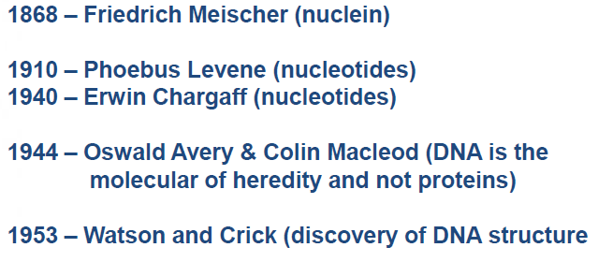
- These people are responsible for telling us what the building blocks for DNA are
  - Friedrich Meischer: Meischer was able to isolate a new molecule known as nuclein from the cell nucleus. He was isolating what he thought was the material that was inherited during fertilization and he found out it was acidic. He had obtained the first purification of DNA
  - Levene and Chargaff: broke down nucleotides and characterized the 4 bases: A,T,G,C. Leven believed that these bases were in equal proportion and Chargaff proved that they were not.
  - Avery and Macleod: question what material is inherited some believed it was protein, they proved that the hereditary material is DNA
  - Watson and Crick: came up with the structure of DNA as a double helix structure using the work of other scientists.

Nucleotides: Building Blocks of Nucleic Acids
- DNA is a polymer compromised of a chain of nucleotides joined together by phosphodiester bonds.
- Phosphodiester bonds: bonds between phosphate of one nucleotide and hydroxyl group of another
- This polymer of nucleotides is also known as nucleic acid.
- Each nucleotide consists of a sugar (five-carbon cyclic ring structure), a phosphate group that is negatively charged, and a nitrogenous base.

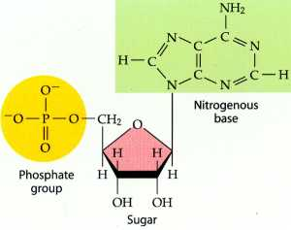

Pentose Sugar
- In DNA the sugar is deoxyribose
  - In the five carbon deoxyribose sugar, the first four of the five carbon atoms, together with an oxygen atom, form a five-membered ring. The fifth carbon atom extends out from the ring. The carbon atoms are numbered clockwise, starting with the carbon atom to the immediate right of the oxygen atom. This first carbon atom is designated as 1' (1 prime), followed by 2' (2 prime), and so on.
  - A deoxyribose sugar has a hydroxyl group (OH) on the 3' carbon, and a hydrogen atom (H) on the 2' carbon.
  - Deoxyribose sugar has lost the hydroxyl group (OH) in its 2' carbon (missing O=deoxy)
- In RNA the sugar is ribose
  - A ribose sugar has a hydroxyl group (OH) on the 3' carbon, and a hydroxyl group (OH) on the 2' carbon.
  - Unlike deoxyribose it contains a hydroxyl group (OH) on its 2' carbon.
- The nitrogenous base is attached to the 1' carbon of the sugar by a glycosyl bond
- The phosphate group is attached to the 5' carbon by an ester bond

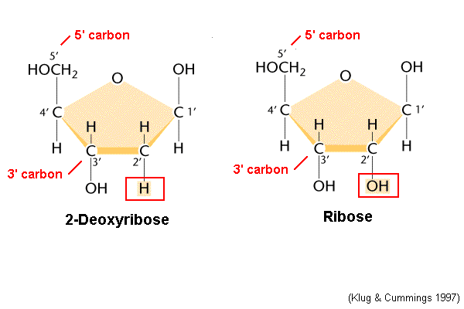
Nitrogenous base
- The source of variation in DNA is found in the nitrogenous bases.
- Four nitrogenous bases exist in DNA: Adenine (A), Thymine (T), Guanine (G) and Cytosine (C)
- In RNA Uracil (U) replaces thymine
- Purines: double ringed structures includes Adenine, Guanine (Pneumonic AG= Silver periodic table= Silver is PURE)
- Pyramidine: single-ringed structures includes Cytosine, Thymine, Uracil (Pneumonic TUC = King TUT = PYRAMID)
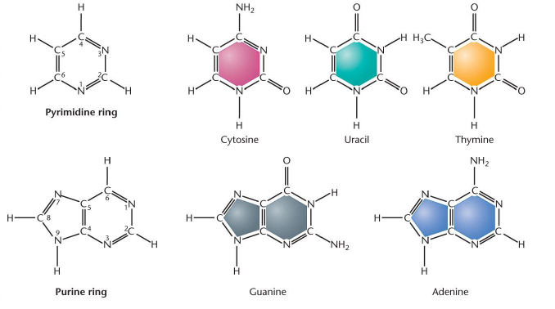
Nucleosides versus Nucleotides
- Nucleotide: nitrogenous base + 5 carbon sugar + phosphate group
- Nucleoside: 5 carbon sugar + nitrogenous base
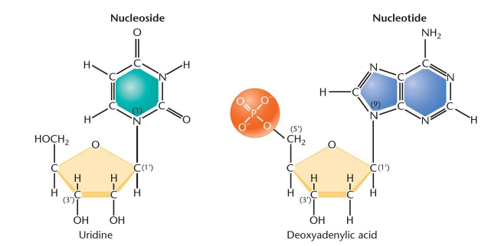
- Naming depends on the nitrogenous base present, whether the pentose sugar is deoxyribose or ribose and whether a phosphate group is present or not:
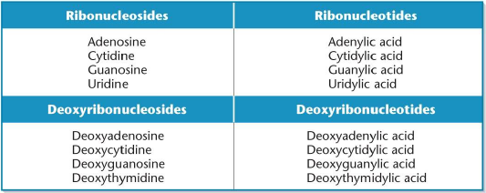
Nucleoside Diphosphate and Triphosphate
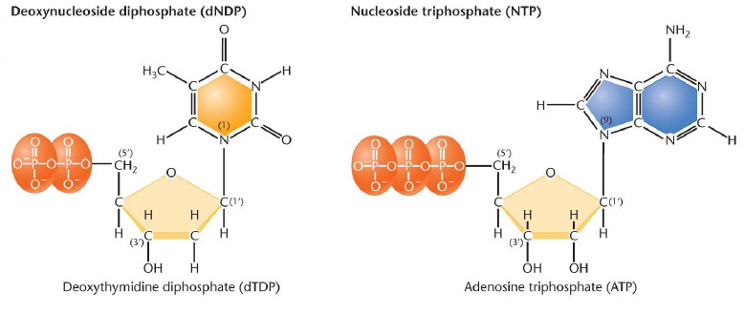
- These are the same thing as a nucleotides since is contains phosphorus but we name as nucleoside
- NDP (2 phosphate groups)
- NTP (3 phosphate groups)
- dNDP/dNTP =deoxynucleoside
- Example: adenine+ ribose sugar+ two phosphate groups= adenosine diphosphate

Polynucleotide
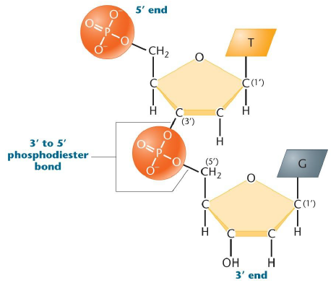

- Polynucleotide=chain of nucleotide bound by phosphodiester bonds
- The phosphate group is attached to the 5' carbon by an ester bond which binds to the hydroxyl group on the 3'end
- bounded from 3' end to 5' end by phosphodiester bond; we are always adding the molecule to the 3' end, this helps track them
- in every position of the molecule, anything can be anywhere

Polynucleotides
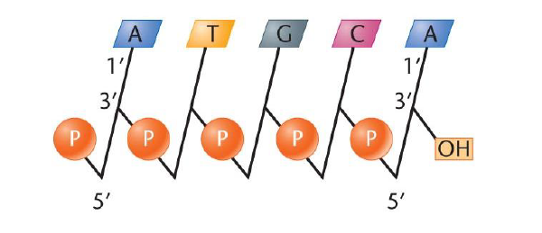
- Storage of information: extraordinary variation is possible.
- For example, a 1000 polynucleotide chain can be arranged 4¹⁰⁰⁰ different ways, each one different from all other possible sequences.
- This great variance is due to the 4 nucleotide bases (A,T,G,C) that can be arranged in any order in a sequence

Basic Composition Studies
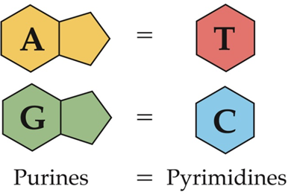

- Chargaff discovered the tendency that A-T are in the same proportion and C-G is in the same proportion
- This means that the nucleotides are paired A-T and C-G
- Chargaff's rule also says that the number of purines (AG) is equal to the number of pyramidines
  - For example: A=30%, T=30%, C=20%, G=20%
  - The proportion of A-T is the same
  - The proportion of C-G is the same
  - Purines (A,G)= 50% and pyramidines (T,C)= 50%

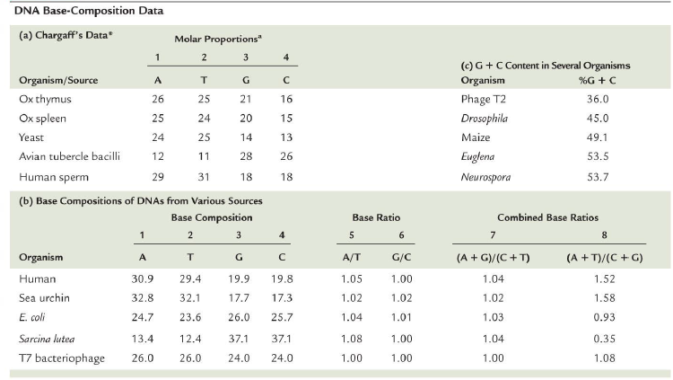

DNA structure: Watson and Crick Model
- DNA is double stranded, two coiled chains around a central axis
- the nucleotide chains are antiparallel: one nucleotide chain runs from 5' to 3' direction and the other from 3' to 5'.
- The 3' end terminates in a hydroxyl group and 5'end ends with a phosphate group
- Nucleotide pairings exist between the two chains A-T and C-G known as complementary base pairing and they face inward towards each other and are perpendicular to the axis
- if you know the sequence on one strand, you also know the sequence on the complementary strand
  - A-T and C-G are not always together, mutation can result in different pairings which can be positive or negative.
- DNA double helix turns clockwise and thus is right-handed
- and makes one complete turn every 10 nucleotides. There is a distance of 3.4-nm for one complete turn.
- 0.34 nm represents the distance between adjacent base pairs.

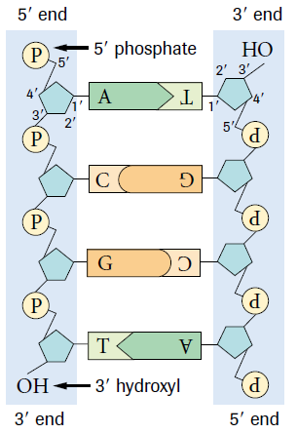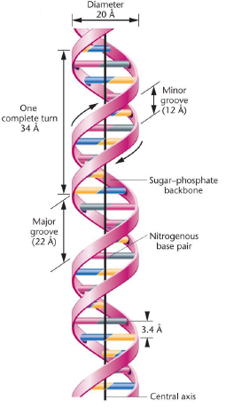

Nucleotide Bonding

- bases offer hydrogen bonds in order for the nucleotide chains to pair together
- these bonds are weak but if there is thousands of them, then the structure is strong and solid
- there are three hydrogen bonds between C-G
- there are two hydrogen bonds between A-T
- nucleotides are bonded with the power of hydrogen bonding, the different numbers of hydrogen bonds means that there are different melting points.

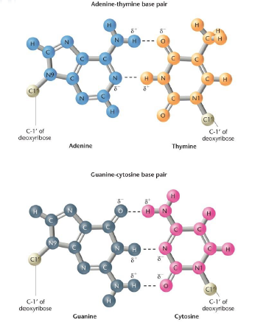

Denaturation and Renaturation of Nucleic Acids

- two curves, red curve shows a melting point at 77ºC and green curve shows a higher melting point of 83ºC
- these melting points meant that half of the sample was dissociated
- Green curve there are greater C-G bonds because there is higher melting point harder to break three hydrogen bonds than two

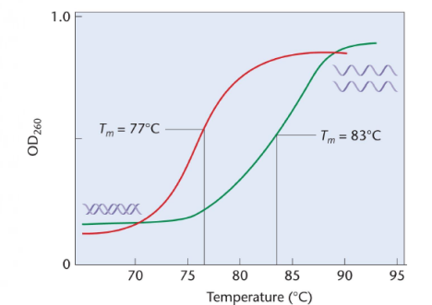

RNA structure is chemically similar to DNA but single stranded

Difference between DNA and RNA
DNA | RNA
Deoxyribose sugar (No oxygen on carbon 2') | Ribose sugar (Hydroxyl group on carbon 2')
Double stranded | Single stranded
Contains thymine instead of uracil | Contains uracil instead of thymine

RNA Molecules
- RNA molecules all originate as complimentary copied one of the two strands of DNA segments during transcription
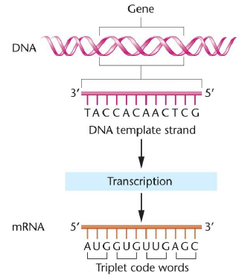
- Examples of RNA molecules:
  - messanger RNA (mRNA)
  - transfer RNA (tRNA)
  - ribosomal RNA (rRNA)
  - small nucleur RNA (sRNA)
  - short interfereing RNA (siRNA)
  - microRNA (miRNA)

Transfer RNA (tRNA)
- single stranded
- Folds back onto itself to form double-stranded regions of complementary base pairings due to hydrogen bonding
- tRNA carries amino acids to the rRNA (ribosomal RNA) during translation (synthesis of proteins from mRNA, messanger RNA).
- The amino acid is bound to the tRNA at 3' end (acceptor site)
- anticodon is the region where tRNA bonds to mRNA
  - If mRNA, read in pair of three is UTU, then the tRNA with anticodon AUA, binds to the strand and drops off the amino acid tyrosine
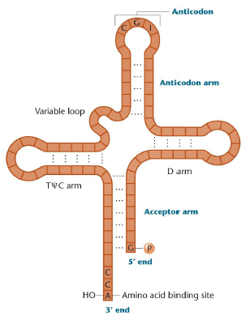
Ribosomal RNA (rRNA)
- single stranded
- part of ribosomes involved in translation of mRNA into proteins
- 80% of all RNA
- important structure of ribosomes
- various forms of rRNA found in prokaryotes and eukaryotes differ distinctly in size
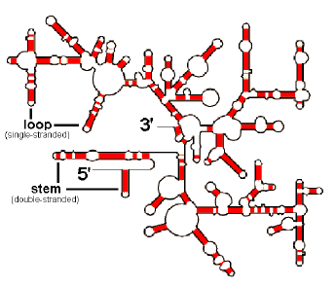

Variations in the Organization of DNA
- viral DNA
  - chromosomes of viruses consist of a nucleic acid molecule either RNA or DNA
  - can be single stranded or double stranded
  - can exist as circular structure or can take form of linear molecules
- bacterial DNA
  - always consist of double stranded DNA molecule circular and double stranded DNA
  - chromosomes + plasmids (extra DNA sequence that can be acquired from another bacteria, carried into the cell, offers organism resistant to drugs, genes to adapt in environments)



