Chapter 1
Characteristics of accounting:
  - Identification, measurement, and communication of financial information about
  - Economic entities to
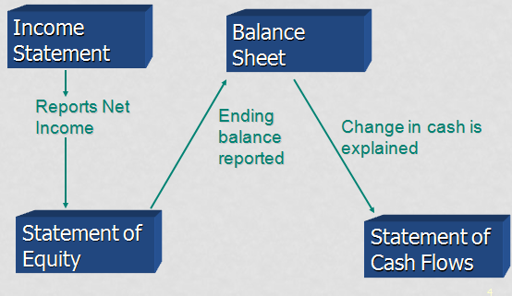
  - Interested persons.

2 classifications: Financial and Managerial

Key stakeholders include:
- investors, creditors, auditors, regulators, analysts, management, standard setters, and others

The Standard Setting Process in Canada – Parties Involved
- Canadian Accounting Standards Board (AcSB)
  - Sets GAAP
  - Responsive to the need and view points of the entire economic community
  - Operates in full public view through due process
- International Accounting Standards Board (IASB)
  - Major international standard setting body
  - Mission “to develop, in the public interest, a single set of high quality, understandable and international reporting standards (IFRSs) for general purpose financial statements
- Provincial Securities Commission(e.g. Ontario Securities Commission)
  - To oversee and monitor capital marketplace
  - Ensure strict adherence to securities law/legislation
- Financial Accounting Standards Board (FASB) and the Securities and Exchange Commission (SEC)
  - FASB is the major standard setting body in the U.S.
  - SEC has the final authority over accounting standards in the U.S
GAAP
- For Not For Profit, private and pensions plans
- CICA handbook 1400-3870

Chapter 2
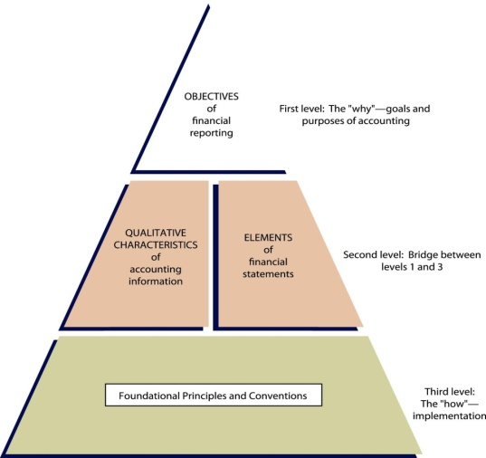
Objective: provide useful info to users, and info that is decision relevant
Qualitative carac.:
Fundamental
- Relevance (makes a difference, predictive/feedback)
- Representational faithfulness (complete, neutral, bias free)
Enhanced
- Comparability
- Verifiability
- Timeliness
- Understandability
Trade-Offs
  - One qualitative characteristics may be sacrificed for another
Constraints
  - Materiality
  - Ability to influence the judgement of a reasonable person
    - Guidelines are usually based on income from continuing operations, assets and liabilities, or revenues
  - Cost versus Benefits
    - Benefits of using the information should outweigh the costs of providing that information
Recognition/Derecognition
Control
- Important factor in determining entities to be consolidated and included in the economic entity
- Some concepts of control include:
  - Having power to direct entity’s activities
  - Not sharing this power
  - Power doesn’t need to be absolute, or even exercised
  - Access to benefits
Revenue Recognition Principle
- Revenue is recognized when
    - Risks and rewards have passed or the earnings process is substantially complete
    - Measurability is reasonably certain and
    - Collectability is reasonably assured
Matching
  - Expenses are matched with revenues that they produce
Measurement
- Historical Cost Principle
  - Represents a value at a point in time (generally fair value at transaction date)
  - Results from a reciprocal exchange
  - Exchange includes an outside party
- Fair Value Principle
  - “the price that would be received to sell an asset or paid to transfer a liability in an orderly transaction between market participants at the measurement date”
Presentation and disclosures
- Anything that is relevant to users’ decisions should be included in financial statements
- Disclosure may be made:
  - Within the main body of the financial statements
  - As notes to the financial statements
  - As supplementary information, including Management Discussion and Analysis (MD&A)

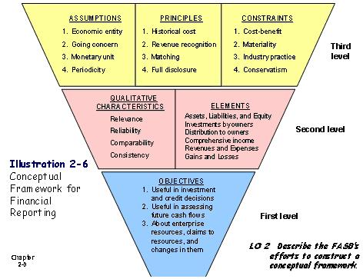

CHAPTER 3: THE ACCOUNTING INFORMATION SYSTEM
Basic Terminology
- Event: The cause of changes of assets, liabilities, and equity
- Transaction: A transfer or exchange between two or more entities or parties
- Account: Where transactions are recorded
  - A separate account is used for each asset, liability, revenue, expense, gain, loss and capital (owner’s equity)
- Permanent accounts (or “real” accounts)
  - Asset, liability, and equity accounts
  - Appear on the balance sheet
  - Permanent accounts are not closed at year end
- Temporary accounts (or “nominal” accounts)
  - Revenue, expense, and dividend accounts
  - Revenue and expenses are on the I/S; dividends are on the equity statement
  - Temporary accounts are closed at year end
  - Adjusting entries
- Entries made at the end of an accounting period
  - Brings all accounts up to date on an accrual accounting basis
  - Ensures that revenue recognition principle are followed and that proper matching occurs
  - Four classifications of adjusting entries:
    - Prepayment Accruals
    - 1. Prepaid expenses 2. Accrued revenues
    - 3. Unearned revenues 4. Accrued expenses
Acocunting Equation
Assets = Liabilities + Shareholders’ Equity
Assets = Liabilities + Capital + Retained Earnings*
*Retained Earnings = Revenues – Expenses – Dividends
Assets = Liabilities + Capital + Revenues – Expenses – Dividends
Closing Entries
- Income Summary
Expense Account (individually)
- Revenue Account (individually)
Income Summary
- Income Summary
Retained Earnings
- Retained Earnings
Dividends

CHAPTER 4: REPORTING AND FINANCIAL PERFORMANCE
Simple step income statement
- Presents only two groupings before Income before Discontinued Operations:
  - Revenues (includes gains)
  - Expenses (includes losses)
- I/T expense often reported separate from exp as the last line item in determining net income
- Advantages:
  - Simplicity
  - Eliminates classification problems for revenues and expenses
- Disadvantage:
  - Operating and non-operating activities reported together
Multi-Step Income Statement
- Operating and non-operating activities are separated
- Advantages:
  - Highlighting regular and irregular activities allows for greater predictive value (assess future earnings) and feedback value (assess past earnings)
  - Provides better detail to compare companies
  - Allows for ratio analysis used to assess performance

- Continuing Operations (3):
  - Operating section: Net Sales, COGS, Selling Expenses, Adminior General Expenses
  - Nonoperating section: Other Revenues and Gains, Other Expenses and Losses
  - Income tax: Separate income tax section on Income from Continuing Operations only
- Discontinued Operations (3): Income/Loss from oper., Gain/Loss from disposition (NET TAX)
- Extraordinary Items (2): Material gains/losses, Reported net of taxes
- Other Comprehensive Income: Includes other gains/losses not included in net incomE
CHAPTER 5: FINANCIAL POSITION AND CASH FLOWS

Balance Sheet
Usefulness
- Also known as Statement of Financial Position
- The balance sheet provides information:
  - for evaluating the capital structure and
  - for computing rates of return on invested assets
- It is also useful for assessing an enterprise’s:
  - Liquidity (time until asset is realized or liability has to be paid)
  - Solvency (ability to pay debts and related interest)
  - Financial flexibility (ability to respond to unexpected needs and opportunities)
Limitations
- Many assets and liabilities are stated at historical cost
  - Information presented is reliable, however
  - Reporting at current fair value would result in more relevant information
- Judgement and estimates are used in determining many of the items reported on the B/S
  - Many “soft” numbers (estimates) are included which may be uncertain
- 3. The balance sheet does not report items that cannot be recorded objectively (e.g. internally generated goodwill)
Classifications
- Similar items are grouped together, with sub-total
- Items with different characteristics are separated
- Individual balance sheet items should be:
  - Reported separately, and in
  - Sufficient detail in order to:
    - Allow users to assess amounts, timing, and uncertainty of future cash flows
    - Allow users to evaluate liquidity, financial flexibility, profitability, and risk
    - Helps to calculate important ratios (e.g. current ratio to assess liquidity)
- More choice and flexibility is permitted under IFRS with respect to the format of the balance sheet (reverse order liquidity is more common).
- Considerations for reporting items separately:
  - Assets that differ in their type or expected function (e.g. inventory vs. capital assets)
  - Liabilities with different implications for the entity’s financial flexibility (e.g. long term debt vs. current debt)
  - Assets and liabilities with different general liquidity characteristics (e.g. cash vs. receivables)
  - Assets, liabilities, and equities with characteristics that allow for easy measurement or valuation

- LIABILITIES
  - Current liabilities
  - Long-term debt
  - Shareholders’ equity
  - Capital shares
  - Contributed surplus
  - Retained earnings
  - Accumulated other comprehensive income / other surplus
- Working Capita(short-term liquidity)
  - C.Assets-C.Liabilities=Working Capital
- Long-Term Liabilities
  - Obligations arising from specific financing situations (e.g. bonds)
  - Obligations from ordinary operations of the enterprise (e.g. pension obligations)
  - Obligations arising from ordinary business operations that are contingent on future events (e.g. product warranty)
- Shareholers Equity
Capital Shares
  - Exchange value of issued shares
  - Disclose authorized, issued, and outstanding amounts
Contributed Surplus
  - Usually reported as one amount
  - Includes issued share premiums
Retained Earnings
  - Amt undistributed earnings
  - Presented as one item
Accumulated OCI
  - Includes unrealized gains and losses on available-for-sale securities, certain types of donations etc
- Additional info
  - Contingencies
  - Accounting Policies
  - Contractual Situations
  - Additional Detail
  - Subsequent Events

- ASSETS
  - Current assets
  - Long-term investments
  - Property, plant, and equipment
  - Intangible assets
  - Other assets

- Investments in debt and equity securities are
presented separately from other assets
- Valued at cost/amortized cost or fair value
- Receivables
- Amounts should be reported separately
based on the nature of their origin:
- Ordinary trade accounts
- Amounts owing by related parties
- Other (substantial) unusual items
- Separate disclosure required for:
- Amtand nature of nontrade rec.
- Receivables pledged as collateral
- Accounts receivable valued at NRV
- Inventory
- Valued at lower of cost and NRV
- Cost flow assumption method (FIFO,wgt
average, specific item) must be disclosed
- Manufacturing enterprise will disclose
completion stage of inventories:
- Raw materials
- Work in progress
- Finished goods
- Non-Current Investments
  - Debt securities
  - Equity securities
  - Sinking funds,
  - tangible assets held as inv. other
- intended held for extended period of time
- Valuation options are:
  - Fair value
  - Amortized cost
  - Equity Method
- Intangible Assets
- two categories:
  - finite life – amortized over useful life
  - indefinite life – not amortized
  - Both are tested for impairment
- Other Assets
  - Assets in special funds
  - Non-current receivables
  - Future income taxes
- Parenthetical explanations (following the items in the balance sheet)
- Notes (to the balance sheet)
- Cross references and contra items (where assets and liabilities may be cross referenced)
- Supporting schedules (as for capital assets’ depreciation)

  - Property held for sale
  - Advances to subsidiaries

Cash Flow Statement
- Operating Activities
  - Main revenue-producing activities
    - When operating cash receipts > cash expenditures
- Investing Activities
  - Changes in long-term assets and investments
    - Sale of property, plant, and equipment
    - Sale of debt or equity securities of other entities
    - Collection of loans to other entities
- Financing Activities
  - Changes in equity and non-operating liabilities
    - Issuance of equity securities
    - Issuance of debt (bonds and notes)
Usefulness
- Cash is a “company’s lifeblood”
- Provides creditors with useful information about a company, such as:
    - Company’s ability to generate net cash from operating activities
    - Net cash flow trends or patterns from operating activities
    - Major reasons for positive or negative net cash from operating activities
    - Whether the cash flows are renewable or sustainable

Provides insight into the following areas:
- Financial Liquidity Current Cash Debt Coverage Ratio = Net Cash Provided by Op. Activities
Average Current Liabilities
- Financial Flexibility Cash Debt Coverage Ratio = Net Cash Provided by Operating Activities
Average Total Liabilities
- Cash Flow Patterns
  - There may be useful patterns identified of cash inflows and outflows from operating, investing and financing activities
- Free Cash Flow
  - Calculated as net cash from operations less capital expenditures and dividends
  - Indicates discretionary cash flow (cash left to invest or expand) to make additional investments, to retire its debt, or to add to its liquidity

CHAPTER 6: REVENUE RECOGNITION
Revenue vs gains
- Revenues: sales that are part of normal earnings process (e.g. sale of manufactured inventory)
- Gains: sales that are not part of the normal earnings process (e.g. sale of capital assets used in production of inventory)
  - Gains commonly result from transactions that do not involve an earnings process, and so realization is key
- Gains and losses could be presented as part of net income or other comprehensive income (covered in subsequent chapters)
Whats I being sold and recieved
- Accounting is different under each situation
  - Sale of goods: physical assets with finite point when control transfers to buyer (generally with transfer of legal title and possession)
  - Sale of services: legal title and possession irrelevant
  - Sale of goods and/or services combinations: complexity in measuring each component of bundled sales or multiple deliverables
- Whats is received: value of deliverables sold = value of consideration received

Concessionary terms:
- It is critical to understand if sales are done under normal terms, or are special/unusual and contain concessionary terms such as:
  - Lenient return/payment policy
  - More accommodating credit policy
  - “Bill and hold” transactions
  - Inclusion of “extras”
- Concessionary terms may create more obligations, or indicate that control hasn’t passed to the buyer
Sales transaction
- Revenue/sales is described as:
  - inflow of economic benefits (e.g. Cash, receivables, etc)
  - arising from ordinary activities
There are two main conceptual views on how to account for revenues/sales:
Earnings approach
    - Revenues are recognized when the following criteria are met:
- Performance is achieved:
        - risks and rewards transferred and/or earnings process substantially complete, ( legal title and possession of goods)
        - measurability reasonably assured: generally fair value
          - Measurement uncertainty generally arises when:
            - we cannot measure the consideration
            - we cannot measure related costs, or
            - we cannot measure the outcome of the transaction
          - revenue recognition under measurement uncertainty:
            - Do not recognize revenues until measurement uncertainty resolved
            - Recognize revenues but measure and accrue amount relating to uncertainty as a cost or reduced revenues (preferred)
    - Messuring parts of a sale
      - Separate each deliverable
        - Relative fair value method
        - Residual value method
      - If components cannot be measured individually, then revenue recognition criteria are applied to the bundled sale as a whole (as if one product/service)

- Collectibility is reasonably assured
- In order to recognize revenues at time of sale, it is necessary to establish ultimate collectibility
- If collectibility cannot be reasonably assured, then revenues cannot be recognized at the time of sale
      - Accounting treatment defaults to cash basis (i.e. recognize income as cash is received)
- [[[Consigment sales]]]
    - *Consignor* ships inventory to the consignee
    - The consignee acts as an agent to sell the inventory
    - Possession has transferred; however legal title remains with the seller
    - Risks and rewards have not transferred
    - Goods are held by seller as “Merchandise on Consignment”
    - Not held as inventory on consignee’s books
    - When merchandise sold, the consignee remits cash to the consignor (after deducting commission and other chargeable expenses)

CONSIGNORS BOOKS

Goods shipped to Consignee
Inventory on Consignment $$$
Finished Goods Inventory $$$
Payment of Freight
Inventory on Consignment $$$
Cash $$$
Notification of Sale
Accounts Receivable $$$
Relevant Expenses $$$
Consignment Sales $$$
Cost of Goods Sold $$$
Inventory on Consignment $$$
(Note: cost includes freight)
Receipt of Cash from Sale
Cash $$$
Accounts Receivable $$$
CONSIGNEE’S BOOKS

No Entry

No Entry

Notification/Payment of Sale
Cash $$$
Payable to Consignor $$$

Remittance to Consignor
Payable to Consignor $$$
Commission Revenue $$$
Cash $$$

Contract-based approach
There are two main ways of accounting for long-term contracts and other service contracts:
  - Percentage-of-Completion Method recognizes revenues and gross profit each period based on progress or contract completion
    - use intput (costs incurred) or output (storeys) measures
- Costs incurred to date = Percent complete
Most recent estimated total costs
- Percent complete x Est.total revenue (or GP) = Revenue to be recognized to date
- Revenue (or GP) to be recognized to date – Revenue (or GP) recognized in prior periods
= Current period revenue (or GP)*
- *Current period revenue – Current costs = Gross Profit
- Financial presentation
- The difference between “Construction in process” and “Billings on construction in process” is recorded on the Balance Sheet as either:
      - Current asset* (with Inventories) if difference is a debit balance or
      - Current liability* if difference is a credit balance
*May be non-current depending on length of contract
- balance in the Construction in Process account represents the costs incurred + gross profit recognized to date
- The balance in the Billings on Construction in process represents the billings made to customers to date
  - Completed-Contract Method recognizes revenue and gross profit only after the whole contract is completed. Can use intput (costs incurred) or output (storeys) measures.
    - Revenue and gross profit are recognized on the completion of the contract
    - Advantage: reported revenue is based on actual results, not estimates
    - Disadvantage: does not reflect current performance; creates distortion of earnings
    - All journal entries are the same as the percentage-of-completion method except that no entry is recorded at the end of the period to recognize revenue and gross profit
    - IFRS does not address this method explicitly (unlike private entity GAAP)

- Long-term contract Loss
  - A long-term contract may produce either:
    - an interim loss on a profitable contract or
    - an overall loss on unprofitable contract
  - Under the percentage-of-completion method, all losses are immediately recognized
  - Under the completed-contract method, losses are recognized only when overall losses result

- Recognizing current and overall losses on LT contracts
  - Current Loss on an otherwise overall profitable contract
Percentage method: recognize loss currently
Completed method: No adjustment needed
- Loss on an overall unprofitable contract
Percentage Method: Recognize entire loss now
Completed Method: Recognize entire loss now
CHAPTER 7: CASH AND RECEIVABLES

Reporting of cash
Reporting cash needs special attention of the following:
  - Restricted cash
    - Compensating balances: min. cash balances maintained by a corporation in support of existing borrowings
    - These funds are not available for use by the corporation, but the bank can use the restricted cash
    - Petty cash, special payroll, and dividend accounts are examples of cash set aside for a special purpose (usually not material)
    - ***note disclosure required
    - If material balance:
      - current assets if ST loans
      - Non-current assets is set aside for investments or financing
  - Cash in foreign currencies
- Amount held in foreign currencies is reported in Canadian dollars at the balance sheet date
- The exchange rate on the balance sheet date is used to translate foreign currencies into Canadian dollars
- If restrictions exist on the foreign funds, those funds are reported as restricted
  - Bank overdrafts
    - represent cheques written in excess of the cash account balance
    - reported as current liabilities (often reported as accounts payable)
    - In general, should not be offset against the Cash account
    - may be offset against available cash in another account if both accounts are at the same bank
  - Cash equivalents
    - Defined as “short-term, highly liquid investments, readily convertible to known amounts of cash…subject to an insignificant risk of change in value.”
    - Original maturity is generally three months or less. FMV
    - Excludes equity securities
    - Examples: treasury bills, money-market funds, commercial paper
    - Under IFRS some equity instruments can be classified as cash equivalents. For example, preferred shares acquired within a short time of their maturity and with a specified redemption date.
Receivables: Introduction
- Classified as current receivables if there is the expectation to collect within one year or operating cycle (Longest)
- Receivables can be classified as either
  - trade receivables: A/R of N/R
  - nontrade receivables
    - Advances to employees or other officers
    - Receivables from the government (e.g. GST recoverable, income tax receivable)
    - Dividends and interest receivable
    - Amounts owing by insurance companies

Receivables: trade discounts VS. Cash discounts
- given to customers often for different quantities purchased (often quoted as a percentage)
- generally not recorded; the price charged (net of the discount) is recorded by the seller as a rec. and revenue
- Cash discounts (or sales discounts) encourage customers to pay faster; they are recorded
Receivables: trade discounts VS. Cash discounts
- Gross method: records discounts when customers pay within discount period
  - “Sales Discounts” are deducted from sales on the income statement
  - Most common method
- Net method: records A/R net of the discount; discounts forfeited by customers are recorded when not taken
  - Preferred method but rarely used
  - “Sales Discounts Forfeited” is recorded as “Other revenue” if customer does not take the discount
Impariment of A/R
- Short-term receivables are reported at their net realizable value (NRV)
- The NRV is the net amount of cash expected to be collected, not necessarily the amt legally receivable
- Calculated as: Gross accounts receivable LESS estimated uncollectible accounts and any returns, allowances, or cash discounts
Estimating uncollectible receivables-allowance method
- Records estimated impairment to properly value accounts receivable and record the bad debt losses as expense in the same accounting period as the sale (matching concept)
- Receivables are reported at their estimated realizable value – i.e., net of an Allowance for Doubtful Accounts
Estimating Uncollectible Accounts
The estimate of uncollectible accounts may be based on(must be reported at NRV either case):
    - Allowance Procedure Only: management frequently estimates uncollectible amounts and adjusts the AFDA
      - Uses past collection experience.
      - Focus: to report a/r at VRV, NOT matching bad debt expense to sales
      - Can use: percentage-of-receivables or aged receivables analysis
    - Mix of Procedures: initially may use percentage of sales (or net sales), but must still adjust at year-end to ensure that AfDA accounts is appropriate
      - Initial use of “percentage-of-sales” approach is based on the relationship between sales and bad debts
      - Matches the estimated cost of bad debts to sales generated in the same accounting period
      - Any existing balance in the AFdA is initially ignored when calculating the current period’s BDexp.
      - Receivables are also reviewed at year-end, adjustements to AfDA are made.

Write-off : allowance method
- When a specific customer’s account is determined to be uncollectible, the following entry is made:
Dr. Allowance for Doubtful Accounts x
Cr. Accounts Receivable –specific customer x
(for the amount to be written off)
- If payment is received after write-off of account, the account is reinstated and payment is recorded:
Dr. Accounts Receivable xxx
Cr. Allowance for Doubtful Accounts xxx
Dr. Cash xxx
Cr. Accounts Receivable xxx
(for the amount collected)
Direct Write-Off method
- If uncollectible amounts are not material, the allowance method is not required
- Instead, direct write-off method can be used
- Record bad debt expense only when specific account is determined to be uncollectible:
Dr. Bad Debt Expense x
Cr. Accounts Receivable x
- No allowance account is used

CHAPTER 8: INVENTORY
Inventory
- Definition of Inventory:
Inventories are “assets:
  - held for sale in the ordinary course of business;
  - in the process of production for such sale; or
  - in the form of materials or supplies to be consumed in the production process or in the rendering of services.”
Costs included in inventory
    - Other issues to consider:
  - Purchases discounts: gross method vs. net method
  - Vendor rebates: cash rebates related to inventory generally recorded as a reduction to the cost of inventory
  - “Basket” purchases and joint product costs: total cost allocated to units based on relative sales value
- Interest or borrowing costs
  - Under IFRS, interest costs are included as product costs if mnfg of inventory takes a long time (If not company has a choice whether to capitalize interest costs or not)
  - Under private entity GAAP, interest costs may be either capitalized or expensed, but policy must be disclosed
Inventory Accounting Systems
- An accurate inventory accounting system is important for:
  - ensuring availability of inventory items
  - preventing excessive accumulation of inventory items
- Just-in-time (JIT) inventory order systems have helped reduce inventory levels
- The perpetual system maintains a continuous record of inventory changes
- The periodic system updates inventory records in the ledger only periodically
Perpetual System
- Purchases of inventory and cost of inventory sold are recorded directly in the Inventory account
- Cost of freight, purchase returns and allowances, and purchase discounts are all recorded in the Inventory account
- Cost of Goods Sold (COGS) is debited and Inventory is credited when inventory is sold
- Periodic inventory counts are still required to ensure reliability
- Any differences between the inventory balance and the physical count are captured in a separate account called Inventory Over and Short (or may be recorded as an adjustment to COGS
Periodic System
- Inventory purchases are recorded as a debit to a Purchases account
- Cost of Goods Sold and Inventory accounts are not kept up to date
- The quantity and cost of inventory on hand is determined by taking a physical inventory count
- Cost of Goods Sold is determined at the end of the period
- Freight, purchase returns and allowances, and purchase discounts are recorded in separate account

Cost Formulas
-The ending inventory in units is the same in all three methods; the cost is different
-The cost of goods sold and the cost of ending inventory are different
-The cost of purchases is the same in all three methods
- Specific Identification
  - Each item sold and purchased is individually identified
  - Required for goods that are not ordinarily interchangeable; and that are produced and segregated for specific projects
  - Advantages:
    - Matches actual costs with revenue
    - Ending inventory reported at specific cost
  - Disadvantages:
    - May be costly to implement and maintain
    - May lead to income manipulation
    - May be difficult to allocate certain costs (e.g., storage, shipping) to specific inventory items
- Weighted Average Cost
  - Justification for using weighted average cost formula:
    - Reasonable to cost inventory based on an average cost
    - Costs assigned closely follows the actual physical flow
    - Simple to apply, objective, less subject to income manipulation
    - Ending inventory cost on balance sheet is made up of average costs
  - Moving-average cost formula refers to a weighted-average method used with perpetual records (both units and dollars)
  - With each new purchase, a new average unit cost is determined
- First-In, First-Out (FIFO)
  - Advantages:
    - Attempts to approximate physical flow of goods
    - Ending inventory made up of most recent costs, therefore close to its replacement cost
    - Does not permit manipulation of income
  - Disadvantages:
    - Current costs not matched to current revenues, as oldest cost of goods are used with current revenue
    - When prices are changing rapidly, gross profit and net income are distorted
Choice of cost formula
- Inventory standards limit the choice of cost formula
- Specific identification is required in some cases
- Should choose the best method that:
  - best reflects the physical flow
  - reflects the most recent costs in the inventory account, and
  - use this method for all inventory assets with same characteristics
Lower of Cost and NRV
- Inventory is initially recorded at cost
- Inventory is valued at the lower of cost and net realizable value (LC&NRV)
- (NRV) is the estimated selling price less the estimated costs to complete and sell
- Comparison of cost and NRV should be done on an item-by-item basis
- Grouping inventory for purposes of valuation is permitted only under certain circumstances
Recording the LC&NRV
- Under the Direct Method:
  - The Inventory account is recorded at its net realizable value at year end if the NRV is less than cost
  - Loss becomes part of cost of goods sold on the income statement
- Under the Indirect (Allowance) Method:
  - Inventory reported at cost with declines and recoveries recorded through an Allowance (valuation) account on the balance sheet; a Loss account is reported on the income statement
  - Recovery of market value decline is recorded up to but not exceeding original cost

Purchase Commitments
- Where a company commits to purchase inventory, but title has not passed to the buyer
- Non-cancellable purchase contracts are not recorded, but if material, they are disclosed in the notes to the financial statements
- Loss provision is recognized on onerous contracts (even though no specific requirement under private entity GAAP)
  - Onerous contracts are contracts where unavoidable costs to complete the contract are higher than expected benefits
Exceptions to the LC&NRV Model
- Inventories measured at Net Realizable Value if:
  - Sale is assured, or there is active market and minimal risk of not completing the sale, and
  - Costs of disposal can be estimated
- Inventories measured at Fair Value Less Cost to Sell include
  - Inventories of commodity broker-traders
  - Biological assets and agricultural produce at point of harvest
    - There is no specific private entity GAAP guidance on measurement of these assets
Effect of Inventory Errors
↓ Inventory: COGS↑, NI↓, Current Ratio↓ Retained earnings↓ Working Capital↓
↑ Inventory: COGS↓, NI↑, Current Ratio↑ Retained earnings↑ Working Capital↑

Disclosures and Presentation
- Examples of required disclosures:
  - Measurement policy
  - Total inventory, as well as inventory by classification
  - Amount of inventory recognized as expense on the income statement (usually reported as cost of goods sold)
  - Any amount of inventory pledged as security for liabilities
- IFRS has more disclosure requirements than private entity GAAP

Comparison of IFRS and private entity GAAP
- Major difference between IFRS and private entity GAAP relates to a specific IFRS standard covering biological assets and agricultural produce at the point of harvest
- Private entity GAAP has no specific guidance in this area

CHAPTER 10: PROPERTY, PLANT, EQUIPMENT

Property Plant Equipment
- Also known as tangible capital assets, plant assets, and fixed assets
- Examples: land, building, equipment, and natural resource properties
- Major characteristics include:
  - Acquired and held for use in operations and not for resale
  - Long-term in nature and usually subject to depreciation
  - Possess physical substance
Acquisition Cost
- Historical cost is the basis for determining cost
- Historical cost is:
  - the asset’s cash or cash equivalent price, and
  - the cost of getting the asset ready for its intended use
- Costs incurred after acquisition are:
  - added to the asset’s cost, if they increase future service potential, or
  - expensed, if they do not add to the asset’s original service potential
Cost Elements
- Capitalized cost of property, plant, and equipment includes all expenditures needed to:
  - acquire the asset (purchase price, net of discounts and rebates)
  - bring it to its location and to state where it is ready for use (including delivery, site preparation, installation, assembly, professional fees, etc)
  - discharge obligations associated with asset’s eventual disposal (e.g. site restoration)
- IFRS and private entity GAAP share the above approach, but sometimes differ in specific application
Self-Constricted Assets
- These are assets constructed by the business for use in operations
- The cost of self-constructed assets includes:
  - Direct materials,
  - Direct labour,
  - Directly attributable overhead (e.g. variable manufacturing overhead)

Dismantling and Restoration Costs
- Companies are often responsible for costs associated with dismantling the asset, removing it, and restoring the site at the end of its useful life
- These costs are often referred to as asset retirement costs and meet the recognition criteria for capitalization as part of PP&E asset costs
- IFRS and private entity GAAP share the above approach, but sometimes differ in specific application
Deferred Payment CONTRACTS
  - Assets, purchased through long-term credit, are recorded at the present value of the consideration exchanged
  - When no interest rate is stated, the cash price of the purchased asset is used to determine imputed interest rate
  - Interest expense is recognized over the term of the deferred payment contract
Non-Monetary Exchanges
- Share-Based Payments
  - When property is acquired by issuing shares, the fair value of the asset received or the fair value of the shares given up is used for the cost of the asset
    - Private entity GAAP and IFRS have slightly different application of this general approach
- If the shares are actively traded, the market value of publicly traded shares is used
- Monetary exchange of assets occurs when:
  - Non-monetary assets (e.g., PP&E) are acquired for cash or other monetary assets (e.g., accounts and notes receivable), or
  - Non-monetary assets are disposed of in exchange for monetary assets
- Non-monetary transaction or exchange of assets occurs when:
  - Non-monetary asset is exchanged for another non-monetary asset
Exchange of Non-monetary Assets
- The basic standard is that the non-monetary exchange is valued at:
  - the fair value of the asset given up, or
  - the fair value of the asset received whichever is more reliably measurable, and
  - gain or loss on the exchange is recognized in income
- Exception to standard:
- If one or more of the following conditions exist:
  - transaction lacks commercial substance,
  - fair values are not determinable,
- Then:
  - new asset cost equals book value of assets given up, and
  - no gain is recognized (but losses are recognized
Monetary Exchange of Assets
Non-monetary Exchange with Commercial Substance: Based on fair value paid.
Non-monetary Exchange – No Commercial Substance

Specific Assets: Land
- Land costs include:
  - Purchase price
  - Closing costs (title, legal, and recording fees)
  - Costs of getting land ready for use (such as removal of old building, clearing, grading, filling and draining)
  - Assumption of liens or encumbrances
  - Additional improvements with an indefinite life
- Sale of salvaged materials reduces cost of land
- Special assessments for local improvements (e.g., pavement) are part of land cost
Land Improvments
- Permanent improvements to the land such as landscaping are added to the Land account
- Improvements with limited lives (such as driveways, walkways, fences, and parking lots) are recorded in a separate Land Improvements account
- These costs are separated from Land as they are depreciated over their estimated useful lives
Specific Assets: Buildings
- Building costs include all costs directly related to buying or constructing the building
- The removal of an old building previously owned and used increases loss on the disposal of the old building
- If land is purchased with an old building on it, any demolition costs less salvage value is charged to Land
Specific Assets: Leasehold Improvements
- In long-term lease contracts, the lessee may pay for improvements on the leased property
  - Examples: construction of building on leased land, improvements to leased building
- These costs are recorded in a separate account called Leasehold Improvements
- Leasehold improvements are depreciated over the lesser of the remaining lease life and the useful life
Specific Assets: Equipment
- Includes delivery equipment, office equipment, factory equipment, machinery, and furniture
- Cost of equipment includes all necessary and reasonable costs incurred to get asset ready for its intended use
- Includes:
  - Purchase price
  - Freight and handling charges
  - Insurance while in transit
  - Costs of special foundation, assembly and installation
  - Cost of trial runs
Specific Assets: Equipment
- Property that is held to generate rental revenue and/or appreciate in value, rather than
  - sell as part of ordinary business or
  - use in production, administration, or supplying of goods and services
- IFRS allows for special accounting subsequent to acquisition

Specific Assets: Natural Resource Properties
- Examples: oil and gas resources, and mineral deposits
- Main characteristics:
  - Asset is completely removed or consumed
  - Asset does not retain original characteristics
- Costs to be capitalized relate to four activities:
  - Acquisition of properties
  - Exploration
  - Development
  - Restoration
- Capitalized costs make up the depletion base, and are depreciated through depletion charge into inventory
Specific Assets: Biological Assets
- Examples: fruit trees, grapevines, livestock
- Special standard under IFRS
  - Measure at fair value less costs to sell, with changes in values going through income statement
Measurements after Acquisition
- There are three main measurement methods to account for property, plant, and equipment subsequent to acquisition:
  - Cost Model (CM)
  - Revaluation Model (RM)
  - Fair Value Model (FVM)
- Under private entity GAAP, CM must be used
- Under IFRS, companies have the following choices:
  - For investment property assets: CM or FVM
  - For other PP&E assets: CM or RM
Revaluation Model
- PP&E assets carried at
  - fair value at the date of revaluation, less
  - any subsequent accumulated depreciation and impairment losses
- Available only for PP&E assets whose fair value can be measured reliably
- Revaluation must be frequent enough so that carrying value is not materially different from assets’ fair value (not necessarily every year)
- When carrying value of asset increases (debit)
  - Credit Revaluation Surplus (equity, OCI), unless increase reverses previous declines recognized in income (in this case, recognize increase in income to extent of prior declines)
- When carrying value of asset decreases (credit)
  - Debit Revaluation Surplus (equity, OCI) to the extent the account has credit balance for the asset. Otherwise, debit is recognized as decrease in income.
- There can be no net increase in net income from revaluing the asset over its life
- Revaluation Surplus is transferred directly to Retained Earnings (either each period, or at only at time of disposal)
Fair Value Model
- Available as measurement option for investment properties (under IFRS only)
- Investment property measured at fair value subsequent to acquisition
- Changes in value reported in net income during period of change
- No depreciation is recognized over asset’s life
- Note that fair value must be disclosed in financial statements, even if cost model is chosen instead of fair value model
Costs Subsequent to Acquisition
- If costs incurred achieve greater future benefits, capitalize costs (Capital expenditure)
- If costs maintain a specific level of service, expense costs (Revenue expenditure)
- Major types of expenditures are:
  - Additions: Increase or extension of existing assets
  - Replacements, major overhauls, and inspections: Substitution of a new part/component for an existing asset, and overhauls/inspections whether or not physical parts are replaced
  - Repairs: Costs that maintain assets in good operating condition
Replacements, Major Overhauls, and Inspections
- Generally meet definition for capitalization, and costs added to carrying amount
- However, replaced assets or previous overhauls and/or inspections already have a depreciated carrying value on books
- Therefore, original asset’s carrying value should be removed
- If original cost and accumulated depreciation are not known, they must be estimated
- Private entity GAAP is less strict than IFRS and allows for new cost to be debited to Accumulated Depreciation or simply added to asset’s carrying value
Repairs
- Ordinary repairs are costs that keep asset in good operating condition
- Ordinary repairs are treated as an expense
- Examples: replacement of minor parts, repainting, lubricating equipment

CHAPTER 11: DEPRECIATION, IMPAIRMENT AND DISPOSITION
- means of cost allocation
- NOT method of valuation
- Involves: allocating the depreciable amount of property, plant, and equipment over the periods expected to benefit from the use of the assets

Factors in the Depreciation Process
4 questions to be answered to determine amount
- What asset components are depreciated separately?
- What is the asset’s depreciable amount?
- Over what period is the asset depreciated?
- What pattern best reflects how the asset’s economic benefits are used up?

Components Depreciated Separately
- Each significant part of a PP&E asset should be identified and depreciated as a separate component
- Multiple components may be grouped for calculating depreciation if they have same useful lives and depreciation methods
- Parts of each PP&E asset that aren’t individually significant can be grouped and depreciated as single component
- Application of components for the purpose of depreciation is required by both private entity GAAP and IFRS. However, IFRS is more detailed and strict.

Depreciation Period
- begins when the asset is available for use ends when the asset is derecognized or classified as held for sale.
- An asset’s useful life and physical life are not the same (expressed in time or units)
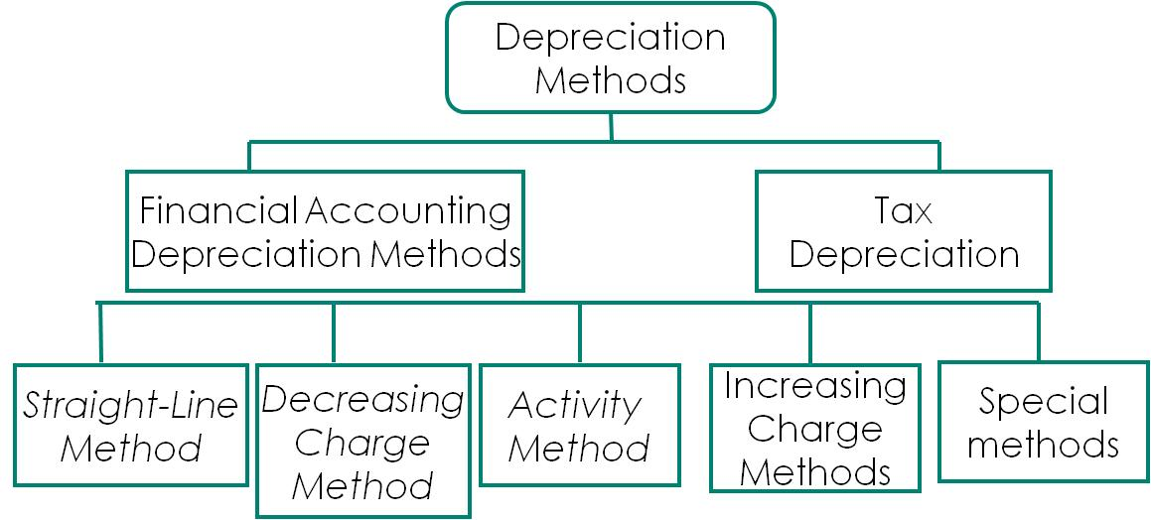
- Useful life/economic life—the period of time over which the asset will produce revenue for the company
- Factors affecting useful life are:
  - economic factors (e.g. obsolescence)
  - physical factors (e.g. wear and tear)
  - legal life (e.g. expiration of contract)

1 Depreciation methods

Comparison between methods
Straight line method | Decreasing charge method | Activity method
- Simple to use  - Based on 2 broad assumptions  -constant usage  - Other costs same each year  - Distorts rate of return | - Best match of some assets’ productivity to cost  - More depreciation in earlier years when asset has greatest benefit | - Only appropriate where usage is not a function of time  - Difficult to estimate total number of units over life of asset

Depletion of natural resources
- Natural resources are depleted (depreciated) over time as they are removed
- Depletion is calculated using an activity method (such as units-of-production)
- The depletion charge is initially debited to Inventory
- When the resource is sold, Inventory is credited and Cost of Goods Sold is debited
- Where an equipment’s useful life is clearly linked to the life of the resource, it is also amortized using the units-of-production method

Depreciation and partial periods
Straight-Line Method
- Calculate the amortization for the portion of the year
- Generally use the nearest full month
Declining-Balance Method
- More complex calculations involved
Units of Production/Use Method
- No special calculations required
- Calculate the usage rate and apply to actual usage for the period
- Same rate used in subsequent years

Revision if depreciation estimates
- estimates need to be reviewed regularly (under IFRS, at least at the end of every fiscal year end)
- When these estimates are revised, depreciation is recalculated
- The revised depreciation is applied prospectively to the remaining life of the asset, i.e., it is accounted for in the period of the change and to future periods
- The changes do not affect prior periods

Impairment: Overview
- Occurs when the carrying amount of the long-lived asset greater than its future economic benefit to the company
- Management needs to regularly evaluate assets for these indicators of impairment
  - IFRS requires this at the end of each reporting period
- If there is an indicator of possible impairment, then the asset must be tested for impairment
- Two main approaches to measuring impairment losses are:
  - Cost recovery impairment model
    - impaired only if carrying amt can’t be recovered from using and eventually disposing of the asset (recoverability test)
      - i.e. impaired if carrying amount > undiscounted future net cash flows
    - Impairment loss is then measured as asset’s
      - carrying amount less fair value
    - Fair value of the asset is best measured by quoted market prices in active markets
      - It is by its nature a present value or discounted measure
    - Impairment losses cannot be reversed. GAAP

  - Rational entity impairment model
  - measured by comparing the asset’s carrying amount and recoverable amount
  - Recoverable amount is measured as higher of
    - Value in use (present value of future net cash flows) AND
    - Fair value less cost to sell
  - Carrying amount < recoverable amount no impairment loss
  - Carrying amount > recoverable amount, impairment loss is difference btwn two values
  - Impairment losses may be reversed, IFRS

Held For Sale
- classified as held for sale if the company intends on disposing the asset by sale and meets strict criteria (ch4)
- Held for sale assets are
  - Reported separately on the balance sheet
  - Not depreciated
  - Measured at the lower of
    - Carrying amount, and
    - Fair value less costs to sell
- Subsequent increases in net realizable value may be recognized as gains, but only to the extent they offset previously recognized losses

Derecognition
- Plant assets may be:
  - retired voluntarily, or disposed of by sale, exchange, involuntary conversion, donation
- Depreciation is recorded up to the date of disposal before determining gain or loss
- Gains or losses from disposal are normally shown with “Other” revenues and expenses in the income statement

Presentation and Disclosures
- There are many significant disclosures required for property, plant, and equipment
- Types of disclosures include the following:
  - cost and the accumulated depreciation
  - depreciation method and rate or period
  - assumptions surrounding fair-value-related measurements
  - carry amounts of assets held for sale
  - outstanding contingencies

CHAPTER 12 INTANGIBLE ASSETS AND GOODWILL
- Intangible assets must meet all of the following characteristics:
  - They are identifiable, having at least one of the following characteristics:
    - Results from contractual or legal rights, or
    - Can be separated from the entity and sold, rented, exchanged, transferred or licensed
  - They lack physical substance, and
  - They are non-monetary
- Identifiable intangibles with similar characteristics should be grouped and reported together

Recognition and measurement at acquisition
- Recognize if
  - probable future economic benefit, and
  - asset can be measured reliably
- Initially recorded at cost
- Intangible assets may be:
  - Purchased
  - Acquired as part of a business combination, or
  - Developed internally

Purchased intangibles
- Cost includes all expenditures to get asset ready to use
- If there are delayed payment terms, recognize financing expense (interest)
- If acquired for shares, cost is generally measured at FV or share value if unknown
- If intangible assets are exchanged for non-monetary assets, the fair value of the item given up or the fair value of the intangible received is used to determine cost
- For a “basket purchase” of intangibles, the cost is allocated based on fair values

Acquired in business combination
Recognized at FV

Internally developed intangibles
- Process of generating intangible assets is broken down into two phases
Research activities:
  - involve planned search or critical investigation aimed at discovery of new knowledge
  - may or may not be directed towards a specific project
Development activities include:
  - translation of research findings or other knowledge into a plan or design for a new product or process, or
  - significant improvement to an existing product or process
- All research costs are charged to expense when incurred
- Development costs are charged to expense except in certain defined circumstances

Development Costs capitalization criteria
  - Technical feasibility
  - Intent to complete for use or sale
  - Ability to use or sell
  - Availability of resources (technical, financial, and other) needed to complete, and to use or sell
  - If intent is to sella market exists and is clearly defined; if intent is to use, there is a definable use/need
  - Product/process clearly defined, and costs can be identified
Examples: Materials and services consumed, Direct personnel costs (e.g., salaries), Fees needed to register a legal right, Amortization of other intangibles needed to generate the asset, Interest and borrowing costs
Useful lives of intangibles
Limited-Life Intangibles
- An intangible asset with limited (or finite) useful life is amortized over its useful life
- Intangibles assumed to have no residual value, unless:
  - There is a commitment to purchase, or
  - There is an observable market
Indefinite-Life Intangibles
- An intangible asset with an indefinite useful life is not amortized and an impairment test is carried out every accounting period
- Indefinite life is not the same as “infinite” (forever)

Types of Intangibles
- Marketing-related
  - Trademarks or trade names
    - Renewable indefinitely every 15yrs. Legal life=unlimited, useful life=limited
    - Costs to acquired capitalized
    - If developed by company, may be capitalized if all 6 requirements met.
  - Newspaper mastheads
  - Internet domain names
  - Non-competition agreements
- Customer-related
  - Customer lists
  - Order/production backlogs
  - Contractual and noncontractual customer relationships
- Artistic-related
  - Ownership rights to artistic endeavours such as literary works, musical works, pictures, photographs and audiovisual material are protected by copyrights
  - Copyrights are granted for the life of the creator, plus 50 years and cannot be renewed
  - Useful life is generally less than the legal life
  - Amortized over period in which benefits accrue
  - Costs of acquiring and defending copyrights may be capitalized
  - Research costs associated with a copyright are expensed
- Contract-based
  - Value of a right resulting from a contractual arrangement
  - Examples: licensing arrangement, leaseholds, construction permits, broadcast rights, service or supply contracts, and franchises
  - A franchise is a contractual agreement where franchisor grants the franchisee the rights to:
    - sell specified products or services
    - use certain trademarks or trade names
    - perform certain functions within a particular geographical area
---cost of franchise (limited life) amortized over lesser of legal or useful life
----unlimited life: amortized over expected useful life or no amortized
----annual op.payments for franchise expensed
- Technology-based
  - Product Patents
    - Physical (tangible) products
    - Legal life of 20yrs
    - Purchase costs capitalized; R&D expensed
    - Amortized, shorter of 20yrs of useful life
    - Legal fees ammortized
  - Process Patents
    - Process by which products are made
  - Computer Software Costs

Goodwill
Only when business combination
- Bargain purchase
  - when FV of acquired identifiable net assets > the consideration transferred for those assets
  - negative goodwill be recognized immediately as a gain in net income
Valution after acquisition
- Charge immediately to expense
  - Results in consistent accounting for purchased goodwill and internally generated goodwill
  - One rationale is that it is difficult to identify the useful life
- Amortize over useful life
  - Better matching of costs to benefits
- Carry at cost indefinitely, unless value impaired
- Consistent with requirements under private equity GAAP and IFRS
Goodwill impairment:
- Because goodwill is not identifiable and does not generate its own direct cash flows, it is assigned to a reporting or cash generating unit (CGU) in order to be tested for impairment
GAAP | IFRS
- test: done whenever events or changes in circumstances indicate possible impairment  - Impairment test: other assets before GW  - Impairment loss carrying amount of reporting unit including goodwill > FV of reporting unit  - Loss calculated as amt of excess  - cannot be reversed | - Test: annually and also whenever there is indication that CGU may be impaired  - Impairment loss exists if carrying amount of unit including goodwill > recoverable amount of unit  - Loss is calculated as amount of excess  - Impairment loss is allocated first to goodwill and then to other assets on a relative carrying amount (proportionate) basis  - Goodwill impairment losses cannot be reversed

Measurement after acquisition
- 2 models for measuring intangible assets subsequent to initial recognition:
  - Cost model (CM)
  - Revaluation model (RM)
- Under private entity GAAP, cost model is the only method allowed
- Revaluation model requires that intangible assets have fair value determined in an active market
- Both models are applied in same way as for property, plant, and equipment

Impairment of Limited life intangibles
- covered by same impairment models and standards as for long-lived tangible assets(see chapter 11)
- Potential impairment is assessed
  - under private entity GAAP, when events or circumstances indicate that carrying value may not be recoverable
  - Under IFRS, at the end of each reporting period
Impairment of indefinite-life intangibles
- Private entity GAAP
  - Use fair value test only
  - Fair value of intangible compared to the carrying amount
  - When fair value is less than carrying amount, impairment has occurred and loss is recorded
  - The recoverability test is not used for indefinite-life intangible assets
- IFRS
  - Compare carrying value and recoverable amount on an annual basis, whether or not there is indication of impairment.

CHAPTER 21: ACCOUNTING CHANGES AND ERROR ANALYSIS

Types of changes
- Changes in Accounting Policy
Change in the choice of “specific principles, bases, conventions, rules, and practices applied by an entity in preparing and presenting financial statements
(DISCLOSURES: nature of change/title, amt of adjustment, reasons)
- Required by GAAP or
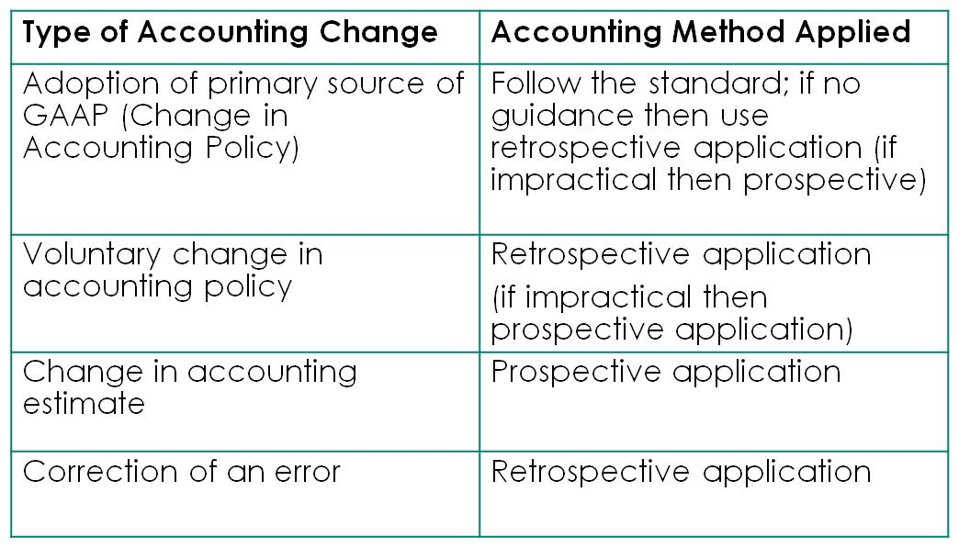
- To portray more reliable and relevant info abt effect of transactions, event, condistion
- NOTNOTNOT:
  - Different policy necessitated by events or transactions clearly different in substance from those previously occurring AND
  - New policy that recognizes events that have occurred for the first time or that were previously immaterial

- Change in Accounting Estimate
Adjustment based on change in circumstances on which a previous estimate was based or as the result of new information, more experience or subsequent developments
(DISCLOSURES: nature, amt affecting current period, IFRS: futire period as well)

- Correction of an error in prior period financial statements
Omissions from or mistakes in F/S of prior periods caused by the misuse or failure to use reliable information that existed at the time financial statements were prepared, intentional or an oversight
(DISCLOSURES: nature of error, amt correction each F/S line, amt correction beginning period)
- Examples, change from non-GAAP to GAAP, oversight, math error, misappropriation of assets

Method to account for changes
Retrospective Treatment (retroactiveapplication)
- Requires calculating the cumulative effect of the change on the financial statements at the beginning of the period as if the new method or estimate had always been used
- An adjustment is made to the financial statements equal to this cumulative effect
- Results in restating all affected prior years’ financial statements on a basis consistent with the newly adopted policy (i.e. as if the new accounting policy had always been used)
Retrospective-with-Restatement
  - Retroactive application of the new method, including income tax effects - entry is made
  - Prior-period financial statements included for comparative purposes are restated
  - Description of the change and effect on current and prior period financial statements disclosed so that statements remain comparable
Retrospective with Partial Restatement
- Retroactively restating prior years’ financial statements requires information that may be impractical to obtain on a cost-benefit basis
- Some standards allow for a partial retrospective application
- The change in policy is applied at the beginning of the earliest period for which restatement is possible
Prospective Treatment
- Previously reported results remain; no change is made
- Opening balances are not adjusted and no attempt is made to correct or change past periods
- New policy or estimate is adopted for current and future periods only and applied to balances existing at the date of the change

Error analysis
- Couterbalancing errors
  - Ex: accrued wages, prepaid expenses, unearned revenue, accrued expenses, purchases, inventory
  - If the books are closed and error counterbalanced, no entry necessary
- Non-counterbalancing errors
  - Ex: depreciation, bad debts
  - If the books are closed, correcting entry needed
- Income tax effects
  - If the error affects prior period income, income tax effects must also be considered

CHAPTER 22 CASH FLOW STATEMENT
The information may help users (investors, creditors, and others) assess the following:
  - Liquidity and solvency – i.e. the entity’s ability to generate future cash flows and its needs for cash resources
  - The amounts, timing, and uncertainty of future cash flows
  - The reasons why net income and net cash flow from operating activities differ
Provides info about cash inflows and outflows, INCLUDES cash AND cash equivalents

Direct Method
- Operating Activities
  - The cash flows resulting from the primary revenue-producing activities of the business, such as
    - Collections from customers
    - Payments to suppliers
    - Payments to employees
    - Payments to CRA for tax
  - Cash flow provided by operating activities necessary for long term sustainability of the business (i.e. to take advantage of new investment opportunities, to pay dividends without seeking external financing etc.)
- Investing Activities
  - The acquisition and disposal of long term assets and long-term investments
  - Examples include:
    - Purchase/disposal of capital assets
    - Acquiring an interest in another corporation
  - Cash flow generated by investing activities shows if the business is investing in additional long term assets that will generate profits and increase cash flows in the future
- Financing Activities
  - Changes in long-term debt or equity capital
  - Examples include:
    - Issuing debt, or repayment of debt
    - Issuing new shares, or repurchase of currently outstanding shares
  - Provides information to assess potential for future claims to entity’s cash, extent of debt and increased interest charges

In favour of Direct Method
- Is more consistent with objective of a statement of cash flows
- Knowing specific sources of cash inflows and purposes of cash outflows helps in est. future cash flows
- Lending officers and other investors prefer direct method
- Both IFRS and PE GAAP encourage the use of direct method as it provides additional information

Indirect Method
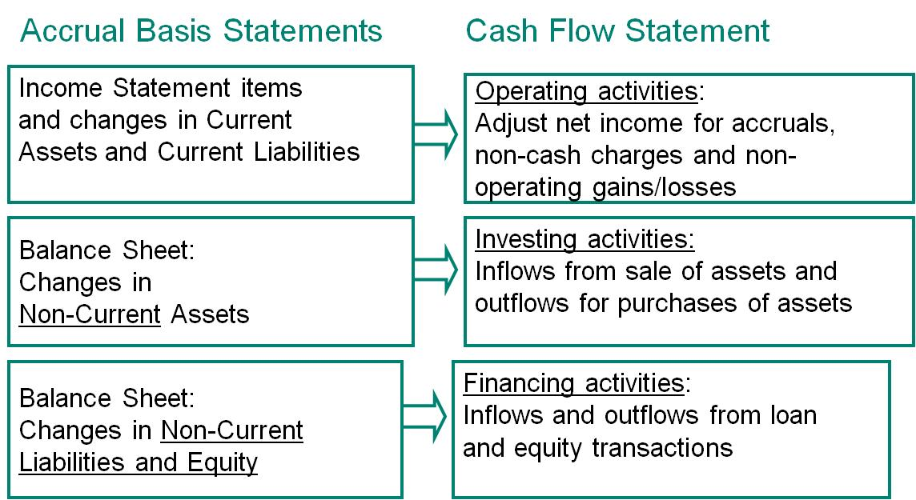

Everything same excepy operating activities.

Other Items
- Income statement gains and losses on disposal of long-term assets must be adjusted in determining cash from operations. Why?
  - These result from investing activities, not operating activities and
  - The amount of the cash flow is the proceeds on disposal, not the gain or loss
- Income statement gains and losses on redemption of long-term debts must be adjusted in determining cash from operations. Why?
  - These result from financing activities, not operating activities and
  - The amount of the cash flow is the amount paid to redeem the debt, not the gain or loss

Disclosures
- IFRS and PE GAAP require similar disclosures on certain items, including the disclosure of:
  - Significant non-cash investing and financing transactions
  - Policy on what makes up cash and cash equivalents
  - Reconciliation of cash and cash equivalents to balance sheet accounts
- IFRS has more strict requirements relating to disclosure of some items, including:
  - Income taxes
  - Interest and dividends (paid and received)
  - Restrictions on cash and cash equivalents
Free Cash Flow
- Non-GAAP measure used by many companies to indicate discretionary cash available for new investments, paying dividends, retiring debt, repurchasing shares, or improving liquidity
- FCF is typically calculated as
  - Net operating cash flows
  - Less: capital expenditures to sustain current level operations
- As it is a non-GAAP measure, some companies calculate FCF differently

