b. Country B

ii.
The combined production for both countries, if they do not trade, is shown above on the right in a table and PPF.
Country B
Resources devoted to clothing | Output of Clothing | Resources devoted to food | Output of food
100% | 25 | 0% | 0
80% | 21 | 20% | 7
60% | 17 | 40% | 12
40% | 13 | 60% | 16
20% | 8 | 80% | 19
0% | 0 | 100% | 22
Combined Output
Resources devoted to clothing | Output of Clothing | Resources devoted to food | Output of food
100% | 53 | 0% | 0
80% | 46 | 20% | 11
60% | 34 | 40% | 23
40% | 25 | 60% | 31
20% | 15 | 80% | 37
0% | 0 | 100% | 43

iii.
Clothing Food
Country A 28 21
Country B 25 22

Country A’s opportunity cost of producing one more unit of clothing in terms of food foregone is 0.75 (21/28) and 0.88 (22/25) for Country B. This means Country A has the comparative advantage in the production of clothing since 0.75 < 0.88.

Country A’s opportunity cost of producing one more unit of food in terms of clothing foregone is 1.33 (28/21) and 1.13 (25/22) for Country B. This means Country B has the comparative advantage in the production of food since 1.13 < 1.33.
Table
Price | Quantity Demanded | Quantity Supplied
0 | = 80-2*A2 \# "0" \* MERGEFORMAT80 | = -20+2*A2 \# "0" \* MERGEFORMAT-20
5 | = 80-2*A3 \# "0" \* MERGEFORMAT70 | = -20+2*A3 \# "0" \* MERGEFORMAT-10
10 | = 80-2*A4 \# "0" \* MERGEFORMAT60 | = -20+2*A4 \# "0" \* MERGEFORMAT0
15 | = 80-2*A5 \# "0" \* MERGEFORMAT50 | = -20+2*A5 \# "0" \* MERGEFORMAT10
20 | = 80-2*A6 \# "0" \* MERGEFORMAT40 | = -20+2*A6 \# "0" \* MERGEFORMAT20
25 | = 80-2*A7 \# "0" \* MERGEFORMAT30 | = -20+2*A7 \# "0" \* MERGEFORMAT30
30 | = 80-2*A8 \# "0" \* MERGEFORMAT20 | = -20+2*A8 \# "0" \* MERGEFORMAT40
35 | = 80-2*A9 \# "0" \* MERGEFORMAT10 | = -20+2*A9 \# "0" \* MERGEFORMAT50
40 | = 80-2*A10 \# "0" \* MERGEFORMAT0 | = -20+2*A10 \# "0" \* MERGEFORMAT60

2. Supply and Demand

b. The slope of quantity demanded is negative because of the law of demand. The law of demand is that the quantity demanded decreases as price increases because consumers are willing to buy less with higher prices.

The slope of quantity supplied is positive because of the law of supplied. The law of supply is that quantity supplied increases as price increases because sellers will produce more if the price per unit is high.

c. The market will be in equilibrium at a price of $25.

d. The reservation price for demand is between $39-$40 because at $40 the quantity demanded hits 0 and at $39 the quantity is 2.

e.
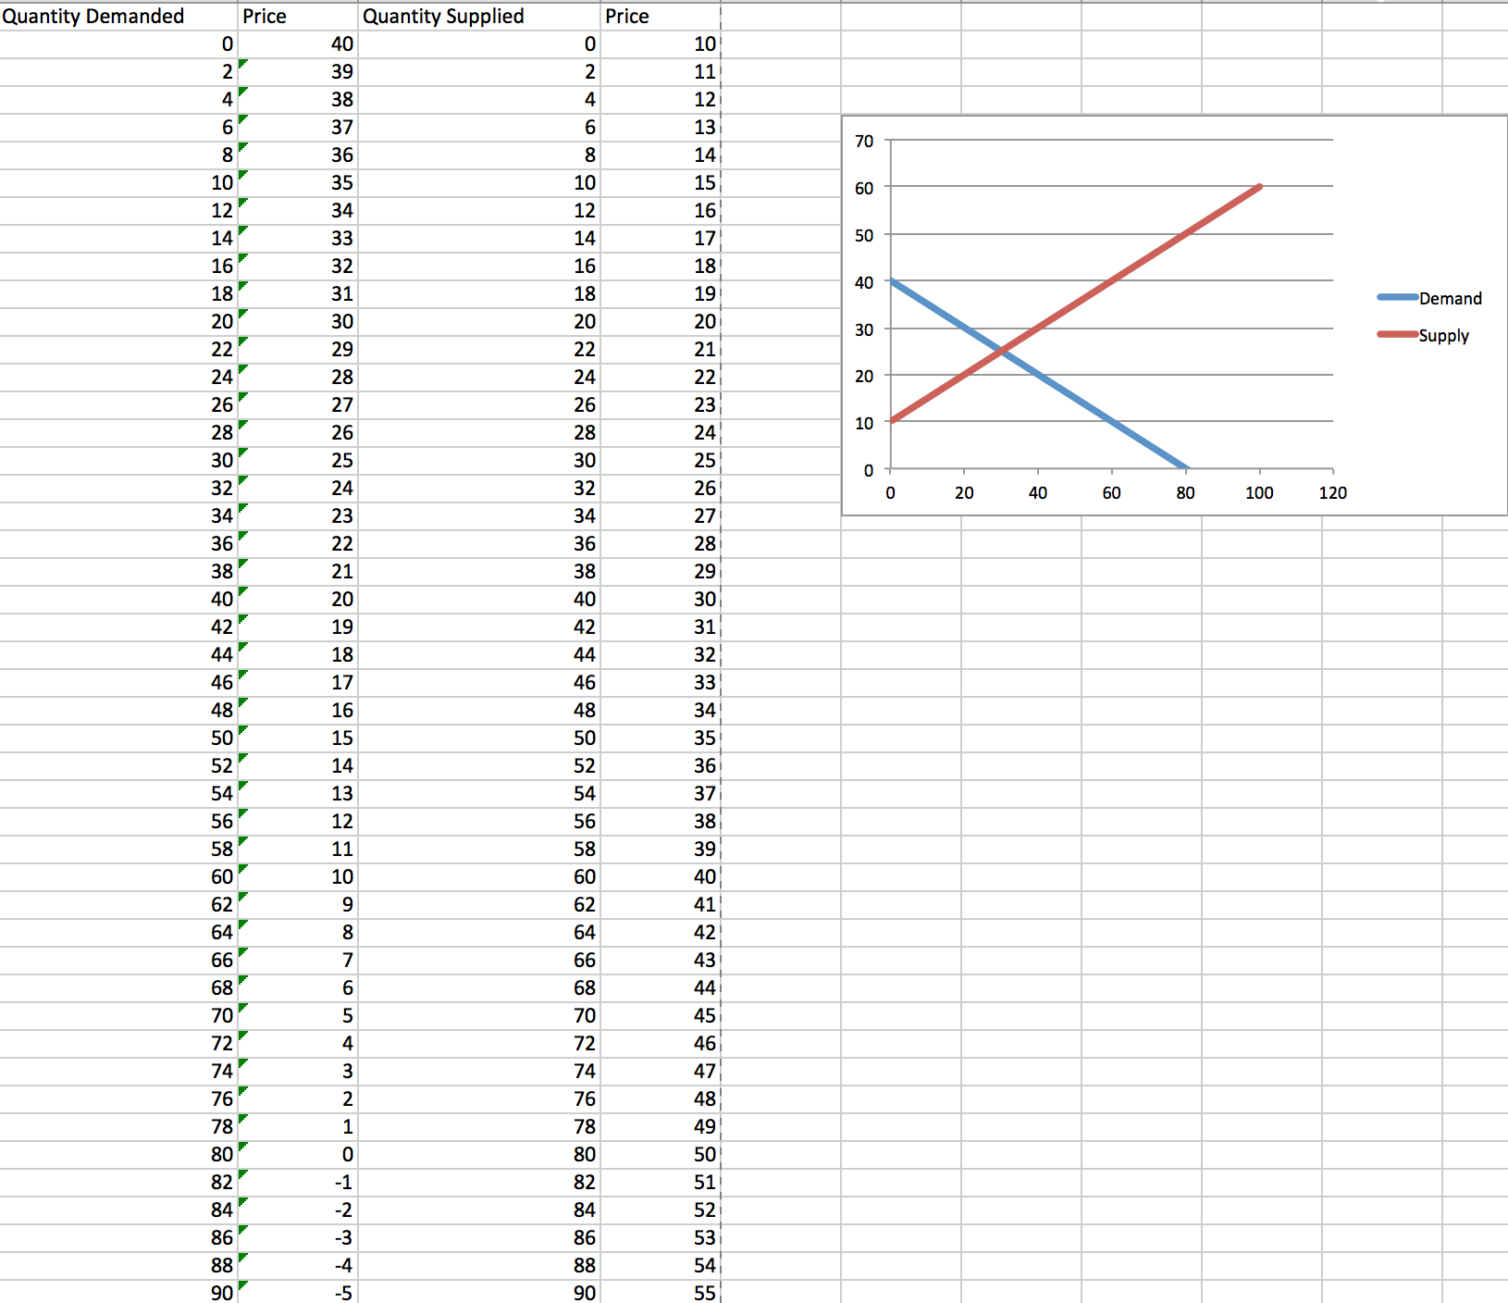
f. The equilibrium price and quantity can be found in the supply and demand curve above where the supply curve meets the demand curve. This is consistent with the previous results showing the equilibrium to be at a price of $25 and a quantity of 30.

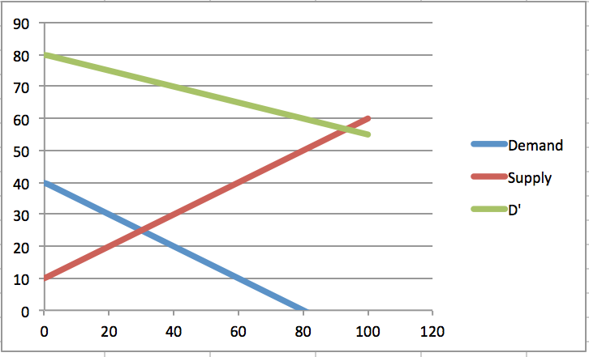
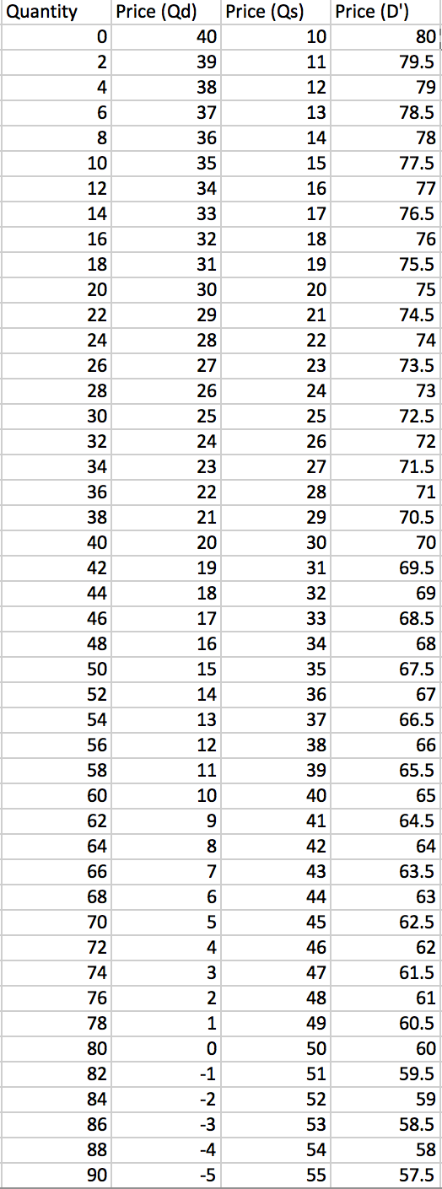
g. & h.
i. The new equilibrium price is $56.67 and the equilibrium quantity is 93.33. The change from D to D’ is an increase in demand because the quantity demanded is higher at each given price. Three factors that could cause this effect are consumer tastes, income, and expectations. Tastes refer to consumers simply wanting the product more than before because of something like trends. A consumer’s income increasing means they can buy more of this product (increasing demand), unless it’s an inferior good, then their income would decrease to cause a higher demand. Expectations can affect the demand because a consumer will buy more of the product if they believe the price will increase later on. The new reservation price for D’ is about $79.9. This has increased from D because the demand of the consumers being higher, meaning the consumers are willing to pay more before denying to buy the product.

j. This new supply curve shows a decrease in supply because the supply demanded is lower at any given price.
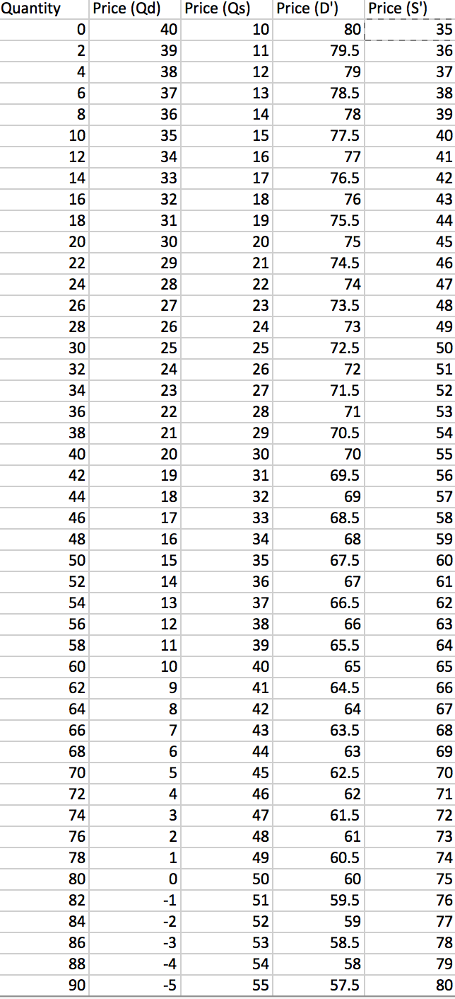
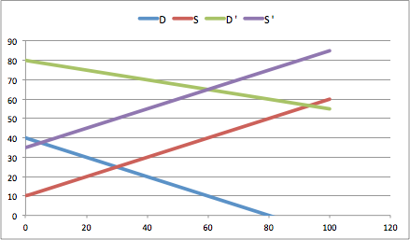
Price
Quantity

l. The new equilibrium price is $65 and the equilibrium quantity is 60. Three factors that could have affected the shift in supply are the expectations, input prices, and the price of related goods. The company may expect the price of the good to rise soon, so they will put more of the good into storage for later sales, this means less supply on the market. If the price of an input increases, the production of the good is less profitable, so the company may reduce production. Also, if a producer believes that by making another good they can make more profit, they may stop production of this good.

3. Elasticity
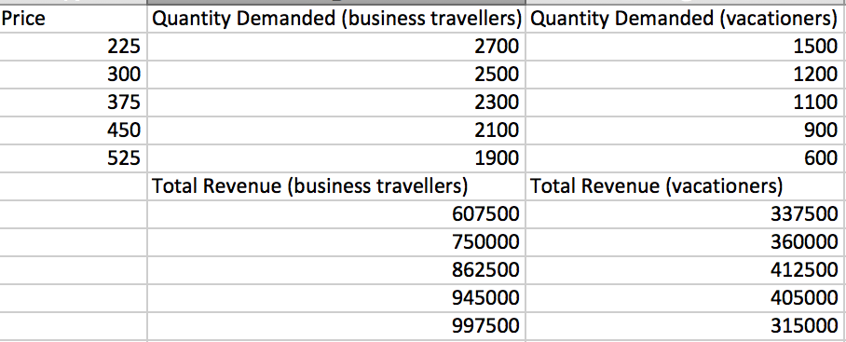
i.
ii. Business Travellers:
Price Elasticity of Demand from $225 to $300

PED = (Q₂ – Q₁)/[(Q₂ + Q₁)/2]
(P₂ – P₁)/[(P₂ + P₁)/2]

= (2500 – 2700)/[(2500 + 2700)/2]
(300 - 225)/[(300 + 225)/2]

= -200/2600
75/262.5

= -0.27

0.27<1

Inelastic
Vacationers:
Price Elasticity of Demand from $225 to $300

PED = (Q₂ – Q₁)/[(Q₂ + Q₁)/2]
(P₂ – P₁)/[(P₂ + P₁)/2]

= (1200 – 1500)/[(1200 + 1500)/2]
(300 – 225)/[(300 + 225)/2]

= -300/1350
75/262.5

= -0.78

0.78<1

Inelastic

iii. The price of tickets rising from $225 to $300 shows an inelastic demand, in both cases, because the total revenue of both parties increases as price increases. Using the mid-point method also shows an inelastic demand because the answers’ absolute values are below 1.

Vacationers:
Price Elasticity of Demand from $450 to $525

PED = (Q₂ – Q₁)/[(Q₂ + Q₁)/2]
(P₂ – P₁)/[(P₂ + P₁)/2]

= (600 – 900)/[(600 + 900)/2]
(525 – 450)/[(525 + 450)/2]

= -300/750
75/487.5

= -2.6

2.6>1

Elastic
iv.
Business Travellers:
Price Elasticity of Demand from $450 to $525

PED = (Q₂ – Q₁)/[(Q₂ + Q₁)/2]
(P₂ – P₁)/[(P₂ + P₁)/2]

= (1900 – 2100)/[(1900 + 2100)/2]
(525 - 450)/[(525 + 450)/2]

= -200/2000
75/487.5

= -0.65

0.65<1

Inelastic

v. Both the business travellers and vacationers price elasticity of demand becomes more elastic as price increases. The PED from $450 to $525 is higher than the PED from $225 to $300 for both parties. The demand became more elastic because consumers do not react well to large increases in price, and so don’t demand as much of it. The elasticity is higher because the price is approaching the reservation price, where consumers will no longer want the product.

vi. Vacationers might have a different elasticity than business travellers because airline tickets are a luxury to vacationers, and more of a necessity to business travellers. Business travellers must go on trips for things like meetings, while vacationeers have nothing vastly important to go to. Also, vacationeers can wait for a decrease in price versus business travellers who must travel on a specific day.

