Chapter 4
- Postmodernity: Changes in the economic structure of society
- While Epidemiology was originally a part of public health, literally meaning the peoples health, with a focus on collectivity, it has became increasingly individualistic and “lifestyle” and “risk” focused. Epidemiology reflects changes in the political and economic structures of modern societies, in which there has been a move away from the provision of services by a centralized state and a remobilization of liberal arguments for individual responsibility and the need for a “small” state.
Postmodernity
- From a sociological point of view, postmodernity refers to changes in capitalistic society over the past 30 years.
  - Decline of the industrial sector, decline in working class, decline in unions, and decline in occupation as a source of identity, weakening between public and private sectors.
- We now live in a set of social organizations that allow us to be reflexive about our social identity, and to construct our own biographies.
- Beck argued, “We will be set free from the social forms of industrial society- class, stratification, family and gender status”.
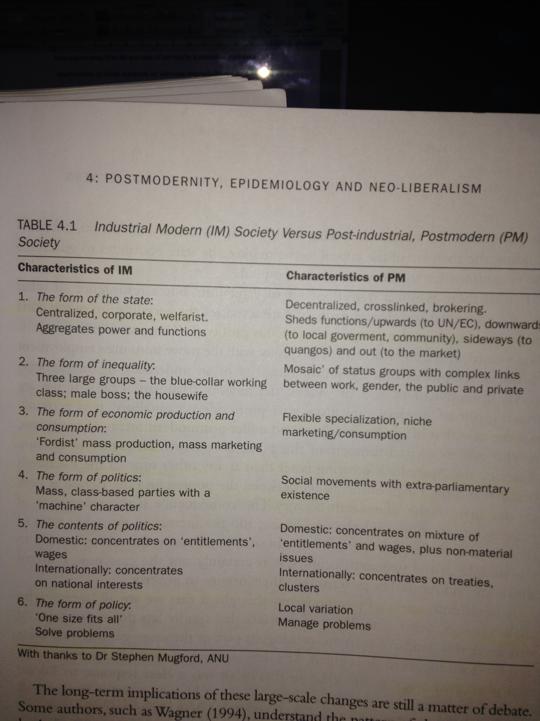

- Postmodernist theory emphasizes the increasing options open to individuals to shape their own lives

Liberalism and the Development of Neo-Liberalism in Health Policy
- Liberalism was the political arm of the new capitalist class that developed out of the industrial revolution
- Its major implication for policy was little government intervention in the market as possible.
- Society was to be the outcome of individuals striving on their own pursuing their own interest and achieving the greatest happiness for the greatest amount of people.
- Quite obviously, there are a few problems with liberalism
  - We do not all start equally
  - Once we have started, other groups have more power than others
- In capitalist society, you must sell your labor in order to survive.
The 19th and Early 20th Century
- The London Poor, Henry Mayhews social journalism on the poor, Engels Condition of the Working Class in England
  - Linked poverty and inequality to disease and death
  - What they had in common:
  - The argument that the pursuit of profit produces sickness and disease
  - Individuals on their own were powerless to protect themselves
  - It was only through the reform of government and collective actions through the unions that better food, water, housing and controls over factories would be affected.
  - Disease clearly went with concentrations of poverty, slums and industrial occupations.
- People are not suffering from diseases of affluence but diseases of poverty.
Limitations of the Risk Factor and Lifestyle Explanations
- First, clinical epidemiology has moved to a focus on individual behaviour (the risk factors)
- Second, it has moved to almost purely statistical ways of communicating its findings
- Epidemiology now reflects the core assumptions of neo-liberalism
  - It is individualistic, and makes little to no reference to “social factors”
  - Focuses more so on individual risk behaviors.
- the more so-called risk factors that are examined, the more difficult it seems to conclude what role they play in determining health
Psycho-Social Perspectives on Social Inequalities in Health
- Durkheim stated that the quality of social life has a serious impact on the mental health of people
  - Argued those with the weakest social ties were at risk of egoistic suicide
    - Overvalued their own existence and began to see themselves as existing, without obligation, to the community around them
  - Also argued that too strong a set of social ties placed the individual at risk of altruistic suicide.
    - By sacrificing themselves, over-zealously on behalf of their group.
- Durkheim sociologists focused on the impact of social networks, social stress and the role of community in preventing or causing illness
- Stress has been conceptualized as working its way out in three major areas of life:
  - Life events, chronic strain, and daily existence
- If these stressors accumulate, and we lose our ability to cope, disease and illness usually follow, usually through depression and anxiety
- Elstad points out that the psycho-social perspective is based on three core assumptions:
  - 1. Psychological stress is an important cause of health inequalities in affluent societies
  - 2. Psychological stress is social produced and distributed
  - 3. Social and personal interrelationships are mediated by inequality
Stress
- Those who are unemployed, homeless, at risk of losing their jobs, living in poverty, face more ongoing, negative, stressful events and experience more sickness.
Major Findings from Social Support Literature
- Social integration is positively linked to mental and physical health and lower mortality rates
- Perceived emotional support leads to better physical and mental health, and helps buffer the impact of major life events
- The most powerful form of support is an intimate confiding relationship
- Those with higher status have a greater sense of support, and involvement in social networks is positively correlated with higher social status
The Social Drift Hypothesis
- Idea that the sick and depressed and stressed move down the social system and accumulate at the bottom
- An individual’s health is the outcome of the probability of a whole series of social events, which tend to multiply negatively the further down the social system you go.
Bury’s Biographical Disruption
- Bury pointed out three aspects of disruption caused by chronic illness:
- The disruption of assumptions and behaviors
- Disruptions in explanatory systems that require a rethinking of biography and self concept
- The response to disruption

