- Facebook interface
  - Users can create a virtual profile that other users can see including:
    - Personal information (Age, Gender, Place of Work, Marital Status, etc.)
    - Hobbies and interests that can attract other users that share the same interests.
    - Can classify pictures and videos in different albums for other users to see.
      - Other users can comment and reply to any video or picture that is posted.
      - Friends can also like or dislike photos and videos
    - Profile picture usually showing the owner of the account’s picture.
      - Once on the facebook page, a user can customize a background photo at the top of their wall.
    - Can add friends and then see their friends, if it is not restricted, from there a user can connect with more people and network themself.
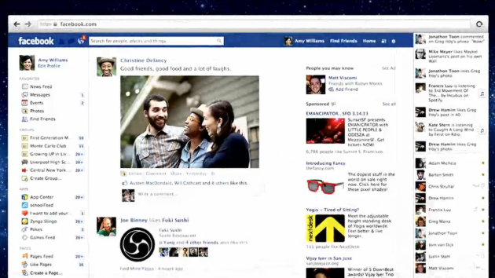

How an individual can promote themselves
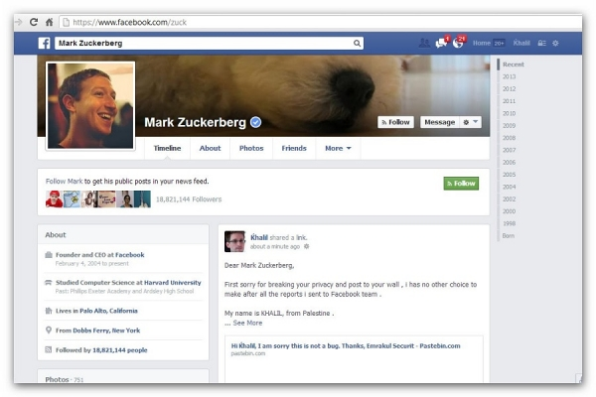
- As stated earlier, a user can change their profile to attract a certain kind of people:
  - An opening background picture is the first thing that jumps out to users when viewing a fan page or profile page. In this picture, the dog.
  - Next the viewer sees the profile picture where they will see exactly how the person looks; most of the time a profile picture shows a photo of the accountholder’s name.
  - The about section can show what kind of work they do, any places they’ve studied or any such personal information that can possibly draw more attention to the page.
  - Also other users can see the pages that were liked by that user. Someone trying to promote themselves would have a lot of likes in the specific field in which they are trying to be recognized in.
  - Others can comment on the ‘wall’ of the user where the user will see their comments the moment they login into their facebook account.
  - Users can also modify their pictures and videos in the photo section, for example, if someone is trying to promote themselves through fashion, they can have different albums for different fashion shows or fashion styles.

