Consciousness and Drugs November -13-2014
Professor Kenneth Campbell

The altering of consciousness by drugs (Chapter 3 in Myers)

Psychoactive drugs
• change perception of external (and internal) environment
• perhaps change mood.

Tolerance

• With repeated use, tolerance develops
• A larger dose is required to produce the same effect
• Withdrawal (craving for drug)
• Physical dependence (physical addiction). Physical pain, craving for drug
• Psychological dependence (psy. addiction). Drugs can act as either a positive or negative reinforce and thus they are repeatedly used (pleasure, relief of negative emotions)
• Tolerance is not even throughout the body.
- While one part of the brain (the “pleasure centre”) will require more of the drug to get the same effect, another part (perhaps cardio-vascular control) cannot tolerate the increase dose.
- For some drugs (particularly the hallucinogens), there may be negative tolerance.
- A lower dosage is required to obtain the same initial effect.
- This might be because some of these drugs linger in the body for a very long time.

False claims about addiction

• All psychoactive drugs lead to addiction.
• No! For some there is no addiction (e.g., LSD). For even highly “addictive” drugs (alcohol, cocaine, heroin) only 10% will show addiction. Also, those who use drugs medically do not usually become addicted to them.
• “Soft” drugs (marijuana, hash, etc) lead to “hard” drugs. No… this is a correlation not a causation.
• To overcome addiction, one needs medical treatment. NO!
o Recovery rates of treated and untreated are rather similar.
• Addiction occurs for many pleasant activities, not only drugs.
o No (compulsion). Moreover all so-called “addictions” should be treated as a disease.
o sensation-seeking; risk-taking; food, gambling, sex…etc. Co-dependence
  - But, perhaps this is a result of how “addiction” is defined.
  - Is it physical?
  - Is it psychological? We repeat behaviour that is positively reinforcing (pleasant) or negatively reinforcing

Types of Psychoactive Drugs

• Depressants (“downers”). Inhibit neural functions (alcohol, barbiturates, opiates)
• Stimulants (“uppers”). Excite neural functions (caffeine, nicotine, amphetamines, cocaine, MDMA)
• Hallucinogens. Alter perception. Evoked sensory images (cannabis, LSD, psilocin, mescaline)

Depressants
- Alcohol
- Barbiturates (tranquilizers)
- Opiates

Alcohol

• Most commonly used drug
• Always depresses neural activity
o but what happens if you depress a centre that controls social inhibition?
•
At larger dosages, a large effect on performance.
• Depresses frontal lobe control (perhaps over limbic system).
o Recall functions of frontal lobe (logic, prediction of consequences, social behaviour, etc)
• Effect on transfer of short-term to permanent memory
• May inhibit REM sleep

Barbiturates (tranquilizers)

• Prescribed to induce relaxation and sleep
• In large doses, will impair memory and judgment
• Can kill (especially in large doses) or in combination with alcohol.

Opiates

• Chemicals such as morphine and heroin that are made from the opium poppy
• Similar in chemical structure to the endorphins, the natural opiates (pain-killers) of the brain
• depress sympathetic nervous system
• depress frontal lobes?
• Pleasure; reduces pain and depression
• Can be addictive
• Brain stops producing its own endorphins
• Need for increasingly larger doses (tolerance)
• Withdrawal from opiates can be exceedingly painful.
• But withdrawal is not nearly as bad as implied by the media!

Stimulants
- Nicotine
- Caffeine
- (Meth)amphetamines (speed, chalk; ice, crystal, glass, tina)
- Cocaine (coke, crack)
- MDMA (Ecstasy, X, XTC, Adam, hug, beans, love drug)

Stimulants

• Excite sympathetic nervous system; cortical arousal
• stay awake; lose weight; boost mood, athletic performance
• “Crash” (agitation, depression) after “rush” (especially for cocaine & MDMA because of depletion of neurotransmitters).

Cocaine, Crack

- Usually sniffed (“snorted”) or injected or smoked (especially crack).
- Rapid rush then a crash.
- Increase focus and mental alertness, eliminate fatigue and decrease the appetite.
- Cocaine users are often talkative, full of energy, confident
- Crack is much more commonly used in young adults than cocaine.
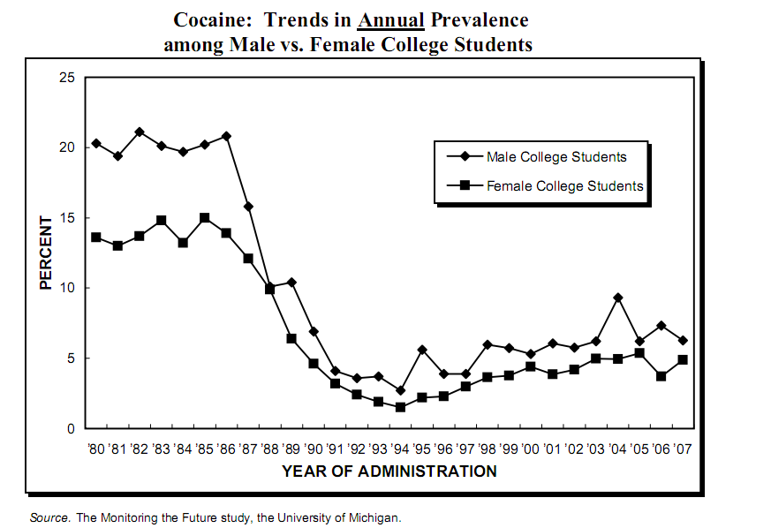
- Problems: When taken in larger amounts and upon prolonged use, cocaine can produce depression, anxiety, irritability, sleep problems, chronic fatigue, mental confusion, paranoia, and convulsions that can cause death.
- Physical or psychological addiction? Monkeys will press lever at high rates (10-15,000 times!) to obtain cocaine.
- Rate of cocaine use has dropped significantly
- In the Figure at the right, usage of university students were asked if they had used cocaine at any time over the last year. About 25% of males and 15% of females reported using it prior to 1990. In 1990, the US enacted a “war on drugs” policy. Usage has increased slightly in the recent past.
- A number of factors influences who uses cocaine. It is associated with professionals (bankers, investors, lawyers, physicians) because it does boost energy and productivity over the short-span for these individuals who often must work very long hours. Also, it may only be affordable for these high paid professionals.

MDMA (Ecstasy)

• A derivative of amphetamine. Thus, has stimulant effects.
• Used in clubs and “raves”
• While it does not cause overt hallucinations, many users report distorted time perception.
- Current evidence suggests primary effect is that it causes the release of serotonin and then blocks its reabsorption.
- The serotonin system plays an important role in regulating mood, aggression, sexual activity, sleep, and sensitivity to pain.
- Perhaps explains mild hallucinatory effects.
- Depletion of serotonin results in depression
- Nasty side effects in high dosages: overstimulation of the sympathetic nervous system. dehydration, overheating, death
- May affect sleep cycle and immune system
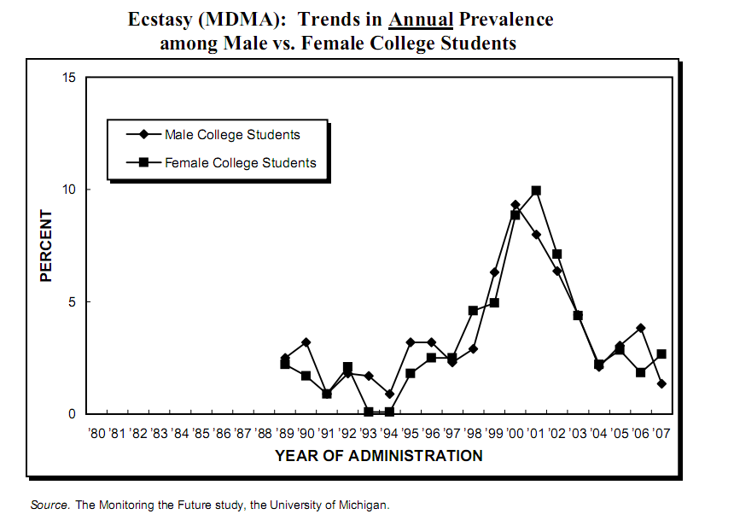
- Research in animals links MDMA exposure to long-term damage to neurons that are involved in mood, thinking, and judgment.
- A study in nonhuman primates showed that exposure to MDMA for only 4 days caused damage to serotonin nerve terminals that was evident 6 to 7 years later.
- In the figure on the right displaying drug usage over the past 35 years, MDMA usage peaked in the early 2000s and has dropped dramatically since then.

Hallucinogens

- Cannabis (Marijuana, hash)
- Psilocin (magic mushrooms), peyote (mescaline),
- LSD

Cannabis (Marijuana, Hash)

- Most illicit drug use involves cannabis.
- Recent (2000+) research suggests that there are cannabinoid receptors in the brain (especially frontal lobes, limbic system).
- The two cannabinoids produced in greatest abundance in the cannabis plant are cannabidiol (CBD) and/or Δ⁹-tetrahydrocannabinol (THC), but only THC is psychoactive.
- There are perhaps 2 or 3 different sub-species of cannabis and perhaps many different strains of cannabis within these species; their effects are very different. Part of the difference in the effects is due to the species but also the THC/CBD ratio.
• Amount of THC has increased sharply in “street” marijuana over the last 10 years.
• relaxation, disinhibition, mild euphoria, mild panic-paranoid
• mild hallucinogenic
• long-lasting effects (opposite of tolerance)
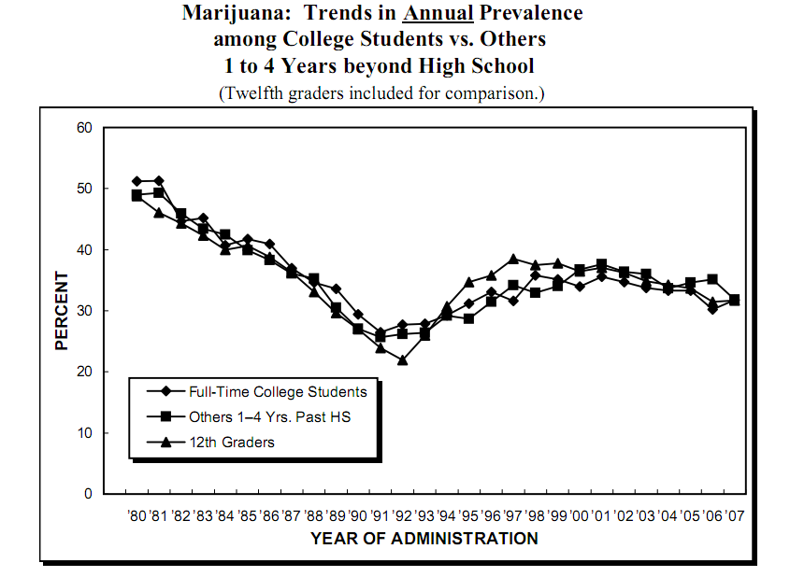
- Little evidence that it is physically addictive (withdrawal is not particularly difficult), BUT it may well be psychologically addictive (it does produce mild euphoria and relaxation and this is reinforcing).
- May be an effective pain-killer
- Perhaps long-term effect on learning and memory
- Effective on performance and cognitive tasks
- Large increase in marijuana abuse and/or dependence since 1990.
- Usage has levelled off recently.
- Usage may be negatively correlated to legality (e.g., NL, Portugal) but there are exceptions (Canada)

Lysergic Acid Diethylamide (LSD) (acid)

- LSD, Psilocin (psilocybe, “magic” mushrooms) and peyote (mescaline)
are similar in chemical structure to 5-HT

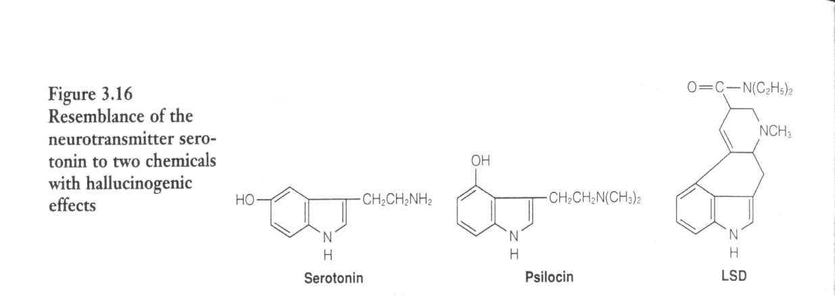
• large distortion of perception with very small (minute) dose
• unpredictable mood change (euphoria to panic)
• Probably not addictive
- Psychological experience vary widely among individuals
- Expansion (often wide) of perception, memories, emotions, time
- Vivid colours
- Hallucinations (can be large); perhaps synaesthesia
- Perhaps good or bad trips
- unpredictable mood change (euphoria to panic)
- Very, very long-lasting effects. A good trip might thus last a long time. But, a bad trip may also last very long and result in panic.

Legality of Drugs -- Success of the “War on Drugs”

- The U.S. declared a war on illicit drug use in the 1970s under the Nixon presidency and then began heavy enforcement for drug use in the 1980s during the Reagan presidency. Those found to be using illicit drugs would be punished by criminal sentences. Those found growing/manufacturing and distributing (“pushing/dealing”) drugs would receive severe criminal punishment. This campaign continues until the present day.
- Most criminologists and health researchers now agree that the campaign has failed. Drug use has not declined.
- Recent (Sept., 2013) research by Evan Wood at UBC, published in the British Medical Journal indicates that for both “soft” (e.g., marijuana) and “hard” (e.g., heroin, cocaine) drugs, availability has not decreased. Wood and colleagues collected data from 1990 to the present from governments’ own drug enforcement agencies in seven different countries. The data thus come from the actual government agencies that were created to control the flow of drugs.
- Why has the availability of drugs not decreased? As Wood points out, all the drugs needed to supply the entire demand in the U.S. could be transported on about 60 transport trucks. At one Texas-Mexico crossing along, more than 5 million trucks enter the U.S. every year. It is also acknowledged that a good deal of the marijuana that is being transported into the U.S. comes from its northern neighbour, Canada. How could all of the supply routes possibly be checked?
- To make matters worse, the potency of the drugs has increased. Between 1990 and 2010, the potency of heroin has increased by 60%, cocaine by 10% and marijuana, by 165%. (See Figure below)
- And if that were not bad enough, the price of the heroin, cocaine and marijuana has dropped dramatically by about 80% from 1990 to 2010, even when controlling for inflation.
- Why has the supply not diminished if the risk of criminal punishment is high? The reality is that potential profit is so high that it is worth the criminal risk. The probability of being caught is low. Why are the drugs more potent and why do the drugs now cost less? The economists have an easy explanation: Capitalist supply and demand. There are now so many drugs being produced and made available that the price has dropped (supply is greater than the demand). There is also increased competition, thus the quality (the potency) of the drugs has increased.
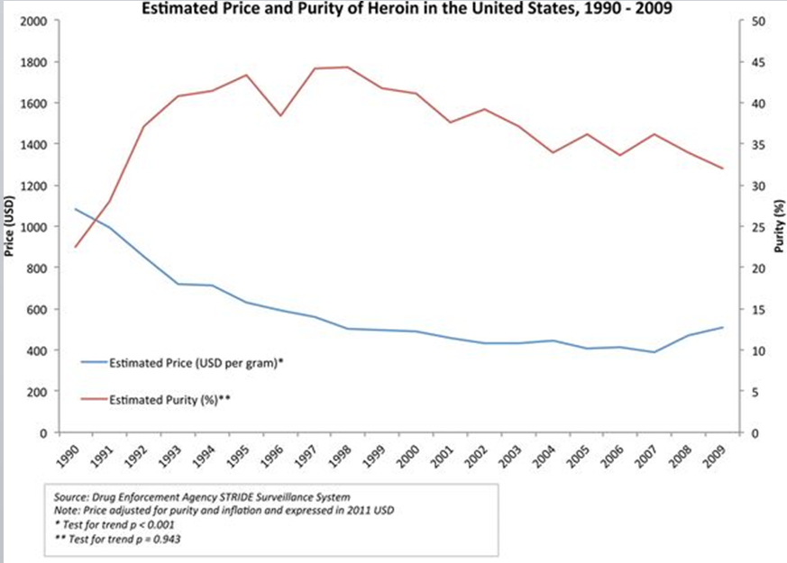

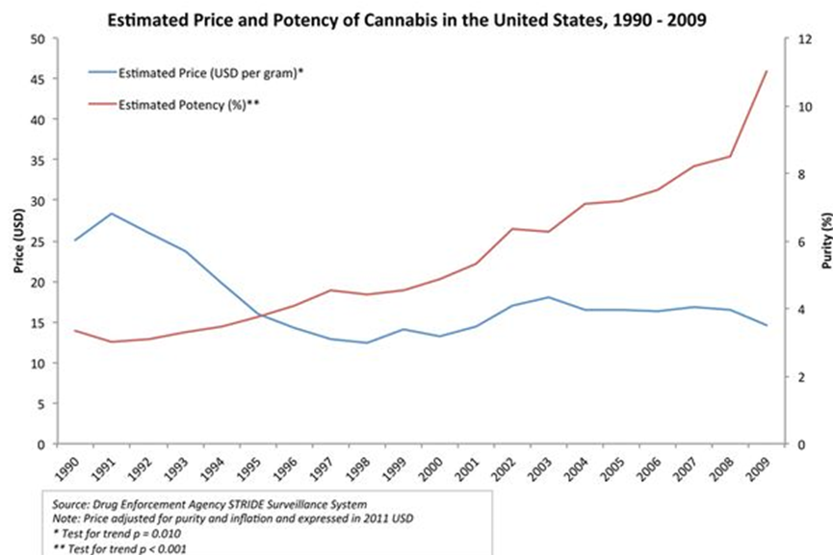

Source: D. Werb, T. Kerr, B. Nosyk, S. Strathdee, J. Montaner & E. Wood. The temporal relationship between drug supply indicators: an audit of international government surveillance systems. British Medical Journal Open, 2013; 3:e003077

Drug Usage

• Many cultural, ethnic, religious and racial differences
- both in actual use and crime rates. But crime rate and actual use may be negatively correlated.
• Some evidence that marijuana usage is negatively correlated to criminal punishment. Usage is lower among citizens in the Netherlands (where it is not illegal) than in the U.S (where it is, in many states). However, cannabis usage among tourists to the Netherlands is quite high.
- Portugal decriminalized usage of ALL drugs in 2001.
- Sharp drop in usage of heroin & marijuana since then; deaths from heroin have halved; crime rates much lower. Use of almost all drugs is now lower in Portugal than in most European countries.
- The states of Colorado and Washington legalized the use of marijuana in 2012.
- In Colorado, violent crime rates have since fallen. Homicide (murder) rates have shown a 50% reduction. There also seems to be very car accidents and a decrease in car accidents resulting in death.
- One might expect more teens to now have tried marijuana in Colorado. Surveys seem however to concur with those of the Netherlands and Portugal. In these surveys, somewhat fewer teens now claim to have tried marijuana. A major concern associated with the legalization of marijuana was that its ease of availability would lead to a large increase in usage. The small decrease in usage in teens may be somewhat spurious but at least it leads to the conclusion that legalization did not result in an increase in usage.
- But cannabis usage is probably higher in Canada (indeed Canada has one of the highest rates of usage in the world) than in the U.S, and Canada has more liberal drug laws.
- Drug laws are enforced differently from province-to-province. Provinces that are more tolerant have higher usage (e.g., British Columbia).

Health & Drugs

- Problem defining “health”-related problems
- Difficult to monitor drug-related “problems”.
- Willingness to contact authorities
- Short- and long-term consequences
- Also, direct and indirect effects
- Long-term problems: nicotine, alcohol
- Often drug usage is mixed

Drug Policy

- In most countries, non-medically prescribed drug (i.e., illicit drug) use is illegal.
- The severity and the extent of enforcement vary from country to country and depend on the “harm” of the drug.
- Many countries: recreational drug use is considered to be detrimental to society and must therefore be outlawed.
- Others : better to try controlling drug use and reducing harm to the individual user (and indirectly to society as a whole) instead of continuing to enforce laws
- In some countries, soft drug use has either been legalized (NL, Spain, some states in the U.S.), decriminalized (many European countries) or laws are often not enforced (many provinces in Canada).

Drug Policy and Drug Harm

- In spite of government programmes designed to decrease drug use, it has been generally accepted that they are ineffective.
- Government drug policy is claimed to reflect drug harm. Thus, drugs are classified according to the harm they cause to the individual or society as a whole. Heroin is claimed to be more harmful than for example marijuana and thus laws and punishment is much more severe. Alcohol is thus assumed to be a relatively harmless drug and is therefore legalized in most countries.
- But who determines the harm a drug causes and thus how is drug policy determined?
- Very recent studies being carried out in Great Britain and in the Netherlands now question government policy. Is drug policy actually consistent with drug harm?
- David Nutt was the head of a government bureau, the Advisory Council on the Misuse of Drugs. He published a number of research articles questioning if drug policy did in fact reflected drug harm. In 2009, he was fired from his position. He is now a university Professor and a former President of the European College of Neuropsychopharmacology.
- In 2007-2010 he noted that:
- Often drug policy is determined more by politics than by scientific fact related to harm.
- The public is confused about the harm that drugs do cause. One of the reasons is that the public is confused is due to the government itself. Their warnings often do not agree with what the scientists claim are the effects of drug.
- They often do not agree with what the drug user experiences. The drug does not seem to be nearly as harmful as the government claims.
- The government also has a long history of deceiving its citizens.
- Often the very ads designed to discourage drug use encourage youth to try it….
- Then they find out, the drug is not all that harmful.
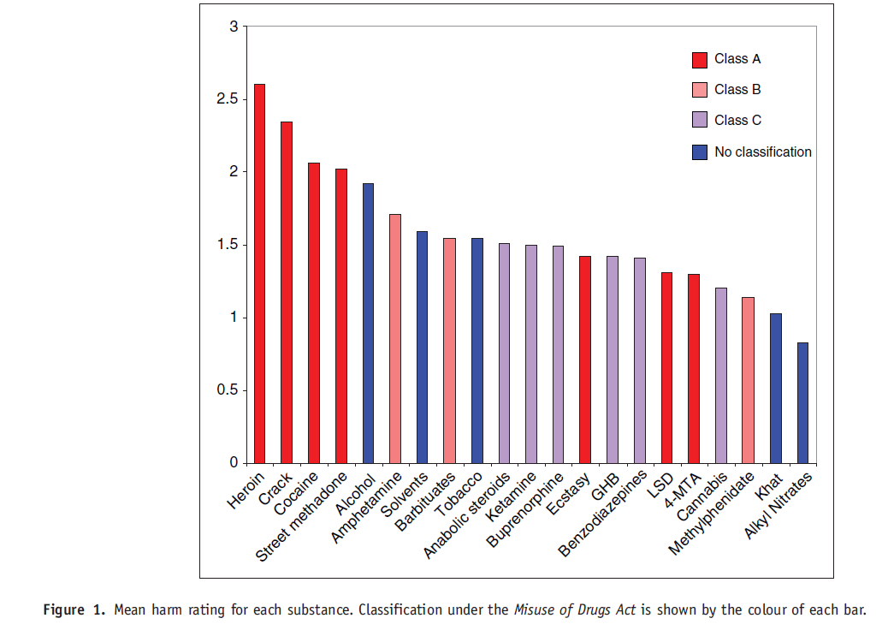
- In the Figure on the right (Source: Celia JA Morgan, Leslie Muetzelfeldt, Mark Muetzelfeldt, David J Nutt and H Valerie Curran. Harms associated with psychoactive substances: findings of the UK National Drug Survey. Journal of Psychopharmacology, 2010, Vol. 24, 147–153), experts who work with drug users (example, physicians, drug counsellors) and drug users are asked to rate their subjective opinion of the extent of harm caused by various drugs. The drug classification in Great Britain is colour coded. Thus, a Class A drug (example, heroin, cocaine, ecstasy, LSD) is considered to be very harmful by the UK government and its use is severely punished. By contrast, a Class C drug is considered to be only mildly harmful with minimal criminal punishment (example, cannabis). Other drugs are unclassified (i.e., either legalized or there is no law against their usage). The agreement between the experts and the users was very high. The results are summarized in the Figure. The participants in the survey rated heroin as the drug that caused most harm, followed by crack cocaine and then cocaine. Ecstasy and LSD, classified by the UK government as Class A drugs as very harmful were not considered to be particularly harmful by either the experts or the users.
- In the study above, experts and drug users were asked their opinions about drug harm. Nutt, King and Phillips (The Lancet, 2010) have provided an objective scale to quantify drug harm. This is based on many factors including physical harm to oneself (e.g., harm from a single dose –perhaps overdosing, harm from long-term use, risks of injecting), risk of dependence (e.g., extent of pleasure with use of the drug, psychological dependence, physical dependence) and social harm or harm to others (e.g. harm damage to property or to others following acute intoxication, social harm – damage to social & business networks, health costs).
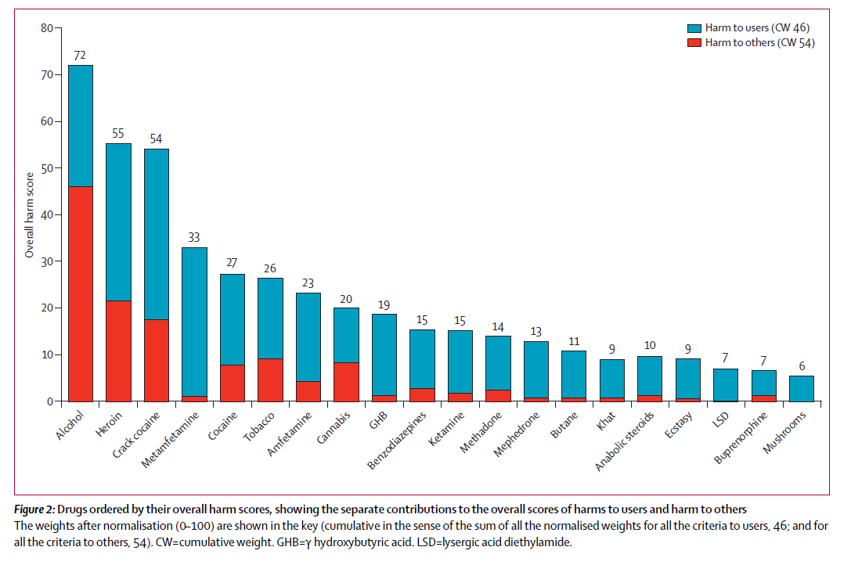
- The results are graphed below. Harm is computed both to the drug user and to others. Using this scale, alcohol a drug widely available in the UK (and in Canada) is the most harmful, especially to others. Yet it is legally available. By contrast, drugs such as ecstasy and LSD are considered to be far less harmful but carry a Class A rating (a high risk of harm) according to UK drug policy. Cannabis, a class B drug, is rated as moderately harmful by Nutt et al. You can thus see why D. Nutt’s results are so controversial!

