Lecture 1 – Intro
Main focus: intro and the industry
Biopharmaceuticals
- Biopharmaceutics: the study of the nature and properties of therapeutic substances and the relationship between these, dosages, and bioactivity
  - Includes:
    - Prescription drugs: small molecules, natural and unnatural peptides, vaccines
    - Natural health products (NHPs): vitamins, plant extracts
    - Diagnostics

- The pharmaceutical sciences are a group of interdisciplinary areas of study involved with the design and synthesis, mode of action, delivery, disposition, and use of drugs.

The Pharmaceutical Industry
- Purpose: to make a profit by supplying materials and techniques that deliver (or promise to deliver) the things that people desire most: GOOD HEALTH.
- Cure vs Prevention
- Major contributing factors:
  - Longevity: increased from about 50 to more than 80 years since the early 1900s.
    - HIGHER STANDARD OF LIVING –better food, safe water, pasteurized milk
    - Infrastructure (garbage removal), work safety, better education
    - Vaccines against communicable diseases (prevention),
    - Drugs, anti-bacterial, anti-hypertensive, cardiovascular drugs, other
    - Diagnostics: improved medical techniques
    - HEALTH CARE SPENDING does not contribute in a major way. US vs Canada vs Japan and Europe.
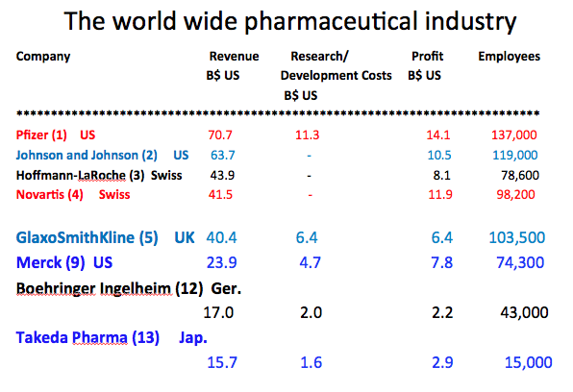
Most prescribed drugs (US)
- Hydrocodone (combined with acetaminophen) -- 131.2 million prescriptions
- Generic Zocor (Simvastatin), a cholesterol-lowering statin drug -- 94.1 million prescriptions
- Lisinopril (brand names include Prinivil and Zestril), a blood pressure drug -- 87.4 million prescriptions
- Generic Synthroid (levothyroxine sodium), synthetic thyroid hormone -- 70.5 million prescriptions
- Generic Norvasc (amlodipine besylate), an angina/blood pressure drug -- 57.2 million prescriptions
- Generic Prilosec (omeprazole), an antacid drug -- 53.4 million prescriptions (does not include over-the-counter sales)
- Azithromycin (brand names include Z-Pak and Zithromax), an antibiotic -- 52.6 million prescriptions
- Amoxicillin (various brand names), an antibiotic -- 52.3 million prescriptions
- Generic Glucophage (metformin), a diabetes drug -- 48.3 million prescriptions
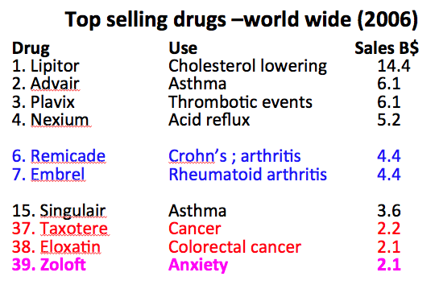
- Hydrochlorothiazide (various brand names), a water pill used to lower blood pressure -- 47.8 million prescriptions.

Top selling drugs
- Americans spent $307 billion on prescription drugs in 2010.
- Lipitor, a cholesterol-lowering statin drug -- $7.2 B
- Nexium, an antacid drug -- $6.3 B
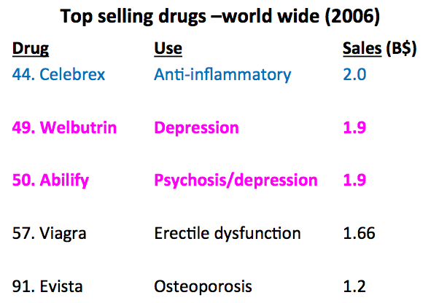
- Plavix, a blood thinner -- $6.1 B
- Advair Diskus, an asthma inhaler -- $4.7 B
- Abilify, an antipsychotic drug -- $4.6 B
- Seroquel, an antipsychotic drug -- $4.4 B
- Singulair, an oral asthma drug -- $4.1 B
- Crestor, a cholesterol-lowering statin drug -- $3.8 B
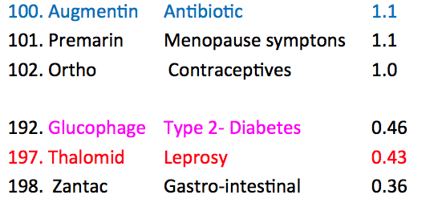
- Actos, a diabetes drug -- $3.5 B

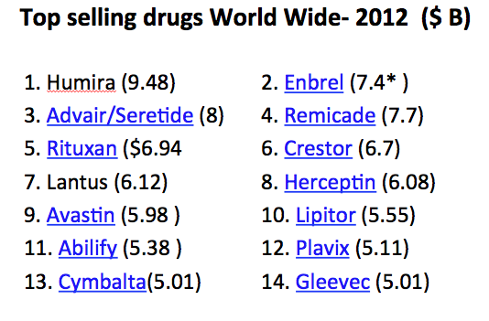
Infliximab, the active ingredient in REMICADE, is a chimeric IgG1κ monoclonal antibody (composed of human constant and murine variable regions) specific for human tumor necrosis factor-alpha (TNFα). It has a molecular weight of approximately 149.1 kilodaltons. Infliximab is produced by a recombinant cell line cultured by continuous perfusion and is purified by a series of steps that includes measures to inactivate and remove viruses.
ENBREL (etanercept) is a dimeric fusion protein consisting of the extracellular ligand-binding portion of the human 75 kilodalton (p75) tumour necrosis factor receptor (TNFR) linked to the Fc portion of human immunoglobulin (IgG1). Etanercept is produced by recombinant DNA technology in a Chinese hamster ovary (CHO) mammalian cell expression system. It consists of 934 amino acids and has an apparent molecular weight of approximately 150 kilodaltons. The compound features a square planar platinum(II) center. In contrast to cisplatin and carboplatin, oxaliplatin features the bidentate ligand 1,2-diaminocyclohexane in place of the two monodentate ammine ligands. It also features a bidentate oxalate group.
Bupropion belongs to the chemical class of aminoketones and is similar in structure to stimulants such as cathinone and amfepramone, and to phenethylamines

The Canadian Pharmaceutical Industry
- Canada represents about 3% of world pharmaceutical sales (2010); top 10 in the world
- Canadian Pharma is composed of R &D (78% of $ sales) and generic drug companies (22% of $ sales).
  - R & D companies are typically owned by multi-nationals; they develop new drugs
  - Generics are often Canadian companies which manufacture drugs after the R&D company patents have expired (20 years)
  - Total Pharma Research Expenses in 2010: 1.2B $
  - Total Pharma Employment in Canada - 27,000 + 35,000 indirect.
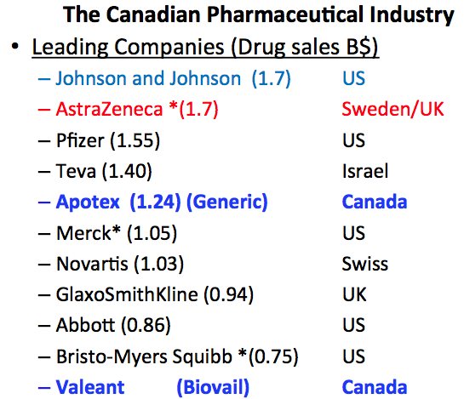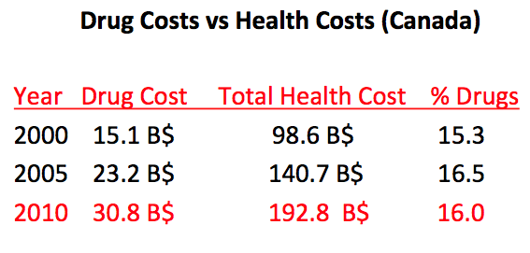

R&D vs Generic Drug Manufacturers
- R&D company drugs (Brand name drugs) cost more than generic drugs
  - Average brand name prescription cost: $72
  - Average generic prescription cost: $27
- Health Canada insures that the generic drugs are “bio-equivalent” with the brand name drugs.
- Approximate Cost to an R&D company to development a Brand Name Drug? ~ 700 M to 1.2B $
- Cost to a Generic company to show “Bioequivalence”?: ~ 10M $

New trends in the Pharmaceutical Industry
- Multinationals
  - Scaling back Research and Development in North America and Europe. Transfer to India and China
  - Much of Manufacturing of drugs is done in places like Eastern Europe, Ireland, Puerto Rico, India and China for cost reasons.
  - Quality control is a key issue : Good Manufacturing Practices (GMP)
- Clinical Trials are typically done in Canada, US and Europe to satisfy the requirements of Health Canada, US Food and Drug Agency and The European Agency
- Final formulations, packaging done in home country
- Research intensive start-up companies.
  - Small companies begin developing potential new treatments often based on the results of academic research.
  - Limited resources, but typically sufficient to identify a serious drug candidate or treatment and bring it to the point of initiating clinical trials
  - Many such companies exist in Canada (Montreal, Toronto, Vancouver, Ottawa, Calgary, Edmonton, Saskatoon)
  - Need to partner with a larger company with much greater financial resources to proceed with the more expensive clinical trials
- Research intensive start-up companies.
  - Small companies begin developing potential new treatments often based on the results of academic research.
  - Limited resources, but typically sufficient to identify a serious drug candidate or treatment and bring it to the point of initiating clinical trials

Contract Research Organizations (CRO)
- Provide research support for Pharma R&D
- Two major types
  - Chemical synthesis
    - Supplies the industry with starting materials, intermediates and often the final product (Active Pharmaceutical Ingredient [API] )
    - Very competitive
    - Needs to follow Good Manufacturing Practices (GMP) and Good Laboratory Practices (GLP)
    - Companies often have specialized capabilities
  - Biological studies.
    - Typically carry our biological evaluations using animal models
    - Includes, toxicity, metabolism, pharmacokinetic, bioavailability studies {ADME studies: Absorption, Distribution, Metabolism, Excretion

Canadian Biotechnology
- B.C. is recognized as one of Canada’s most successful biotechnology centres and is home to 30 per cent of the country’s biotech firms. The sector includes roughly 250 biopharmaceutical, medical device, bio-products and bio-energy companies that provide more than 5,000 jobs, including the 2,000 people working at public sector research agencies.
- Other Canadian Biotech/Biopharm hot spots: Montreal, Ottawa, Toronto, Saskatoon, Edmonton

New trends in the Pharmaceutical Industry
- Diagnostics and Personalized Medicines.
  - Examples: Breast cancers, Blood clotting
  - Globe and Mail Sept 4, 2013: Merger creates Canada’s largest Diagnostics Company (4th largest world wide)

Academic research
- Much research with potential in the health field is carried out at Universities and Medical Schools and Hospital Research Institutes.
- In Ottawa: Faculty of Science, Faculty of Medicine, Ottawa Hospital Research Institutes, U of O Heart Institute
- Converting Academic research to “commercial products”

Converting Academic Research to Commercial Products
- Academic researchers license their discovery to a pharmaceutical company, they start new companies
- Academic researchers team with focused Government-Industry Institutes to develop the idea (product) to the point where larger companies are interested in acquiring the “intellectual property” (IP) and develop it into a commercial product

Academic research -> commercial products
- Government/Industry Research Institutes
- Mandate: to take promising academic research, carry out additional research to verify the potential and increase IP
- Eventual Goal: License or sell the research results (IP) to a larger company for further development
  - Ontario Institute for Cancer Research (Toronto)
  - Center for Drug Research and Development (BC)

