3 Homeostasis: Introduction to the Autonomic Nervous System and Endocrine System

3.1 Define and identify the main characteristics of homeostasis (pp.8-11)

3.1.1 Define homeostasis, giving at least 2 physiological examples

Homeostasis

- Body contains trillions of cells, and what a marvelous machine you body is
- Walter Cannon, an American physiologist of the twentieth century, spoke of the “wisdom of the body”, and he coined the word homeostasis to describe its ability to maintain relatively stable conditions even though the outside world changes continuously.
- Walter Cannon: ability of the body: “to maintain relatively stable internal conditions even though there is continuous change in the outside world”
- Not unchanging - rather a dynamic state of equilibrium involving many systems:
- Adequate blood levels of vital nutrients
- Heart activity/blood pressure monitored & adjusted as needed
- Wastes must not accumulate
- Body temperature
- Although homeostasis is translated to unchanging, the term does not really mean a static, or unchanging, state.
- It indicates a dynamic state of equilibrium, or a balance, in which internal conditions vary, but always within relatively narrow limits
- The body is in homeostasis when its needs are adequately met and it is functioning smoothly
- Maintaining homeostasis is virtually every organ system plays role in maintaining the constancy of the internal environment.
- Adequate blood levels of vital nutrients must be continuously present
- Heart and blood pressure must be constantly monitored and adjusted so that the blood is propelled to all blood tissue.
- Waste must not be able to accumulate and body temperature must be precisely controlled.
- Wide variety of chemical, thermal, and neutral factors act and interact in complex ways
- Sometimes helping and hindering the body as it works to maintain its “steady rudder”

3.1.2 List the 3 essential components of a homeostatic control mechanism, defining the roles of each

Homeostatic Control

- Communication with the body is essential for homeostasis
- And this is accomplished chiefly by the nervous and endocrine systems, which use neutral electrical impulses or blood-borne hormones, respectively as information carries
- The variable, the factor or event being regulated all homeostatic control mechanisms are processes involving at least components that work together
- Receptor is some type of sensor that monitors the environment and responds to changes, called stimuli, by sending information (input) to the second component, the control center.
- Input flows form the receptor to the control center along the so-called afferent pathway
- The Control Centre determines the set point, which is the level or range at which a variable is to be maintained.
- It also analyzes the input it receives and determines the appropriate response or course of action
- Information (output) then flows from the control center to the third component the effector along the efferent pathways

- Difference between Afferent and Efferent: Afferent pathway approaches the control center and Efferent information exits from the control center
- The Effector provides the means for the control center’s response (output) to the stimulus
- The results of the response than feed back to influence the effect of the stimulus, either reducing it (in negative feedback) so that the whole control process is shut off, or enhancing it (in positive feedback) so that the whole process at an even faster rate

3 essential characteristics:

- Receptor: senses change (stimulus) & sends info (afferent pathway) to:
- Control centre: determines set point for variable maintenance; analyzes info & determines
Correct response
- Effector: provides means for response (output along efferent pathway)
- Feedback (negative/positive) allows for regulation within a range/enhanced response

3.1.3 Differentiate between positive and negative feedback; define disease and aging in terms of homeostasis

Negative Feedback Mechanism

- Homeostatic control mechanisms are negative feedback mechanism.
- In these systems, the output shuts off the original effect of the stimulus or reduces its intensity.
- These mechanisms cause the variable to change in a direction opposite to that of the initial change, returning it to its “ideal “ value
- Ex. Of nonbiological negative feedback system: home heating system connected to a temperature-sensing thermostat. It houses both the receptor (thermometer) and the control center. If the thermostat is set at 20 degrees Celsius, the heating system is triggered on if it drops below that setting. As heat is produced by furnace the temperature rises and when it reaches 20 degrees or slightly more, the thermostat triggers furnace off. This process results in the cycle form the furnace turning off and on so that the temperature stays near the desired temperature.
- Your body “thermostat”, located in a part of your brain is called the hypothalamus, operates in a similar function
- Regulating of body temperature is only one of the way the nervous system maintains the constancy of the internal environment
- Another type of neural control mechanism us seen in the withdrawal reflex mentioned earlier, in which the hand is jerked away from a painful stimulus as broken glass.
- Output reduces or shuts off stimulus – 2 options:
- 1 hormone or neural pathway regulating a process: negative feedback ↓ secretion
- Process regulated in opposite directions by 2 different hormones or neural pathways – e.g: blood glucose
- Goal of negative feedback: prevent sudden, severe changes

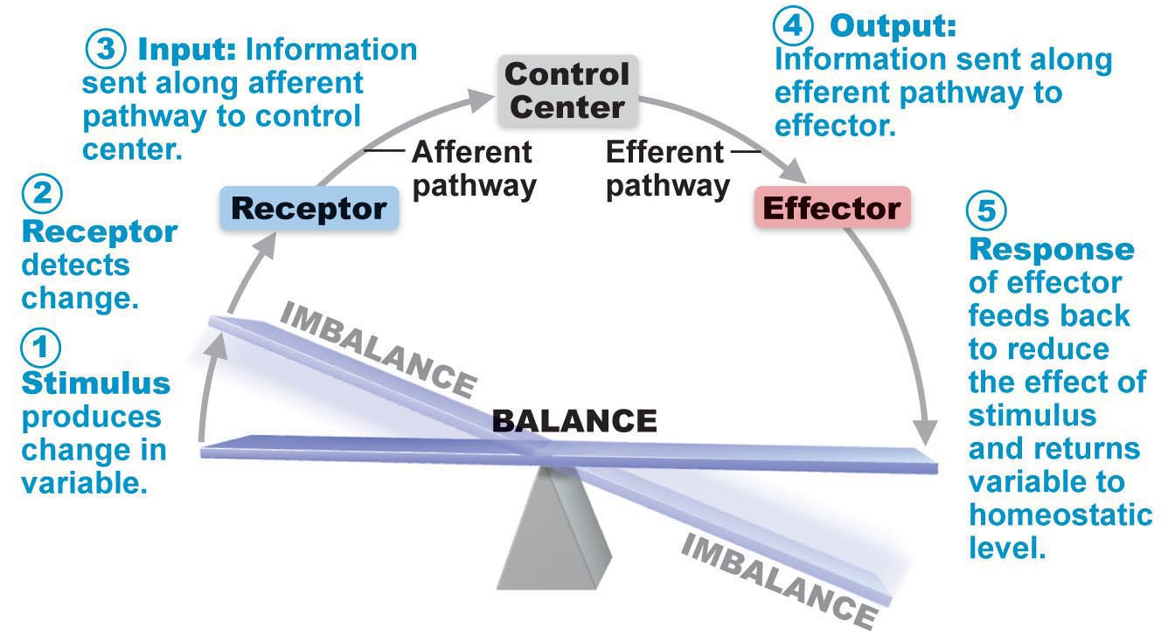
Figure 1.4 Interactions among the elements of a homeostatic control system maintain stable internal conditions

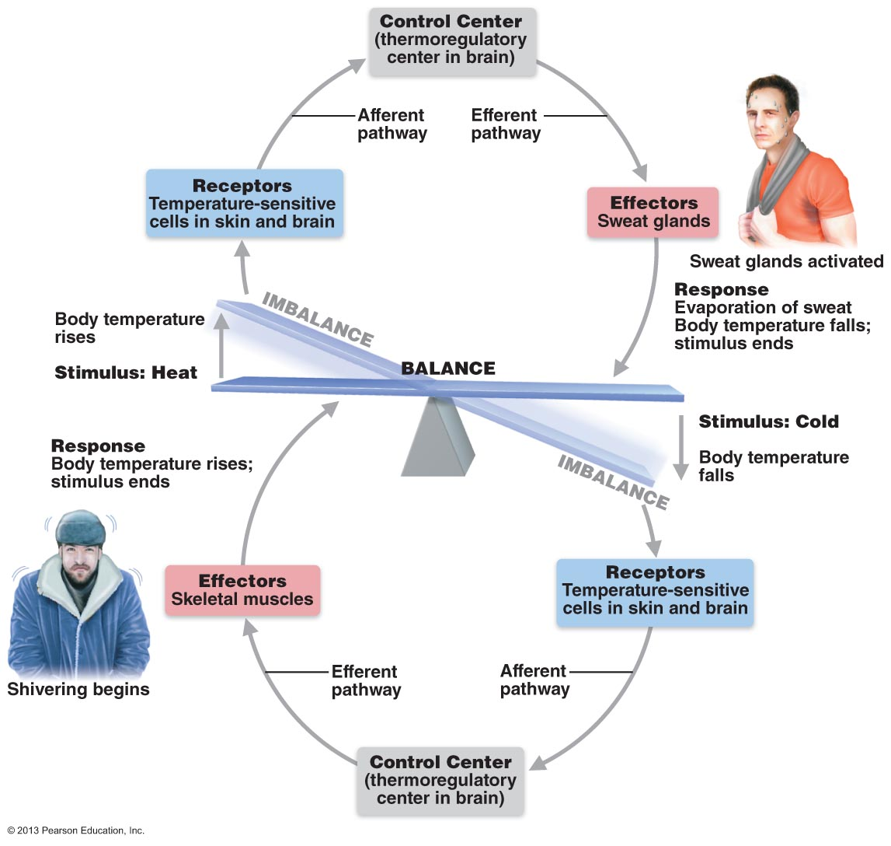

Figure 1.5 Body temperature is regulated by a negative feedback mechanism
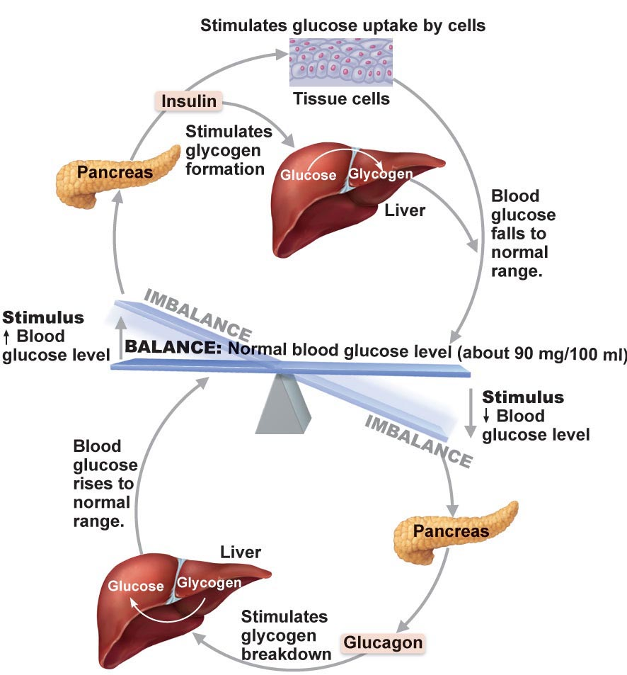

Figure 2 On slide #4 (negative feedback mechanism)

- The endocrine system is equally important in maintaining homeostasis.
- Good example of hormonal negative feedback mechanism is the control of blood sugar (glucose) by insulin.
- As the blood sugar tries to rises, receptors in the body sense this change, and the pancreas (the control center) secretes insulin into blood.
- This change in return prompts body cells to absorb more glucose, removing it from the bloodstream.
- As the blood sugar falls, the stimulus for insulin release ends.
- The body’s ability to regulate its internal environment is fundamental
- All negative feedback mechanism have the same goal:
- Preventing sudden severe changes within the body
- Body temperature and blood volume are only two of the variables that need to be regulated
- Other negative feedback mechanisms:
- Regulate heart rate
- Regulate blood pressure
- Regulate the rate and depth of breathing
- Regulate blood levels of oxygen, and carbon dioxide, and minerals

Positive feedback mechanism

- The result or response enhances the original stimulus so the response is accelerated
- This feedback mechanism is positive because of the change that results proceeds in the same direction as the initial change, causing the variable to deviate further and further from its original value or range
- In contrast to the negative feedback controls, which maintain some physiological function or keep blood chemicals within narrow ranges, positive feedback mechanisms usually control infrequent events that do not require continuous adjustments.
- They set off the series of the events that may be self-perpetuating and that, once initiated, have amplifying or waterfall effect
- Because these characteristics, positive feedback mechanisms are often referred to as cascades (from the Italian word meaning “to fall”)
- Two familiar examples of their use as homeostatic mechanisms are:
- The enhancement during labor contractions during birth and blood clotting
- In chapter 28 describes the positive feedback mechanism in which oxytocin, a hypothalamus hormone, intensifies labor contractions during the birth of a baby
- Oxytocin causes the contractions to be released, which causes more contractions, and so on until the baby is finally born. The birth ends the stimulus for oxytocin release and shuts off the positive feedback mechanism.
- Blood clotting is a normal response to a break in the wall of a blood vessel and is an excellent example of an important body function controlled by positive feedback mechanism
- Once a vessel has been damaged, blood elements called platelets immediately begin to cling to the injured site and release chemicals that attract more platelets.
- This growing pileup of platelets temporarily “plugs” the tear and initiates the sequence of events that finally forms a clot.
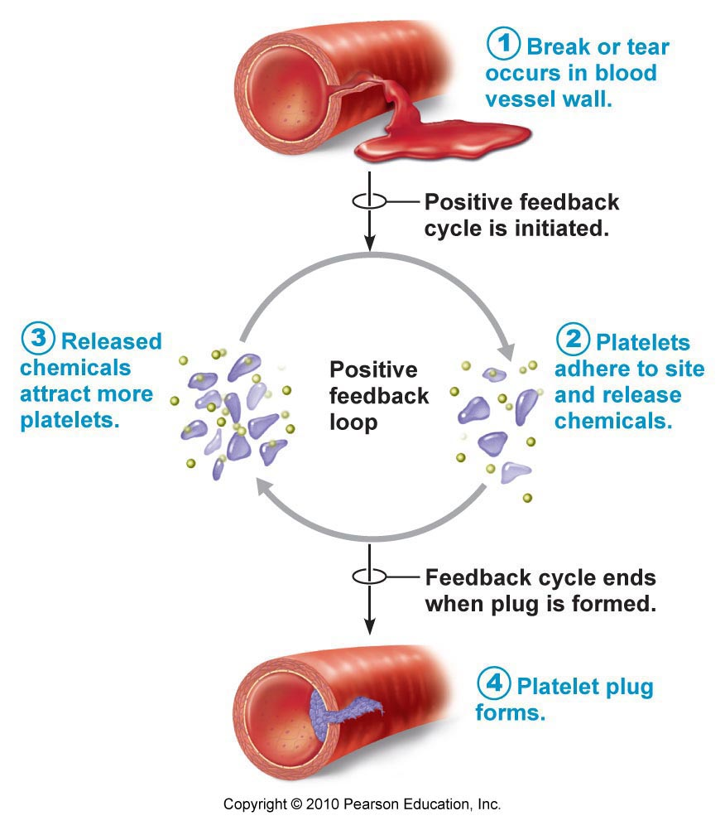
Figure 1.6 A positive feedback mechanism regulates formation of a platelet plug

- PFM are likely to race out of control, so they are rarely used to promote the moment-to-moment well-being of the body.
- Some PFM including this one may have local reach
- For ex. Blood clotting is accelerated in injured vessels, but does not normally spread to the entire circulation

Positive Feedback
Mechanism
• Response of mechanism enhances original stimulus  output is further stimulated
• Change occurs in same direction as original response
• Goal to be attained
• E.g: blood clotting - how is this still, overall, maintaining homeostasis??

Homeostatic Imbalance
- Homeostasis is very important and as a result disease can be considered as a result of its disturbance, a condition called homeostatic imbalance.
- So basically as we age our body becomes less efficient, and our internal environment becomes less and less stable.
- These events increase our risk for illness and produce the changes we associate with aging
- Another source of homeostatic imbalance occurs when the usual negative feedback mechanisms are overwhelmed and destructive positive feedback mechanisms take over.
- Some instances if heart failure reflect this phenomenon
Homeostatic Imbalance
- Most disease seen as a disturbance of homeostasis = homeostatic imbalance
- Aging associated with progressive decrease in our ability to maintain homeostasis greater risk for illness

3.2 Introduction to the Nervous System (pp. 525-527, 535-538)

3.2.1 compare the autonomic and somatic nervous system

Comparison of the Somatic and Autonomic Nervous System
- Differences between the somatic and autonomic systems as well as areas of functional overlap
- Both systems have motor fibers, but somatic and autonomic nervous system differ in: (1) their effectors, (2) their efferent pathways and ganglia, and (3) target organ responses to their neurotransmitters
3.2.1.1 Using a flowchart, indicate the positions of the autonomic and somatic nervous systems in the structural organization of the nervous system as a whole
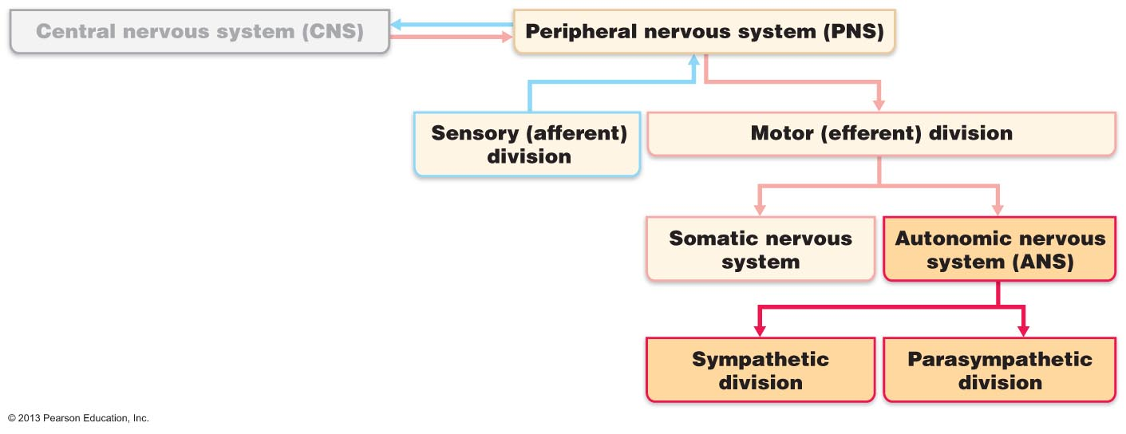
Figure 14.1 Place of the ANS in the structural organization of the nervous system

• Auto = self; nom = govern
• ANS = system of motor neurons to smooth & cardiac muscle & glands to allow responses usually without our awareness

  - Shunt blood to more needy areas
  - Speed/slow heart & respiratory rates
  - Adjust blood pressure, body temp
  - Increase/decrease gastric secretions

- Effectors: The somatic nervous system stimulates skeletal muscles, whereas the ANS innervates cardiac and smooth muscle and glands. Differences in the physiology of the effector organs account for most of the remaining differences between somatic and autonomic effect on their target organs
- Efferent pathways and Ganglia
- In the somatic nervous system the motor neurons are in the CNS, and their axons are extend in the spinal or cranial nerves all the way to the skeletal muscles they activate. Somatic motor fibers are typically thick, heavily myelinated group A fibers that conduct nerve impulses rapidly
- In contrast the ANS use two neurons chain to react to reach its effectors:
- The cell body of the first neuron, the preganglionic neuron, resides in the brain or spinal cord. Its axon, the preganglionic axon, synapses with the second motor neuron.
- Postganglionic neuron (ganglionic neuron) is the second motor neuron. It cell body is an autonomic ganglion outside the CNS. Its axon, the postganglionic axon, extends to the effector organ.
Preganglionic axons are thin, lightly myelinated fibers, and postganglionic axons are even thinner and nonmyelinated.
- Conduction through the autonomic efferent chain is slower than the conduction in the somatic motor system.
- The pre. and post. Fibers are incorporated in the spinal and cranial nerves
- The autonomic ganglia are motor ganglia, containing cell bodies of motor neurons, they are the sites of synapse and information transmission from preganglionic to postganglionic neurons
- Somatic motor division lacks ganglia entirely
- The dorsal root ganglia are part of the sensory, not the motor, division of PNS

Neurotransmitter Effects
- All somatic motor neurons release acetylcholine at their synapses with skeletal muscle fibers.
- The effect is always excitatory, and if stimulation meets threshold, the muscle fibers contract
- Autonomic postganglionic fibers release two neurotransmitters: norepinephrine (NE) secreted by most sympathetic fibers, and Ach secreted by parasympathetic fibers
- Depending on the type of receptors on the target organ, the effect may be excitatory or inhibitory.

Overlap of Somatic and Autonomic Function
- Higher brain centers regulate and coordinate both somatic and autonomic motor activities, and most spinal nerves (and many cranial nerves) contain both somatic and autonomic nerves
- Moreover, most of the body’s adaptations to changing internal and external conditions involve both skeletal muscles and visceral organs
- For ex. When skeletal muscles are working hard, they need more oxygen and glucose, so control mechanisms speed up heart rate and dilate airways to meet these needs and maintain homeostasis
- ANS does not act in isolation, it is only one part of our highly integrated nervous system
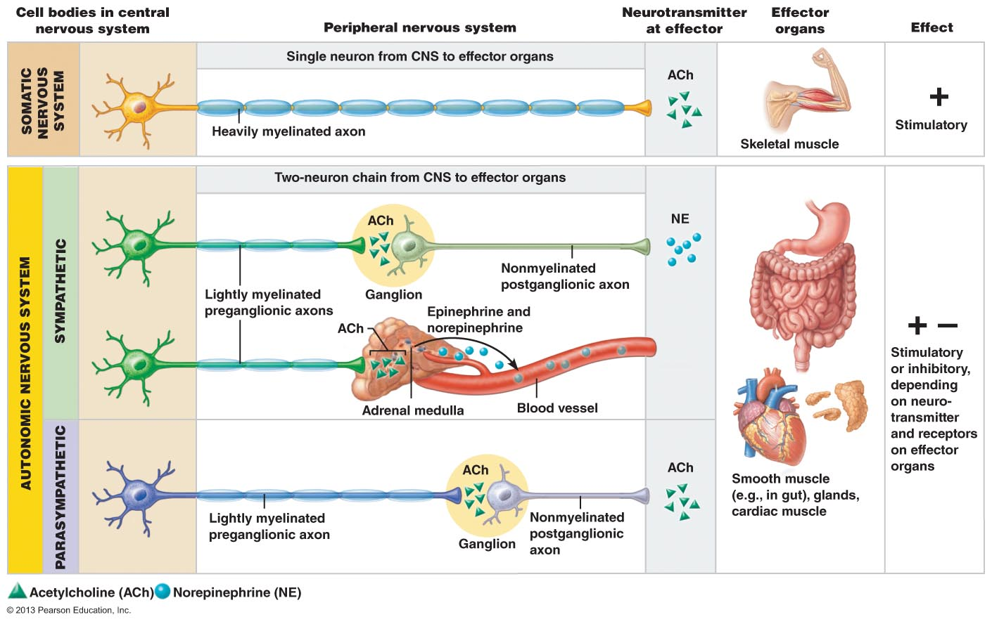

Figure 14.2 Comparison of motor neurons in the somatic and autonomic nervous system

3.2.2.1 Distinguish between the PNS and SNS in terms of the types of processes regulated

ANS Divisions

- ANS has two arms, parasympathetic and sympathetic
- The parasympathetic division promotes maintenance functions and conserve body energy, whereas the sympathetic division mobilizes the body during activity
- Serve the same visceral organs but cause opposite: while one division stimulates certain smooth muscles to contract or a gland to secrete, the other division inhibits that action.
- Through this dual conservation, the two divisions counterbalance each other to keep body systems running smoothly

Role of the parasympathetic Division

- Parasympathetic division, sometimes called the “rest and digest” system, keeps body energy use as low as possible, even as it directs vital “housekeeping” activities like digesting food and eliminating feces and urine.
- (This explains why it is a good idea to relax after a heavy meal: so sympathetic activity does not interfere with digestion)
- Parasympathetic activity is best illustrated in a person who relaxes after a meal and reads a magazine.
- Blood pressure and heart rate are regulated at low normal levels, and the gastrointestinal tract is actively digested food.
- In the eyes, the pupils are constricted and the lenses are accommodated for close vision to improve the clarity of the close-up image (such as magazine)

Role of the Sympathetic Division

- The activity of the sympathetic division (often called the “fight-or-flight system”) is evident when we are excited or find ourselves in emergency or threating situations, such as being frightened by street toughs late at night.
- A rapidly pounding heart; deep breathing; dry mouth, cold, sweaty skin, and dilated eye pupils are sure signs of sympathetic nervous system mobilization
- During any physical activity, the sympathetic division also promotes a number of other adjustments
- It:
- Constricts visceral (and sometimes cutaneous) blood vessels, shunting blood to active skeletal muscles and the vigorously working heart
- Dilates the bronchioles in the lungs, increasing ventilation (and thus increasing oxygen delivery to body cells)
- Causes the liver to release more glucose into the blood to accommodate the increased energy needs of body cells

- At the same time the sympathetic division temporarily damps nonessential activities, such as gastrointestinal tract motility
- Ex. If you are running mugger, digesting lunch can wait, it is better to give your muscles all the energy it needs in order to get out of danger
- In active situations the sympathetic division generates a head of steam that enables the body to cope with the situation that threaten homeostasis.
- Provides optimal conditions for an appropriate response threat.
- Parasympathetic division is D division (digestion, defecation, and diuresis (urination)
- Sympathetic division as E division (exercise excitement, emergency, embarrassment)
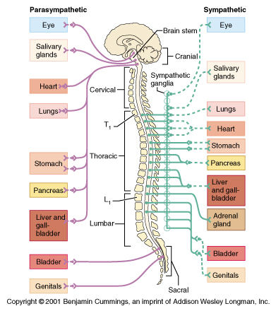
Figure 14.3 the subdivision of the ANS

Interactions of the Autonomic Divisions

- Most visceral nerves receive dual innervation from both the parasympathetic and sympathetic divisions
- Both ANS divisions are partially active
- Action potential continually fire down both sympathetic and parasympathetic axons, producing a dynamic antagonism that precisely control visceral activity. However, one division or other usually predominates in given circumstances, and in a few cases.
- Two divisions actually cooperate with each other

Antagonistic Interaction
- Antagonistic effects, described earlier, are most clearly seen on the activity of the heart, respiratory system, and gastrointestinal organs. In a fight-or-flight situation, the sympathetic division restores heart rate and airway diameter to resting levels and then attends to processes that refuel your body cells and discard wastes

Sympathetic and Parasympathetic Tone
- We have described the parasympathetic division as the “ rest and digest” division, but the sympathetic division is the major actor in controlling blood pressure, even at rest.
- Few exceptions, the vascular system is entirely innervated by sympathetic fibers that keep the blood vessels in a continual state of partial constriction called sympathetic, or vasomotor, tone
- When blood pressure is too low to maintain blood flow, the sympathetic fibers fire more rapidly, causing blood vessels to constrict and raining blood pressure
- When blood pressure too high, sympathetic fibers fore less rapidly and the vessel dilate
- Alpha blockers, drugs that block the response in these vasomotor fibers, are sometimes used to treat hypertension (high blood pressure)
- During circulatory shock (inadequate blood flow to body tissues), or when more blood is needed to meet the soaring needs of working skeletal muscles, blood vessels serving the skin and abdominal viscera strongly constrict.
- Blood shunting helps maintain circulation to vital organs and skeletal muscles.
- Sympathetic division’s dominance of blood vessels, parasympathetic effects normally dominate the heart the smooth muscle of digestive and urinary tract organisms.
- These organs exhibit parasympathetic tone. The parasympathetic division slows the heart and dictates the normal activity levels of the digestive and urinary tract
- Sympathetic can override parasympathetic time of stress
- Drugs that block parasympathetic division increase heart rate and cause fecal and urinary retention
- Parasympathetic fibers activate most glands, except for adrenal glands and sweat glands of skin.

Cooperative effects
- The best example of cooperative ANS effects occurs in the external genitalia.
- Parasympathetic stimulation dilates blood vessels in the external genitalia
- Producing the erection of the male penis or female clitoris during sexual excitement
- Sympathetic stimulation then causes ejaculation of semen by the penis or reflex contractions of the vagina

Homeostatic Imbalance
- Autonomic neuropathy (damage to autonomic nerves) is a common complication of diabetes mellitus
- Earliest and troubling symptoms sexual dysfunction
- 75% of male diabetes experience erectile dysfunction
- Female diabetes often experience reduced vaginal lubrication
- Frequent manifestation of autonomic neuropathy include dizziness after standing suddenly (poor blood control), urinary incontinence, sluggish eye pupil reactions, and impaired sweating
- Maintaining tight control of blood glucose levels is the best way to prevent diabetic neuropathy

Unique Roles of the Sympathetic Division
- The adrenal medulla, sweat glands and arrector pili muscles of the skin, the kidneys, and most blood vessels receive only sympathetic fibers
- The sympathetic system innervates these structures because most of us sweat under stress, our scalp “prickles” during fear, and our blood pressure skyrockets when we get excited

Thermoregulatory Response to Heat
- Sympathetic division mediates reflexes that regulate body temperature
- Ex applying heat to the skin causes blood vessels in that are to dilate reflexively
- When systemic body temperature rises, sympathetic nerves
- Dilate skin’s blood vessels, allowing heat to escape from skin flushed with warm blood
- Activate the sweat glands to help cool the body, preventing heat loss from the skin.

Release of Renin From the Kidneys
- Sympathetic impulses stimulate the kidneys to release renin, an enzyme that causes the formation of blood pressure-increasing hormones

Metabolic effects
- Through both direct neural stimulation and release of adrenal medullary hormones, the sympathetic division promotes a number of metabolic effects not reversed by parasympathetic activity.
- It increase the metabolic rate of body cells
- Raises blood glucose levels
- Mobilizes fats for use as fuels
- Medullary hormones also cause skeletal muscle to contract more synchronously
- Neural bursts, which put muscle contractions on a “hair trigger”

Localized Versus Diffuse Effects
- In parasympathetic division, one preganglionic neuron synapses with one postganglionic neurons
- Additionally, all parasympathetic fibers release ACh, which is quickly destroyed by acetylcholinesterase.
- Parasympathetic division exerts short-lived, highly localized control over its effector
- Sympathetic division, preganglionic axons branch profusely as they enter sympathetic trunk, the synapse with post ganglionic neurons at several levels
- The sympathetic system’s neurotransmitter, Ne is inactivated more slowly then the parasympathetic system’s ACh, because NE must be taken back up into the presynaptic ending before being hydrolyzed or stored
- Epinephrine is potent at increasing heart rate

Control of Autonomic Function

- Although the ANs is not usually considered to be under voluntary control, its actively is regulated by CNS controls in the spinal cord, brain stem, hypothalamus, and cerebral cortex
- Hypothalamus is the integrative center at the top of the ANS control hierarchy
- Orders flow to lower and lower CNS centers for execution
- Cerebral cortex may modify the workings of ANS
- It does so at the subconscious level and by acting through limbic system structures on hypothalamus centers

Brain Stem and Spinal Cord Controls

- The hypothalamus is the “boss”, but the brain stem reticular formation appears to exert the most direct influences over autonomic functions
- Ex. Certain motor centers in the ventrolateral medulla (cardiac and vasomotor center) reflexively regulate heart rate and blood vessel diameter
- Sensory impulses involved in these autonomic reflexes reach the brain stem via vagus nerve afferents
- Midbrain centers control the muscles concerned with pupil diameter and lens focus
- Defecation and micturition reflexes the empty the rectum and urinary bladder are integrated at the spinal cord level but are subject to conscious inhibition

Hypothalamic Controls
- Hypothalamus is the main integration center of the autonomic nervous system
- Anterior hypothalamic regions direct parasympathetic functions, and posterior areas direct sympathetic functions
- Hypothalamic center exert their effects both directly and via relays through the reticular formation
- In turn influences the preganglionic motor neurons in the neuron the brain stem and spinal cord.
- Hypothalamus acting through ANS, coordinates heart activity, blood pressure, body temperature, water balanced and endocrine activity
- Hypothalamus also mediates our reaction to fear via its association with the amygdala and the periaqueductal gray matter

Cortical Controls
- Influence of the biofeedback on Autonomic function:
Biofeedback is a way of becoming aware of physiological conditions (such as heart rate and blood pressure), with the goal of being able to influences them consciously
During biofeedback training, subjects are connected to monitoring devices that detect and amplify changes in these physiological processes.
The feedback comes in the form of flashing lights and audible tones
Involuntary function by concentrating on calming, pleasant thoughts
Biofeedback techniques have been successful in helping individuals plagued by migraine headaches
Cardiac patients also use them to manage stress and reduce their risk of heart attack

Hypertension, or high blood pressure may result from an overactive sympathetic vasoconstrictor response promoted by continuous high levels of stress. Hypertension is always serious because it forces the heart to work harder, which may precipitate heart disease, and increases the wear and tear on artery walls. Hypertension is sometimes treated with adrenergic receptor-blocking drugs that counteract the effects of the sympathetic nervous system on the cardiovascular system

3.3 Endocrine System

3.3.1 Describes the Different Structural Classes of Hormones; Using the Cycle AMP Messenger System As A Example, Distinguished Between the Mechanism of Action of Protein/Peptide Hormones versus Steroid Hormones

- The nervous system regulates the activity of muscles and glands via electrochemical impulses delivered by neurons, and those organs respond within milliseconds
- The means of control and speed of the endocrine system are very different: The endocrine system influences metabolic activity by means of hormones.
- Hormones are chemical messengers travel through the blood and regulate the metabolic function of other cells in the body
- Binding the hormone to cellular receptors initiates responses that typically occur after a lag period of seconds or even days
- Hormones ultimately target most cells of the body producing a widespread and diverse effects
- The major processes control and integrate are:
- Reproduction
- Growth and Development
- Maintenance of electrolyte, water and nutrient balance of the blood
- Regulation of cellular metabolism and energy balance
- Mobilization of body defenses

- The scientific study of hormone and the endocrine organs is called endocrinology
- Endocrine organs are widely scattered about the body
- Exocrine glands: produce nonhormonal substances, such as sweat and saliva, and have ducts that carry these substances to a membrane surface
- Endocrine glands (ductless glands): produce hormones and lack ducts. They release their hormones into the surrounding tissue fluid, and they typically have a rich vascular and lymphatic drainage that receives their hormones
- Hormone producing cells in endocrine glands are arranged in cords and branching networks, situation that maximizes contact between them and the capillaries surrounding them

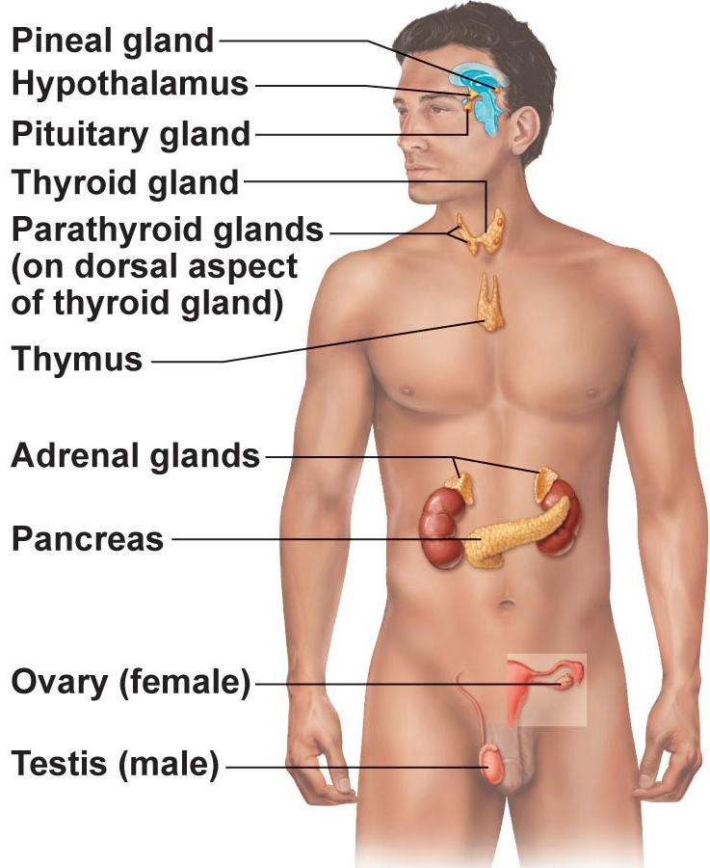
Figure 16.1 Location of selected endocrine organs of body
What is a hormone?
Chemical substance released into the ECF that regulates the metabolic function of other cells in the body
Remember:
• Hormones must bind to specific receptors to influence target cell
Function
• Hormones are specific; level of target cell activation depends on:
  - Hormone concentration
  - Target cell receptor content
  - Affinity of hormone for receptor

- The endocrine glands include the pituitary, thyroid, parathyroid, adrenal, and pineal glands
- The hypothalamus, along with its neural functions, produces and releases hormones, so we can consider the hypothalamus a neuroendocrine organ
- Several organs such as the pancreas, ovaries and testes, and placenta all contain endocrine tissue and also perform other functions

- Adipose release leptin, the thymus releases thymic hormones
- Autocrines are chemicals that exert their effects on the same cells that secrete them. Ex certain prostaglandins released by smooth muscle cells cause those smooth muscle cells to contract
- Paracrines also act locally (within same tissue) but affect cell types other than those releasing the paracrine of chemicals. Ex. Somatostatin released by one population of pancreatic cells inhibits the release of insulin by a different population of pancreatic cells

Hormones

The Chemistry of Hormones

- Amino acid based: Most hormones are amino acid based. Molecular size varies widely in this group from simple amino acid derivatives, to peptides, to proteins
- Steroids: Steroid hormones are synthesized from cholesterol. Of the hormones produced by the major endocrine organs, only gonadal and adrenocortical hormones are steroids
- Eicosanoids which include leukotrienes and prostaglandins
- Leukotrienes are signaling chemicals that mediate inflammation and some allergic reaction
- Prostaglandins have multiple targets and effects, ranging from raising blood pressure and increasing the expulsive uterine contractions of birth to enhancing blood clotting, pain and inflammation

Mechanism of Hormone Action
- Hormones influence the activity of only those cells that have receptors for it. These are called target cells.
- Hormones bring about their characteristics effects by altering target cell activity
- They increase and decrease the rates of normal cellular processes
- A hormone typically produces on or more of the following changes:
- Alters plasma membrane permeability or membrane potential, or both, by opening or closing ion channels
- Stimulates synthesis of enzymes and other proteins within the cell
- Activates or deactivates enzymes
- Induces secretory activity
- Stimulates mitosis

Mechanism of Hormone Action:
• Hormones alter levels of cell activity:
» Membrane permeability/potential (channels)
» Synthesis of enzymes within cells
» Enzyme activation/deactivation
» Induction of secretory activity
» Stimulation of mitosis

3 structural groups of hormones:
  - Amino acids, peptides, proteins
  - Steroid hormones (derivatives of cholesterol)
  - Eicosanoids (from arachadonic acid)

- Hormones communicate with target cells … this depends on the chemical nature of the hormone and the cellular location of the receptor.
- In general, hormones act at receptors in one of two ways
- Water-soluble hormones (all amino acid-based hormones except thyroid hormones) act on receptors in the plasma membrane. These receptors are usually coupled via regulatory molecules called G proteins to one or more intracellular second messengers which mediate the target cell’s response
- Lipid-soluble hormones act on receptors inside the cell, which directly activate genes
- Receptors for water-soluble hormone must be in plasma membrane because they cannot enter the cell
- Receptors for lipid-soluble steroid and thyroid hormones are inside the cell because these hormones can enter the cell

Plasma Membrane Receptors and Second-Messenger Systems
- Second messengers generated when a hormone binds to a receptor in the plasma membrane, cyclic AMP (cAMP), which is used by neurostransmitter and olfactory receptors
- The Cyclic AMP Signaling Mechanism: this mechanism involves the interaction of 3 plasma membrane components they are hormone receptor, a G protein and an effector enzyme (adenylate cyclase). The to determine intracellular levels of cyclic
- Hormones binds receptor acting as the first messenger, binds to its receptor in the plasma membrane.
- Receptor activates G protein. Hormone binding causes the receptor to change shape. Allowing them to bind to an inactive G protein. The protein is activated, as the guanosine diphosphate (GDP) bound to it is displaced by the high-energy compound GTP. This behaves like a light witch: It is “off” when GDP is bound to it, and “on” when GTP is bound
- G protein activates adenylate cyclase G protein binds to effector enzyme adenylate cyclase, g protein stimulates adenylate cyclase but others inhibit it. Eventual the gtp bound to g is hydrolyzed to g and the g protein becomes inactive once again
- Cyclic AMP activates protein kinases cAMPs triggers a cascade of chemical reactions by activating protein kinases
Protein kinases are enzymes that phosphorylate add a phosphate group to various proteins, many of which are other enzymes

- Intracellular enzyme phosphodiesterase
2 main mechanisms of action:

- Peptide/protein hormones: bind to cell surface receptor » activation of membrane-bound G protein » production of 2nd messenger (e.g: cyclic AMP (cAMP), calcium) activation of protein kinases to regulate activity of key enzymes

Control of Hormone Release
- The synthesis and release of most hormones are regulated by some type of negative feedback mechanism,

Endocrine Gland Stimuli
- Three types of stimuli trigger endocrine glands to manufacture and release their hormones: humoral, neural and hormonal stimuli
- Hormonal Stimuli: Secrete their hormones in direct response to changing blood levels of certain critical ions and nutrients.
- These stimuli are called humoral stimuli
- Simplest endocrine controls
- Hormones released in response to humoral stimuli include insulin, produced by the pancreas and aldosterone one of the adrenal cortex hormone
Neural Stimuli
- Nerve fibers stimulate hormone release
- Response to stress, release of norepinephrine and epinephrine by adrenal medulla

Hormonal Stimuli
- Endocrine glands release their hormones in response to hormones produced by other endocrine organs
- Hypothalamic pituitary target endocrine organ feedback loop lies ate very core of endocrinology
- Promote rhythmic hormone release, with hormone blood levels rising and falling in specific pattern

Half-life, Onset & Duration of Hormone Activity
- Hormones are potent chemicals and they exert profound effects on their target organs even at very low concentrations
- Hormone circulate in blood in two forms free or bound to a protein carrier
- Lipid soluble hormones travel in the bloodstream attached to plasma protein
- Concentration of circulating hormone in blood at any time reflects (1) its rate of release, and (2) the speed at which it is inactivated and removed from the body
- Hormones rapidly degraded enzymes in their target cells
- The length of time for hormone’s blood level to decrease by half is referred to as half-life varies of fraction of a minute to a week
- Water-soluble hormones shortest half lives
- Some hormone provoke target organ response immediately where as others might take hours
- Duration of hormone action is limited ranging from 10 seconds to several hours

• Hormones are potent
• Blood level of hormone depends on:
» Rate of synthesis
» Rate of degradation/clearance from blood

• Half-life: persistence of a hormone in the blood; usually < 1 min to 30 min
• Time to onset of hormone action variable: enzyme activation - rapid (minutes); enzyme synthesis - hours to days
• Some hormones secreted as prohormones; activated once reach target cell
Permissiveness is the situation in which hormone can exert its full effects
Synergism occurs when more then one hormone produces the same effects at the target cell are combined effects are amplified
Antagonism occurs when one hormone opposes the action of another hormone

The Pituitary Gland and Hypothalamus
- Pituitary gland or hypophysis secretes at least eight hormones
- Usually said to be the size of a pea
- The funnel-shaped infundibulum, connects the gland to the hypothalamus
- Pituitary has 2 major lobes
- One lobe is neural tissue and other is glandular
- Posterior pituitary is composed largely of neural tissue such as pituicytes and nerve fibers
- Neurohormones received ready-made from the hypothalamus
- Hormone storage area
- Neurohypophysis used to indicate the posterior lobe alone
- The anterior pituitary or adenohypophosis is composed of glandular tissue
- Manufactures and release a number of hormones

Pituitary Gland:
- Size & shape of a pea
- Infundibulum connects pituitary to hypothalamus

Posterior lobe:
- Axon terminals
- Hormone storage area
- Antidiuretic hormone (SON)
- Oxytocin (PVN)
- Structurally similar (both are nonapeptides); but very different functions!!

To Summarize:
2 key homeostatic regulatory systems:
Autonomic nervous system

  - Sympathetic versus parasympathetic
  - Sensory and motor neural pathways
  - Fast response

Endocrine system

  - Hormones released into extracellular fluid and often travel to target organs via bloodstream
  - Slower response time but response can be long-lived
  - Different chemical classes of hormones with associated mechanisms of action

