ADM2336A - Chapter 1: Introduction to Organizational Behaviour
Course objectives
Understand the influence of 3 factors on individual and group behavior in organizations
- Individual
- Organization
- Interpersonal
- Conflicts
- Agreement
- Power and leadership
- Etc.
Levels of analysis 层次分析法
Individual
Dyads group
Organization

What is Organizational Behaviour?
- Attitudes and behaviours of individuals and groups in organizations
- How organizations can be structured more effectively
- How events in the external environment affect organizations

Effective organizational leaders tend to possess identical personality traits
False – Leaders’ behaviour is impacted by situations, etc.

Nearly all workers prefer stimulating, challenging jobs.
Depends on the perception

Pay is the best way to motivate most employees and improve job performance.
Can be both. Depends on the situation.

Goals of Organizational Behaviour
- Predicting OB and events: knowing when people will make ethical decisions, create innovative products, or engage in sexual harassment
- Explaining OB and events in organizations: knowing why certain events occur
- Managing OB: Controlling the behaviour of employees
  - Management: The art of getting things accomplished in organizations.

Contemporary Management – Contingency Approach
- The general answer to many problems in organizations is: “It depends”
- Dependencies are called contingencies
- The contingency approach to management recognizes that there is no one best way to manage.
- An appropriate management style depends on the demands of the situation.

Some Contemporary Management Concerns
Five issues with which organizations are currently concerned:
- Diversity: Local/ Global
- Employee: Organizational Relationships
- A focus on quality, speed, and flexibility
- Talent management
- Corporate social responsibility (CSR)

Job performance
- Behaviour
- Under employees’ control
- Relevant to organization goals
Task performance
Proficiency with which employees perform activities that are formally recognized as part of their job.

Organization citizenship behaviors
- Altruism
- Diligence
- Sportsmanship
- Civic virtue

Counterproductive work behavior
- Against the organization
- Against organization members

ADM2336A - Chapter 2: Personality and Learning
Personality
- The relatively stable set on psychological characteristics that influence the way an individual interacts with his or her environment and how he or she feels, thinks, and behaves
- Personality has a long history in organizational behaviour
- This has led to three approaches:
  - Dispositional: Individual dispositions and personality, individuals are predisposed to behave in certain ways
  - Situational: characteristics of the organizational setting, such as rewards and punishment, influence people's feelings, attitudes, and behaviour
  - Interactionist 相互作用者(Between situation and people’s disposition): to predict and understand OB, one must know something about an individual's personality and the setting in which he or she works
Not part of personality
- Culture
- Religion
- Skills
- Mood

Personality and the Situation (environment)
- Situations can be described as being either ‘weak’ or ‘strong’
- In weak situations, roles are loosely defined, there are few rules and weak reinforcement and punishment contingencies
- Personality has the strongest effect in weak situations (ex. A newly formed volunteer community organization)

Implications of the Interactionist Approach
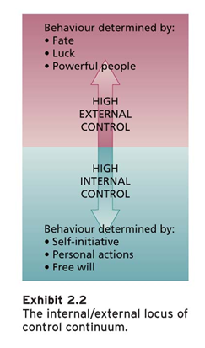
- Some personality characteristics are useful in certain organizational situations

The five factor model of personality – exhibit 2.1 p.42
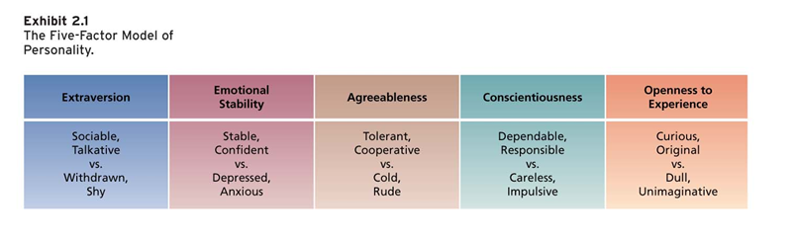
Big Five and Organizational Behaviour
- Conscientiousness 尽责: performance on most jobs dues to hard work and achievement MOST IMPORTANT FACTOR related to work motivation retention and attendance at work
- Agreeableness 适合: jobs that require interaction and involve helping, cooperating, and nurturing others; also jobs with teamwork and cooperation
- Neuroticism (Emotional stability): will have more effective interactions with co-workers and customers Most related to job satisfaction
- Openness to experience: jobs that involve learning and creativity - not related to job satisfaction
- Extraversion 外向性: jobs that require interpersonal interaction ex. Managers and sales people
Internal and external locus of control – exhibit 2.2 p. 45

A set of beliefs about whether one's behaviour is controlled mainly by internal or external forces

There are other specific dimension – people who determine outcomes internally (free will, personal actions) or externally (luck, fate) locus of control

Self-monitoring
- The extent to which people observe and regulate how they appear and behave in social settings and relationships
- High self-monitors:
  - Observe and control the images that they project
  - Engage in socially appropriate behaviour
  - Gravitate to jobs that require role-playing and the use of their self-presentation skills (sales, law, public relations, and politics)
  - Are more involved in their jobs, perform better, and are more likely to emerge as leaders

Self-Esteem
- The degree to which a person has a positive self-evaluation.
- People with high self-esteem:
  - Have favourable self-images
  - Less susceptible to external/social influences
  - React less badly to negative feedback
  - Make more fulfilling career decisions and have higher job satisfaction and job performance
  - Are more resilient to the strains of everyday work life
- Behavioural plasticity theory: people with low self-esteem tend to be more susceptible to external influences than those who have high self-esteem.

Recent Developments in Personality and Organizational Behaviour

- Positive and negative affectivity
- People who are high on positive affectivity (PA) experience positive emotions and mood and view the world in a positive light
- People who are high on negative affectivity (NA) experience negative emotions and moods and view the world in a negative light
- PA and NA are emotional dispositions that predict people's general emotional tendencies

- Proactive 积极主动 personality
- A relatively stable personal disposition that reflects a tendency to behave proactively
- Proactive behaviour: taking initiative across a range

- General Self-Efficacy (GSE) 一般自我效能
- A general trait that refers to an individual’s belief in his or her ability to perform successfully in a variety of challenging situations
- Can be learned
- Motivational rather than affective

- Core self-evaluations
- A broad personality concept that consists of more specific traits that reflect the evaluations people hold about themselves and their self-worth or worthiness, competence, and capability
- Includes self-esteem, general self-efficacy, self-control, emotional stability
- Higher CSE:
  - Job satisfaction
  - Life satisfaction
  - Job performance
  - Capability

What is learning?
- A relatively permanent change in behaviour potential as a result of practice or experience
- Learn practical skills (job-specific skills, knowledge, and technical competence), intrapersonal (problem solving, critical thinking, learning about alternative work processes, and risk taking), interpersonal (interactive skills such as communicating, teamwork, and conflict resolution), and cultural awareness (learning the social norms of organizations and understanding company goals, business operations, and company expectations and priorities)

Operant learning theory
- discovered by B.F. Skinner
- The subject learns to operate on the environment to achieve certain consequences
- Operantly learned behaviour is controlled by the consequences that follow it
- Can be used to increase the probability of desired behaviours and to reduce or eliminate the probability of undesirable behaviours.

Learning Effects – exhibit 2.4
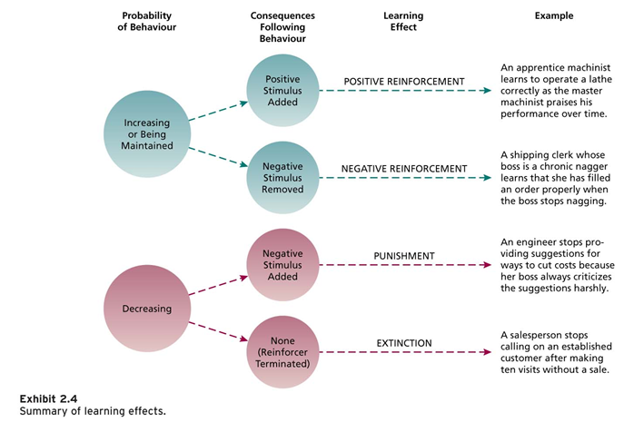

Increasing the probability of behaviour using reinforcement (the process by which stimuli strengthen behaviours)
- Positive reinforcement
  - Increases or maintains the probability of some behaviour by the application or addiction of a stimulus to the situation in question
  - Ex. Food, praise, money, or business success
- Negative reinforcement increases or maintains the probability of some behaviour by the removal of a stimulus from the situation in question

Organizational errors involving reinforcements
- Confusing rewards with reinforcers
- Neglecting diversity in preferences for reinforcers
- Neglecting important sources of reinforcement
  - Performance feedback: providing quantitative or qualitative information on past performance for the purpose of changing or maintaining performance in specific ways
  - Social recognition: involves informal acknowledgement, attention, praise, approval, or genuine appreciations for work well done from one individual or group to another

A reinforcer should be applied right away without delay after occurrence

Reducing the probability of Behaviour
- Extinction: terminating the reinforcement that is maintaining some unwanted behaviour
- Punishment: involves following an unwanted behaviour with some unpleasant, aversive stimulus. When the actor realizes that the behaviour leads to unwanted consequences, this should reduce the probability of the response.
- Using punishment effectively:
  - Make sure the punishment is truly aversive
  - Punish immediately
  - Do not reward unwanted behaviours before of after punishment
  - Do not advertently punish desirable behaviour

Social Cognitive Theory: Learning from observing the behaviour of others
- Observational learning: the process of observing and imitating the behaviour of others
- Self-efficacy: beliefs people have about their ability to successfully perform a specific task
- Self-regulation: the use of learning principles to use one's own behaviour:
  - Collect self-observation data
  - Observe models
  - Set goals
  - Rehearse
  - Reinforce oneself

Organizational learning practices
- Organizational behaviour modification (O.B. Mod) involves the systematic use of learning principles to influence organizational behaviour
- Employee recognition programs: formal organizational programs that publicly recognize and reward employees for specific behaviours
- Training programs: planned organizational activities that are designed to facilitate knowledge and skill acquisition to change behaviour and improve performance.
- Career development: an ongoing process in which individuals progress through a series of stages that consist of a unique set of issues, themes, and tasks

ADM2336A - Chapter 3: Perception, Attribution, and Diversity
Which of the following statements most accurately defines perception?
- Perception is the process of interpreting messages of our senses to provide meaning

Why is perception important?
- People base their actions on the interpretation of reality that their perpetual system provides

Perception has three components:
- A perceiver
- A target that is being perceived
- The situation

Factors affecting the Perceiver
- Past experiences lead the perceiver to develop expectations that affect current perceptions
- Needs unconsciously influence perceptions by causing us to perceive what we wish to perceive
- Emotions, such as anger, happiness can influence perception

Factors affecting the target
- Ambiguous targets are especially susceptible to the interpretation and the addition of meaning
- Perceivers have a need to resolve ambiguities
- The perceiver does not or cannot use all the information provided by the target

The Situation
- The most important effect that the situation can have is to add information about the target
- The perception of the target can change with the situation even when the receiver and perceiver remain the same

Bruner's Model of the Perceptual Process
- When the perceiver encounters an unfamiliar target, the perceiver is very open to the informational cues in the target and the situation
- The perceiver will actively seek out cues to resolve ambiguity
- As the perceiver encounters some familiar cues, a crude categorization of the target is made.
- The search for cues then becomes less open and more selective
- The perceiver will search for cues that confirm the categorization of the target
- As the categorization becomes stronger, the perceiver will ignore or even distort cues that violate initial perceptions
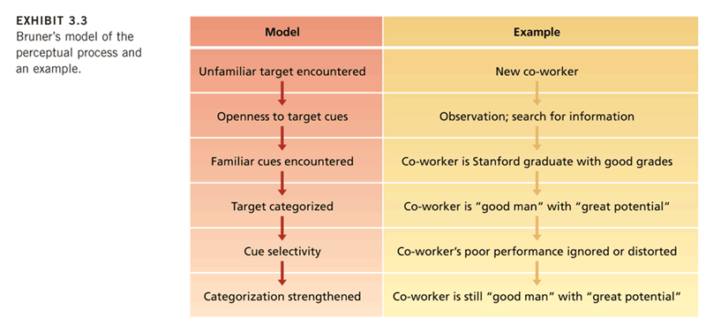
Basic Biases in Person Perception
- Primacy and Recency Effects
  - The reliance on early cues or first impressions is known as the primary effect - often has a lasting impact
  - The tendency for a perceiver to rely on recent cues or last impressions is know as the recency effect
- Reliance on Central Traits
  - Personal characteristics of a target person that are of particular interest to a perceiver
  - Central traits often have a very powerful influence on our perception of others
  - Physical appearance is a common central trait in work settings that is related to a variety of job related outcomes
  - Conventionally attractive people better than unattractive people in terms of a variety of job-related outcomes (e.g. getting hired)

- Implicit Personality Theories
  - Personal theories that people have about which personality characteristics go together
  - Perhaps you expect hardworking people to also be honest, or people of average intelligence to be more friendly
  - If such implicit theories are inaccurate, they provide a basis for misunderstanding

- Projection
  - The tendency for perceivers to attribute their own thoughts and feelings to others
  - In some cases, projection is an efficient and sensible perceptual strategy
  - Can lead to perceptual difficulties

- Stereotyping
  - The tendency to generalize about people in a social category and ignore variations among them
  - There are three specific aspects to stereotyping:
    - We distinguish some category of people
    - We assume that individuals in this category have certain traits
    - We perceive that everyone in this category possesses these traits

My perceptions of people are strongly influenced by how kind they are to others - Central trait

According to Bruner's model of perception, we are most open to cues about a targets. - first impression

Which of the following is indicative of an implicit personality theory in part of the speaker - introverts are honest

Attribution 属性，归因
- The process by which we assign causes or motives to explain people's behaviour
- An important goal is to determine whether some behaviour is caused by dispositional or situational factors
- Dispositional 意向的: suggest that some personality or intellectual characteristic unique to the person is responsible for the behaviour. Ex. Intelligence, greed, friendliness, or laziness
- Situational: suggest that the external situation or environment in which the target person exists was responsible for the behaviour. Ex. Bad weather, good luck, proper tools, or poor advice.

Attribution cues
- We rely on external cues and make inferences from these cues when making attributions
- Three implicit questions guide decisions:
  - Does the person engage in the behaviour regularly and consistently? (consistency cues)
    - How consistently a person engages in a behaviour over time
    - High consistency leads to dispositional attributions, inconsistency leads to situational attribution
  - Do most people engage in the behaviour, or is it unique to this person? (consensus cues)
    - How a person's behaviour compares with that of others
    - Low consensus behaviour leads to dispositional attribution
  - Does the person engage in the behaviour in many situations, or is it distinctive to one situation? (Distinctiveness cues)
    - Reflect the extent to which a person engages in some behaviour across a variety of situations
    - Low distinctiveness behaviour leads to a dispositional attribution
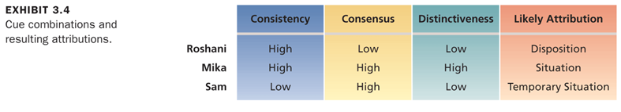
Cue combinations and resulting attributions
- Consider three employees who are absent from work
  - Roshani is absent a lot, her co-workers are seldom absent, and she was absent a lot in her previous job
  - Mika is absent a lot, her co-workers are also absent a lot, but she was almost never absent in her previous job
  - Sam is seldom absent, her co-workers are seldom absent, and she was seldom absent in her previous job

Mark was late, same with everyone else - consensus

Mark was late for everything, he has no consideration for others - distinctiveness

Biases in attribution
- Although observers often operate in a rational, logical manner, informing attributions about behaviour, this does not mean that such attributions are always correct
- There are three biases in attribution:
  - Fundamental Attribution Error
    - The tendency to overemphasize dispositional explanations for behaviour at the expense of situational explanations
    - We fail to realize that observed behaviour is often distinctive to a particular situation
  - Actor- Observer Effect
    - The propensity for actors and observers to view the causes of the actor's behaviour differently
    - Actors are prone to attribute much of their own behaviour to situational factors while observers are more likely to invoke dispositional causes
  - Self-Serving Bias
    - The tendency to take credit for successful outcomes and to deny responsibility for failures
    - People will explain the same behaviour differently on the basis of events that happened after the behaviour occurred

Person Perception and Workforce Diversity
- Workforce diversity refers to differences among recruits and employees in characteristics, such as gender, race, age, religion, cultural background, physical ability, or sexual orientation
- The workforce is becoming more diverse
- Many organizations have not successfully managed workforce diversity:

- The changing workplace
- The Canadian population and labour force is becoming increasingly multicultural and multiethnic
- Many employees are required to interact with people from substantially different national or corporate cultures
- Increased emphasis on teamwork as a means of job design and quality enhancement

- Valuing Diversity
- Organizations are adopting diversity as part of their corporate strategy
- A critical motive is the basic fairness of valuing diversity
- Diversity and its proper management can yield strategic and competitive advantages:
  - Improved problem solving and creativity
  - Improved recruiting and marketing
  - Improved competitiveness in global markets
- Organizations are adopting diversity as part of their corporate strategy

- Stereotypes and Workforce Diversity
- A major barrier to valuing diversity is the stereotype
- Common workplace stereotypes:
  - Gender: women are severely underrepresented in managerial and administrative jobs (salary, development, promotion, etc.)
  - Age: knowing that a person falls into a certain age range or belongs to a particular age generation, we have a tendency to certain assumptions about the person's physical, psychological, and intellectual capabilities
  - Race and ethnicity

www.implicit.harvard.edu

Managing diversity with stereotype reduction
- Diversity needs to be managed to have a positive impact on work behaviour and an organization
- Management can use a number of strategies:
  - Managing Diversity Strategies:
    - Select enough minority members to get them beyond taken status
    - Encourage teamwork that brings minority and majority members together
    - Ensure that those making career decisions about employees have accurate information about them
    - Train people to be aware of stereotypes

Questions/ clarifications (done in class)
- 3 main components of perception are a bit unclear; especially concept of ambiguity
  - Perceiver
  - Situation
  - Target
  - Ambiguity relates to the three main components of perception because there is always ambiguity in the target. More ambiguous the target, the more sense we have to make. Ambiguity is the aspect of the target. We could be looking at the same individual, because I've met this person, I might have a different impression of her than you
- How objective vs. subjective measures in interviews and evaluations affect rater errors (leniency, harshness, central tendency, halo effect, similar-to-me effect)
  - Want low rater errors
  - Leniency: rate people greater than their true performance
  - Harshness: rating people hard; giving bad ratings
  - Central tendency: rate everyone the same way
  - Halo Effect: The rating of an individual on one trait or characteristic tends to colour the ratings on other traits or characteristics
  - Similar-to-me effect: the rater gives more favourable evaluations to people who are similar to the rater in terms of background or attitudes
  - Objective: ex. Attendance vs. subjective: more interpretation on the evaluator. Contributing to the class. If no one in the class is saying anything good, then one person says something decent, the teacher will thing that it's excellent because no one else has been saying anything good. I guess in a way, it depends on the situation?
  - Subjective measures are better for interviews. Researchers found that unstructured interview types are better, better results.
- Linking concepts from different chapters and real life application

ADM2336A - Chapter 4: Values, Attitudes, and Work Behaviour
September-22-11
10:00 AM
Do you think accepting bribery is wrong?
- situational

What about stealing?
- Situational: robin hood stole from the rich to give to the poor

Bribery and stealing are concepts of right and wrong. They seem very straight forward. However, simple topics can have very different meanings. Difference in value can help determine the confusion.

What are Values?
- A broad tendency to prefer a certain state of affairs over others (ex. Political, different occupations, etc.)
- Values are very general, and don't tell too much about how a person will behave in a certain situation
- A broad tendency to prefer certain states of affairs over other. They are very general and do not tell about a person’s behaviour. Yet we don’t know enough about the person still.
- Guiding principles.
- Values are also represented in organizational missions
- The mission of Southwest Airlines is dedication to the highest quality of Customer Service delivered with sense of

Work centrality
- The extent to which work is an individual’s central life interest.
What is your work centrality?
- The major satisfaction in my life comes from my job
- The most important things that happen to me involve my work
- I live, eat, and breathe my job
- I would probably keep working even if I didn’t need the momey.
Work centrality is
- Related to the avg. # of hours worked
- Related to the avg. # of vacation days

Do values vary by culture?

Values across Cultures:
- Work centrality: how much of a role does work play in your life. Low/ high work centrality.
- Hofstede's values: Dutch social scientist surveyed over 116 000 IBM employees located in 40 countries about their work-related values.
  - Power distance: the extent to which an unequal distribution of power is accepted by society members
  - Uncertainty avoidance: the extent to which people are uncomfortable with uncertain and ambiguous situations
  - Masculinity/ Femininity: masculine cultures clearly differentiate gender roles, support the dominance of men, and stress economic performance. Feminine cultures accept fluid gender roles, stress sexual equality, and stress quality of life
  - Individualism/ collectivism: Tends to be studied a lot. Explains a lot of differences in cross cultural research
    - Individualistic societies stress independence, individual initiative, and privacy.
    - Collective cultures favour interdependence and loyalty to family or clan
  - Long/ short- term orientation: cultures with long-term orientation stress persistence, perseverance, thrift, and close attention to status differences; cultures with short-term orientation stress personal steadiness and stability, face-saving, and social niceties
- Hofstede’s Value: identifying key values in which cultures differ. Comparing people’s value in different countries but the same organizations. (Individualism vs. Collectivism.)

Implications of Cultural Variation
- Exporting OB theories (most of these theories are created in North America), different people are motivated by different things in different countries) question the application of theory in other countries. Most are developed in North America and by North Americans. Underlying values of the individual are very North American. It’s not that is SHOULD make a difference, but it MIGHT make a difference.
- Importing OB theories: Everyone was interested in how Japanese companies were doing so well. Everyone was interested in importing management values.
- Appreciating global customers: companies are now appealing more and more to a global market. Makes you realize how different products in different country will sell.
- Developing global employees: making sure employees from different cultures can survive in the long term. Work is not about skills and work in many countries across the world.

In a collective culture…
- It may be a good idea to reward groups instead of individuals - people identify more with a group than an individual, people don't want to stand out in front of their employees, it may lead them to downplay their performance. We need to understand different values to adapt better in different cultures.

What are attitudes?
- A fairly 1) stable 2) evaluative tendency to respond consistently to some specific 3) target (object, situations, person, or category of people) （fairly stable (un)favorable evaluations of specific objects, situations, persons, or catagories of people）
- Component: Affective(feel)+behaviour(think)
- Attitude -> behaviour
- Belief + value = attitude -> behaviour
- Value work vs. I hate my boss: attitudes impact the behaviour in a more expanded form.
- Belief is how you think and value is how you feel the world to be and they are determined by attitudes.

Getting an education will allow me to get a good job, higher status and a good income - the speaker is expressing a belief

I have a positive view towards education - the speaker is expressing attitude

What is Job performance?
- Performance is:
  - Behaviour (i.e. the actions employees do)
  - That are under employees' control
  - That are relevant to organizational goals
Three types of job performances:
- Task performance:
  - Proficiency with which incumbents perform activities that are formally recognized as part of their job.
  - Traditional, you were hired to perform outlined in the job description.
- Organizational citizenship behaviour (OCB):
  - Voluntary behaviours that help the organization and/or coworkers.
  - performance that is not really on the description but would like you to do. Enhances the image of the organization. (OCB: about and beyond of job description)
- Counterproductive Work Behaviour (CWB):
  - Voluntary behaviours that hurt the organization and/or workers.
  - Counter productive work behaviour: against organization and individual.
An expanded definition of job performance:
- Organizational citizenship behaviours (OCB)
  - Voluntary
  - Spontaneous and discretionary
  - Unlikely to be rewarded
  - In aggregate benefits the organization
- Examples:
  - Altruism: helping others
  - Courtesy: respectful of others
  - Diligence: meeting deadline, following rules
  - Sportsmanship: positive representations within and outside organizations
  - Civic virtue: political life of organization
- Counterproductive work behaviours (CWB)
  - Against the organizations
    - Theft
    - Destruction of property
    - Misuse of time and resources
    - Poor atten
dance, tardiness
    - Poor quality of work
    - Use of drugs and alcohol
  - Against organizational members
    - Inappropriate verbal comments
    - Harmful physical behaviours
    - Political deviance (e.g. rumours)
In accordance to attitudes the task performance and OCB and CWB should be high.

What is job satisfaction?
- Collections of attitudes that workers have about their jobs. Attitudes is the satisfaction one has in the work environment.
  - Facet satisfaction: being satisfied with the job that you do, co workers, your pay, different facets
  - Overall satisfaction: satisfaction with everything. The average of the facets.

What determines job satisfaction? – If everything is same for two workers what makes them have different attitudes?
- A persons job satisfaction is determined by a number of factors:
  - Discrepancy
  - Fairness
  - Disposition
  - Mood and emotion
Factor of Satisfaction
- Work tasks( work itself)
- Pay
- Promotions
- Coworkers
- Supervisors
Disposition
Some people are predisposed to be more satisfied
- ↑Conscientiousness, extraversion
- ↑Self-esteem, internal locus of control
- ↓Negative affectivity ↓neuroticism

- Discrepancy theory
You will be more satisfied if the job outcomes you receive are = or >than those you expected.
- Job satisfaction stems from the discrepancy between the job outcomes wanted and the job outcomes that are perceived to be obtained (explains job satisfactions. The less distance there is the more satisfied you are)

- Fairness
- Perception of fairness in the workplace
- Aka Organization Justice
- There are three basic kinds of fairness:
  - Distributive 分配 fairness
    - How fair are the outcomes of the decision
    - Equity
    - Equality
    - Need
    - Fairness that occurs when people receive what they think they deserve from their jobs
    - Focus on the distribution of work rewards and resources
    - Equity theory
      - my outcomes/my inputs = other's outcomes/ other's inputs
      - She get's paid more, I get paid less: she might be working more than me, so I won't be dissatisfied. If we are doing the same amount of work, but she gets paid more, then I will get feelings of inequity
      - Your perception of the outcome you get as fair or just. Equity theory: we are satisfied when the comparison of my inputs and their input is equitable. Outcome is low relatively to another’s works. This can be caused due to different inputs. Feelings of inequity can affect job satisfaction outcome.
  - Procedural 程序fairness
    - Procedures are used consistently across time and people.
    - Accurate information
    - Two-way communication
    - Appeals are welcome
    - Process used to determine work outcomes is seen as reasonable
    - It is concerned with how outcomes are decided and allocated
    - When the process are consistent or the evaluation is structured and in a fair manner. You understand the process is fair. Outcome is decided or allocated.
Distributive vs. procedural Fairness
When outcomes are favorable
- Procedural matter less

  - Interactional fairness 互动公平
    - Perception of the fairness of the interpersonal treatment 人际处理
    - Interpersonal
    - informational
    - Fairness that occurs when people feel that they received respectful and informative communications about an outcome
    - Can lead fair/unfair outcomes or procedures to be perceived as fair/unfair
    - Your satisfaction with the outcome can change on the basis of the interactional fairness
    - Ex. Being laid off, if you know about the situation, how it's dealt with, so that the employee feels like they are being cared about.
    - It can make a fair and unfair...
    - First org: good with employee economy. They let the employee tell what’s happening and show that it’s caring. Second org: you are just fired without reason and causation. The outcome is identical. There is a higher sense of interaction towards the outcome. Thus the satisfaction is better.
Why should managers care about Job Satisfaction?
- High job satisfaction is related to:
  - ↑Task performance and OCB
  - ↑Customer Satisfaction
  - ↑Off the job satisfaction
  - ↑Mental health
  - ↓Absenteeism
  - ↓PROPENSITY to Turnover

If you experience interactional unfairness at work, how will this affect your satisfaction at work?
- You will be dissatisfied with your boss

- Disposition
- Some people are predisposed to be more or less satisfied with their job
- Job satisfaction is related to personality traits
- Job satisfaction when you are younger, is related to when you get older

- Mood and emotion and affective events theory
- Emotions and moods can influence job satisfaction. Tend to result from events and short lived.
- Affective events theory : having an interaction with a co-worker can influence the job satisfaction

Job satisfaction research has pointed to the influence of dispositional factors because..
- Job satisfaction may be stable over time regardless of current employer
- Adolescence dispositional measure is related to job satisfaction
- Optimism, etc. also related

Antecedents and outcomes of JS. Predict the level of job satisfaction
- Antecedents (in NA):
  - Mentally challenging work: work that tests employees' skills and abilities
  - Adequate compensation: pay and satisfaction are positively related
  - Career opportunities: availability of career opportunities and opportunities for promotion are important
  - People: friendly, considerate, good-natured superiors and co-workers contribute to job satisfaction
- Consequences:
  - Absence from work - increase
  - Turnover - increase
  - Performance - decrease
  - Organizational citizenship behaviour (OCBI & OCBO): voluntary, informal behaviour that contributes to organizational effectiveness - decrease
  - Customer satisfaction and profit - decrease

What job satisfaction facet is more likely to stimulate high performance?
- Content of work
- Complex job and there is more autonomy in the work. The effort you put has more and better outcomes.

Organizational commitment 组织承诺
- An attitude that reflects the strength of attachment that and employee feels toward the organization
- Types:
  - Affective: stay in the organization because you want to. Emotionally attached to the company (most related to better performance)
Employees’ identification with and involvement in the organization
Staying because you WANT to
  - Normative 规范标准: stay in organization because you feel like you should stay in the organization (you ought to stay)(ex. Treat you really well, paid for education, etc.)
Feeling of obligation to remain loyal
Staying because you OUGHT to
  - Continuance:停留 commitment to stay because you feel like you have to. You've been there for a long time. Pension, etc.
Perceptions of costs associated with staying vs. leaving
Staying because you NEED to

Affective and normative commitment leads to better performance.
Continuance commitment - performance begins to decline, withdrawn behaviour in terms of absence. In all cases you reduce turnover. Affective and normative increase higher performance. Continuance commitment is considered negative, and withdrawal behaviour but not turnover. Normative more than continuance but not as much as affective.

ADM2336A - Chapter 5: Theories of Work Motivation
What is Motivation?
- The extent to which persistent effort is directed toward a goal
- The basic characteristics of motivation:
  - Effort
  - Persistence 坚持
  - Direction
  - Goals
- You’re in the situation to achieve a goal
- You are persistent and directed toward your goals
- Two broad types of motivations
  - Intrinsic motivation 内在动机: motivation that stems from the direct relationship between the worker and the task and is usually self-applied. Doing the task because of the sake of the task. You really enjoy doing what you do.
    - Examples include:
      - Feelings of achievement, accomplishment, challenge, and competence derived from performing one's job, and the sheer interest in the job itself
  - Extrinsic motivation: motivation that stems from the work environment external to the task itself. It is usually applied by others. Motivation that is external and applied from other.
    - Examples include:
      - Pay, fringe benefits, company policies, and various forms of supervision

Extrinsic vs. intrinsic motivators
- Some evidence that the availability of extrinsic motivators can reduce the intrinsic motivation stemming from the task itself
- This appears to occur under very limited conditions and is easily avoidable
- Both kinds of rewards are important and compatible in enhancing work motivation
- When you introduce an external motivation that already has intrinsic value they change it into extrinsic. Example: kids being talented this is managed by parents to provide external rewards. This can be avoided. You can reward them, but do not make it contingent on performance but you can reward them though.

In research this only occurs in limited situations, and can be avoided, don't make it contingent on the performance

Some researchers have argues that intrinsic and extrinsic motivation are incompatible. By this they mean that extrinsic rewards make you increase extrinsic motivation? I think that's what it is

Factors Contributing to individual job performance
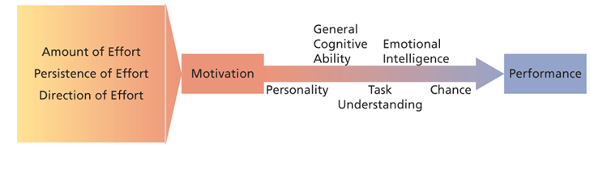
You might be very motivated, but if you don't understand what you have to do, it won't translate to higher performance
Performance: the extent to which an organizational member contributes to achieving the objectives of the organization
General cognitive ability: the person's basic information processing capabilities and cognitive resources
Emotional intelligence: the ability to understand and manage one's own and other's feelings and emotions

Two broad classes of theories
- 'What' motivates
  - Need theories
- 'How' to motivate
  - Process theories

Need theories of work motivation
What motivates?
Need theories:
- Maslow's Hierarchy of need's
  - motivated from the bottom up
  - Can only move to a higher level need, once a lower need has been satisfied.
  - There is a hierarchy, move through needs vertically. The most needed need is the lowest level need. Once satisfied the need is no longer motivated. Exception is self-actualization.
    - Physiological: food, shelter, water, etc.
    - Safety: security, stability, freedom from anxiety, etc.
    - Belongingness needs: social interaction, affection, love, companionship, etc.
    - Esteem needs: adequacy, competence, independence, strength, and confidence, etc.
    - Self-actualization: the desire to develop one's true potential as an individual to the fullest extent and to express one's skills, talents, and emotions in a manner that is most personally fulfilling
- Aldefer's ERG theory
  - Subsumes the five needs that Maslow specifies into three
  - Don't need to satisfy a lower level need before moving up
  - Similarity to Maslow’s Theory. However, it is not a rigid hierarchy. The lower level need can be a motivating need again.
    - Existence needs: food, shelter, pay, and safe working conditions
    - Relatedness needs: satisfied by open, accurate, honest interaction rather than uncritical pleasantness
    - Growth needs: involve the full utilization of one's skills and abilities and the creative development of new skills and abilities
- McClelland's theory of Needs:
  - Motivated to satisfy our needs. Also needs are specified. Is not a hierarchy, needs he specify has a trait for each person.
  - Need for achievement
    - Want to perform challenging tasks well
    - Direct and immediate feedback
      - Entrepreneur, sales
    - Overcoming challenge
  - Need for power
    - Want to influence others, make an impact
      - Politics
  - Need for affiliation (most motivated in situations where you feel like there is a community/ support)
    - Sociable/ helping
    - Emotional attachment.
    - Want to establish/maintain good interpersonal relationships
      - Public relations and social network

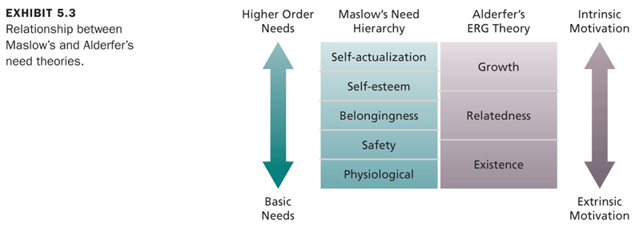

Managerial implications of need theories
- Appreciate diversity of the needs of individual employees
- Offer personalized incentives and goals
- Appreciate the motivational potential of intrinsic motivators and the existence of higher-order needs

Process theories of work motivation ' How are people motivated? '
- Motivation theories that specify the details of how motivation occurs
- Three important process theories:
  - Expectancy theory
  - Equity theory
  - Goal setting theory

Hypothetical expectancy model: (exhibit 5.4)
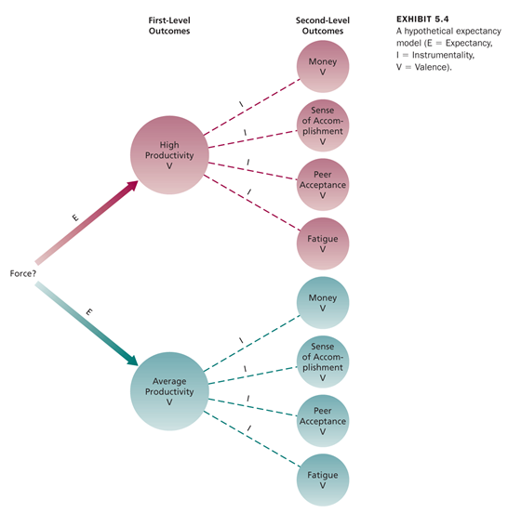
- Expectancy theory
- A process that states that motivations is determined by the outcomes that people expect to occur as a result of their actions on the job OR motivation is determined by the outcomes that you expect to get from a task/work that you do.
- The basis components of Victor Vrooms theory are:
  - Outcome: consequences that follow work behaviour.
    - 1st level outcomes – primary interest to the organization
    - 2nd level outcomes – interest to the person
  - Instrumentality: The probability of achieving a first level outcome, will bring you to the second level outcome ( all from the perspective of the individual)
  - Expectancy: the likelihood/belief that you can achieve the first level outcome. Loses all motivation if you can't believe that you can achieve it.
  - Valence: the expected value of work outcomes; the extent to which they are attractive or unattractive. Valence of 2nd level outcomes is the value to you. First level valence is the sum of the outcomes to you multiplied by the probability that you will get it. What are the results going to be to you? The value of the valance of the 1st level out come and 2nd level. What is the value for the 2nd level? Value of high productivity is going to be a composite or sum everything that is going to follow to you. Valance of 1st level out is value to you. Sum of achieving 1st level outcome times the probability of getting instrumentality.
  - Force: the effort directed towards a first-level outcome. Brings it all together. Valance of 1st level * the expectancy (that you can do it); the effort directed towards a first-level outcome
  - Valence 1st level outcome = sum (instrumentalities * 2nd level valences)
  - Force = 1st level valence * expectancy

The premises of expectancy theory
- People will be motivated to perform in those work activities that they find attractive (valence) and that they feel they can accomplish (expectancy)
- The attractiveness of various work activities depends on the extent to which they lead to favourable personal consequences
- Based on the perceptions of the individual worker

Managerial implications of expectancy theory
- One of the most basic things managers can do is ensure that their employees expect to be able to achieve first-level outcomes
- First-level outcomes should be clearly instrumental in obtaining positive second-level outcomes and avoiding negative outcomes
- Managers should analyze the diverse preferences of employees and attempt to design individualized 'motivational packages' to meet their needs

The consultant said to a client company, 'look you offer the highest pay in the industry, if you tied it to performance you would get some real motivational punch! The consultant I saying that … instrumentality is low is second level valence is high

- Equity theory
- Employees want to be treated differently- Employees want to be treated fairly
- Perceived equity of the distribution of rewards among employees
- Equity exists when the employee feels his/her inputs (experience, skills , efforts…

Equity: my outcomes/my inputs = other's outcomes/ other inputs

Inequity
- Under compensations: strong reaction
  - My outcomes/my inputs < other's outcomes/ other inputs
- Overcompensations: rationalize, no reaction
  - My outcomes/my inputs > other's outcomes/ other inputs

Ways to restore equity
- Modify truly or perceptually
  - Own input or outcome
  - Comparison to other's input or outcome
- Change the comparison 'other'
- Leave the situation
- Research findings:
  - Supportive of theory for under-compensation
  - Little evidence for overcompensations inequity
  - Individual differences exist in equity sensitivity

Equity theory: Managerial implications
- Negative motivational consequences of perceived under-compensations
  - Absenteeism, turnover, dissatisfaction, theft..
- Understand that equity is a perception
  - Seek to understand who is comparison other, and what is being compared
- Comparison 'other' may be outside the organizations
  - Be aware of competitors' compensation policies

- Goal setting theory: employees need goals
- Organizations have goals - these need to be translated into individual employees goals
- Goals are most motivational when they are
  - Specific
  - Challenging: Don't want it too challenging, don't want employees to think that it is impossible
  - Those to which organizational members are committed: more committed if they help set the goals
  - Those for which employees receive accurate and timely feedback on their progression

Goal setting: Managerial implications 管理启示
- Break up larger and ambiguous individual organizational goals into smaller specific ones
- When there is distrust between employees and mangers used participative goal setting rather than imposed goals
- Provide accurate feedback
- Management by objectives ( MBO)
  - Organizational program aimed at facilitating goal establishment, goal accomplishment, and employees development
  - Translate organizational goals into specific behavioural objectives for employees

ADM2336A - Chapter 6: Motivation in Practice
Motivation in Practice
-$$ as a motivators
Motivation through job design
Money as a motivator
- What do the need theories say?
  - ERG is similar to Maslow's theories
  - This is why we have a minimum wage :)
- What do the process theories say?
  - Pay would be a motivator if it had a higher valence?
- What does the research say?
  - Money does work as a motivator

Potential problems with wage incentives 工资奖励
- Wage incentives can increase productivity at the expense of quality
- A threat to the establishment of wage incentives exists when workers have differential opportunities to produce at a high level
- Wage incentives that reward individual productivity might decrease cooperation among workers
- The way jobs are designed can make it very difficult to install wage incentives

Job design as a motivator
- The goal of job design is to identify the characteristics that make the tasks more motivating that others and to captures these characteristics in the design of jobs
- An attempt to capitalize on intrinsic motivation

The job characteristics model (exhibit 6.5)
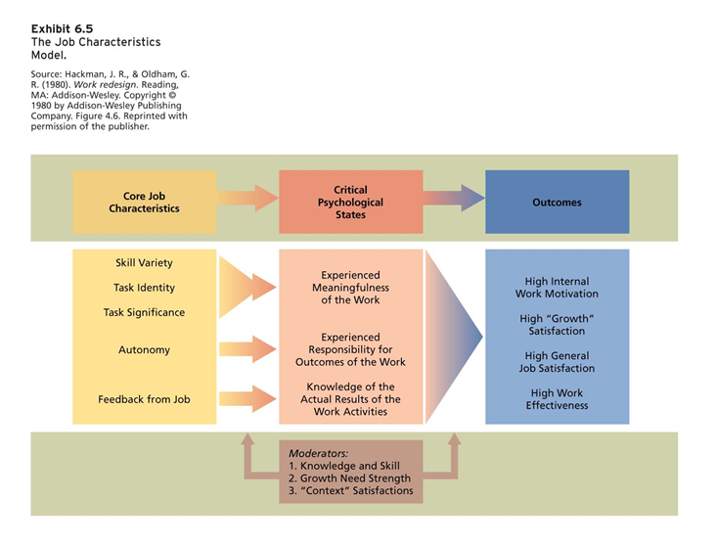
- Skill variety: the opportunity to do a variety of job activities using various skills and talents
- Autonomy: the responsibility for the outcome of the work; the freedom to schedule one's own work activities and decide work procedures
- Task significance: the impact that a job has on other people
- Task Identity: the extent to which a job involves doing a complete piece of work, from beginning to end
- Feedback: information about the effectiveness of one's performance
- Increase the core job characteristics increases the critical psychological states
- Be aware of the moderators:
  - Not everyone has the same need to grow in their work

Motivational potential score
- The motivational potential score (MPS) of a job is calculated using the following formula:
- Skill variety + task identity + task significance * autonomy * job feedback
3
- Job diagnostic survey (JDS) 工作诊断调查 measures the core characteristics of jobs
  - Individuals report the amount of the various core job characteristics contained in their jobs
  - An overall measure of the motivating potential of a job can be calculated from scores on the core job characteristics

Job enrichment 工作丰富化
- Design of jobs to enhance:
  - Intrinsic motivation
  - Quality of work life
  - And job involvement 工作投入
- Strategies
  - Combining tasks: increases variety of skill; assigning tasks that might be performed by different workers to one individual
  - Establishing external client relationships: involves putting employees in touch with people outside the organization who depend on their products or services
  - Establishing internal client relationships: putting employees in touch with people who depend on their products and services within the organization
  - Reducing supervision or reliance on others: increases the autonomy or control one has over their own work
  - Forming work teams: work/ task variety, can share work tasks teams can be formed when a product or service is too large or complex for one person to complete alone or to complete an entire product
  - Increasing direct feedback: If you get feedback, you feel like your job is actually doing something.

Potential problems with job enrichment
- Problems can occur when is it instituted without a careful diagnosis of the needs of the organization and particular hobs in question
- Beware of job enlargement! 扩大就业
- Job enrichment can encounter a number of challenging problems:
  - Poor diagnosis
  - Lack of desire or skill
  - Demand for rewards
  - Union resistance
  - Supervisory resistance

Activity: job diagnosis survey

Work Design: attributes of the task, job, and social and organizational environment
- Motivational characteristics
  - Includes task characteristics which are similar to the core job characteristics of the job characteristics model
  - Knowledge characteristics refer to the kinds of knowledge, skill, and ability demands required to perform a job
  - Note distinction between task variety and skill variety
- Social characteristics
  - Has to do with the interpersonal and social aspects of work and includes:
    - Social support: the degree to which a job provides opportunities for advice and assistance to others
    - Interdependence: the degree to which the job depends on others and others depend on it to complete the work
    - Interaction outside of the organization: the extent to which the job requires employees to interact and communicate with individuals external to the organization
    - Feedback from others: the extent to which others (ex. Coworkers and supervisors) in the organization provide information about performance
- Work context characteristics
  - Refers to the context within which work is performed and consists of:
    - Ergonomics: the degree to which a job allows correct or appropriate posture and movement
    - Physical demands: the amount of physical activity or effort on the job
    - Work conditions: the environment within which a job is performed (e.g. the presence of health hazards, noise, temperature, and cleanliness of the working environment)
    - Equipment use: the variety and complexity of the technology and equipment used in a job

Management by Objectives (MBO)
- An elaborate, systematic, ongoing program designed to facilitate goal establishment, goal accomplishment, and employee development
- The MBO process involves manager-employee interactions:
  - The manager meets with individual workers to develop and agree on employee objectives which can include job performance and personal development objectives.
  - There are periodic meetings to monitor employee progress in achieving objectives.
  - An appraisal meeting 评估会议 is held to evaluate the extent to which the agreed objectives have been achieved.
  - The MBO cycle is repeated.
Research evidence
- Research evidence shows clear productivity gains associated with MBO.
- A number of factors are associated with the failure of MBO programs:
  - Lack of commitment from top management.
  - An overemphasis on measurable objectives at the expense of more qualitative objectives.
  - Excessive short-term orientation.
  - Performance review becomes an exercise in browbeating 吓唬 or punishing employees for failure to achieve objectives.

Alternative Working Schedules as Motivators for a Diverse Workforce
- Many organizations have modified traditional working schedules.
- The purpose is to meet diverse workforce needs and promote job satisfaction.
- Alternative working schedules制度 can also facilitate recruitment and reduce costly absenteeism and turnover.
- There are 4 types of alternative work schedules:
  - Flex-time: an alternative work schedule in which arrival and departure times are flexible
    - Flex-time is well suited to meeting the needs of a diverse work-force and is most frequently implemented in office environments.
    - Research evidence:
      - Employees prefer it compared to fixed hours.
      - Work attitudes are more positive.
      - Has a positive effect on productivity, job satisfaction, and satisfaction with work schedule.
      - Lowers employee absenteeism.
  - Compressed workweek: work schedule in which employees work fewer than normal five days a week but still put in a normal number of work hours per week
    - Potential roadblocks to implementation:
      - Possible reduced customer service
      - Negative effects of fatigue 疲劳
    - Research evidence:
      - Research shows a positive effect on job satisfaction and satisfaction with work schedule but no effect on absenteeism or productivity
  - Job and work sharing:
    - Job sharing: two part-time employees divide the work of a full-time job
    - Work sharing: reducing the number of hours employees work to avoid layoffs when there is a reduction in normal business activity
    - Research evidence:
      - Work sharing cuts costs, saves jobs, avoids layoffs and allows organizations to retain skilled workers.
      - Job sharing can result in coordination problems if communication is not adequate.
      - Job sharers must make a concerted effort to communicate well with each other as well as with superiors, co-workers, and clients.
  - Telecommuting: a system by which employees are able to work at home but stay in touch with their offices through the use of communications technology, such as computer network, voice mail, and electronic messages
    - Distant staffing enables employees to work for a company without ever having to come into the office or even be in the same country.
    - Telework centres provide workers all of the amenities of a home office in a location close to their home.
    - Distributed work programs involve a combination of remote work arrangements that allow employees to work at their business office, a satellite office, and a home office.
    - Research evidence:
      - Telecommuting has a small but positive effect on perceived autonomy and lower work-family conflict.
      - It has a positive effect on job satisfaction and job performance and results in lower stress and turnover intentions. 离职意向
      - It does not have detrimental 有害的 effects on the quality of workplace relationships or one’s career prospects.
      - A greater frequency of telecommuting is associated with a greater reduction in work-family-conflict and stress.
      - The positive effects of telecommuting are mostly due to an increase in perceived autonomy. 自主性

ADM2336A - Exam Review. WHOOT!
October-13-11
10:08 AM
Midterm review
- Five short answer essay questions
- Chaps 1-6 (191-208)
- Lecture notes
  - Don't forget the discussion of job performance on the intro slides

Chapter 4

What is job performance?
-going to see this come up a lot in the Mid-term/exam?
-3 types
- Task performance
  - Proficiency with which incumbents perform activities that are formally recognized as part of their job
- Organizational citizenship behaviour (OCB):
  - Going above and beyond the call of duty
  - Voluntary behaviours that help the organization and/or coworkers
  - Know the OCB's in the book:
    - Helping behaviour, offering assistance to others
    - Conscientiousness on details of work
    - Being when the inevitable frustrations of organizational life crop up
    - Courtesy and cooperation
- Counterproductive Work Behaviour (CWB):
  - Voluntary behaviours that hurt the organization and/or workers

Chapter 2 review:

- Personality:
  - The big 5 factors (OCEAN)
    - Openness to experiences
    - Conscientiousness
    - Emotional stability/Neuroticism
    - Agreeableness
    - Extraversion

What is a motivational trait compared to an affective trait?
-neuroticism ?

How do Employees Learn?
- Operant learning:
  - Employees learn a connection between a behaviour and a consequence
- The 'environment' delivers consequences that:
  - Increases the probability of behaviour OR
  - Decreases the probability of behaviour

Learning
- Use reinforcement if you want to increase the probability that a behaviour will reoccur
  - Positive reinforcement
    - The addition of a (pleasant) stimulus that increases or maintains the probability of some behaviour
  - Negative reinforcement
    - The removal of an (unpleasant) stimulus that increases or maintains the probability of some behaviour
- Use punishment or extinction if you want to decrease the probability that a behaviour will reoccur
  - Punishment
    - The application if an aversive (unpleasant) stimulus following some behaviour designed to decrease the probability of that behaviour
  - Extinction
    - Process by which people stop displaying a specific behaviour because their environment does not react to it

Chapter 3

Perception, attribution and judgement
- Perceptual biases
  - Primacy and recency
  - Reliance on central traits
  - Implicit personality theories
  - Projection
  - Stereotyping
- Biases in the interview:
  - Primacy, ideal candidate stereotype, contrast effect, - information is overweighed
- Biases in performance appraisal
  - Primacy and recency, errors (leniency, harshness, central tendency), similar-to-me, halo/horns
  - Halo: identify a positive trait in someone, then everything else about them is coloured by that trait. One characteristic dominates your impression on someone
  - Horns: is the opposite, a negative trait in someone dominates your impression on someone

Cues used to make attributions
- Consistency cues
  - Does the person engage in the behaviour regularly and consistently?
- Consensus Cues
  - Do most people engage in the behaviour, or is it unique to this person?
  - Low consensus is behaviour to do with personality
- Distinctiveness cues
  - Focus is on situations, do you react to the same way in all situations? Or does it depend on the situation?
  - If you're high on distinctiveness, it depends on the situation

Chapter 4

Attitudes and Values
- Job satisfaction
  - Components: cognitive & affective
  - Determinants: ( What determines job satisfaction?!)
    - Facets: work, $, promotion, coworkers, supervisors
    - Disposition: people tend to be consistent on their level of job satisfaction. It's not distinctive on the job?
    - Fairness/justice
      - Distributive justice (only refers to how fair you think an outcome is)
        - How fair are the outcomes of the decision?
          - Equity, equality, need
      - Procedural justice
        - How fair is the process that was used to make the decision?
          - Procedures are used consistently across the time and people
          - Accurate information is used
          - Two-way communication is allowed
          - Appeals to the procedure are welcomed
      - Interactional justice
        - Perception of fairness of the interpersonal treatment
          - Interpersonal, informational
    - Discrepancy theory
      - Job satisfaction stems from the discrepancy between the job outcomes wanted and the job outcomes that are perceived to be obtained (explains job satisfactions. The less distance there is the more satisfied you are)
    - Mood and emotion
      - Emotions and moods can influence job satisfaction. Tend to result from events and short lived.
      - Affective events theory : having an interaction with a co-worker can influence the job satisfaction
Discrepancy theory is the difference between the outcome that you get and the outcome that you want

- Organizational commitment:
  - Affective : you want to stay in the organization
  - Normative: Obligated to stay in the organization
  - Continuance: feel like you have no other options so you have to stay
  - They all have a negative affect to turnover
  - Affective has a higher performance
- Values
  - Work centrality
  - Hofstede's values
    - Power distance
    - Uncertainty avoidance
    - Masculinity/femininity
    - Individualism/collectivism
    - Long-term/short-term orientation

Question: From a cultural perspective, are some values better than others for the organization? (ex. Power distance, collectivism)
A: NO

Chapter 5

Motivations
- Need theories: 'What' motivates
  - Maslow hierarchy : start at the bottom and accomplish each step before moving up. The most motivational need is always the lowest level. Once made to self actualize, it's perpetually motivating
  - Alderfer's ERG : don’t need to from one need to the next, you can skip levels
  - McClelland's nach, npow, naff (achievement, affiliation, power)
- Process theories: 'How' to motivate
  - Goal setting theory
    - Specific and measurable, challenging
  - Equity theory
  - Expectancy theory
    - Valence of the second level outcome is the value to you.
    - Valence sum (instrumentalities*2nd level valences)
  - Job characteristic model (chapter 6)

Chapter 6

Job vs. work design
- Job design- focus on specific aspects of a job (job characteristics)
- Work design- broader. Considers:
  - Task characteristics - similar to job design and the job characteristics model
  - Knowledge of characteristics - required to perform BLAH
  - And there are a few more

Example questions
Your friend yang is a territory manager for a pharmaceutical sales company. Recently, one of his sales representatives, Lisa, seems to have been lacking in motivation. Knowing that you are currently enrolled in an OB class, yang has asked for your expertise
- As any good consultant would, first, tell yang how the field of OB defines motivation
- Use your knowledge of Goal Setting Theory to design a motivational intervention for Lisa (hint, organize your intervention around all the factors that make goals effective)

