**Read headings & chapter summary.
**See how many pages to get a rough idea.
**Go for everything one small section at a time.
**The only way to eat an elephant is one bite at a time.

Asher Hanif
2014/9/23
PSYCH1000
Chapter 3 – Psychology: Biological Foundations of Behavior

Neurons
Specialized cells that makeup the nervous system. They are linked together in circuits but not like together for the circuits in a brain.

3 Major Components
Cell body, dendrites, and an Axon.

Cell Body (Soma)
Contains biochemical structures needed to keep the neuron alive.

Dendrites (Greek for Tree) INPUT / Receiving Signals
Antennas sort of which collect messages from the neighbouring neurons and send them onto the Soma or the cell body where information gets combined and processed. They can receive input from up to 1000 or more neighbouring neurons.

Axon OUTPUT
The part of the neuron which extends out from one side to send electrical impulses away from the cell body to other neurons, muscles, or glands. Branches out at its end to form the axon terminals which can be up to several hundred.

Given the neurons structure it is clear as to how trillions of interconnections in the brain can be made to conduct the complex psychological activities that are of interest to psychologists. There are more than 200 neurons that have been observed through electron microscopes.

Neurons are supported in their functions by glial cells (Glue) which surround neurons and hold them in place. The glial cells also make nutrient chemicals which neurons need to for the myelin sheath around some of their axons and absorb toxins and waste materials that might damage neurons. Glial cells also protect toxins from entering the brain.

How Neurons Work
Neurons do two major things, they generate electricity that creates nerve impulses and release chemicals that lets them communicate with other neurons and with muscles and glands.

1. At rest, neurons have electrical resting potential due to the distribution of ions inside and outside the neuron.
2. After being stimulated the flow of ions in and out the membrane reverses electrical charge of the resting potential producing an action potential, or nerve impulse. (The flow of ions excites the resting potential into production an action potential)
3. The original distribution of ions is restored, the neuron is at rest again.

Although neurons are surrounded by bodily liquid the cell membrane itself is semi-permeable which only allows for ions to pass through the ion channels.

The high concentration of Na outside the cell (Positive Ions) combined with the high concentration of Chloride Ions (Negative) inside the cell results in uneven distribution which is the neurons resting potential. The neuron at this stage is said to be in a state of polarization. (-70 millivolts)

The action potential is the sudden reversal of the neuron’s membrane voltage which the membrane voltage momentarily moves from -70 millivolts to +40 aka depolarization.

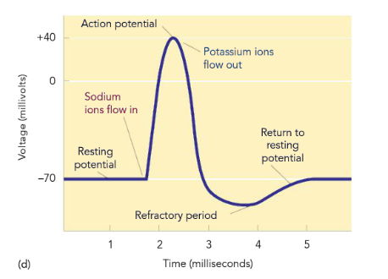
During the absolute refractory period the membrane is not excitable and can’t generate another action potential. The all-or-none law states that all action potentials occur at a uniform and maximum intensity or they do not occur at all.

The Myelin Sheath
Axons which transmit data throughout the brain and spinal cord are covered by a tube like myelin sheath, the fatty whitish insulation layer derived from glial cells during development. The sheath is interrupted at regular levels by the nodes of ranvier where the sheath is either thin or absent all together. The sheath helps signals go faster and without them the signals are capable of “fusing out.”

Neurons do not make actual physical contact but communicate at a synapse which is the small gap or space between the axon terminal of one neuron and the dendrite of another neuron.

In addition to producing chemical signals neurons also produce neurotransmitters which are chemical substances that carry messages across the synapse to excite other neurons or inhibit their firing. The molecules are stored in chambers called synaptic vesicles and get carried along with an action potential into the fluid-filled space (Synaptic Cleft). The molecules then bind themselves to receptor sites.

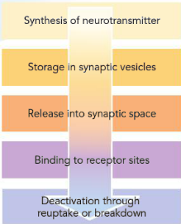
Neurotransmitters which create depolarization are called the excitatory transmitters.
Neurotransmitters which create hyperpolarization are inhibitory in their function.

After binding to a receptor it continues to active or inhibit the neuron until it is shut off, or deactivated.
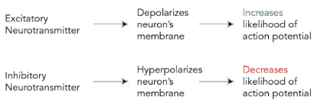

Important neurotransmitters**

Norepinephrine
Excitatory and Inhibitory functions involved at various sites involved in neural circuits controlling learning, memory, wakefulness, and eating.
Undersupply – Depression
Oversupply – Stress and Panic attacks.

Acetylcholine
Excitatory at synapses involved in muscular movement and memory.
Undersupply – Alzheimer’s
Oversupply - Muscle contractions, convulsions

Dopamine
Excitatory and Inhibitory involved in voluntary movement, emotion arousal, learning, motivation, experiencing pleasure.
Undersupply – Parkinson’s Disease and Depression
Oversupply – Schizophrenia

Serotonin
Inhibitory at most sites, involved in mood, sleep, eating, and arousal.
Undersupply – Depression, sleeping, and eating disorders.

Gamma aminobutryric acid (GABA)
Inhibitory transmitter involved in all behaviors, especially anxiety and motor control.
Destruction of GABA-producing neurons in Huntington’s disease produces loss of motor control as well as personality changes.

Sensory neurons carry input messages from the sense organs to the spinal cord and brain.
Motor neurons transmit output impulses from the brain and spinal cord to the body’s muscles and organs. Finally there are neurons that link the input and output functions, Interneurons.

**recover more of the detailed info about important neurotransmitters and the brain

The Brain
>Cortical Organization
>Neural Disorders
>Lateralization
>Split Brain

Split brain is when somebody has had their corpus collosom separated to control epilepsy which is interesting because n normal situations nothing happens when the two sides of the Brian are split. The brain hemispheres are specialized and that they communicate but also the idea that these two hemispheres can function independently. We are going to try and understand what happens when we do an operation such as this.

How are the cortical areas organized?

What happens if these areas are damaged?

Is there a separate consciousness in each hemisphere?

Hearing – Auditory Cortex
Seeing – Visual Cortex
Speaking – Motor Cortex
Generating – Auxipital Lobe

Association Areas tell you what you hear, see, or are doing.
>Integrate & Interpret

Neural Disorders
Apraxia
>Inability to perform smooth actions.

Agnosia
>Inability to interpret sensory information.
Prosopagnosia, individual cannot see faces.
Impacts the fusiform gyrus and there are processing areas where visual info gets sent to and there is a particular area designed to recognize faces. People who have been damaged here have an inability to identify individuals. There is another area that identifies objects.

Aphasia
>Speech
Broca’s > Expressive
Difficulty in stringing words together
>Telegraphic
-Frontal Lobe

Wernicke’s Aphasia > Receptive
Difficulty in understanding.
-Temporal Lobe

“Indication of movement of pieces of apparatus or intimating the cost of apparatus in various forms”

*These vary in severity*

Lateralization & Split – Brain

Left Right
Verbal NonVerbal
-Language Space
-Reading -Form Synthesis
-Logical Though -Emotion

Hemispatial neglect
-ignoring everything on the left hand side
Found only in humans.

Visual right field gets processed in left brain and visual left in the right side.

