Final Exam Review
Bio 321- Dr. Stirling (2014)
Topic 1: Sociality
Prisoner’s Dilemma
- Best personal outcome is ratting out the other
- That’s the other’s best personal outcome too
- So…you’d both do it, right? That leads to worst outcome!
- Therefore, cooperating will be better.
Temptation > Reward > Punishment > Sucker

Evolution of cooperation
- Kin selection
  - r > c/b
- Direct reciprocity
  - w > c/b
- Indirect reciprocity
  - q > c/b
- Network reciprocity
  - b/c > k
- Group selection
  - Multi-level selection
  - Complex social interactions (next slide)

- r: relatedness
- w: prob. of next encounter
- q: prob. knowing reputation
- k: avg. # neighbours

Group Selection: Cooperators & Free-riders
- “A”s increase fitness for everyone!
- Natural Selection doesn’t distinguish between A and B
  - If there is a cost (altruism), can distinguish
  - If lower own fitness, the behaviour will go extinct within the group/subpopulation
  - So……..why would that evolve?
  - Models assume selection among groups
  - In reality, selection for forming groups (genome-level)
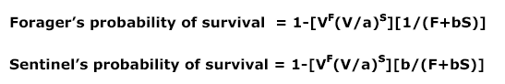

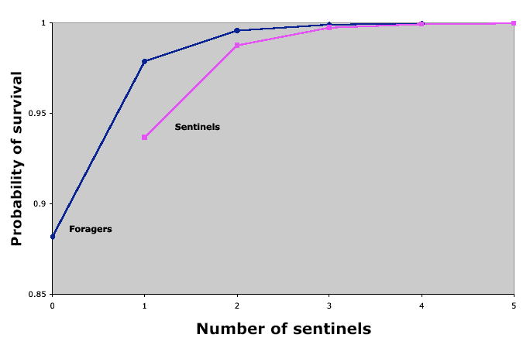

Topic 2: Speciation
- Change in allele frequencies:
  - Founder effects
  - Drift
  - Migration,
  - Adaptive evolution (positive selection)

Differences large enough?
- Speciation
  - Physical Isolation
  - Genetic Divergence
  - Secondary contact (hybrid zones)
  - Assimilation or Isolation,
  - Radiation or Extinction

Hybrid Zones:
- After geographic isolation (speciation) 2 diverged meet and cross-fertilize
- Doesn’t fly with the biological species concept (fertile offspring)
- Fit other definitions
- Primary hybrid zones = divergence btn adjacent popn’s.
  - Could lead to parapatric speciation
- Secondary hybrid zones = contact btn 2 popn’s that were allopatric before
  - Most are these (so they think)

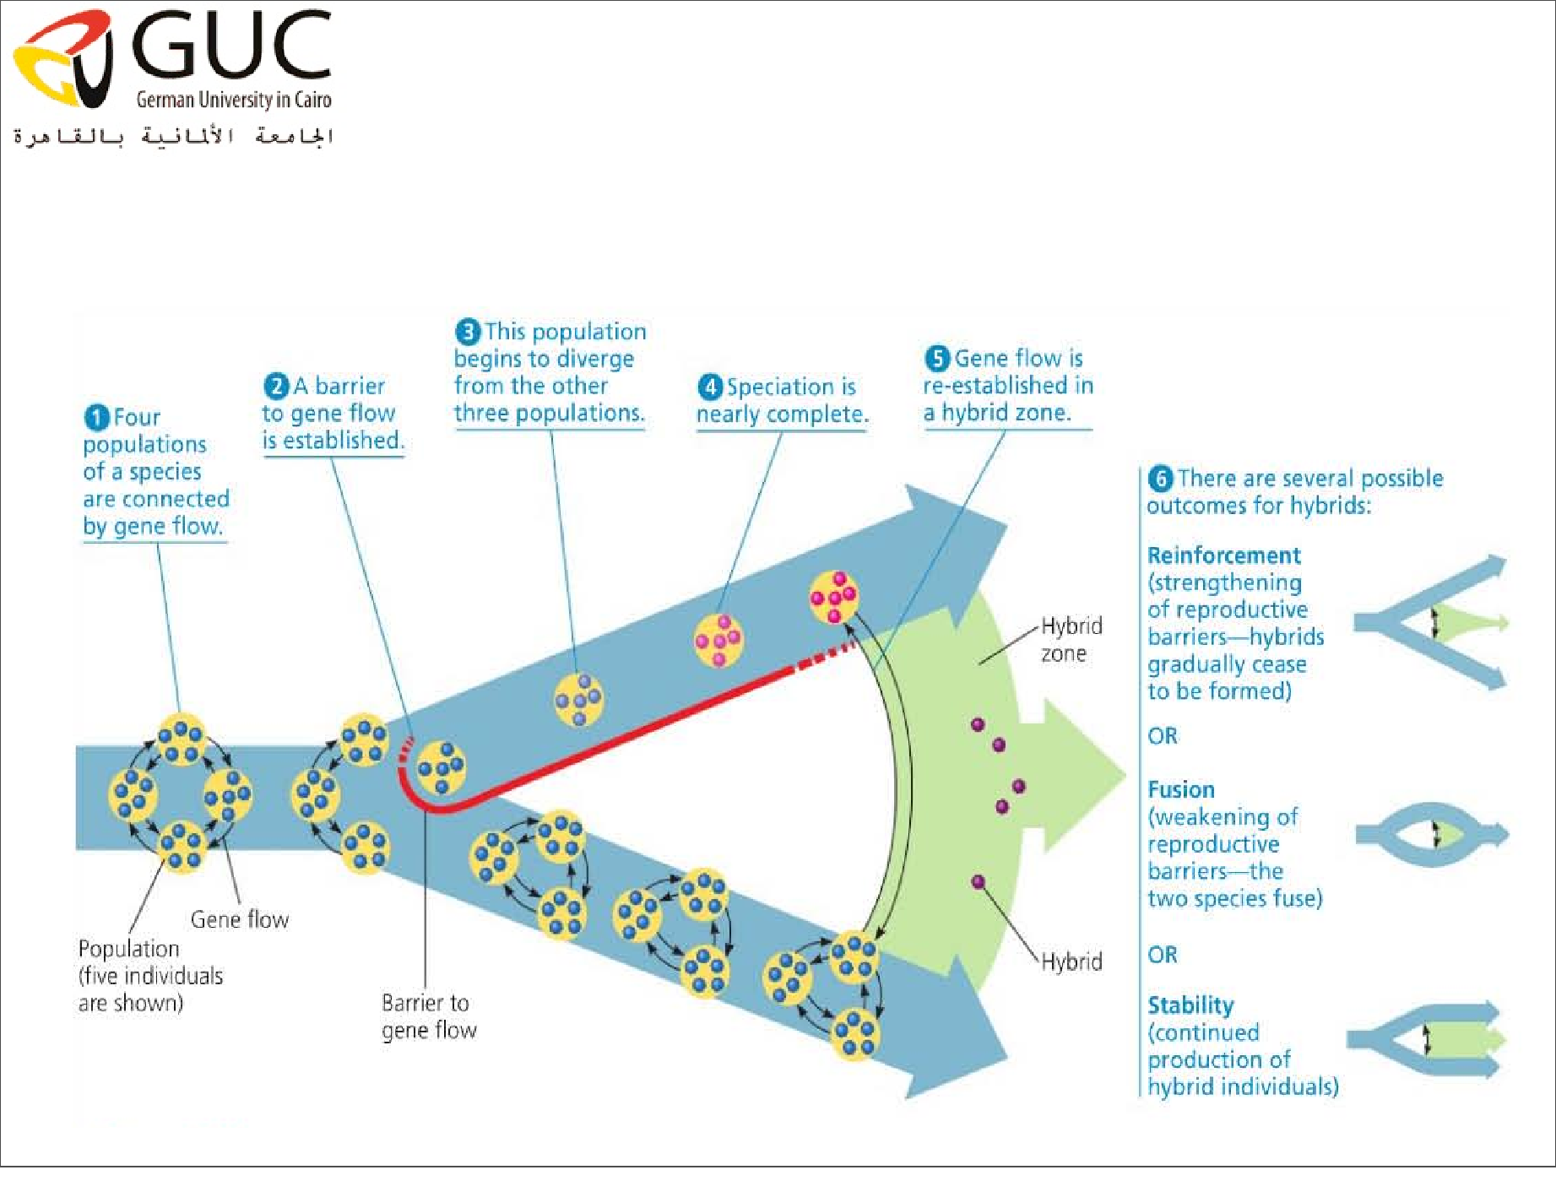

Speciation Types:
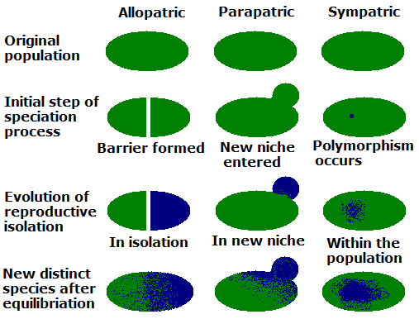

Two Processes:
- Ecological Speciation (reproductive isolation and/or reinforcement)
- Mechanisms of genetic divergence
  - Allopolyploidy or autopolyploidy
  - Chromosomal rearrangements + hybrid incompatibility
  - Dobzhansky-Muller hybrid incompatibility
    - Mechanism for prezygotic isolation
  - Haldane’s Rule
    - Evolution of postzygotic isolation

Dobzhansky-Muller Model:
- Allopatric populations…same ancestor
- New allele fixed
- These two are diverged species and incompatible (their alleles don’t know each other so don’t know how to play nicely with each other)
- Messes up the proteins that come about after transcription and translation. Hybrid offspring are NOT viable!
- Separately, these lineages can reproduce with the ancestral pop’n.
- If advantageous mutations, will become permanent in each respective population
- 2 new species!

Dobzhansky-Muller Model cont’d
- Evolution of genetic incompatibility. (Hybrid)
- Why can’t closely related species produce viable offspring?
  - At least 2 loci must be in play
  - Have a new allele in a population
  - Put that allele in same genetic background
  - Why no workies?
  - MUST have allele at another locus that is incompatible

Haldane’s Rule (which is an observation):
- Noticed in early speciation
- Sibling species or subspecies get it on
- Their kids are hybrids (F1 generation)
  - Absence of one sex OR
  - One sex rare OR
  - One sex sterile
- So what does it mean?
  - Initial step in evolving postzygotic isolation
Genetic processes driving speciation somehow!

Definition of Species:
- Morphological species concept: you look familiar…
- Ecological: this is my space…find your own!
- Biological: (isolation): can you make a kid that can make a kid? (Problems for asexual species)
- Recognition: you look familiar. Sex? (Problems for asexual species)
- Evolutionary: own evolutionary ways/fate
Genetic:
- Phylogenetic: organisms w/unique genetic history OR smallest monophyletic group sharing a unique character(s) (in general, neutral sequence).
- Bar Code: (neutral sites in gene- percent divergence >3% )

Topic 3: Phylogenetics
Phylogenies:
- Order organisms
- Based on evolutionary history (“known”)
- Build based on traits
  - Traits: observable characteristics
  - Currently use DNA sequences
Remember! Phylogenetic trees are HYPOTHESES about evolutionary relations

Definitions:
- Analogous Trait: Shared by 2(+) species NOT b/c of common descent. Example, living in the desert.
- Parsimony: The best tree, based on fewest character changes
- Convergent evolution:
- Divergent evolution: Closely related pop’ns/species diverge b/c nat. sel. operates differently on each.
- Homologous Trait
- Paraphyletic : Includes common ancestor of all in the group but not everyone that came from that ancestor.
- Polyphyletic: Group excluding common ancestor of the members and/or all descendants of the common ancestor
- Clade: Every descendant species of C.A. (no one else!)
- Convergent evolution: Leads to analogous traits
- Node: Branching point (species)
- Homologous Trait: Trait shared by 2(+) species b/c of inheritance from shared common ancestor
- Homoplasy: Trait similar in two species, not because of common ancestry (b/c of convergent evolution).
- Symplesiomorphy: Derived trait appearing in only one sister taxa (thus is very recent). Problematic.
- Synapomorphy: Derived trait shared in two popn’s (inherited from recent common ancestor).
- Taxon: Group of related organisms
- Vestigial Trait: Traits that had a function in the evolutionary past but no longer serve one
- Monophyletic group: Every descendant species of C.A. (no one else!)

Topic 4: Macroevolution
- Microevolution = varieties within a group.
  - Same descendants
  - Horizontal changes
  - Natural selection
  - Recombination of pre-exiting genetic material
- Macroevolution = major change over time
  - New organisms ; can’t mate with ancestor
  - Ex. Land mammal to whales
  - Vertical changes

Macroevolution vs. Microevolution:
- Macro = Above or at species level
- Micro = changes in allele frequencies WITHIN a population or within a species
BOTH TYPES DESCRIBE THE SAME PROCESS!
The difference?
Time Scales!

Darwinian
- Microevolution hypothesis – at the genetic level + visibly, natural selection happening on individuals. Therefore, diversification!
- Phyletic gradualism everyone starts off from the same points and gradual radiates.
Macroevolution
- Species selection – that radiation is not constant. Sometimes there is a lineage more successful, or less…
- Punctuated equilibrium hypothesis – radiation, stasis, fast evolution
- Any sudden change for the species
  - Mutation
  - Environmental change

Asexual species:
- Clones only
- Good clones have success
- Selection pressure is on competitively good clones
- This selection seems to be PUNCTUATED by appearance of new successful clones
- Then there is stasis
- Then there can be extinction

Topic 5: Human Evolution
14.4 – read it!

Haldane’s Rule!



