Chandler on business
Greiner on evolution/growth of organizations
Tannebaum & Schimdt on leadership
Collins & Porras on company’s vision
Zaleznik, managers and leaders

Chandler

The key concepts

Economies of scale:
Large plants can produce products at a much lower cost than small ones because de cost per unit drops as the volume of output rises.

Economies of scope:
Large plants can use many of the same raw and semi-finished materials and intermediate production processes to make a variety of different products.

MAJOR CLAIM
But for firms benefit from theses economies:
- Flow of materials must be kept constant
- National (and international) marketing and distribution functions must be created
- Teams of lower and middle managers need to be recruited

SECONDARY CLAIMS:
- Once a firm loses the opportunity to be a first mover, it is difficult to regain competitive advantage.
- Entrepreneurial companies that do not make investments to create organizational capabilities cannot achieve long-term success.
- Growth through unrelated diversification is a poor company strategy.
- Business ownership patterns have diminished the likelihood of many

Concept list
- Economies of scale & economies of scope
- Functional divisions, management hierarchy & geographical expansion
- First movers & challengers
- Research & development (innovation)
- Related & unrelated diversification
- Separation of top and middle managers (in the case of unrelated diversification)
- Entrepreneurial enterprise (staying small)
- Stock market pressure (due to ownership pattern)
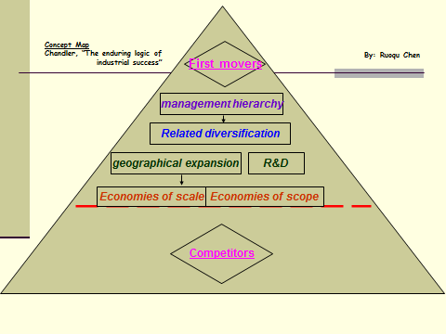
- Short-term thinking (due to market pressure)

NOTES from class
- Cost advantages are realized by placing a company’s different facilities under a single management
- Reduce production costs through economies of scale and scope
- Dominant companies: when managers and executives understand the logic of managerial enterprise (logic of growth & competition)
- Successful firms capitalize on economies of scale and scope, create management structures, and invest in research and development
- Capitalize on economies of scale and scope
  - Economies of scale: large companies can produce products at a much lower cost than small ones because cost/unit drops as the volume of output rises (geographic expansion related to this sort of economy)
  - Economies of scope: large companies can use the same raw materials and intermediate production processes to produce a variety of different products (moving into related markets)
- Invest in creating national & international marketing & distribution organizations
- Fist movers: companies that quickly dominated their industries by making large investments & gaining competitive advantage.
  - Once the opportunity is lost, difficult to regain competitive advantage
- Innovation & strategy: more powerful weapons than price
- Companies should:
  - Improve quality products
  - Reduce costs
  - Create new markets
  - Engage in systematic research and development to improve existing products and develop new ones
  - Differentiate products from competitors
  - Move into growing markets & out of declining ones
  - Expand & enlarge plant size
  - Keep a steady flow of information and material throughout the company
  - Ensure proper communication between different sectors of the business

- Ignoring to logic of managerial enterprise: costly, confirming to it: keep companies competitive
- Successful companies: essential investments in production, distribution, marketing and management. First movers!
- Aggressively exploiting cost advantages of economies of scale & scope: encourages product & process innovation
- Many companies fail to invest, reinvest & grow
- Managerial enterprise can stagnate & managers can make wrong decisions
- Growth: basic goal of managerial enterprises
  - Can be done by moving abroad or into new markets in related industries
- Many managers move into industries in which their enterprises have no competitive advantage. Believe that if they’re successful in their industry, they can be it everywhere. Acquisitions and mergers but no knowledge of the new industries!
- Growth through unrelated diversification (acquiring businesses for which they have little): poor business strategy (ignorance of logic of managerial enterprise)
  - Leads to separation of top vs middle managers
  - Managerial weakness
- Many companies must invest in widespread restructuring because of loss of control (shares sold to individuals who now have part ownership)
- Business ownership patterns: diminished likelihood of many firms’ long-term success
- Important to hire managers with experience and skills to understand the company’s products, processes, markets & competitors
- Lose markets and profits to those in other industries IF:
  - Entrepreneurial enterprises fail to become managerial enterprises

GREINER

Major claim
Organizations grow through a series of evolution and revolution phases that are function of the age and the size of the organization.
Management practices that work well in one phase bring on a crisis in the next.
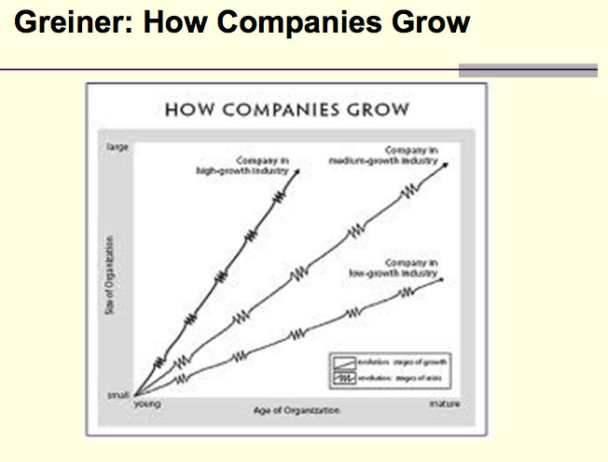

Primary concepts
- Age of the organization
- Size of the organization
- Stages of evolution
- Stages of revolution
- Growth rate of industry
- Management style
- Organizational structure

5 phases to growth
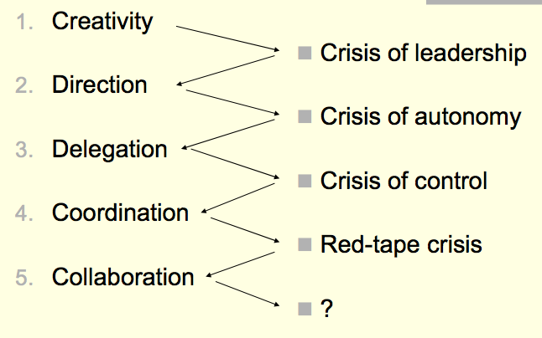

concept map
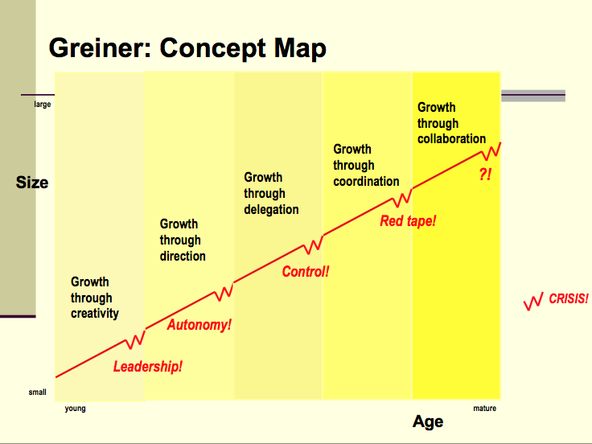
For each evolution phase, student should know:
- The exact name of the evolution phase
- The characteristics of the evolution phase (what is happening)
- The issues that lead to a crisis
- The exact name of the crisis
- The required solution for the crisis

secondary claim
- Organizations should not try to skip phases
- Top managers whose style is no longer appropriate should remove themselves
- Growth is not inevitable

Advantage of large, bureaucratic organization
- Hierarchical authority promises control and responsibility
- Specialization of sub-units promises accountability, control and expertise
- Management by rules promises control and consistency
- Being impersonal promises objectivity, consistency and equality
Examples of RED TAPE:
- Each department has its own agenda, and departments don’t cooperate to help other departments get the job done.
- Top managers are dangerously ill-informed and insulated from what is happening on the front lines or in "the field”
- Quantitative measurements are favored over qualitative measurements, so the concentration is on quantities of output, with less and less concern for quality of output.
- Both employees and customers are treated more as numbers than people

Note from class
- Behavior of individuals and companies determined primarily by past events and experiences rather than by what lies ahead
- Series of developmental phases: organizational growth
- Phase begins with period of evolution (steady growth & stability) and ends with a revolutionary period (turmoil and change)
- Resolution of each revolutionary period determines if a company will move forward to a next stage of evolution

Five dimensions that shape an organization’s development:
  - Age: Lifespan of organization. Management problems and principles are routed in time. They don’t last throughout the life of an organization.
  - Size: Companies’ problems and solutions change depending on the number of employees.
  - Stages of evolution: prolonged growth
  - Stages of revolution: inevitable, turbulence, crisis between evolutions. Companies must abandon past practices. Major changes. Major solutions in one period become major problems in a later period
  - Growth rate of its industry: Speed of stages related to speed of the industry. Short evolutionary period in fast-growing industries & vice-versa

- Revolutionary period: characterized by the dominant management style used to achieve growth & by the dominant management problem that must be solved before growth can continue
- Phase: result of previous phase & cause for the next. Can only move forward.
- Solutions breed new problems. Management practices that work well in one phase bring on a crisis in the next phase.
- Managers should predict problems & prepare solutions before a revolution gets out of hand. Top managers who style is no longer appropriate should remove themselves.

Evolution 1: Creativity- Emphasis on creating product & market
Revolution 1: Crisis of Leadership- Development of unwanted management responsibilities. Must find strong manager with knowledge & skill to lead company out of confusion. Solve managerial problems & pull organization together
Evolution 2: Direction- Period of sustainable growth, directive leadership
Revolution 2: Crisis of Autonomy- Lower-lever employees dislike the centralized hierarchy, want to take initiatives on their own. Top-level managers dislike giving up responsibility to lower managers. Delegation.
Evolution 3: Delegation- Application of decentralized organizational structure. Separation of management & authority between top & lower managers.
Revolution 4: Crisis of Control- Top-level managers feel as though they are loosing control & seek to regain control over the company as a whole
Evolution 4: Coordination- Use of formal systems to achieve greater coordination & top-level managers take responsibility of the new systems
Revolution 4: Red tape crisis- Conflict between line & staff, between headquarters & field. Both criticize the bureaucratic system that has evolved. Organization too large to be managed through formal, rigid systems.
Evolution 5: Collaboration- Strong interpersonal collaboration. Spontaneity in management actions, more flexible approach to management. No more formal systems. Team work!
Revolution 5: ?- Psychological saturation of employees who grow exhausted from the intensity of teamwork & innovation.
- Managers have to know where they are in the phases of development to be aware when it’s the time to change
- Managers should work with the flow of the tide rather than against it. Not skip phases!! Each produces strengths & learning experiences essential for future success.
- A stage can only come to a close by means of certain specific solutions that are different from the solutions of the previous phase of revolution.
- To move ahead, companies must introduce planned structures that solve a current crisis & fix the next phase of growth.

Tannabaum & Schmidt
New problem: How the modern manager can be ‘’democratic’’ in his relations with subordinates and at the same time maintain the necessary authority and control organization.
New focus: Emergence of the concept of ‘’group dynamics’’ and its focus on members of the group rather than solely on the leader. The designated leaders deliberately attempted to reduce their own power and make group members as responsible as possible.
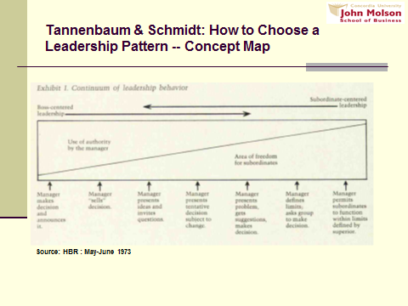

2 types of leader bahavior
Authoritarian behavior: boss made too much decisions himself
Democratic behavior
Manager makes decision & announces it: boss identifies problem, considers alternative solutions, chooses 1 & reports it for implementation. No opportunity for subordinates to participate.
Manager sells his decision: Identifies problem, arrives at a decision & persuades subordinates to accept it.
Manager presents his ideas & invite questions: Opportunity for subordinates to get explanation of his thinking. Invites questions for understanding of what he wants to accomplish.
Manager presents tentative decision subject to change: subordinates have influence on decision. Presents proposed solution for their reaction.
Manager presents problem, gets suggestions & makes decision: manager identifies problem. Capitalize on the knowledge & experience of those who are on the “firing line”.
Manager defines the limits & requests the group to make a decision: manager passes to the group the right to make decisions, he only defines the problem to be solved & the boundaries for decision.
Manager permits the group to make decisions with prescribed limits: group freedom, very occasional, limits specified by the superior of the team’s boss. If boss decides to participate, participation with no more authority than the others.

3 forces impact

Forces in the manager
Manager’s behavior, he will perceive his leadership problems in a unique way. Influence his behavior.
    - His value system: how strongly does he feel that individual should have a share in making the decisions which affect them?
    - His confidence in his subordinates: Trust. Considering their knowledge & competence with respect to the problem.
    - His own leadership inclinations: some managers seem to function more comfortably and naturally as highly directive leaders, others in team role.
    - His feeling of security in an uncertain situation: managers with control reduces predictability of outcome

Forces in the subordinate
Subordinate different personalities, they each have expectations about how the boss should act in relation to them. Greater freedom to subordinates if:
    - Subordinates have relatively high needs for independence
    - Subordinates have a readiness to assume responsibility for decision-making.
    - They are interested in the problem & feel it is important.
    - They understand & identify with the goals of the organization.
    - They have the necessary knowledge & experience to deal with the problem.
    - They have learned to expect to share in decision making.

Forces in the situation
Characteristics of the general situation will affect manager’s behavior. Work group, nature of problem, and pressure of time.
    - Type of organization: values & traditions of organizations. Job descriptions, policies, and public statements by top executives. Size.
    - Group effectiveness: consider how effectively its members work together as a unit. Group that developed habits of cooperation can tackle a problem more effectively than a new work. Similar backgrounds & interests. Degree of confidence.
    - Problem itself: nature of problem, problem complex or no.
    - Pressure of time: clearly felt pressure on the manager. If he needs immediate decision, it is difficult to involve many people. Time pressure less intense: possibility to bring subordinates for decision.
    - Think of long-run strategy
    - Attaining objectives:
      - Raise level of employee motivation
      - Increase readiness of subordinates to accept change
      - Improve quality of all managerial decisions
      - Develop teamwork and morale
      - Further the individual development employees

keys to success
Successful leader: aware of forces, behaves appropriately. Able to be direct & to provide freedom.
Successful manager: neither a strong leader nor permissive one. Maintains a high batting average in accurately assessing forces that determine what is the most appropriate behavior to have.

notes from class
- Importance of employee involvement & participation in decision making
- Authoritarian behavior: when boss made a decision without staff meeting
- 2 types of leader behavior:
  - Authoritarian behavior: boss made too much decisions himself
  - Democratic behavior
- Often he is not quite sure how to behave
- It goes from boss-centered leadership to subordinate-centered leadership
- New continuum of manager-nonmanager behavior: same thing but managers-nonmanagers
  - New behavior in which total are of freedom shared by manager & nonmanagers is constantly redefined by interactions between them & forces in the environment
  - Manager & nonmanagers may be governing forces in their group’s environment, contributing to the definition of the total are of freedom
  - Group can function without a manager, with managerial functions being shared by group members
  - Group, as a unit, can be delegated authority & can assume responsibility within a larger organizational context

- 4 Essential questions:
  - Can a boss ever relinquish his responsibility by delegating it to someone else? Manager should expect to be held responsible, should accept the risk. Amount of freedom he gives to subordinates can’t be greater than the one he is given by his own superior.
  - Should the manager participate with his subordinates once he has delegated responsibility to them? His decision. He knows where he sees himself and should tell it to the group.
  - How important is it for the group to recognize what kind of leadership the boss is using? Very important for relationship. Manager has to be honest.
  - Can you tell how democratic a manager is by the number of decisions his subordinates make? Number not important. Significance of decisions, which the boss entrusts to his subordinates very important.

- Appropriate style depends on:
  - Forces in the manager: manager’s behavior, he will perceive his leadership problems in a unique way. Influence his behavior.
    - His value system: how strongly does he feel that individual should have a share in making the decisions which affect them?
    - His confidence in his subordinates: Trust. Considering their knowledge & competence with respect to the problem.
    - His own leadership inclinations: some managers seem to function more comfortably and naturally as highly directive leaders, others in team role.
    - His feeling of security in an uncertain situation: managers with control reduces predictability of outcome
  - Forces in the subordinate: subordinate different personalities, they each have expectations about how the boss should act in relation to them. Greater freedom to subordinates if:
    - Subordinates have relatively high needs for independence
    - Subordinates have a readiness to assume responsibility for decision-making.
    - They are interested in the problem & feel it is important.
    - They understand & identify with the goals of the organization.
    - They have the necessary knowledge & experience to deal with the problem.
    - They have learned to expect to share in decision making.
  - Forces in the situation: characteristics of the general situation will affect manager’s behavior. Work group, nature of problem, pressure of time.
    - Type of organization: values & traditions of organizations. Job descriptions, policies, public statements by top executives. Size.
    - Group effectiveness: consider how effectively its members work together as a unit. Group that developed habits of cooperation can tackle a problem more effectively than a new work. Similar backgrounds & interests. Degree of confidence.
    - Problem itself: nature of problem, problem complex or no.
    - Pressure of time: clearly felt pressure on the manager. If he needs immediate decision, it is difficult to involve many people. Time pressure less intense: possibility to bring subordinates for decision.
    - Think of long-run strategy
    - Attaining objectives:
      - Raise level of employee motivation
      - Increase readiness of subordinates to accept change
      - Improve quality of all managerial decisions
      - Develop teamwork and morale
      - Further the individual development employees

Collins & porras
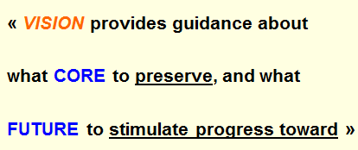

Core ideology
Enduring character of an organization – a consistent identity that transcends products or market life cycle, technological breakthroughs, management fads, and individual leaders.
(Glue that holds the organization together during its growth)

Core value and core purpose
Core values: system of guiding principles of what is important, essentials and enduring tenets, small sets of guidance principles.

Core purpose: organization’s most fundamental reason for existence, people’s idealistic motivation for doing their work.
DISCOVERING CORE IDEOLOGY :
- Do not create or set core ideology,
- Description of what actually exists, not just what we wish existed
- Needs to be meaningful and inspirational only to people inside the organization
- Find people who are predisposed to share the organization’s core values and purpose
- More than creating a perfect statement!

creative process
Envisioned future: what we aspire to become, to achieve, to create. Something that will require significant change and progress to attain.

BHAGs: Big, Hairy, Audacious, Goals
- 10 – 30 years
- Powerful way to stimulate progress
- Clear & compelling; serve as unifying focal point of effort; acts as a catalyst for team spirit
- Takes little or no explanation
- No a sure bet!
Vision level BHAG: clear, compelling, bold mission or goal of a company that stimulates progress – it is motivating
Vivid description: vibrant, engaging, and specific description of what it will be like to achieve the BHAG – it is a creative process

Vivid description: passion, emotion, and conviction. Some managers are uncomfortable expressing emotion about their dreams, but that’s what motivates others
BEWARE OF THE ‘’WE’VE ARRIVED SYNDROME’’
Arises once an organization has achieved one BHAG and fails to replace it with another.
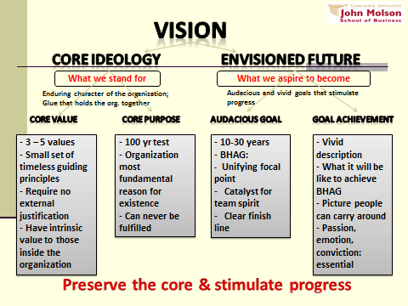

Notes from class
VISION (Collins & Porras)
- To enjoy enduring success: core values & core purpose fixed but business strategies & practices change and adapt.
- To achieve long-term success, it is important to preserve the core while stimulating progress.
- Great companies understand the difference between what should change and what stands.
- Vision: guidance about what core to preserve and what future to stimulate progress toward
- Well conceived vision:
  - Core ideology: what we stand for & why we exist, who we are
  - Envisioned future: what we aspire to become, to achieve, to create. Something that will require significant change and progress to attain.
- More important to know whom you are than where you are going. Where you are going changes with the world around you.
- Core ideology- glue that hold an organization together during its growth:
  - Core values: system of guiding principles of what is important
  - Core purpose: organization’s most fundamental reason for existence
- Core ideology discovered by looking inside. Authentic, can’t fake it.
- Core ideology: role to guide & inspire, not to differentiate. 2 companies can have the same core values or purpose
- Core ideology: meaningful & inspirational to those inside the company
- Clear and well-articulated ideology attracts to the company people whose personal values are compatible with the company’s core values and repels those whose are not
- Company: can have a very strong core ideology without a formal statement
- Core values: product excellence, good customer service, respect for the individual, quality, market focus, teamwork. Ex: Walt Disney’s- imagination and wholesomeness
- Core values: doesn’t depend on market requirements but on founder’s beliefs
- Company should not change its core values in response to market changes, rather it should change markets, if necessary, to remain true to its core values
- Core values: define what a company stands for & held even if they become a competitive disadvantage
- Great companies decide for itself what values it holds to be core, independent of the current environment
- No universally right set of core values, companies only have a few of them
- Core values do not change VS operating practices & strategies (open to change)
- Core values must last in the company forever no matter how the world around it changes
- Mars Group: group of individuals who are responsible for articulating the core values of the company because they are exemplars of those values
- Effective core purpose: reflects people’s motivation for doing the company’s work. Captures soul of organization.
- Core purpose: goes beyond making profit, should last at least 100 years, should not be confused with specific goals or business strategies (which should change many times in 100 years)
- You can achieve a goal but you cannot fulfill a purpose
- Purpose does not change but inspires change
- Powerful method for getting at a purpose: ask the five whys
- Companies need to have a clear understanding of their purpose in order to make work meaningful & attract, motivate, and retain outstanding people
- Do not confuse core ideology (captures what you stand for and why you exist) with core competence (strategic concept that defines a company’s capabilities, what it is particularly good at)
- Visionary company: core competencies change over time VS core ideology stands
- Envisioned future:
  - A 10-to-30 year audacious goal (BHAG)
  - Vivid descriptions of what it would be like to achieve the goal
- Vision level BHAG: clear, compelling, bold mission or goal of a company that stimulates progress – it is motivating
- Serves as a focal point of effort and has a clear finish line so that the organization can know when it has achieved the goal
- BHAG: not a sure bet but the company must believe that it can reach the goal
- Vivid description: vibrant, engaging, and specific description of what it will be like to achieve the BHAG – it is a creative process
- Vivid description: passion, emotion, and conviction. Some managers are uncomfortable expressing emotion about their dreams, but that’s what motivates others
- Core purpose – not some specific goal – is the reason why the organization exists. A BHAG is a clearly articulated goal. Core purpose can never be completed, whereas the BHAG is reachable in 10 to 30 years.
- Envisioned future: exciting, would continue to keep the organization motivated even if the leaders who set the goal disappeared
- “We’ve Arrived Syndrome” arises once an organization has achieved one BHAG and fails to replace it with another

zaleznik

main claim
‘’Managers embrace process, seek stability and control, and instinctively try to resolve problem quickly…
Leaders in, contrast, tolerate chaos and lack of structure and are willing to delay closure in order to understand the issue more fully.” (p.74)
Vision VS execution and results

sub-claims
- Business leaders have much more in common with artists, scientists, and other creative thinkers than they do with managers. (p. 74)
- Organizations need both managers and leaders to succeed.
- For those who become managers, a survival instinct dominates the need for risk, and with that instinct comes an ability to tolerate mundane, practical work (p. 77)
- Managerial personalities form moderate and widely distributed attachments. Leaders, on the other hand, establish, and also break off, intensive one-to-one relationships
- Leaders work in the opposite directions. Where managers act to limit choices, leaders develop fresh approaches to long-standing problems and open issued to new options. (p. 77)
- Leaders work from high-risk positions. (p. 77)

Chapter 1: critical thinking
Critical thinking is an approach to reading, thinking, and learning that involves asking questions, examining our assumptions, and weighing the validity of arguments.
Critical thinkers are self-aware, curious and independent.
Self-aware: they work at knowing their own biases and can name the strategies they are using when they make judgments.
Curious: explore the surface of issue by challenging ideas, try new approaches, seek new viewpoint, and want to extend their knowledge.
Independent: they listen to ideas and learn from them, and use that learning to develop their own opinions.
BUYERS BEWARE: a critical thinker does more than passively accept ideas of others, even including the ideas of business experts.
Being a critical thinker means going beyond the level of being a passive sponge.
DIMENSIONS OF CRITICAL THINKING:
- Purposeful: when we use these thinking strategies, we are trying to settle a problem, develop an answer to a question, or decide on appropriate action. It behooves us to ensure that out thinking is directed at a significant and useful purpose and that we can state clearly points at issue.
- Quality of the evidence
- Underlying assumptions and values
- Causal claims
- Techniques of persuasion

Chapter 2: claims
A claim is the major conclusion of a piece of writing that the author is trying to persuade you to accept. It is pointless (inutile) to criticize a thesis if you are unable to say clearly what the author’s claim is.
Words to identify a claim: therefore, thus, in summary, I believe that, clearly, in short, the data show that, as a result, in fact, and synonyms.
The other statements are evidences: the examples and reasoning that are presented to support the claim.

uncontested claims
We might accept a claim without examining the evidence.
Conditions in which you may accept a claim without challenge:
1. We usually do not contest claims that are consistent with our own experiences and observations, things that we have actually seen, heard, or touched: The roads are congested with traffic between 4pm and 6pm.
Similar, we accept claims that relate to subjective experiences: Golf is my favorite sport.
2. Some claims appear to be facts that are independent of interpretation: Quebec is larger than Nova Scotia.
Events that happened are often not questioned: train accident or merger between two firms.
3. Areas in which there is agreement among experts, or strongly supported general claims that are common sense. Knowledgeable and intelligent people claim: You cannot physically be in two places at one time.
Business scholars agree that: Frederic Taylor has often been called the father of modern management.
4. Technical or mathematical claims are accepted: a megabyte is 0.0009 of a gigabyte.

contestable claims
When a claim does not fall into one of the categories described above, we need to question its truth. Contestable claims often introduce new ideas that awaken curiosity and cause people to think about things in new ways.
We need to see the crucial difference between simply stating that something is true and providing relevant and solid reasoning for our statements.
PRESENTING A CLAIM:
- sentence (short text)
- list of important concepts
- series of propositions about how these concepts are related
- concept map (graphically, diagram or drawing)
Concept maps are a compact way of summarizing complex material and can make the author’s claim very memorable. The strength of a concept map is its ability to summarize concisely large amounts of information.

Chapter 3: evidence

Sharpen your analytical skills
Critical thinking = Analyzing the validity of arguments presented in a text
- Identify the author’s major conclusions
- Describe & evaluate supporting evidence
- Uncover assumptions & values
- Determine soundness of causal logic
- Deconstruct use of persuasive language

definitions
Claim: central idea that the author is trying to persuade you to accept
Evidence: any statement that is a response to the question ‘Why this is true?’
Claim+ evidence = argument
Several arguments in longer piece of writing

Evaluate the supportive argument
Finding the evidence
can consist of:
Statistics, Details of past events,
Anecdotes, Quotes, etc...
Cue words:
Because, As a result, In the first place,
For example, In addition, etc...
Examples :
Central claim: ‘’Students today are more knowledgeable than they were a decade ago’’
Contestable claim
Why is this true?
Early learning in daycare (2-4)
Skills of teachers (5-8)
Availability of computers (9-11)

evaluate the supportive evidence
Criteria to test the quality of the evidence:
Accuracy
Difficult to judge without an independent source of information
2 ways to proceed:
- Do our own research to verify accuracy
- Use proxies to evaluate accuracy: trivial errors, grammar, spelling mistakes, inaccurate quotes, or precision.
Precision
Comes from numbers and quotes
-18.4% is better than “quite well” or “almost 20%”
- Ambiguous words should not be overused
- Numbers and direct quote should be provided
- Precision creates the impression of accuracy
- Beware of over-precision
Sufficiency
How much evidence?
- Importance of claim
- Potential damage
Fallacy of hasty generalization
Representativeness
- Variety in the sources of evidence should match the variety in the population
- Fallacy of hasty generalization
Authority
- Training, credentials, experience of others
- Classics or current writing
- Context-dependent
- Fallacy of false appeal to authority
- Fallacy of argumentation ad populum (bandwagon)
Clarity of expression
- Quantitative data should be interpreted
- Direct quotation should also be interpreted
Other objections: issues of relevance related to underlying assumptions

chapter 4: underlying assumptions
Underlying assumptions: it is a logical link that fills the gap between the evidence and the claim.
Implicit or explicit principles that form the bases of our beliefs and reasoning.
Tells us whether an evidence for a claim is relevant.

how to fin underlying assumptions
We find underlying assumptions by looking at what people write, then making guesses about what they must believe in order to have written that. We look at the gap between the evidence and the claim: What must be true if the claim is to follow from this evidence? What general principal might link this particular claim to this particular evidence?

reality assumptions
Reality assumption: our belief about reality; about the way things are. In particular, when we consider experience that is consistent with a given belief, the belief becomes taken for granted.
CHANLLENGING THE REALITY ASSUMPTIONS:
One an author’s reality assumptions are made explicit, the next step is to evaluate their accuracy.
- critiquing the quality of the assumption
- challenging by providing data that would show that the assumption is incorrect

Value assumptions
Value assumption: our ideals, our standards of right and wrong, the way things ought to be.
CHANLLENGING THE VALUE ASSUMPTIONS:
Value conflicts and differential value rankings are reasons for disagreement about the relevance of the evidence presented for claim.

effective writing
Critical thinking about underlying assumption can help you to improve you won writing. A large quantity of evidence for your claims and ensuring that the evidence is of good quality are both necessary but not enough to be convincing. It is also important to make it clear that each piece of evidence is relevant.
- Self-questioning about conflicting assumptions is a key to effective writing.
- Think as your audience
- state your value preferences explicitly and argue for them

