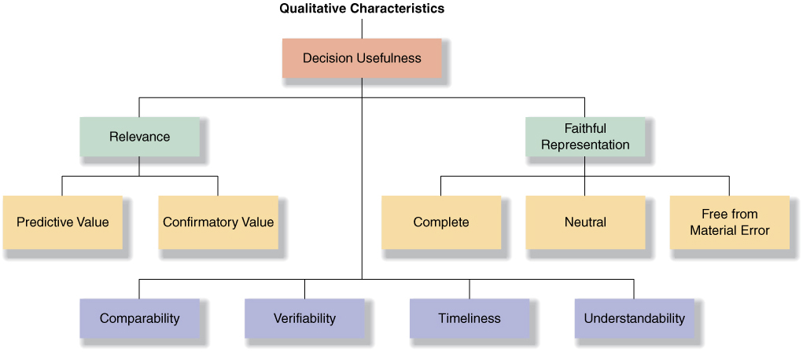
Fundamental (to be useful)
- Relevancy: makes a difference in a decision, predictive value, feedback/confirmatory value
(1) To be relevant, accounting information must make a difference in a decision:
predictive value – relevant information helps users make predictions about the ultimate outcome of past, present and future events
feedback value – relevant information helps users confirm or correct prior expectations timeliness – must be available before it loses its capacity to influence their decisions
- Faithful representation: complete, neutral, reasonably free from error or bias.
(2) Representational Faithfulness – the numbers and descriptions represent what really exists or happened F/S must be transparent (i.e., reflect economic substance rather than legal form)
reliable and verifiable – independent measures, using the same measurement methods, obtain similar results
neutrality – factual, truthful, unbiased – information cannot be selected to favour one set of stakeholders over another
reasonably free from error or bias
Enhancing (degrees of usefulness)
- Comparability: across companies. – Resource allocation decisions involves evaluation of alternatives and valid evaluation can only be made if comparable information is available
- Verifiability: similar results under independent measures, using the same measurement methods, obtain similar results
- Timeliness: information must be available before its loses its usefulness.
- Understandability: allows reasonably informed users to see the significance of the information.
Consistency (across periods)
– similar events have the same accounting treatment from period to period
– when accounting treatment changes, full disclosure is made

ELEMENTs OF STATEMENT
Asset: economic resource with probable future benefits.
Liability: probable future sacrifices of economic resources.
Shareholders’ Equity: financing provided by owners and business operations.
Revenue: increase in assets or settlement of liabilities from ongoing operations.
Expense: decrease in assets or increase in liabilities from ongoing operations.
Gain: increase in assets or settlement of liabilities from peripheral activities.
Loss: decrease in assets or increase in liabilities from peripheral activities.

Assumptions
Separate entity: Activities of the business are separate from activities of owners.
Continuity (going concern): The entity will not go out of business in the near future.
Unit-of-measure: Accounting measurements will be in the national monetary unit (i.e., $ in Canada).

Principle
Historical cost: Cash equivalent cost given up is the basis for the initial recording of elements.
The COST CONSTRAINT suggests that information should be produced only if the perceived benefits of increased decision usefulness exceed the expected costs of providing that information.
PRUDENCE suggests that care should be taken not to (1) overstate assets and revenues or (2) understate liabilities and expenses.

