Concordia University
Research Grant Proposal
Community Based Programs for Children Have a Positive Impact on the Child, the Family and the School and the Community
Don_Murr
10/9/2014

Abstract: Children are not islands which stand alone in the community. They are woven into every aspect and their wellbeing is indicative to the wellbeing of the community. With less and less support found in the traditional venues locally based community groups focused on the child and their best interests are critical. This present grant proposal outlines the project description, proposed budget, timeline and requirements needed to see this project to fruition. A three-fold approach must be taken with local businesses, citizens as well as Government support coming along side this project where no one stakeholder must bear the entire responsibility.

Table of Contents
Project Description 3
Background 4
Community Population Breakdown 5
Timeline & Schedule 8
Budget 9
Value to the Community 10
References 11

Project Description
W

ith so much riding on the outcome often so little is done to prevent the inevitable; children are at risk and it is our responsibility to act. The family is under much duress and the effects go far beyond the individual child’s behavior; it is linked to emotional, social, academic and health related issues.(Cummings & Schatz, 2012). The connections between the family, the children and the community have to be facilitated and encouraged to flourish (McFarland-Piazza, Lord, Smith, & Downey, 2012). The umbrella organization will be called Kids in the Park.
The benefit to having this connection is only increased when we look at children with special needs (McFarland-Piazza et al., 2012). There is no doubt that there is an overwhelming need to do something. We may not be able to change the world but we are convinced that we can change this community. There is no quick solution, no easy path. To change the outcome in a community takes time; we believe if there is a better beginning there is a better future (Pancer, Nelson, Hasford, & Loomis, 2013).

This community based group already has the support of local business as well as the support of a large number of citizens who are concerned for the well being of our community. The proposed location has been offered at a reduced rate with no security deposit required. We have secured a preferred rate on the required insurance as well have established strong relationships with local suppliers. The majority of the proposed personnel will be on a voluntary basis and are coming from the local educational institutions in the community. We do on plan to have a staff on salary but as you will see even on the paid positions there has been a considerable reduction on estimated costs when based on the level of commitment and professionalism we are anticipating from the candidates.

This project has been over 18 months in the planning and putting into place everything that can be done. With the last of the funding in place we plan to be fully operational in the 2nd quarter of 2015.

Average Family Income Longueil Burroughs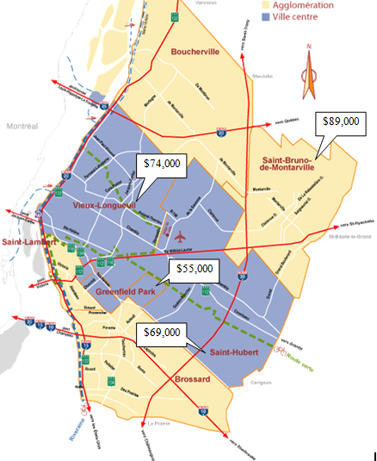

Timeline

Expenses | 2015 | 2016
Personal
Executive Director | 39,000 | 42,000
Administrative Assistant | 24,000 | 27,000
Custodial Services | 12,000 | 14,000
Kitchen Services | 18,000 | 20,000
Security | 21,500 | 24,000
Business
Supplies | 35,000 | 37.750
Rent | 36,000 | 39,000
Insurance | 32,000 | 58,000
Computer Support | 4,000 | 4,500
Electricity | 6,000 | 7,500
Total Expenses | 227,500 | 236,038

What is the value to the community; perhaps the better question would be what the cost of not doing anything is.
We do not believe in Government handouts, however, we do believe that every stake holder in the community should bear some responsibility.
There is a famous saying that says “It takes a community to raise a child”. There are not many who would argue against that.
The real issue is who is going to pay for it.
We believe this is not a cost be paid out but rather an investment being made.
We believe that which you invest in today will reap much more then was paid out in the future.

References
Cummings, E., & Schatz, J. (2012). Family conflict, emotional security, and child development: Translating research findings into a prevention program for community families. Clinical Child & Family Psychology Review, 15(1), 14-27. doi:10.1007/s10567-012-0112-0
McFarland-Piazza, L., Lord, A., Smith, M., & Downey, B. (2012). The role of community-based playgroups in building relationships between pre-service teachers, families and the community. Australasian Journal of Early Childhood, 37(2), 34-41.
Pancer, S. M., Nelson, G., Hasford, J., & Loomis, C. (2013). The better beginnings, better futures project: Long-term parent, family, and community outcomes of a universal, comprehensive, community-based prevention approach for primary school children and their families. Journal of Community & Applied Social Psychology, 23(3), 187-205. doi:10.1002/casp.2110

