PSYC233: Adolescence

Chapter One: Introduction

- Framework of the Book: An Overview
  - Foundations
    - Chapters 1 – 5
  - Contexts
    - Chapters 6 – 12
  - Problems and Resilience
    - Chapter 13
- Themes of the Book: An Overview
  - Implications of Cultural Contexts
  - Historical Contrasts
  - Interdisciplinary Approach
  - Gender Issues
  - Globalization
- Chapter Content Overview
  - Adolescence in Western Cultures: A brief history
  - Adolescence and emerging adulthood
  - The transition to adulthood
  - The scientific study of adolescence and emerging adulthood
  - Adolescence around the world: A brief regional overview
- Adolescence is…
  - …The period after puberty beings and before adult roles are taken on…
  - …Culturally constructed
  - …a fairly new term, coming into common usage in the early 20th century
- Adolescence: A cultural construct
  - Almost all cultures recognize “adolescence” as a life period
  - The length, content, and daily experience differs across cultures
  - Different cultures define adult status, roles, and responsibilities differently.
- Adolescence in Western Cultures: Ancient Greece
  - Life Stage/Plato on Education:
    - Infancy [birth – 7yrs old]:
      - The infant’s mind is too undeveloped to learn much
    - Childhood [7 – 14yrs old]:
      - Education should focus on sports and music
    - Adolescence [14 – 21yrs old]:
      - Capacity for reason allows for study of science and math
- Early Christian Times to Middle Ages
  - Influence of Saint Augustine’s autobiography, “Confessions”
  - The Children’s Crusade of 1212
  - The University students were typically between the ages of 13 and 15.
  - During this period young people were considered, innocent, having a lack of knowledge, and lack of experience
- Adolescence 1500 – 1890
  - Life-cycle service which began in the late teens and 20s
  - Young people would engage in various trades and crafts
  - Common in the United States
  - Rates of crime, premarital sex, and alcohol use increased.
- The Age of Adolescence: 1890 – 1920
  - Contributing Factors:
    - [1]. Legislation prohibiting child labor
    - [2]. Requirements for children to attend secondary schooling
    - [3]. Adolescence as a distinct field of scholarship
- G. Stanley Hall: Key Ideas
  - Child Study Movement:
    - Research to better the lives of children and adolescents
  - Founder:
    - The study of adolescence and wrote the first textbook on adolescence
  - Recapitulatio:
    - Development of an individual re-enacts evolution of human species
  - Storm and Stress:
    - Upheaval and disorder is a normal part of adolescent development
    - The Storm and Stress Debate
      - “to be normal during the adolescent period is by itself abnormal” [p. 275, Anna Freud]
- Adolescence: From Hall’s Time to Our Time
  - 1900:
    - 14 – 24yrs
  - 2012:
    - 10 – 18yrs
  - From 1900 to 1970, initial age of menarche has declined [12.5yrs]
  - First signs of puberty being about two years prior to menarche, at about age 10.
- Emerging Adulthood is the age off…
  - Identity explorations
  - Instability
  - Self-focus
  - Feeling in-between
  - Possibilities
  - Ages 18 – 25
- What Do You Think?
  - Is 25 a good upper age boundary for the end of emerging adulthood?
  - Where would you put the upper age boundary, and why?
  - What is the best age to enter a committed relationship and marriage?
  - Arnett [2011] reported 26 for women and 28 for men
- Median Marriage Age [Average]
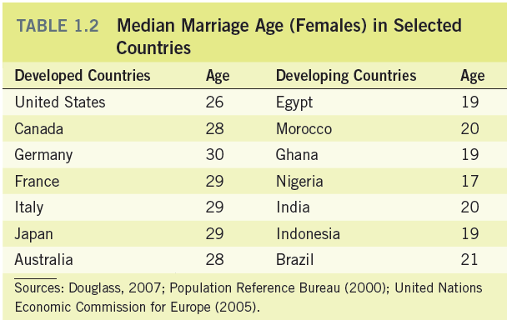

- The Transition to Adulthood: American Style
  - Legally an adult at age 18
  - Characterized by Individualism:
    - Accepting responsibility for oneself
    - Making independent decisions
    - Becoming financially independent
- The Transition to Adulthood: Other Perspectives
  - Israel:
    - Completing Military Service
  - Argentina:
    - Being able to support a family financially
  - India/China:
    - Being able to support their parents financially
- Individualism & Interdependence
  - Individualism:
    - [a]. Learning to stand alone
    - [b]. Self-Sufficient
    - [c]. Values of independence and self-expression
      - Geert Hofstede*****
- Applying Standards of the Scientific Method
  - Question:
    - Identify a research idea
  - Hypotheses:
    - Finding an answer to an important question that emerges from theory or previous research
  - Research Design:
    - Plan for how and when to collect data
  - Sampling:
    - Choosing participants to represent the population of interest
  - Procedure:
    - The way the study is conducted and data is collected
  - Methods:
    - Strategies for collecting data
- Research Issue: Sampling a Population
  - A researcher surveys young adults in a drug rehabilitation program to find out about the frequency of drug use among American urban adolescents. She determines that 100% of the young adults in the sample have used drugs.
    - Can we generalize this sample across the entire population?
- Research Issue: Informed Consent
  - A researcher wants to observe adolescents in their “habitat”. She goes to a school and hangs out, taking pictures and talking to students about their lives. The adolescents do not know she is a researcher.
  - Is this an ethical way of conducting research? [NO!]
- Research Issue: Reliability and Validity
  - You have a 50lbs weight that has been tested on a NASA scale. You put it on your bathroom scale and it reads 45lbs. You weigh it five more times, each yielding a result of 45lbs.
    - Is your scale a reliable measure? Is your scale a valid measure?
      - The scale is reliable because it obtains the same results every time.
      - The scale is NOT valid because it is NOT truly or accurately measuring the weight (given that the NASA scale is valid).

- Research Methods
Method | Description | Example
Ethnography | Participant observation | Mead in Samoa  Harvard Adolescence Project
Biological Measurement | Measurements of biological factors | Tanner [timing and sequence]
Experimental Research | Treatment and control | Research on media use  Testing anti-smoking interventions
Naturalistics… | Situation occurs naturally [not controlled by the researcher] | Twin studies

- Research Methods
Type of Data | Quantitative | Qualitative
Strategies | Close-ended questionnaires | Interviews
Applications | Large scale surveys | Adolescents and emerging adults describe their own experiences in their own words
Drawbacks | Restrictive in terms of responses | Coding and categorizing is time-consuming
Benefits | Yields large scale, comprehensive data | Richness and complexity

- Correlation vs. Causation
  - Example: In a study, physical exercise was found to be related to happiness. The more people exercised the happier they tended to be.
  - Can we assert that exercise causes happiness?
    - Correlation does not imply causation.
    - Interpretation is needed to understand relation between correlation and causation.
- Research Designs: Advantages and Limitations

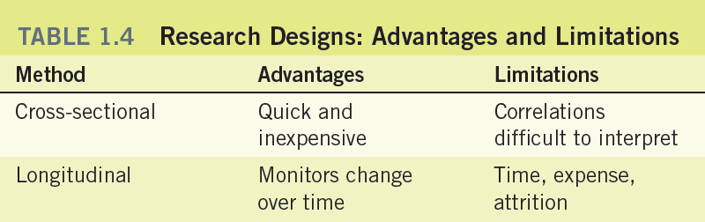

- Sub-Saharan Africa
  - As the 21st century begins, it is plagued by numerous serious problems including chronic poverty, war, and an epidemic of HIV/AIDS
  - Africa has been described as a “rich continent whose people are poor”
  - Living standards in Africa have declined over the past 50yrs and an increasing number of young people live in poverty
  - War is also a frequent part of life for Africans
  - The AIDS epidemic affects young people in three ways
    - [1]. Many are forced into deeper poverty by their parents death
    - [2]. Young Africans will become AIDS victims themselves.
    - [3]. They will be required to assume leadership of their families.
- North Africa & The Middle East
  - The Muslim religion is the predominant influence on all aspects of cultural life.
  - Three key issues face young people of this region in the 21st century:
    - [1]. Strength of Islam:
      - This strength varies from countries with strict adherence [Kuwait] to countries with a semblance of democracy [Morocco]
    - [2]. Patriarchal authority:
      - The father’s authority in the family is to be obeyed unquestioningly
    - [3]. Position of women:
      - Have a long tradition of keeping tight control over women’s appearance and behavior.
- Asia
  - Some of the major issues affecting young people are:
    - [1]. Tradition of filial piety
      - This means that children are expected to respect, obey, and revere their parents [especially the father]
    - [2]. Arranged marriages and dating
      - Parents choose a mate for their children
      - This remains a strong tradition even in cultures that have become highly industrialized
    - [3]. Intense pressure at the secondary school level
      - The Confucian tradition places strong emphasis on education – this leads to high pressure school
    - [4]. Rights of women
      - Females have fewer rights and opportunities than males
- India
  - The main issues facing young people in India will be:
    - [1]. School vs. Work
      - One of the few countries that does not have compulsory education and therefore many young people are illiterate [especially girls in rural areas]
    - [2]. The tradition of early arranged marriages
      - In the past, children were often married before reaching puberty, and even now about half of India’s young people marry in their teens
    - [3]. Caste System
      - People are believed to be born into a particular caste based on their moral and spiritual conduct in their previous life – this system determines a person’s status in Indian society.
    - [4]. Rights of women
      - Has a long tradition of holding women to be of inferior status from birth onward
- Latin America
  - Two key issues for young people are:
    - [1]. Political stability
      - Sources of instability include military coups followed by military dictatorships, communist revolutions, and civil wars between communist and anti-communist forces
    - [2]. Economic growth
      - Despite having great natural resources, the countries of Latin America have not prospered economically
      - Unemployment among adults is high and unemployment among young people is even higher, exceeding 25%
- The West
  - The principal issues for young people in the West are:
    - [1]. Education
      - Educational opportunities are not evenly distributed in most Western Countries
      - Some argue that Western countries produce far more college graduates than the economy really needs
    - [2]. Unemployment
      - Unemployment among the young is a serious problem in the United States and most European countries, especially among minorities
    - [3]. Leisure
      - Most of the leisure activities are media-based and include social networking sites.
    - [4]. Young minorities
      - Are disadvantaged, in the workplace and often experience discrimination.

- Influence of Gender Issues
  - Children become aware of their own gender by the age of two.
  - Culture expectations become more prominent during puberty for adolescents
  - Gender and profession choice
  - Gender and clothing choice
- Globalization
  - Means increasing technology and economic integration to make the world more homogenous
  - Bicultural is defined as becoming aware of one’s local identity and the larger global culture identity
  - Resilience is the ability of children and adolescents to overcome obstacles
- Key Chapter Ideas
  - Adolescence and emerging adulthood is culturally constructed and varies among cultures.
  - Adolescence emerged in its modern form circa 1890 – 1920
  - Emerging Adulthood is the period from 18 – 25
  - The scientific method includes a variety of strategies for studying adolescence and emerging adulthood.
  - The cultural view of adolescence and emerging adults varies by world regions.
  - This book is divided into foundations, contexts, and problems and resilience.

Defining Adolescence: The Scope of the Field

- Topical Areas of Adolescence
  - Physical development: focus on the body’s biological makeup.
  - Cognitive development: growth and change in intellectual capacity
  - Social and personality development: interactions with others and enduring characteristics.
- The Link between Age and Topic
  - Focusing on a specific period during adolescence:
    - Early adolescence
    - Middle adolescence
    - Late adolescence
- Adolescence Today
  - Challenges:
    - Pressures
    - Stereotypes
  - Generalizations
    - Diversity of experiences
- The Roots of the Study of Adolescence
  - Plato
    - New capabilities
  - Aristotle
    - “Heated by nature as drunken men by wine”
  - Rousseau
    - Reason
    - Curiosity
- The Scientific Method and the Study of Adolescence
  - The scientific method
    - Identify question
    - Formulate explanation
    - Conduct study
  - The problems of using common sense
  - Used by developmental scientists, and every other scientific discipline, the scientific method uses the processes of identifying, asking, and answering questions to help understand the world and unlock its secrets.
- What is a Scientific Attitude
  - Two Components:
    - Open-mindedness
    - Skepticism
  - Listen to ideas different from one’s own
  - What is the evidence?
  - Willingness to re-examine one’s beliefs
- What is the Scientific Method?
  - Systematic search for objective, empirical evidence
  - Process of testing hypotheses
  - Use theory to generate a prediction
  - Gather evidence that bears on the prediction
  - Revise theory in light of new evidence
- Research Approaches to Adolescence
  - Populations and representative samples
  - Observational methods
  - Correlational studies: How are variables linked?
  - Correlations do not prove cause and effect
  - Experiments manipulate the cause, observe effect
  - Independent and dependent variables in experiments
- Strategies for Studying Development
  - Cross-sectional research
  - Different groups represent different ages
  - Longitudinal research
  - Combines cross-sectional and longitudinal techniques
- The Ethics of Adolescence Research
  - Rights of research participants
  - Risks of deception
  - American Psychological Association Code of Ethics
  - Importance of gaining informed consent
- Underrepresented Groups in Adolescence Research
  - White middle-class male adolescents as “the model”
  - Gender bias in adolescent research
  - Ethnic, cultural, and class biases
  - The role of in group bias
  - Seeing “others” as “all the same”
- Becoming an Educated Consumer Of Research
  - What is the source of information?
  - How reliable is a particular finding?
  - Is a finding of practical importance?
  - Can a finding be generalized to other adolescents?
  - Does the study show cause and effect relationships?
- Measuring Change During Adolescence
  - Longitudinal Studies:
    - Individual change over time
  - Cross-Sectional Studies:
    - Different ages at the same time
  - Sequential Studies:
    - Combination of Longitudinal and Cross-Sectional Studies
- Research Techniques for Studying Development.
  - In a cross-sectional study, 13-, 15-, and 17-year olds are compared at a similar point in time (in 2007). In longitudinal research, a set of participants who are 13 years old in 2007 are studied when they are 15 years old (in 2009) and when they are 17 years old (in 2011). Finally, a sequential study combines cross-sectional and longitudinal techniques; here a group of 13-year-olds would be compared initially in 2007 with 15- and 17-year-olds, but would also be studied later, when they themselves were 15 and 17 years old. Although the graph does not illustrate this, researchers carrying out this sequential study might also choose to retest the children who were 15 and 17 in 2007 for the next 2 years. What advantages do the three kinds of studies offer?

- Today’s Perspectives on Adolescents
  - Psychodynamic Perspective
    - Freud’s psychoanalytic theory
      - Psychosexual development
    - Erikson’s psychosocial theory
      - Stage theory
      - Identity
- Psychoanalytic Theories
  - A sequence of psychosexual stages
  - Re-emergence in adolescence of childhood conflicts
  - Need for separation from the family
  - Defense mechanisms in adolescence
  - Erikson and psychosocial stages
  - Need to develop a sense of identity
- Today’s Perspectives on Adolescence
  - Behavioral Perspective
    - Classical conditioning
    - Operant conditioning
      - B.F. Skinner
      - Albert Bandura
- Learning and Social Cognitive Theories
  - Skinner and operant conditioning
  - Behavior changed by its consequences
  - Bandura’s social cognitive theory
  - Learning by observing what others do
  - Importance of self-efficacy beliefs
- Today’s Perspectives on Adolescence
  - Cognitive Perspective
    - Piaget
      - Schemas
      - Assimilation and accommodation
    - Information processing
    - Cognitive neuroscience
  - Contextual Perspective
    - Bioecological approach
      - Microsystem
      - Mesosystem
      - Exosystem
      - Macrosystem
      - Chronosystem
    - Vygotsky
      - Construction
      - Tools

  - Urie Bronfenbrenner’s bioecological approach to development presents five levels of the environment that simultaneously influence individuals: the macrosystem, exosystem, mesosystem, microsystem, and chryosystem.
- Ecological and Developmental Systems Theories
  - Bronfrenbrenner’s ecological theory
  - Adolescents affected by nested levels of social groups
  - Lerner and developmental systems
  - Adolescents play active role in own development
  - Importance of interacting developmental contexts
- Today’s Perspectives on Adolescence
  - Evolutionary Perspective
    - Darwin’s – On the origin of species
    - Lorenz
    - Behavioral genetics
- Social and Anthropological Theories
  - Mead’s fieldwork in the South Pacific
  - Role of society and culture
  - Adolescence need not be stressful
  - Benedict: Continuous and discontinuous societies
- The Future of Adolescence?
  - Increase specialization
  - Advances in genetic foundations
  - Culture
  - Interdisciplinary
  - Public policy
- Endocine System: Chemical Couriers
  - Chemical communication network
  - Hormones
  - Sex hormones
    - Androgen
    - Estrogen
  - HPG Feedback system [Hypothalamus, Pituitary, Gonads]
  - Hormones and emotions
- The Endocrine Glands
  - Location and function of the major endocrine glands. The pituitary gland controls the functioning of the other endocrine glands and in turn is regulated by the hypothalamus.
- Hormones, Puberty and Growth
  - Endocrine glands produce hormones that control growth
  - The hypothalamus controls the endocrine system
  - Endocrine system includes pituitary, gonads
  - Gonads are ovaries [female] and testes [males]
  - Gonads produce sex hormones: estrogens, androgens
- Adrenarche and gonadarche: Prelude and start of puberty
  - Adrenarche: changes in glands begin at around age 9.
  - Gonadarche: occurring about two years after adrenarche
  - Protein production by fat cells
- The HPG Axis
  - Feedback loop involving hypothalamus, pituitary, gonads
  - Hypothalamus monitors levels of sex hormones
  - When levels too low, hypothalamus signals pituitary
  - Pituitary signals gonads: produce more hormones
  - At puberty, set point for hormones rises
  - Increased hormones initiate physical, sexual development
- Sexual Maturation During Adolescence
  - Reproductive organs mature
  - Ovaries [girls] produce egg cells or ova
  - Testes [boys] produce sperm cells
  - Genitals [penis, vagina] become more adult-like
  - Secondary characteristics – breasts, pubic hair
  - Tanner stages describe course of development
- Coming of age: Sexual Maturation
  - Primary sex characteristics
  - Secondary sex characteristics
  - Sexual maturation:
    - Female: menarche
    - Male: spermarche
- Body image: Reactions to the physical changes of puberty
  - Adolescent reaction
  - Psychological components
  - Gender differences in reporting milestone
- The timing of puberty: The consequences of early and late maturation
  - Early maturation
    - Positive for males
    - Negative outcomes for females
  - Late maturation
    - Mixed findings for males
    - Positive in the long run for females
- Growth during adolescence: the rapid pace of physical and sexual maturation
  - Growth spurts
    - Males grow 4.1 inches a year
    - Females grow 3.5 inches a year
    - Weight gain
    - Body configuration changes
- Growth Patterns
  - Patterns of growth are depicted in two ways. The figure on the left shows height at a given age, while the figure on the right shows the height increase that occurs from birth through the end of adolescence. Notice that girls begin their growth spurt around age 10 while boys begin the growth spurt at about age 12. However, by the age of 13, boys tend to be taller than girls. Why is it important that educators be aware of the social consequences of being taller or shorter than average for boys and girls?
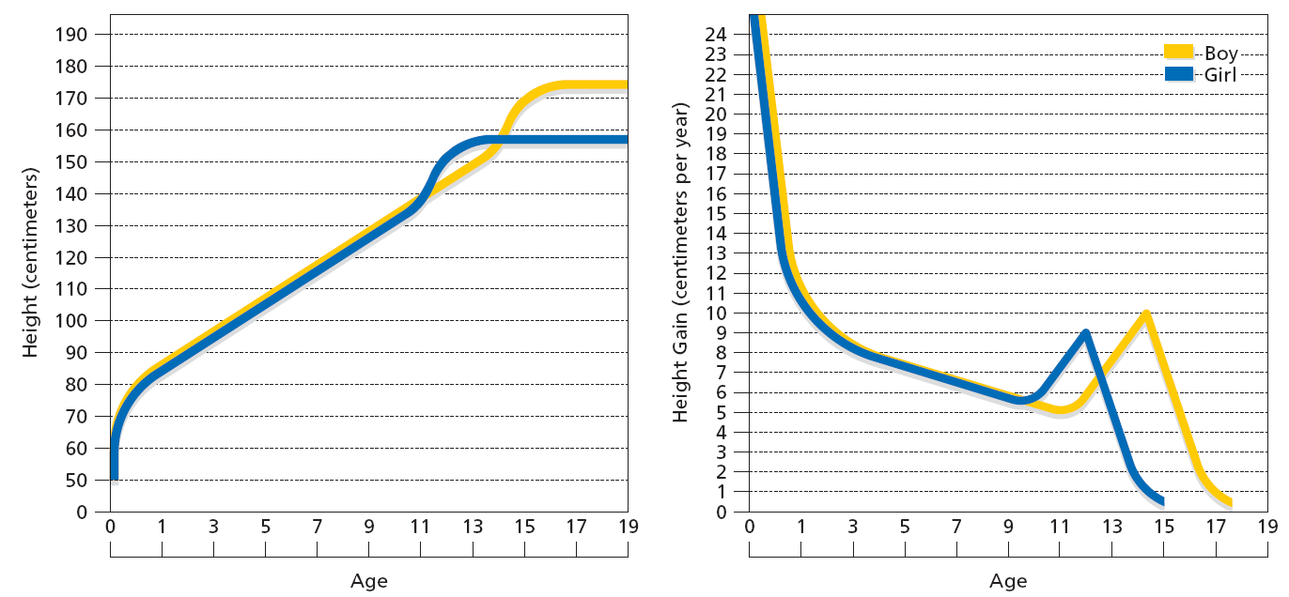

- Menarche and the Secular Trend
  - Menarche: girl’s first menstrual period
  - Menarche comes late in puberty
  - In US, age of menarche 12-13 years
  - Secular trend: age declined in recent decades
  - Menarche affected by nutrition, physical exertion
  - Menarche comes later in poorer countries
- How Girls Respond to puberty
  - Leaving childhood brings pride and stress
  - Breast development noticed by others
  - Some girls not prepared for menarche
  - Early-maturing girls more anxious and depressed
  - Early-maturing girls draw attention from older boys
- How Boys Respond to puberty
  - First emission of sperm early in puberty
  - “Wet dreams” and masturbation
  - Self-consciousness about penis size and growth
  - Early-maturing boys seen as more mature
  - Early-maturing boys more popular with peers
- How Parents Respond to Puberty
  - Parents must adapt to adolescent changes
  - Teens demand more input, fewer restrictions
  - Parent-child conflict eases across adolescence
  - Gender intensification—push toward typical roles
  - Distancing hypothesis—less parent-child intimacy
- How Cultures Respond to Puberty
  - Puberty rites recognize transition to adulthood
  - “Sweet sixteen,” quinceañero, Bas/Bar Mitzvah
  - Traditional rites for girls at menarche
  - Rites for boys harsher, more painful
- Nutrition and Food: Fueling the growth of adolescents
  - Obesity
    - 1 in 5 adolescents are overweight
    - Combination of causes
  - Exercise and sports
  - Anorexia and bulimia
    - Dangerous psychological disorder
    - More common in females but males suffer as well
- Tired Teens: Struggle to get enough sleep
  - Nine hours a night ideal
  - School and other responsibilities creates for adolescents a busy schedule minimizing sleep
  - Changes in school schedule have been found to work in some school districts

- Adolescent Sleep Requirements
  - Sleep deprivation in adolescents comes at a time when their internal clocks are shifting, and many go to bed later and sleep later in the morning.
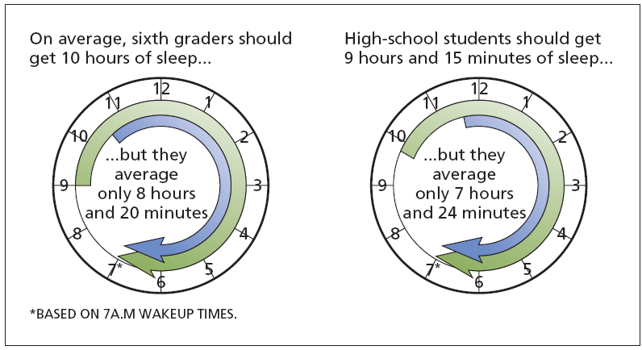

- Brain Development During Adolescences
  - Brain almost adult size by adolescence
  - Synaptic pruning: less-used circuits eliminated
  - Myelination leads to greater efficiency
  - Decision-making areas of cortex mature slowly
  - “Pleasure centers” mature more quickly
- How Puberty Affects Mood
  - Young adolescents more emotional than children
  - Emotional swings reduced later in adolescence
  - Hormones and mood affect each other
  - More social stressors during adolescence
- Effects of Puberty on Body Image
  - Physical changes focus attention on body
  - Cultural standards linked to dissatisfaction
  - Unrealistic media images of ideal adult bodies
  - Media effects different for boys and girls
  - Barbie and GI Joe
- Health Issues During Adolescence
  - Changing sleep needs with adolescence
  - Most American teens are sleep-deprived
  - Teens need more calories than children or adults
  - Fast-food habits linked to being overweight
  - Physical activity drops off across adolescence
  - Regular exercise has physical and psychological benefits.
Basics of Adolescence, Biology, Puberty
- Adolescence
  - Adolescence refers to the age period between childhood and adulthood
    - Tweens:
      - 10 – 13 years old
    - Teens:
      - 13 – 18 years old
    - Emerging adulthood:
      - 18 – 25 years old
  - Transitional period
    - Continuity and discontinuity with childhood
  - Time of:
    - Evaluation
    - Decision making
    - Commitment
    - Finding a place in the world
  - Interaction of:
    - Genetics
    - Biology
    - Environment
    - Social factors
  - Relationships with parents’ changes.
- Today’s Adolescent
  - Temptations
    - Drug use
    - Sexual activity
  - Given adequate opportunities and support to become competent adults
    - Why?
- Puberty
  - Rapid physical maturation
    - Hormonal
    - Bodily changes
  - Most noticeable changes
    - Signs of sexual maturation
    - Increases
      - Height
      - Weight
- Timing of Puberty
  - Age of onset of puberty depends on:
    - Gender [girls ahead by months of years]
    - Genes and Ethnicity
    - Weight [malnutrition delays puberty]
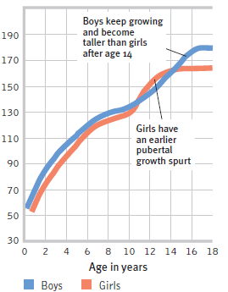
    - Stress [causes puberty earlier]
- Adolescent Physical/Sexual Development and Differences
  - Puberty is the time of sexual maturation [becoming physically able to reproduce].
  - During puberty, increased sex hormones lead to:
    - Primary and secondary sex characteristics
    - Some changes in mood and behaviour.
  - Height changes are an early sign of puberty.
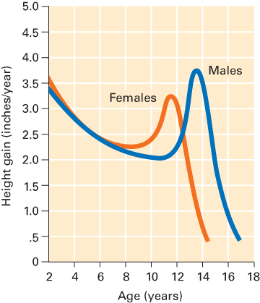
    - Because girls begin puberty sooner than boys, girls briefly overtake boys in height.
- Weight and Height: The Growth Spurt
  - Girls
    - Early adolescence
      - Outweigh boys
      - Tall or taller than boys
    - Mean age growth spurt at 9yrs
  - Boys
    - Mean age growth spurt at 11yrs
- Hormonal Change
  - Puberty interaction of:
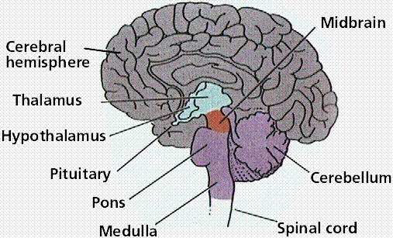
    - Hypothalamus
    - Pituitary gland
    - Gonads
      - Particularly important
        - Testes
        - Ovaries

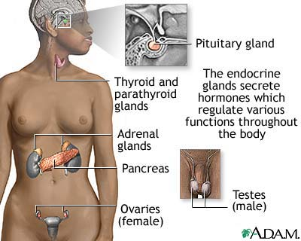
  - Hypothalamus
    - Monitors eating and sex
  - Pituitary gland
    - Growth
    - Regulates other glands
  - Gonads
    - Testes male
    - Ovaries female

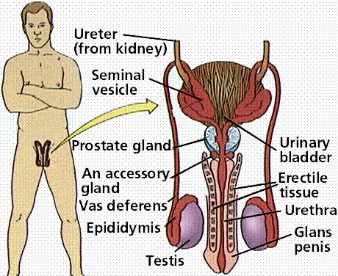
- Male Gonads: Testis
  - Hormones: MALE
    - Gonads: Testosterone
      - Hormones associated with development of:
        - Genitals
        - Increase height
        - Change voice
  - The influence of testosterone
    - Skin:
      - Hair growth
      - Balding
      - Sebum production
    - Liver:
      - Synthesis of serum proteins
    - Male sexual organs:
      - Penile growth
      - Spermatogenesis
      - Prostate growth and function
    - Brain:
      - Libido
      - Aggression
    - Muscle:
      - Increases in strength and volume
    - Kidney:
      - Stimulation of erythropoietin production
    - Bone marrow:
      - Stimulation of stem cells
    - Bone:
      - Accelerated linear growth closure of epiphyses
- Hormones: Female
  - Ovaries
    - 2 groups of female sex hormones produced in ovaries
      - Estrogen
      - Progesterone
  - Estradiol type of estrogen
    - Hormone associated with development of:
      - Breast
      - Uterus and vagina
      - Skeletal
      - Distribution of fat
        - Hips, legs and breast
- Hormones: Female and Male
  - Testosterone and estradiol
    - Present in both sexes
- Hormones
  - Affect hormones: Suppress or Activate
    - Behaviour
    - Sexual activity
    - Exercise
    - Moods
    - Stress
    - Eating patterns
- Age of Puberty
  - Boys:
    - 10 – 13 years
  - Girls:
    - 9 – 15 years
  - Affect puberty’s timing and makeup
    - Nutrition
    - Health
    - Other environmental factors?
- Study 2010: 1, 000 girls in 3 American cities
  - 7 year olds developing breasts:
    - 10% of white girls
    - 25% of African-American girls
      - 5% 10 years ago.
  - Rise in early puberty linked to:
    - Rise in obesity in U.S. children
    - Environment
    - Genetics
  - Concerns of breast cancers in these girls later
- Puberty Begins
  - Puberty is a period of rapid physical growth and sexual maturation
  - The sequence of physical changes is universal, but the timing varies [typically lasting 3 – 5years]
  - Age of onset ranges between 8 – 15 years.
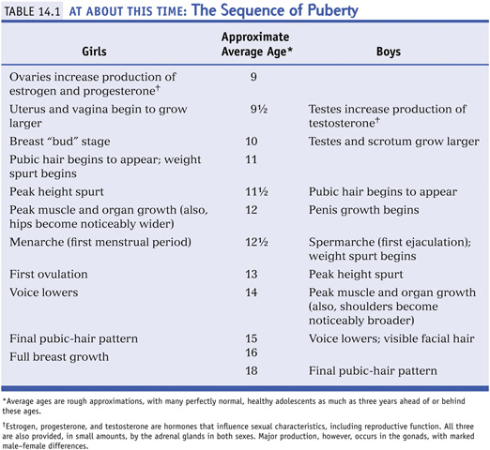

  - Menarche:
    - The term for a girl’s first period. It signals that ovulation has begun [although is often irregular for a few years]
  - Spermarche:
    - The term for a boy’s first ejaculation, which signals sperm production has begun
- Hormones
  - Puberty begins with a signal from the hypothalamus – to the pituitary gland – to adrenal glands [the HPA axis] and gonads.
  - Gonads release testosterone and estradiol.
  - Hormones influence MOOD and THOUGHT.
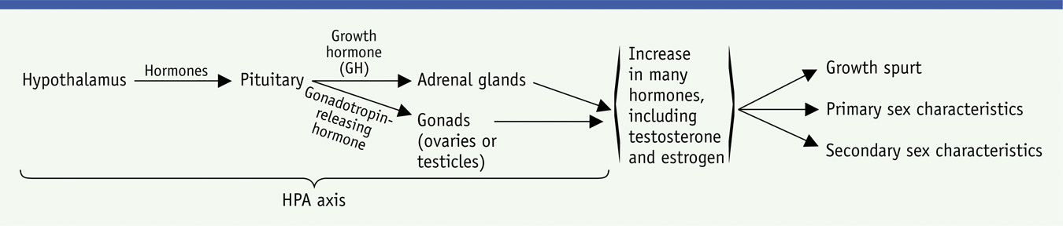
- Biological Sequence of Puberty

- Sexual Maturation
  - Primary sex characteristics:
    - The parts of the body directly involved in reproduction [e.g. testicles, ovaries]
  - Secondary sex characteristics:
    - Not necessary for reproduction
      - Examples:
        - Odor, acne, breast development, hair, voice changes
- Gender Development
  - Gender:
    - Refers to the physical, social and behavioural characteristics that are culturally associated with male and female roles and identity.
      - Some of these traits may be genetic differences; other role differences may be nurtured by culture.
- Gender Differences and Similarities
  - Compared to Men, Women [as a group, on average]:
    - Start puberty 2 years sooner
    - Live 5 years longer
    - Have 70% more fat
    - Have 40% less muscle
    - Are 5 inches shorter
    - Express more emotion
    - Are more vulnerable to anxiety, depression
    - Are less prone to autism, alcohol dependence, ADHD, antisocial personality, and suicide
  - Similarities:
    - 45 out of 46 genes are unisex
    - Same body and brain structures and functions
    - Similar levels of intelligence, knowledge, happiness
  - Mental and Behavioral Health:
    - Women are more likely to have depression, anxiety, or eating disorders
    - Men are more likely to have autism, ADHD, and antisocial personality disorder
  - Biological
    - Women enter puberty earlier, live longer, and have more fat and less muscle
      - Men murder far more people than women do; it is hard to discern whether this difference is caused by men’s ability or tendency to commit murder.
- Gender and Aggression
  - Men behave more aggressively than women, and are more likely to behave in ways that harm others
  - This difference applies to physical aggression rather than verbal or relational aggression.
  - And yet violent acts by women do occur, including acts of terrorism.
    - Sometimes news reports make a big deal about the differences between two groups, (Males and Females), without bothering to comment on how big this difference is compared to the differences within each group.
      - In this example, even if the average man DOES have higher self-esteem than the average woman, it would be ridiculous [that is, unsupported by the data] to predict, “he’s a man, so he probably thinks highly of himself.”
- Sudden Emotions
  - Hormones contribute to the conflict, moodiness, and sexual urges of adolescents, but are not the only cause
  - Social and cultural reactions to visible body changes also play a large roll.
- Early and Late Maturation
  - Mature earlier or later perceive selves differently
    - In what ways?
  - Early maturation increases vulnerability to problems
    - More likely to:
      - Smoke
      - Drink
      - Depressed
      - Eating disorder
      - Earlier independence from their parents
      - Older friends
      - Date
      - Earlier sexual experiences
  - Early maturing GIRLS are at higher risk of:
    - Teasing
    - Early sexual activity
    - Eating disorders
    - Early substance use
  - Early maturing BOYS are at higher risk of:
    - Rebellion
    - Breaking the law
    - Stress and depression from relationships
  - Late maturation: Correlations
    - Late maturation may also be difficult, especially for boys in a school in which athletics is valued.
    - Later maturing girls may feel anxiety about when puberty will hit. [Anyone remember “Are you there God, it’s me, Margaret” by Judy Blume]
- Bigger and Stronger
  - The growth spurt is a sudden and rapid period of physical growth during puberty.
  - Sequence is weight, height, and muscles.
  - Females gain more fat, males gain muscle
  - The lungs and heart increase in size.
- Other Physical Changes
  - The lymphoid system [tonsils, adenoids] decrease in size. This makes teens less susceptible to asthma and colds.
  - Skin gets oilier, sweatier, and more acne-prone.
- Body Rhythms
  - Most teenagers’ bodies prefer to stay up late and sleep in late.
  - Teens also tend to get too little sleep for their growing bodies.
    - Lack of sleep has been associated with higher risk of mood disorders and driving problems.
- Sleep Patterns
  - 9 to 10 hours best
  - Half of adolescents less than 8hrs of sleep
    - Results in:
      - More tired or sleepy
      - Cranky
      - Irritable
      - Falling asleep in school
      - Depressed mood
      - Drinking caffeinated beverages
- Brain Development in Adolescence
  - Research has found that the limbic system, an emotional and impulsive part of the brain, develops prior to the prefrontal cortex, the rational, logical part of the brain.
  - This in part explains some of the impulsive, emotional reactions of teens.
- Neural Connections
  - Myelination of the prefrontal cortex improves with age, fostering improvements in decision-making, rational arguments, and even reaction time.
  - Experiences during adolescence are particularly crucial and lasting.

- Brain Development Significant Structural Changes
  - Corpus callosum
    - Thickens
      - Improves ability to process information
      - Corpus callosum connects hemispheres
- Health During Adolescence
  - In general, adolescence is a HEALTHY age period.
    - Problem-free reproduction
    - Peak athletic performance
    - High energy and endurance
    - Body systems function at an optimal level
    - Death by disease is rare [Worldwide]
  - Unfortunately, teens seem to engage in behaviors that put their health at risk.
  - The incidence of eating disorders has also increased, especially among females.
  - Fatal accidents, suicides, and homicides are leading cause of death, especially for males.
- Injury and Death
  - Accidental deaths during adolescence are likely due to:
    - Body changes [e.g. testosterone]
    - Brain changes [e.g. limbic system]
    - Social context [e.g. alienation, “macho”]

Chapter Two: Biological Foundations

- Chapter Overview
  - Endocrine system
  - Primary sex characteristics
  - Secondary sex characteristics
  - Cultural, social, psychological responses to puberty
  - Biological development and the environment
- Puberty
  - Derived from the Latin word “pubescere” which means to “grow hairy”
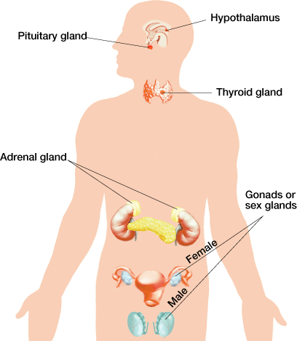
  - The body undergoes a biological revolution that dramatically changes the adolescent’s anatomy, physiology, and physical appearance
- The Endocrine System
  - Hormonal changes being here
    - Gradually increases production of gonadotropin-releasing hormone [GnRH]
      - Recent evidence indicates that this occurs once a threshold level of body fat is reached.
    - Fat cells produce leptin that provides the signal to the hypothalamus.
  - Hypothalamus
    - Monitor levels of androgens and estrogens in the bloodstream
  - Pituitary gland
    - Responds to the reduction in GnRH by reducing production of FSH, LH and ACTH
  - Gonads & Adrenal glands
    - Respond to lower levels of FSH and LH by reducing the amount of sex hormones produced
  - SET POINT
    - When sex hormones reach an optimal level and the hypothalamus reduces GnRH to begin this process
- Pituitary Gland and Gonadotropins
  - Pituitary gland releases gonadotropins
  - Increase in GnRH affects the pituitary gland
  - Gonadotropins influence production of sex hormones
  - Gonadotropins stimulate development of gametes
- Growth Spurts
  - Not all parts of the body grow at the same pace
  - Asynchronicity in growth explains the “gangly look” in early adolescence
    - Extremities are the first to hit the growth spurt
- Adolescent Obesity
  - Obese adolescents have higher levels of leptin
  - One-third of all American adolescents eat fast food for at least one meal per day
  - Decline of physical activity
  - The influence of watching television
  - Increase of availability of sodas and junk food machines in the schools
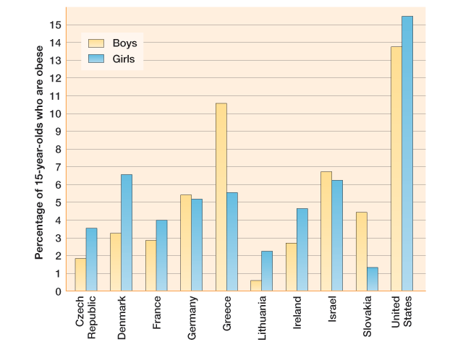

- Is This True?
  - Reaction time is slower in emerging adulthood.
    - Reaction time is actually faster in the early twenties than at any other time of life.
  - Grip strength in men peaks in emerging adulthood
    - Yes…and followed by a steady decline
  - Cardiac output peaks at 18 years of age
    - Cardiac output, the quantity of blood flow from the heart, peaks at age 25.
- Physical Functioning in Emerging Adulthood
  - Emerging adulthood is the period of the lifespan with the least susceptibility to physical illness
  - Lifestyles of many emerging adults often include a variety of factors that undermine health such as
    - Poor nutrition
    - Lack of sleep
    - Stress of juggling school/work/multiple jobs
  - Automobile accidents are the leading cause of death among emerging adults in the United States
  - Homicide is another common cause of death in the U.S. during emerging adulthood
  - Rates of contracting sexually transmitted diseases, including HIV, are the highest in the early twenties
  - Rates of substance use and abuse peak in early 20s
- Sex Characteristics
  - Boys
    - Primary sex characteristics
      - Production of sperm
      - Development of sex organs
    - Secondary sex characteristics
      - Hair growth in pubic areas, underneath arms, chest, face, shoulders, and back
      - Skin becomes rougher
      - Sweat glands increase production
  - Girls
    - Primary sex characteristics
      - Production of eggs
      - Development of sex organs
    - Secondary sex characteristics
      - Hair growth in pubic areas, underneath arms, and a slight amount of facial hair
      - Skin becomes rougher
      - Sweat glands increase production
      - Slight enlargement of breasts known as breast buds
- … Facts about females
  - Women are born with 400,000 immature eggs in each ovary; this drops to 80,000 by puberty
  - Once a girl reaches her first menstrual period [menarche], one egg develops into a mature egg [ovum] about every 28 days
  - Females release about 400 eggs over the course of their reproductive lives
- … The truth about men
  - Males have no sperm in their testes when they are born and do not produce any until they reach puberty
  - The average age that sperm production begins [spermarche] is approximately 12 years old.
  - Boys produce sperm in astonishing quantities – there are between 30 and 500 million sperm in the typical male ejaculation, which means they produce millions of sperm everyday
- The Order of Pubertal Events
  - Girls
    - Downy pubic hair
    - Appearance of breasts buds
    - Growth spurt
    - Growth of sexual and reproductive organs
    - Menarche
    - Secretion of increased skin oil and sweat
    - Development of underarm hair
  - Boys
    - Growth of testes
    - Appearance of pubic hair
    - Growth spurt
    - Increased growth of penis
    - Deepening of the voice
    - Secretion of increased skin oil and sweat
    - Development of facial hair
- Pubertal Caveat
  - Virtually all the studies considered in the order of pubertal development have been conducted with White adolescents in the West
  - Three studies demonstrate the variations that may exist in other groups
    - Worthman [1987]
    - Lee, Chang, and Chan [1963]
    - Herman-Giddens [1997; 2001]
- Kikuyu Culture in Kenya [Worthman 1987]
  - Boys show the first physical changes of puberty before their female peer
  - A reversal of the Western pattern
- African American Girls [Herman-Giddens et al., 1997; 2001]
  - Many African American girls at age 8 [50%] were found to begin developing breast buds and pubic hair considerably earlier than White girls [15%]
- Chinese Girls [Lee, Chang, and Chan 1963]
  - Pubic hair began to develop in most girls about 2 years after the development of breast buds and only a few months before menarche
  - In sharp contrast to the Western studies, which found pubic hair and breast buds developed together about 2 years before menarche
- Downward Secular Trend of Menarche
  - Puberty begins earlier in cultures where good nutrition and medical care are widely available
  - In the U.S. the average age is 12.5
  - Illness and thinness tend to inhibit the development of body fat resulting in delayed puberty
  - Advances in food production have enhanced nutrition and therefore puberty has come sooner

- Age of Menarche and SES
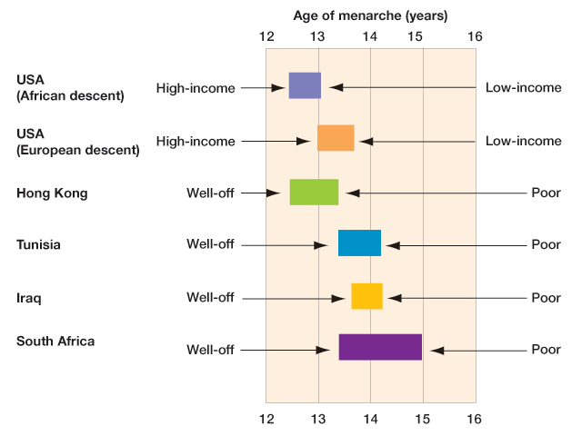

- Cultural Responses to Puberty: Rituals Traditional Cultures
  - 68% of cultures had puberty rituals for boys
  - Typically rituals require the young man to display courage, strength, and endurance
  - The rituals are often violent, requiring boys to submit to and sometimes engage in bloodletting of various kinds
  - 79% of cultures had puberty rituals for girls
  - Menarche is the pubertal event that is most often marked by ritual.
  - Cultural views are mixed as to whether menstrual blood is an omen or a positive sign of fertility
- How do parent-adolescent relations change at puberty?
  - Conflict increases
  - Closeness decreases
  - Parents and adolescents seem less comfortable in each other’s presence
    - What is it about reaching puberty that causes parent-child relations to change? The answer is uncertain. Various explanations have been proposed, centering mostly on how the biologically based incest taboo between parents and children becomes activated once children reach sexual maturity, resulting in more distant relaitonships.
- Responses to Menarche and Semenarche
  - Menarche signifies reproduction as well as semenarche
  - Girls reported menarche made them feel “grown up”
  - Premenstrual syndrome [PMS]
  - Semenarche
- Early Maturation – Girls
  - The effects of early maturation are especially negative for girls.
  - Early maturing girls are at risk for a variety of problems:
    - Depressed mood
    - Negative body image
    - Eating disorders
    - Substance use
    - Delinquency
    - School problems
    - Conflicts with parents
- Late Maturation – Girls
  - Late maturing girls have few of the problems that early-maturing girls have
  - Although they can suffer from:
    - Teasing
    - Negative body image [during the years when other girls have begun to develop]
  - However, by their late teens they tend to have a more favourable body image than other girls
  - They are more likely to end up with the lean body build that tends to be regarded as attractive in Western majority cultures
- Early Maturation – Boys
  - The effects of early maturation tend to be positive for boys
  - Early maturing boys have:
    - More favourable body image
    - Higher popularity
  - Not everything is favourable; they tend to be involved in:
    - Substance use
    - Delinquency
    - Sex
- Late Maturation – Boys
  - Late maturing boys show evidence of problems
  - Compared with boys who mature “on time”, late maturing boys have higher rates of:
    - Alcohol/substance use
    - Delinquency
    - Lower grades in school
    - Deviant behavior
- Nature vs. Nurture
  - Popular debate between biology and the environment
  - Biological factors [nature]
  - Environmental factors [nurture]
  - The BOTH nature AND nurture concept
  - Theory of genotype-environment effects

- Genotype-Environment Interactions
  - Genotype
    - A person’s inherited genes
  - According to the theory
    - Both genotype and environment make essential contributions to human development
  - Genotype-environment interactions take three forms:
    - Passive
      - Occur in biological families when parents provide both genes and environment
    - Evocative
      - Occur when a person’s inherited characteristics evoke responses from others in their environment
    - Active
      - Occur when people seek out environments that correspond to their genotypic characteristics
- Key Chapter Ideas
  - Hormonal changes lead to changes in physical functioning and to development of primary and secondary sex characteristics.
  - Emerging adulthood is a time of peak physical functioning for most people.
  - Cultures influence the experience of puberty through: nutrition and medical care that affect pubertal timing; rituals that give meaning to pubertal changes; and information.
  - According to genotype–environment interactions theory, environmental and genetic influences are difficult to separate, as in some ways genes shape the environment.
  - During adolescence and emerging adulthood, greater autonomy allows young people to seek out environmental influences that will enhance their inherited abilities.
  - The typical age of puberty has declined steeply in industrialized countries over the past 150 years; the first evident changes of puberty take place between 10–12.
  - Primary sex characteristics are involved in reproduction and secondary sex characteristics do not relate to reproduction.
  - Culture impacts the onset of puberty based on nutrition and access to medical care as well as rituals around this.
  - Adolescent peers exchange information among themselves, but what they tell each other is not always accurate or healthy.
  - Adolescents often experience their biological changes with limited information about what is happening to them.

Bronfenbrenner and Ecological Theory
- Themes and Approaches
  - Ecological systems
  - Stage-environment fit
  - Cultural diversity
  - Globalization
  - Practical applications
  - Positive development
- Adolescence in Earlier Years
  - Adolescents treated differently in different eras
  - Citizenship at adulthood in ancient Greece, Rome
  - Life-cycle service in pre-industrial Europe
  - Rousseau: We should cherish childhood, adolescence
  - Child labor in 19th-century American industry
  - Adolescence seen as a social problem
- Adolescence in 20th Century America
  - “The Age of Adolescence”
    - Role of child labor laws and longer schooling
    - Age stratification
    - Social science discovers adolescents
    - Teenagers in novels, movies, and comics
    - “Baby boom” after World War II
- American Teens Today
  - Stereotype of sex, drugs, rock, violence
  - Effects of changing family structures
  - Growing influence of peers
  - Consumerism: Having to have the right stuff
  - Mixed messages about adolescent sexuality
- Ecological Systems Theory
  - Development is the result of the relationships between people and their environments.
  - Implications
    - Cannot evaluate a child’s development only in the immediate environment.
    - Must also examine the interactions among the larger environments that a child develops in.
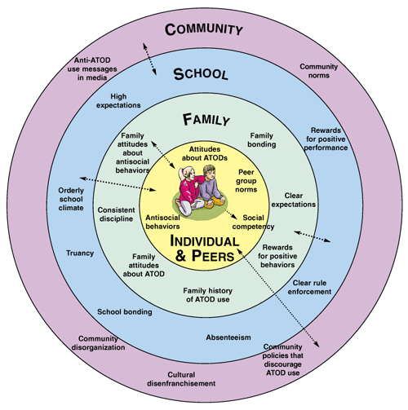
- The FOUR Layers
  - Microsystem:
    - Relationships with direct contact to the child
  - Mesosystem:
    - Connection between relationships of child’s microsystem
  - Exosystem:
    - Structures in which child the child does not have direct contact
  - Macrosystem:
    - Cultural context
- The Phases and Tasks of Adolescence
  - Adolescent phases linked to different tasks
    - Early adolescence (11–14), adapting to puberty
    - Middle adolescence (15–18), independence, intimacy
    - Late adolescence (19–22), work, relationships, values
- Our Evolving Society
  - The Silent Generation:
    - Born between 1925 and 1940; characterized as conservative and traditionalist
  - The Baby Boomers:
    - Born from the mid-1940s until the early- to mid-1960s
  - Generation X:
    - 1960s until about 1980
  - Generation Y:
    - Millennial Generation, born from about 1980 until 2000
  - Generation ?:
    - Born after 2000; not adolescents yet
- The Prolongation of Adolescence
  - Many adult life transitions are delayed
    - Stay in school longer
    - Financial dependence on parents
    - Move out of parents’ home later
    - Marry later
- Why the Prolongation of Adolescence?
  - Why?
    - Good jobs require skills
    - Sexual Permissiveness
    - Parents willing to support longer
    - Maturity
    - Emerging adulthood
- Biological and Evolutionary Theories
  - G. Stanley Hall and recapitulationism
  - Adolescents as “savages”
  - “Storm and stress”
  - Evolutionary explanations of adolescence
  - The role of reproductive fitness

Chapter Three: Havighurst’s Developmental Tasks of Adolescence
- Havighurst
  - Havighurst defined developmental tasks as:
    - Skills, knowledge, functions and attitudes and individual has to acquire at a certain point in his/her life.
    - They are acquired through physical maturation, social expectations, and personal efforts
  - Successful mastery of these tasks will result in adjustment and will prepare the individual for the harder tasks ahead.
  - Failure in a given developmental task will result in a lack of adjustment, increased anxiety, social disapproval, and the inability to handle the more difficult tasks to come.
    - Each task in the prerequisite for the next one.
    - There is a biological basis for some of these tasks, and therefore a definite time limit within which the task must be accomplished.
    - The inability to master a task within its time limit may make later learning of that task more difficult if not impossible.
    - There is, therefore, a “teachable” moment for many developmental tasks.
  - Through its socializing agents and method of reinforcement and punishment, society attempt to help the individual learn those developmental tasks at their proper age levels.
  - The developmental tasks for adolescence [approx. 12 – 18yrs] are:
    - [1]. Accepting one’s physique and accepting a masculine or feminine role
    - [2]. Attaining/establishing new relations with age-mates of both sexes
    - [3]. Attaining emotional independence from parents and other adults
    - [4]. Achieving assurance of economic independence
    - [5]. Selecting and preparing for an occupation
    - [6]. Developing intellectual skills and concepts necessary for “civic” competence
    - [7]. Desiring and achieving socially – responsible behavior
    - [8]. Preparing for marriage 7 family life
    - [9]. Building conscious values in harmony with an adequate scientific world picture.
      - [Havighurst 1951]
- Socialization
  - Socialization:
    - The complex, lifelong social experience by which people develop their human potential and learn culture
      - Social experience is also the foundation of personality, a person’s fairly consistent patterns of acting, thinking and feeling.
  - Human Development:
    - Nature and Nurture
      - Biological Sciences Nature
      - Social Sciences Nurture
- Socialization: The Concept
  - Socialization is the process by which individuals internalize the values, beliefs, and norms of a given society and learn to function as a member of that society.
  - Definition:
    - The process of social interaction that teaches the child the intellectual, physical, and social skills needed to function as a member of society, including cultural knowledge.
  - Through socialization children both:
    - Learn their culture
    - Acquire a personality
- Primary Socialization: Becoming Human
  - Much takes place before age 5
  - Carried out by parents and family
  - Includes:
    - Language development
    - Internalization of norms, values, etc.
    - Establishing identity [“Who am I?”]
    - Human development [Intellectual, Emotional, Social]
- Socialization: Two Types
  - [1]. Primary Socialization:
    - Occurs in childhood
    - Lays foundation that influences self-concept and involvement in social life
  - [2]. Secondary Socialization:
    - Learning that occurs after people have undergone primary socialization
    - Continues throughout life **
- Anticipatory Socialization
  - Preparing for a role.
    - Examples:
      - Education
      - Training or practicing a sport or activity
      - Choosing a major or career
      - Engagement
      - Pregnancy
- Resocialization
  - Drastic form of adult socialization
  - Changes entire environment, culture, and possibly self-concept
    - Moving to foreign country
    - Being institutionalized or incarcerated
    - Joining military
  - Total institution: controls all basics of everyday life, aimed at resocialization

- Traditional Cultures
  - From Girl to Woman
    - Girls typically work alongside their mothers early age.
    - Girls typically maintain a close relationship with their mothers
    - During adolescence the ‘world contracts for girls’
    - Girls have narrower socialization at adolescence because their budding sexuality is more likely to be tightly restricted
  - From Boy to Man
    - Boys typically have less contact with their families and more contact with peers
    - During adolescence the “world expands for boys”
    - Boys enjoy new privileges reserved for men
    - For boys, manhood is something that has to be achieved
- Nature vs. Nurture
  - Nature
    - Darwin’s groundbreaking study of evolution led people to think that human behavior was instinctive.
  - Nurture
    - Biological explanations came under fire during the 20th century.
    - Behaviorism – behavior is learned rather than instinctive [Watson]
    - Biology is still important, but whether you develop you inherited potential depends on how you are raised.
  - Nurture matters more in shaping human behavior because nurture is our nature
  - Families
    - The family is the most important agents of primary socialization, which is the process of mastering the basic skills required to function in society during childhood.
    - Characteristics of the family as an agent of socialization:
      - Small group
      - Frequent face-to-face content
      - High motivation of parents to care for children
  - Schools
    - Schools are largely responsible for secondary socialization, or socialization outside the family after childhood.
    - Instructing students in academics and vocational subjects is just one part of the school’s job.
    - In addition a hidden curriculum teaches students what will be expected of them in the larger society after they graduate.

  - Peer Groups
    - From middle school through adolescence, the peer group is often the dominant socializing agent.
    - Peer groups help children and adolescents separate themselves from their families and develop independent sources of identity.
    - They are especially influential in lifestyle issues such as appearance, social activities, and dating.
  - Mass Media
    - The mass media includes TV, radio, movies, videos, CDs, the Internet, newspapers, magazines, and books.
    - The fastest growing in usage is the Internet, but TV still takes up the most time.
- Socialization and Self-Esteem
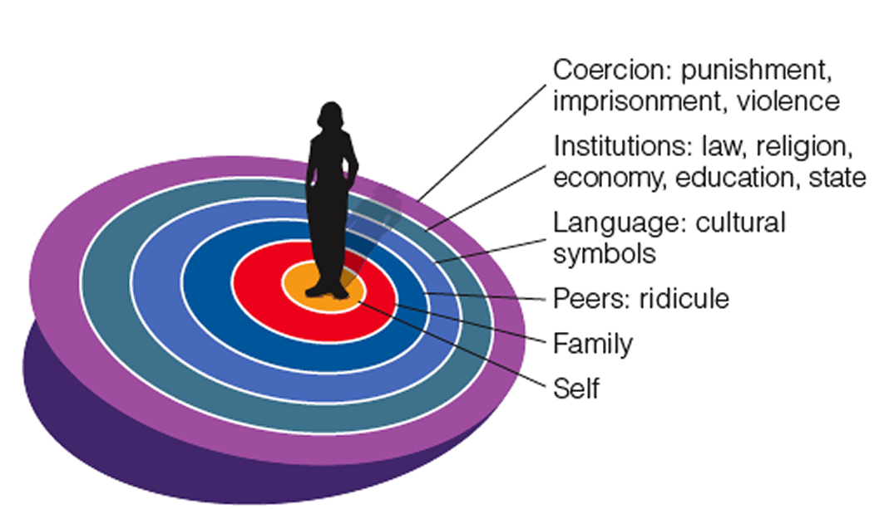
  - How much value one sees in oneself is greatly affected by socialization how you are seen by society.
  - A national study of 9th and 12th graders examined the eating behaviors:
    - 57% of the girls and 31% of the boys reported eating disorders
    - Fear about one’s appearance to others was associated with this risky behavior.
- Consequences of Socialization
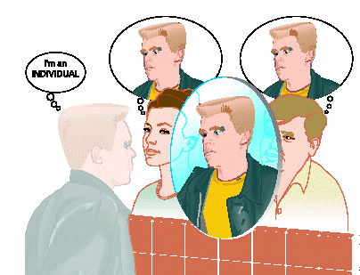
  - [1]. Establishes self-concepts.
  - [2]. Creates the capacity for role taking.
  - [3]. Creates the tendency for people to act in socially acceptable ways.
  - [4]. Makes people bearers of culture
- Looking-Glass Self
  - How we think we appear to others.
  - How we think others judge us.
  - How these make us feel – proud, embarrassed or something else.
- Mead: Taking the Role of the Other
  - [1]. Imitation stage:
    - Children imitate behavior of those around them.
  - [2]. Play stage:
    - Children take on the role of significant others.

  - [3]. Game stage:
    - Children internalize an abstract understanding of how society sees them
- Socialization Across the Life Cycle
  - Childhood:
    - Establish identity and values.
  - Adolescence:
    - Form a consistent identity
  - Adulthood and Old Age:
    - Learn new roles and expectations in adult life.
- Freud’s Elements of Personality
  - ID:
    - Represents the human being’s basic drives
      - Unconscious and demands immediate satisfaction; present at birth. Society opposes the self-centered ID.
        - Ex. “NO!” Is the first word a child learns
      - To avoid frustration, a child must learn to approach the world realistically.
  - Ego:
    - A person’s conscious efforts to balance innate pleasure-seeking drives with the demands of society
      - Develops as we become aware of ourselves and realize we cannot have everything that we want.
  - Superego
    - The cultural values and norms internalized by an individual
      - Operates as our conscience, telling us why we cannot have everything we want.
      - Begins to form as a child matures over time.
- Piaget’s Theory of Cognitive Development
  - Studied human cognition, which is how people think and understand.
  - 4 Stages of Development
    - [1]. Sensorimotor Stage
      - Experience the world only through their senses; [birth – 2yrs]
    - [2]. Preoperational Stage
      - First use of language and other symbols [2 – 6yrs]
    - [3]. Concrete Operational Stage
      - First see connections in their surroundings [7 – 11yrs]
        - Ex. Blocks Together vs. Apart – Bigger?
        - Ex. Liquid in Tall/Thin vs. Short/Round container – more?
    - [4]. Formal Operational Stage
      - Think abstractly and critically [12yr +]
  - Critical Review
    - Saw the mind as active, creative, and continually developing.
    - Acknowledged the role of both biological maturation and social experience.

