Lecture 17
Religion
- Religion is the social institution whose purpose it is to provide meaning and purpose to finite life, and to deal with questions such as “why”?
- According to William James, however, the content and intensity of religious beliefs are influenced by micro- and macro-level structures.
- Sometimes, religion acts as a force for social stability, and other times it acts as a force for social change.

Sociology & Theology
- Sociology and theology are not equivalent.
- Sociology, as a social science, relies on knowledge obtained through systematic, empirical study. Theology, on the other hand, relies on knowledge obtained through faith.
- (Of course, science is powerfully shaped by values and untested beliefs, just as theology is powerfully shaped by scientific discoveries and by social structures.)
- Where theology focuses on the truth and value of religious beliefs and practices, sociology focuses on the ways in which religious beliefs and practices shape, and are shaped by, social reality.

Theoretical Approaches to Religion:Structural Functionalism
- Structural Functionalism: Emile Durkheim
- The collective conscience “comprises the common sentiments and values that people share as a result of living together.” (Brym et al., 2013:411) The collective conscience is larger than the individual.
- While not all religions include belief in a god(s), all religions divide the world into the profane and the sacred, where the profane “refers to the secular, everyday world” and the sacred “refers to the religious, transcendent world”. (Brym et al., 2013:411)
- Through the use of totems, or objects “that symbolize the sacred”, and rituals, or “public practices designed to connect people to the sacred” (Brym et al., 2013:411), individuals experience the social solidarity-enhancing effects of religion.
- For Durkheim, society is God.

- Conflict Theory and Feminist Theories: e.g. Max Weber, Karl Marx
- On the other hand, conflict theorists and feminist theorists observe that religion can also have the effect of inciting social conflict.
- Moreover, when religion does increase or maintain social cohesion, it also often reinforces social inequality.

- Even though a religion may arise as a counter-cultural social movement led by a charismatic leadership promoting social change, equality, and freedom, charismatic religious leadership has a tendency, eventually, to become routinized.
- According to Weber, the routinization of charisma is “the transformation of divine enlightenment into a permanent feature of everyday life.” (Brym et al., 2013:413)
- Through the routinization of charisma, religious inspiration becomes transformed into a stable social institution, or “church” (best understood as a non-denominational religious institution that takes the form of “a bureaucratic religious organization that has accommodated itself to mainstream society and culture” -- Brym et al., 2013:416)), with defined roles (e.g. religious leaders and religious followers).
- The personal charisma of the original religious leaders comes to inhere as office charisma in the roles of the institution.

- Frequently, religion has been used to reinforce patriarchy by placing women in a subordinate position.
- It has also been used to support inequalities based on social class and on race.
- When protest against inequality occurs, it typically arises from the oppressed lower strata. One of the Judaeo-Christian stories most often used as a model for social movements promoting equality and freedom, is that of the exodus of the Jews from Egypt, since that story is about the liberation of slaves.

Theoretical Approaches to Religion: Symbolic Interactionism
- Symbolic interactionism: Max Weber
- Especially through his classic work, The Protestant Ethic and the Spirit of Capitalism, Weber drew attention to the sacred meanings that people attach to objects and practices, and to the practical consequences of these socially constructed meanings on social life.

Modernization and Secularization
- Until the end of the Middle Ages and the beginning of Modernity, the Roman Catholic Church held the monopoly over religion in the West.
- The RC Church vigourously suppressed and persecuted opposing belief systems and practices, in order to eliminate religious competition.
- Then, with industrialization and the beginning of Demographic Transition, the hegemonic status of the RC Church, and of numerous other powerful social structures (guilds, the patriarchal family, etc.), began to weaken.

Level of Human Development and Importance of Religion
- The relationship between a society’s level of development and the importance of religion (i.e. religiosity) is easy to see.

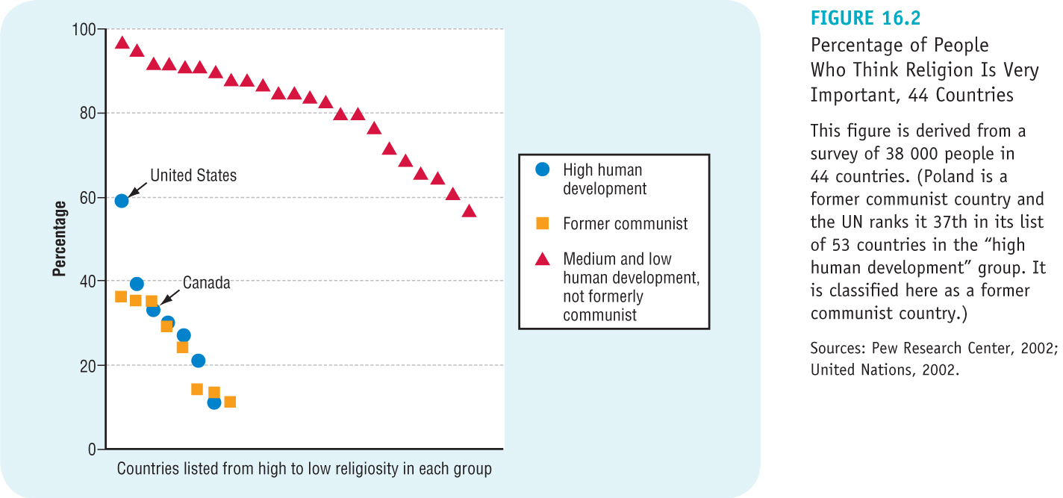

- Moreover, according to Reginald Bibby (Chapter 26 in White & Carroll, 2013), “A massive shift in population growth from the developed countries of the North to the developing countries of the global South will result in a changing global religious landscape.” He cites Scott M. Thomas to add, “‘A new kind of world is in the making, … and the people, states, and religious communities that compose the global South are making it.’”

Modernization and Secularization
- This gave rise to Max Weber’s idea of the “disenchantment” of the world, and to the development of the secularization thesis.
- The secularization thesis claims “that religious institutions, actions, and consciousness are on the decline worldwide” (Brym et al., 2013:418), (even though the thesis does not claim that religion will disappear entirely).

Religion is not dead….
- In spite of the decline of the importance of religion, many people still believe that religion is important, and many people are still involved in religious institutions and in religious practices.
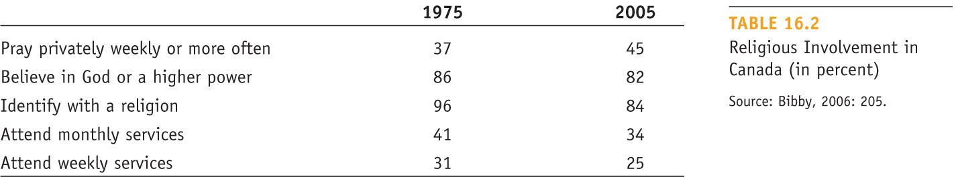

Persistence and Revival of Religion
- In spite of predictions to the contrary (e.g. Karl Marx, Peter L. Berger, et al.), religion has not disappeared; on the contrary, it displays robust health, and even intensification and increase, in some places and circumstances.
- Part of the intensification of religious belief and practice is the result of an increase in religious fundamentalism – especially Protestant fundamentalism, although fundamentalism is evident in every religious Tradition around the world.
- Fundamentalists “interpret their scriptures literally, seek to establish a direct, personal relationship with the higher being(s) they worship, are relatively intolerant of non-fundamentalists, and often support conservative social and political issues.” (Brym et al., 2013:419)
- The first use of the term “fundamentalist” occurred in the 1920’s in the U.S., in the context of the debate between creationists and Darwinists, but membership in fundamentalist religious organizations has increased substantially since the 1960’s.

Revised Secularization Thesis
- Consequently, sociologists had to revise the secularization thesis in the 1990’s.
- The revised secularization thesis “holds that worldly institutions break off from the institution of religion over time. As a result, religion governs an ever-smaller part of most people’s lives and becomes largely a matter of personal choice.” (Brym et al., 2013:421)
- In particular, religion comes to govern “just” the spiritual part of most people’s lives, and to be regarded as a personal and private matter.
- This shift in the social place and role of religion tends to increase individual possibilities for personal religious syncretism.

Religion as a Marketplace
- The process of a religious revival occurring within a context of an overall decline in religious participation, can also be understood in the terms of a religious marketplace.
- In a market of religion, religious organizations supply services (e.g. counselling, pastoral care, youth activities, adult education, etc.) to the faithful who demand such religious activities.
- This model regards religion as a sort of McDonaldized industry, in which different religious corporations compete with each other for members/adherents, and aggressively engage in processes of innovation and diversification.

Types of Religious Organizations
- Several different types of religious organizations can be identified:
  - Churches, and ecclesia (i.e. state-supported churches). Within churches and ecclesia, are subgroups called denominations, which “are the various streams of belief and practice that some churches allow to coexist under their overarching authority.” (Brym et al., 2013:424)
  - Sects, which “usually form by breaking away from churches because of disagreement about church doctrine. Sects are less integrated into society and less bureaucratized than churches are.” (Brym et al., 2013:424) Sects are usually led by individuals with charismatic authority, which is itself “based on a belief in the claims of extraordinary individuals that they are inspired by a god or some higher principle.” (Brym et al., 2013:424)
  - Cults, which are “small groups of people deeply committed to a religious vision that rejects mainstream culture and society.” (Brym et al., 2013:424) Cults are also typically led by charismatic leaders.

- In the following table, notice especially the differences between type of organization, type of leadership, and class base of members.


