- Which of the following cells do not divide?
  - Astrocytes
  - Neurons
  - Adipose cells
  - Epithelial cells
- Which of the following is true about the lysosomes?
  - They store proteins and lipids produced at the endoplasmic reticulum
  - They contain proteolytic enzymes
  - Their main function is to neutralize free radicals
  - They contain their own DNA
- Peroxisomes:
  - provide protection against free radicals and toxins
  - absorb nutrients from digested food and store them for future use
  - produce mucus that protects parts of the digestive organs from the effects of powerful enzymes needed for food digestion
  - secrete buffers in order to keep the pH of the digestive tract close to neutral
- Which of the following is true about the rough endoplasmic reticulum?
  - It is devoid of ribosomes
  - It is involved in lipid synthesis
  - It is involved in protein synthesis
  - Both A) and B)
  - Both A) and C)
- Structures UNLIKELY to be found in areolar connective tissue include:
  - skeletal muscle fibers
  - reticular fibers
  - mast cells
  - collagen fibers
- Mitochondria:
  - are double membrane structures involved in breakdown of ATP
  - synthesize proteins for use outside of cell
  - are involved in production of ATP
  - are found only in muscle cells
- The plasma membrane of human cells:
  - contains phospholipids and cholesterol
  - contains protein carriers and channels
  - is fluid due to the presence of the saturated fatty acids
  - A) and B)
  - all of the above
- Movement of potassium through a selectively permeable membrane against its concentration gradient is called:
  - diffusion
  - facilitated diffusion
  - osmosis
  - active transport
  - endocytosis
- The principal function of cholesterol within the cell membrane is to:
  - stabilize the membrane and regulate its fluidity
  - provide an energy source
  - provide a means of communication among cells
  - act as transporter
- Lipids are moving into the muscle cells:
  - via simple diffusion
  - via facilitated diffusion
  - via active transport
  - using clathrin-coated vesicles that capture glucose and sodium molecules via pinocytosis
- Select the correct statement(s) regarding epithelia:
  - stratified epithelia are present where protection from abrasion is important
  - tight junctions prevent separation of the epithelial cells when skin is poked with a finger or pinched
  - simple squamous epithelium line blood vessels
  - both A) and B)
  - all of the above
- Which of the characteristics of lose connective is TRUE?
  - It is primarily concerned with secretion
  - It lines all of the body’s cavities and chambers
  - It usually contains a variety of cells and fibres
  - It is usually arranged in a single layer of cells
- Which of the following junctions bind neighboring cells and are linked to intracellular keratin filaments?
  - Glycocalyx
  - Adherens junctions
  - Gap junctions
  - Tight junctions
  - Desmosomes
- Which of the following statements is FALSE regarding diffusion?
  - The rate of diffusion depends on the surface area
  - Molecular weight of a substance does not affect the rate of diffusion
  - The higher the temperature the faster the diffusion rate
  - The greater the difference in concentration gradient between two sides of the membrane, the faster the rate of diffusion
- An excitatory neurotransmitter that leads to change in hillock’s membrane potential from -70 to -45 mV causes:
  - production of an action potential at the hillock
  - opening of the ligand-gated channels at the hillock
  - partial depolarization at the hillock
  - hyperpolarization at the hillock
- Goblet cells:
  - produce mucus
  - produce hormones and secrete them to blood
  - secrete their products onto body surfaces and body cavities via active transport
  - all of the above
- High body content of the TNFα has been associated with:
  - obesity
  - chronic inflammation
  - increased number and size of the adipose cells
  - both A) and B)
  - all of the above
- Dendrites of postsynaptic neurons:
  - store neuroransmitters
  - contain ligand-gated postsynaptic receptors
  - contain centrioles and mitotic spindles neded for cell division
  - contain voltage-gated channels
- Which of the following is true about the saltatory conduction?
  - It takes place in dendrites
  - It can be impaired by sclerosis multiplex
  - It takes place in all types of axons
- A positive feedback is observed:
  - between sodium influx and repolarization
  - between sodium influx and depolarization during a depolarizing phase of action potential
  - between potasium influx and depolarization during a depolarizing phase of action potential
  - between sodium and potassium
- Neuroglia of the PNS that provide myelination of axons are called:
  - ependymal cells
  - Schwann cells
  - oligodendrocytes
  - astrocytes
  - microglia
- During a relative refractory period:
  - sodium gates are closed and some of potassium gates are opened
  - sodium and potassium gates are opened
  - all of the gates are closed
  - sodium gates are opened and potassium gates are closed
- The point at which one neuron communicates with another neuron is called:
  - synapse
  - cell body
  - receptor
  - effector
  - axon hillock
- The part of a neuron that usually generates action potentials is called:
  - axon hillock
  - dendrite
  - neurolemma
  - Schwann cell
  - soma
- Which of the following is TRUE about the electrical synapses?
  - Their communication is often bidirectional
  - They use tight junctions for fast and synchronized impulse transmission
  - They are typical for the neuromuscular junctions
  - All of the above
- A neuronal circuit in which a single impulse is transmitted from one to several neurons is called:
  - diverging circuit
  - converging circuit
  - parallel circuit
  - reverberating circuit
- Which of the following will occur when an excitatory postsynaptic potential (EPSP) is being generated on the dendritic spike’s membrane?
  - Specific sodium gates will open and an action potential will be produced
  - A single type of channel for sodium and potassium will open leading to depolarization and a graded potential
  - Specific potassium gates will open and a neuron will become hyperpolarized
  - Sodium gates will open first, then close as potassium gates open leading to production of an action potential and opening of the postsynaptic gates
- Factor(s) contributing to a negative resting membrane potential of neurons include(s):
  - leakage of sodium ions out of the neuron
  - leakage of potassium ions out of the neuron
  - presence of the negatively charged organic molecules in the extracellular space
  - active transport of potassium ions out of the nerve cells
- Calcium ions play an essential role in chemical synapses. They:
  - are responsible for generation of the action potentials on the soma of postsynaptic membranes
  - are necessary for exocytosis of neurotransmitters from the presynaptic terminal knobs of axons
  - are involved in the postsynaptic potentiation
  - both A) and B)
  - both B) and C)
- During the hyperpolarization phase of an action potential, which of the following situations exists?
  - The inside of the membrane is becoming positive with respect to the outside
  - The membrane potential remains equal to the resting membrane potential
  - The inside of the membrane is becoming less negative with respect to the outside
  - The inside of the membrane is becoming more negative with respect to the resting membrane potential
- Which of the following statements is TRUE?
  - Myelination of neuronal axons in the peripheral nervous system is performed by oligodendrocytes.
  - The afferent nerve fibers carry impulses from the CNS to the effectors
  - Neurons are characterized by a long lifespan
  - Regions of the brain and spinal cord containing dense collection of myelinated fibers are called ganglia
- When acetylcholine binds to chemically-gated postsynaptic receptors it can:
  - lead to opening of both fast and slow ion channels
  - lead to fast opening of the ion channels via G-protein associated mechanism
  - lead to slow opening of the voltage-gated ion channels on the postsynaptic membrane
  - lead to opening of the ligand-gated channels on the presynaptic membrane
- An afferent neuron conducts impulses:
  - to the CNS
  - from the CNS to the effector
  - to muscle cells that it innervates
  - between two nerve cells of the CNS
- The major function of the T-tubules in muscle is to:
  - conduct action potentials
  - store calcium
  - synthesize actin and myosin myofilaments
  - produce graded potential
- The basic contractile unit of a skeletal muscle fiber is a:

  - myofibril
  - sarcoplasmic reticulum
  - sarcomere
  - myofilament

- Calcium ions removed from the............................... of the skeletal muscle cells lead to……………..
  - troponin; muscle contraction
  - tropomyosin; muscle relaxation
  - myosin; uncovering of the active sites on actin
  - cytosol; muscle relaxation
- In a relaxed muscle fiber, which of the following are found in the A band on both sides of the H zone?
- thick filaments only
- thin filaments only
- cross bridges
- both thick and thin filaments
- thick filaments and cross bridges

- Cross-bridge formation (attachment of actin and myosin) requires:

  - breakdown of troponin that blocks active sites on actin
  - removal of tropomyosin from the active sites on actin
  - activation of myosin by hydrolysis of ATP on myosin heads
  - Both A) and B)
  - Both B) and C)

- Nebulin is:
  - an intermediate filament supporting and positioning myosin in the sarcomere
  - an intermediate filament supporting and positioning actin in the sarcomere

- Which of the following statements regarding skeletal muscle is true?

- The lower is the number of motor units that are activated, the higher is an overall force output during voluntary contraction
- The smallest motorneurons have the lowest functional threshold and are recruited first
- The smallest motorneurons innervate the largest muscle fibres
- None of the above

- During an isotonic contraction, the muscle:

- does not change in length and increases tension
- becomes longer and moves the load
- becomes shorter and moves “the load”
- becomes shorter but does not change tension

- Which of the following statements concerning the characteristics of different muscle fibres is FALSE?

  - Large diameter fast type IIx (b) fibres fatigue easily
  - Type Tx (b) muscle fibres are important for maintain our posture
  - Slow twitch muscle fibres contain a large number of mitochondria
  - Oxidative, type I muscle fibres do not fatigue easily

- During a speedy activity lasting about 2 minutes, the main energy source is:

- Anaerobic: ADP and phosphate
- Anaerobic: ATP and phospocreatine
- Anaerobic: glycogen
- Aerobic: blood glucose
- Aerobic: fatty acids
- Partially fused tetanus:
  - is a phenomenon that occurs in striated and cardiac muscle cells
  - is a sustained contraction with incomplete relaxation between stimuli
  - results from a continuous stimulation
  - results from a very frequent stimulation without a sufficient time for relaxation

- The force developed by skeletal muscle can be increased by:

- increased frequency of stimulation
- increased size and number of motor units recruited
- angle of muscle fibres pinnation at no more than 30°
- Both A) and B)
- all of the above

- Muscle fatigue can be caused by:

  - decreased hydrogen ions production during exercise
  - depletion of fat
  - depletion of phosphocreatine
  - all of the above

- Which of the following statements is true about the skeletal muscle fibres?

  - Each skeletal muscle fibre is innervated by one motor neuron
  - All skeletal muscle fibres are aerobic
  - During muscle contraction the distance between Z-discs remains unchanged
  - Sarcolemma of the neuromuscular junction contains voltage-gaited channels

- Amino acids:

  - may be used as energy source in the absence of carbohydrates in the diet
  - produce more energy than fatty acids and carbohydrates
  - are usually used for energy during short bursts of intense exercise
  - are never used as energy source

49. Which of the following (A), (B), or (C) would happen to the red blood cell placed in a hypotonic solution?
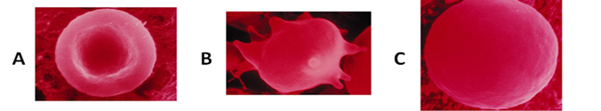

- Which of the following (A) or (B) represents opening of the ligans-gated calcium channel?
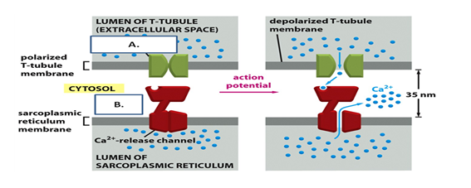

51. Which of the following (A), (B), or (C) represents a single twitch of the fast twitch x (b) muscle fibre?
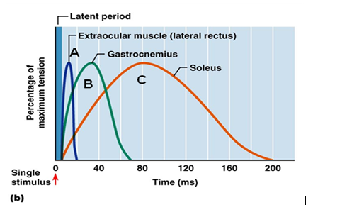

52. Which of the following represents repolarization?
- A2
- C2
- C3
- D4
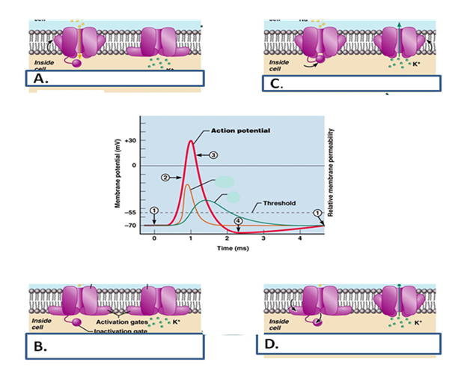

53. Please name the following tissues (A, B, C and D) and provide examples of their location in the body (one location for each type of tissue) (2 marks)

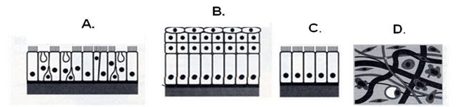
  - Pseudosratified epithelium.
  - Stratified squamous epithelium
  - Simple columnar epithelium
  - Areolar connecting tissue

