- Which of the following mature cells do not have nuclei?
  - Red blood cells
  - Astrocytes
  - Neurons
  - Columnar epithelial cells
- Which of the following is true about the smooth endoplasmic reticulum?
  - It is devoid of ribosomes
  - It is involved in lipid synthesis
  - It is involved in protein synthesis
  - Both A) and B)
  - Both A) and C)
- Which of the following is true about the lysosomes?
  - They store proteins and lipids produced at the endoplasmic reticulum
  - They contain proteolytic enzymes
  - Their main function is to neutralize free radicals
  - They contain their own DNA
- Peroxisomes:
  - absorb nutrients from digested food and store them for future use
  - produce mucus that protects parts of the digestive organs from the effects of powerful enzymes
  - provide protection against free radicals and toxins
  - secrete buffers in order to keep the pH of the digestive tract close to neutral
- Cell types likely to be found in areolar connective tissue include:
  - fibroblasts
  - macrophages
  - mast cells
  - all of the above
- Mitochondria:
  - are double membrane structures involved in breakdown of ATP
  - synthesize proteins for use outside of cell
  - are involved in production of ATP
  - are found only in muscle cells
- The plasma membrane of human cells:
  - is semi-permeable
  - contains phospholipids and cholesterol
  - contains protein channels and receptors
  - A) and B)
  - all of the above
- Movement of swater through a selectively permeable membrane is called:
  - diffusion
  - facilitated diffusion
  - osmosis
  - active transport
  - endocytosis
- Glucose and amino acids can cross cellular membranes of the intestinal epithelium and enter the epithelial cells together with sodium ions:
  - via simple diffusion
  - via facilitated diffusion
  - via active transport
  - using clathrin-coated vesicles that capture glucose and sodium molecules via pinocytosis
  - using the difference in sodium concentration gradient created by the action of the sodium-potassium pump
- Select the correct statement(s) regarding epithelia:
  - stratified epithelia are present where protection from abrasion is needed
  - cells of the skin epithelium easily separate when skin is poked with a finger or pinched
  - simple squamous epithelium line blood vessels
  - both A) and B)
  - both A) and C)
- The principal function of cholesterol within the cell membrane is to:
  - provide an energy source
  - provide a means of communication among cells
  - stabilize the membrane and regulate its fluidity
  - act as transporter
- Which of the characteristics of lose connective tissue is TRUE?
  - It is usually well vascularized and innervated
  - It is usually arranged in a single layer of cells
  - It is primarily concerned with secretion
  - It lines all of the body’s cavities and chambers
- Which of the following junctions binds neighboring cells and is linked to intracellular actin filaments?
  - Tight junction
  - Desmosome
  - Glycocalyx
  - Adherens junction
- Which of the following statements is CORRECT regarding diffusion?
  - The rate of diffusion is independent of temperature
  - Molecular weight of a substance does not affect the rate of diffusion
  - The lower the difference in concentration gradient between two sides of the membrane, the faster the rate of diffusion
  - The greater the difference in concentration gradient between two sides of the membrane, the faster the rate of diffusion
- Goblet cells:
  - produce hormones and secrete them to blood
  - secrete their products onto body surfaces and body cavities via active transport
  - are numerous in the digestive and respiratory systems
  - all of the above
- High body content of the adipose tissue:
  - has been associated with chronic inflammation
  - may lead to insulin resistance and type 2 diabetes mellitus
  - has been associated with elevated CRP levels reflecting increased number but not size of the adipose cells
  - both A) and B)
  - both B) and C)
- The region of neurons where the secretory vesicles with neurotransmitters are stored is called:
  - soma
  - axon terminal
  - Nissl body
  - dendrite
- An excitatory neurotransmitter that leads to change in hillock’s membrane potential from -70 to -65 mV causes:
  - production of an action potential at the hillock
  - opening of the ligand-gated channels at the hillock
  - partial depolarization at the hillock
  - hyperpolarization at the hillock
- Soma (cell body) of postsynaptic neurons:
  - stores neuroransmitters
  - contains centrioles and mitotic spindles needed for cell division
  - contains voltage-gated channels
  - contains ligand-gated postsynaptic receptors
- Which of the following is true about the saltatory conduction?
  - It takes place in myelinated fibers only
  - It takes place in all types of axons
  - It takes place in dendrites
- A positive feedback is observed:
  - between sodium influx and depolarization during a depolarizing phase of action potential
  - between potasium influx and depolarization during a depolarizing phase of action potential
  - between sodium influx and repolarization
  - between sodium and potassium
- During an absolute refractory period:
  - sodium gates are closed and potassium gates are opened
  - sodium and potassium gates are opened
  - all of the gates are closed
  - sodium gates are opened and potassium gates are closed
- The part of a neuron that generates and conducts impulses (action potentials) is called:
  - soma
  - axon
  - dendrite
  - neurolemma
  - Schwann cell
- Neuroglia of the CNS that can modulate the availability of neurotransmitters and/or postsynaptic binding of neurotransmitters, are called:
  - ependymal cells
  - Schwann cells
  - oligodendrocytes
  - astrocytes
  - microglia
- Which of the following is TRUE about the electrical synapses?
  - Their communication is usually unidirectional
  - They use gap junctions for fast and synchronized impulse transmission
  - They are found in the neuromuscular junctions
  - All of the above
- Which of the following will occur when an excitatory postsynaptic potential (EPSP) is being generated on the dendritic spike’s membrane?
  - Specific sodium gates will open and an action potential will be produced
  - Specific potassium gates will open and a neuron will become hyperpolarized
  - Sodium gates will open first, then close as potassium gates open leading to production of an action potential and opening of the postsynaptic gates
  - A single type of channel for sodium and potassium will open leading to depolarization and a graded potential
- Factor(s) contributing to a negative resting membrane potential of neurons include(s):
  - leakage of sodium ions out of the neuron
  - leakage of potassium ions out of the neuron
  - presence of the negatively charged organic molecules inside the neurons
  - Both A) and B)
  - Both B) and C)
- A neuronal circuit in which a single impulse is transmitted over and over again is a:
  - diverging circuit
  - converging circuit
  - parallel circuit
  - reverberating circuit
- The point at which one neuron communicates with another neuron is called:
  - synapse
  - cell body
  - receptor
  - effector
  - axon hillock
- Calcium ions play an essential role in chemical synapses. They:
  - are responsible for generation of the action potentials on the soma of postsynaptic membranes
  - are necessary for exocytosis of neurotransmitters from the presynaptic terminal knobs of axons
  - are responsible for opening of the chemically-gated ions channels on the postsynaptic membrane
- Which of the following statements is TRUE?
  - Myelination of neuronal axons in the peripheral nervous system is performed by oligodendrocytes.
  - The afferent nerve fibers carry impulses from the CNS to the effectors
  - Neurons are characterized by a long lifespan
  - Regions of the brain and spinal cord containing dense collection of myelinated fibers are called ganglia
- When acetylcholine binds to chemically-gated postsynaptic receptors it can:
  - lead to fast opening of the ion channels letting both sodium and potassium move into the postsynaptic neuron
  - lead to slower opening of the ion channels via the G-protein associated mechanism
  - lead to fast opening of the voltage-gated ion channels on the postsynaptic membrane
  - lead to opening of the ligand-gated channels on the presynaptic membrane
- During the hyperpolarization phase of an action potential, which of the following situations exists?
  - The inside of the membrane is becoming less negative with respect to the outside
  - The inside of the membrane is becoming more positive with respect to the outside
  - The membrane potential remains equal to the resting membrane potential
  - The inside of the membrane is becoming more negative with respect to the resting membrane potential
- The major function of the sarcoplasmic reticulum in muscle cells is to:
  - conduct nerve impulses
  - store of calcium
  - synthesize actin and myosin myofilaments
  - provide a source of myosin for the contraction process
- Calcium ions binding to ............................... in the skeletal muscle cells leads to……………..
  - troponin; uncovering of the active sites on actin
  - motor unit; muscle contraction
  - tropomyosin; muscle relaxation
  - actin; uncovering of the active sites on actin
- In a relaxed muscle fiber, which of the following are found in the H zone?
- thick filaments only
- thin filaments only
- cross bridges
- both thick and thin filaments
- thick filaments and cross bridges

- The basic contractile unit of a skeletal muscle fiber is:

  - a sarcomere
  - a myofilament
  - a myofibril
  - the sarcoplasmic reticulum

- Cross-bridge formation (attachment of actin and myosin) requires:

  - breakdown of troponin that blocks active sites on actin
  - removal of tropomyosin from the active sites on actin
  - activation of myosin by hydrolysis of ATP on myosin heads
  - Both A) and B)
  - Both B) and C)

- Titin is:
  - an intermediate filament supporting and positioning myosin in the sarcomere
  - an intermediate filament supporting and positioning actin in the sarcomere

- Which of the following statements regarding skeletal muscle is true?

- Increasing the number of motor units that are activated (hence, muscle mass), increases overall force output during voluntary contraction
- The smallest motorneurons have the lowest functional threshold and are recruited last
- The smallest motorneurons innervate the largest muscle fibres
- None of the above

- During an isometric contraction, the muscle:

- does not change in length and increases tension
- becomes longer and moves the load
- becomes shorter and moves “the load”
- becomes shorter but does not change tension

- Which of the following statements concerning the characteristics of different muscle fibres is FALSE?

  - Large diameter fast type IIx (b) fibres fatigue easily
  - Slow twitch muscle fibres contain a large number of mitochondria
  - Oxidative, type I muscle fibres do not fatigue easily
  - Glycolytic muscle fibres have generous capillary supply and contain myoglobin

- During a speedy activity such as the 100 meters dash, the main energy source is:

- Anaerobic: ADP and phosphate
- Anaerobic: ATP and phospocreatine
- Anaerobic: glycogen
- Aerobic: blood glucose
- Aerobic: fatty acids
- Fused tetanus:
  - is a phenomenon that occurs in striated and cardiac muscle cells
  - is a sustained contraction with partial relaxation between stimuli
  - results from a continuous stimulation
  - results from a very frequent stimulation without a sufficient time for relaxation

- The force developed by skeletal muscle can be increased by:

- increased frequency of stimulation
- increased size and number of motor units recruited
- angle of muscle fibres pinnation at no less than 30°
- Both A) and B)
- all of the above

- Muscle fatigue can be caused by:

  - insufficient carbohydrate consumption before and during exercise
  - excessive hydrogen ions production during exercise
  - depletion of fat
  - both A) and B)
  - all of the above

- Which of the following statements is true about the skeletal muscle fibres?

  - Each skeletal muscle fibre is covered by epimysium
  - All skeletal muscle fibres are aerobic
  - During muscle contraction Z-discs move toward the center of the sarcomere
  - Sarcolemma of the neuromuscular junction contains voltage-gaited channels

- Amino acids:

  - produce similar amount of energy as fatty acids
  - are usually used for energy during short bursts of intense exercise
  - are never used as energy source
  - may be used as energy source in during starvation

49. Which of the following (A), (B), or (C) represents a single twitch of the slow twitch muscle fibre?
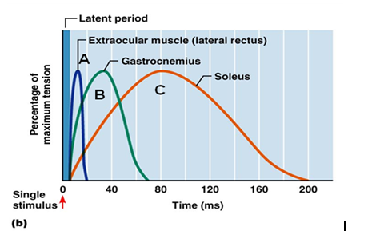

50. Which of the following (A), (B), or (C) would happen to the red blood cell placed in a hypertonic solution?
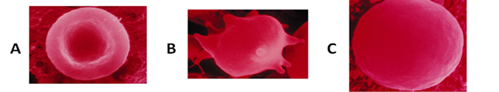

- Which of the following (A) or (B) represents the voltage-gated calcium channel?
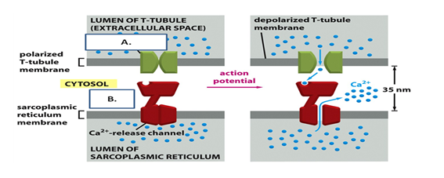

52. Which of the following represents depolarization?
- A2
- C2
- C3
- D4
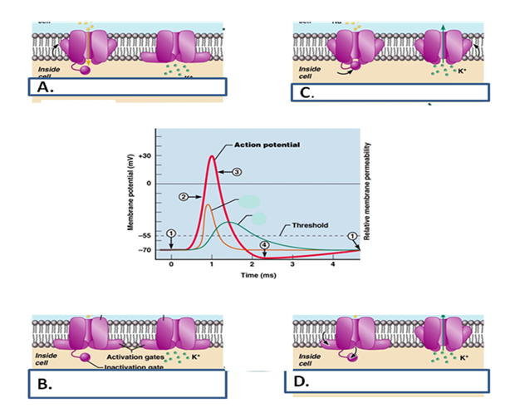

53. Please name the following tissues (A, B, C and D) and provide examples of their location in the body (one location for each type of tissue) (2 marks)
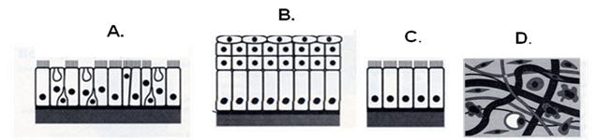
  - Pseudosratified epithelium.
  - Stratified squamous epithelium
  - Simple columnar epithelium
  - Areolar connecting tissue

