Information Processing and Mental Chronometry

- Sensorimotor transformations and processes: organization and control of action
- Cognitive and psychological processes that support action

3-STAGE INFORMATION PROCESSING MODEL
Input (stimulus) -> cognitive processing -> output (response)

- stimulus identification
  - receives information from senses
  - identifies and classifies information
  - extract relevant information
  - stimulus characteristics: clarity, complexity, intensity
- response selection
  - decide on a plan of action
  - translate between stimulus and response
  - cognitive operations process info
  - stimulus-response relations: # of alternatives, predictability, compatibility
- response programming
  - organize and prepare a response
  - send appropriate motor commands
  - response characteristics: duration, accuracy, complexity

OPERATIONS OF INFORMATION PROCESSING STAGES
S -> stimulus identification -> response selection -> response programming -> R
- stimulus identification
  - stimulus characteristics:
    - clarity, complexity, intensity
- response selection
  - stimulus-response relations:
    - # of alternatives, predictability, compatibility
- response programming
  - response characteristics:
    - duration, accuracy, complexity

BASIC ASSUMPTIONS OF INFORMATION PROCESSING MODEL
- mental operations occur between reception of stimulus and production of response
- cognitive operations process information
- processing is time consuming
- stimulus characteristics, complexity of decision-making, complexity of response will affect processing

PROTOTYPICAL REACTION TIME PARADIGM
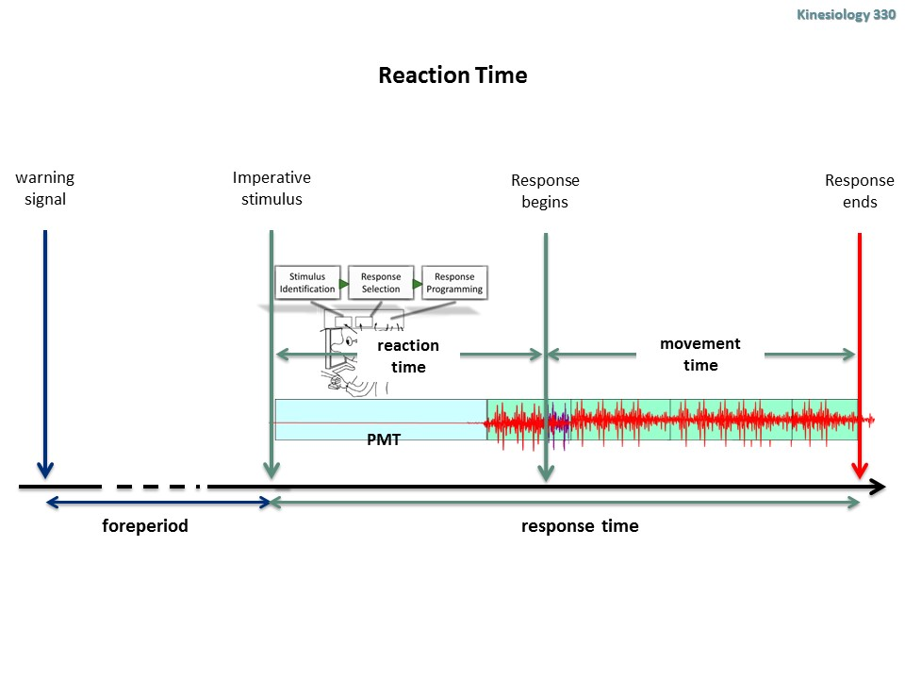
REACTION TIME PARADIGM
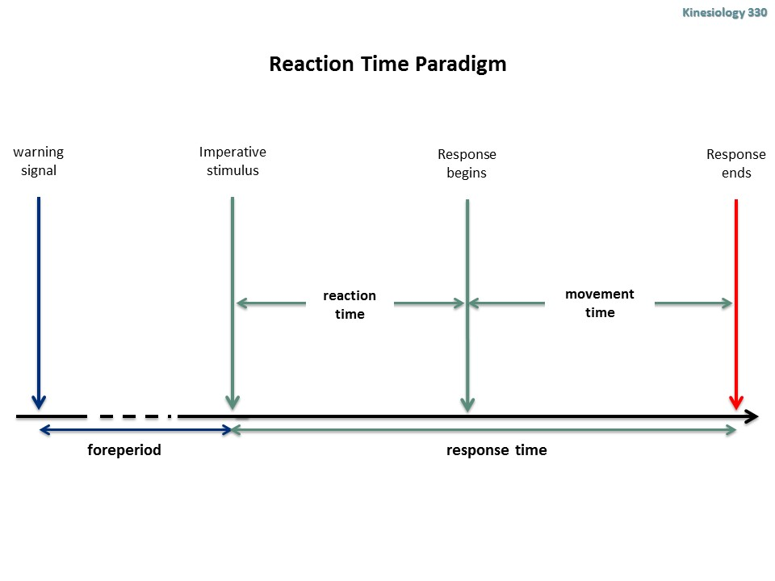

DEFINE KEY TEMPORAL INTERVALS IN A REACTION TIME PARADIGM
Fore period:

FRACTIONATING REACTION TIME
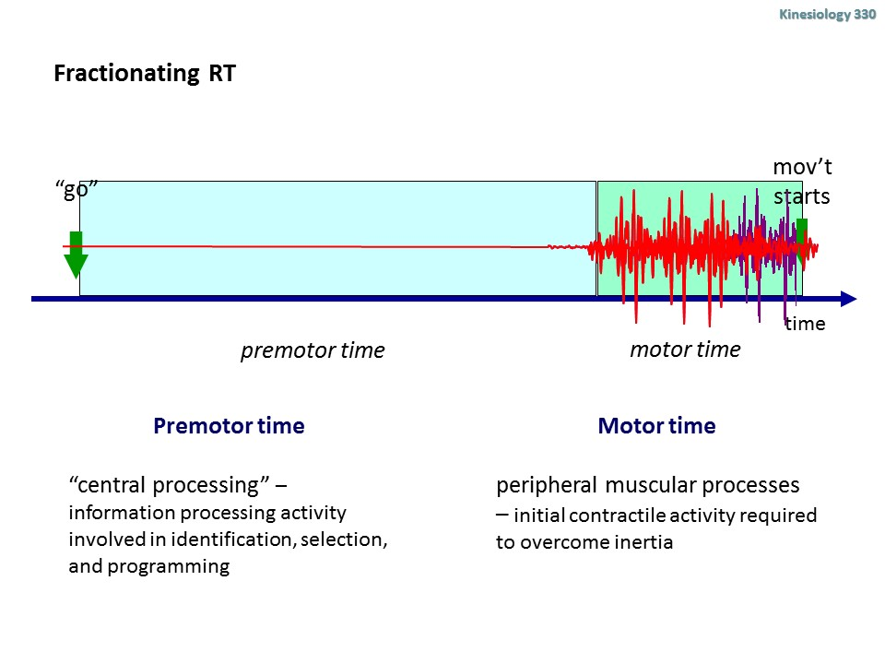

PRINCIPLES OF S-R COMPATABILITY AND TRANSLATION
RESPONSE SELECTION AND S-R TRANSLATION
- sensory system: to receive information from the world or from the body
- motor system: to move us around and manipulate objects
- control system: to determine on the basis of sensory information what is going on, and give commands to produce a response

DEFINE S-R COMPATABILITY
- S-R compatibility:
  - degree of natural or learned correspondence b/w a stimulus and a response
  - affects how easy [degree of] it is to translate input to the response you need to give (output)
- compatibility: degree to which relationships are consistent with human expectations.. where compatibility relationships are designed into the system. Mental expectation/cognitive concept

DESCRIBE BASIC COMPATABLITY TYPES
  - conceptual compatibility
    - degree to which codes and symbols correspond to people’s conceptual associations
    - mental model perceived by viewer
  - movement compatibility
    - degree of correspondence b/w movements of displays and controls and response of system being controlled
  - modality compatibility
    - degree of correspondence between stimulus-response modalities
    - ex. auditory vs. visual stimulus = verbal, action response
  - spatial compatibility
    - compatibility in spatial arrangement of controls and displays, or stimuli and responses

DESCRIBE EVERYDAY EXAMPLES OF SRC

OBJECTIVES:
Sensory system: to receive information from the world or from the body
Motor system: to move us around and manipulate objects
Control system: to determine on the basis of sensory information what is going on, and give commands to produce a response.

Information process model:
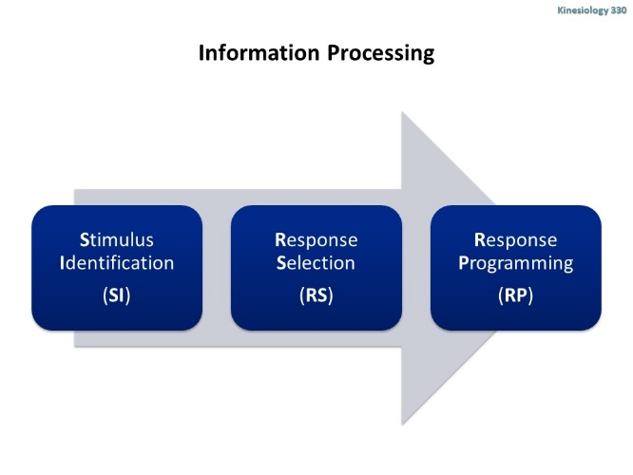
SR compatibility- What is S-R compatibility?
- Degree of natural or learned correspondence between a stimulus and response
- Affects how easy it is to translate between the input to the response you need to give (output)
Compatibility is…
- “… the degree to which relationships are consistent with human expectation… where compatibility relationships are designed into the system… learning is faster, reaction time is faster, fewer errors are made, and user satisfaction is higher”
Types of compatibility
- Conceptual compatibility
- Degree to which codes ad symbols correspond to people’s conceptual associations (wheelchair sign, airport sign, hospital sign)
- Movement compatibility
- Degree of correspondence between movements of displays and controls and response of system being controlled
- Modality Compatibility
- Degree of correspondence between stimulus-response modalities

DEFINE AND DESCRIBE PHENOMENON OF SPATIAL COMPATIBILITY
- What is happening b/w stim and response
- It reveals something of how our info processing works. The middle part of the model.
- Compatibility effects are:
- Pervasive effects evident in performance of simple laboratory tasks, everyday perceptual-motor interactions, to complex human-machine interactions
- Provides a measure of, and theoretical insight into, basic cognitive processes that occur between perception and action
Spatial compatibility effects
- Spatial compatibility effects are not due to the anatomical congruence between the cerebral hemispheres processing the stimulus and response – but a function of the cognitive coding of stimulus and response representations.
- How is the response location coded?
- In terms of the position of the effector?
- In terms of the position of the response goal?
- Spatial compatibility depends on the location of the response goal, not the location of the effector.
Coding response goal locations (using drumsticks in hands behind crossed)
- Are you coding the effector or the response goal?
- If you’re coding the response effector (hand), contralateral mapping would be faster.
- If you’re coding the response goal location (drumstick), ipsilateral mapping would be faster.
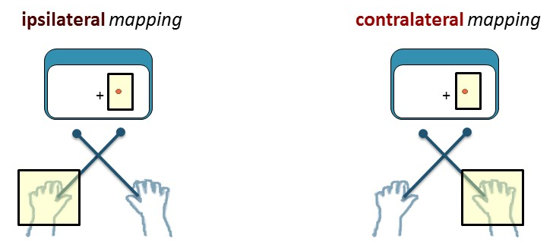
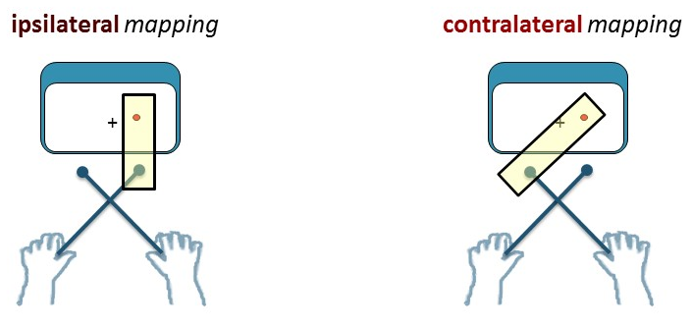
Steering wheel- Turn steering wheel toward or away from sound
- Hands at top: wheel towards was faster, wheel away was slower
- Hands at bottom: no difference between the two.
Visual display and lever
- Visual field is key – they code in terms of left or right based on how you look at it.
Spatial compatibility effects
- Spatial coding of stimulus and response sets can be flexible, depending on the performer’s frame of reference.
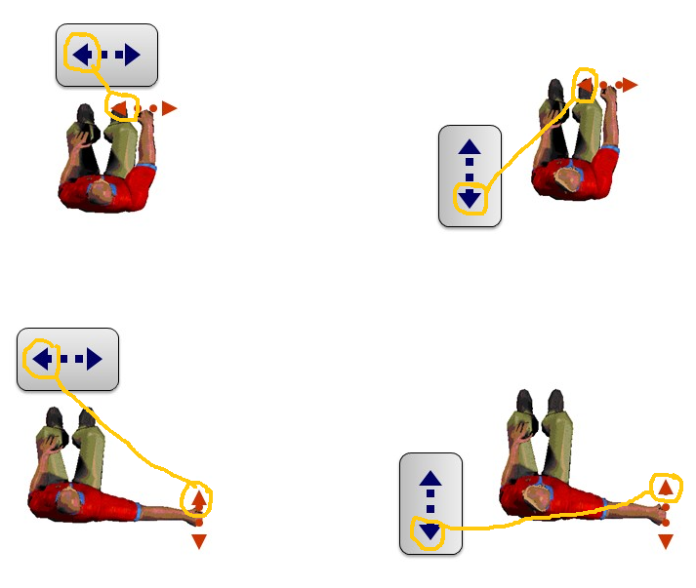
When stimulus and response dimenions don’t correspond, how are stimulus and response elements coded?

DEFINE AND DESCRIBE CHARACTERSTICS OF SPATIAL CODING
Two possible mapping conditions:
- ipsilateral mapping: response on same side light is on
- contralateral mapping: response with opposite
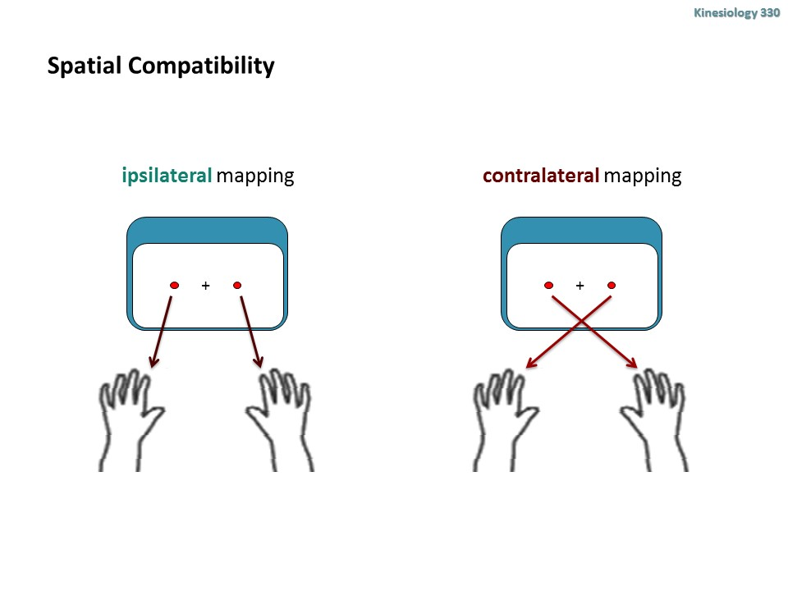
Spatial Coding:
- Stimulus and response sets are “coded” (represented) in terms of their spatial locations
- Spatial relationships can be explicit (e.g., based on absolute spatial positions) or implicit (e.g., responding to symbols)
- When stimulus and response codes match, responses are faster and more accurate than when code DO NOT match.
- SRC effects attributed to more efficient translation between SR codes.

DISTINGUISH B/W COGNTVE CODING AND ANATOMICAL CODING MECHANISMS
- cognitive coding
  - spatial compatibility effects

- neuro-anatomical congruence
  - between cerebral hemispheres processing the stimulus response
  - uses same side of brain hemisphere, independent on special codes
Cognitive vs. neuro-anatomical correspondence
- Are spatial compatibility effects due to cognitive coding of stimulus and response codes?
- Or are compatibility effects due to the anatomical congruence between the cerebral hemispheres processing the stimulus and response.
- Cognitive coding is faster (ipsilateral) and slower (contralateral)
- Neuro-anatomical is faster (ipsilateral) and slower (contralateral)

How does your anatomical pathway affect spatial compatibility?
- It’s faster to perform an ipsilateral reaction.
- If you see something on your left and you have to respond with your left hand, your left eye will send a sensory response to the right side of your brain
- Since you are responding with your left hand, your right brain will send a motor response to the left hand.
- An ipsilateral reaction is faster because the reaction does not need to transfer to the other hemisphere of the brain to perform a motor action.
- Transferring from right to left hemisphere does take some amount of time.

How does crossing your arms defer the anatomical pathway and spatial compatability?
- Anatomically speaking, you would assume crossing your arms would cause the reaction to take longer because the stimulus has to cross the brain to perform a motor movement.
- Spatial compatibility states that if a stimulus and a reaction are on the same side, it will have a faster reaction time.
- Through the experiment we will find out that spatial processing overpowers what our anatomical reasoning thinks.
Simply cross your hands; NOW CONSIDER…
- Cognitive coding would state ipsilateral would be faster and contralateral would be slower.
- Neuro-anatomical would now state ipsilateral would be slower and contralateral faster.
- Ipsilateral would still ultimately be faster, but both ipsilateral and contralateral would have a longer reaction time than if your hands weren’t crossed.

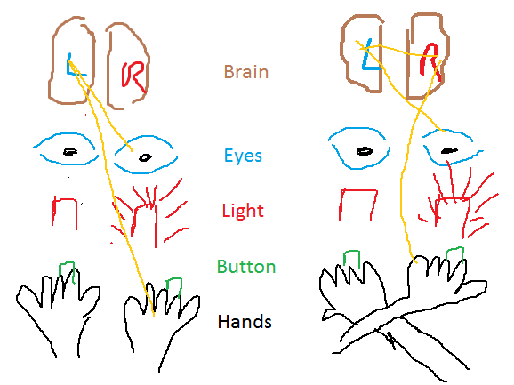

DEFINE AND EXPLAIN HOW FRAMES OF REFERENCE IMPACT COMPATIBILITY EFFECTS**
- Ex.// Mac vs. PC scrolling
- Spatial coding of the stimulus and response sets can be flexible depending on performer frame of reference
- spatial compatibility effects are not due to the anatomical congruence between the cerebral hemispheres processing the stimulus and response but a function of the cognitive coding of stimulus and response representations
- spatial compatibility depends on location of the response goal, not the location of the effectors [where the hand is]
- **visual field is key: they coded in terms of L or R based on how you look at it consistent frame of reference is visual axis (slide)

DESCRIBE AND EXPLAIN THE BASIS OF THE SALIENT FEATURES CODING PRINCIPLE
- Salient features coding principle:
  - Stimulus and response sets can be coded in terms of the salient features of each dimension
    - What distinctive feature might stand out for each dimension

  - Translation is faster when the salient features of stimulus and response sets are mapped together and correspond than when they do NOT correspond
    - When salient features match translation= faster; not match= slower
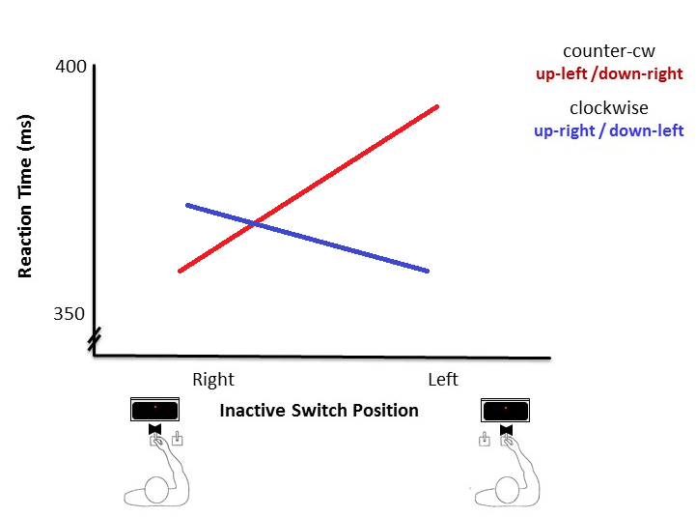

DEFINE ORTHOGONAL SPATIAL COMPATIBILITY AND THE PURPOSE OF EXAMINING ORTHOGONAL SPATIAL REALTIONS
orthogonal: 90 degrees from each other

Othogonal spatial dimensions
- Clock wise vs. counter clockwise
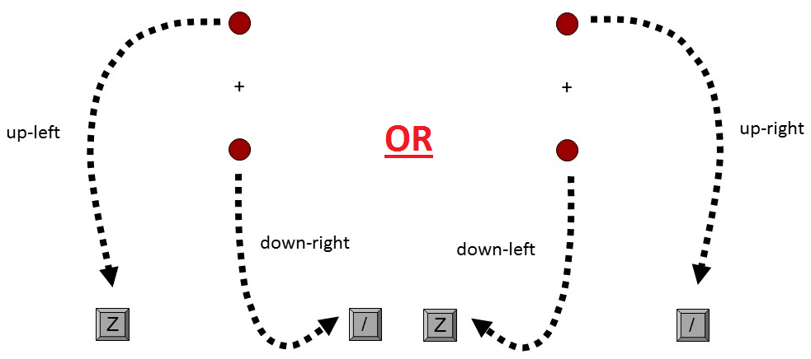

- Orthogonal spatial compatibility- clockwise and counter clockwise had about the same RT
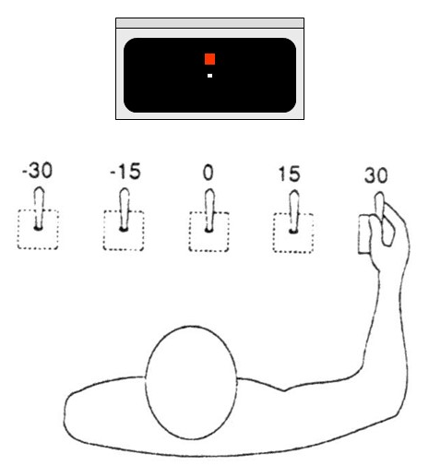
- From -30 to midline, counter clockwise was faster
- From midline to 30, clockwise was faster
- The explanation being….

DEFINE AND DESCRIBE THE SIMONE EFFECT
Simon effect: assigned to what the stimulus is **spatial locations irrelevant to task**
- respond to stimulus feature
- location of stimulus feature
- location of stimulus irrelevant
- stimulus features are mapped to spatial responses
  - compatible/ ipsilateral/ congruent

  - incompatible/ contralateral/ incongruent
    - when green stimulus on left and must respond with right hand

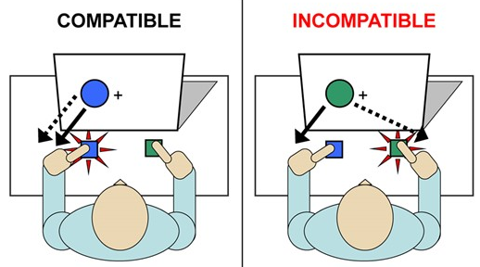
Simon Effect Protocol
- Respond to stimulus feature
- Location of stimulus is irrelevant
- Stimulus features are mapped to spatial responses
- Left stimulus with Left response position equals faster reaction time (or Right with right)
Dimensional Overlap Model | Dual Process Model
- When stimulus and response sets have dimensions that overlap, compatibility is determined by the correspondence between elements of the s-R sets.  - Elements in the stimulus set can automatically activate corresponding elements in the response set.  - If the activated response is the required one, it will be initiated rapidly.  - If the activated response is not the required one, it will be initiated slowly and be prone to errors. | Stimulus –response correspondence can affect performance in two ways:  - Abrupt stimulus onset automatically primes the spatially corresponding response  - “unconditional” process  - Task-dependent S-R transformation is applied in order to intentionally translate the stimulus code into the appropriate response  - “conditional” response

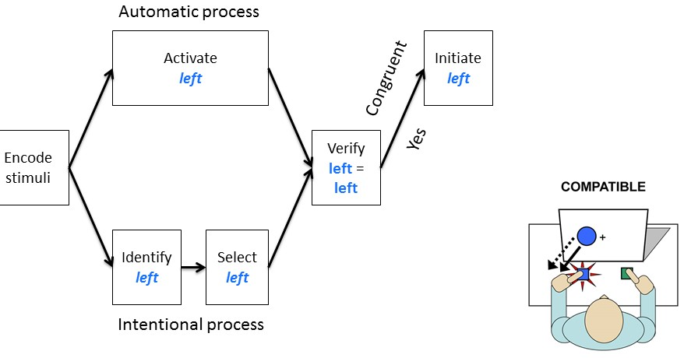
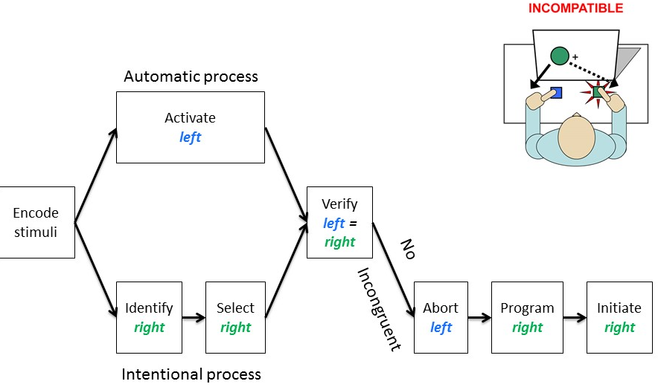
General points of compatibility:
- Can occur in a wide variety of perceptual-motor situations
- Are based on a conceptual correspondence of S-R mappings, rather than physical correspondence
- Can occur regardless of whether stimulus location is relevant or irrelevant for determining the response
- Coding of S-R sets can be flexible
- Reflects processes associated with response selection and perceptual-motor translation

Stages of information processing
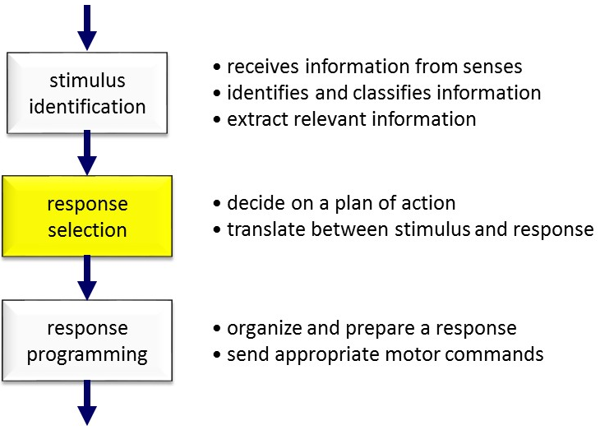

DISTINGUISH B/W THE SPATIAL COMPATIBILITY AND SIMON EFFECTS

EXPLAIN THE DIMENSIONAL OVERLAP AND RESPONSE COMPETITION ACCOUNT OF SRC AND SIMON EFFECTS

DESCRIBE AND DISCUSS THE EMPIRICAL EVIDENCE FOR DUAL-PROCESS MODELS OF SRC EFFECTS

