MIDTERM TWO

HOMEOSTASIS

Homeostasis – dynamic (not unchanging) state of equilibrium/balance in which internal conditions vary, but always within relatively small limits
- Walter Cannon: ability of the body “to maintain relatively stable internal conditions even though there is continuous change in the outside world”
- Involves many systems
  - Adequate blood levels of vital nutrients
  - Heart activity/blood pressure monitored and adjusted as needed
  - Wastes must not accumulate
  - Body temperature

Homeostatic control
- Communication by the nervous and endocrine systems
  - Use neutral electrical impulses or blood-borne hormones as info carriers
- Variable: all homeostatic control mechanisms are process involving at least 3 components
  - Receptor: sensor that monitors the environment and respond to changes (stimuli)
    - Ex) Sense change in blood sugar lvl
  - Sends information (input) to the second component (control center)
  - Input flows form the receptor to the control center along the afferent pathway
  - Afferent (approaches control center) outgoing to brain / Effecter (exits control center) stimulates response
  - Control center: determines set point (lvl at which something is to be manipulated) for variable maintenance; analyzes info and determines correct response

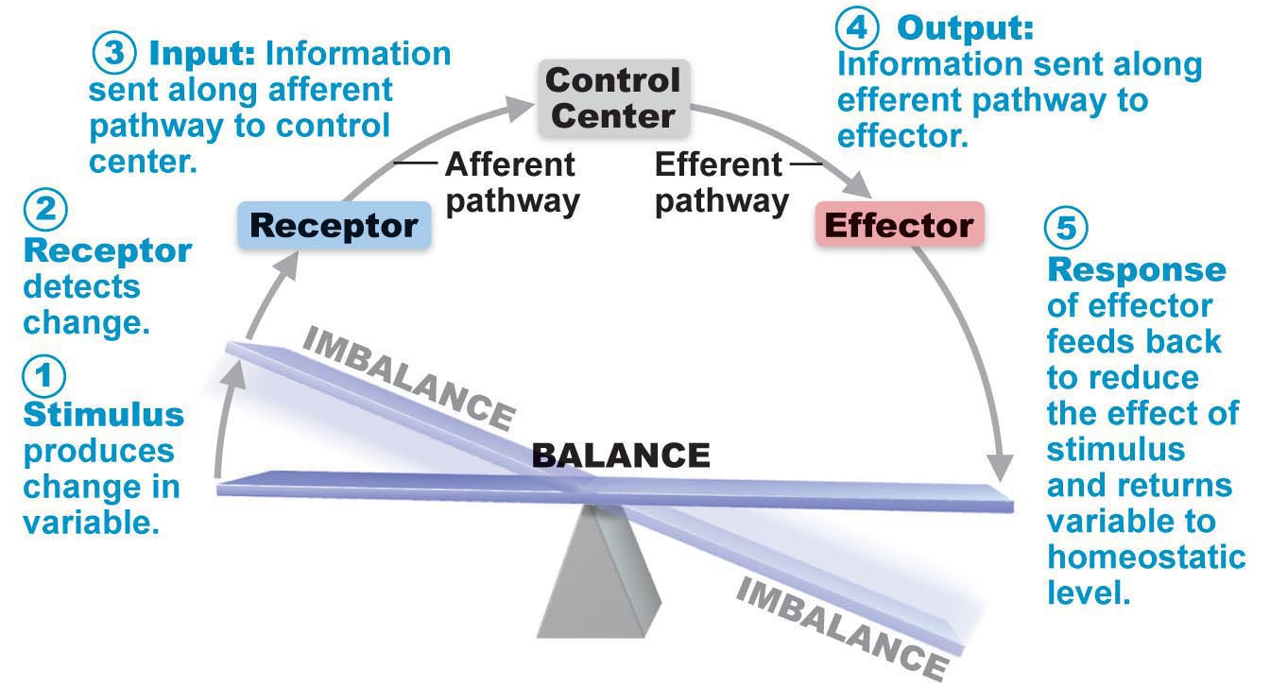

- Negative feedback: output shuts off original effect of stimulus/reduces it
  - Back to ideal value
  - In hypothalamus
  - Regulation of body temp
  - Withdrawal reflex
  - Goal: prevent sudden, severe changes
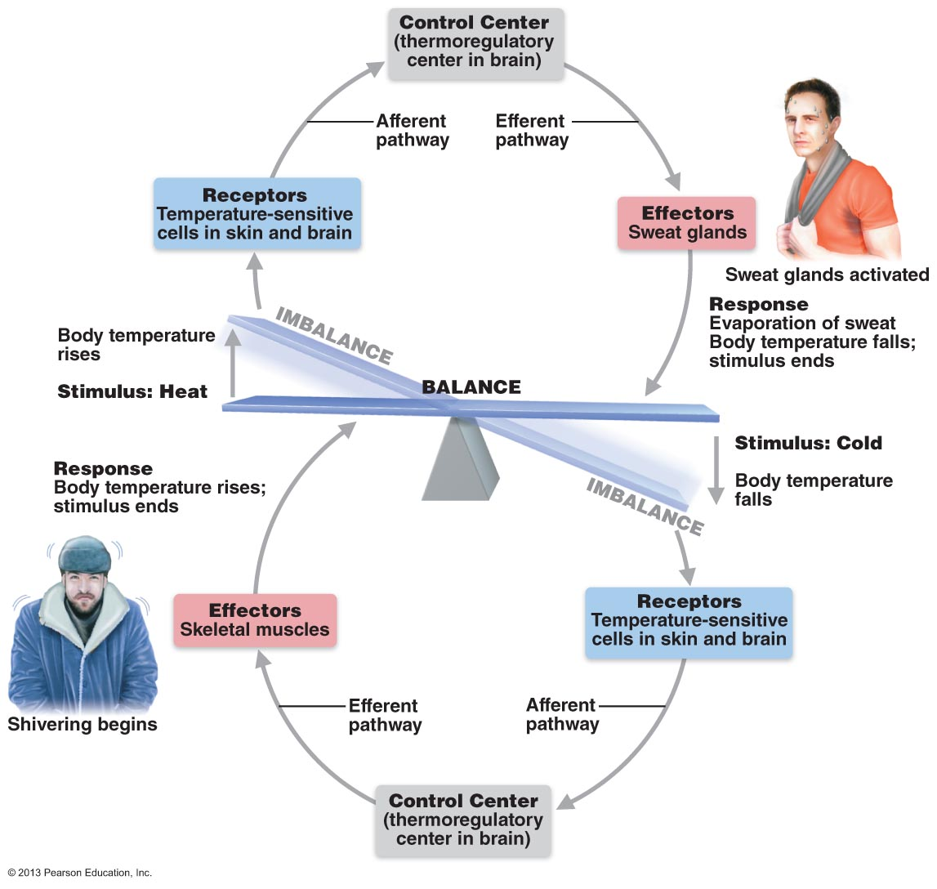
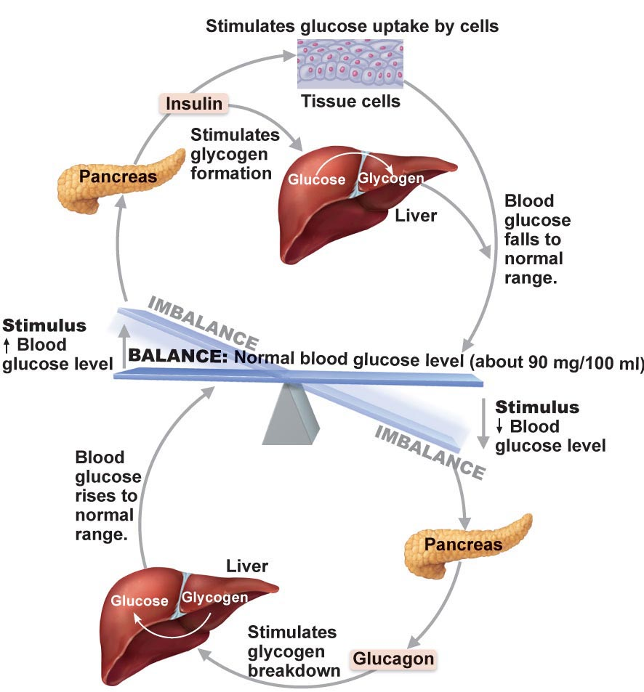

- Positive feed back: response that enhances the original stimulus
  - Labor contractions (oxytocin being released) and blood clotting (however it helps maintain blood flow and volume; still maintaining homeostasis)

Homeostatic Imbalance
- Most diseases can be seen as a homeostatic imbalance (any disturbance in homeostasis)
  - As we age our body’s control systems become less efficient and internal environments become less stable more susceptible to illness as we age
- When neg. feedback is overwhelmed and positive feedback takes over (destructive)

Differences between somatic and autonomic nervous system
- Effectors
  - Somatic nervous system stimulates skeletal muscles
  - ANS stimulates cardiac and smooth muscles and glands
- Efferent pathways and ganglia
  - SNS: motor neuron cell bodies are in the CNS, axon extend in spinal nerves, thick nerves, myelinated, rapid (no ganglia)
  - ANS: two neuron chain
    - Preganglionic neuron: in brain/spinal cord (thin, lightly mylinated)
    - Postganglionic neuron: cell body is in autonomic ganglion outside CNS, its axon the postganglionic axon extends to effector organ (even thinner, non myelinated)
      - Conduction is slow
- Neurotransmitter
  - SNS: acetylcholine (ACh) always excitatory
  - ANS: norepinephrine (NE) sympathetic fibers, and ACh, parasympathetic fibers
    - Response can be excitatory or inhibitory

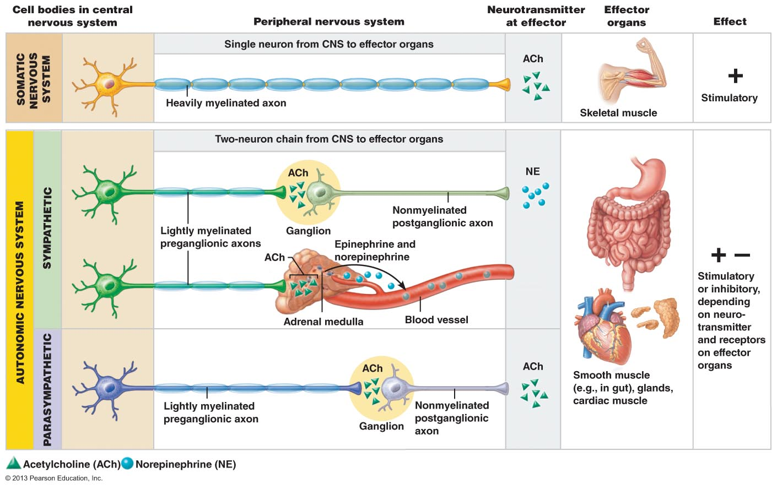

- Sympathetic = fight or flight
- Parasympathetic = resting and digesting

- ANS
  - Shunt blood to more needy areas
  - Speed/slow heart & respiratory rates
  - Adjust blood pressure, body temp
  - Increase/decrease gastric secretions

Parasympathetic
- Rest and digest
- Keeps energy lvls low housekeeping activities
- What are the predominate effects of the parasympathetic ns when reading a newspaper after a meal??
  - Ddigestion, low heart rate, parasympathetic output to slow down breathing and heart rate, vision will be focused on something close, all parasympathetic division
- ‘D’ system: digestion, defecation, diuresis
Sympathetic
- Flight or fight
  - Pounding heart, deep breathing, dry mouth, cold, sweaty skin, dialated pupils
- Needed during physical activity
  - Constricts visceral blood vessels, works heart
  - Dilates bronchioles in lunges, increasing ventilation
  - Causes liver to release more glucose into blood to accommodate increased energy needs of cells
- ‘E’ system: exercise, excitement, emergency, embarrassment
- Overrides parasympathetic
- Major actor in controlling blood pressure

Differences in the anatomy of the ANS
- PNS aka craniofacial division starts in the brain and spinal cord
  - Long pregang and short post gang fibres (in visceral effector organs)
- SNS are in thoracolumbar (thoracic and lumbar regions of spinal cord)
  - Short pregang and long postgang (in spinal cord)

Effects of drugs
Antagonistic interactions
- Activity of the heart, respiratory system and gastrointestinal system
  - In flight or fight the sympathetic division increases heart rate, dilates airways and inhibits digestion
  - When the emergency is over the parasympathetic brings you back to resting levels
Sympathetic and parasympathetic tone
- Sympathetic tone: state of partial vasoconstriction of the blood vessels maintained by sympathetic fibres (in vascular system)
  - Alpha-blockers = drug that block the responses in these vasomotor fibres (sympathetic nerve fibers that cause the contraction of smooth muscle in the walls of blood vessels, regulating blood vessel diameter)
    - Blood shunting
- Parasympathetic tone: normal level of parasympathetic output, sustains normal gastrointestinal and urinary tract activity, lowers heart rate
  - SNS can override this
  - Drugs that block parasympathetic response increase heart rate and make you pee and poo
  - Activate all glands but adrenal and swear glands
- Most visceral organs get dual innervation
 | PNS | SNS
Heart | Decrease | Increase
GI System | Stimulated | Inhibited
Resp. System | Decrease | Increase

Cooperative Effects: regulation of external genitalia during intercourse
- PNS: dilation of blood vessels in penis
- SNS: ejaculation, reflex peristalsis of females vagina

Unique roles of the sympathetic division (cant be reversed by parasympathetic)
  - Adrenal medulla, sweat glands, arrector pili muscles of skin, the kidney and most blood vessels only receive sympathetic fibers
  - Parts of the sympathetic nervous system can be activated individually
  - Effects of sympathetic nervous system stick around longer than para
    - We need time to “come down” after
- Regulates body temp
- Release renin from kidney (increases blood pressure)
- Increases metabolic rate
- Raises blood glucose levels
- Mobilizes fats for use as fuels
- Increases mental alertness
- Increases speed/strength of muscle contractions

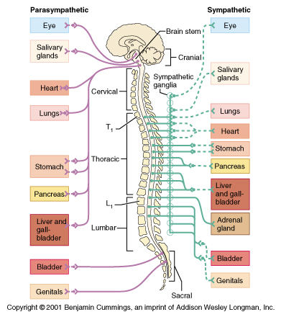

The PNS and ANS differ as to:
- Sites where nerves originate
- Relative lengths of pre- and post-ganglionic fibers
- Locations of ganglia

Brain Stem and Spinal Cord controls
- Anterior hypothalamus = parasympathetic function
- Posterior areas = sympathetic
- Hypothalamus coordinates via cardiac and vasomotor centers in the contralateral medulla
  - Heart activity
  - Blood pressure
  - Body temp
  - Water balance
  - Endocrine activity
  - Fear via amygdala
  - Emotions etc
- Cortical controls - aware of whats going on
  - e g: meditation & biofeedback allow some conscious control over visceral activities
  - e g: during meditation, can lower heart & breathing rates, oxygen use, metabolic rate
  - Biofeedback to improve management of migraine headaches, stress & cardiac function
- Homeostatic imbalances of ANS
  - Hypertension

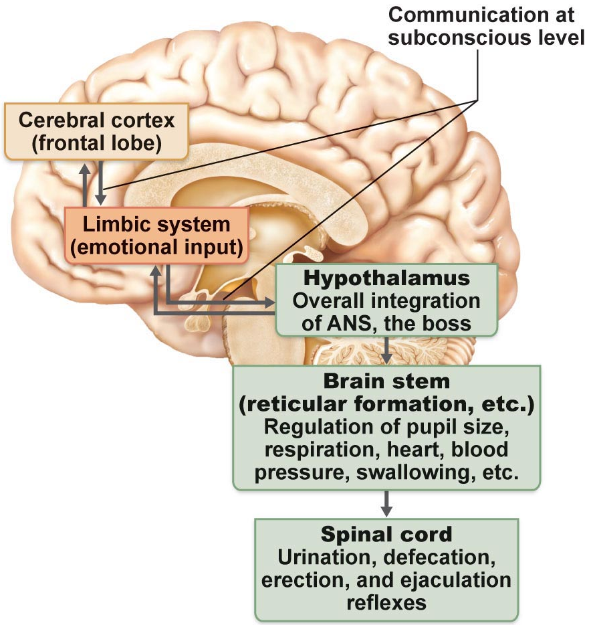

- After surgery, patients are often unable to urinate and bowel sounds are absent. What division of the ANS is affected by anaesthetic (drug that causes loss of sensation) ?
  - PSN
- A risk factor for ulcers can be stress and the associated excess activity of the sympathetic nervous system. eg: one contributing factor to ulcers is a severe reduction in blood flow to the stomach wall. How is this related to sympathetic function?
  - Stress, reductions of blood flow to the stomach. The stress activates SNS, redirect bf to heart and lungs at the expense of the GI tract, reducing mucus, and then less protection to wall of stomach so acid has more chance to eat away at stomach

THE ENDOCRINE SYSTEM

- Hormone: Chemical substance released into the ECF that regulates the metabolic function of other cells in the body
  - Hormone = to excite
  - Binding of hormones to cellular receptors initiates response after lag period of seconds to days
  - Once initiated these response last much longer than those induced by nervous system
- Hormones are specific; level of target cell activation depends on:
- (i) Hormone concentration
- (ii) Target cell receptor content
- (iii) Affinity (lvl of attraction) of hormone for receptor

- Major processes
  - Reproduction
  - Growth and development
  - Maintenance of electrolyte, water, and nutrient balance of the blood
  - Regulation of cellular metabolism and energy balance
  - Mobilization of body defenses
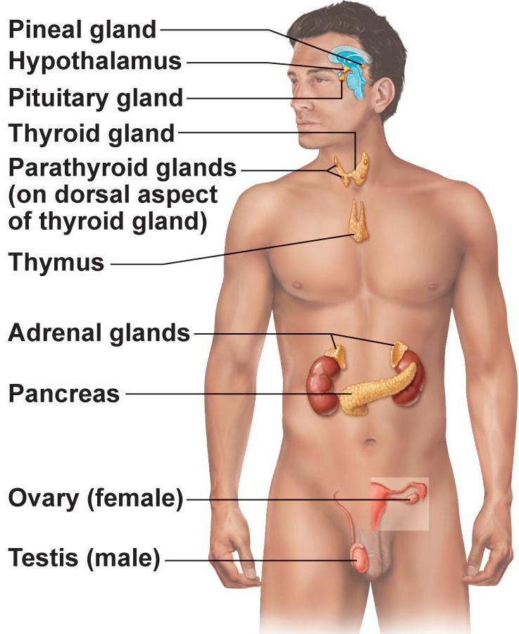

Exocrine glands: produce non-hormonal substances such as sweat and saliva, have ducts
Endocrine glands: ductless, produce hormones and release them into the surrounding tissue fluid

Chemistry of hormones

- Water-soluble hormones
  - All amino acid based hormones except thyroid act on receptors in the plasma membrane
  - Coupled via regulatory mol G proteins to one or more intracellular second messenger
    - cAMP, calcium
- Amino acid based
  - Most hormones
  - Thryoxine
  - Peptides
  - Proteins
Peptide/protein hormones
- Hormone binds receptor messenger (on surface)
- Receptor activates G protein
- G protein activates adenylate cylase
- Adenylate cyclase convert ATP to cAMP
- cAMP actives protein kinases
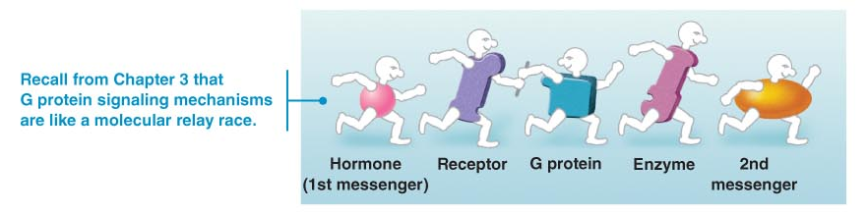

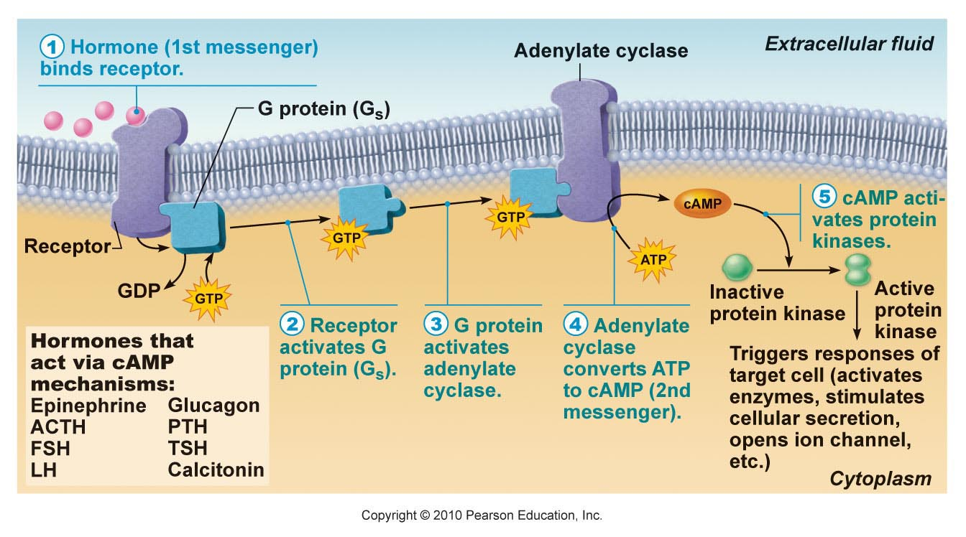

- cAMP depends
  - On type of target cell
  - Specific protein kinases it contains
  - Substrates w/in that cell available for phosphorylation
- cAMP (activates protein kinase enzyme) is only there briefly
  - Due to mol being degraded by intracellular enzyme phosphodiesterase
    - Good because no extracellular controls are needed to stop activity
- cAMP is most common second messenger
  - Calcium can be used

Steroid (lipid soluble)
  - Synthesized rom cholesterol
  - Gonadal and adrenocortical
  - Entry into nucleus and activation of gene transcription
- Lipid soluble
  - Steroid and thyroid
  - Act on receptors inside the cell
  - Directly activates genes
  - Don’t use secondary messenger
  - Diffuse into their target cell where they bind to and activate an intracellular receptor
    - Then bind to nuclear chromatin & binds to specific regions of DNA ‘turning on’ a gene
    - Starting transcription of DNA to produce mRNA
    - mRNA is translated on the cytoplasmic ribosomes
      - produces specific proteins including enzymes that promote metabolic activities & can promote synthesis of structural proteins
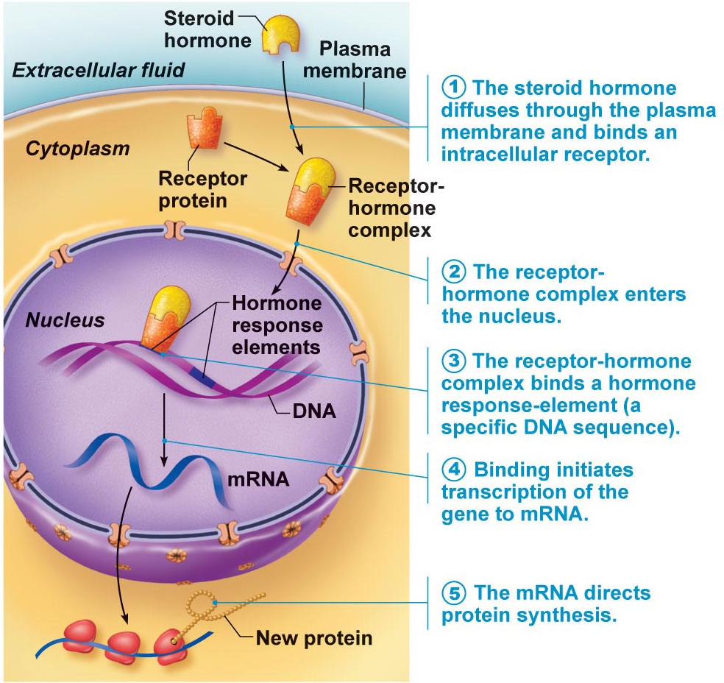

Protein kinases: enzymes that phosphorylate (add phosphate group to various proteins

Eicosanoids
- From arachadonic acid

Mechanisms of Hormone Action
- Hormones influence activity only to those tissue cells that have receptors for it
  - Target cells
    - Alter target cell activity (increase/decrease cell processes)
      - Ex) when epinephrine binds to certain smooth muscle cells in blood vessel walls it stimulates them to contract
• Hormones alter levels of cell activity:
» Membrane permeability/potential (channels)
» Synthesis of enzymes within cells
» Enzyme activation/deactivation
» Induction of secretory activity
» Stimulation of mitosis

- Hormones must have specific binding sites in cell in order to activate
Target cell activation depends on
- Blood levels of the hormone
- Relative numbers of receptors for that hormone on/in target cell
- Affinity (strength) of the binding between the hormone and the receptors
- As a rule:
  - Large number of high affinity receptors produce a pronounced hormonal effect
  - Smaller number of low affinity receptors reduce the target cell response/cause endocrine dysfunction
- Hormones are dynamic
  - If levels of hormones are low, target cells can form additional receptors for that hormone
    - Up regulation
  - And vise versa
    - Down regulation (desensitizes target cells)
- Hormones influence the number of their own receptors and the number of receptors that respond to other hormones
  - Progesterone down-regulates estrogen receptors in the uterus (stopping estrogen action)

Control of Hormone Release
- Regulated by negative feedback (set point) sometimes positive feedback (goal)
- External and internal stimulus trigger hormone secretion
  - Blood lvl of hormones vary w/in narrow range
    - Rate of synthesis
    - Rate of degradation/clearance from blood
- Half-life: persistence of a hormone in the blood; usually < 1 min to 30 min
- Time to onset of hormone action variable: enzyme activation - rapid (minutes); enzyme synthesis - hours to days
- Some hormones secreted as prohormones (not active or low levels with out target tissue when attached to target tissue it gets activated); activated once reach target cell
- Duration (how long the cell keeps producing that hormone, depends on hormone and process) of hormone action also variable (hours to days)
- Onset: how soon after a cell is exposed to a hormone can you get a response
- Potent chemicals great effects on target organs with low concentrations
- Free or bound to a protein carrier
  - Lipid sol travel in blood stream attached to a plasma protein
  - Most other circulate without carriers

- Endocrine Gland Stimuli
  - Humoral
    - Whole body
    - Hormone secretion in direct response to change in blood level of a nutrient, ion (ex: parathyroid hormone (PTH) and blood calcium, insulin and blood glucose)
  - Neural
    - Not common
    - Nerve fibers stimulate hormone release
      - Response to stress
      - Sympathetic NS and epinephrine released by adrenal medulla, hypothalamic neurons and oxytocin release
  - Hormonal stimuli
    - Regulates system
    - 3-tiered system involving hypothalamus, pituitary and target endocrine gland

    - Hypothalamus tells pit gland to increase or decease amount of hormone then hormone travels through blood stream, then increases or decreases how hormones stimulate response in target gland
      - Hypothalamic-pituitary axis
    - Not neurotransmitters because they are not released at a synapse
      - They are hormones
    - Portal system: two capillary beds directly linked between/with 2 veins, travel directly to anterior pit without having to go through whole body!
      - Provides a direct communication from A to B without having to go through whole body

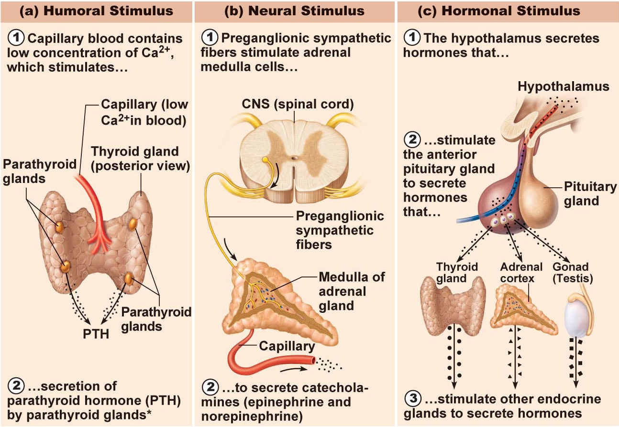

Interaction of hormones at target cells
- Permissiveness
  - One hormone cannot exert its full effect without another hormone being present
    - Reproductive & thyroid system
- Synergism
  - More than one hormone produces the same effect at the target cell and their combined effects are amplified
    - Glucagon and epinephrine cause liver to release glucose to the blood, when released together the amount of glucose is 150% of what is released when each hormone acts alone
- Antagonism
  - One hormone opposes the action of the other
    - Insulin is antagonized by glucagon

Pituitary gland – secretes at least 8 hormones
- Size and shape of a pea
- Infundibulum connects pit to hypothalamus
- 2 lobes
  - Neural and glandular tissue
- Posterior lobe
  - Neural tissue
  - Releases neurohormones
  - Axon terminals
  - Hormone storage area
  - Antidiuretic hormone (SON)
    - Stimulates the kidney to reabsorb water, reducing urine vol.
  - Oxytocin (PVN)
    - Synthesized in hypothalamus
      - Stimulates contractions of uterus and ejection of milk
Structurally similar (both are nonapeptides); but very different functions!!
- Anterior (master gland)
  - Glandular tissue
  - Manufactures and releases hormones

Prolactin = we don’t usually need it, unless having children
Under inhibitory effect of PIH ***
When a baby is trying to feed it will ^ the TRH release overriding dopamine and releasing prolactin

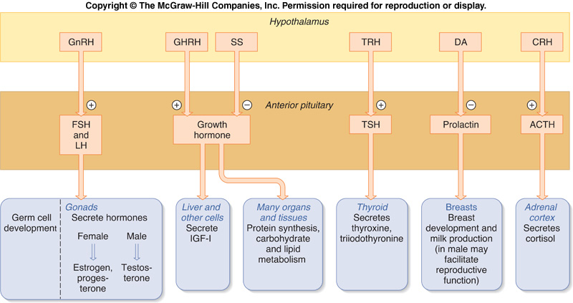

To Summarize:
2 key homeostatic regulatory systems:
- Autonomic nervous system
  - Sympathetic versus parasympathetic
  - Sensory and motor neural pathways
  - Fast response
- Endocrine system
  - Hormones released into extracellular fluid and often travel to target organs via bloodstream
  - Slower response time but response can be long-lived
  - Different chemical classes of hormones with associated mechanisms of action

Blood
- Only fluid tissue in body (formed element suspended in plasma)
  - Formed elements in plasma – non living (fluid part)
    - Erythrocytes or RBC
    - Leucocytes or WBC
    - Platelets
  - Plasma is 55% blood volume
- Physical characteristics
  - Colour is scarlet (O2 rich) or dark red (02 poor)
    - Colour change is due to amount of 02 bound to hemoglobin
  - More sense/viscous than water
  - pH = 7.35-7.45
  - Temp 38 (regulated in body)
  - 8% of body weight (5-6L in males, 4-5 in girls)

Functions of blood
- Distribution
  - Delivering oxygen from the lungs and nutrients from the digestive tract to all body cells
  - Transporting metabolic waste products form cells to elimination sites
  - Transporting hormones from the endocrine organs to their target organs
- Regulation
  - Maintaining appropriate body temp
  - Maintaining normal pH
    - Blood proteins act as buffers to prevent excessive changes in blood pH
    - Blood acts as reservoir for body’s alkaline reserve
  - Maintaining adequate fluid volume in the circulatory system
- Protection
  - Preventing blood loss
    - When blood vessel is damaged platelets and plasma proteins initiate clot formation and halting blood loss
    - Preventing infection
      - Antibodies in WBC

Blood Plasma
- Straw coloured
- 90% water + solutes (over 100)
  - Nutrients, gases, hormones, wastes, proteins
- Plasma proteins
  - 8% of weight
  - produced by liver (except hormones and gamma globulins)
  - not taken up by cells to be used as fuels
- Albumin
  - 60% plasma protein
  - Carrier to shuttle certain mol through circulation
  - Blood buffer
  - Plasma osmotic pressure (keeps water in blood stream)
    - Major osmotic ion: positively charged Na+
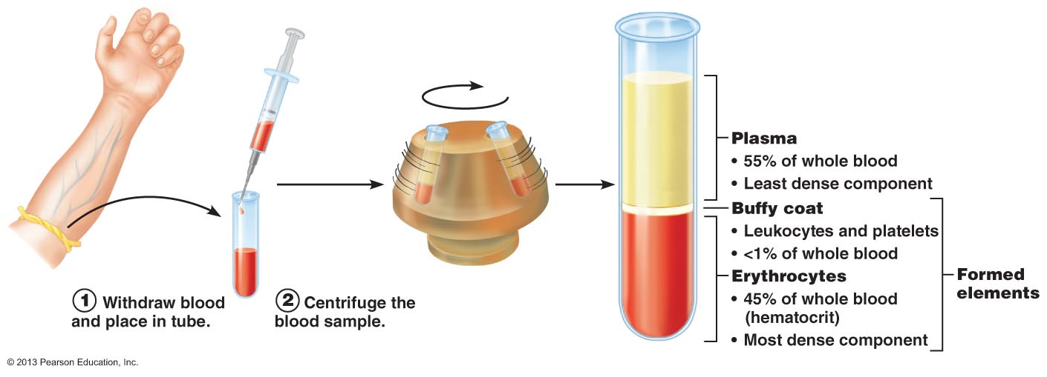

Formed Elements
- Erythrocytes have no nuclei or organelles and platelets are cell fragments
- Only leukocytes are complete cells
- Formed elements survive in the bloodstream for only a few days
- Most blood cells do not divide, stem cells divide continuously in red bone marrow to replace them
- Red blood cells: disc shaped
- Gaudily stained spherical white blood cells
- More red blood cells than any other element

Erythrocytes
- Small cells 7.5 nanometers in diameter
- Bound by a plasma membrane but don’t have a nucleus (anucleate)
  - Bags of hemoglobin (97%)
- Shape is good for gas exchange
- Don’t consume any of the oxygen they carry because they don’t have mitochondria and generate ATP by anaerobic mechanisms
- Women have less RBC b/c of menstrual cycle and less testosterone (stimulates release of RBC)
- When RBC count rises blood becomes more viscous and flows more slowly
- And vise versa
- Spectrin: attach to cytoplasmic face of RBC plasma membranes maintains the biconcave shape of a RBC
  - helps RBC rebound back to normal shape when it gets out of v small capillaries
- Transports 20% of CO2 back to lungs
- Central depression = where nucleus was before nucleus was ejectedgives more surface area so gasses can move in and out of cell
- Smaller than WBC
- Hemoglobin = protein globin bound to red heme pigment
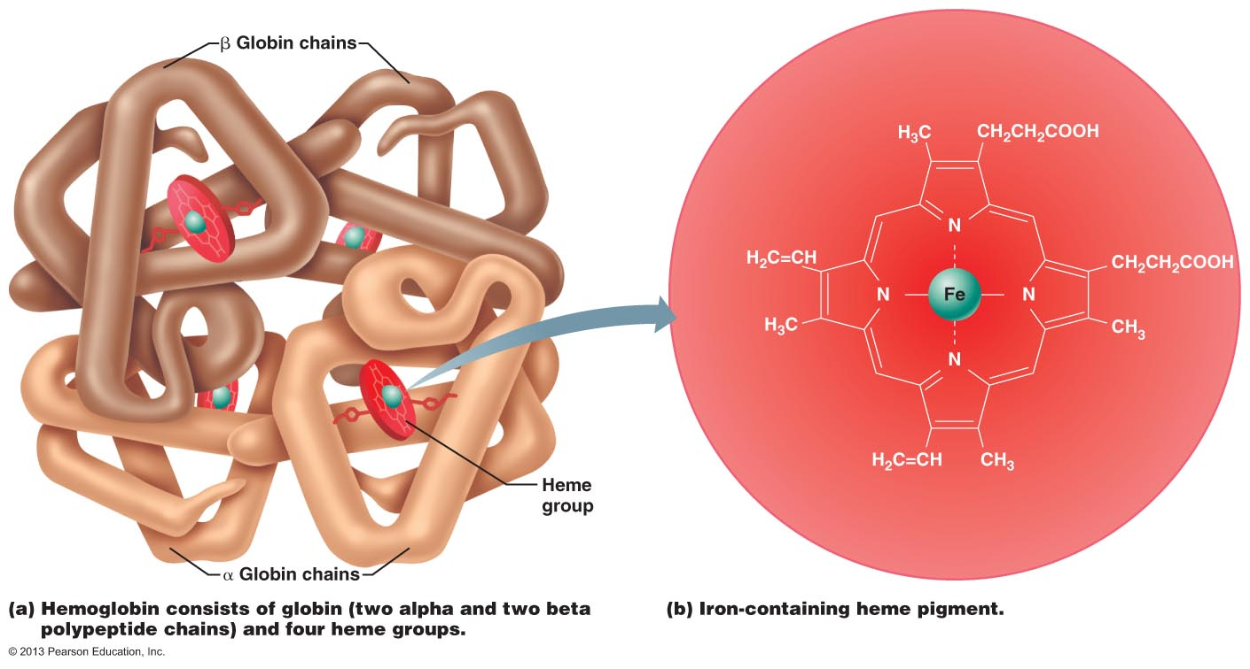

- Globin = 4 polypeptide chains (2α & 2β); 4 Fe-containing central heme groups
- Each Fe can reversibly bind one molecule of oxygen (4 per Hb molecule; each RBC contains 250 million Hb molecules!!)
- OxyHb a different shape and colour than deoxyHb
- O₂ combines with heme group but CO₂ combines with globin part carbaminohemoglobin
- Hb contained in erythrocytes:
> keeps it from fragmenting and being lost
> keeps it from contributing directly to osmotic pressure & blood viscosity
Production of Erythrocytes
- Blood cell formation = hematopoiesis (in red bone marrow)
- Immature blood cells, macrophages, fat cells and reticular cells *secrete the connective tissue fibers)
- 100 billion new cells everyday
- All come from hematopoietic stem cell
- All cells come from hemocytoblast
Stages of erythropoiesis (process of red blood cell formation) last 120 days
- Hematopoietic stem cells myeloid stem cells proerythroblast
(i) Synthesis of rybosomes
(ii) Make hymoglobin under rRNA from nucelus
(iii) Ejection of nucclues
(iv) RBC in blood
- Reticulocyte = immature RBC 1-2% of RBC
- Reticulocyte count = rough index of rate of RBC formation

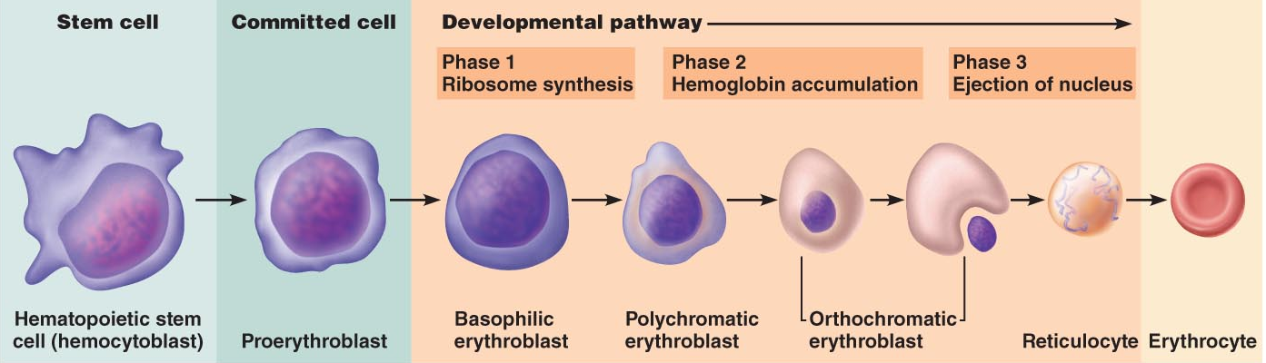
- Not number of erythrocytes in blood that controls the rate of erythropoiesis
  - Control is based on their ability to transport enough oxygen to meet tissue needs
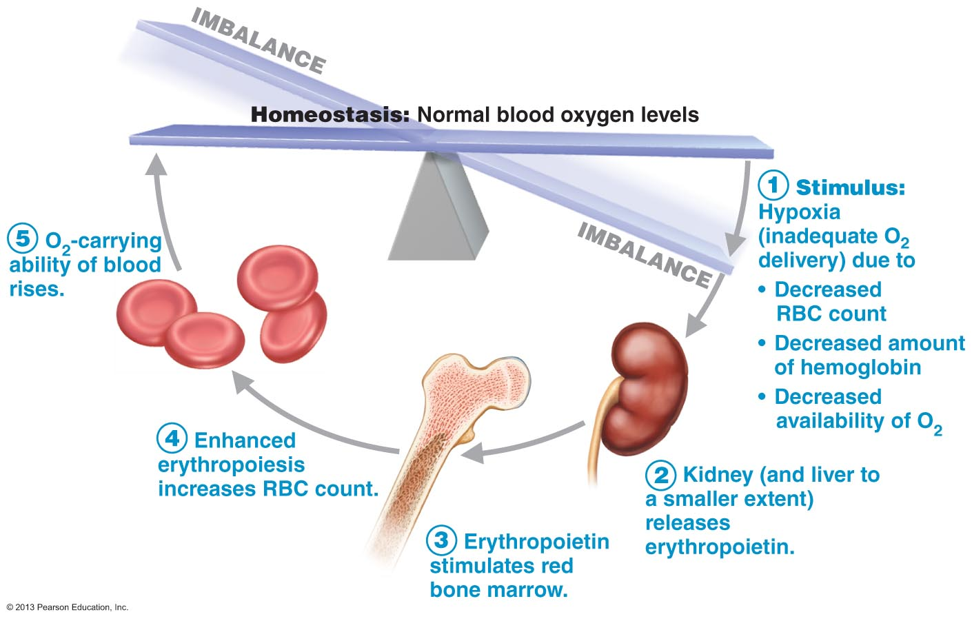

Regulation of Erythropoiesis:
- Too few leads to tissue hypoxia (O2 deprivation) anemia
- Too many = blood is undesirably viscous polycythemia
- To ensure homeostasis new cells are produced at the rate of 2 million per second
  - Hormonally dependent on right supply of iron, amino acids and B vit
- Erythropoietin (EPO), produced in kidney, glycoprotein hormone stimulates formation of RBC
  - Drop in normal blood oxygen lvls that triggers EPO formation
    - Reduced # of RBC due to haemorrhage or RBC destruction
    - Insufficient haemoglobin per RBC (iron deficiency)
    - High altitudes or pneumonia (reduced availability to oxygen)
  - Blood oxygen lvl is monitored not number of RBC
  - Erythropoietin stimulates red marrow cells that are already committed to become erythrocytes to mature more rapidly
  - Route of stimulation
    - Hypoxia kidneys erythropoietin activation of bone marrow more mature RBCs
  - Testosterone enhances production of EPO in kidneys
  - Renal failure patients: additional problem is lack of EPO (RBC counts can be 50% of normal); helped by recombinant EPO
  - Athletes & EPO abuse: can increase hematocrit from 45% to 65%; BUT increased viscosity plus dehydration during race can clotting, stroke, heart failure

Dietary Requirements
- Absorption of dietary iron controlled by body’s storage levels
  - 65% already in Hb
  - Rest stored in liver, spleen, bone marrow (ferritin, hemosiderin)
  - Iron transported in blood loosely bound to transferrin (transport protein)
  - Loss of iron: feces, urine, sweat
- Avg daily loss=1.7 mg (♀), 0.9 mg (♂)
- Vitamin B₁₂ & folic acid essential
- Free iron is toxic
  - Stored in cells as protein iron complexes
    - Ferritin and hemosiderin
    - Must be bound to a protein

Destruction of Erythrocytes
- Grow old after 100-120 days
  - Lose flexibility
  - Cant synthesize new proteins or divide
- Heme of their haemoglobin split from the globin
- Core of iron is salvaged (bound to ferritin or hemosiderin) and stored for reuse
- Balance of heme group is degraded to bilirubin
  - Yellow pigment that is realised to the blood and binds to albumin for transport where the liver cells pick it up and turn it into bile
    - Becomes stercobilin or urobilnogen
- Amino acids (globin) are released into circulation for reuse

Erythrocyte Disorders
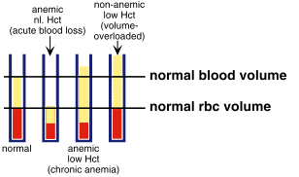
- Anemia lacking blood
  - Bloods oxygen carrying capacity to too low to support normal metabolism
  - Tired, pale, short of breath, chilly - causes:
  - Insufficient numbers of RBCs
  - Decreases in Hb content:
  - Abnormal Hb: (e.g. sickle cell anemia)
  - Pernicious anemia
    - Effects elderly, destroys cells of own stomach
  - Lack of iron and B12
  - Renal anemia
    - Lack of EPO
  - Plastic anemia
    - Destruction or inhibition of red bone marrow by drugs and chemicals
- Too many red blood cells destroyed
  - Haemolytic anomia
    - Erythrocytes rupture or lyse prematurely
  - Thalassemias
    - Mediterranean
    - One of the globin chains is absent and erythrocytes are thing
  - Sickle-cell anemia
    - Change in one amino acid in beta chain of globin
- Polycythemia
  - Excess of erythrocytes
  - Increase blood viscosity causing it to sludge/flow slow
  - Polycythemia vera: cancer in the bone marrow that leads to the increased rate of production of RBC
  - Secondary polycythemia: as a result of something else going up to a high alt.
  - Artificial polycythemia: blood doping

Platelets
- Not cells
- ¼ diameter of lymphocyte
- Fragments
- Megakaryocytes = very large cells
- Contain purple staining granules that contain clotting factors and enzymes
- Anucleate = lifespan of about 10 days
- Regulated by thrombopoietin (in liver)
- 250,000-5000,000 platelets/ul blood
- Stick to damaged site and temporaly block the break
- Megakaryoblast = first stage of clotting, big mature cell with a huge Multilobed nueclus and a large cytoplasmic mass
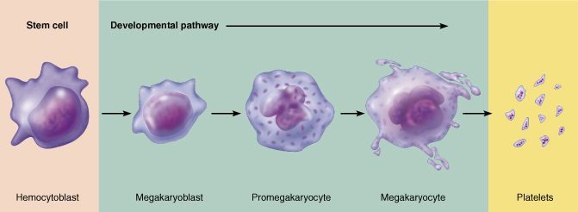

Hemeostasis – stoppage of bleeding

- Fast, localized and controlled
- Vascular Spasm – immediate response to blood vessel injury, results in constriction
  - Triggers: Pain reflexes, chemicals from endothelial cells and platelets
  - Purpose: allows time for the next two steps
    - Reduces time for bleeding out by slowing down blood flow in the area of damged tissue to make it reasier for blood clot to form
- Platelet plug formation
  - Platelets don’t stick to each other or to the smooth endothelial linings of blood vessels
    - NO and prostacyclin prevent platelet aggregation in undamaged tissue and restrict aggregation to the site of injury
  - Interfere with activation of blood clots (exposure to collagen released the clotting factor) platelets swell with exposure to collagen
  - Von Willebrand factor
    - Stabilizes bound platelets by forming a bridge between collagen and platelets
    - Platelets swll form spiked processes become sticker and release chemical messenger including
      - ADP: enhances aggregation and degranulation
      - Serotonin and thromboxane A2 – enhance cular spasm and aggregation
- Coagulation -Blood clotting
  - Reinforces the platelet plug with fibrin threads (glue)

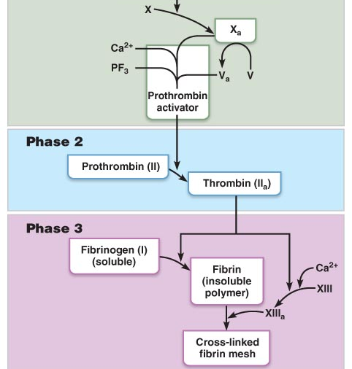

Phase 1: two pathways to prothrombin (enzyme) activator
- Coagulation can be started by intrinsic or extrinsic pathway
  - Usually trigger both
- Outside the body (test tube)
  - Only intrinsic
- Negatively charged membranes
  - PF3
  - Both pathways can be activated only in the presence of PF3
    - Activated Factor X
      - Then it activates complex calcium ions
      - Then it forms prothrombin activator
        - Slowest step of blood clots
          - Once this is activated clot forms in 10-15 sec
- Intrinsic pathway – positive feedback
  - Factors needed for clotting are present within the blood
  - Triggered by neg charged surfaces such as activated paltelets collagen or glass (which is why this pathway can be initate clotting in a test tube) or in a slightly damaged vessel
  - Slower because it has many intermediate steps
- Extrinsic pathways – bypass many steps of intrinsic pathway
  - Tissue factor it requires is outside of blood
  - Triggered by exposeing blood to a factor found in tissues underneath the damaged cells
    - Tissue factor (TF) or factor III
  - Faster b/c it bypasses several steps of intrinsic pathways
    - In severe tissue trauma it can form a slot in 15 seconds
- Phase one ends with the formation of a complex substance called prothrombin activator

Phase 2: Common pathway to thrombin
- Prothrombin activator catalyzes the conversion of a plasma protein prothrombin to active enzyme thrombin

Phase 3: Common pathway to the fibrin mesh
- Thrombin catalyzes the transformation of the soluble clotting factor fibrinogen into fibrin
  - Doesn’t convert to an enzyme
  - Fibrin strands glue the platelets together to make a web that forms the clot
- In presence of calcium ions thrombin activates facor XIII (fibrin stabilizing factor)
- Anticoagulants: factors that inhibit clotting
  - Normally dominate that prevent clotting except when a vessel is ruptured

Why is it good to have a slow pathway?
- Don’t always need a blood clot, there isn’t always a break in a blood vessel
- If a clot forms in a place where there is an unbroken blood vessel it can clog the blood pathway

Clot Retraction
- Within 30-60 min clot retraction stabilizes the clot
  - Contain actin and myosin
  - As platelets contract they pull on surrounding fibrin strands
    - Squeeze serum (plasma minus the clotting proteins) out
      - Draw edges closer
- Platelet-derived growth factor (PDGF) release platelets during degranulation stimulates sooth muscle cells & fibroblasts to divide & rebuild walls
- Endothelial cells multiply to fill gap in lining
  - VEGF = vascular endothelial growth factor
Fibrinolysis
- Removal of clot when no longer needed
- Key enzyme is plasmin (precursor = plasminogen, activated by tPA (tissue plasminogen activator) released by endothelial cells
- Begins with 2 days & continues until clot is dissolved
- Without it blood vessels would become completely blocked

Factors Limiting Clot Growth or Formation
- Removal of clotting factors
- Inhibition of activated clotting factors
- For clotting to begin the concentration of activated clotting factors must reach a certain lvl
- Don’t form in rapid moving blood because activated clotting factors are diluted and washed away (procoagulants) stops growing when it contacts blood flowing normally
- Final step of clotting = when fibrinogen is polymerized into fibrin
  - The binding of thrombin makes fibrin an anticoagulant by absorbing onto fibrin threads (limits clot size)
  - Antithrombin III = protein present in plasma which inactivates escaping thrombin
    - Protein C inhibits intrinsic clotting factors as well
  - Heparin, a natural anticoagulant in blood (basophils & mast cells) - enhances activity of antithrombin III and inhibits intrinsic pathways
  - Smooth endothelial lining of undamaged blood vessels (also endothelial-derived heparin & prostacyclin)
- Clotting formation requires procoagualtion factors > anticoagulation factors

**To keep the victim unaware of its presence, these leeches secrete an anaesthetic (painkiller) to numb the skin while biting. H. medicinalis also produce a potent anticoagulant, Hirudin, to keep blood fluid during feeding.
Eating only twice a year, these leeches will ingest 10 to 15 mL of blood causing them to bloat to as much as 11 times their original body size.
Researchers have been able to isolate hirudin to study how it prevents blood from clotting. Many experiments show that hirudin acts by inhibiting the blood protein thrombin. Thrombin is responsible for converting fibrinogen into fibrin blood clots. By inactivating thrombin, hirudin prevents solid blood clots from forming. Hirudin also limits the ability of platelets to stick together and initiate clots.
Only if your blood cells are damaged do they get clots
Leeches inhibt the action of thrombin, inhibt blood clots

Factors Preventing Undesirable Clotting

- Antithrombic substances (nitric oxide and prostacyclin) prevent platelet adhesion
- Vit E quinone = anticoagulant
- Thromboembolic disorders
  - Undesirable clot formation
  - Thrombus = a clot that develops and persitis in an unbroken blood vessel – can block critical blood circulation on those tissues
    - Traveling on an airplane can promote thrombus die to stasis
    - Aspring intergeres with the production of prostaglandin and inhibits thromboxane A2 formation(promotes blood cloting)
      - Not technically a blood thinner, stops random clots form forming
      - Prescribed if the patient has high blood pressure
  - Embolus = a thrombus that has broken free and can get stuck in a vessel of a small diameter
    - tPA, streptokinase to dissolve clot
  - Embolism = a clot that travels from site where it was formed

- Bleeding disorders
  - Prevent normal clotting
  - Thrombocytopenia = a reduction in the number of platelets circulating in the blood
    - Spontaneous bleeding from small blood vessels
      - Normal movement leads to bruising (petechiae)
      - Comes from any condition that destroys red bone marrow
        - Radiation, drugs etc
      - Platelet count under 50,000 uL of blood
      - Whole blood transfusion = temp relief because the blood cells die after 120 days
  - Impaired Liver Function
    - Unable to synthesize usual supply of clotting factors
    - Severe bleeding occurs
    - Can come from hepatitis or cirrhosis
    - Vit K deficiency (wont be able to produce clotting factors
    - When liver is impaired it cant produce clotting facots and bile and is required to absorb fat and Vit K
  - Haemophilia = a term loosely applied to several different hereditary bleeding disorders that exhibit similar signs and symptoms
    - Deficiency of factor VIII

Transfusion and Blood Replacement

- Whole blood transfusion
  - Needed when blood loss is rapid and substantial
  - body compensates for some blood loss by:
(i) vasoconstriction to decrease blood vessel volume
(ii) increased rate of erythropoiesis

- Packed red cells = whole blood from which most of the plasma and leukocytes have been removed good for anemia
  - Good for restoring oxygen carrying capacity
- Shelf life for blood when mixed with heparin (Ca⁺⁺ chelator, anticoagulant) 4 degrees and 35 days
- Antigen = anything the body sees as foreign generates immune response
  - Agglutinogens
  - Newborn blood has no agglutinins (begin to appear within 2 months; peak @ 8- 10 yrs, slowly decline with age

- ABO blood groups
  - Type A and type B
  - Blood can be A, B, AB, O
  - O has neither agglutinogen universal donor
  - Agglutinins act against RBC carrying ABO antigens that are not present on a perosns own RBC (newborn lacks this)
  - A person with neither A or B antigens possesses both anti-A and anti-B antibodies
    - Group A blood have anti B antibodies and vise versa
    - AB has neither antibody universal recipient
    - Type 0+ blood is most common, then 0-
    - Then A
Blood type Antigens Antibodies
A A Ant-B
B B Anti-A
AB A & B None
O None Anti-A/B
    - Then B
    - Least common is AB

- Rh blood groups

- Rh blood groups (52 named Rh agglutinogens, each w own Rh factor)
  - C, D, E are common
  - 85% of Americans are Rh+
    - RBC carry D antigen
    - Anti-Rh antibodies don’t form spontaneously in blood of Rh-
      - If Rh- person gets Rh + immune system becomes sensitized and produces anti-Rh antibodies against foreign antigen
      - Hemolysis does not occur at first transfusion bc it takes time for body to make anti-bodies
        - Every time after the persons antibodies will attack and rupture donor RBC
        - Rh- mothers carrying second Rh+ fetus treated with RhoGAM (anti-Rh serum) to prevent erythroblastosis fetalis
  - Transfusion reactions: Agglutination and Hemolysis
    - Recipients plasma agglutinins attack the donors RBC
      - The donors plasma antibodies may agglutinate in recipients RBC but they are v diluted so it isn’t usually a problem
      - Clogs small blood vessels
        - Clumps begin to rupture or are destroyed by phagocytes Hb released
        - RBC can lyse immediately is reaction is severe
      - Overall result
        - Blocked flow to tissues
        - Reduced oxygen carrying ability of blood
        - Hb precipitates/clogs kidney tubules
          - Possible kidney failure
      - Also: fever, chills, nausea, vomiting, general toxicity - critical to prevent kidney failure by administering alkaline fluids to dilute & dissolve Hb; also diuretics to pee
      - Autologous transfusion (eg: 1 unit/4 days up to 3 days before surgery)
        - Their own blood
  - Blood Typing
    - Blood volume is very important
    - Saline sol. Mimics the electrolyte composition of plasma
      - Ringers sol.
    - Plasma expanders
      - Vol replacement restores adequate circulation but cant replace 02 carrying ability

The Heart

- Transport system pump
- Hollow blood vessels= delivery routes
- Ride side: oxygen poor blood from body tissues
  - Pumps blood to lungs to get oxygen and get rid of CO2
  - Pulmonary circuit
- Left side: oxygen rich blood
  - Pumps it though out the body
  - Supplies oxygen and nutrients to body tissues
  - Systemic circuit
- Right atrium and left atrium = receiving chambers
- Ventricles = pumping chambers
- Weights 250-350 grams
- Mediastinum = medial cavity of the thorax containing the heart, great vessels and trachea
- Extends obliquely for 12-14 cm from 2nd rib to 5th intercostal space; 2/3 of mass on left side; right side lying on diaphragm
- Broad, flat base directed toward rt shoulder; apex points toward lt hip
- Pericardium: = strong thick protection
  - Fibrous pericardium
    - Tough, dense connective tissue
    - Protects the heart
    - Anchors it to surrounding structures
    - Prevents overfilling of the heart with blood
  - Serous pericardium
    - Thin, slippery, two layer membrane
    - Forms closed sac
    - Supports movement/comfort
  - Parietal layer
    - Lines internal surface of fibrous pericardium
    - Attaches to the larges arteries exciting the heart
  - Visceral layer
    - Epicedium
  - Pericardial cavity= between parietal and visceral layers
    - Fluid filled, allows movement
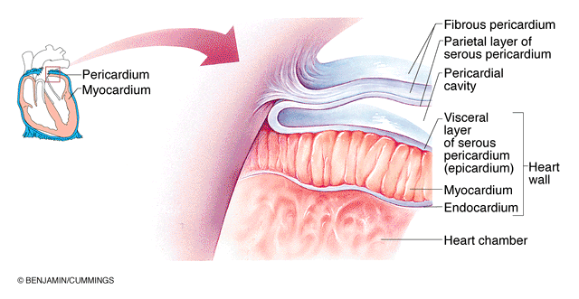

- Myocardium = muscle part responsible for contraction
  - Cardiac muscle = bulk of heart
  - Branching cardiac muscles cells arranged into bundles and the connective tissue wrappings of these bundles
    - Reinforce myocardium internally and anchor cardiac muscle fibers
    - Provide additional support for great vessels and valves
    - Direct spread of action potential across heart to specific pathways
  - Collagen and elastic fibers
- Endocardium = endothelium cells lining heart
  - Thin connective tissue layer
  - Continuous with endothelium of vessels leaving and entering heart

Chambers and Associated Great Vessels
- 2 superior atria
- 2 inferior ventricles
- Interatrial septum = partition that divides the heart longitudinally (separates the atria and interventricular septum separates the ventricles)
- Right ventricle – forms most of the anterior surface of heart
- Left ventricle – dominates the inferoposterior aspect of heart
  - Forms apex
- Coronary sulcus = carry blood vessels supping the myocardium
  - Encirciles the junction of the atria and ventricles like a crown
- Anterior interventricular sulcus
  - Cradles the anterior interbentricular artery
  - Marks the anterior position of the septum
  - Separates R/L ventricles

Atria
- Receiving chambers
- Right atria
  - 2 parts
    - Smooth walled posterior
    - Anterior portion which bundles of muscle tissue form ridges in the walls
      - Pectinate muscles
- Left atria
  - Smooth and pectinate muscles found on in the auricle
  - Fossa ovalis – marks sport where an opening existed in the fatal heart
    - Foramen ovale
      - O2 oxygenated by fetus
- Blood enters right atrium via
  - Superior vena cava
    - Returns blood from body regions superior to the diaphragm
  - Inferior vena cava
    - Returns blood from the body areas below the diaphragm

  - Coronary sinus
    - Collects blood draining from the myocardium
- Pulmonary veins
  - Enter left atrium
  - Transport blood from the lungs back to the heart
  - Best seen in posterior view
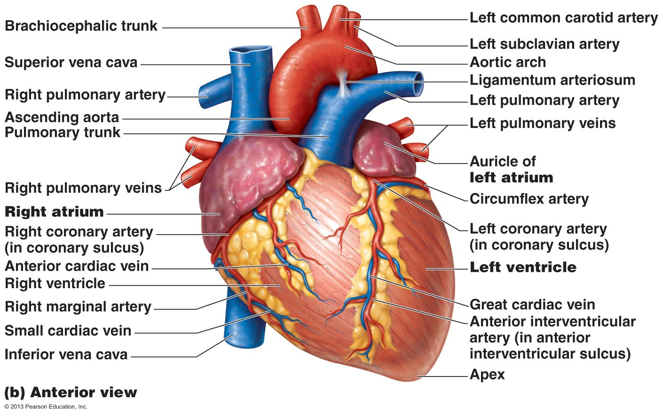

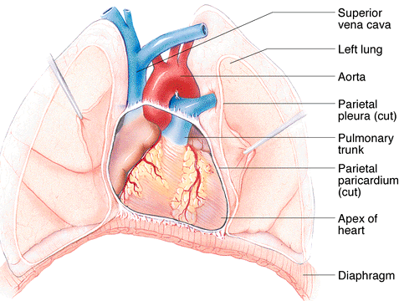
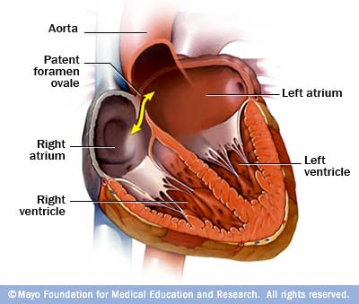

Ventricles – discharging chambers
- Pumps of the heart
- Walls much thicker – esp left ventricle
- Right ventricle: pumps blood to pulmonary trunk
- Left ventricle: pumps blood to aorta
  - 3x thicker than right
  - Generates more pressure than right
  - More powerful pump
- Most the vol of heart
- Internal walls have muscle bundles
  - Trabeculae vraneae mark the internal walls of the ventricular chambers
  - Papillary muscles (valve function)

Heart Valves
- Unidirectional
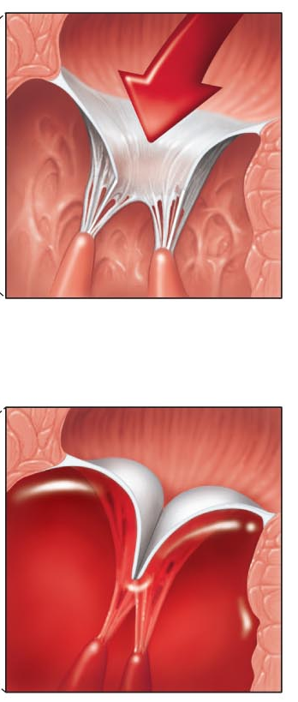
- Atrioventricular (AV) valves
  - 2, one located at each atrial-ventricular junction
  - Prevent backflow into artia when the ventricles contract
  - Right AV
    - Tricuspid valve
    - Right atrium to right ventricle
  - Left AV
    - Mitral valve (bicuspid valve)
      - Left atrium to left ventricle
  - Chordae tendineae
    - Heart stinges
    - White collagen cords
    - Help valve from bursting open
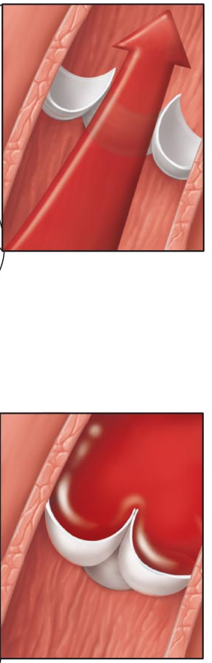
- Semilunar Valves
  - Paired from ventricles to either pulmonary or systemic circuits
  - Pulmonary valve: right ventricle to pulmonary artery
  - Aortic valve: left ventricle to aorta

- Valvular insufficiency: it doesn’t close 100%
  - Blood backflows
- Stenosis: doesn’t open 100%, opening is narrower, extra workload on heart, makes it work harder
  - Valves becomes stiff

Pathway of blood
- Equal volumes of blood are pumped to the pumoary and systemic circuits
- Pulmonary circuit is a short, low pressure circulation
- Systemic circuit (left ventricle) is a long pathway (whole body) and has about 5x the friction/resistance to blood flow
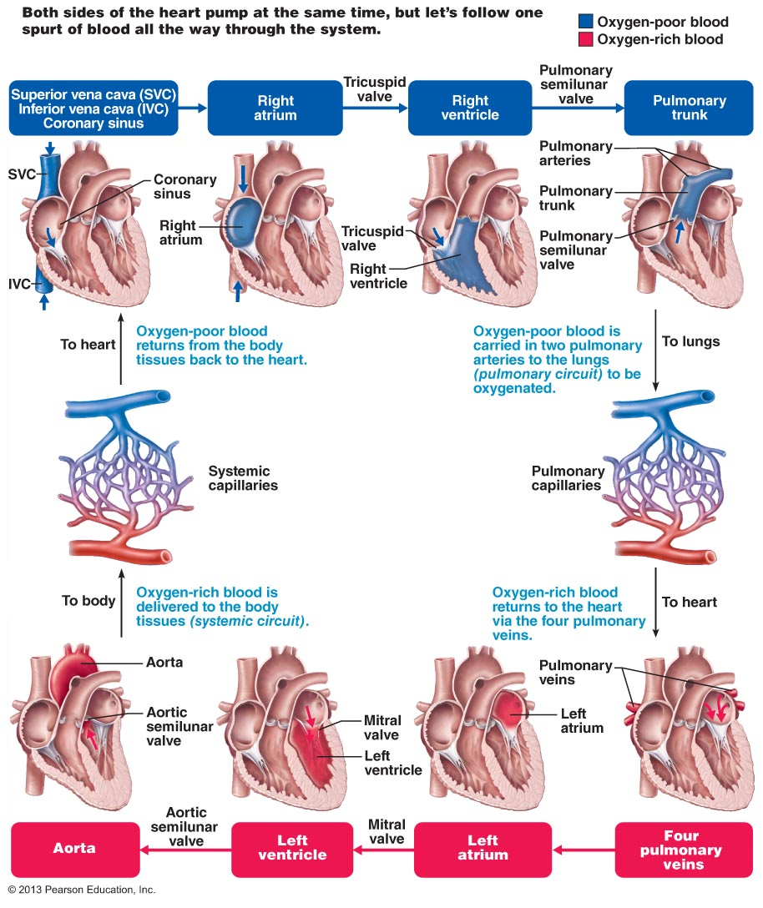

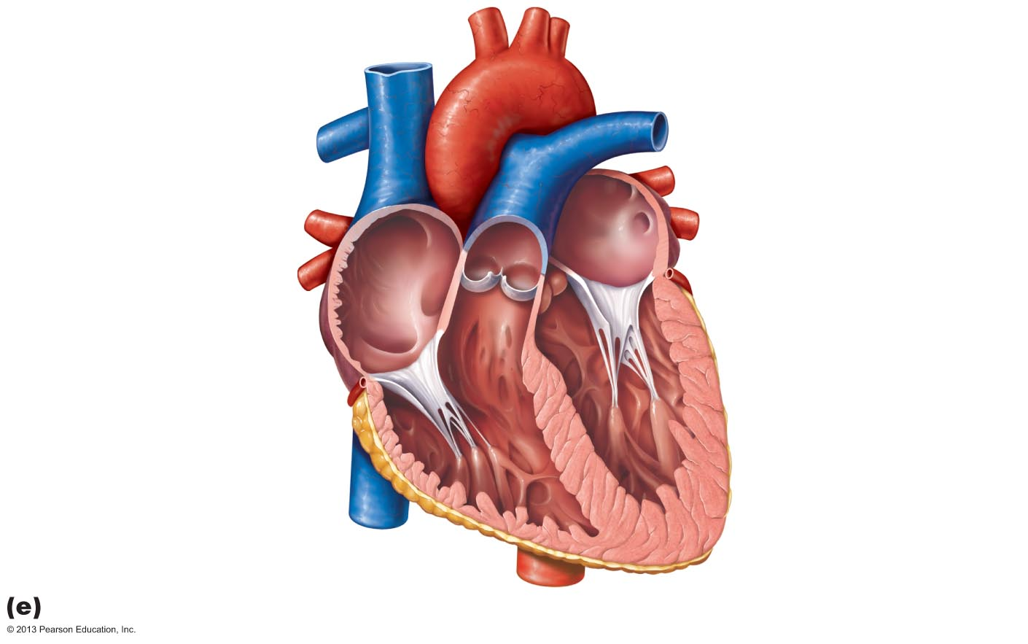
1
2
3
4

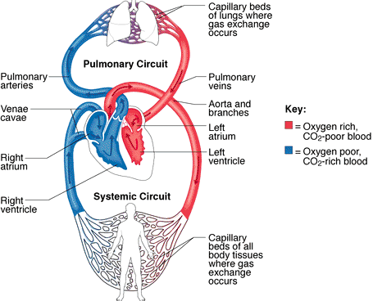
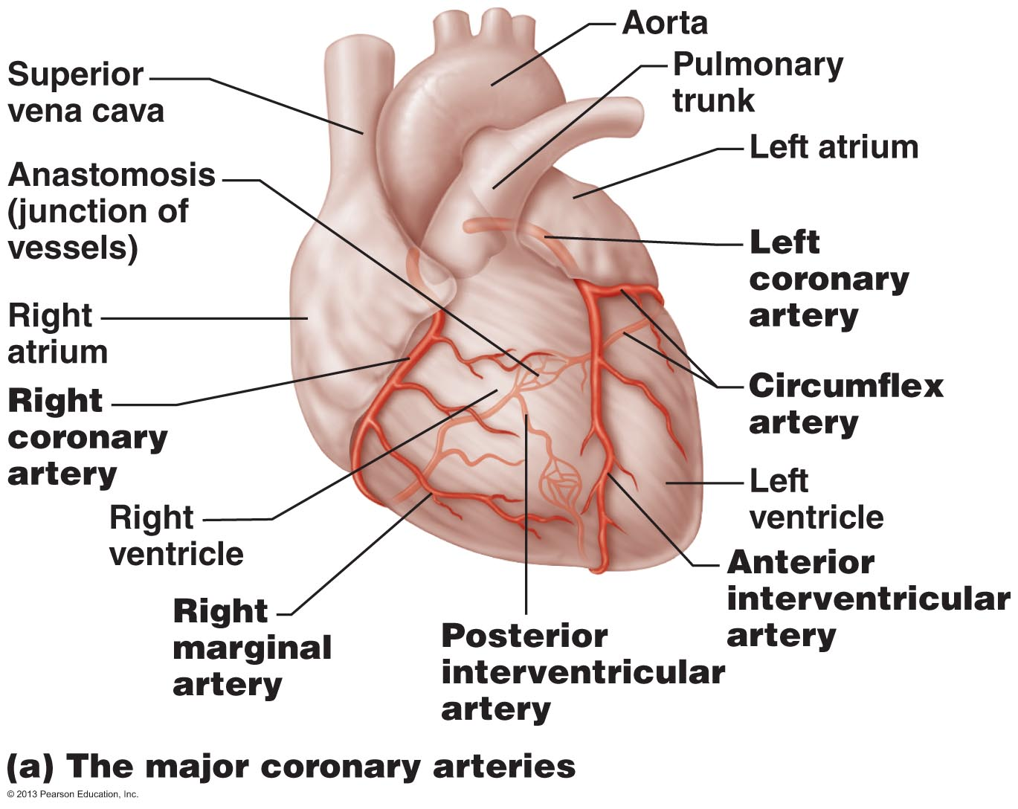
Coronary Circulation
- Left coronary artery runs towards the left side of the heart and divides into two major branches
  - Anterior interventricular artery
  - Circumflex artery: supplies left atrium and posterior walls of left ventricle
- Right coronary artery right side of heart
  - Right marginal artery which serves the myocardium
  - Posterior interventricular artery
- Shortest but most important circulation in body
- Both coronary arteries are from base of aorta and encircle the heart in coronary sulcus
- If something goes wrong, gets plugged etc the heart is in trouble, gives the person chest pain, heart attack, maybe death
- Dependent on continuous supply of fuel mol
- Cutting of blood supply = lack of o2 and fuel therefore heart will stop beating
- Many anastomoses which provide alternate routes for nourishment if given artery being to be occlusion
  - Total occlusion: tissue death and heart attack
  - Actively deliver blood when heart is relaxed
  - Largely ineffective when ventricles contacting because they are compressed by the contracting myocardium
- Heart requires 1/20 of body’s blood supply but it only 1/200 of the bodies weight
  - Left ventricle gets most blood supply

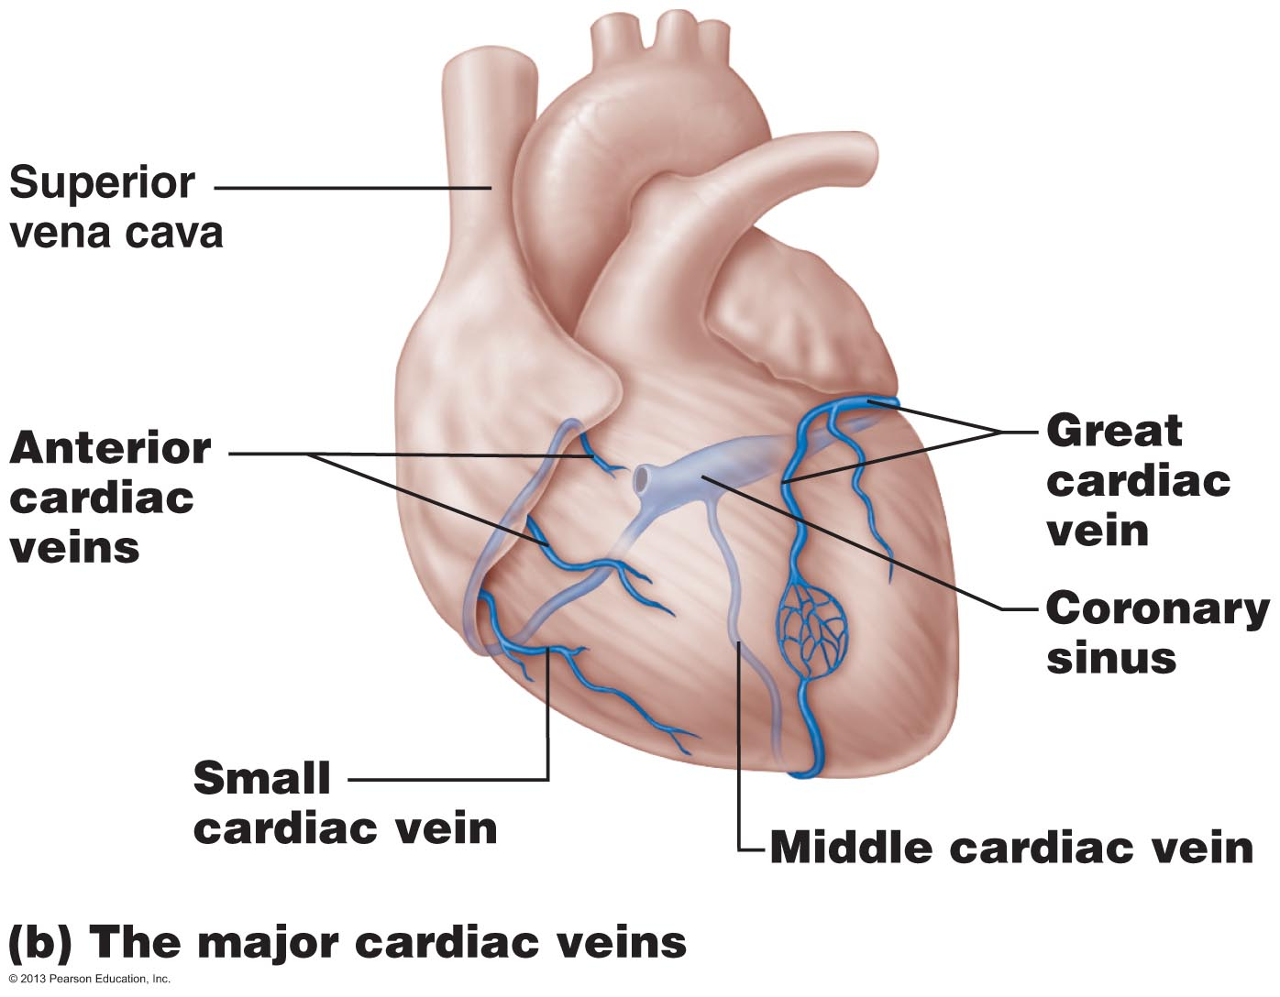
Coronary Veins
- Venous blood is collected by cardiac veins
  - Path roughly follow those of coronary arteries
- These veins join to form the coronary sinus
  - Empties into right atrium
- 3 major parts of sinus
  - Great cardiac vein
  - Middle cardiac vein
  - Small cardiac vein
- There are many anterior cardiac veins that empty directly into the right atrium
- Angina pectoris = thoracic pain caused by deficiently in blood delivery to myocardium
  - Severe chest pain and lac of oxygen in blood
- Myocardial Infraction (MI) = condition characterized by dead tissue areas in the myocardium caused by interruption of blood supply to the area
  - AKA heart attack
- Desmosomes for strong cell-cell adhesion during contraction
- Gap junctions for electric coupling »» functional syncytium
  - Allows ions to jump from cell to cell

Cardiac VS Skeletal muscle
Cardiac Muscle
shorter, fatter
single or double nuclei
intercalated disks (desmosomes, gap junctions) = interdependence
functional syncytium
20-40% of volume is mitochondria
myofibril diameters vary & much branching gives indistinct striations
fewer T-tubules; less elaborate Ca⁺⁺ delivery
less developed sarcoplasmic reticulum
almost exclusively aerobic metabolism
abundance of fuel type determines fuel used

Skeletal Muscle
longer, cylindrical
multinucleate
structural independence; motor unit grouping
functional independence
2-5% of volume is mitochondria
uniform myofibrils give distinct striations
many T-tubules; complex Ca⁺⁺ delivery
complex sarcoplasmic reticulum
readily uses anaerobic metabolism
intensity determines fuel type used
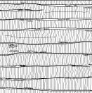
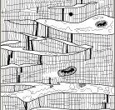

Differences in contraction of skeletal and cardiac muscle
Means of stimulation
- Skeletal: must be stimulated to contract by a nerve ended
- Cardiac: self excitable
  - Automaticity/autorhymicity

Organ versus motor unit contraction
- Skeletal: impulses do not spread from cell to cell
- Cardiac: all fibers in heart contract or the heart doesn’t contract at all

Length of absolute refractory period
- Skeletal: contraction last 15-100 ms w/ refractory period of 1-2 ms
- Cardiac: absolute refractory lasts over 200 ms, nearly as long as the contraction
  - Prevents tetanic contractions which would stop the hearts pumping action
  - Don’t want sustained contraction, want individual contractions
  - Duration of AP is roughly the same duration of contractile response

- 1% of cardiac muscles are autorhythmic
  - Spontaneously depol and thus pace the heart
  - Not neuro tissue cardiac tissue
- Most of heart is contractile muscle fibers
  - Responsible for hearts pumping activity
- All or non law: applies to chamber rather than individual cells

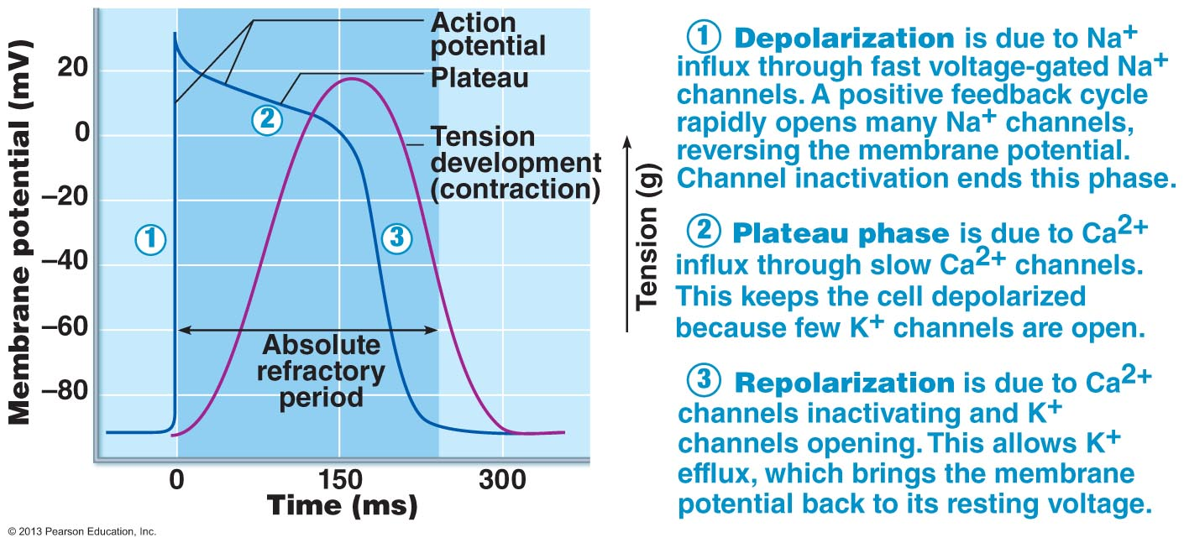
Action potential of cardiac cells
• Absolute refractory period almost = muscle twitch allows heart to fill again
• Heart needs to be stimulated in just one location; whole organ responds

- Cardiac muscle depolarization and contraction is intrinsic doesn’t need nervous system
  - If all nerve connections to the heart were severed the heart would beat rhythmically
- Intrinsic cardiac conduction system
  - Non-contractile cardiac cells specialized to initiate and distribute impulses throughout the heart
  - Depol and contracts in orderly sequential manner
Action potential initiation by pacemaker cells
- Unstimulated contractile cells of the heart maintain a stable resting membrane potential
  - Cardiac pacemaker cells (intrinsic conduction system) have an unstable resting potential that continuously depol/drift slowly towards threshold
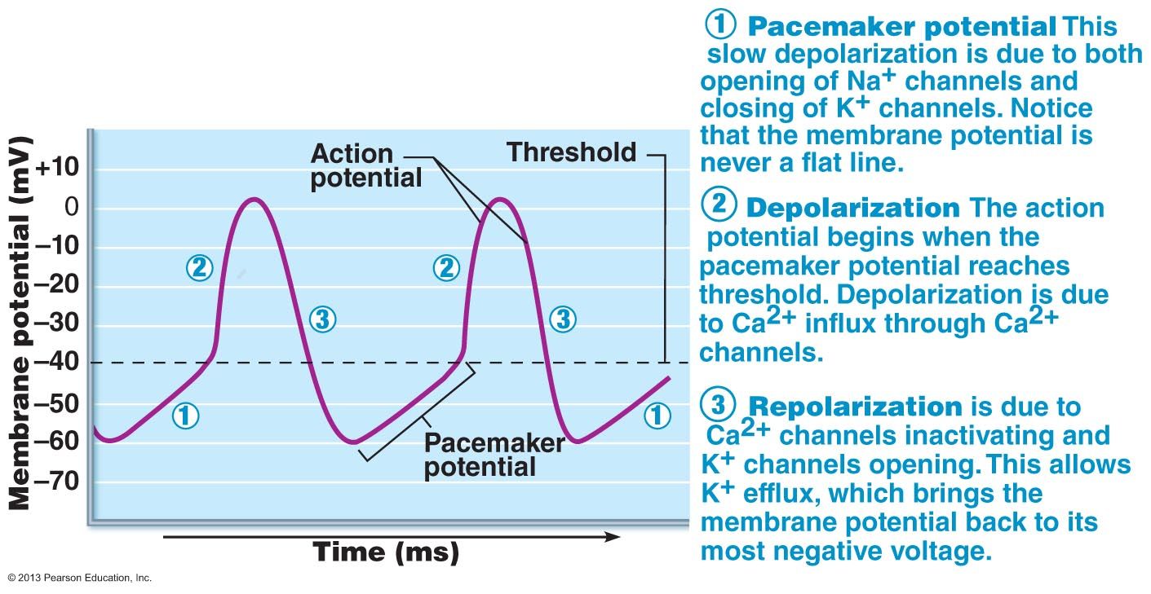
  - Called pacemaker potentials/prepotentials

Pacemaker: spontaneously contracts the quickest
- Closing of K channels, allow to repol
- When they gradually close you lose K
- Less pos charge leaving the cell, you are hanging on to more of K therefore the cell is more pos
- Influx of Ca in autorthymic cell that spikes AP

Sequence of excitation

AP generated by SA node passes to:
(2) AV node
(3)(Short delay), AV bundle – only electrical connection
- AKA bundle of His
(4) Right & left bundle branches
(5)Purkinje fibers

Sinoatrial node (SA)
- Right atrial wall
- 75 impulses per min
- Sets pace for heart due to fast depol rate
- Sinus rhythm – determines heart rate

Defective SA node
- AV node can become pacemaker
  - 40-60 bpm (slower than sinus rhythm)
Heart block
- In total heart block no impulses get through & ventricles beat at intrinsic rate (too slow to maintain circulation)

0.22 sec (220 msec) from initiation at SA node to depolarization of last of ventricular cells
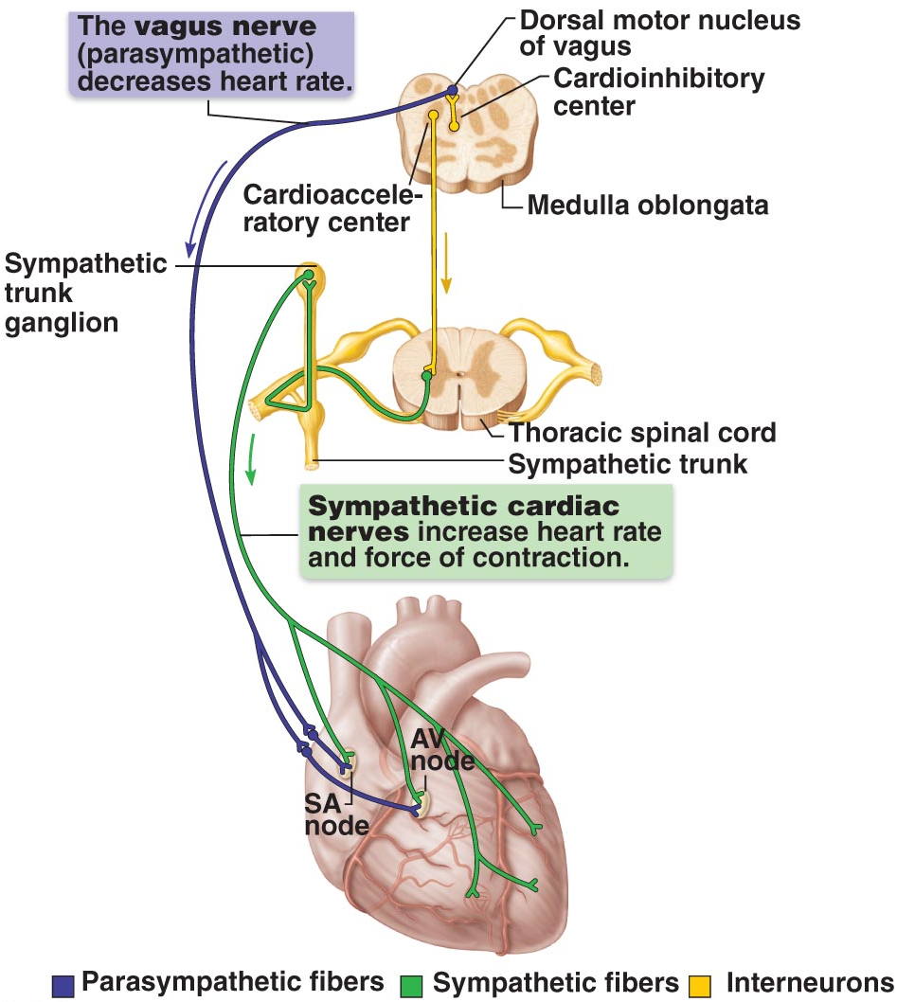
Rate of SA node depol is regulated by autonomic nervous system
- Parasympathetic NS: decreases diastolic depol rate
- Sympathetic NS: increases depol and repol rates
- Tonic parasympathetic dampening effects on heart rate
- Rate of depol is influence by both sympathetic and parasympathetic system
- 90 bpm when sympathetic ns needs heart to perform at high rate
- Bradycardia – slower than normal HR
- Tachycardia – high than normal HR
- Sinus rhythm – normal rate set by pacemaker (SA node) at rest

The nodal cells of the heart, unlike cardiac contractile muscle fibers, have an intrinsic ability to depolarize spontaneously. This reflects their unstable resting membrane potential which drifts slowly toward threshold for firing, that is -40 mV These spontaneously changing membrane potentials, called pacemaker potentials , are largely (but not entirely) due to reduced membrane permeability to potassium.
Ultimately, when threshold is reached, gated channel open, allowing extracellular calcium to rush into the cells and reverse the membrane potential.
From the atrium through the tricuspid valve to the right ventricle, through the pulmonary valve valve to the pulmonary trunk to the right and left pulmonary arteries , to the capillary beds of the lungs , to the pulmonary veins, to the left atrium of the heart through the bicuspid valve , to the left ventricle through the aortic semilunar valve to the aorta , to the systemic arteries, to the capillaries of the body tissues, to the systemic veins, to the superior and interior venicava , which enter the right atrium of the heart.

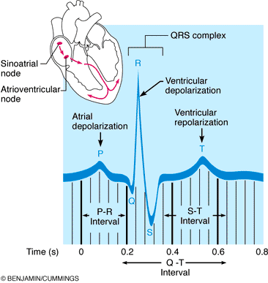
Electrocardiography
- Electrocardiogram (ECG): records electrical changes during heart activity relies on conductible activity of body fluids
- (i) P-wave = atrial depolarization
- (ii) QRS complex = ventricular depolarization
- (iii) T-wave = ventricular repolarization
- Atrial repol Caught up in completely of QRS, atrial is repol at the same time ventricle is depol
- ECG cant measure contractual rate of heart
- Note: ECG records only voltage (current flow) and time; shows only electrical events, but from these can deduce contractile events

Heart sounds
- Lub Dub pause Lub Dub pause etc
- Pause is when heart is relaxing
- LUB occurs as the AV valves close
  - Ventricular pressure rises about atrial pressure
  - Louder than DUB
- DUB occurs when the AL valves snap shut at the beginning of ventricular relaxation (diastole)
  - Short and sharp
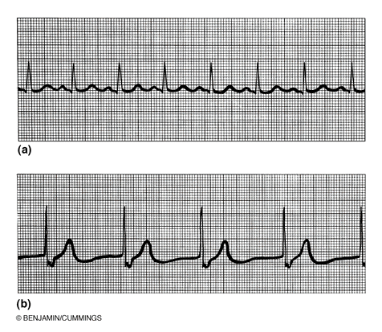
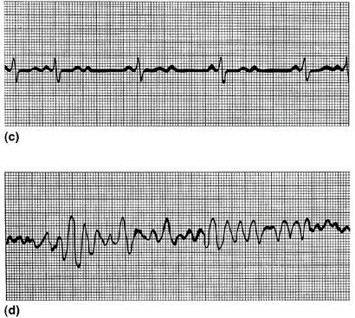
- Normal sinus rhythm

- Ventricular fibrillation (nothing is driving a coordinated response of the heart)

- 2nd degree heart block – heart cant beat fully, don’t always have depol and repol

- Nonfunctional SA node – no p wave

Cardiac Cycle – all events associated with the blood flow through the heart during one complete heartbeat
Systole – period of contraction pumping out
Diastole – periods of relaxation heart filling
- Always follow electrical events seen in ECG
- Atrial systole and diastole followed by ventricular systole and diastole

1. Period of ventricular filling: mid-to-late diastole » pressure low (but P_{atria}> P _{ventricles}), AV valves OPEN; SL valves CLOSED
after 70% ventricular filling, AV valves begin to close → P wave & atrial systole; atrial pressure increases & final 30% of blood enters ventricles (end diastolic volume or EDV) → atrial diastole for rest of cycle

2) Ventricular systole (comprises QRS complex & T waves): ventricles begin to contract → increased pressure closes AV valves - period of isovolumetric contraction (volume constant; a closed system) →increased pressure opens SL valves → ventricular ejection phase (aortic pressure up to 120 mm Hg)

3) Isovolumetric relaxation: early diastole → ventricles relax; pressure decreases rapidly; backflow of aortic/pulmonary blood closes SL valves (dicrotic notch); ventricles a closed system = isovolumetric relaxation
4) Back to (1): atria continued in diastole & have been filling; when pressure > ventricular pressure, AV valves open and we are back to (1)
- 75 bmp: each cardiac cycle = 0.8 secs
- Atrial systole: 0.1 sec
- Ventricular systole = 0.3 sec
- Guiesecent period = 0.4 sec
2 features driving cardiac cycle
1) Blood flow though heart controlled entirely by pressure changes
2) Blood flows from higher to lower pressure through any available opening
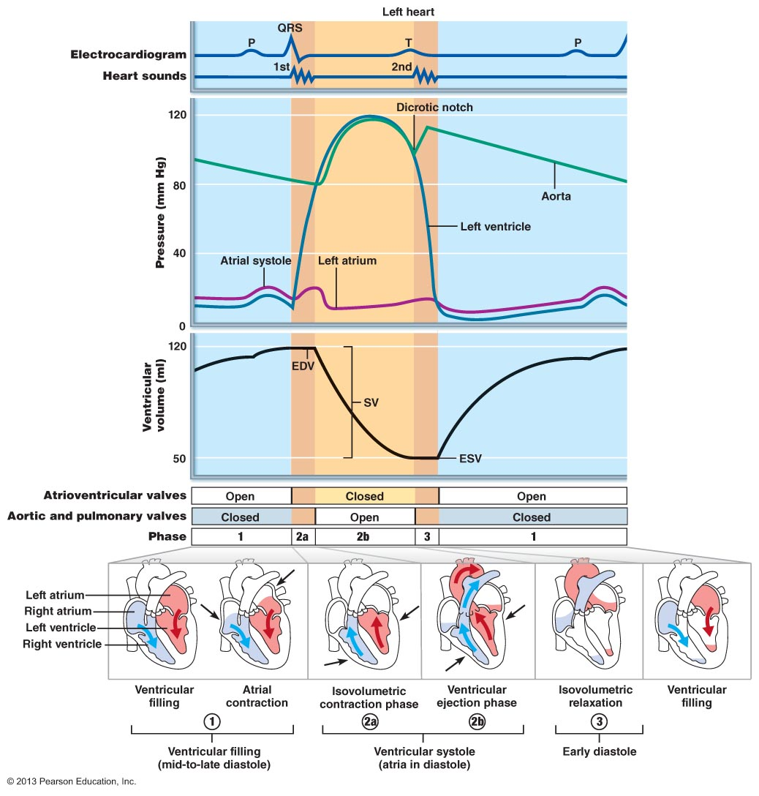

Heart Murmurs:
(1) Due to valvular obstruction »» high velocity jet of blood through narrow opening »» higher pitch of sounds
(2) Due to valvular insufficiency »» leakage of blood back causes sounds when there should be silence

Fill in the blanks:
The contraction of the ventricles is referred to as systole and the period of ventricular relaxation is called diastole . The first heart sound is a result of closure of the AV valve valves and second heart sound is closure of the semi lunar valve valves causes the second heart sound. The heart chambers that have just been filled when you hear the first heart sound are the ventricles . The chambers that have just emptied when you hear the first heart sound are the atria . Immediately after the second heart sound, the atria are filling and the ventricles have emptied. Abnormal sounds, or murmurs usually indicate valve problems.
1. During atrial systole:
a) the atrial pressure exceeds ventricular pressure
b) 70% of ventricular filling occurs
c) the AV valves are open
d) valves prevent backflow into the great veins
e) a and c

2. Once threshold is reached in pacemaker cells:
a) opening of sodium gates
b) opening of calcium slow channels
c) opening of calcium fast channels
d) opening of potassium gates

Cardiac Output (CO)
- The amount of blood pumped out by each ventricle in 1 minute
- Product of the heart rate and stoke volume
- Stoke volume volume of blood pumped out by one ventricle with each beat
  - Force of centricular contraction
- Normal resting HR = 75 bmp
- Normal stoke volume = 70 ml/beat
- Average CO = HR x SV
- CO= 75 x 70 = 5250 ml/min
- Total blood volume is 5L RBC makes complete circuit in in about 1 min
- Better physical fitness = higher CO
- Cardiac Reserve
  - Difference between resting and max CO
  - CO ⇑ 4-5 times in a fit person
  - CO ⇑ 7 times in a well-trained marathon runner
- SV= EDV-ESV = 120ml/beat – 50 ml/beat = 70 ml/beat
  - 60% of blood in the chambers per beat (each ventricle)
- Preload, contractility and afterload are the most important factors
  - Preload
    - Degree to which muscle cells are stretched just before they contract
      - Controls stoke volumes
    - Frank-starling law of the heart
      - Relationship between preload and stroke volume
      - Within defined limits the heart will pump whatever volume of blood it receives
    - Slow heart beat allows more time for ventricular filling
      - Exercise speeds up venous return
      - SV may double during exercise but decreases EDV
    - Proportional relationship between between EDV and SV
  - Contractility
    - EDV (change in contractillity) is intrinsic factor
    - Contractile strength achieved at a given muscle
    - Independent of muscle strength
    - Increases with rise of Ca2+
    - The higher the contractility the more blood expelled form the heart
  - Afterload
    - Pressure in the aorta that the aortic center lunar valve has to overcome in order to open
      - 120/80 blood pressure
        - bp is 80 when you get the preeesure over 80, valve opens
        - 130/92 after load is 92, the heart will have to work harder to push blood out
        - wall of right ventricle is thinner than left so it doesn’t need to contract as forcefully
        - after load in LV is higher than RV
  - Norepinephrine increases heart contractility via cyclic AMP
  - Tachycardia leads to reduced cardiac output because there is less time for filling, it is only pushing out very small amounts of blood, it wears out a lot quicker
  - NE (symp): increases rate of spontaneous depolarization → heart rate is ⇑
  - ACh (parasymp ns): decreases rate of spontaneous depolarization (hyperpolarizes pacemaker cells) »» heart rate is ⇓
  - Depol faster = faster HR
  - Flux in any plasma electrolyte effect HR, not psychological conditions
  - Norepinephrine – neurotrans used by sympathetic NS , slowing down effect



