ADM1370-Information Technology

Module #1 with Craig Kuziemsky
Social Nomics-Unit 1

Info System: To provide accurate, timely, and usefull information. (Each element must be present and all of the elements must work together

-Info: Employee payrill report
-Student grade sheet ect.

An Info system consists of five parts:
-People: Knowledge, skills, training ect.
-Procedures: User manuals, guidelines, data entry procedures.
-Software: Opperating systems, Apps (word, spreadsheet)
-hardware: Monitor, Keyboard, Printer, ect.
-data: Raw facts, usually w/ no meaning

Info Systems=IT plus procedures, and people that produce and utilize info.
IT= hardware+software+data
-products
-methods
-inventions
-standards

*Cannot buy InfoSystems but you can buy IT (Buy and lease hardware, license products)

Data vs Information
-Data are streams of raw facts
-Info is data shaped into a meaningful form

3 Core Activities of Info Systems:
-Input: Captures raw data from organization or external environment
-Processing: Converts raw data into meaningful form
-Output: Transfers processed info to people or activities that use it.
Extra: Feedback: Output returned to appropriate members of org to help evaluate or correct input stage.

Technology and Info Systems
-Using information systems effectively requires an understanding of the organization, management, and information technology shaping the systems. An information system creates value for the firm as an organizational and management solution to challenges posed by the environment.

Digital Persona:
-The digital way that people conduct processes
-One of the biggest challenges (but ways of being innovative) is defining the digital persona of social media mediated business
-This is the ultimate objective that businesses face

Why study Info Systems?
-In today’s workplace, it is vital that IS work effectively and reliably
-IS managers do not only work with the IT dept (IS will be apart of your job in other business functions such as marketing, operations, HR, Finance, Accounting ECT.

Remember
-Digital firms use information systems to enable the seamless flow of information between different parts of the organization as well as between the organization and its suppliers and customers
-Conducting business electronically enables new levels of efficiency, competitiveness, and profitability (i.e. strategy) – ‘Digital Persona’
-As you read the course material think of examples of information and computing systems and how they can be used in business. Marketing, HR, Finance - how do they contribute to making the business more competitive?

E-Business 101
-Consumers
-Producers
-Information
-Conectivity

Digital Trends
-Mobile tools (ie. Smartphones) are changing the way we do business
-Changing the way businesses market products, design, find customers, interact w/ customers

Capital Management and Business
-Info and Communications Tech (ICT) is the largest single component of capital investment
-Managers need to know how to invest this capital wisely
-VERY Important to future
-Wikis and social networking apps have changed how we access and use info

Digital Persona of Business
-How businesses, customers, suppliers, ect. Interact in the digital era
-Often changes the landscpae of how business processes are done
-Impacts, Marketing, branding, communications, and relationship building.

Peer- to- Peer Exchange
-P2P (ie. Napster) change how we access music. It put the sharing into social media
-Changed business, new laws, and changed the business landscape

Web 2.0
-Web 2.0 describes World Wide Web sites that use technology beyond the static pages of earlier Web sites

Social Media
-Group of internal-based applications that build on the ideological and technological foundations of Web 2.0, and that allow the creation and exchange and user generated content.

Types of Social Media
-Social Networks: Facebook
-Multimedia sharing: YouTube
-Blogs: Tumblr
-Content Aggregators: Reddit
-Microblogs: Twitter
-Discussion Forums: IGN Boards
-Social/Collaborative Bookmarking and Taging: StumleUpon

Business Uses of Social Media
-Marketing and Sales
-PR
-Research and development
-HR

Old Wine in a New Bottle
-Social media does not change the business processes we do rather it changes how we do the processes
-It increases the value of info (but doesnt necassarilly change the info itself|)
-It increases nc- coefficient of connectivity- this is what connects people, info and processes

Overview of Socialnomics
-how social media transforms the way we live and do businesses
-The book is about impact of socail media on businesses and consumers
-Also about implications for business and suggestions to improve performance in various business functional areas

Chapter 1 of Social Nomics
-People still desire an understanding of what the majority is doing. Social media is that mechanism
-Social media makes u more productive, it helps with info indigenstion.
-Business models need to shift. Simply digitizing old business models doesnt work; businesses need to fully transform to properly addres the impact and damands of social media.
-News finds us
-Newspapers and magazines are going under cause of free bloggers who are better and free
-Social media catalogs the info and makes it easier to find
-Word of mouth, spreads the information quickly and globally
-Its digital aspect allows the original integrity of the message to remain in tact
-Tracable to an original source
-Social media drives social commerce
-Businesses have to use social media
-Socialnomics- word of mouth on digital steroids

Page 4 (Mass Markets to mass niches)
-Maslow's hierchy of needs in the context of consumers (individual satisfaction and acceptance and social interigation)
-Information distribution (TV.) used to be one to many
-Chris Andersons long tail describes how niche info access is the new normal

*information provided at the right time and place makes people more productive. That applies to both business and personal lives

The Long Tail
-Chris Anderson succinctly describes the ability of the internet within free markets to easily and effectively service small interest groups
-the mass market is turning into a mass of niches
-Anderson argues that products in low demand or that have a low sales volume can collectively make up a market share that rivals or exceeds the relatively few current bestsellers and blockbusters, if the store or distribution channel is large enough
-a significant portion of Amazon.com's sales come from obscure books that are not available in brick-and-mortar stores. The long tail is a potential market and, as the examples illustrate, the distribution and sales channel opportunities created by the Internet often enable businesses to tap that market successfully.

Sally Supermarket and JetBlue Airlines
-Social media is not a waste of time its a time saver
-Social media can help people

Business Processes
-Manner in which work is organized, coordinated, and focused to produce a valuable product or service
-Concrete work flows of material, info, and knowledge-set of activities
-Unique ways to coordinate work, info, and knowledge
-Ways in which management coordinates work
Ex. Of business processes- Manufacturing and production, sales and marketing

Cross functional Business Processes:
-Goes beuond boundary between sales, marketing, and manufacturing, and research and development
Ex. Orger fulfillment process

Socio-Technical View of Information Systems
-Includes issues and insights contributed from technical and behavioral disciplines
Technical approach:
-Emphasizes mathimatically based models
-Computer science. Management science. Operations research
Behavioural Approach:
-Behavioural issues (stratigic business intigration, implimentation, etc.)
-Psychology Economics, Sociology.

Business Processing Info Systems and Complementary Assets
-Investing in info tech does not gurentee good returns- variations exist
-Variations are caused by factors such as
- Adopting the right business model
- Investing in complimentary assets (organizational and management capital)
- Organizational assets
- Managemerial assets
- Social assets-Tech standards, internet and tech infrastructure

Socio-Technical View of Info Systems: Includes issues and insights contributed from technical and behavioral disciplines.
-Technical Approach:
- Emphasizes mathematically based models
- Computer science, management science, ops research
-Behavioral Approach:
- Behavioral ussues (strategic business integration, implementation, ect.)
- Psychology, economics, sociology.

-What might have happened to Apple if its top executives had not supported investment in iPods?
-Did Apple gain a competitive advantage from its decision to invest in an online music business?
-How did Apple gain a competitive advantage through its introduction of the iPod?

Innovative Connectivity
-Social media tools connect people to processes and info
-apps are simply the means of doing that to help prevent info indigestion
-Business processes gain new prespectives-people and businesses become more productivity
-It accelerates the data info cycle to make info more efficient
Data Info Knowledge

Digitization
-Basically means the replacemet of physical tasks by digital means- facebook is a social digitization
-Signifigant business relationships have been digitally enabled
-supply chains are a good business example- we used to design products face to face but now we often do it piece by piece in different locations

Digital Goods: goods that can be delivered over a digital network

Digitization Impacts:
-required new laws because of tech
-Online banking

Competitive Advantage
-To survive and thrive an organization must create a competitive advantage
- Comp adavtage: a product or service that an org customers place a greater value on than similar offerings from a comp.
- First mover advantage-Occus when an organ can signifigantly impact its market share by being first to market with a comp advantage

Porters 5 forces model:
-Use IT to reduce buyer power thus creating a competitive advantage) through loyalty programs
1. Bargaining power of customers
2. Threat of new entrants
3. Bargaining power of suppliers
4.Threaof substitute goods
5. Competitive rivalry within an industry

Five factors to consider when assessing impact on IT on business:
1. Internet growth and technology convergence
2. Transformation of the business enterprise
3. Growth of a globally connected economy
4. Growth of knowledge and information-based economies
5. Emergence of the digital firm

Economics of Digital Goods:
- Cost of producing first unit is almost the entire cost of the product: marginal cost of producing 2nd unit is almost zero
- Costs of delivery over the Internet are very low
- Marketing costs remain the same
- Consumer costs are also reduced

3 Strategies for genersating revenue from wen 2.0 apps
-Advertisng
-Subscriptions
-Commisions

Wikis
-A website or similar online resource which allows users to add and edit content collectivity
-Wikis are collaboration tools

The World is Flat- Unit 2
The world is Flat
-The global economic playing field has been leveled
-Competition is worldwide
-Few jobs or markets are constrained by geographic boundries
-Successful managers must be able to leverage tech to be successful in this world

Impacts of The world of Flat
-Broadens the distribution of timely information
-Icreases the speed of decision making
-Empowers lower-level employees
-Increases management span of control
-Flattening organizations, more virtual firms, increasing flexibility
-Distrubting info to empower lower level employees and cut out middle management
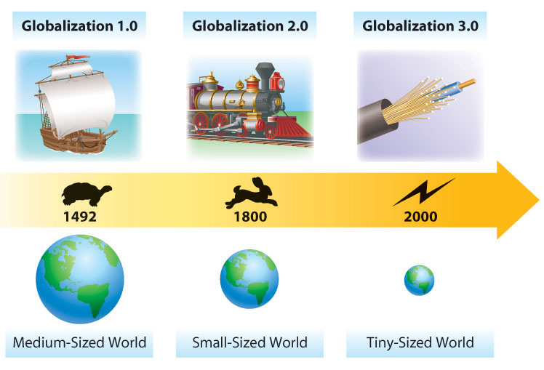

The 10 Flatteners
- Fall of the berlin wall
- Netscape goes public (first mainstream browser)
- Development of workflow software
- Uploading/ open sourcing (Free software, collaboration)
- Self-Organizing Collaborative Communities.
- Individuals as consumers and producers of content.
- Fast dissemination of information, news and events.
- Collaboration on open-source & free software.
- Social Media and user generated content
-Social Media:
Social Media is a group of Internet-based applications that build on the ideological and technological foundations of Web 2.0, and that allow the creation and exchange of User Generated Content.
-User-Generated Content (i.e. You Tube)
-term popularized in 2005
-various forms of media content that are publicly available and created by end-users.
3 basic requirements for UGC: (OECD, 2007)
- needs to be published either on a publicly accessible website or on a social networking site accessible to a selected group of people
- needs to show a certain amount of creative effort
- needs to have been created outside of professional routines and practices
- Outsourcing
- Offshoring
- Supply Chaining
- In-Sourcing
- In forming
-Individuals and small groups are globalizing
-The ability to build and deploy your own supply chain of info, knowledge and entertainment (search engines)
- The Steroids
-The new tech that are amplifying aall other flatteners
-Ex. Computing speed/ capacity, IM, videoconference/ skype.
-Key words, digital, mobile, personal, virtual
-the three specific examples of Digital Steroids cited by Friedman
1: Computing Speed / Storage / Portability ;
2: Peer-to-Peer Features (IM, File Sharing);
3: Voice over IP (e.g. Skype)

Triple Convergence
-In 2000 all the flatteners converged
-3 powerful tech forces
- Chap computing devices
- Low cost
- open standards
-The sharing of knowledge and work- in real time, without regard to geography, or, in the future even language

Business Implications of Flattening
-Hard work not necessary
-Stratagies must be aligned and apropriate with tools
-Must be innovative and creative
-New oportunities for developing customer relationships
-Customers bargaining power
-Subs for products or services

- Opportunities to alter how business processes are conducted (e.g. efficiency)
- New opportunities for building brands and developing customer relationships (e.g. CRM)
- Companies that are better at using IS in general and social media in particular do a better job of dealing with Porter’s 5 threats

Challenges of operating in the digital world
-Gov
-Economical
-Demographic
-Cultural
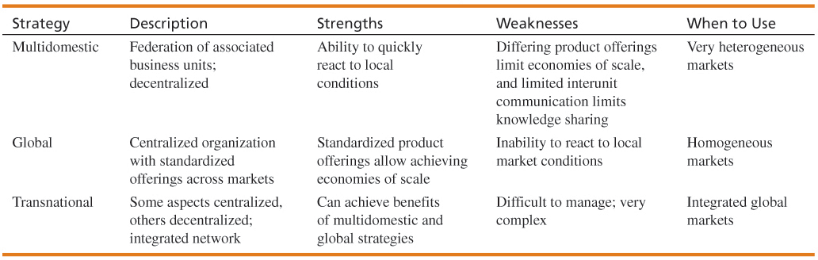

Fundamentals of Web 2.0- Unit 3

Social media crisis
-A crisis issue that arises in or is amplified by social media, and results in negative media coverage, a change in business process, or financial loss.
Characteristics:
-Tech helps create a negative buzz around a brand product or service
-Powered through small low-level events can rise to high level intensity

Commercial aspects of web 2.0 and social networking apps
-Viral word of mouth blogging (viral blogging)
-Classifified jobs
-Special advertisement campaigns
-mobile advertising increased sales can come from harnessing techniques based on personal preferences such as collaborative filtering

Web 2.0 Attitude
-Spontanious movement of people using online tools to connect, take charge of their own experience and get what they need- info, support, ideas, products, and bargaining power from eachother
-Markets are conversations.
-These networked conversations are enabling powerful new forms of social organization and knowledge exchange to emerge.
-As a result, markets are getting smarter, more informed, more organized. Participation in a networked market changes people fundamentally.
-People in networked markets have figured out that they get far better information and support from one another than from vendors.

Job Roles of a social media strategist
-Work closely with maerketing staff to understand marketing strategies and goals
-reasearch most appropriate social media channels for your business
-determine best tools to manage your business and train internal staff on how to manage these accounts using the tools
-develop metrics and institute tracking devices to gauge return on investment
-advise on how to deliver promotional content and campaigns through the channels
-monitor changes in social media tech, channels, and tools and make adjustnents and provide training

Web 2.0 Apps
-software as a continually-updated service that gets better the more people use it, consuming and remixing data from multiple sources, including individual users, while providing their own data and services in a form that allows remixing by others, creating network effects through an architecture of participation
-blogs
-wikis
-widgetn and mashups
-sharing sites
-rss (really simple syndication)
-social media

Web 1.0 vs 2.0
-Web 1.0 marketing goal is to influence
-Web 2.0 is relationships

Mashups:
-A mashup is a web application that combines data or functionality from more than one source into a single integrated interface or tool
-Mashups are applications generated by combining content, presentation, or application functionality from disparate sources.
-Creating mashups is all about finding data, functionality, and services and using them to both solve problems and create opportunities.

Industry and Market Disruptors
-Disruptors
Companies that introduce a significant change in their industries thus cause disruption in the way business is done
-Checklist of questions to help identify disruptors
- Is the service or product simpler, cheaper, or more accessible?
- Does the disruptor change the basis of competition with the current suppliers?
- Does the disruptor have a different business model?

Does the product or service fit with what customers value and pay for?

**One of the biggest forces changing business is the Internet (remember – it is the basis for all other flatteners)

Social Capital
-The advantage created by a person's location in a structure of relationships
**Remember business is about building relationships of all sorts to create “Social Capital.” – these relationships can be with customers, suppliers, media etc

Social networking analysis:
SNA is the mapping and measuring of relationships and flows between people, groups, organizations, computers, or other information or knowledge processing entities

Enterprise 2.0 Tools
Enterprise 2.0 refers to Web 2.0 technologies used for some business purpose:
- Promote collaboration and knowledge exchange among employees, consultants and company partners
- Advertise and build brand awareness, e.g., BlendTec on Youtube.com
Business use of Web 2.0 technologies:
- Recruiting and professional networking
- Marketing, promotion, and sales
- Internal collaboration and communication
- Supply chain management 2.0

Business social networks
- To build better customer relationships
- To improve knowledge management
- To facilitate recruiting and retention
- To increase business opportunities
- To build a community
- To gain expert advice
- To improve tradeshow experiences
- To improve communication and collaboration

Metrics
- Tool
- Tactic
- Strategic
- ROI

Web 3.0
Characteristics of Web 3.0:

Web 3.0 = (4C + P + VS)
where
3C = Content, Commerce, Community
4th C = Context
P = Personalization
VS = Vertical Search
-----------------------------------
3C = Content, Commerce, Community
4th C = Context:
defines the intent of the user; for example, trying to purchase music, find a job, or share memories with friends and family.
P = Personalization:
refers to the user’s personal characteristics that impact how relevant
VS = Vertical Search:
refers to a search strategy that focuses on finding information in a particular content area, such as travel, finance, legal, and medical.
-------------------------------------------
Semantic Web
Languages of Web 3.0: e.g., RDF (Resource Description Framework), OWL, and SPARQL; API (Application Programming Interfaces)
Artificial intelligence (AI)
Mobility – pushes drive for new technologies
Barriers
closed data sources
incompatible data structures and format
fractured Web
lack of Net Neutrality

*Short answer question on final; ex. Steve jobs question from 1st lecture.

