COMM 210
Chapter 2: Claims

Claim= “major conclusion of a piece of writing” Linda Dyer, Critical Thinking
Two kinds of claims:
- Contestable “Boys are smarter than girls”
- Not contestable/unproblematic “We are all going to die”
- Usually= math theories.

The Enduring Logic of Industrial Success, Chandler
Key concepts
- Economies of scale:
Large plants can produce products at a much lower cost than small ones because the cost per unit drops as the volume of output rises
- Economies of scope:
Large plants can use many of the same raw and semi-finished materials and intermediate production processes to make a variety of different products
Claims:
For firms to benefit from these economies:
- Flow of materials must be kept constant
- National (and international) marketing and distribution functions must be created
- Teams of lower and middle managers need to be recruited
- If you invest early enough, you can being a leader of that industry
  - Find a gap in the industry=” you’re the first player in”
    - McDonalds, no the first ones, but the first to have developed the concept
  - Once a firm loses the opportunity to be a first mover, it is difficult to regain competitive advantage
  - Entrepreneurial companies that do not make investments to create organizational capabilities cannot achieve long-term success
- Believe in merging the structures
  - PepsiCola bought Pizzahut, KFC,.. = Sell more Pepsi. (Deal with Concordia).
  - Growth through unrelated diversification is a poor corporate strategy
  - Business ownership patterns have diminished the likelihood of many firms’ long-term success (Thomas Edison)
- Core technologies dev.
- Believes in standardized, not customized ones.
- Bigger= better BUT, being bigger= buying other companies + producing more.
Successful firms capitalize on economies of scale & scope, create management structures and invest in research & development

CHANDLER’S CONCEPT LIST:
- Economies of scale & economies of scope
- Functional divisions, management hierarchy & geographical expansion
- First movers & challengers
- Research & development (innovation)
- Related & unrelated diversification
- Separation of top and middle managers (in the case of unrelated diversification)
- Entrepreneurial enterprise (staying small)
- Stock market pressure (due to ownership pattern)
- Short-term thinking (due to market pressure)

Critical Business thinking, Chapter 3, Dyers- Evidence

Argument= Combination of a claim and the evidence for it
Evidence= any statement that is a response to the question
- Each piece of evidence has to be explained
- We can’t be absolutely certain: test its quality:
  - Accuracy=Verify the information (Miswrite one’s name on our CV).
  - Precision= have an appropriate level of precision (8.6% whether than 8%)
  - Sufficiency=Do you need multiple pieces of data?
  - Representativeness= is the evidence/data is really representative of the claim? Don’t throw any other factors.
  - Authority= our credit/experience, etc…
  - Clearness= No only numbers= they have to be explained. You have to know your audience.

Evolution and Revolution as organizations grow, Larry E. GREINER

- Deals with how companies can face crisis
- Each crisis and solutions have their own characteristics
- Can’t succeed if you aren’t always analyzing and forecasting outside of the company… but also inside!
- Organizations grow through a series of evolution and revolution phases that are function of the age and the size of the organization
- Management practices that work well in one phase bring on a crisis in the next one
- There are 5 faces of companies’ growth
- Creativity= Analysis of a crisis= leadership crisis
- Direction=crisis of autonomy tough to delegate
- Delegation= crisis of control (top-level executives)
- Coordination=red tape crisis (crisis of confidence
- Each department has its own agenda, and departments don’t cooperate to help other departments get the job done
- Top managers are dangerously ill-informed and insulated from what is happening on the front lines or in "the field”
- Quantitative measurements are favoured over qualitative measurements, so the concentration is on quantities of output, with less and less concern for quality of output
- Both employees and customers are treated more as numbers than people
- Collaboration

- If you go through all these phases, you will have a stronger company
- Organizations should not try to skip phases
- Top managers whose style is no longer appropriate should remove themselves
- Growth is not inevitable If you don’t go through you growth will cease
- Be consistent= structure is very important in a company’s growth
Advantages of large bureaucratic organizations
- Hierarchical authority promises control and responsibility
- Specialization of sub-units promises accountability, control and expertise
- Management by rules promises control and consistency
- Being impersonal promises objectivity, consistency and equality

Week 4: Leadership
-A born leader?
- In today’s world, everyone can be a leader
- Different kind of leaders (appointed by someone…)
- How to choose a leadership pattern, Schmidt
- A good leader knows where to step in
- Every good man has to know who is leading.
- The one common aspect= respect. A good leader always has respect from his team.
- What values do the manager have?
  - Independent
- Companies’ style can develop leaders
- How much does the manager have to get involved?
  - The leadership of your team, will influence your team’s future
  - They developed themselves in every new situation

Midterms: one or two articles from a business magazines, we may or may not give you the articles in advance= Four short questions and one relatively long answer. Short answers and a one-page essay. 2h exam.

Critical Business thinking, Chapter 4, Dyers-Underlying assumptions

The assumption is why the author is writing the article
Underlying assumption: It is a logical link that fills the gap between the evidence and the claim.
- They are usually implicit
- If the underlying assumptions are questionable: the argument is not acceptable
- Tell us whether evidence provided for a claim is relevant
How to find them:
- Put oneself in the role of the writer
- It can be hard when an author is very knowledgeable and assume the reader is familiar with the topic
- Require that we learn more about the issue
Reality assumption: Our beliefs about what events have taken place, what exists, or how things work in the world. They are our beliefs about reality.
Value assumption: Our ideals(What values we believe in), our standards of right and wrong, the way things ought to be. Recognizable words: Ought, should, desirable, unacceptable.
- Values are subject to change
Effective writing: Articulate the underlying assumptions and examine them with care= Is this assumption always true?

Week5: Companies’ Vision

Bring clean copies of the article + writing tool + Scrap paper + one translation dictionary.
Can put point forms if the question asks for it.

Dyers chapter 6: techniques of persuasion

Techniques of persuasion

– Anticipate objections based on
• Negative evidence (show that it is misleading)
• Alternative/rival causes (same evidence can be consistent with different interpretations)
• Debatable/Conflicting assumptions (If you know that there are reality assumptions that your audience might feel are debatable or wrong, you must provide explicit data to back up your assumptions)
– Limit claims you cannot rebut:you must concede points that you cannot refute (there’s no shame)
• Acknowledging limitations make your writing MORE persuasive
– Rhetoric – Use of language & form: Talking to a lawyer (formal terms), doctor (medical terms)…
- Be complete, Detail, (evidence and assumptions) = don’t be vague
-Tone (scholarly vs. narrative)
-Vividness (being concrete draws attention); bring evidence to life, attracting attention to your points and making them memorable for your readers.

SWOT: Strength (internal= what do we do well…), weaknesses, opportunity,

Chapter 9: Communicating for Employment

Handy: The Sigmoid Curve
The Sigmoid Curve:
-It is the story of a product’s life cycle and of many a corporation’s rise and fall
-There is life beyond the curve. The secret to constant growth is to start a new sigmoid curve before the first one peters out.
-The real energy for change comes only when you are looking disaster in the face, at point B on the first curve. At this point it is going to require mighty effort to drag oneself up to where, by now, one should be on the second curve. At point B, resources are depleted and energies are low. For an individual, an event like being laid off typically takes place at point B,
-If a company is left at point B, only new people will have the credibility and the vision to lift the place back onto the second curve: At this point, however, it is going to require a mighty effort to drag oneself up to where, by now, one should be on the second curve. To make it worse, the current leaders are discredited because they are perceived to have led the organization down the hill.
-It is wise for a company to start their second curve at point A and to ensure renewal and the continued growth of their organization.
-Maintaining traditional business strategies and never adapting to new markets (think of Blockbuster) will never be able to reach the second curve and will eventually die.

Sigmoid is always continuous growth: always try for the best.
Death is inevitable
Need to do something new before “it gets boring”.

Frederick Herzberg: One More Time: How do you Motivate Employees?

Herzberg’s concepts:

Motivating with KITA:
- Negative KITA: fear of what will happen if something is not done. Will never lead to motivation.
-Negative physical KITA-> It is a physical attack; it directly stimulates the autonomic nervous system and usually leads to negative feedback from employees.
-Negative psychological KITA-> This has more advantages over physical KITA because the cruelty is not visible (the hurting is internal). Those who use this type of KITA like managers receive ego satisfaction. If the employee complains, he or she can be accused of being paranoid because there is no tangible evidence of an attack.

2. Positive KITA: rewards, incentives, seduction to get and employee to “move” or “jump”.
“Do this for me or the company, and in return I will give you a reward, an incentive, more status, a promotion, all the quid pro quos that exist in the industrial organization”

**KITA is NOT motivation because we are kicking our employees each time to do something. For motivation, one needs no outside stimulation because one WANTS to do it. KITA results only in short-term movement

3. Hygiene factors: These factors are extrinsic and do NOT provide job satisfaction. Hygiene factors are what employers do to get their employees to move. Hygiene factors are tied in with the KITA concepts. Hygiene factors include company policy, supervision, salary, status, working conditions, etc.

4. Motivator or Growth factors: This is the primary cause to job satisfaction. The growth or motivator factors that are intrinsic to the job are achievement, recognition for achievement, the work itself, responsibility, and growth or advancement.

5. Dissatisfiers (mentioned above)
6. Satisfiers (mentioned above)

7. Horizontal job loading: reducing personal contribution of employees rather than giving them opportunities for growth in their accustomed jobs in order to enrich certain job. Job loading enlarges the meaningless of a job. Examples of job loading include:
- Increasing the quota of hamburgers that need to be produced without extra time given
-Asking a dishwasher to mop the floors as well in his shift (adding another meaningless task)
-Removing the most difficult parts of the job to free the worker to accomplish more less challenging tasks.

8. Vertical job loading: Has internal motivators involved. Examples include:
-Introducing new difficult tasks not previously handled (growth and learning)
-Removing some controls while retaining accountability (responsibility and achievement)

9. Job enlargement: No change in challenges.

10. Job enrichment: a systematic attempt to motivate employees by manipulating the motivational factors.

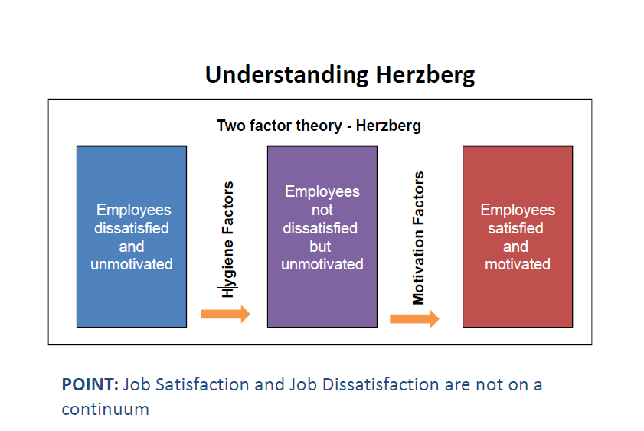
Vertical job loading (providing motivator factors)

What might you do to ‘improve’ a job?
• Remove some controls while retaining accountability
• Increase accountability of individuals for own work
• Give person a complete natural unit of work
• Grant additional authority; job freedom
• Make periodic reports directly available to workers themselves rather than supervisors
• Introduce new, more difficult tasks
• Assign workers to specialized tasks, enabling them to become experts

Steps for JOB ENRICHMENT (instilling motivators)

How might you go about improving a job?
• Select jobs, approaching them with the conviction that they can be changed
• Brainstorm possible changes
• Remove hygiene & horizontal loading issues
• Avoid direct participation by the employees whose jobs are to be enriched
• Be prepared for an initial drop in performance
• Expect first‐line supervisors to experience some anxiety

Not all jobs can or need to be enriched.
Ultimate reward in motivation is personal growth

