Claim:
Less Drug, More Shoppers: the Canadian pharmaceutical industry is under siege.

Have We Reached Peak Burger: Burger joint growth in the US is at its peak.

SPAARC:

Sufficiency:

Precision:

Accuracy:

Authority:

Representativeness:

Clarity of Expression:

BHAG: Big, Hairy, Audacious Goal (10-30 year)
Less Drug, More Shoppers: Shoppers mart future goal is to be able to turn their stores into “medical hubs” to give out vaccines and treat minor ailments.

Have We Reached Peak Burger: Right now, fast-food restaurants are kind of stuck and must look to something new if they wish to succeed in the future. McDonald’s is testing out a make-your-own burger concept.

Underlying Assumptions: the gap between claims and evidence
Reality Assumption: our beliefs about reality; how things are

Companies should invest in distribution.
Evidence: By opening its first large-format location, the company became a kind of department store for the 21st century, only successful and well loved. That opening set off a decade of huge and profitable growth for the company. Between 2001 and 2011, the company increased the selling space in its stores to 13.2 million square feet from 5.2 million and more than doubled its annual sales to $10.5 billion from $5 billion.
Related diversification is a good corporate strategy
Shoppers doesn’t plan on giving in just yet. Having already gone from drugstore to superstore, it’s now looking at transforming itself into a neighborhood medical hub as well.

Value Assumption: our ideals, our standards of right and wrong, the way things ought to be

Greiner’s phases of growth and Have We Reached Peak Burger:

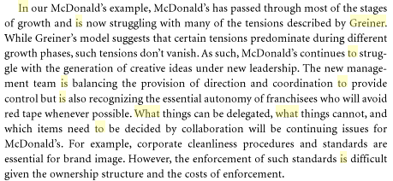

Chandler’s concepts and Less Drug, More Shoppers:
- Diversifying into new markets
  - Medical hub
  - Administer more vaccines
  - Treat minor ailments
- Economies of scale and scope
  - 13.2 million square feet of selling space

