BIO1140 C- Introduction to Cell Biology

Lecture 2: What is a cell? - Reading
Cell Theory:
- all organisms are composed of one or more cells.
- The cell is the basic structure and functional unit of all living organisms
- Cells arise only from the division of pre-existing cells.

Unicellular:
- almost all bacteria(diameter of 0.5 um) and archaea
- some protists, such as amoebas
- some fungi, such as yeasts
Multicellular:
- plants(diameter of 10um to a few hundred)
- animals(diameter of 5 to 30 um)

Microscopy: a technique used for producing visible images of objects, biological or otherwise, such as cells and the structures within them that are too small to be seen by the human eye.

Light Microscope: use light to illuminate the specimen.
Electron Microscopes: use electrons to illuminate the specimen.
Magnification: the ratio of the object as viewed to its real size, usually given as something like 1200:3.

Plasma Membrane: all cells are bounded by this, it is a bilayer made of lipids with embedded protein molecules.
Lipid Bilayer: hydrophobic barrier to the passage of water-soluble substances, but selected water-soluble substances can penetrate cell membranes through transport protein channels. This selective movement of ions and water-soluble molecules through the transport proteins maintains the specialized internal ionic and molecular environments required for cellular life.
Cytoplasm: made up of all parts of the cell between the plasma membrane and the central region. Contains the organelles, the cytosol, and the cytoskeleton. Also conducts stimulatory signals from the outside into the cell interior and carries out chemical reactions that respond to these signals.
Organelles: small, organized structures important for cell function.
Cytosol: aqueous solution containing ions and various organic molecules.
Cytoskeleton: protein-based framework of filamentous structures that among other things, help maintain proper cell shape and plays key roles in cell division and chromosome segregation from generation to generation.

Two Fundamentally different types of cells:
Prokaryotic(pro=before; karyon=nucleus):
- bacteria and archaea
- nucleoid: DNA-containing central region of cell, has no boundary membrane separating it from the cytoplasm.
- Shapes include: spherical, rodlike, and spiral
- Genetic material is in nucleoid(region of cell contains a highly folded mass of DNA)
- Messenger RNA: DNA molecule information is copied into this type of RNA molecule.
- Ribosomes: small, roughly spherical particles in cytoplasm use the information in the mRNA to assemble amino acids into proteins. Consists of a small and large subunit, each formed from a combination of ribosomal RNA and protein molecules.
- Cell wall: in almost all prokaryotic cells the cell wall surrounds the plasma membrane. It provides rigidity and within the capsule, protects the cell from physical damage.
- Plasma Membrane: contains most of the molecular systems that metabolize food molecules into the chemical energy ATP.
- Flagella: many bacteria and archaeans move through liquids and wet surfaces by using this long, threadlike protein fibre that extends from the cell surface.
- Bacterial Flagellum: helically shaped, rotates in a socket in the plasma membrane and cell wall to push the cell through ha liquid medium.
- Pili: hairlike shafts of protein extending from cell wall. Main function is attaching the cell to surfaces or other cells.

Eukaryotic:
- domain eukarya is divided into 4 major groups: protists, fungi, animals and plants.
- DNA is contained within a membrane-bound compartment(nucleus)
- Cytoplasm contains extensive membrane systems that form organelles.
- Plasma membrane surrounds it as the outer limit of the cytoplasm.
- Nuclear Envelope: nucleus is separated from the cytoplasm by this. Consists of two membranes. Lamins lines are a network of proteins that reinforce the inner surface of the nuclear envelope in animal cells.
- Nuclear pore complex: large, octagonally symmetrical, cylindrical structure formed of many types of proteins called the nucleoporins. It exchanges components between the nucleus and cytoplasm and prevents transport of material not ments to cross the nuclear membrane.
- Nuclear pore: a channel through the complex is the path for the assisted exchange of large molecules such as proteins and RNA molecules with the cytoplasm.

Lecture 2: Introduction to Cell Biology
What is a cell?
- fundamental unit of life
- every organism either consists of cells or is itself a single cell
- surrounded by a membrane
- has a control center: nucleus
- cytoplasm: made of water, sugars,salts, organic molecule
- responds to external stimuli
- must be reproduced by another cell

- Cell theory:
- All organisms consist of one or more cells
- The cell is the basic unit of structure for all organisms ( Theodor Schwann, 1839, Matthias Schleiden, 1838)
- All cells arise only from pre-existing cells( Rudolf Virchow, 1855)

- Can one speak of the cell?
- Enormous diversity in form, function and size:
- Simple to complex shapes
- 200 nm to 13 cm diameter; can be >1 m long( ostriche egg is one single cell)
- shape often reflects function(ex: if they have a large surface area then they are most likely used for transportation)
- jack-of-all-trades to extreme specialization
- Similar basic chemistry (unity)- cells have a single similar common ancestor
- Similar chemical composition ( proteins, lipids, carbs, nucleic acids)
- Metabolism; use of ATP as the cellular energy currency
- Use of DNA for genetic information (all cells have same structure of DNA)

- Size matters… (um= micron, nm= nanometer)
- Units relevant to cell biology:
- 1um= 10^-6m
- 1nm=10^-9m
- Cells are small:
- ‘typical' prokaryote 1-5 um
- ‘typical’ eukaryote 10-30um

- Practice makes perfect.. match the appropriate dimension to the cell/cell structure.
- Ribosome diameter(30nm) 0.007um=7nm
- Nucleus diameter 30 nm
- Mitochondrion length(3x10^-6m) 0.006 mm=6um
- Giraffe axon length (1x10^6um) 1x10^6um=1m
- Microfilament diameter 3x 10^-6m=3 um

- Why are cells small?
- SA:V ratios, SA determines how much space there is for exchange. V determines how much will exchange. As cells get larger SA:V will drop(6:1 & 3:1)
- Rates of diffusion: the larger the cell, the longer the process of diffusion will.
- Adequate concentrations or synthetic capacity: as cells get larger they require more of the substrate in order for the reaction to proceed. May not be able to synthesize enough of the adequate concentrations so therefore life cannot proceed

- Prokaryotic and eukaryotic cells differ in their solutions to the problem of size:
- Prokaryotes:
- Solution stay small, typically 1-5um
- Simple structure: cell wall, plasma membrane, cytoplasm that lacks organelles ( cyanobacteria possess photosynthetic membranes), ribosomes, nucleoid, flagellum
- Genetic material is in the form of a single celled circular structure containing mostly DNA, in the form of a nucleoid.
- Archaeans( extremophiles), bacteria(usually cause disease: e.coli,-small rodshaped, anaerobic, found in lower gut of mammals, most strains of it don’t cause any problems. )
- Eukaryotes:
- Protists( single-celled organisms), Fungi, Animals, Plants(multicellular)
- Solutionscompartmentalization of cellular functions(membrane elaboration), transport systems
- Interior is subdivided by membrane bound organelles, because of this, you need fewer molecules to achieve those adequate concentrations.
- Transport systems, move things around very quickly
- Microvilli help increase the surface are without affecting the volume by much.
- Mitochondria are the power houses of the cell and allow for sufficient amounts of ATP to be produced.
- Multicellular eukaryotes:
- Arabidopsis thaliana- plant, a weed, easy to grow in lab, has a small genome
- Caenorhabditis elegans- only 959 cells, simple, shows aging, development, behaviours.
- Danio rerio- zebra fish, rapid development, reproduce easily, can regenerate the heart tissue
- Drosophila melanogaster- reproduce quickly, good when studying genetics because it has visible phenotypes
- Mus musculus- small, reproduce fast, large numbers in small spaces, mammals
- Saccharomyces cerevisiae- brewers and bakers yeast
- 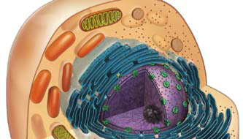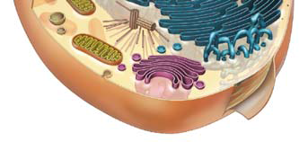

The relationship between eukaryotic and prokaryotic cells:
- Endosymbiont theory:
- Mitochondria from incorporation of aerobic prokaryote
- Chloroplast from (later) incorporation of cyanobacterium
- Evidence to support this theory? Fossil record

- Compare mitochondria and chloroplasts to prokaryotic cells:
- Mitochondrion:
- Oxidative metabolism yielding ATP
- ~2um
- double membrane, cristae
- circular mDNA; smaller, simpler ribosomes
- reproduce by binary fission
- 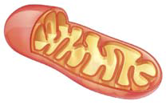

- Chloroplast:
- Conversion of light energy to chemical energy (complex carbohydrates)
- ~5um
- double membrane + thylakoids
- circular cpDNA; smaller, simpler ribosomes
- reproduce by binary fission
- 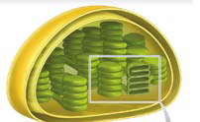
- Sequencing of small-ribosomal-subunit RNAs that make up mitochondrion
- Tried to look for similarities between the different types of RNA
- At the sequence level, the ribosomes at the mitochondrions and chloroplasts are more similar to prokaryotes then eukaryotes.
- Mitochondrial 13S-18S rRNA shows more sequence homology to prokaryotic 16S rRNA than to cytosolic 18S rRNA
- Chloroplast 16S rRNA shows more sequence homology(80-90%) to prokaryotic 16S rRNA than to (<60%) cytosolic 18S rRNA

Present day examples of endosymbiosis:
- Symbiotic animals containing green photobionts (eg. Some sponges, hydra, the salamander)
- Solar-powered sea slugs(kleptoplasty)

*How does kleptoplasty in Elysia chlorotica differ from the endosymbiotic origin of chloroplasts? *

Topic 2- Cell Membranes
Reading: chapter 5
Objectives:
- Functions of cell membranes
- The fluid mosaic model
- The lipid bilayer- phospholipids, glycolipids and sterols
- The ‘mosaic’ of membrane proteins
- Membrane properties
- Solute movements across membranes and membrane potential
- Cell-to-cell signaling
- Lipid-soluble signals cross the membrane
- Water-soluble signals require membrane receptors

Functions of Cell Membranes- an overview
- Fluid mosaic model
- Singer & Nicolson 1972
- Fluid lipid molecules in which proteins are embedded and freely floating
- Functions:
- Define boundaries; selectively permeable barrier
- Localization and organization
- Scaffold for biochemical activities (enzymes)
- E.g. mitochondria
- Regulation of solute transport:
- In an out of cell and/or organelles
- Uphill or downhill
- E.g. Na, K-ATPase
- Responses to external signals:
- Receptors and signal transduction
- E.g. B-adrenoreceptor
- Cell-to-cell communication:
- Recognition, adhesion, exchange of materials
- Gap junctions, plasmodesmata
- Inner mitochondrial membrane: 76% protein, 24% lipid
- Plasma membrane of Schwann cell (myelin sheath): 18% protein, 82% lipid

Membrane Structure
- Fluid Mosaic Model:
- Lipid-protein assembly in which components are held together in a thin sheet by non-covalent bonds
- Two fluid lipid layers- structural backbone, permeability barrier
- Mosaic of proteins- unique complement responsible for specific functions
- ~10 nm thick
The Lipid Bilayer:
- Gorter and Grendel, 1925
- Key component of permeability barrier
- Composition:
- Phospholipids(amphipathic):
- Phosphoglycerides, e.g. phosphatidylcholine:
- Glycerol backbone
- Hydrophilic head group: phosphate + choline, serine, ethanolamine, inositol
- 2 fatty acids(16-18 C); saturated & unsaturated
- Sphingolipids, e.g. sphingomyelin:
- Sphingosine backbone
- Hydrophilic head group: phosphate + choline, serine, ethanolamine
- 1 fatty acid
- Glycolipids (glycosphingolipids):
- Single sugars or oligosaccharides
- Antigens (e.g. ABO blood groups)
- Sterols (steroids):
- Derivatives of 4-ringed bydrocarbon skeleton
- Absent from prokaryotes
- Cholesterol (animals, some protists)
- Phytosterols (plants)
- Ergosterol (fungi)

- Test your knowledge…
- The lipid bilayer functions as a permeability barrier because..
- the lipids are held together by covalent bonds that prevent unwanted movement across the membrane
- it is difficult for hydrophilic molecules to traverse the hydrophobic core of the lipid bilayer
- the lipid bilayer is thick, so that the diffusion distance becomes too great for rapid transit across the lipid bilayer
- the glycolipids of the lipid bilayer recognize and bind molecules that the cell wishes to exclude
- none of the above
- explain your answer

- Test your knowledge…
- Which of the following remedies is likely to be most effective against athlete’s foot, a fungal infection of the human foot?
- Oseltamivir, an anti-viral agent better known as Tamiflu
- Micronazole, an inhibitor of ergosterol synthesis
- Penicillin, an inhibitor of peptidoglycan (bacterial) cell wall formation
- Sodium azide, an inhibitor of oxidative metabolism
- None of the above
- explain your answer

- Properties of the lipid bilayer: membrane asymmetry
- Lipids distributed unequally between the two leaflets
- Established during membrane biogenesis
- Flip-flops vs rotation and lateral diffusion
- Properties: membrane fluidity
- Fluid nature of membrane essential for function
- Fluidity reflects:
- C chain length and saturation
- Head group polarity
- Buffering effect of sterols
- Temperature
- Homeoviscous adaptation:*
- Alterations in lipid composition to maintain membrane fluidity at different environmental temperatures
- Dietary adjustments of fluidity: Semi-palmated sandpiper:
- Migratory flight from summer to winter habitat includes 2-week stop-over at Bay of Fundy prior to transoceanic journey
- Birds feed on mudshrimp that is very high in PUFA
- PUFA-rich diet increases PUFA in membranes
- Improves fatty acid mobilization for flight endurance

- The plot thickens: from endurance athletes to couch potatoes:
- Elevated citrate synthase (CS) activity in sandpipers:
- Correlated with body fat
- Diet or other factors?
- i.e. causation or correlation?
- Experimental test:
- Fed quail PUFA-rich diet
- Found 58-90% increase in aerobic enzyme activities
- Concluded that dietary lipids:
- Regulate membrane fluidity
- Mimic effects of endurance training in boosting the aerobic capacity of muscle

- Test your knowledge…
- A protist(Giardia) is suddenly expelled from a warm human intestine into cold water. Which of the following adjustments might the protist make to maintain membrane fluidity following this change in temperature?
- decrease the length of the hydrocarbon tails in its membrane phospholipids
- decrease the proportion of unsaturated hydrocarbon tails in its membrane phospholipids
- decrease the amount of cholesterol in the membrane
- decrease the proportion of phosphatidyl-choline relative to phosphatidylethanolamine.
- Both (a) and (d) would be appropriate responses for the protist to make to maintain the same level of membrane fluidity following the change in environmental temperature
- explain your answer
Membrane Proteins:
- The ‘mosaic ‘ component of the fluid mosaic model
- Functions include:
- Transport
- Enzymes
- Signal transduction
- Attachment/recognition
- 3 types: integral, peripheral, lipid-anchored

Integral membrane proteins:
- amphipathic with one or more hydrophobic regions
- usually transmembrane (single or multipass)- extend across the thickness of the membrane
- transmembrane domains (form hydrophobic interactions with the nonpolar core of the membrane) typically a-helix of 20-30 hydrophobic aa residues
- e.g. 7-TMD receptors, receptor tyrosine kinase, ion channels, carrier proteins
Peripheral membrane proteins:
- membrane-associated through non-covalent interactions
- dynamic relationship with membrane
- e.g. membrane-cytoskeleton “linking” proteins
Lipid- anchored membrane proteins:
- Membrane-associated through covalent linkages to phospholipids
- Fatty-acid anchored
- Intracellular orientation
- E.g. G proteins
- GPI anchor ( glycosylphosphatidylinositol)
- Extracellular orientation
- Cleaved with phospholipase C
- E.g. type IV carbonic anhydrase

Thought exercise:
- how can the different properties of membrane proteins be used to distinguish among integral, peripheral and GPI-linked (lipid-anchored) proteins experimentally?

Movement Across Membranes
Overview:
- Importance of size, polarity/charge, gradient
- How?
- Passive transport:
- Simple diffusion
- Facilitated diffusion
- Active transport:
- Primary
- Secondary

Passive Transport:
- Diffusion
- Spontaneous; based on random movements
- Driven by diffusion gradient (downhill)
- For solutes without a chargeconcentration gradient
- For gasespartial pressure gradient
- For ionselectrochemical gradient
- For waterosmotic gradient
- Membrane permeability determines whether diffusion is simple or facilitated
- Partition coefficient ratio of solubility in organic solvent that in water, oil vs water, how lipiphilic the molecule is,
- Simple diffusion- small, lipophilic molecules, can cross membrane on their own with diffusion gradient, hydrophobic molecules, small polar molecules. Rate of diffusion is a linear function. As gradient gets larger molecule moves faster.
- Facilitated diffusion- hydrophilic molecules: relies on channel or carrier proteins, can be polar but large. Direction of diffusion gradient. When all transporters are being used (saturated)then rate cannot increase. Usually see saturation kinetics and possibly of inhibition of different types of compounds.

- Facilitated diffusion:
- Channel proteins- integral transmembrane proteins, act with non polar core of membrane. In center its hydrophilic amino acid residues that allow passage of K ions
- Ions, water
- Highly selective- K channel will only allow K ions to pass through
- Leak vs gated (e.g. voltage-gated, ligand-gated)- leak= open all the time, gated=open and close at different times. Voltage- open and close as membrane potential changes, movement can happen in either direction depending on the diffusion gradient. ligand= when particular chemicals bind to them. Aquaporin- allow certain water molecules to pass through, for more rapid transport of water across membrane. Ex. In kidney for reabsorption. Leak channels.
- Inhibitors- blocks channel so no transport can occur
- Carrier proteins- integral transmembrane proteins. Carry molecules through membrane, molecule binds to it and causes comformation of transporter to change in carrier protein caused by binding of solute and then solute is moved across and lets go into other side of membrane.
- Ions, larger polar molecules
- Highly selective- only allow particular molecule that transporter is for
- Uniporter(transfers single type of solute across, ex. Glucose transporter), co-transporter(move 2 or more types of molecules across at the same time in the same direction), exchanger(antiporter, move 2 solutes across at the same time but in different directions, according to their diffusion gradient)
- Inhibitors
- Direction of solute movement driven by gradient
Slide 33**
Intrinsic directionality- is the movement only in one direction regardless of the diffusion gradient, or can they move in either direction?

Active Transport
- Carrier-mediated movement against gradient (uphill) via coupled input of energy (“pumps”)
- Highly selective
- Unidirectional- intrinsic directionality, only one direction
- Primary active transport -
- ATP hydrolysis directly coupled to transport of solute against diffusion gradient
- Several types
- P-type: phosphorylation, phosphate group that is removed from atp is attached to pump itself. Need binding of solute, hydrolysis of atp and phosphate group to bind to pump for it to operate
- Move cations (Na, K, Ca, H)
- Reversibly phosphorylated
- E.g. Na, K-ATPase- animal cells, very important
- V-type- move H+ - use atp to move H ions, v= vacuolar, acidify vacuoles, on vacuolar membrane and plasma membrane. Key difference is that theres no phosphorylation in v-type, phosphate group doesn’t have to bind to pump.

- Pumps, channels and membrane potential (Vm)- membrane potential is voltage difference across cell membrane. Reflects unequal charge throughout membrane. Get this difference from pumps that create conc. Differences.
- Resting Vm is inside negative and reflects
- Na and K gradients established by Na, K-ATPase
- Leak channels for K ( and Na)
- Excitable cells use changes in Vm as a signal
- Changes in ion conduction affect Vm
- E.g. Na channels open, allowing Na entry- depolarization
- 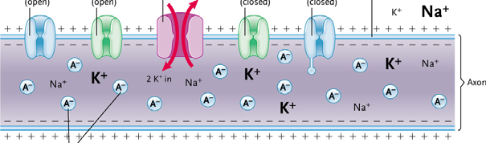

Test your knowledge..
- A cell is treated with the Na, K-ATPase inhibitor ouabian. What happens to Vm?
- nothing because Vm depends on ion leak not ion pumping
- the cell membrane becomes permeable to Na and K
- the cell hyperpolarizes (Vm falls to a more negative value)
- Vm slowly rises to approximately zero as Na and K gradients are lost.*** Na will gradually leak inside and K will leak out until membrane potential reaches zero.
- None of the above
- Explain your answer

Secondary active transport: make use of the energy expended to create the gradient and use it to bring another solute into the cell. 2 different proteins are involved, takes advantage of greadient established by primary pump. Can operate in cotransport or exchange.
- Simultaneous transport of two solutes
- Downhill transport along gradient established by primary active transport allows uphill transport of second solute
- Na gradient in animal cells- kidney
- H gradient in plant cells (also bacteria, fungi)

Apply your knowledge: transport in the mammalian kidney
- Filtration followed by reabsorption
- Transport maximum for glucose and diabetes mellitus (lose glucose in their urine)
- Can you identify…
- A uniporter? glucose
- A co-transporter? Sodium, glucose & Na bicarbonate
- An exchanger? Sodium proton exchanger, sodium potassium
- Facilitated diffusion via a carrier? glucose
- Primary active transport? Na,KATPase
- Secondary active transport? Na, glucose and Na proton exchanger
- 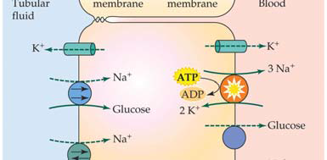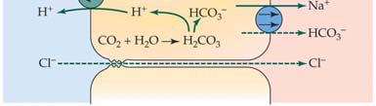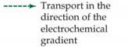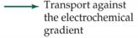

Case Study- Urea transport in Gulf toadfish
- Urea- highly polar, low lipid solubility, low membrane permeability
- Mammals- urea transporters (UT)
- What about toadfish?
- Conclusions from these data?

Thought exercise:
- Can you design an experiment to distinguish between facilitated diffusion and secondary active transport?

Membranes and Cell-to-Cell Signalling:
- Water-soluble vs lipid-soluble signal molecules
- Location of receptor
- E.g. stress hormones- adrenaline, cortisol.

Steps in a signaling pathway:
- Reception:
- Ligand-binding site
- Only cells with receptor respond to signal
- Transduction:
- Conversion of signal to cellular response
- Amplification
- Cellular response:
- Changes in gene expression
- Changes in protein activity
- Responses can be cell type-specific
- Termination

Pause for reflection:
- If binding of the signal molecule to a surface receptor is what triggers the
cellular response, i.e. the signal molecule itself does not enter the cell, then…

a. The cellular response should also be triggered by external application of
unrelated molecules that are sufficiently similar in shape to the signal molecule
to be able to bind to the receptor.
b. Metabolic poisons should prevent the cellular response.
c. The cellular response should not be triggered by injection of the signal
molecule into the cytoplasm of the cell.
d. All of the above are true
e. Only a and c are true
- Explain your answer.

Membrane Receptor Signaling Systems:
- Membrane receptors are integral membrane proteins
- Ligand-gated channels
- Enzyme-coupled receptors
- G protein-coupled receptors
- Receptor tyrosine kinases (enzyme-coupled receptors)
- Activation of cytoplasmic protein kinase domain
- Phosphorylation (tyrosine residues)
- Dimer formation
- activation of tager proteins to create elaborate signaling complex
- typically regulate cel lgrowth and proliferation (e.g. growth factors)
- 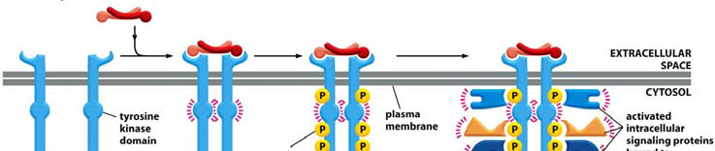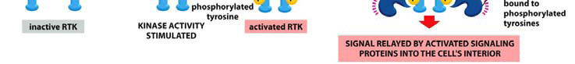
- G protein-coupled receptors:
- Activate GTP-binding proteins (G protein)
- G protein initiates cellular response, typically via 2nd messenger
- G proteins are heterotrimers: Ga binds GTP(or GDP), Gb and Gy form a unit
- G proteins are molecular switches: GTP bound=on, GDP bound=off
- G proteins are diverse

Test your understanding..
- GTPyS is a non-hydrolyzable analogue of GTP. How would use of GTPyS in a cell affect G protein signaling?

- A common G protein signaling pathway uses cAMP as a 2nd messenger
- G protein activateds the enzyme adenylyl cyclase
- cAMP activates protein kinase A
- Example: liver glycogen breakdown in the “fight or flight” response
- Phosphorylation cascade
- amplification

Pause for reflection:
- What is the advantage of a phosphorylation cascade?

Test your understanding..
- caffeine is a phosphodiesterase inhibitor. How might caffeine consumption affect the liver’s response to adrenaline?

Consolidate your knowledge:
- contrast and compare RTK and G protein-coupled receptor signaling pathways
- identify reception, transduction and cellular responses for each
- slide 59***

Lipid-soluble signals & intracellular receptors:
- Signals enter cells by diffusion
- e.g. steroid hormones
- Receptors are ligand-activated transcription factors
- Ligand-binding domain
- DNA-binding domain
- Regulate gene expression
- activated receptor binds to a response element
- Cellular response
- reflects genes regulated by the response element

Pop Quiz: midterm type questions. What is something and why does it matter. And distinguish between two things.
- what is homeoviscous adaptation and why does it matter? Refers to changes in membrane lipid composition, to counteract factors of temperature,goal is to keep membrane fluidity constant. Matters because in order for cell to function, membrane has to function properly, has to be able to allow specific things in and out. to receive signals, act as a semipermeable barrier.
- What is the mudshrimp corophium volutator and why does It matter? Rich in polyunsaturated fatty acisd and eaten by semi** sandpaper. Matters because its content allows the bird to modify its membrane to enhance fatty acid uptake and ATP production during flight. Polyunsaturated fatty acids trigger atp production through a series of events.
- Distinguish between causation and correlation. – causation is they are linked because a change in one causes a change in the other variable. correlation refers to 2 things that are changing because they are linked so they happen at the same time.
- Distinguish between a peripheral membrane protein and a fatty-acid anchored membrane protein. – peripheral is held onto membrane by noncovalent interactiongs. Fatty is held by its covalent linkage to a fatty acid that is inserted into the core of the membrane. Peripheral is on surface of membrane by non covalent interactions on either surface. Fatty is on cytosolic leaflet of membrane.
- What is a transmembrane domain and why does it matter? Domain is found in a protein, non polar due to side chains on the amino acids, sequence of amino acid residues(20-30), alpha helix structure, embedded into bore of membrane, non polar region. Matters cause domain hold proteins in place in membrane.

TOPIC 3- CELLULAR ENERGETICS
Reading:
- chapter 4.3 and 6
Objectives:
- Energy flow and the energy currency (ATP)
- Glycolysis and fermentation
- The mitochondrion as the energy powerhouse of the cell
- Pyruvate oxidation and the citric acid cycle
- Oxidative phosphorylation- electron transport, chemiosmosis powers ATP synthesis
- The regulation of ATP synthesis

Energy Flow and the Energy Currency- ATP
- Why do cells need energy?
- Biosynthesis
- Mechanical work
- e.g. movement in cell, cell movement
- concentration work
- e.g. active transport
- Electrical work
- transport of ions with generation of membrane potential
- Generation of heat
- Generation of bioluminescence

- Energy flow through the biosphere
- Photosynthesis- transformation of light energy into chemical energy
- Cellular respiration- conversion of chemical energy from carbohydrates/lipids/proteins to ATP (catabolic pathways of metabolism)
- 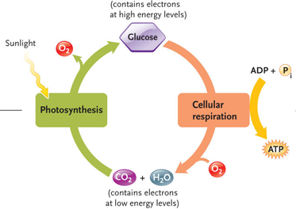
- ATP couples energy-yielding processes to energy-requiring processes
- Hydrolysis of ATP releases energy
- Charge repulsion
- Increased entropy
- Resonance stabilization
Glycolysis and Fermentation:
- ATP generation without oxygen
- Glycolysis= glucose(6-C) catabolized to pyruvate (2 x 3-C) yielding 2ATP and 2 NADH
- ATP production by substrate-level phosphorylation
- Fate of pyruvate depends on O2 availability
- In absence of O2, NAD+ is regenerated
Glucose2 pyruvate (O2) Pyruvate oxidationCitric acid cycleoxidative phosphorylation (many ATP)
Glucose2 pyruvatefermentationlactate(e.g. skeletal muscle) or Ethanol (e.g. S. cerevisiae, anoxic goldfish)

Pause for reflection:
- In the absence of O2, fermentation is essential to…
- generate energy through the production of lactate or ethanol
- avoid the accumulation of pyruvate
- regenerate NAD+ so that glycolysis can continue*?
- avoid the accumulation of H+ (generated when NAD+ is reduced)
- all of the above explain why fermentation is essential in the absence of O2
- explain your answer

- Regulation of glycolysis
- Feedback regulation
- Goal is maintenance of cellular [ATP]:[AMP]
- Allosteric regulation of key enzymes
- Allosteric regulators
- Activators
- Inhibitors
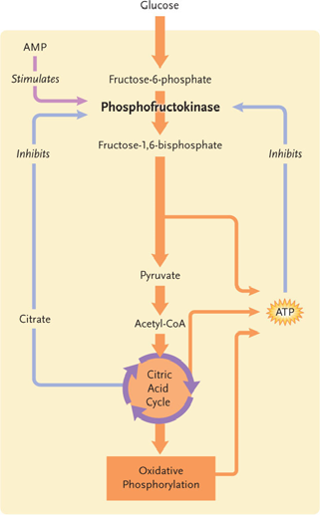

- Pyruvate enters the mitochondrion
- Porin, pyruvate-H+ cotransporter
- Remainder of aerobic respiration occurs in the mitochondrion
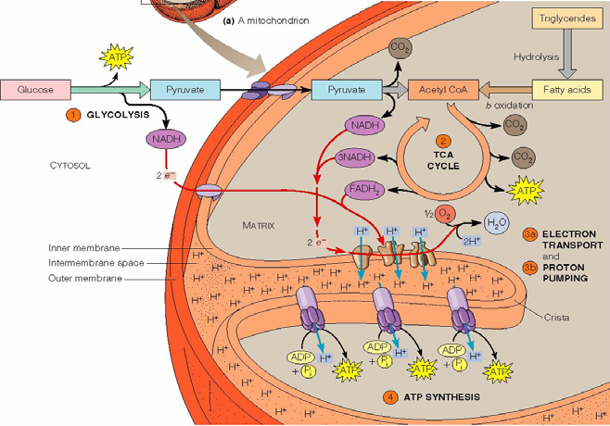

The Mitochondrion- powerhouse of the cell
- Structure-function relationships
- Outer membrane contains porins
- Inner membrane
- High fluidity
- Permeability barrier
- Highly folded
- 75% protein (pyruvate transporter, electron transport chain, ATP synthase)
- Matrix contains enzymes of pyruvate oxidation, citric acid cycle
- Prokaryotic origins
- Isolation by differential centrifugation
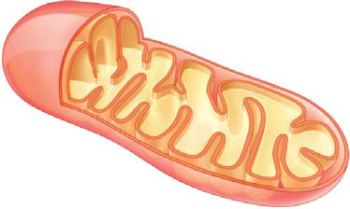
Consolidate your knowledge
- A mitochondria can be considered to have four functional compartments. What are they? Provide one distinguishing characteristics of each.
- Would you predict that heart cells or skin cells would have a higher density of cristae in their mitochondria? Justify your answer.

Pyruvate oxidation and the citric acid cycle
- Enzymes in mitochondrial matrix (with one exception)
- Yields 2 ATP, 8 NADH and 2 FADH2 (per glucose)
- Allosteric regulation of key enzymes
- at steps where NADH produced
- NADH is allosteric inhibitor
- Pyruvate dehydrogenase complex
- allosteric regulation
- covalent activation (by dephosphorylation)
- 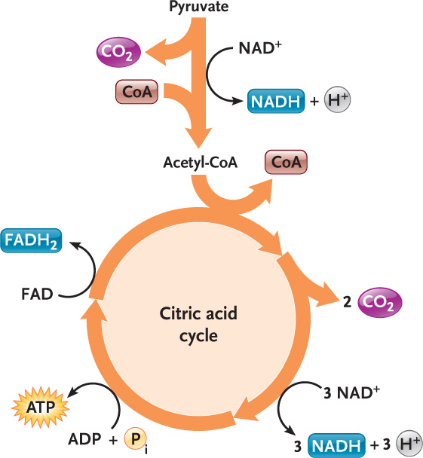

Oxidation Phosphorylation:
- Reoxidation of coenzymes by transfer of e to ETC; O2 is final e acceptor.
- affinity for e increases along ETC
- Creation of proton gradient that drives ATP synthase
- Chemiosmotic model- Peter Mitchell 1961
- Ubiquinone(carries both protons and electrons and picks them up on the matrix side of the membrane and drops them off on the inner membrane side)and complex 3 (complex 1,3 and 4)are both proton pumps(carrier), they are unidirectional so they do not operate in reverse
- ATP synthase (F0F1 ATPase)
- F0 is in membrane and F1 is part that sticks out into matrix
- Proton (translocator) carrier driving molecular rotary motor
- When protons enter the F0 part, it creates a spinning motion and then Rotator allows for ATP generation in F1 ‘head’(bottom)
- “the stator stock” holds the F0 to the F1
- NADH~10H+~3ATP
- Therefore, 10 NADH 30 ATP
- FADH2~2ATP
- Therefore, 2 FADH24 ATP

Substrate-level phosphorylation Oxidative phosphorylation
4 ATP + 34ATP = 38 ATP
(36 ATP in eukaryotes) efficiency ~40-50%
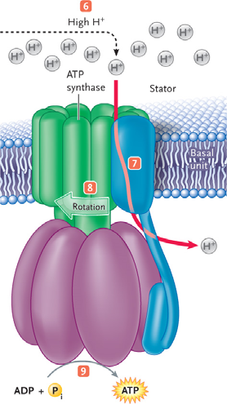

Test your understanding
- Based on the chemiosmotic model, predict the results of the following experiments:
- isolated mitochondria are placed in an incubation soluble. Does solution pH change? How?
- Isolated mitochondria are placed in an incubation solution containing cyanide (NaCN). Protons are added to the solution. Is ATP generated?
- Membrane vesicles containing ATP synthase and bacteriorhodopsin(a proton pump activated by sunlight) are created. Is ATP generated? How?
- Isolated mitochondria are treated with the H+ ionophore 2,4- dinitrophenol (DNP, chemical that makes holes in the membrane that protons can go through). What happens to ATP production?

Proton leak as a thermogenic mechanism:
- Uncoupling protein (UCP1)- in mitochondria, proton channel, inserted into membrane when animal needs heat. when in inner mito membrane it shuts down atp synthesis so all energy that goes into proton gradient is lost as heat. Very inneficient. Brown fat is a thermogenic tissue. Brown fat because mitochondria give it a dark color. In a bat.
- Heat generation by nonshivering thermogenesis in brown (generates heat) adipose tissue. Small animals retain the brown fat as adults.

Pause for reflection…
- the theoretical ATP output is 38. Fewer ATP are actually achieved in eukaryotes. Why?

Limitations on ATP generation in eukaryotes
- entry of e from glycolysis into mitochondrion
- use of mitochondrion proton gradient for transport
Oxidative phosphorylation is regulated by supply of ADP- feedback regulation pathway
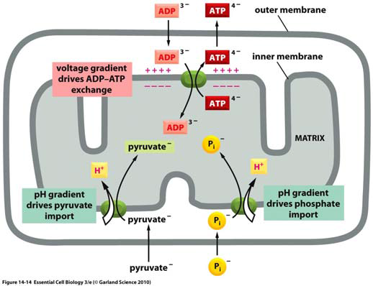
Hibernation and torpor
- Metabolic rate and body temperature lowered to conserve energy
- MR<5% of active animal
- Tb=5 C
- Does active metabolic suppression contribute to hibernation & torpor? Can shut down rate of atp synthesis from mitochondria.
- Isolated mitochondria from liver of torpid vs active animals
- mitochondrial respiration reduced by up to 88%.
- ground squirrels choose PUFA-rich foods prior to hibernation.
- low PUFA higher Tb and MR, shorter torpor
- excess PUFA shallower, shorter torpor

Pause for reflection…..
- suppression of mitochondrial respiration contributes to lowering of metabolic costs during hibernation and torpor. How else could cellular energy costs be reduced?

Consolidate your knowledge:
- Discuss structure-function relationships at the mitochondrion*
- Identify structural features
- Relate these structural features to the function they support

MIDTERM #1:
- Topic 1: Intro to cell biology- what is a cell?
- Suggested readings: chapter 2, 3.5, purple pages (F52-F56)
- Objectives:
- Cell theory
- Basic properties of cells
- Cell diversity: pro vs euk cells
- Model organisms
- Topic 2: Cell membranes:
- Suggested readings: chapter 5, 36.2a-d, p 320 fig. 14.12, ch. 35.2b-c, fig.35.4
- Reading: chapter 5
- Objectives:
- Functions of cell membranes
- The fluid mosaic model- lipid bilayer: phospholipids, glycolipids and sterols
- ‘Mosaic’ of membrane proteins
- membrane properties
- solute movements across membranes and membrane potential
- cell-to-cell signaling:
- lipid-soluble signals across the membrane
- water-soluble signals require membrane receptors
- Topic 3: Cellular energetics:
- Suggested readings: ch.4.3 and 6
- Objectives:
- Energy flow and the energy currency (ATP)
- Glycolysis and fermentation
- The mitochondrion as the energy powerhouse of the cell
- Pyruvate oxidation and the citric acid cycle
- Oxidative phosphorylation: electron transport & chemiosmosis powers ATP synthesis
- The regulation of ATP synthesis

SECOND HALF: Midterm #2
DNA & RNA STRUCTURE

Reading:
- chapter 12.1-12.2, pp 257-264
- other sections referred to in the figures
- material from the scientific literature
Objectives: to understand structure-function relationships
Structure of DNA and RNA:
- “the static and the dynamic”
- basic chemistry
- basic structural forms
- DNA and RNA modifications

Key Questions that we will try to answer:
- What is the structure of DNA and how do we know?
- Is DNA always the genetic material?
- Is the DNA structure always the same?
- Is the DNA structure in the cell relevant?
- Is the genome what we think it is?
- Without chromatin, would it be necessary to invent it? (next section)

Useful Information (F37-F39)
- The bases are heterocyclic, aromatic rings
- The numbering system
- 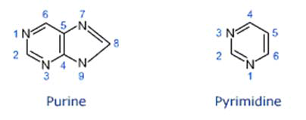
If this was RNA what would change?
- Uracil replaces thymine (no –Me group)
- Ribose replaces deoxyribose (2’ OH)
The Basic Building Blocks for DNA & RNA (F37-F39)
- There are 4 nitrogenous bases (4 types, A, C, G, T) (adenine, cytosine, guanine, thymine)
- A base is a purine or pyrimidine
- (adenine, cytosine, guanine, thymine)
- A base + a pentose sugar = nucleoside
- if the sugar is a deoxyribose, it is a deoxyribonucleoside (deoxyadenosine, deoxycytidine, deoxyguanosine, deoxythymidine)
- A nucleoside + phosphate = deoxynucleotide
- (deoxyadenosine 5’-monophosphate, deoxycytidine 5’-diphosphate, etc.)
- There are 5’-monophosphates, 5’-diphosphates, 5’-triphosphates (deoxyadenosine 5’-monophosphate (dAMP), deoxadenosine 5’-diphosphate (dADP), deoxadenosine 5’-triphosphate dATP).

DNA is the genetic material (at least most times):
A brief summary of the evidence:
- Transformation experiments
- Chargaff’s rules
- Phage infection experiment
- X-ray analysis
- Role of model building
- The modern “synthesis”- DNA structures

The Basic or Archetypal Structural Forms for DNA and RNA:
Type of Organism | Genetic Material | Organization
“Bacterium” | dsDNA(s)-circular | Protein/DNA-Nucleoid
“Eukaryote” | dsDNA-linear | Protein/DNA-chromosome
Mitochondrion | dsDNA-circular | Protein/DNA
Chloroplast | dsDNA-circular | Protein/DNA
Virus | Ss or ds DNA-circular or linear | Protein/DNA
Viroid | ssRNA- circular | None?

NOTE: except for viroids, WHY NUCLEIC ACID AND PROTEIN?

Griffith’s Experiment:
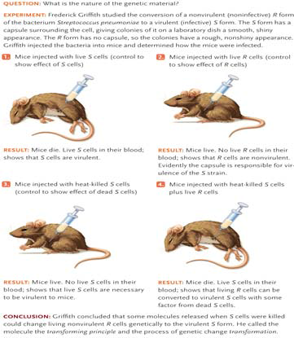

Experiment of Avery-Macleod-McCarty:
Treatment* | Activity | Transformation
None | None | Yes
“Trypsin” | protease | Yes
“Chymotrypsin” | protease | Yes
“Ribonuclease” | RNAse | Yes
“Deoxyribonuclease” | DNAse | None
- I have given them their modern names

Experiments of Chargaff:
- Chargaff used harsh chemicals to degrade DNA into the four bases then quantified the amount of each. The experiment gave 2 discoveries, now summarized as Chargaff’s Rule.
- The number of Adenosine bases is equal to the number of Thymine bases, and number of Cytosine bases is equal to Guanine bases. A=T and C=G
- The proportion of A:T and C:G holds true for both strands
- For example in humans A=30.9% and T=29.4%; G=19.9% and C=19.8%
How can we explain this result? Conversely how can we explain DNAs where the Rule does not apply?
(Caveats?)

Fibre Diffraction Experiment:
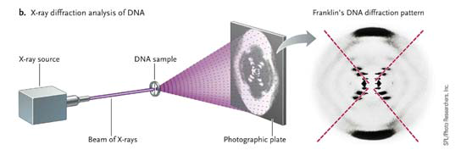
- this only works if you have models and crystal structures for small ds DNAs e.g. tetramers.
- After many years we have a standard model- “B-DNA”

Natural DNA forms a right-hand helix:
- (if you look along the length of the helix from the top, the strands spiral down and to the right)
- Note: you do see reproductions where the DNA is left-handed, even in leading journals or advertisements or posters!
- The two strands are “anti-parallel” (read 5’ to 3’ but in opposite directions)
- 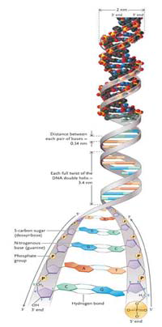

The DNA structure is NOT always the same. Why NOT?
- DNA changes during replication, transcription and other processes;
- With abnormal DNA composition the structure can change.
- A DNA is found in RNA/DNA hybrids (transcription)
- AT-rich DNA has different grove parameters
- Z-DNA is found in GC-rich DNA and is left-handed!
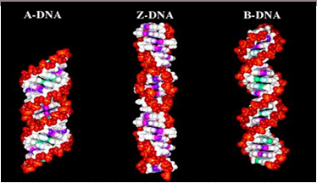
Example 1: models of different DNA structures.
- these in vitro results suggest that microheterogeneity can occur in the DNA structure!

There are a variety of “strange structures” but do they “exist” in nature?
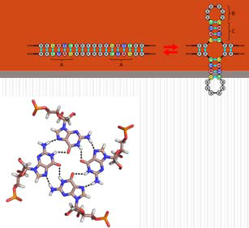
G_tetraplex
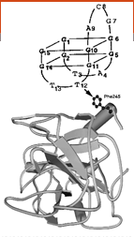DNA aptamers**

The Basic Structural Forms for DNA and RNA
- DNA released from bacteriophage (bacterial virus). You can see individual ds DNA!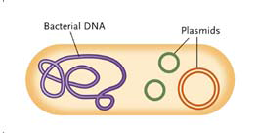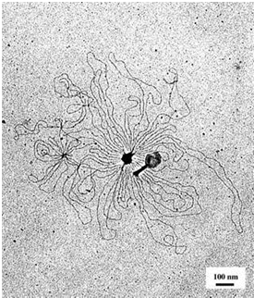
- 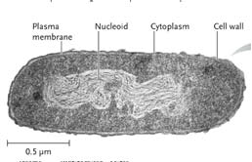

- DNA released from chromosome. After you remove histones you can see individual ds DNA!**
- 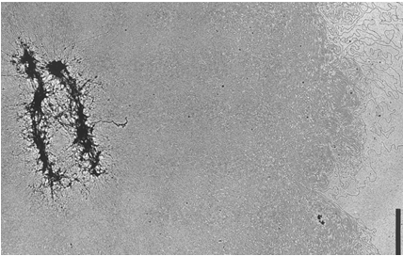
We can conclude that there are many structures for DNA & DNA-Protein in the cell. This is not surprising because…

RNA Structures are highly organized:
- Primary (5’ GGGCGUG…etc)
- Secondary (could you have predicted it?)
- Tertiary (could you have predicted it?)
- Red dots are modified bases
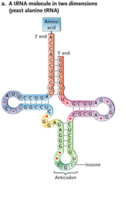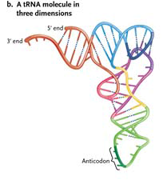

Model of a group II intron showing Extensive pairing with itself (p295).
This is a ______________ structure.
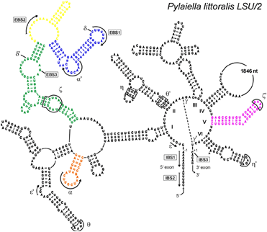

The Basic Structural Forms for DNA and RNA- Is That All There Is?**
- DNA can be extensively modified in the cell. These modifications are normally post replication.
- While there are many modifications we will only discuss (later) the methylation of cytosine. 5-methylcytosine (5MeC) is implicated in the regulation of eukaryotic genes.

- RNA can be extensively modified in the cell. These modifications are normally post transcriptional.

- While there are many modifications we will only discuss (later) the methylation of guanosine and polyadenylation of mRNA; RNA editing that changes cytosine to uridine; and some modification in tRNA that affect structure.

- More info about these can be found in Supplemental Information of the BIO1140 WEB site. I suspect more are waiting to be discovered.

What lessons can we draw from these examples?
-chemistry is important for structure and function
-tertiary structure is important for correct binding of proteins
-structures are dynamic, they are affected by ...............
-can we predict the tertiary structure?

We can conclude that there are many structure for DNA, DNA-Protein, RNA, & RNA-Protein in the cell. This is not surprising because..

- Summary
- Structures of DNA & RNA
- What are the main remaining issues?
- What more do we need to know?

OBJECTIVES OF THIS LECTURE:
- By the end of this lecture you will be able to..
- Describe, name and distinguish the building blocks of DNA and RNA (review)
- Summarize the experimental evidence supporting DNA as the genetic material; use this material to predict the results of future experiments
- Describe the basic structural FORMS of DNA & RNA in various organisms
- Describe the STRUCTURES of DNA
- Describe the standard, double-stranded DNA structure and its consequences on biological processes
- Explain microheterogeneity and its biological significance

