- Lecture 1:
- What is sport and exercise psychology?
  - “ The scientific study of human behavior in sport and exercise, and the practical application of that knowledge
  - Psychology: primarily scientific study of human behavior, affect and cognition
  - Sport and Exercise: Activities involving powers, skills, competition, strategy and/or chance, and engaged in for the enjoyment, satisfaction and/or personal gain of the participant and/or others
  - Sport and exercise psychology includes: sport science, performance enhancement, and psychological principles applied to sport settings
  - Exercise: more structured, usually a purpose/goal, to improve ones fitness
  - Physical Activity: anything including moving or any energy expenditure
- History of the field

- Lecture 2:
- Explain sport and exercise psychology and what sport and exercise psychology specialists do.
  - Sport and exercise specialists enhance:
    - Performance, social and physical well-being, life satisfaction and positive emotions
    - Encourage people to go from good to better
    - Ex: people who have breast cancer and are weak go to specialist and come out even stronger than before the exercise

- Explain the differences between educational and clinical/counselling orientations in sport and exercise psychology.
- Training to be a Sport and Exercise Psychologist Specialist:
  - Sport Science Education:
    - Working in university and college settings requires strong teaching and research skills
    - Academics work in:
      - Sport science
      - Research methods
      - Additional courses in psychology and/or counselling
  - Clinical and Counselling Sport and Exercise Psychology:
    - Clinical Psychology focuses on:
      - Assessing and rehabilitating serious psychological dysfunctions
    - Counselling focuses on:
      - Helping people with adjustments and/or development problems

- List the diverse educational training opportunities in sport and exercise psychology.
  - Research:
    - Design, implement, and evaluate research
    - Theoretical and applied research
  - Teaching:
    - University undergraduate and graduate courses
    - Educational services to community and sport organizations
  - Consulting:
    - Help individuals and teams improve performance, manage demands, and enhance well-being
    - Educational
    - Counselling
    - Clinical
  - Areas of study at UofO:
    - Stress, coping, and emotion in adolescent sport
    - Friendships and social support
    - Motivation for sport and physical activity
    - Perceptions of physical self
    - Sport commitment
    - Etc

- Identify basic standards of conduct and service in sport and exercise psychology.
  - Ethics concerned with matters of right or wrong
  - Ethics refers to parameters of relationship between consultant and client
  - Ethical responsibility: at best help athletes, at worst, do no harm
  - Ethical codes provide guidelines governing relationships
  - 3 Codes of ethics relevant in Canada:
    - Association for Applied Sport Psychology (AASP) Ethical Principles and Standards
    - Canadian Sport Psychology Association Code of Ethics
    - Canadian Psychology Association Code of Ethics for Psychologists
  - CPA Canadian Code of Ethics for Psychologists:
    - Principle 1. Respect for the Dignity of Persons
      - Reinforces moral rights regardless of culture, religion, gender, sexual orientation, etc.
    - Principle 2. Responsible Caring
      - Minimize harm and maximize benefits
      - Ethical responsibility that if you see that you are doing harm to a patient or person in an experiment you must stop the process for their safety.
    - Principle 3. Integrity in Relationships
      - Maintain objectivity and remain unbiased
      - Ex: make sure you’re not acting like buddies with the patient, fine line between you as the consultant and them as the patient.
    - Principle 4. Responsibility to Society:
      - Develop knowledge through inquiry
- Outline Canada’s sport and exercise psychology history
  - Dr. Rikk Alderman- University of Alberta
    - Establishes first PhD program in Canada
  - Dr. Albert Carron- University of Saskatchewan
    - Moves to university of western
    - Starts influential research program
    - Research was about cohesion and if that really does help teams
  - Dr. Terry Orlick- University of Ottawa
    - Begins prominent career as teacher and consultant
  - Key events since 1990s’:
    - Expansion and diversification of sport, exercise, and health psychology in Universities
    - Canadian universities offer graduate programs in sport and exercise psychology
    - Canadian Mental Training Registry established
    - AAASP develops ‘certified consultant’ designation in 1991

- List key sport and exercise psychology journals and organizations
  - 1965- Establish International Society of Sport Psychology
  - 1967- First conference for North American Society for Psychology of Sport and Physical Activity (NASPSPA)
  - 1969- First Canadian Society for Psychomotor Learning and Sport Psychology (SCAPPS) meeting
  - 1970- Start International Journal of Sport Psychology
  - 1979- Journal of Sport and Exercise Psychology
  - 1986- The Sport Psychologist publishes first issue on applied topics
  - 1986- Association for the Advancement of Applied Sport Psychology founded
  - 1989- The Journal of Applied Sport Psychology established

- Describe future trends in sport and exercise psychology
- Increased specialization and diversification
- Increased research and teaching opportunities
- Increased demands for training in clinical and counselling psychology
- Interdepartmental collaboration in teaching, research and practice
- Ethics and competencies
- Working in performance enhancement teams
- Online consulting and service provision
- Consulting with athletes and exercisers with disabilities
- Knowledge translation- (making it more accessible to the audience, talk to doctors, patients, etc. differently, trying to share the info with everyone you can and make it sound more interesting to them depending on who they are)
  - Share the info with other researchers so that they wont try to recreate the same situation and spend more money, they may have info to help you as well.

- Lecture 3:

- Be able to recognize and classify methods of knowing
- Slide 6*
  - Intuition: Developing implicit understanding of phenomena of interest in absence of formal training
  - Authority: Accepting the authority’s truth
  - Tradition: historically rooted knowledge with no emphasis on current information
  - Authorities: experts whose opinions are considered the final word in knowledge acquisition
  - Logic: knowledge generated through application of formal rules of reasoning to problem in question
  - Basic Research: deals with testing fundamental mechanisms, producing conditions or events without undue concern for the practical utility (working in a lab, ex: Muscle Biopsy)
  - Applied Research: generates solutions to immediate problems irrespective of mechanistic details (done out in the field)

- Differentiate scientific research from other sources of knowledge
- Scientific research includes:
- Description, Explanation, Prediction, Control*
  - Variable: attributes or characteristics that can change or vary, taking on more than one value (can change over time or stay stable)
  - Independent Variable: the manipulated variable explaining (or causing) study outcomes
  - Dependent Variable: phenomenon of interest expected to change because of the manipulated independent variable
  - Extraneous Variables: variable other than IV that could influence the DV
  - Nomothetic: attempts to isolate rules or observations that pertain to most cases, on most occasions, or in most contexts. (find a rule that pertains to many of the population. Very generic findings that don’t apply to only a select few people)
  - Idiographic: concerns special or unique cases that doesn’t apply to most people on majority of occasions
  - Hypothesis: educated guess regarding the outcome of a research study (quantitative research always has a hypothesis)
  - Null Hypothesis: indicates no relationship between the variables under study or no difference exists between the group receiving or not receiving the independent variable. (ex: no relation between amount of hotdogs sold and amount of goldfish dying)
  - Alternative (or research) Hypothesis: educated guess regarding the independent variable. Specify the direction of the outcome (positive/negative). Ex: it is hypothesized that with a diet children with obesity will loose weight
  - Causal: process of identifying agents that when manipulated bring about the desired changes in the DV’s of interest

- Be able to explain the steps of the scientific method
- Scientific Method: Series of steps organized sequentially to generate knowledge
  - Developing the Problem
    - Ask a question/purpose
    - Identifying variables: IV and DV
    - Does self talk predict anxiety levels among elite swimmers prior to competing? IV Self Talk, DV Anxiety
    - Are there gender differences in self-confidence among adult exercisers? IV Gender, DV Self Confidence
    - Do perceptions of competence in sport and social support from parents predict self-esteem and motivation in children? IV Competence and Parental Support, DV Self esteem and Motivation
  - Formulating the Hypothesis
    - Testable: written so can be disproved or supported
    - You can never PROVE a hypothesis, you can support it
    - Poor: Extraversion has an effect on sport performance
    - Better: Athletes higher in extraversion will tend to have higher levels of sport performance
  - Gathering Data
  - Analyzing and Interpreting the Results

- Discuss the importance of ethics in scientific research
- Research Ethics Board (REB): Oversees the Interagency Advisory Council on Research Ethics policies and procedures.
  - Ensures integrity and safety of participants and researchers
- Respecting Participants: Concerns anonymity and confidentiality of participant data.
  - Anonymity: inability to identify research participants
  - Confidentiality: retaining participant data in confidence. Keeping it locked up so no one can gain access to the information
  - Informed Consent: informing participants of what participation entails
- Beneficence: Concerns maximizing potential benefits while minimizing possible harm to participants
- Justice: Balance between participants suffering being ‘researched’ in conjunction with whom derives research study benefits
- Tuskegee Study (USA):
  - What happened? Told black men that they didn’t have syphilis but they actually did and people were just studying and doing research on them and the syphilis. Violating code of ethics
  - Who was involved and why? African American men
  - What were the consequences?
  - What violations of the ethical guidelines occurred? Principle 1. Respect for the dignity of persons. Principle 2, responsible caring
- Other Ethical Issues:
  - Moral, legal, and ethical ramifications
  - Plagiarism
  - fabrication

- Be able to define theory, study, experiment and professional practice, and explain the characteristics of each.

- Theory: represents a set of interrelated constructs that presents a systematic view of a phenomenon by specifying the relation between these constructs with the purpose of explaining and predicting the phenomenon
  - Acts like a blueprint
  - Example: Theory of Planned Behaviour
    - Independent variables: attitude toward the behaviour, subjective norm
    - Dependent variable: the end goal/outcome, behaviour
  - Theory is bot ha guide and a goal of research
    - It serves as a source for questions to research and it explains behaviour
  - Theory is described as a systematic explanation of a phenomenon based on scientific evidence
  - Never final but are constantly developed and revised or replaced with new information
- Study: seeks to understand processes or perspectives.
  - Interviews
  - Observation
  - examination
- Experiment: a scientific procedure undertaken to make a discovery, test a hypothesis, or demonstrate a known fact.
- Characteristics:
  - Control
  - Replication
  - randomization
- Professional Practice: getting experience in the field of interest
- Explain the role of measurement in the research process
- Measurement: Assigning numbers to variables
  - Nominal: assigning numbers to variables representing measurement only as labels. i.e. #15
  - Ordinal: assigning numbers to variables so that a variable can be “rank-ordered”. i.e. first, second or third on Olympic podium
  - Interval: assigning numbers to variables so that distances between numbers are equal. i.e. one cm, two cm, three cm, etc.
  - Ratio: assigning numbers to variables so that the true zero exists representing a complete absence of the variable under study. i.e. number of training sessions a person attends.
- Type of scale matters because….
  - Affects what you can do statistically with the data
  - Affects how we interpret data
  - Can be different types of analyses with different scales
- Purposes of Statistics:
  - To summarize a set of data
  - To provide standardized feedback and evaluation
  - To determine relationships among variables
  - To predict outcomes from known characteristics
  - To make population estimates from sample variables
- Basic Measurement Concepts:
- Psychometrics: Assessment of psychological variables using numbers
- Reliability:
  - Consistency or stability of scores derived from a test or measurement procedures
  - Observed Score: actual numerical value derived from test
  - True Score: variable of interest plus some error of measurement
- Validity: Extent to which test scores serve intended function. i.e. height measured in meters.
  - Sources of construct validity:
    - Consent validity
    - Criterion validity
    - Consequential validity

- Explain the importance of sampling and design in sport and exercise psychology research.
- Sampling: selecting observations for research study purposes
  - Sample: selection of observations from a larger population (a little sample of the theo pop.
  - Theoretical Population: all possible elements (ex: all university students)
  - Study Population: all accessible elements (everyone you have access too)
  - Ex: saying “human kinetics students are more likely to be active than other programs” cant say this because you’re only testing one group of people, you need variation.
- Design:
  - Research Design: plan followed to execute study
  - Internal Validity: extent to which study’s results are attributed to treatment rather than design flaws
  - Internal Validity Threat: plausible explanation for findings irrespective of treatment or manipulated variables
  - Threats:
    - Maturation
    - History
    - Mortality
    - Diffusion of treatment
  - What kind of things will influence internal validity?
    - Diffusion of treatment: at the beginning people will do exactly what you tell them to do but then it dies down and they don’t it the prescribe way anymore (ex: taking medicine)
  - Randomized Experimental Designs:
    - Randomly assigns participants to different conditions
    - Manipulates independent variable
  - Quasi-Experimental Designs:
    - Does not randomly assign participants to different conditions
    - Ex: first 20 people who walk into the class are put into intervention a and then next 20 is b and then the rest is c. Not randomized because people come into class with their friends and therefore are a bit more similar to each other then others so its not random.
  - Non-Experimental Designs:
    - Common in sport and exercise psychology research
    - Establish relationships in absence of group assignment or variable manipulation
    - Studies where were not changing or manipulating anything
    - Ex: have people fill out an online survey, didn’t modify their behaviour at all. Limitation: cannot confer causality once you get the results.

- Discuss the utility of qualitative inquiry in sport and exercise psychology
  - Qualitative inquiry: Understand phenomenon of interest from participants perspective.
    - Interview the participants after the study, ask them what they enjoyed, what they would do differently, etc.
  - Quantitative vs. Qualitative – differences:
    - One is more numeric, one is more textual
    - Quantitative: goal is to get a big sample so you can generalize your sample
    - Qualitative: purposefully sample people who you think are going to be key informants. Ex: study on volleyball and the transition between high school and uni, not going to ask all athletes, only ask v-ball players in final year of HS who are transferring
- Common Approaches:
  - Basic Interpretive Qualitative Study:
    - Seeks understanding phenomena, processes, or perspectives
    - Interviews, observation, document examination
    - Analyzes data to identify patterns and themes
  - Phenomenology:
    - Concerns essence of lived experiences
    - sheds previous beliefs and preconceptions
    - when you are going to do a study with a group of people who experience something. Very specific group of people
    - ex: positive development post breast cancer survivors
  - Grounded Theory:
    - Develops theory inductively derived from data
    - Codes data, constantly compares with others
    - End result: to come up wit ha theory to explain or predict a specific phenomenon
    - Ex: student and researcher wanted to know what contributed to performance in a group of young swimmers, interviewed the students, coaches, and parents and got all different perspectives. End result: theory to predict performance in this group
  - Case Study:
    - Descriptions and analyses of single unit
      - i.e. individual, group, program, event, community, etc.
    - use disciplinary and methodological perspectives
    - ex: 100 year old marathon runner, so you would do a a study on that person.
    - Always very unusual/unique situations
  - Ethnography:
    - Study of culture around group or team
    - Data interpreted in sociocultural framework
  - Narrative Analysis:
    - Presents story in first person
    - Speak as if you were the person, recounting what the person told you
- Merits of Qualitative Research:
  - Is it a good qualitative study or is it not persistent?
  - Use triangulation: get data from different ways and see how comparative it is or different researchers do the data and see if they come up wit the same results. Or go back to participants and ask if this really reflects what they were telling you and then they explain if it is or if no you were making it sound better then it is.

- Discuss similarities and differences in theories and models of motivation**?

- Lecture 4: Chapter 3
- Define personality and incorporate concept of individual differences
- Personality: The underlying, relatively stable, psychological structures and processes that organize human experience and shape a person’s actions and reactions to the environment.
  - Overall organization of psychological characteristics
  - Thinking, feeling and behaving- differentiates us from others and leads us to act consistently across time and situations
- Disposition: A broad, pervasive, encompassing way of relating to particular types of people or situations
  - People with different personalities are going to interpret different situations differently
  - Ex: before a football game one guy may be very pumped up and ready to do. But another guy may have anxiety and be freaking out right before the game because they handle the situation differently.

- Describe traits and various perspectives on traits such as the Big Five
- Personality Traits:
  - Trait: a relatively stable characteristic or quality that may represent a portion of one’s personality
  - State: Momentary feelings and thoughts that change depending on the situation and time
  - Know the different between trait and state***
  - Depends on the situation and on the time
  - People have certain traits that influence behaviour
  - Trait theories imply:
    - Consistency of behaviour from one situation to the next
    - Generalizability of behaviour between contexts
    - Implies that wherever you go you are the same type of person
    - The way you behave because of your personality is generally always the same
- Trait Models:
- 1. Cattell’s, “Trait Personality Model”:
  - 16 different personality trait dichotomies
  - dichotomous, ex: relaxed is the opposite of tense
- 2. Digman’s, “Big Five Model”:
  - researchers want to know where athletes fall, if they are more open to experiences or no
  - ex: is It more extroverted people who are more likely to engage in PA?
  - stems from psychology
  - look closely at the factors associated with the Big Five model of personality.
    - How might theses characteristics impact training and competitive behaviours of athletes?*
      - How dedicated they are
      - Different roles on a sports team, introverted and extroverted people
    - Relationships, sports and academics- is your personality the same across all these contexts? Do they change?
      - Kind of testifies against the theory that personality traits are constant across different contexts.
      - Ex: around your friends you may be more extroverted but in class you’re more introverted and quiet

- Briefly explain personality measurement tools including sport-specific measures and related ethical issues
- Measurement of Personality:
  - Trait and state measures
    - E.g. general confidence vs. state confidence
  - Measures should be specific to sport
    - Situation-specific tests predict behaviour more accurately than do general trait measures
  - Trait (general): no specific context, “how are you doing?”
  - State: can be in certain context, can be right before or after a competition. Far more predictive of behaviour than general measures
    - Ex: the way I feel right before a competition is going to predict how I feel way more than asking how you’ve felt in the last 7 days
  - 2 Major Categories:
      - Projective test: Subjective open-ended questions
      - Interesting but difficult to score
      - Tell a participant to say what they see:
        - Very hard to link these answers to personality
        - Every person will see something different
        - Trait type measure
      - Objective test: Standardized-individual has choice
        - E.g., multiple-choice, or t/f questions
        - More standardized, less interpretation, less bias
- Sport Specific Measures:
  - Athletic Motivation Inventory (AMI)
    - First sport-specific psychological test
    - Measures personality traits within a specific sport:
      - Drive, determination, leadership, aggressiveness, self-confidence, emotional control, conscientiousness, mental toughness
    - Very long process
    - Gives you info about a persons drive, their ability to stay focused, their motivation, how capable are they at dealing with the stress outside of their sport
  - Sport Competitive Anxiety Test (SCAT)
    - Measures trait anxiety
    - Take average score from their ratings
    - 10 statements scored on a 3-point scale
    - asks a person on a scale of 1-5 before you go to your competition, how tense are you?
  - Profile of Mood States (POMS)
    - Assesses 6 transient, distinct mood state
    - Long and short form questions
    - Get an idea on how much tension, depression, each person has
- Differentiate how personality might develop, involving psychodynamic, humanistic and cognitive-behaviour perspectives
- Psychodynamic Approach:
  - All behaviour interconnected and driven by unconscious forces
  - Freud’s structure of personality included:
    - Id: “pleasure principle”- forget all reason, im going to do this because it will be fun and I don’t care about any of the consequences
    - Ego: “reality principle”- what is realistic? What is rational for me to do. Acts as a mediator between what is realistic and what is pleasurable
    - Superego: “should/should not principle”. What should I do vs. what shouldn’t I do
- Humanistic Psychology:
  - focuses on personal responsibility, human growth, personal striving, and individual dignity
  - Maslow’s Hierarchy of Needs
    - Once basic needs are met, individuals strive to meet higher needs
    - Depending on what personality people have, they will strive to meet different needs and go higher up on the pyramid
    - Top of pyramid is reaching your full potential
- Cognitive-Behavioural Approach:
  - Behaviour is learned through experience
  - Three factors influence behaviour:
    - Situational expectancies- what you expect through different situations
    - Generalized expectancies- what you just expect
    - Reinforcement value- is there a specific reward/value to me acting a certain way
  - Social Learning Theory
    - Bandura emphasized the importance of observational learning and modelling
    - People can learn simply by being exposed to, or observing, the behaviours of others
    - People learn from television, magazines, DVDs, etc.
- Interactionist Approach:
  - Most preferred approach by psychologists today
  - How personality develops
  - Behaviour>situations> personality>
  - Situations/environment and personal factors reciprocally influence behaviour
  - Sample of situational factors:
    - Competitive vs. practice conditions
    - Sport vs. “off the field”
    - Level of pressure and expectations

- Explain recent personality research findings in sport and exercise psychology
  - Risk-taking/Sensation seeking:
    - Declines with age
    - Males are more drawn to high-risk sports than females
    - High-risk athletes report more emotional stability, conscientiousness and energy
  - Competitiveness:
    - Desire to engage in and strive for success in sport achievement situations
    - Sport Orientation Questionnaire: measures athletes desire to win along three specific dimensions:
    - competitiveness
    - win orientation
    - goal orientation
    - Males are more competitive than females
    - Athletes are often more competitive than non-athletes
    - Women usually score higher on wanting to be more cooperative
  - Perfectionism:
    - Maladaptive perfectionism: excessive, unrealistic standards of performance, high doubt, high self-criticism, fear of failure, and high distress. Where you get really focused on your failures, set unachievable goals
    - Adaptive perfectionism: realistic goal setting, judging success through personal improvement and effort, self-discipline, and achievement striving. Its good.
  - Mental Toughness:
    - Most critical psychological characteristics for achieving excellence in elite sport
    - 10 key characteristics under 3 broad categories:
      - Strong confidence and motivation
      - Managing competition and training stress
      - Maintaining and regaining focus when distracted
    - People who have strong confidence and motivation will perform better

- Understand the limitations of personality in explaining athletic and exercise behaviour and performance*

- Lecture 5- chapter 4
- Define motivation and apply definitions to your own physical activity behaviour
- Motivation: the internal and/or external forces that produce the initiation, direction, and persistence of behaviour
  - Direction- situations that a person seeks out, approaches, or is attracted to
  - Intensity- how much effort
  - Persistence- maintaining intensity over a continuous period
- Describe different approaches to understanding motivation as applied to behavioural change
- Approaches to Understanding Motivation:
- Behavioural
    - Focuses on conditioning or learning from environment determines people’s actions
      - Operant conditioning
      - Vicarious conditioning
      - Operant strategies
    - Vicarious- do I see other people performing this behaviour and does this motivate me?
    - Ex: cancer patients talking to eachother and say they are going to do a dragon boat race so the other one goes to watch, does that motivate them?
    - Really the environment that determines their motivation and if they are going to do it
- Cognitive:
    - Thought patterns and cognitive habits determine behaviour
    - Automatic thought processes, cognitive errors and core beliefs can be altered with continued persistence
- Cognitive-Behavioural:
    - Based on two tenets
      - Cognitions influence emotions and behaviours
      - Behaviour affects thought pattern and emotion
    - Effective for increasing self-reported exercise behaviour (ex: self-monitoring, goal setting, etc.)
    - Behaviour may influence the motivation that you have

- Apply select theories and models of motivation to your sport or exercise behaviour
  - Transtheoretical Model: explains how individuals initiate and adopt physical activity*****
- Pre-contemplation- No recognition of need for or interest in change
- Contemplation- thinking about changing. Ex: doctor says you have high BP so maybe you’ll think about starting PA
- Preparation- Planning for change, start realizing that it is important, setting yourself goals to start engaging in it
- Action- adopt new behaviours
- Maintenance- Ongoing practice of new, healthier behaviours. Ex: go to aerobic class every week
    - Helps you identify a persons readiness to engage in a behaviour
    - Relapse: could be in stage 5 for 3 months and then relapse into stage 2.
      - Greatest risk for relapse in preparation stage. Primary barriers: time, access to facilities, etc.
    - Reasons for relapse:
      - School
      - Injury
      - Death in family
    - Factors influencing stage progression:
- Self-efficacy: the belief in one’s capabilities. If you believe that you are able to do PA then you are far more likely to move from action to maintenance stage
- Decisional balance: ‘balance’ of comparative potential gains and losses. If pros outweigh the cons then more likely to move to next stage
- Process of change- 10 cognitive, affective and behavioural strategies used to progress through the stages. How effective are the strategies you’ve chosen? Ex: if you are good at goal setting then its more likely that you will engage in the PA or persist in it and continue to do it

*Self-efficacy and behavioural are key in discriminating people between pre-contemplation and contemplation
  - Theory of Planned Behaviour:
    - Personal and social factors influence behaviour
    - Largest determinant of behaviour is intention
    - 3 main factors:
- Attitude reflects positives and negatives of engaging
- Subjective norms reflect social pressure to perform (Do I like in society that values sport and exercise or a society that doesn’t value it and its fine to be a couch potato)
- Perceived behavioural control reflects extent behaviour is volitional (how much control do have over engaging in a behaviour?)
    - 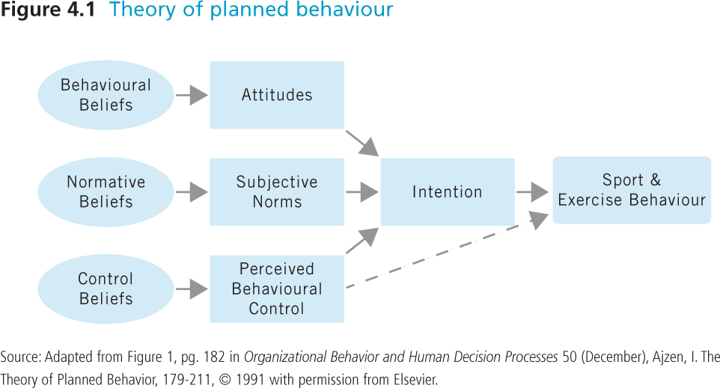
    - Be able to draw model**
    - Predicts PA in diverse clinical populations. E.g., cancer survivors, spinal cord injury patients, etc.
  - Social Cognitive Theory: Describes factors that affect and determine behaviour
    - 7 main constructs:
        - Observational learning
        - Goals
        - Outcome expectations- your expectations
        - Outcome expectancies- the value of the outcome to yourself
        - Self-regulation
        - Behavioural outcomes
        - Self-efficacy
    - Behaviour more likely to occur if people have high self-efficacy (i.e., the extent or strength of one’s belief in one’s own ability to complete tasks and reach goals
    - Factors Influencing Self-Efficacy:
        - Mastery experience: previous performances influence one’s beliefs of capability
        - Vicarious experiences: comparing to others who have similar skills
        - Verbal persuasion: self-talk and encouragement from coaches and significant others
        - Physiological and affective states: Physical and emotional cues associated with performance and behaviour
  - Self-Determination Theory:
    - Motivation is a multidimensional construct
    - Extent to which behaviours are volitional (out of your own free will) or controlled
    - Tendency for growth with optimal conditions
    - 4 mini-theories within
    - 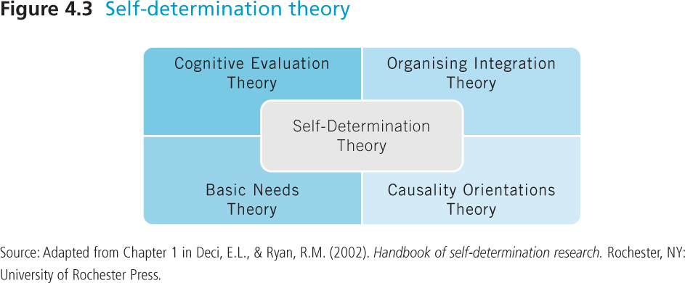
  - Organismic Integration Theory:
    - Motivation lies on a continuum ranging from less self-determined to most self-determined motivation
    - 6 different sub-types of motivation
    - Extrinsic motivation: external reasons, done to achieve a specific purpose
    - Not self-determined: control motivation
    - Self-determined: tonimus, out of your own free will, you want to do them
    - Extrinsic motivation:** 4 types
      - External regulation: actions performed to meet an external demand or avoid punishment (do it because you want something out of it)
      - Introjected regulation: external sources are internalized and behaviours are reinforced via internal pressures (perform behaviour to avoid guilt)
      - Identified regulation: behaviour is valued, deemed important, and is done out of choice but it is still for extrinsic reasons (participating in soccer because it helps with socialization)
      - Integrated regulation: activity is personally important and directed towards a valued outcome (im a soccer player and playing hard, training every day, and eating healthy is what a good soccer player does)
    - Intrinsic Motivation: people are intrinsically motivated by tasks that are fun, challenging and provide excitement
      - Actually enjoy the activity
      - 3 types:
        - To know: performing an activity to learn something new, to explore, out of curiosity (gymnastics)
        - To accomplish: performing an activity to master a task or to create something (improving in diving)
        - To experience stimulation: performing an activity to have sensory pleasure (adrenaline rush that you get from it)
  - Self-Determination Theory: want to move clients from the top (amotivation) to the bottom (IM to experience stimulation)
    - 3 Psychological Needs:
      - Autonomy: the need to perceive that one has choice and are in control of one’s own behaviour
      - Competence: the need to feel effective at achieving desired outcomes
      - Relatedness: the need to authentically connect with others and feel involved in the social context
    - Research:
      - Greater competence, autonomy and relatedness are associated with more self-determined motivation
  - Achievement Goal Theory: people motivated to demonstrate competence
    - 2 goal orientations:
      - Task (mastery) goal orientation
        - Motivation based on performance effort and improvement and to perform at one’s best
        - Winning would be a natural outcome to improvement, however, motivation is not a function of demonstrating superior performance as compared to opponents
        - Behavioural outcomes:
          - Choose learning opportunities at risk of displaying mistakes
          - Put lots of effort into it
          - Every practice youre going to try to perfect the skill you choose until you master it
      - Ego (performance) goal orientations
        - Degree to which a person is motivated to engage in sport for the purpose of winning and outperforming others
        - This person is motivated by comparing their ability with others, and to demonstrate superior competence
        - Not as focused on mastering a skill, you just want to be the best and outdo people
        - Behavioural outcomes:
          - Avoid learning opportunities that have risk of displaying error
          - Give up in face of failure
          - Ex: someone challenges you to a race but you only say yes if you know youre going to win else wont show competence if you lose
          - Make up lots of excuses
      - Perceived Motivational Climate: persons’ perceptions of achievement goals promoted by leaders (coaches, instructors, parents)
      - 2 types:
        - Mastery-based: put in effort and it will happen
        - Performance-based: opposite, stress interpersonal competition amongst the athletes. Give prizes. Not good long term, for performance or participation
      - Research:
        - Ego orientation associated to maladaptive perfectionism (person who is never satisfied, always focuses on their flaws=negative outcomes)
        - Task orientation associated with adaptive perfectionism (set a realistic bar to meet and become even better)
        - Environments emphasizing performance associated with ego orientation (coaches that are always talking about performing better and winning)
  - Competence Motivation Theory: behaviour is directed, selective, and persistent owing to “an intrinsic need to deal (effectively) with the environment”
    - Called effectance motivation: need for competence is an inherent part of life starting in childhood
    - We attempt to master our surroundings, and when were successful, we feel pressure
    - Ex: if you arent intested in drawing then you don’t really care if you can draw anything other then a stick man so you wont try or be motivated cause you don’t care. But if its something that has become a part of you or is expected of you then you will be more motivated and try much harder
    - 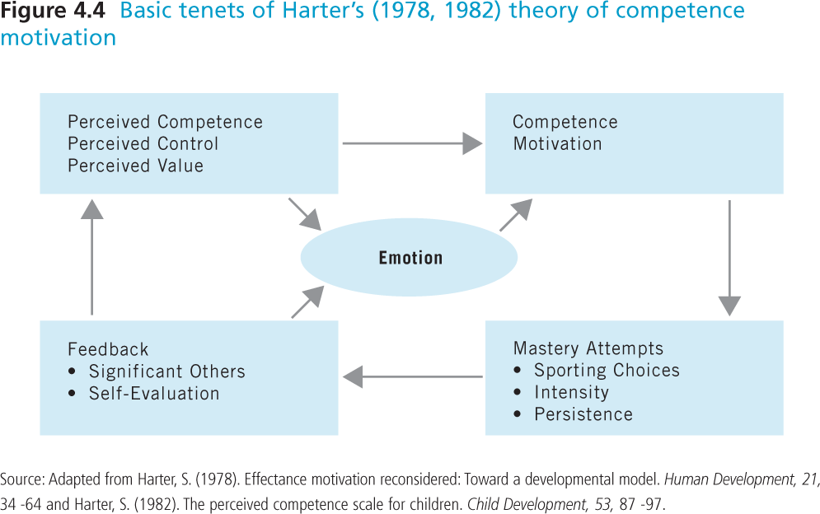
  - Sport Commitment Model: it’s a “psychological state representing desire or resolve to continue sport participation”
    - 5 factors predict or determine sport commitment:
      - Sport Enjoyment: positive feelings related to sport
      - Involvement alternatives: degree to alternative activities are more/less desirable
      - Involvement opportunities: opportunities that arise through playing (ex: being on swim team allows you to meet new people, feel like youre apart of a family
      - Personal investment: personal resources devoted to sport (how much do I actually have to be in times of personal sacrifice)(will motivate you to stay in sport or not to)
      - Social Constraints: pressures and expectations to stay involved (parents may pressure you because of all the difficulties they go through to make it happen for you)
    - Social support: can feel supported by parents but at the same time can be a social constraint, and pressure you and expect a lot out of you.
      - Entrapment = social constraint
      - Attracted = social support

- Understand how various social influences, including family and peers, affect motivation for physical activity
  - Nurturing relationships may enhance motivation and behaviours
    - Leaders who are more supportive and less controlling, who provide positive performance-contingent feedback promote more adaptive forms of motivation
    - Parent and peer relationships impact motivation
    - Social support
  - Social interactions and relationships motivate participants
    - Coaches can be positive and supportive
    - Parents can provide resources and be models
    - Parents can promote sport and activity

- Myths:
- MYTH: Motivation is a trait. You either are a motivated individual or you are not
- MYTH: Competence is the main motivator for engaging in physical activity
- MYTH: Enjoyment is the best motive to help us understand physical activity

- Lecture 6- Theories and Models of Behaviour Change

- Social Ecological Models:
  - Emphasize that health promotion should focus on both intrapersonal behaviours and multiple-level factors that influence the specific behaviour
  - Focuses on interrelationships between individuals and the social, physical and policy environment
  - Everyone affected by interactions among overlapping ecosystems:
    - Microsystem: immediate systems in which people interact
    - Mesosystem: location where interactions among microsystems take place
    - Exosystem: all external systems that influence the microsystem
    - Macrosystem: larger sociocultural context in which a person resides; encompasses all other systems. (are they living in Canada or india where they could use different strategies because cultures are different)
  - Individual: at center
    - Personal factors that increase/decrease the likelihood that people will be active or engage in sports
      - Knowledge, attitudes, behaviours, beliefs, motivation
      - Skills, abilities, disabilities/injuries
      - Age
      - Sex
      - Level of education
      - Self-efficacy
    - Can use in combination with other theories
  - Social Environment: comprises the relationships, the culture and the society who they interact with
    - Influence on physical activity and sport behavior
      - Family members
      - Friends
      - Cultural background
      - Socioeconomic status of the community
    - Strategies that bring change at this level include:
      - Support groups
      - Peer programs
      - Community education
  - Physical Environment: natural environment and built environment
    - Can positively or negatively influence physical activity and sport behavior
    - Built: how are cities made
      - Provides opportunities for interventions
      - Create walking or biking tracks
    - Natural: the weather
      - Has fewer opportunities for intervention
    - Safety
    - Public transport
    - Question? Do you think bixie bikes increase peoples PA?
      - Some people who take the bike were already commuting actively by walking, but not instead they are just taking the bike
      - Its not making people who drive use the bikes
      - Bike paths make it more likely for it to happen
  - Policy:
    - Legislations, regulatory or policy making actions that have the potential to affect physical activity and sport behavior
    - Often legal actions
    - Policy includes:
      - Urban planning policies
      - Active transport policies
      - Education policies
      - Workplace policies
    - Hardest level to change
    - Need multiple studies showing evidence of this
  - Limitations of this model:
    - Environmental and policy changes can take a long time and a lot of money to implement
    - Building fitness facilities does not mean that people will become more PA
    - Expensive and time consuming
    - Need to find out what people in the community actually want

- Health Belief Model:
  - to answer: why do people not engage in physical activity and sports when we know that there is so much to gain from it?
  - Shows that health-seeking behavior is influenced by a person’s perception of a threat posed by a health problem and the value associated with actions aimed at reducing the threat
  - How much at risk am I of a disease? Is doing a particular going to reduce that risk?
  - Says that a person’s health-related behavior depends on their perception of 4 aspects:
    - Perceived severity of a potential illness (2 people who have exact same health etc. may have 2 different perceptions of potential illnesses)
    - Perceived susceptibility to that illness (do I have any family history that will make me more likely to get that illness?)
    - Benefits of taking preventive action (if doctor says you should quit drinking to prevent something from occurring, but you like having a glass of wine on occasion then the benefits may not outweigh it and wont really care)
    - Barriers to taking that action
  - Factors that influence how much you think its risky or dangerous to have a stroke:
    - Demographic variables (age, sex)
    - Sociopsychological (personality, social class)
  - Cues to action:
    - Mass media campaigns
    - Advice from others
    - Illness of family member
    - Dr. explanation
  - Perceived susceptibility: refers to a person’s perception that health problem is personally relevant
  - Perceived severity: action will not occur if the person perceives the severity to be high enough to have serious complications
  - Perceived benefits: refers to the persons belief that a given behavior will cure the illness or help to prevent it
  - Perceived costs: refers to the complexity, duration, and accessibility and accessibility of the treatment
  - Motivation: desire to comply with a treatment and the belief that people should do what
  - Modifying factors: personality variables, socio-demographic factors, etc.

- Lecture 7- chapter 5
- Define and differentiate among anxiety-related concepts such as arousal, trait anxiety, social physique anxiety, competitive anxiety, and somatic anxiety
- Arousal: a blend of physiological and psychological activation of an individual’s autonomic nervous system
  - NOT anxiety
  - Ranges from deep sleep to peak activation
  - Non-directional: can be pleasant or unpleasant
- Anxiety: multidimensional construct that reflects negative feelings of worry or threat about a future event
  - Always unpleasant (no positive anxiety)
  - Characteristics:
- elicited following an appraisal
- universal across people of all cultures
- has a distinct physiology
- observed through discrete facial expression
- associated with unique set of action tendencies
  - Disorders:
    - Panic disorder: intense fear and discomfort
    - Agoraphobia: when you feel its very hard for you to escape a place (people who don’t like being on plains)
    - Social phobia: fear of publicly speaking
    - Obsessive compulsive
    - Generalized anxiety: hard to find out what trigger the anxiety
    - Post-traumatic stress: after a specific event (people who’ve gone to war)
- Somatic (physiological) Anxiety: physiological and affective elements that develop directly from autonomic reactions
  - Measures:
    - Muscle tension
    - Blood pressure and heart rate
    - Skin responses
    - Central nervous system
- Cognitive (mental) Anxiety: concerns or worries that reduces ability to focus or concentrate.
  - Measures: self-report inventories

- Context Specific Anxiety:
  - Social Anxiety: occurs during social situations
    - i.e. speaking in front of groups
  - Competitive Trait Anxiety: associated with sport or competition
    - i.e. concerns about body, performance, skills
    - someone who experiences anxiety before a game or sporting event
  - Social physique anxiety: experiencing anxiety due to others’ evaluations of physique in social settings
    - Concern that people are going to negatively evaluate the appearance of your body
- State Anxiety: emotional state characterized by feelings of apprehension and tension due mainly to the individual’s perception of the present or upcoming situation as threatening
  - Transitory in that it fluctuates over time
- Trait anxiety: more general predisposition to respond with apprehension, worry and nervousness across many situations
  - High trait individuals are more susceptible to state anxiety before a competition
  - Constantly worrying about certain situations

- List and describe the dimensions of an anxiety response, such as intensity, frequency of cognitive intrusions, and directional interpretation of anxiety
  - Intensity of Symptoms: examines amount of level of symptoms
  - Frequency of Cognitive Intrusions: % of thoughts and feelings about competitions
  - Directional Interpretations of Symptoms: either facilitate (positive) or debilitative (negative)
- Have to ask them these 3 questions to get a generalized idea of the impact it might have on them:
  - How intense are the symptoms?
  - How frequent do you experience them?
  - How do they feel that it affects them? Does it facilitate certain behaviours or make them want to avoid certain things?
- List and describe personal and situational sources of anxiety in sport and exercise settings
- Personal Sources of Anxiety:
- Age, experience and skill level
    - Ex: if im playing at a very high level but feel like I lack some skill because im playing up with older players then they may experience anxiety
- Gender: research inconsistent
    - Females experience higher social physique anxiety
    - Greater pressure for women to conform an ideal body
- Trait anxiety:
    - Influence level of cognitive trait anxiety and social physique anxiety
- Self-confidence and self-presentational beliefs
    - Beliefs about capability and presenting body favourably are sources of anxiety
    - Positive beliefs lower levels of state anxiety
- Self-regulation strategies
    - Coping skills: behaviours to adjust physiological arousal and degree of worry or concern. i.e. imagery, self-talk
    - Self-handicapping behaviours: actions or choices that externalize failure and internalize success. i.e. select unattainable goals, exaggerate injuries
- Environment-Based Sources of Anxiety:
- temporal patterning
- mirrors- good for people to watch the movements that they are doing, but also creates anxiety due to your image, or people can see you not doing the right thing makes you get anxiety
- clothing- people wearing weird clothing beside you on the treadmill may make you feel anxiety and make you feel bad about your body maybe
- others- some gyms have all womens gyms- helps people cope with their anxiety
- exercise leader- physical characteristics of them, participants may compare themselves to them, could motivate some people to try harder because they want to look like them

- Discuss how anxiety is specific to competitive and exercise settings and state the personal sources of anxiety that affect anxiety responses in those settings

- Describe how anxiety affects exercise behaviour
  - High Social physique anxiety individuals may exercise to improve bodies and receive positive evaluations
  - High SPA people may also avoid exercise to avoid situations of being evaluated
  - SPA led to lower levels of physical activity in women with low levels of self-presentation

- Explain how anxiety affects sport performance using three different theories
- Anxiety Models:
  - General arousal based approaches:
    - Drive theory: as arousal increases, performance increases (linear relationship)
    - Inverted U theory: performance is optimal at a moderate level of arousal. Optimal level varies by person and activity
  - State anxiety approach:
    - Zones of optimal functioning: states that athletes possess a zone or range of optimal functioning just prior to competition, not just a single optimal level. Zone depends on athlete
  - Multidimensional anxiety approaches:
    - Multidimensional anxiety theory: predicts relationship between cognitive and somatic components of anxiety and performance
      - Cognitive anxiety: negative linear relationship with performance, cause it interferes with your attention to focus on the game
      - Somatic anxiety: inverted-U relationship with performance. Certain degree to which somatic may be good. Performance will increase to which you experience somatic anxiety but then it will decrease if too much anxiety
    - Cusp catastrophe theory: combined influences of cognitive state anxiety and physiological arousal.
      - As arousal increases, performance increases to a point (like inverted U), but if it goes beyond an optimal level, performance drops off sharply as the athletes goes over the edge (catastrophe)
      - If you have low anxiety but mid point arousal, then that’s where youre performance is going to be the best/most optimal
      - Characteristics: performance (z), cognitive anxiety (y), physiological arousal (x), performance surface is on top

- Describe the cognitive and physiological mechanisms that are affected by anxiety, which in turn, affects sport performance
- Mechanisms of Change:
  - Cognitive mechanisms:
    - Anxiety affects amounts and types of information processed (task relevant vs. task irrelevant)
    - Performance improves if unimportant distraction cues are blocked
    - Performance may be diminished if important task-relevant cues missed
    - Ex: if youre a very anxious person then it will be hard for you to focus on the main point, you listen to everything and cant zone everything else out
    - Highly anxious athletes attend to task-irrelevant info more than low anxious athletes
    - Highly anxious athletes attention is governed by subjective importance of cues (i.e. threat) rather than location in visual field
    - Ex: pay attention to cues during the game that wont help them focus
    - Always worrying on the negative part and focus on that
    - Ex: what if I don’t get this serve in vball?
    - Affects type of cognitive processing (conscious control vs. automatic)
      - Anxiety causes shifts to conscious processing
        - Paralysis by analysis- makes you choke because you start self-doubting. Usually a super easy task for you but because you’re so anxious you choke
        - Ex: hurdles, becomes second nature to runner but because of anxiety they have to think how many steps do they take before these two hurdles and then start thinking too much about them.
  - Physiological Mechanisms:
    - High arousal can decrease performance on fine motor tasks
    - High arousal associated with movement coordination difficulties
    - Elevated anxiety may predispose athletes to injury
    - May have less precision/coordination
    - Ex: biathelon

- Common Myths:
- MYTH: Anxiety symptoms are generally the same for all sport and exercise participants
- MYTH: Exercise always helps to reduce anxiety
- MYTH: Pre-competitive anxiety always negatively affects sport performance

