GIS5001 Lab Exercise # 4
Due Date: Saturday, 11th October 11:59pm
This Lab is worth 5% of your final mark
Q-GIS – Different Methods of Displaying GIS Data
Overview : The students will use the Quantum GIS (QGIS) software to analyze and interpret a GIS dataset. They will utilise the software and the various tools within it to query and classify geographic spatial information to produce desired results.
Submission Requirements : Each student will:
- Follow the inclass Lab Exercise instructions;
- Complete the attached questions (Annex A) exercise sheet and ;
- Submit an individual digital copy via blackboard to the instructor by the due date listed above.
- Each submission will be named as follows:
  - StudentlastNameInitials_Lab4.doc (ex. PulleyblankMW_Lab4.doc)

Late Policy : 10 % penalty per day. After three (3) days late 0%

Part 1: QGIS Project Setup
- Please follow the steps in the QGIS Project Setup Instruction document found online through Blackboard in the Resource Aids folder and use the following parameters.
- All Data for this Lab can be found on Blackboard. You must download and unzip the files into your appropriate vector folder.
- This project will be titled LAB_4
- In the Settings Menu, Select Options and under the Coordinate Reference System Tab: Type
  - Type : NAD27 / Alabama East in the filter area
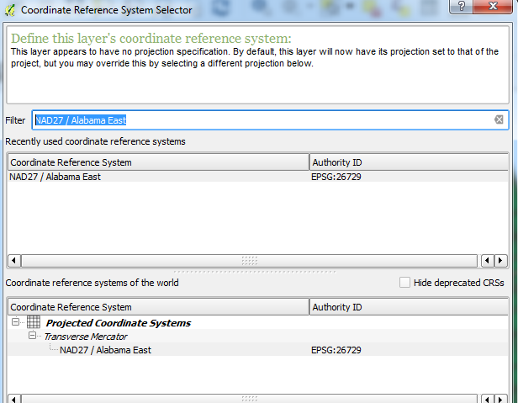
  - Select it under the list at the bottom; click Apply, Click Ok, Save your Project.

Part 2: Categorizing and Displaying GIS Data.
- Load the four (4) Vector Shapefiles located in the Alabama folder into your QGis Project and save.
- Arrange the layers in the following top to bottom manner:
  - RoadCLines
  - RoadEdges
  - Parcels
  - Blocks
- Adjust the colour for these layers for suitable viewing.
- Save your project.
- Open the attribute table for the Parcels Layer.
- Examine and become familiar with the field title headings. We will need to know these when we use the query builder function in QGIS.
- With the Parcels layer selected ( highlighted in the Layer area), right click and select Expression . 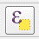The dialog box below should appear.

- Create an SQL(Expression) Statement to isolate and display all “R” zones from the ZONING_S field.
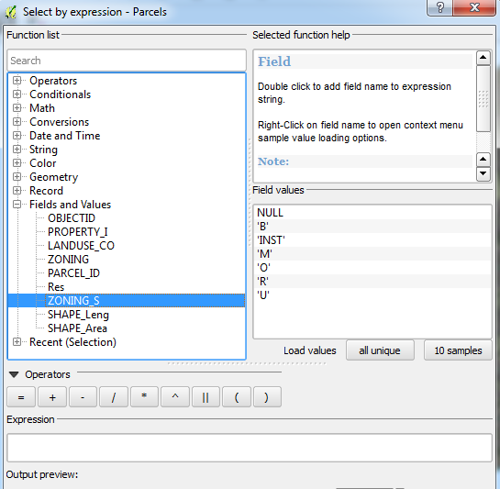
- Test your statement and exit the Expression Builder to view your results.

We will now examine some basic statistics about your selection that you created.
- Under the Vector Tab, select Analysis Tools, then Basic Statistics.
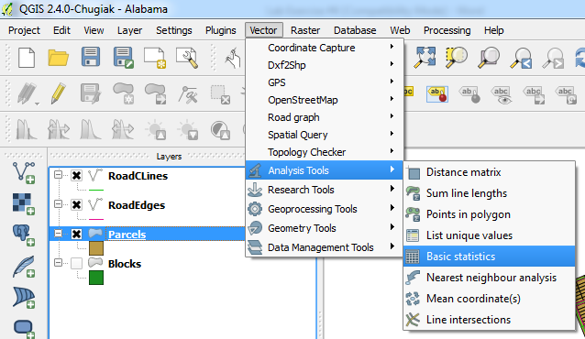
- Ensure you have the following parameters set prior to clicking ok.
- You will be given some basic stats on the selected features.
- REMEMBER to Unselect 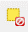your queried result by clicking on the Clear button. This must be done each time before starting an new expression.
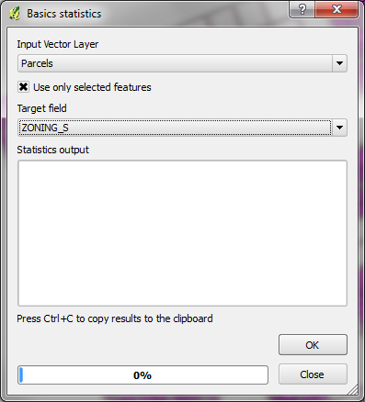
You can now see the merits of making the software do the work, rather than you spending time examining all the data to determine the results !
Annex A - Questions to be submitted for Grading. (Out of 10 marks)
- How many different values are there in the Zoning_S column? List them.
NULL '
B'
'INST'
'M'
'O'
'R'
'U'

- Create an SQL Query statement to identify and segregate all of the “R” Zones in the ZONING_S field.
Type the SQL Statement used : "ZONING_S" = 'R'

  - How many Parcels are zoned “R”?
2009 Parcels are Zoned R
  - What is the total area ( Sum in sq Yds) for all the “R” zones on the Parcel Layer?
20482584.51 squared yards

- The City Council has decided that for the summer of 2014, they will be re-paving the following streets:
  - Third St;
7093.990277 yards
4.03 miles

  - Ninth St;
7297.252202
4.15 miles

  - Twelveth St; and
6801.204124 yards
3.86 miles

  - Pepper Lane (Ln)
4638.901799 yards
2.64 miles

What is the total number of miles for the four (4) roads?
25831.3484 Yards
14.68 miles

(Careful – Shap_Leng field is in Yards !)
[Hint – Use the same procedure for question #2 to get your answer!]

Units - For questions # 2 and # 3, the units in the Layers for Parcels [SHAPE_Area] are sq yds and for RoadCLine [SHAPE_Leng] are yards.
This differs from the interactive measuring unit of metres that is set up in the project properties. As with Excel, if you are summing data in a column, it will not convert the data for you from yds to metres. It will leave the values as they are listed., in our case yards or square yards
MWP

