Organizational Behaviour
Mid term chapters : 1, 2, 5
What is Organizational Behaviour?
- Organizational behaviour: is a field of study devote to understanding, explaining, and ultimately improving the attitudes and behaviours of individuals and groups in organizations
- Human resources management: takes the theories and principles studied in OB and explores the “nuts and bolts” applications of those principles in organizations
  - Difference between HR vs OB
    - OB study might explore the relationship between learning and job performance
    - HR study might examine the best ways to structure training programs to promote employee learning
- Strategic management focuses on the product choices and industry characteristics that affect an organization’s profitability
    - Strategic management study might examine the relationship between firm diversification and firm profitability
The Role of Management Theory
- Scientific management: using scientific methods to design optimal and efficient work processes and tasks
  - Classical management scholars, Frederick Taylor (1856-1917) and Max Weber (1864-1920)
- Bureaucracy: an organizational form that emphasizes the control and coordination of its members through a strict chain of command, formal rules and procedures, high specialization, and centralized decision making
- Human relations movement: field of study that recogniz3es that the psychological attributes of individual workers and the social forces within work groups have important effects on work behaviour
An Integrative Model of OB
- Below is an integrative model of OB, that is designed to provide a roadmap for the field of organizational behaviour
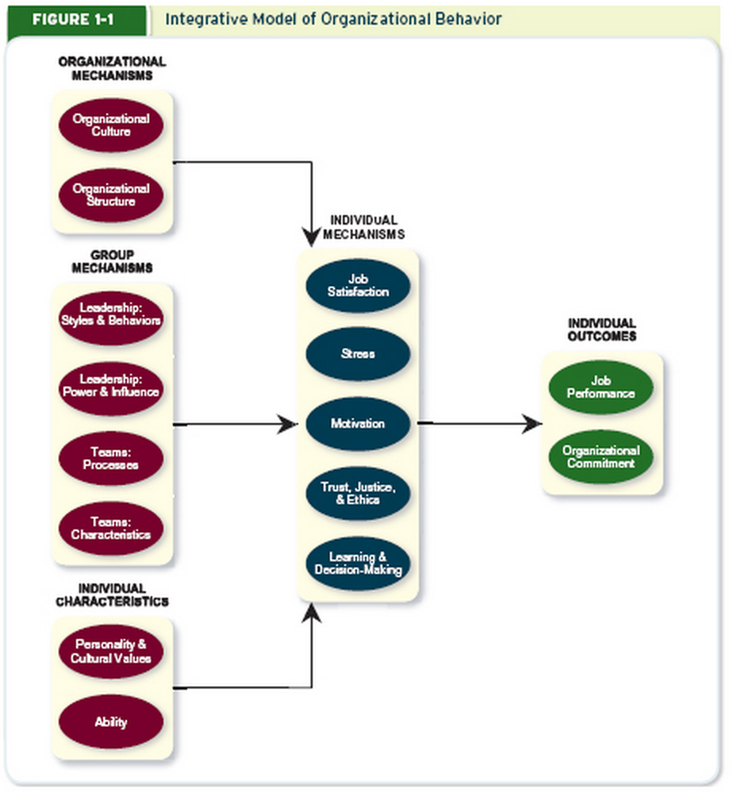

Individual Outcomes
- the 2 primary outcomes of interest to organizational behaviour researchers
  - job performance
  - organizational commitment
- Most employees have 2 primary goals
  - Perform their jobs well\
  - To remain members of an organization that they respect
- Most managers have 2 primary goals
  - To maximize their job performance
  - To retain these employees for a significant length of time
Individual Mechanisms
- There are a number of individual mechanisms that directly affect job performance and organizational behaviour
  - Job satisfaction captures what employees feel when thinking about their job and doing their day-to-day work
  - Stress reflects employees’ psychological response to job demands that tax or exceed their capacities
  - Motivation captures the energetic forces that drive employees’ work effort
  - Trust, justice, and ethics reflect the degree to which employees feel that their company conducts business with fairness, honesty, and integrity
  - Learning and decision making deals with how employees gain job knowledge and how they use that knowledge to make accurate judgments on the job
Individual Characteristics and Group Mechanisms
- Important to understand what factors improve individual mechanisms, focus on key individual characteristics
  - Personality, Cultural Values, and Ability
- The integrative model acknowledges that employees do not work alone
  - Work in one or more groups or teams led by some formal leader
- These group factors shape satisfaction, stress, motivation, trust and learning
- Explore the characteristics of an effective team
  - Their norms, member roles, and the way members depend on and relate to one another
- Describe team processes that explain how groups and teams behave, how members communicate and manage diversity
Organizational Mechanisms
- Individuals and groups function within an organizational context
The Value of an Integrative Model
Building a Conceptual Argument
- Resource-based view: a model that argues that rare and inimitable resources help firms maintain competitive advantage
  - This view suggest that resource is more valuable when it is rare
    - Rare: in short supply
    - Good people are rare, which makes them more valuable
    - If good people are rare, then the effective management of OB should prove to be a more valuable resource
  - This view also suggest that resource is more valuable when it is inimitable
    - Inimitable: incapable of being imitated or copied
    - Good people are more difficult to imitate
    - 3 reasons why people are inimitable
      - History
        - People create a history through a collective pool of experience, wisdom, and knowledge that benefits the organization
      - Numerous Small Decisions
        - This concept captures the idea that people make many small dicisions day in and day out.
        - Big decisions can viewed by competitors and copied easily
        - To successfully mimic a competitor it would be necessary to take into consideration all the little day-to-day decisions and trade-offs that employees make every day
        - Often invisible to competitors
      - Socially Complex Resources
        - People are the source of socially complex resources (culture, teamwork, trust, and reputation)
        - Not always clear how they came about, though it si clear which organizations do (and do not) possess them
        - Culture, teamwork, trust, and reputation spring from the social dynamics within a given organization at a given time (not easily copied)
Research Evidence
- Several research studies have been conducted on the topic, each employing a somewhat different approach
- One study gathered the following information for each firm:
  - Average annual rate of turnover
  - Productivity level
  - Market value of the firm
  - Corporate profitability
- The results revealed
  - One-unit increase in the proportion of the workforce involved in the practises was associated with
    - an approx. 7% decrease in turnover rate
    - $27,000 more in sales per employee
    - $18,000 more in market value
    - $3,800 more in profits
- Better OB practises better firm performance
- Another study surveyed 136 non-financial companies that made initial public offerings
  - The results revealed that firms that valued OB had a 19% higher survival rate than firms that did not value OB
SO What’s So Hard?
- Jeffrey Pfeffer provides on potential answer
  - The effective management of OB requires a belief that several different practises are important, along with a long-term commitment to improving those practices
  - Summarized by the rule of one-eight
    - The belief that at best one-eight, or 12% of organizations will actually do what is required to build profits by putting people first
How do we Know What we Know About Organizational Behaviour?
- Theory: a collection of verbal and symbolic assertions that specify how and why variables are related, as well as the conditions in which they should be related
  - Tells a story and supplies the familiar who, what, where, when and why
- Hypothesis: written predictions that specify relationships between variables
- Correlation: the statistical relationship between 2 variables
- What is the correlation between social recognition and job performance?
  - A study on burger king fast food drive-ins, found burger kings with social recognition had quick average times for drive through orders than those without
  - Also conclude that social recognition was just as effective as a financial “pay for performance” system
- Meta-analysis: a method that combines the results of multiple scientific studies by essentially calculating a weighted-average correlation across studies
Takeaways
- Organizational behaviour is a field of study devoted to understanding and explaining the attitudes and behaviours of individuals and groups in organizations. More simply, it focuses on why individuals and groups in organizations act the way they do
- The 2 primary outcomes in organizational behaviour are job performance and organizational commitment
- A number of factors affect performance and commitment, including individual mechanisms (job satisfaction; stress; motivation; trust; justice and ethics; learning and decision making), individual characteristics (personality, cultural values, and ability), group mechanisms (team characteristic, diversity, processes, and communication; power, influence, and negotiation; leader styles and behaviours) and organizational mechanisms (organizational structure and organizational culture and change)
- The effective management of organizational behaviour can help a company become more profitable because good people are a valuable resource. Not only are good people rare but they are also hard to imitate. They create history that cannot be bought or copied, they make numerous small decisions that cannot be observed by competitors, and they create socially complex resources such as culture, teamwork, trust, and reputation
- A theory is a collection of assertions, both verbal and symbolic, that specifies how and why variables are related, as well as the conditions in which they should be related. Theories about organizational behaviour are built from a combination of interviews, observation, research reviews, and reflection. Theories form the beginning point for the scientific method and inspire hypotheses that can be tested with data
- A correlation is a statistic that expresses the strength of a relationship between 2 varibales. In OB research, a 0.5 correlation is considered “strong”, a 0.30 correlation is considered “moderate” and a 0.10 correlation is considered “weak”

Chapter 2 - Job Performance
- Begin understanding the integrative model of organizational behaviour with job performance
  - Understanding one’s own performance is a critical concern for any employee, and understanding the performance of one’s unit is a critical concern for any manager
- Job performance: employee behaviours that contribute either positively or negatively to the accomplishment of organizational goals
What does it Mean to be a “Good Performer”?
- Behaviours of good job performer fall into 3 broad categories
  - Task performance
  - Citizenship behaviour
  - Counterproductive behaviour
Task Performance
- Task performance: employee behaviours that are directly involved in the transformation of organizational resources into the goods or services that the organization produces
  - Set of explicit obligations that an employee must fulfill to receive compensation and continued employment
- Routine task performance: well-known or habitual responses by employees to predictable task demands
- Adaptive task performance: thoughtful responses by an employee to unique or unusual task demands
- Creative task performance: ideals or physical outcomes that are both novel and useful
- Job analysis: a process by which an organization determines requirements of specific jobs
  - 3 steps involved in conducting job analysis
- list of all the activities involved in a job is generated
- Each activity on this list is rated by “subject matter experts” according to things like the importance and frequency of the activity
- The activities that are highly rated in terms of their importance and frequency are retained and used to define task performance
- National Occupational Classification: a national database of occupations in Canada, organizing over 30,000 job titles into 520 occupational group descriptions
Citizenship Behaviour
- Citizenship behaviour: voluntary employee behaviours that contribute to organizational goals by improving the context in which work takes place
- Research suggest 2 main categories differing according to who benefits from the activity: co-workers or the organization
  - Interpersonal citizenship behaviour
  - Organizational citizenship behaviour
- Interpersonal citizenship behaviour: going beyond normal job expectations to assist, support, and develop co-workers and colleagues
  - Helping: assisting co-workers who have heavy workloads, aiding them with personal matters, and showing new employees the ropes when they are first on the job
  - Courtesy: Sharing important information with co-workers
    - Keep others in the loop because they never know what information might be useful to someone else
  - Sportsmanship: maintaining positive attitude with co-workers through good and bad times
- Organizational citizenship behaviour: going beyond normal expectations to improve operations of the organization, as well as defending the organization and being loyal to it
  - Voice: speaking up to offer constructive suggestions for change, often in reaction to a negative work event
  - Civic virtue: participation in company operations at a deeper than normal level through voluntary meetings, readings, and keeping up with news that affects the company
  - Boosterism: positively representing the organization when in public
Counterproductive Behaviour
- Counterproductive behaviour: employee behaviours that intentionally hinder organizational goal accomplishment
  - Counterproductive behaviours can be grouped into 3 specific categories
    - Property deviance
    - Production deviance
    - Political deviance
- Property deviance: behaviours that harm the organization’s assets and possessions
  - Sabotage: purposeful destruction of equipment, organizational processes, or company products
  - Theft: stealing company products or equipment from the organization
- Production deviance: intentionally reducing organizational efficiency of work output
  - Wasting resources: using too many materials or too much time to do too little work
  - Substance abuse: the use of drugs or alcohol before coming to work or while on the job
- Political deviance: behaviours that intentionally disadvantage other individuals
  - Gossiping: casual conversations about other people in which the facts are not confirmed as true
  - Incivility: communication that is rude, impolite, discourteous, and lacking in good manners
  - Personal aggression: hostile verbal and physical actions directed toward other employees
  - Harassment: unwanted physical contact or verbal remarks from a colleague
  - Abuse: employee assault or endangerment from which physical and psychological injuries may occur
Summary: What Does it Mean to be a “Good Performer”
- Means someone is good at the particular job tasks that fall within his or her job description, whether those tasks are routine or require more adaptability
- Means the employee engages in citizenship behaviours directed at both co-workers and the larger organization
- Means they will refrain from engaging in the counterproductive behaviours that can badly damage the climate of the organization
Application: Performance Management
- Describe general ways in which job performance information is used to manage employee performance
- Spotlight 4 of most representative practises
  - Management by objectives
  - Behaviourally anchored rating scales
  - 360-degree feedback
  - Forced ranking
- How social networking software is being used for performance management purposes in organizations
Management by Objectives
- Management by objectives: a management philosophy that bases employee evaluations on whether specific performance goals have been met
- How it works
  - An employee meets with manager to develop a set of mutually agreed upon objectives that are measurable and specific
  - They both agree on the time period for achieving those objectives and the methods used to do so
  - Employee performance can be gauged by referring to the degree to which the employee achieves results that are consistent with the objectives
Behaviourally Anchored Rating Scales
- Behaviourally anchored rating scales: use of examples of critical incidents to evaluate an employee’s job performance behaviours directly
- BARS approach to create the following response anchors
  - 5 = Open-minded; learns new methods easily
  - 4 = Willing to make changes without much need for persuasion or supervision
  - 3 = Able to make changes with average amount of instruction
  - 2 = Requires persuasion and supervision to make changes
  - 1 = Unwilling to accept changes; does not adjust readily

360-Degree Feedback
- 360-Degree feedback: a performance evaluation system that uses ratings provided by supervisors, co-workers, subordinates, customers, and the employees themselves
- The idea is it will provide a more balanced and comprehensive examination of performance
- Problems with the application
  - Ratings may vary across sources, there is the question of which source is most correct
  - Raters may give biased evaluations if they believe that the information will be used for compensation, as opposed to just skill development
- Therefore, it is best suited to improving or developing employee talent, especially if the feedback is accompanied by coaching about how to improve the areas identified as points of concern
Forced Ranking
- Forced ranking: a performance management system in which managers rank subordinates relative to one another
  - Vitality curve;
    - top 20% are A players (possess the 4 Es of leadership)
      - high energy levels
      - ability to energize others
      - edge to make tough yes or no decisions
      - ability to consistently execute and deliver on promises
    - middle 70% are B players (backbone)
- Downfalls of forced ranking
  - Forces managers to give bad evaluations to employees who may be good performers
  - Employees become hypercompetitive with one another to avoid finding themselves in a lower category
Social Networking Systems
- Requiring employees to post or update weekly and quarterly goals, managers then monitor the information and provide feedback
- Advantages seen with using these technologies
  - Provide performance information that is much more timely, relative to traditional practises that measure performance quarterly or even yearly
  - Although might be unpleasant to learn from your peers that a presentation you gave is boring, it is better than giving 50 boring presentations and then getting the news from your boss
Takeaways
- Job performance is the set of employee behaviours that contribute to organizational goal accomplishment. Job performance has 3 dimensions; task performance, citizenship behaviour, and counterproductive behaviour
- Task performance includes employee behaviours that are directly involved in the transformation of organizational resources into the goods or services that the organization produces. Examples of task performance include routines task performance, adaptive task performance, and creative task performance
- Organizations gather information about relevant task duties using job analysis and the National Occupational Classification (NOC)
- Citizenship behaviours are voluntary employee activities that may or may not be rewarded but that contribute to the organization by improving the overall quality of the setting in which work takes place. Examples of citizenship behaviour include helping, courtesy, sportsmanship, voice, civic virtue, and boosterism
- Counterproductive behaviours are employee behaviours that intentionally hinder organizational goal accomplishment. Examples of counterproductive behaviour are sabotage, theft, wasting resources, substance abuse, gossiping, incivility, harassment, and abuse
- MBO, BARS, 360-degree feedback, and forced ranking practises are 4 way that organizations can use job performance information to manage employee performance

Chapter 3 – Organizational Commitment
- Organizational Commitment: an employee’s desire to remain a member of an organization
- Organizational commitment is important because yo want to be able to retain employees that are talented for a long period of time so the organization can benefit from their efforts
  - The most immediate cause of all forms of withdrawal behaviour is the level of overall commitment felt by an individual
- Estimates suggest the cost of turnovers
  - 0.5 times the annual salary plus benefits to replace an hourly worker
  - 1.5 times the annual salary plus benefits to replace a salary employee
  - 5 times the annual salary plus benefits to replace an executive
- Withdrawal behaviour: employee actions that are intended to avoid work situations
What Does it Mean to be “Committed”
Forms of Commitment
- Affective commitment: an employee’s desire to remain a member of an organization due to a feeling of emotional attachment
- Continuance commitment: an employee’s desire to remain a member of an organization due to an awareness of the costs of leaving
- Normative commitment: an employee’s desire to remain a member of an organization due to a feeling of obligation
- Although people place different weightings of importance on each type of commitment, they are important insight into why someone might be committed and what an organization can do to make employees feel more committed
- Focus of commitment: the people, places, and things that inspire a desire to remain a member of an organization
Affective Commitment
- What would it feel like if you leave your organization
  - Those who feel a sense of sadness, have identified themselves with the organization, accept that organization’s goals and values and are more willing to exert extra effort on behalf of the organization
  - since affective commitment reflects emotional bond to the organization, its only natural that the emotional bonds among co-workers influence it.
- Erosion model: a model that suggests that employees with fewer bond with co-workers are more likely to quit the organization
- Social influence model: a model that suggests that employees with direct linkages to co-workers who leave the organization will themselves become more likely to leave
Continuance Commitment
- Continuance commitment exist when there is a benefit associated with staying and a cost associated with leaving
- Factors that affect continuance commitment
  - The total amount invested (in terms of time, effort, energy, etc.) that an employee has made in mastering his or her work role or fulfilling his or her organizational duties
  - Lack of employment alternatives
    - Depends on factors like; economic conditions, the unemployment rate, and the marketability of a person’s skills and abilities
  - Embeddedness: an employee’s connection to and sense of fit in the organization and community
Normative Commitment
- Normative commitment exist when there is a sense that staying is the “right” or “moral” thing to do.
- A many ways to build a sense of obligation-based commitment among employees
  - Personal work philosophies
  - Organizational socialization
  - Create a feeling that the employee is in the organization’s debt
  - Programs aimed at promoting inclusiveness and workplace integration, the company helps these new Canadians obtain their Canadian professional designations through a technical mentoring and development program
Withdrawal Behaviour
Scenario: you’ve been working at your company for 3 years, and served on a key product development team for past several months. Unfortunately, the team has been struggling of late. In an effort to enhance the team’s performance, the organization has added a new member to the group. This member has a solid history of product development but is, by all accounts, a horrible person to work with. You can easily see the employee’s talent bt find yourself hating every moment spent in that person’s presence. This situation is particularly distressing because the team won’t finish its work for another nine months at the earliest. What would you do in this situation?
- Research suggest you might respond in one of 4 ways
  - You may exit: a response to a negative work event in which one becomes often absent from work or voluntarily leaves the organization
    - This is an active, destructive action by which an individual either ends or restricts organizational membership
  - May voice: a response, often in reaction to a negative work event, in which an employee offers constructive suggestions for change
    - This is an active, constructive action in which individuals attempt to improve the situation
  - You may reacting in loyalty: a passive response to a negative work event in which one publicly supports the situation but privately hopes for improvement
    - Passive, but constructive action
  - You may neglect: a passive, destructive response to a work event in which one’s interest and effort in work decline
- Organizational commitment should decrease the likelihood that an individual will respond to a negative work event with exit or neglect
- Organizational commitment should increase the likelihood that an individual will respond to a negative work vent with voice or loyalty
- Withdrawal behaviour comes in 2 forms
  - Psychological withdrawal: mentally escaping the work environment
    - Daydreaming: a form of psychological withdrawal in which one’s work is interrupted by random thoughts or concerns
    - Looking busy: a form of psychological withdrawal in which one attempts to appear consumed with work when not performing actual work tasks
    - Cyberloafing: a form of psychological withdrawal in which employees surf the Internet, e-mail, and instant message to avoid doing work-related activities
    - Socializing: a form of psychological withdrawal in which one verbally chats with co-workers about non-work topics
    - Moonlighting: a form of psychological withdrawal in which employees use work time and resources to do non-work related activities
  - Physical withdrawal: a physical escape from the work environment
    - Tardiness: a form of physical withdrawal in which employees arrive late to work or leave work early
    - Long Breaks: a form of physical withdrawal in which employees take longer-than-normal lunches or breaks to spend less time at work
    - Missing Meetings: a form of physical withdrawal in which employees neglect important work functions while away from the office
    - Absenteeism: a form of physical withdrawal in which employees do not how up for an entire day of work
    - Quitting: a form of physical withdrawal in which employees voluntarily leave the organization
- Independent forms model: a model that predicts various withdrawal behaviours are uncorrelated, so that engaging in one type of withdrawal has little bearing on engaging in other types
  - EX: “I can’t stand my job, so I do what I can to get by. Sometimes I’m absent, sometimes I socialize, and sometimes I come in late. There’s no real rhyme or reason to it; I just do whatever seems practical at the time.”
- Compensatory forms model: a model indicating that the various withdrawal behaviours are negatively correlated, so that engaging in one type of withdrawal makes one less likely to engage in other types
  - EX: “I can’t handle being around my boss. I hate to miss work, so I do what’s needed to avoid being absent. I figure if I socialize a bit and spend some time surfing the web, I don’t need to ever be absent. But if I couldn’t do those things, I’d definitely have to stay home… a lot”
- Progression model: a model indicating that the various withdrawal behaviours are positively correlated, so that engaging in one type of withdrawal makes one more likely to engage in other types
  - EX: “I just don’t have any respect for my employer anymore. In the beginning, I’d daydream a bit during work or socialize with my colleagues. As time went on, I began coming late or taking long lunch. Lately I’ve been staying home altogether, and I’m starting to think I should just quit my job and go somewhere else.”
Summary: What Does it mean to be “Committed”?
- It means that the employee has a strong desire to remain a member of the organization, maybe because he or she wants to stay, needs to stay, or feels they ought to stay.
  - Retaining employees means stopping the progression of withdrawal that begins with psychological forms and escalates to behavioural forms
- Note that psychological withdrawal goes on to affect physical withdrawal, which represents the progressive nature of such behaviours
Trends that Affect Commitment
Diversity of the Workforce
- the ethnicity of workers is expected to change, with visible minorities making up 1/3 of the Canadian labour force
- the age of the workforce is going to change, as the bulk of baby boomers will be retiring reducing the overall supply of talent and changing the age structure within organizations
  - medical advances are helping older employees remain vital longer
  - baby boomers are very educated and their prolonged work time can help economic output
- As the economy become more global, more and more employees are foreign born.
  - These employees may feel less embedded in their current jobs
  - May reduce the sense of continuance commitment
The Changing Employee-Employer Relationship
- A few generations ago, employees assumed they would work for a single organization for their entire career
- In 1980s and 1990s as downsizing became more common, increases in temporary workers and outsourcing fundamentally altering the way employees view their relationships with their employers
  - Downsizing: a form of involuntary turnover, when employees are forced to leave the organization regardless of their previous levels of commitment
- Downsizing doesn’t usually work
  - It revolves around the organizational commitment levels of the “survivors”
  - The employees who remain with the organization after downsizing are often stricken with “survivor syndrome”
    - Survivor syndrome is characterized by anger, depression, fear, distrust, and guilt
    - it tends to reduce organizational commitment
  - Creates a challenge to maintain affective commitment
  - Creates a challenge to maintain normative commitment
    - The sense that people should stay with their employer may have been eroded by downsizing, with personal work philosophies now focusing on maximizing marketability for the next opportunity
- Psychoogical contracts: employee beliefs about what employees owe the organization and when the organization owes them
- Transactional contracts: psychological contracts that focus on a narrow set of specific monetary obligations
- Relational contracts: psychological contracts that focus on a broad set of open-ended and subjective obligations
Application: Commitment Initiatives
- Perceived Organizational support: the degree to which employees believe that the organization values their contributions and cares about their well-being
Takeaways
- Organizational commitment is the desire on the part of an employee to remain a member of the organization. Withdrawal behaviour is a set of actions that employees perform to avoid the work situation. Commitment and withdrawal are negatively related to each other- the more committed employees are, the less likely they are to engage in withdrawal
- There are 4 forms of organizational commitment. Affective commitment occurs when employees want to stay and is influenced by the emotional bonds between employees. Continuance commitment occurs when employees need to stay and is influenced by salary and benefits and the degree to which they are embedded in the community. Normative commitment occurs when employees feel that they ought to stay and is influenced by an organization investing in its employees or engaging in charitable efforts
- Employees can respond to negative work vents in 4 ways: exit, voice, loyalty, and neglect. Exit is a form of physical withdrawal in which the employee either ends or restricts organizational membership. Voice is an active and constructive response by which employees remain supportive while hoping the situation improves on its own. Neglect is a form of psychological withdrawal in which interest and effort in the job decrease
- Examples of psychological withdrawal include daydreaming, socializing, looking busy, moonlighting, and cyberloafing. Examples of physical withdrawal include tardiness, long breaks, missing meetings, absenteeism, and quitting. Consistently with the progression model, withdrawal tend to start with minor psychological forms before escalating to more major physical varieties
- The increased diversity of the workforce can reduce commitment if employees feel lower levels of affective commitment or become less embedded in their current jobs. The employee-employer relationship, which has changed due to decades of downsizing, can reduce affective and normative commitment, making it more of a challenge to retain talented employees
- Organizations can foster commitment among employees by fostering perceived organizational support, which reflects the degree to which the organization cares about employees’ well-being. Commitment an also be fostered by specific initiatives directed at the 3 commitment types

Chapter 4- Job Satisfaction
Job Satisfaction
- Job satisfaction: a pleasurable emotional state resulting from the appraisal of one’s job or job experiences; represents how a person feels and thinks about their job
- Top drivers of job satisfaction are:
  - Money
  - Corporate cuture
  - Opportunity to use skills
  - Opportunity to learn
  - Ability to be creative
Why are Some Employees More Satisfied Than Others?
- Employees are satisfied when their job provides the things they value
  - Value: things that people consciously or unconsciously want to seek or attain
Value Fulfillment
- Value-percept theory: a theory that argues that job satisfaction depends on whether the employee perceives that their job supplies those things that they value
  - Dissatisfaction = (V_{want} – V_{have}) x (V_{importance})
    - V_{want} reflects how much of a value an employee wants
    - V_{have} reflects how much of that value the job supplies
    - V_{importance} reflects how important the value is to the employee
- People evaluate job satisfaction according to specific facets of the job
  - Pay satisfaction: employees feelings about the compensation for their jobs
  - Promotion satisfaction: employees feeling about how the company handles promotions
  - Supervision satisfaction: employees’ feelings about their boss, including their competency, communication, and personality
  - Co-worker satisfaction: employees’ feelings about their co-workers, including their abilities and personalities
  - Satisfaction with work itself: employees’ feelings about their actual work tasks
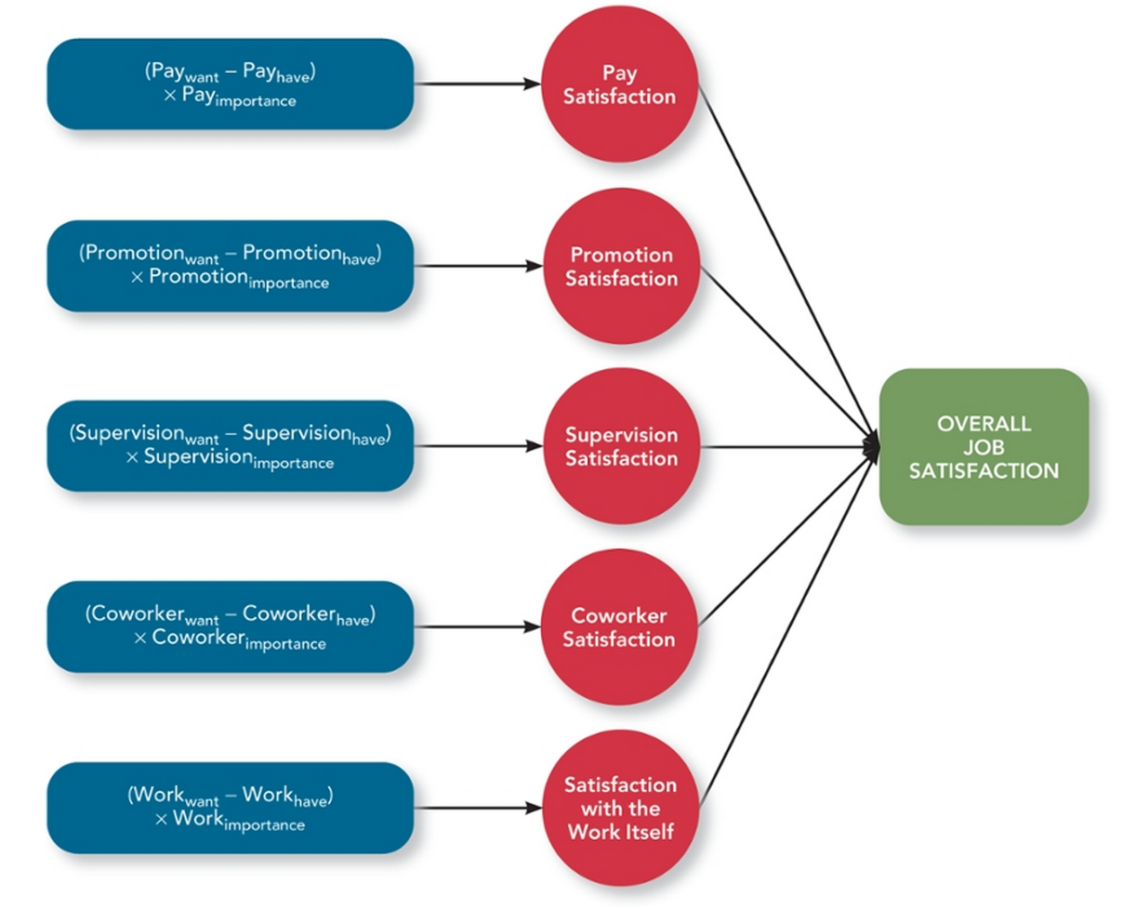
Satisfaction with the Work Itself
- 3 critical psychological states make work satisfying
  - Meaningfulness of work: a psychological state indicating the degree to which work tasks are viewed as something that counts in the employee’s system of philosophies and beliefs
  - Responsibility for outcomes: a psychological stat indicating the degree to which employees feel they are key drivers of the quality of work output
  - Knowledge of results: a psychological state indicating the extent to which employees are aware of how well or how poorly they are doing
- Job characteristics theory: a theory that argues that 5 core characteristics (variety, identity, significance, autonomy, and feedback) combine to result in high levels of satisfaction with the work itself
  - Variety: the degree to which a job requires different activities and skills
  - Identity: the degree to which a job offers completion of a whole identifiable piece of work
  - Significance: the degree to which job really matters and impacts society as a whole
  - Autonomy: the degree to which job allows individual freedom and discretion regarding how the work is to be done
  - Feedback: in job characteristics theory, the degree to which the job itself provides information about how well the job holder is doing
- 2 other variables employees want
  - Knowledge and skill: the degree to which the employees have the aptitude and competence needed to succeed on their job
  - Growth need strength: the degree to which employees desire to develop themselves further
Mood and Emotions
- Job satisfaction reflects what you think and feel about your job, and this can fluctuate over time
- Part is rational, appraisal of the job and things it supplies. The other part is emotional, which varies thought the day for better or worse
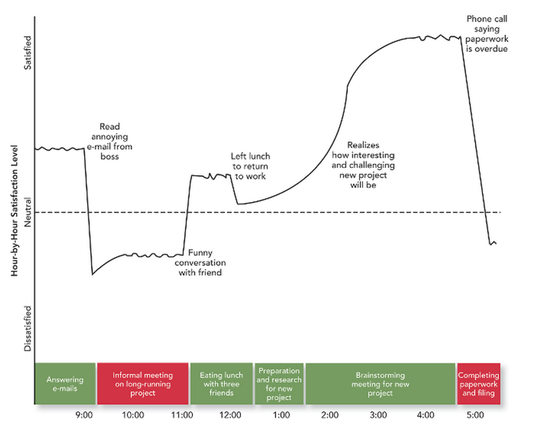
- 2 concepts that affect flows of satisfaction
  - Moods: states of feeling that are mild in intensity, last for an extended period of time, and are not directed at anything
    - Moods categorized in 2 ways: pleasantness, engagement
    - Affective events theory: a theory that describes how workplace events can generate emotional reactions that impact work behaviours
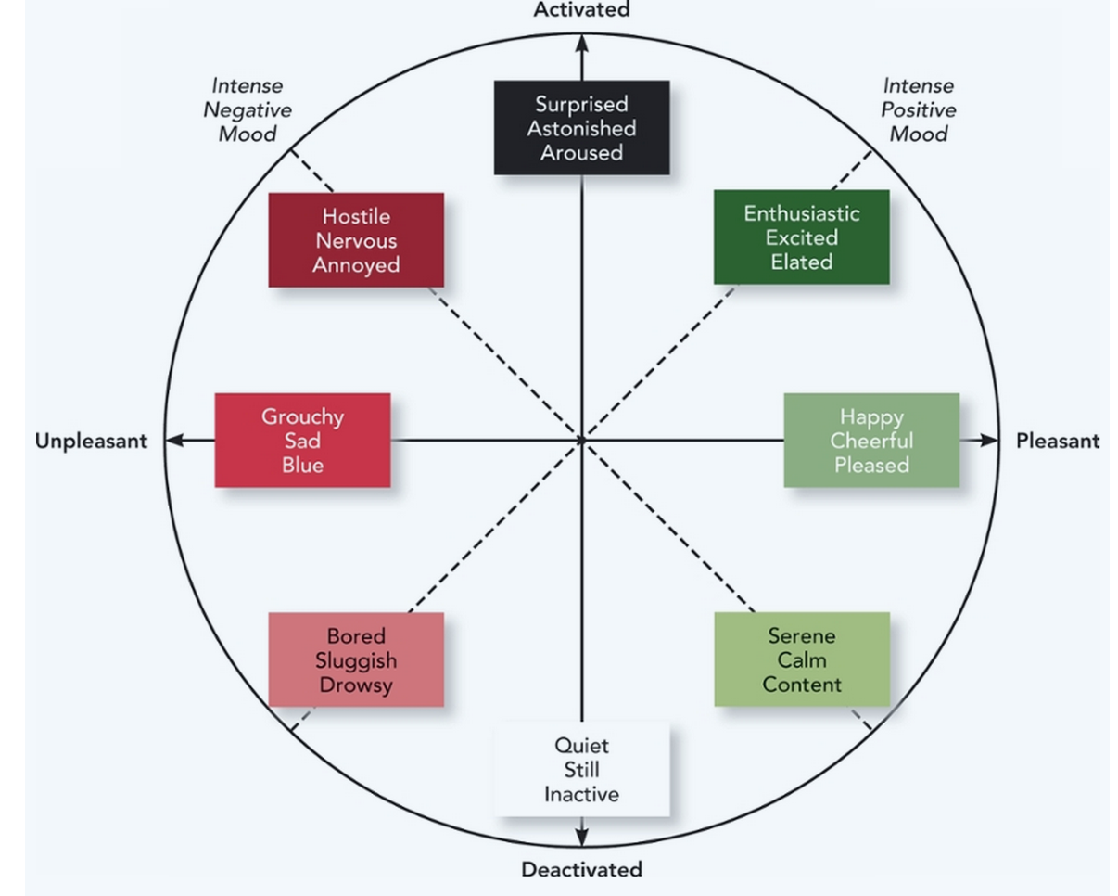
  - Emotions: intense feelings, often lasting for a short duration, that are clearly directed at someone or some circumstance
    - Difference in moods and emotions comes from how describe them to others
      - Mood: “I’m feeling grouchy”
      - Emotions: “I’m feeling angry at my boss”
    - Positive emotions: employees’ feeling of joy, pride, relief, hope, love, and compassion
    - Negative emotions: employees’ feelings of fear, guilt, shame, sadness, envy, and disgust
    - Emotional labour: the management of their emotions that employees must do to complete their job duties successfully
    - Emotional contagion: the idea that emotions can be transferred from one person to another
Summary: Why are Some Employees More Satisfied than Others?
- The rational appraisals people make about their job and the things it supplies for them
  - Pay, promotions, supervision, co-workers, and the work itself
- Satisfaction with work itself, is affected by 5 core job characteristics
  - Variety, identity, significance, autonomy, and feedback
- Daily fluctuations in how people feel
  - Positive and negative moods
  - Positive and negative emotions
How important is Job Satisfaction
- Job satisfaction is moderately correlated with task performance and creativity
  - Positive feelings improve task persistence and attract more help and support from colleagues
- Job satisfaction is moderately correlated with citizenship behaviour
  - Satisfied employees engage in more frequent “extra-mile” behaviours to help their co-workers and their organization
  - Positive feelings increase their desire to interact with others and often result in spontaneous acts of helping and other instances of good citizenship
- Job satisfaction is moderately negatively correlated with counterproductive behaviour
- Job satisfaction influences organizational commitment
  - Job satisfaction is strongly correlated with affective commitment
    - Why would employees want to leave a place where they’re happy?
  - Job satisfaction is strongly correlated with normative commitment
    - Satisfied employees are more likely to feel an obligation to remain with their firm and need to “repay” the organization for wtv it is that makes them so satisfied
  - Job satisfaction is uncorrelated with continuance commitment
    - Satisfaction does not create a cost-based need to remain with the organization

Life Satisfaction
- Life satisfaction: the degree to which employees feel a sense of happiness with their lives in general
- Connection between job satisfaction and life satisfaction makes sense given how much of our lives are spent at work
  - Increases in job satisfaction have a stronger impact on life satisfaction than do increases in salary or income
Application: Tracking Satisfaction
- Job Descriptive Index (JDI): a facet measure of job satisfaction that assesses an individual’s satisfaction with pay, promotion opportunities, supervision, co-workers, and the work itself
- Developpers suggest a few guide lines
  - Everyone must participate
  - Surveys be anonymous, for honesty
  - Some demographic information is important but too much will make them feel like they could be identified
  - Administered by the firm’s human resources group or outside consulting agency
- Data is collected and question to be explored
  - Data can indicate whether the organization is satisfied or dissatisfied by comparing average scores
  - Compare organization’s scores with national norms
  - Allow for within-organization comparisons to determine which departments have highest and lowest levels of satisfaction
- Results
  - Fed back employees
  - Improvement effort
  - Organization should be prepared to react to survey with specific goals and action steps
  - Organization that struggles with satisfaction could attempt to redesign key job tasks, increasing the 5 core job characteristics
Takeaways
- Job satisfaction is a pleasurable emotional state resulting from the appraisal of one’s job or job experiences. It represents how you feel about your job and what you think about your job
- Values are things that people consciously or subconsciously want to seek or attain. According to value-percept theory, job satisfaction depends on whether you perceive that your job supplies those things that you values
- Employees consider a number of specific facets when evaluating their job satisfaction. These facets include pay satisfaction, promotion satisfaction, supervision satisfaction, co-worker satisfaction, and satisfaction with the work itself
- Apart from the influence of supervision, co-workers, pay and work itself, job satisfaction levels fluctuate during the course of the day. Rises and falls in job satisfaction are triggered by positive and negative events that are experienced. Those events trigger changes in emotions that eventually give way to changes in mood
- Moods are stats of feeling that are often mild in intensity, last for an extended period of time, and are not explicitly directed at anything. Intense positive moods include being enthusiastic, excited, and elated. Intense negative moods include being hostile, nervous, and annoyed. Emotions are states of feeling that are often intense, last only a few minutes, and are clearly directed at someone or some circumstance. Positive emotions include joy, pride, relief, hope, love, and compassion. Negative emotions include anger, anxiety, fear, guilt, shame, sadness, envy, and disgust
- Job satisfaction has a moderately positive relationship with job performance and a strong positive correlation with organizational commitment. It also has a strong positive relationship with life satisfaction
- Organizations can assess and manage job satisfaction using attitude surveys such as the Job Descriptive Index (JDI), which assesses pay satisfaction, promotion satisfaction, supervisor satisfaction, co-worker satisfaction, and satisfaction with the work itself. It can be used to assess the lvels of job satisfaction experienced by employees, and its specific facet scores can identify interventions that could be helpful

Chapter 5 – Stress

Stress
- Stress: the psychological response to demands when there is something at stake for the individual, and when coping with these demands would tax or exceed the individual’s capacity or resources.
- Stress depends on the nature of the demand and the person who confronts it
    - Stressors: demands that cause the stress response
      - Performance expectations
    - Strains: Negative consequences of the stress response
      - Anxiety
  - EX: Feeling toward the end of a semester
Why are Some Employees More “Stressed” Than Others
- Transactional theory of stress: a theory that explains how stressful demands are perceived and appraised, as well as how people respond to the perceptions and appraisal
- (Step) process of appraisal: evaluation of whether a demand is stressful and, if it is, the implications of the stressor in terms of personal goals and well-being
- Demand causes stress, (Implications of the stressor in terms of their personal goals and overall well-being)
    - Benign job demands: job demands that are not appraised as being stressful
Types of Stressors
- Hindrance stressors: stressors that tend to be appraised as thwarting progress toward growth and achievement
- Challenge stressors: stressors that tend to be appraised as opportunities for growth and achievement

Work Hindrance stressors
  - Various roles we fill at work are source of different types of work related hindrance stressors
  - Types of work-related hindrance stressors’
    - Role conflict: others’ having differing expectations of what an individual needs to do in a role
    - Role ambiguity: a lack of direction and information about what needs to be done in a role
    - Role overload: an excess of demands on an employee preventing him or her from working efficiently
    - Daily hassles: reflects the relatively minor day-to-day demands that get in the way of accomplishing the things that we really want to accomplish

Work Challenge Stressors
- Types of work related challenge stressors’
  - Time pressure: the sense that the amount of time allotted to do a job is not quite enough
  - Work complexity: the degree to which job requirements tax or just exceed employee capabilities
  - Work responsibility: the number and importance of the obligations that an employee has to others
Non-Work Hindrance Stressors
- Work-family conflict: a form of role conflict in which the demands of a work role hinder the fulfillment of the demands in a family role (or vice versa)
  - Employees who have trouble switching off the frustration after they go home, become irritable and impatient with family and friends
- Negative life events: events such as a divorce or death of a family member that tend to be appraised as a hindrance
- Financial uncertainty: uncertainties with regard to the potential for loss of livelihood, savings, or the ability to pay expenses

Non-Work Challenge Stressors
- Family time demands: the amount of time committed to fulfilling family responsibilities
- Personal development: participation in activities outside of work that foster growth and learning
- Positive life events: events such as marriage or the birth of a child that tend to be appraised as a challenge
How Do People Cope With Stressors?
- According to transactional theory of stress, after people appraise a stressful demand, they ask themselves “What should I do” and “What Can I do?” to deal with this situation
  - These are, the secondary appraisal: when people determine how to cope with the various stressors they face
    - Coping : behaviours and thoughts used to manage stressful demands and the emotions associated with the stressful demands
    - Types of coping
      - Behavioural coping: physical activities used to deal with a stressful situation
        - EX: cope by doing more work, cope by avoiding work
      - Cognitive coping: thoughts used to deal with a stressful situation
        - EX: Cope by thinking of different ways of accomplishing a task
        - EX: Cope by convince oneself that tasks are that bad after all
      - Problem focused coping: behaviours and cognitions of an individual intended to manage the stressful situation itself
      - Emotion-focused coping: behaviours and cognitions of an individual intended to help manage emotional reactions to the stressful demands
    - The choice of a coping strategy has important implications for how effectively people can meet or adapt to the different stressors that they face
      - Choose how to cope by a set of beliefs
      - Choose how to cope based on a particular strategy gives them some degree of control over the stressor
    - The factors that determine how people develop a sense of control
      - The nature of stressful demand itself
        - People are likely to feel less control over a stressor when they appraise it as a hindrance rather than a challenge
The Experience of Strain
- We previously defined strain as negative consequences associate with stress
- How does stress cause strain?
  - The body has a set of responses that allow it to adapt and function effectively in the face of stressful demands, but if the stressful demands do not ramp down or the demands occur to frequently, the body’s adaptive responses become toxic
  - if the chemicals in the blood remain elevated because of a prolonged stressor, the body begin to break down,
- Negative consequences
  - Physiological strains: reactions from stressors that harm the human body
    - Stressors can reduce the effectiveness of body’s immune system
    - Stressor can harm the body’s cardiovascular system, cause the heart to race, increase blood pressure, and create coronary artery disease
    - Stressors can cause problems with the body’s musculoskeletal system
    - Stressors cause gastrointestinal system problems
  - Psychological strains: Negative psychological reactions from stressors such as depression, anxiety, and anger
    - Burnout: the emotional, mental. And physical exhaustion from coping with stressful demands on a continuing basis
  - Behavioural strains: patterns of negative behaviours that are associated with other strains
Accounting For Individuals in the Stress Process
- Types of ways people react to stressful demands
  - Type A Behaviour Pattern: people who tend to experience more stressors, to appraise more demands as stressful, and to be prone to experiencing more strains
    - Strong sense of time urgency and tend to be impatient
  - Type B Behaviour Pattern: people who tend to experience less stressor, to appraise less demands as stressful, and to be prone to experiencing less strains
  - First, type may have more a direct influence on the level of stressors that a person confronts
- Social support: the help people receive from others when they are comfronted with stressful demands
- Instrumental support: the help people receive from others that can be used to address a stressful demand directly
- Emotional support: the empathy and understanding people receive from others that can be used to alleviate emotional distress from stressful demands
- Social support can influence the stress process in several ways
- Social support focuses on how it buffers the relationship between stressors and strains
  - According to research, high levels of social support provide a person with instrumental or emotional resources that are useful for coping with the stressor
Summary: Why are some Employees more “Stressed” than Others?
- A person level of stress depends on a few factors
  - The stressors the employee is experiencing, hindring and challenge stressors originating in both work and non-work domains
  - How those stressors are appraised and coped with, determines whether physiological, psychological, and behavioural strains are experienced
  - Whether the employee is Type A or Type B and whether the employee has a high or low amount of social support
How Important is Stress?
- Check the integrative model
  - Hindrance stressors have a weak negative relationship to job performance
  - Hindrance stressors have strong negative relationship with organizational commitment
  - Challenge stressors have a weak relationship with job performance
  - Challenge stressors have a moderate relationship with organizational commitment
Application: Stress Management
Assessment
- Stress audit: an assessment of the sources of stress in the workplace
  - First category of questions might involve the degree to which the organization is going through change that would likely increase uncertainty among employees
  - Second category of questions might center around work itself
  - Third category of questions may involve the quality of relationships not only among employees but also between employees and the organization
Reducing Stressors
- After stress audit reveals a problem, next step is alternative course of action, accomplished in 2 ways
  - Organization could try to eliminate or significantly reduce stressful demands
    - Job sharing: when 2 people share the responsibilities of a single job
  - Employee sabbaticals: gives employees the opportunity to take time off from work to engage in an alternative activity

Providing Resources
- As a supplement to reducing stressors, organizations can provide resources that help employees cope with stressful demands
  - Training interventions: practices that increase employees’ competencies and skills
    - Sense that demands are more controllable
  - Supportive practices: ways in which organizations help employees manage and balance their demands
    - Flexible hours give employees the ability to cope with demands away from work
    - Allowing workers to work from home
    - Making an effort to accommodate and support employees who are returning to work after a disabling injury or illness, or after a lengthy leave, not only facilitates successful reintegration but conveys a message, the organization cares about and values its members
    - Managers can be trained how their behaviours help or hinder heir employees’ efforts to cope
Reducing Strains
- Organizations use practices that reduce strains, types of strain-reducing practice involve
  - Relaxation techniques: calming activities to reduce stress
    - Teach people how to counteract the effects of stressors by engaging in activities that slow the heart rate, breathing rate, and blood pressure
  - Cognitive-behavioural techniques: various practices that help workers cope with life’s stressors in a rational manner
    - Involves self-talks, people learn to say things about stressful demands that reflect rationality and optimism
  - Health and wellness programs: employee assistance programs that help workers with personal problems such as alcoholism and other addictions
Takeaways
- Stress refers to the psychological response to demands when there is something at stake for the individual and coping with these demands would tac or exceed the individual’s capacity or resources. Stressors are the demands that cause the stress response, and strains are the negative consequences of the stress response
- Stressors come in 2 general form: challenge stressors, which are perceived as opportunities for growth and achievement, and hindrance stressors, which are perceived as hurdles to goal achievement. These 2 stressors can be found in both work and non-work domains.
- Coping with stress involves thought and behaviours that address one of 2 goals: addressing the stressful demand or decreasing the emotional discomfort associated with the demand
- Individual differences in the Type A Behaviour Pattern affect how people experience more stressors, appraise more demands as stressful, and be prone to experiencing more strains. Another individual factor is the degree of social support that is experienced
- The effects of stress depend on he type of stressor. Hindrance stressors have a weak negative relationship with job performance and a strong negative relationship with organizational commitment. In contrast, challenge stressors have a weak positive relationship with job performance and a moderate positive relationship with organizational commitment
- Because of high costs associated with employee stress, organizations assess and manage stress using a number of different practices. In general, these practices focus on reducing or eliminating stressors, providing resources that employees can use to cope with stressors, or trying to reduce the strains.

Chapter 6- Motivation
Motivation
- Motivation: a set of energetic forces that determine the direction, intensity, and persistence of an employee’s work effort
  - Effective job performance requires high levels of both ability and motivation
- Motivation is a set of distinct forces, both internal and external
- Motivation determines a number of facets of an employee’s work effort
- Motivation determines what employees do at a given moment, the direction in which their effort is channelled
- Engagement: a widely used term in contemporary workplaces that has different meanings depending on the context; most often refers to motivation, but it can refer to affective commitment
Why are some Employees More Motivated Than Others?
Expectancy Theory
- Expectancy theory: a theory that describes the cognitive process employees go through to make choices among different voluntary responses

Expectancy
- Expectancy: the belief that exerting a high level of effort will result in successful performance on some task
- Factors that shape our expectancy
  - Self-efficacy: the belief that a person has the capabilities needed to perform the behaviours required on some task
    - Employees consider efficacy levels they consider
      - Past accomplishments
      - Verbal persuasion because friends, co-workers, and leaders can persuade employees that they can get the job done
      - Dictated by emotional cues, in that feelings of fear or anxiety can create doubts about task accomplishment
    - Efficacy sources shape analyses of how difficult the task requirement are and how adequate an employee’s personal and situation resources will prove to be
Instrumentality
- Instrumentality: the belief that successful performance will result in some outcome or outcomes

Valence
- Valence: the anticipated value of the outcome(s) associated with successful performance
  - Positive valence outcomes; slarary increases, bonuses, rewards
  - Negative valence outcomes: disciplinary ations, demotions, and terminations
- What makes some outcomes more positively valenced
  - Needs: groupings or clusters of outcomes viewed as having critical psychological or physiological consequences
  - Growth opportunity
  - Social oppprtunity
  - Attractive outcomes satisfy a number of different needs
  - Extrinsic motivation: desire to put forth work effort due to some contingency that depends on task performance
  - Intrinsic motivation: desire to put forth work effort due to the sense that task performance serves as its own reward
- Meaning of money: the idea that money can have symbolic value in addition to economic value
Motivational Force
- The direction of effort iss dictated by 3 beliefs: expectancy (E P), instrumentality (p O) and valence (V)
- Expectancy theory suggest that the total motivational force to perform a given action described using this formula
  - Motivational Force = (EP) X (∑[(PO) X V]
  - Note: signs in the formula; motivational forces equals zero if any one of the 3 beliefs is zero
Goal Setting Theory
- Goal setting theory: a theory that views goals as the primary drivers of the intensity and persistence of effort
  - theory argues that assigning employees specific and difficult goals will result in higher levels of performance than assigning no goals, easy goals, or do your best goals
    - specific and difficult goals: goals that stretch an employee to perform at their max level while still staying within the boundaries of their ability
- A difficult goal is one that stretches employees to perform at their max level while staying within the boundaries of their ability
- When motivating someone, what needs to change are the goals people set for themselves
    - Self-set goals: the internalized foals that people use to monitor their own progress
      - People use to monitor their own task progress that have been shown to drive motivation and behaviour
      - Goal setting work well when the assigned goal alters the level of the self-set goal
        - Goals mobilize energy and effort levels
        - Affecting effort intensity, want to reach a specific and difficult goal causes people to persist at tasks even when they experience difficulties
        - Having a specific goal triggers people to think about and consider different ways of reach their goals
    - Feedback: in goal setting theory refers to progress updates on work goals
    - Task complexity: the degree to which the information and actions needed to complete a task are complicated
    - Goal commitment: the degree to which a person is determined to reach the goal
    - S.M.A.R.T. goals: Stands for Specific, Measurable, Achievable, Result-based, Time-sensitive goals

