- Summarize the general anatomical features of the digestive system.
- Two Main Groups of Organs:
- 1) Alimentary canal (gastrointestinal tract or Gut):
- - mouth, pharynx, esophagus, stomach, small intestine, large intestine
- continuous muscular tube from mouth to anus
  - digests food
  - absorbs digested fragments through lining into the bloodstream
  - excretes end products of digestion
- 2) Accessory digestive organs:
- - teeth, tongue, gallbladder, salivary glands, liver, pancreas
- - most of these accessory organs produce secretory products such as saliva, bile, enzymes to aid in digestion of food

- Most digestive organs in the abdominopelvic cavity which is lined with slick, friction-reducing serous membranes. The peritoneum is the most extensive of these serous membranes:
- Visceral Peritoneum: covers external surfaces of digestive organs and is continuous with the parietal peritoneum: lines walls of abdominopelvic cavity
- Peritoneal Cavity: slitlike space between visceral and parietal peritonea – contains fluid secreted by the serous membranes
- 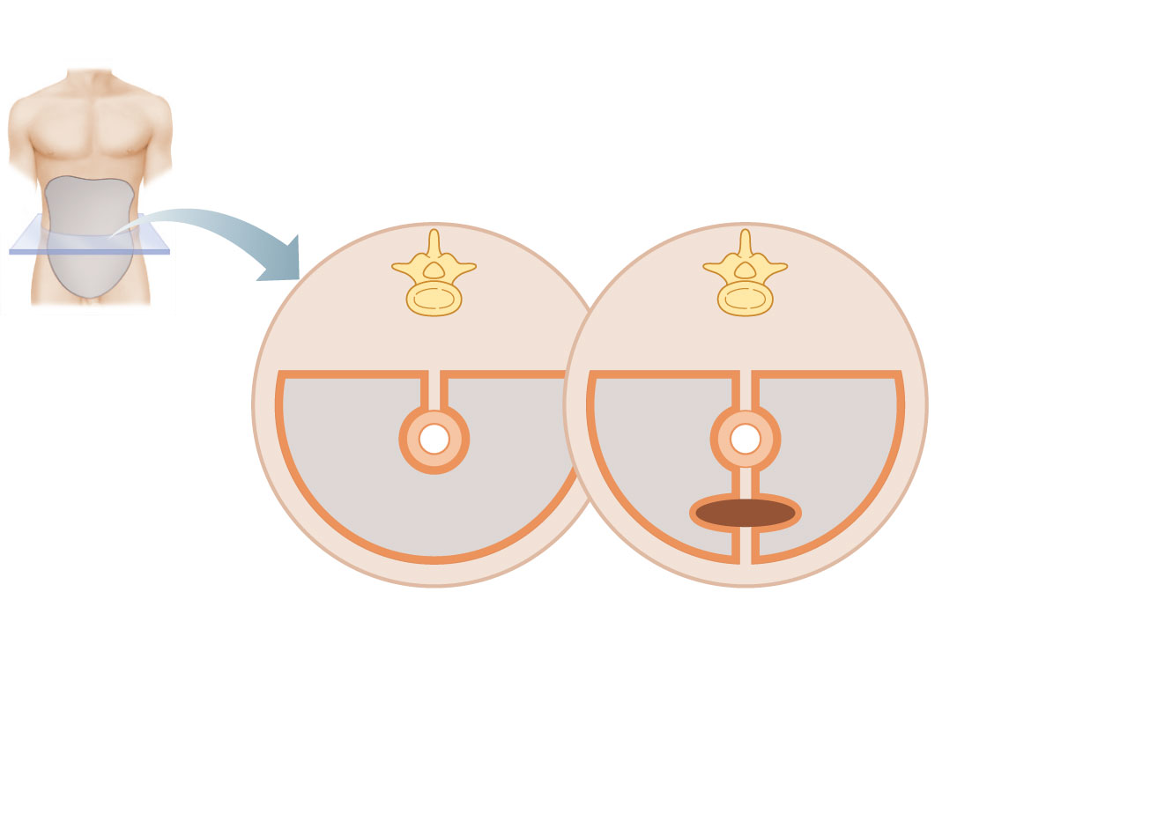

Peritoneal
cavity
Parietal
peritoneum
Visceral
peritoneum
Ventral
mesentery
Abdominopelvic
cavity

- Mesentery: fused double layer of parietal peritoneum. Carries blood vessels, lymphatic vessels and nerves to organs of the GI tract

- Relationship between various digestive organs and the peritoneum.
- - Most digestive organs keep a mesentery and remain in the peritoneal cavity. Others, like the pancreas lose their mesentery during development and come to lie posterior to the peritoneal cavity. Such organs are referred to as retroperitoneal.

- Peritonitis: inflammation of the peritoneum

- Outline the blood supply serving the main components of the GI tract.
- Splanchnic Circulation: includes arteries that branch off abdominal aorta to serve digestive organs and the hepatic portal circulation
- Arteries and Organ Served:
  - Hepatic liver
  - Gastric stomach
  - Splenic spleen
  - Superior and inferior mesenteric small and large intestines
- - these arteries usually receive ¼ of the cardiac output; this increases after a meal

- venous return from much of the abdominopelvic region is via inferior vena cava. However, venous return from the digestive viscera is indirect via the hepatic portal circulation.

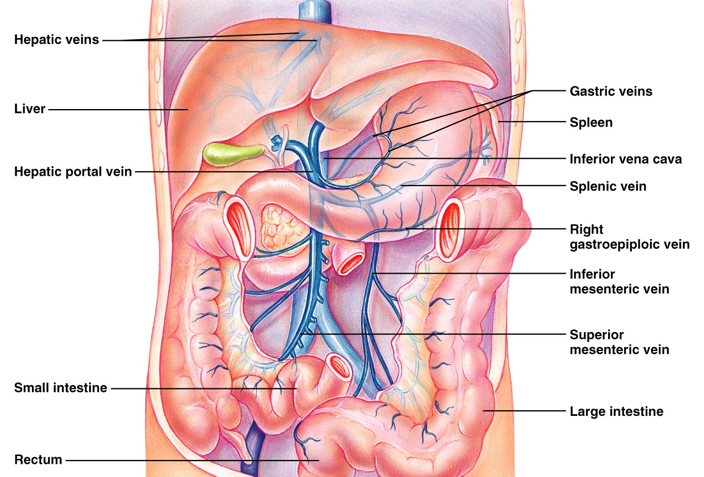

- liver is essential for detoxification

Four layers are typical for most of the GI tract
- Muscularis Externa
- Submucosa
- Serosa
- Mucosa

Histology of the GI tract wall.

Mucosa (innermost):
  - Secretion: mucus, digestive enzymes, hormones
  - Absorption: end products of digestion
  - Protection: against infection

- Mucosa consists of 3 sub layers:
- 1) surface epithelium: columnar epithelial + goblet cells (especially abundant in stomach), also cells that secrete enzymes and hormones in the stomach and small intestine
- 2) lamina proporia: lose connective tissues with capillaries, isolated lymph nodules; some bunches of these nodules (tonsils, appendix) in key areas.
- 3) muscularis mucosae: thin layer of smooth muscle cells – responsible only for local movements of mucosa. Also causes the mucosa to form extensive folds in the small intestine so that they can increase the surface area.

- Submucosa: moderately dense connective tissue layer containing blood and lymphatic vessels, lymph nodules, nerve fibers. Highly elastic – allows stomach to regain shape after large meal
- Muscularis Externa: mixing propulsive movements of GI tract, inner circular layer + outer longitudinal layer; thickens to form sphincters at organ-organ junctions, In the gut sphincters are essential because they’re unidirectional flow of what we consume.
- Serosa: outermost, protective layer = visceral peritoneum. Loose connective tissue vovered by single layer of squamous epithelial cells

- - the esophagus is surrounded by an adventitia instead of serosa, this is a fibrous connective tissue that binds the esophagus to surrounding tissues.
- - retroperitoneal structures have both a serosa on the side facing the peritoneal cavity and an adventitia on the side against the dorsal body wall.

Describe the functional anatomy of the GI tract.

The Mouth: vestibule and oral cavity proper oral or buccal cavity; bounded by lips, cheeks, tongue and palate. The tongue is covered by a stratified squamous epithelium; epithelium on gums, hard palate and back of tongue is also modestly keratinized.

Lips and Cheeks: core of skeletal muscle.
  - 1) orbicularis oris – lips
  - 2) buccinators – cheeks
  - hold food in place during chewing; role in speech
- - red margin is your lips and is red because the epithelia layer is thinner

- Palate: hard palate anteriorly; soft palate posteriorly
  - Hard palate underlain by palatine bones and palatine processes of maxillae; tongue pushes food against rigid surface during chewing
  - Soft palate mostly skeletal muscle; closes nasopharynx when we swallow
  - Palatoglossal/palatopharyngeal arches join soft palate to the tongue and oropharynx

- Tongue:
  - Interlacing masses of skeletal muscle fibers and taste buds + some mucous and serous glands
  - Important for chewing, mixing of food with saliva forms a bolus to swallow
  - Important during speech
  - 1) intrinsic skeletal muscles: within tongue, not attached to bone, 3 planes (transvers, longitudinal, vertical)
  - 2) extrinsic skeletal muscle: attach bones of skull or soft palate to the tongue
  - median septum divides tongue into 2 identical halves; lingual frenulum attaches tongue to floor of mouth

- - 3 types of papillae (projections) on tongue:
- 1) filiform papillae: conical, contain keratin, numerous in parallel rows, provide friction for manipulating foods
- 2) fungiform papillae: mushroom shape, widely scattered, vascular core with a reddish hue; contain taste buds
- circumvallate papillae; v-shaped row at back of tongue; like fungiform but with an additional surrounding furrow; contain taste buds

- Salivary Glands:
- 3 pairs of extrinsic salivary glands:
- 1) parotid glands – anterior to ear between masseter muscle and skin
- 2) submandibular glands – along medial aspect of mandible
- sublingual glands – under tongue
- Buccal Glands -

- Describe the Functional Anatomy of the mouth, pharynx and esophagus:
- The Teeth: in sockets (alveoli) in gum covered margins of mandible/maxilla
- Primary Dentition: also called deciduous, milk, or baby teeth
- Permanent Teeth: larger, deeper roots all but 3rd molars appear by end of adolescence
- Teeth have specialized morphology reflecting different tasks:
- Incisors: chisel shaped for cutting
- Canines: conical for tearing, piercing
- Premolars: (bicuspids) and molars: grinding, crushing

- Tooth Structure:
  - 2 major regions
  - 1) Crown – above gingiva, covered by enamel (Ca++, salts; hardest substance in body) but enamel producing cells degenerate when teeth emerge
  - 2) Root – embedded in jawbone; 1 root for I, C and PM
  - outer surface of root covered by calcified connective tissue (cement) – attaches tooth to periodontal ligament
  - Gingiva adhere to enamel with age, recede to sensitive cement

- Cell bodies of odontoblasts line the pulp cavity (contains connective tissue, blood vessels, nerve fibers). The pulp cavity extends into root, leading to the root canal, enamel, dentin, cement are all calcified and resemble bone, but are avascular. Cement and dentin (but not enamel) also contain collagen.

- The Pharynx
  - Mouth oropharynx laryngopharynx (common passageway) stratified squamous epithelium; pharyngeal muscle = skeletal muscle

- The Esophagus
  - Muscular tube -25cm; collapsed when empty
  - Straight down mediastinum of thorax; through diaphragm at esophageal hiatus and joins stomach at cardial orifice; diaphragm also supports sphincter
  - 4 Layers:
    - mucosa = nonkeratinized stratified squamous cells mucosa and submucosa thrown into folds when esophagus empty; folds flatten during food transit
    - submucosa contains mucus secreting esophageal glands
    - muscularis externa is skeletal muscle in upper 1/3, then smooth muscle in lower 2/3
    - fibrous adventitia instead of slippery serosa

- Describe the functional anatomy of the stomach
- - stomach acts as a temporary storage tank, initiation of protein digestion and converts contents to chime
- - fixed at esophagus and small intestine but is movable in between
  - 1. Gross Anatomy:
    - 25cm long with a capacity of 50mL – 4L
    - regions: cardia fundus body pyloric region (antrum to pyloric canal to pyloric sphincter
- - stomach is innervated by the autonomic nervous system
  - 1. Sympathetic (fight or flight) fibers from thoracic splanchnic nerves
  - 2. Parasympathetic (resting and digesting fibers from vagus nerve
- - microscopic anatomy:
  - surface epithelium is entirely goblet cells which produce mucous and an underlying bicarbonate rich layer in between millions of gastric pits leading to gastric glands which produce gastric juice, the composition of which varies depending on the region of the stomach
    - a) mucous neck cells: at necks of glands, produce a different type of mucin (acidic) for unknown reasons
    - b) parietal cells: secrete HCl and intrinsic factor
    - c) chief cells secrete pepsinogen (precursor of pepsin)
    - d) enteroendocrine cells; secrete hormones including gastrin, histamine, serotonin and somatostatin
- - the lumen of the stomach is an extremely harsh environment containing high concentrations of HCl and proteases (in the form of pepsin)
- - the stomach protects itself by: a mucousal layer; mucus and bicarbonate.tight junctions between cells to prevent leakage, replacement of epithelial cells by stem cells which reside at the gastric pit/gastric gland junction. Epithelium renewed every 3-6 days

- - How does Helicobacter pylori contribute to ulcers?
  - Create a niche by neutralizing HCl
  - Secrete cytotoxins – damage mucosa
  - Disrupt cellular adhesion
  - Cause inflammation and further tissue damage
  - These events leave the mucosa highly vulnerable to the HCl in the stomach, leading to ulcers

- Describe the macroscopic and microscopic anatomy of the small intestine.
- The small intestine is the major digestive organ and is responsible for absorption of virtually all nutrients and much of the water.
- It extends from the pyloric sphincter (stomach – duodenum) to the ileoceecal valve
  - 3 Sections:
    - duodenum – mostly retroperitoneal. Although the shortest anatomical division of SI, it is an important structure as it harbours the hepatopancreatic ampulla and sphincter
    - jejunum – empty, intraperitoneal
    - ileum – leads to large intestine, intra peritoneal
- - the jejunum and ileum are suspended from posterior abdominal wall by a fan shaped mesentery and are framed by the large intestine
  - innervation: sympathetic – thoracic splanchnic nerves
  - parasympathetic – vagus nerve

- Microscopic Anatomy of the Small Intestine
- 1) plicae circulares: deep (1cm), permanent, circular folds in mucosa and submucosa; increase surface area and slow rate of passage of chime
- 2) villi: fingerlike projections of mucosa, longest in duodenum (greatest absorption)
- 3) microvilli: comprises the brush border

- - intestinal crypts are located between villi. Crypt cells secrete intestinal juice (mostly water/mucous, slightly alkaline
- - crypts also contain paneth cells which secrete lysozyme
- - the epithelium of the villus sheds into the intestinal lumen and is completely turned over every 4-6 days by stem cells

- - One or more of the four layers (tunics) of the GI tract typically exhibit specialized, organ specific, features

- Describe the functional anatomy of the liver and gall bladder.
- Gross Anatomy:
  - Largest gland in the body. Situated under diaphragm and protected by rib cage
  - 4 loves, right left caudate quadrate
  - the functional units of the liver are composed of hexagonal lobules. Within each lobule, hepatocytes radiate from a central vein.

- - At each of the 6 corners of the hepatic lobule is a portal triad, composed of a portal arteriole, a portal venule and a bile duct.
- - Bile produced from the liver exits via multiple bile ducts that fuse to form the common hepatic duct. This then fuses with the cystic duct which drains the gallbladder to form the bile duct which subsequently joine the main pancreatic duct at the hepatopancreatic ampulla which enters the duodenum

- - As well as producing bile, hepatocytes also 1) process nutrients, store glycogen, synthesize plasma proteins; 2) store fat soluble vitamins 3) detoxify blood
- - The gallbladder:
  - thin walled, green muscular sac, stores and concentrates bile for eventual secretion into the duodenum via the cystic duct >> bile duct

- Describe the functional anatomy of the pancreas.
- - tadpole shaped, largely retroperitoneal, gland extending across the abdomen from its tail (adjascent to the spleen) to its head. Produces pancreatic juice – contains a wide range of digestive enzymes and bicarbonate secreted via the pancreatic duct to the bile duct/hepatopancreatic ampulla, emptying into the duodenum. The accessory pancreatic duct also empties into the duodenum
- Describe the Anatomy of the Large Intestine
- - absorbs water from indigestible food residues
- 1) Gross Anatomy:
  - 3 Distinguishing features:
    - longitudinal muscle layer is reduced to 3 bands of smooth muscle termed teniae coli. Tone causes wall to pucker into:
    - Haustra: pocket-like- bulges of large intestine
    - Epiploic Appendages: small fat-filled pouches of visceral peritoneum that hang from surface of large intestine

- Regions: Cecum (blind pouch), appendix, colon, rectum, anal canal
- Veniform Appendix: blind, wormlike structure attached to posteromedial surface of cecum. Contains masses of lymphoid tissue. Its twisted structure is an ideal location for bacteria to accumulate and multiply appendicitis.
- Colon: ascending, transverse, descending, sigmoid; retroperitoneal except for transverse and sigmoid regions
- Anal Canal: external to abdominopelvic cavity; 3cm
- 2 Superficial venous plexuses associated with anal canal – when inflamed, leads to haemorrhoids
  - no haustra in rectum or anal canal; muscular layers complete and well developed so can expel feces regulate by internal smooth and external skeletal muscle anal sphincters

- Microscopic Anatomy:
  - Mucosa is simple columnar epithelium except in anal canal which is lined by stratified squamous epithelium; abundant crypts with many goblet cells (eases fecal passage and protection)

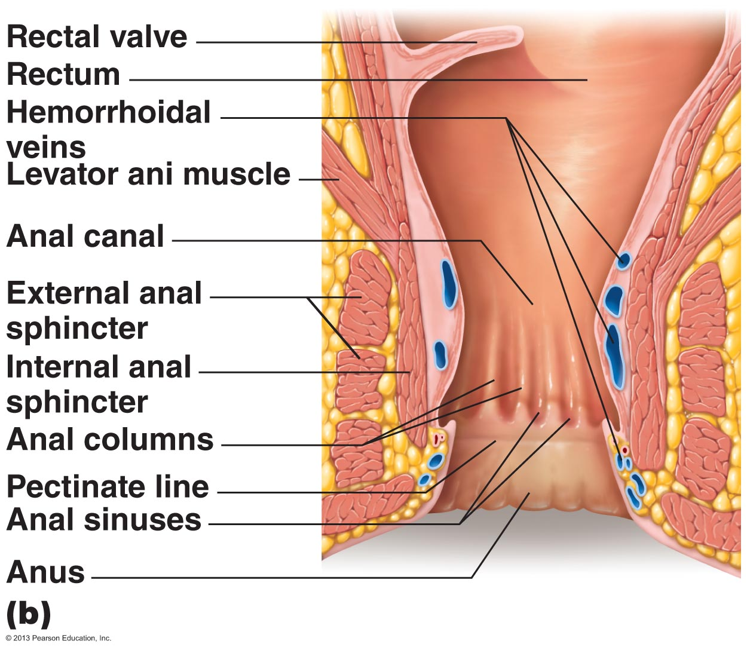

- 1. List, define and provide examples of the 6 digestive processes
  - Ingestion – taking in of food to the digestive tract normally via the mouth.
  - Propulsion – mechanical process of moving food through alimentary canal, food is subsequently moved through the digestive tract via peristalsis, an involuntary process involving smooth muscle. Note that while peristalsis involves directional movement of food, it also contributes some mixing due to alternate waves of contraction and relaxation of smooth muscles in the organ walls.
  - Mechanical Digestion – Physical process – prepares food for subsequent chemical and or enzymatic digestion, often begins with swallowing. Segmentation, an additional example: mixed food with digestive juices. Increases absorption by repeatedly moving different parts of food mass over intestinal mucosa.
  - Chemical Digestion – series of catabolic steps used to break down complex food molecules into their basic building blocks, usually necessary for absorption. This process relies on enzymes which are either secreted into the lumen of the alimentary canal
  - Absorption – the process whereby the passage of digested end products, vitamins, minerals and water from the lumen of the GI tract through the mucosal lining via active or passive transport into blood or lymph. Most absorption takes place in small intestine
  - Defecation – elimination of fecal matter from the body via anus

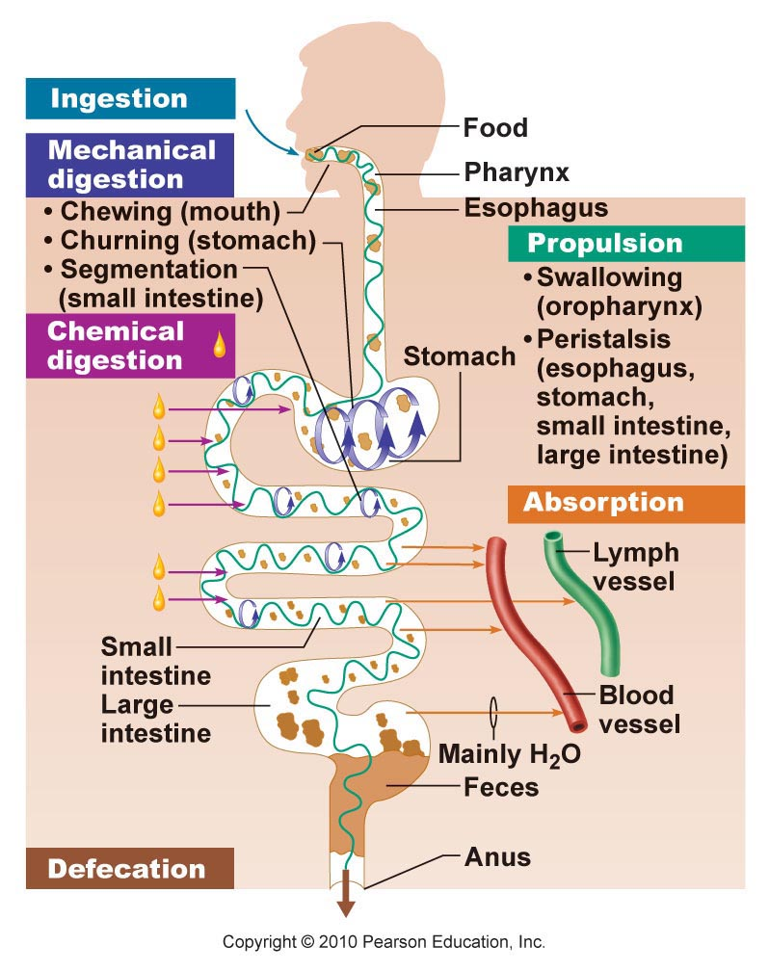
- 2. Summarize the basic concepts pertaining to the control of digestive function
- - Regulatory mechanisms act to create optimal conditions in the GI lumen for both digestion and absorption of the products of digestion
  - Regulatory Stimuli can be Mechanical or Chemical:
  - Mechano, osmo, and chemoreceptors located in walls of GI tract organs to detect such stimuli
  - Key Signals
    - Stretch of organ wall due to filling (mechanoreceptors)
    - Osmolarityw and pH of contents which change during food processing (osmoreceptors)
    - Substrates and end products of digestion (chemoreceptors)
  - Regulation can be Extrinsic or Intrinsic; 2 kinds of nerve reflex activity:
    - Short reflexes: mediated by local enteric plexuses in response to GI tract stimuli (intrinsic
    - Long reflexes: triggered by extrinsic or intrinsic stimuli, involve CNS centres and extrinsic autonomic nerves
    - Reflexes typically converge on submucosal plexus and or myenteric plexus
  - Generally smooth muscle excitation by nerves secreting acetylcholine or substance P and inhibited by nerces secreting vasoactive intestinal peptide (VIP) or nitric oxide (NO)
    - Stomach and small intestine also contain hormone producing cells that respond to local chemical factors, signals from nerve fibers or to stretch
    - Hormones may act locally or travel via blood to adjacent organs to influence secretory or contractile activity
- 3. Describe the digestive activities associated with oral cavity and their regulation
  - Mouth – the only part of the GI tract for ingestion, digestive function of mouth carried out by teeth, tongue, salivary glands, (mechanical, chemical)
    - Mouth also begins propulsive act of swallowing food traverses pharynx and enters esophagus
  - Digestive processes in mouth:
    - Mechanical = chewing (mastication) Partly voluntary and partly reflexive, results in mechanical breakdown and mixing of food.
    - Chemical Enzymes secreted by products of salivary glands
  - Salivary Glands and the Production of Saliva
    - Cleanses the mouth
    - Dissolves food chemicals so they can be tasted
    - Moistens and compacts food bolus
    - Contains salivary amylase – begins digestion of starchy food
  - 3 pairs of extrinsic salivary glands
    - Parotid Glands: predominantly serous cells produce – 25% of saliva
    - Submandibular glands: serous and mucous cells – 70% of saliva
    - Sublingual glands: predominantly mucous cells, 5% of saliva
  - Serous cells –
  - Mucous cells –
  - Composition of Saliva:
    - 97-99% water (therefore hypo osmotic; pH 6.75-7
    - osmolarity depends on stimulus for salivation and precise glands that are active
    - contains electrolytes (Na+, K+, Cl-, PO3-, HCO3-), amylase (initiates starch digestion) mucin (lubricates), urea and uric acid (metabolic waste products)
    - Intrinsic salivary (buccal) glands secrete lingual lipase
  - Control of Salivation
    - Avg output = 1000-1500 ml/day
    - Intrinsic salivary glands keep mouth moist. Intake of food and or other stimuli are required to activate extrinsic glands up to 4ml/min
    - Regulated by autonomic nervous system
      - Chemoreceptors and mechanoreceptors in mouth signal to the salivatory nuclei in brain stem, results in increased parasympathetic activity viaserous secretions
      - Chemoreceptors activated most strongly by acids, while mechanoreceptors acticated by any mechanical stimulus in mouth
      - Sympathetic stimulation causes increase in mucous secretion. Strong stimulation constricts blood celles serving saliva glands – dry mouth
      - Salivation can also be triggered by sight, smell, or even the thought of food
- 4. Describe the voluntary and involuntary regulation of deglutition; define and indicate some potential causes of heartburn
  - Swallowing (Deglutition):
    - Coordinated activity of tongue, soft palate, pharynx, esophagus involved 22 separate muscle groups – 2 phases, buccal and pharyngeal – esophageal
    - Buccal Phase: occurs in mouth; voluntary – tip of tongue forced against hard palate. Tongue is then contracted to force bolus food into oropharynx. In pharynx, food stimulated tactile receptors resulting in involuntary reflex activity
    - Pharyngeal – esophageal phase: involuntary; controlled by swallowing centre in medulla and lower pons through cranial nerves (including vagus). All routes to stomach blocked off and food squeezed into esophagus by peristaltic contractions.
  - What is heartburn?
    - Burning, radiating, substernal pain due to regurgitation of gastric juice into esophagus
    - Causes: gastric reflux, due to eating/drinking to excess, obesity, or pregnancy, running, hiatal hernia
- 5. Describe the digestive functions of the stomach and their regulation
  - stomach
    - a temporary storage tank
    - chemical breakdown of proteins begins; food converted to chime
  - Digestive Processes Occurring in Stomach
    - Mechanical digestion via churning action of stomach and propulsion
    - Protein digestion essentially only type of significant enzymatic digestion – primarily via the action of pepsin. In children, stomach glands also secrete rennin which acts to digest casein
    - Lipid soluble drugs such as alcohol and aspirin are easily absorbed by the stomach mucosa, can produce gastric bleeding
    - Only stomach function essential to life is production of intrinsic factor
    - Secretion of HCl facilitated reduction of food particles into chime denatures proteins and nucleic acids: also transforms inactive pepsinogen into pepsin and destroys bacteria.

- Describe the digestive functions of the stomach and their regulation.
- Stomach a temporary storage tank, chemical breakdown of proteins begins; food converted to chime

- Digestive Processes Occurring in Stomach
  - Mechanical digestion via churning action of stomach and propulsion
  - Protein digestion essentially only type of significant enzymatic digestion – primarily via the action of pepsin. In children, stomach glands also secrete rennin which acts to digest casein
  - Lipid soluble drugs are easily absorbed by the stomach mucosa
  - Only stomach function essential to life is production of intrinsic factor
  - Secretion of HCl facilitates reduction of food particles into chime, denatures proteins and nucleic acids; also transforms inactive pepsinogen into pepsin and destroys bacteria

- Regulation of Gastric Secretion
  - Gastric mucosa secretes up to 2-3L of gastric juice each day
  - Controlled by both neural and hormonal mechanisms
    - Neural: long (vagus nerve mediated) and short (local enteric) nerve reflexes
    - Hormonal: Gastrin (secreted by G cells of stomach and duodenum) stimulations secretion of pepsinogen and HCl

- - Stimuli acting at three distinct sites: the head, the stomach, and the small intestine impact on gastric secretory activity. Accordingly , there are three phases of gastric secretion: cephalic, gastric, intestinal

- Cephalic Phase:
  - Occurs before food enters the stomach, short lived phase (few minutes long)
  - Olfactory/taste buds inputs hypothalamus vagal nuclei of medulla oblongata – leads to stimulation of secretion of gastric juice
  - Visual/conscious thought inputs conditioned reflex based on prior experience (this reflex significantly reduced if depressed/no appetite) triggered by the smell, taste, sight, or even simple the thought of food

- Gastric Phase:
  - 3-4 hours long, provides 2/3 gastric secretions
  - initiated by distension of stomach, peptides, low aciditiy
  - distension: receptors local and long (vagal reflexes release of Ach increases output of gastric juices
  - peptides and low acidity: more important trigger, leads to secretion of gastrin by G cells of stomach antrum and histamine. Gastrin increases gastric juice secretion especially HCl by parietal cells
    - proteins are buffers
    - gastrin secretion inhibited when gastric ph<2 (feedback)

- Process of HCl Secretion:
  - H+ actively pumped (against steep concentration gradient) into stomach lumen in response to Gastrin + Ach + Histamine
  - H+ derived from carbonic acid
  - Cl- follows H+ to maintain electrical balance

- Gastric Problems:
  - Ulcer:
    - Excess acid secretion by stomach overcomes protective mucus barrier and damages organ lining (esophagus, stomach or duodenum
    - More common in esophagus or duodenum because their linings are not created to endure the effects of excess acid
    - Risk factors: smoking, habitual use of NSAIDs, alcohol, certain chronic disease
    - Treatment: cimetidine (tagamet) – inhibits histamine H2 receptor interaction

- The Intestinal Phase:
  - An excitatory component followed by an inhibitory component
  - Excitatory mediated by intestinal gastrin from intestinal mucosal cells triggered by low pH and foodstuffs as chime first enters duodenum
  - Inhibitory enterogastric reflex occurs as duodenum continues to fill with H+, proteins, gats etc. Result:
    - Vagal nuclei in medulla inhibited
    - Local reflexes inhibited
    - Sympathetic fibers activated – pyloric sphincter tightens
  - Secretion of enterogastrones: secretin, cholecystokinin
  - Result: gastric secretion decreases and gastric emptying slows
  - Beneficial Effects:
    - Small intestine protected from excess acidity
    - Entry of chime correlated with intestinal processing ability

- Gastric Motility and Emptying: Receptive relaxation of smooth muscle (fundus and body) – allows stomach to stretch without increasing tension

- 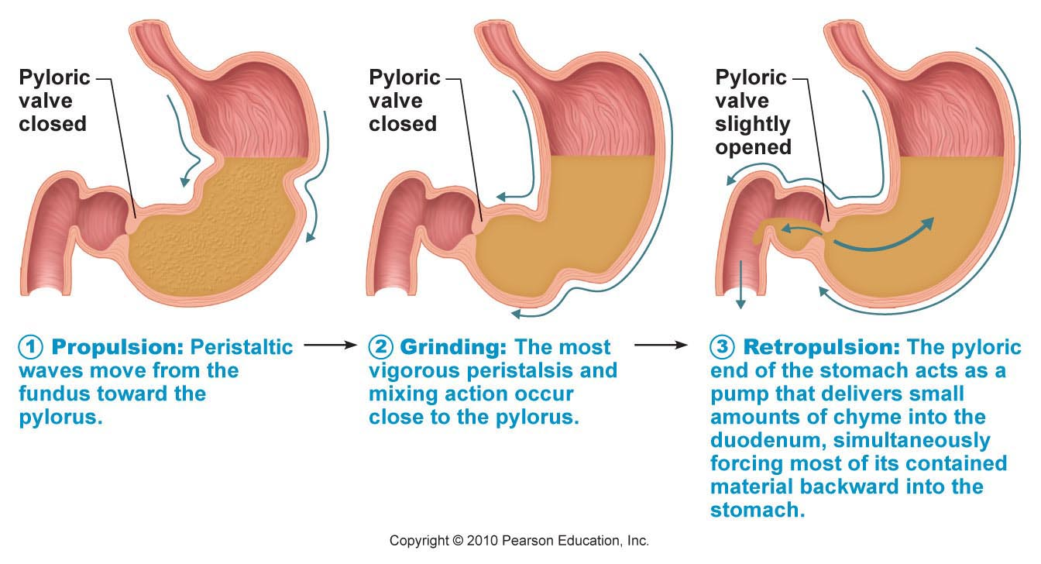

- Regulation of Gastric Emptying:

- - stomach usually empties completely within 4 hours after a meal, depending on volume of meal and contents. Carbohydrate meal moves through quickly; fats slow movement by coating top of chime and being digested slowly in duodenum – delays stomach emptying to up to 6 hours; rate of stomach empting is largely dependent on signaling from duodenum.

- Gastric Problems:
  - Vomiting:
    - Excessive stretching of stomach/intestine or presence of irritants ex. Bacterial toxins, excessive alcohol, spice foods
    - Emetic centre in medulla is stimulated and motor responses elicited:
      - Skeletal muscles of abdominal wall and diaphragm contract
      - Cardiac sphincter relaxes
      - Soft palate rises to close off nasal passages

- Composition of Bile:
  - Yellow green, alkaline, hepatocytes produce 500-1000mL bile/day
  - Contains bile salts, bile pigments, cholesterol, neutral fats, phospholipids and electrolytes
  - Main bile pigment is bilirubin (waste product of hemoglobin) intestinal bacteria convert bilirubin to stercobilin turns feces brown

- - only digestive function of liver: to produce bile, a cholesterol derivative
- - gall bladder: a storage organ for bile – contracts upon stimulus to release bile
- - bile is a fat emulsifier, bile production and flow into the duodenum increases during digestion
- - liver produces bile constantly, when digestion not occurring: hepatopancreatic sphincter is closed, bile backs up through the cystic duct and is stored and concentrated in gall bladder
- release of bile into duodenum occurs when muscular wall of gall bladder contracts, bile expelled into cystic duct bile duct

- Regulation of Bile Release into Small Intestine
  - When digestion not occurring, hepatopancreatic sphincter closed
  - Major stimulus for gallbladder contraction is cholecystokinin
  - Secretin also increases bil synthesis
  - Cholecystokinin:
    - Stimulates gallbladder contraction
    - Stimulates secretion of pancreatic juice
    - Relaxes hepatopancreatic sphincter

- Bile salts are conserved by recycling 90-95% through enterohepatic circulation: ileum (bile transporter) to blood to liver to new bile. Bile salts in portal circulation is the most important stimulus for bile secretion.

- 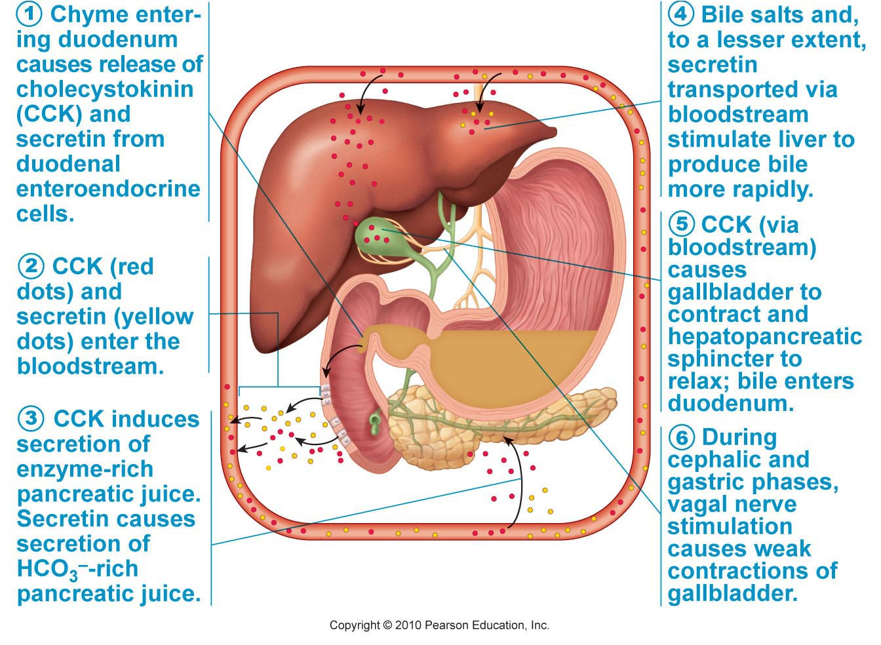

- Gall Stones:
  - Crystalline concretion formed within the gallbladder by accretion of bile components
  - Gallstone Treatments: dissolve with drugs, pulverize with usound, vaporize with lasers, surgical removal of gall bladder

Describe the exocrine function of the pancreas and its regulation.
  - Acini: groups of secretory acinar cells clustered around ducts. Mediate the exocrine function of the pancreas
  - Produces a range of enzymes that digest all categories of food
  - 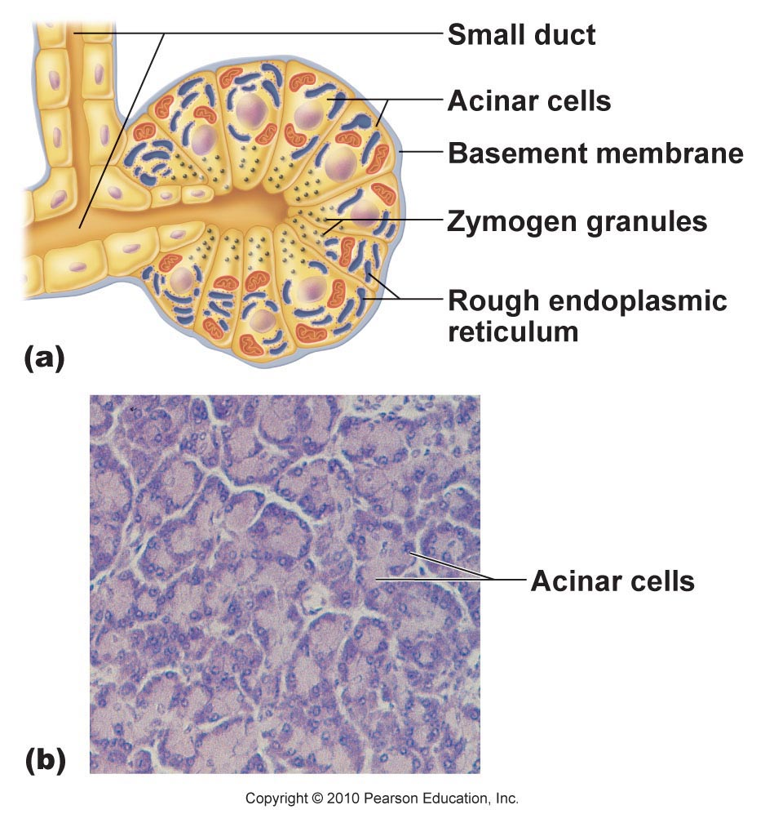

- - bicarbonate production in stomach – alkaline tide
- - pancreas secretes bicarbonate to neutralize HCl in chime. A result of this bicarb secretion is extrusion of H+ into the blood stream by the pancreas. This counters the bicarb secreted by the stomach resulting in neutral pH of venous flow returning to the hard

- Regulation of Pancreatic Secretion:
  - Secretin: trigger for secretion, stimulates pancreatic duct cells to secrete water, bicarbonate – rich juice
  - CCK: trigger for seretion stimulates pancreatic acinar cells to serete enzyme – rich juice
  - Presence of both hormones results in substantial increase in pancreatic secretions

- Parasympathetic Nervous System:
  - Vagal stimulation of secretory activity
  - Primarily during cephalic and gastric phases of gastric secretion

- Requirements for Optimal Intestinal Digestive Activity:
  - Optimal liver and pancreatic function
  - Slow, measured delivery chime form stomach
  - Serves 2 roles, neutralize stomach HCl, contents of stomach are hypertonic

- Motility of Small Intestine:
  - Segmentation most common motility pattern
  - Initiated by intrinsic pacemaker cells in longitudinal muscle layer; operate at different frequencies
  - Intensity of segmentation altered by long and short reflexes and by hormones
  - Once absorption almost finished, segmentation wanes, motilin is then released by duodenum, this initiates peristalsis starting in the proximal duodenum and running 50-70cm
  - Process then repeats itself
  - Once chime has passed through the small intestine, back pressure from cecum closes valve flaps

