Key Words: Hadean era

Word | Definition | Page
Adhesion | The adherence of molecules to the tissue in the tubes of plants, mechanism used to transport fluids through a plant | 45
Achaean eon | See Achaean def: these are one of the two domains of Prokaryotes, they have some unique molecular and biochemical traits but also share many traits with bacteria and some other traits with eukaryotes  Considered to be the age of bacteria, this generation starts with small anaerobic bacteria in the oceans and ends with larger aerobic bacteria that create the oxygen rich planet and atmosphere we know today  These bacteria are tremendously diverse and numerable considering they have been on the earth for 3.8 billion years  The most notable change of this time is shift from completely anaerobic bacteria to aerobic bacteria, meaning they can synthesis h2O to create energy  Before it was though that al prokaryotes were the same, until recently when gene sequencing of these prokaryotes were studied and they were split into 2 groups: the Bacteria(eubacteria) and the Archaea  The proposal of 3 domains: bacteria, Archaea and Eukaryota  The first two domains became interesting for their use of horizontal gene transfer of gene swapping  Achaean period:  - 3700 Ma - Photosynthesizing bacteria  - 3500 Ma - Oldest fossils  - 3400 Ma - Small continents form  - 3100 Ma - Continents begin shifting  - 2700 Ma - First eukaryotes  - 2600 Ma - Bacteria on land  - 2500 Ma - Banded iron formations | Website, notes
Biomonomer | I’m guessing a biomonomer is just a monomer as it relates to biology????  So monomer: A molecule that may react chemically to another molecule of the same type to form a larger molecule such as simer, trimer, tetramer, polymer etc  It is the simplest unit or form of a polymer  Ex. A monomer of lactose is a glucose and the monomer of a chain of DNA is the nucleotide and amino acids is the monomer of complex proteins | google
Biopolymers | A compound made up of several repeating units, disaccharides such as lactose, maltose, cellulose, glygogen and starch are the poly sacharides that consist of the monomer: Glucose | google
Building phase of the earth
Carbon | An element, very often found in organic compounds, naturally found in its pure form as coal, graphite or diamond. Carbon bonds with three oxygen’s to form carbonate  Bicarbonate Definition:  HCO3  Sedimentation of calcium carbonate  CO2 +H20 creates carbonic acid and then hydrogen ions are added to create carbonate.  This then binds with calcium in water to create Calcium carbonate at this carbon dioxide is locked in sediment that’s rests on the bottom of the ocean.  Bicarbonate can easily be turned back to co2 and water and also into carbonate.
Cenozoic | Palaeogene period (65 - 24 Ma)  Palaeocene (65 - 54 Ma)  60 Ma - Primates  57 Ma - Rodents  55 Ma - Bats  Eocene (54 - 33 Ma)  50 Ma - Whales  40 Ma - Continents near present day conditions, drying and cooling trend begins  33 Ma - Late Eocene extinction  Oligocene (33 - 24 Ma)  25 Ma - Ape/Human line evolves, grasses  24 Ma - Short term warming and drying  Neocene period (24 Ma - present)  Miocene (24 - 5.3 Ma)  20 Ma - Inland seas dry out, great mountain building, kelp forests  18 Ma - Grazing horses  16 Ma – Orangutang line separates from African Ape/Hominid  9 Ma - Miocene extinction  6 Ma - Chimpanzee and Hominid line separate  Pliocene (5.3 - 1.8 Ma)  5.2Ma - Hominids  2 Ma - Global ice ages begin  Pleistocene (1.8 - 0.01 Ma)  0.6Ma - Early Humans  0.1Ma - Modern Humans  0.01Ma - Late Pleistocene extinction  Holocene (0.01 Ma - present | website
Central Dogma | A theory in genetics and molecular biology subject to several exceptions that genetic information is coded in self-replicating DNA and undergoes unidirectional transfer to messenger RNA’s in transcription which act as templates for protein synthesis in translation.  Basically the theory that states DNA makes RNA and RNA makes proteins, shows that protein are transbribed and are derived from a complicated proccess | google
Chemical evolution | The process that occurred 3.8 billion years ago when simple inorganic molecules form organic molecules, these were the first steps in the development of the planet and lasted less than a billion years. This theory was simulated in miller-Urey experiment (see def miller-Urey experiment) but basically they found under certain terrestrial or earthlike conditions, inorganic compounds can be formed in the oceans water. | google
Cohesion | The high resistance of water molecules to separate
Crystal lattice of water | The structure that water molecules make when it freezes to form ice. Ice us less dense than water due to its polarity and how it creates a hexagonal shape when it freezes, this is assumed that this is pure water and there is no air trapped in it:  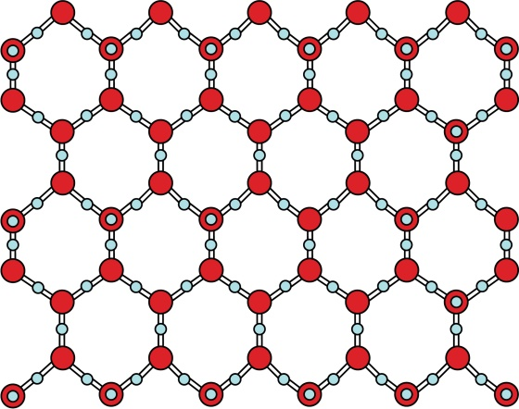
Emergence | Defined as the process whereby larger entities and regularities arise through interactions among smaller or simpler entities that themselves do not exhibit such properties.  In biology, it is accepted that life emergered from the reactions of inorganic molecules to create more complex molecules, LUCA and simple cell membranes emerged from that and from that the Archea, bacteria and Eukaryotes we know today | google
Eras | A long distinct period of history with a particular feature or characteristic
Eukaryote | An organism in which DNA is enclosed in a nucleus  Eukaryotes comprise animals, plants and fungi which are mostly multicellular and various other groups in the protest domain | 30
Mesozoic | Triassic period (248 - 206 Ma)  220 Ma - Mammals, dinosaurs, crocodiles  215 Ma - Flying reptiles  206 Ma - Late Triassic extinction  Jurassic period (206 - 144 Ma)  200 Ma - Pangea starts to break apart  150 Ma - Birds  Cretaceous period (144 - 65 Ma)  130 Ma - Flowering plants  65 Ma - Tropical climate extends to polar regions, end Cretaceous extinction
Evaporation | Heat transfer through the energy required to change a liquid to a gas | Common knowledge
Geological time scale | Mapping the history of events using stratigraphy, the earth is organized into various time sections dating back to the creation if the earth:  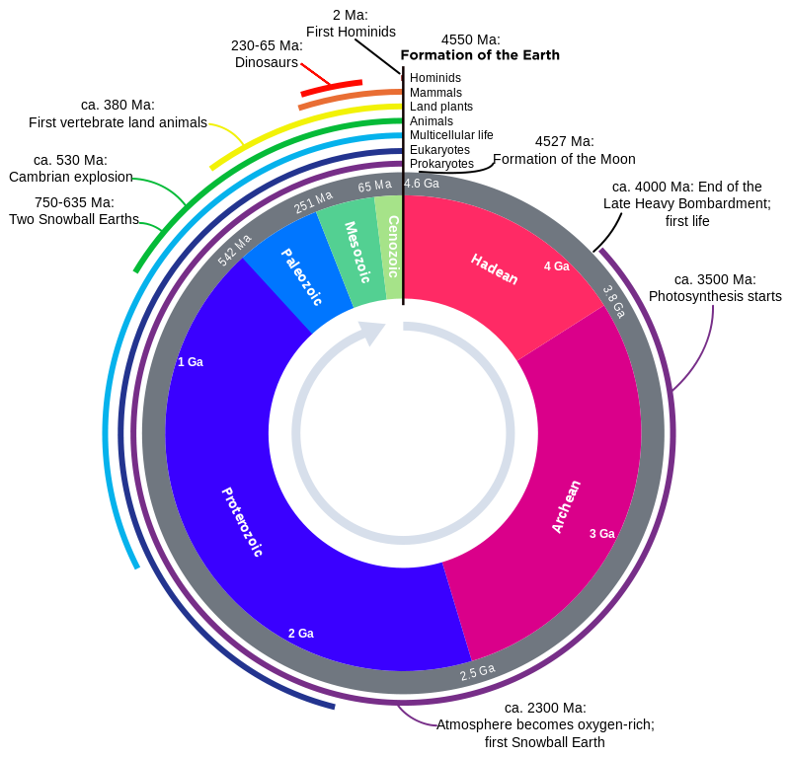
Goldilocks zone | Also known as the “Circumstellar habitable zone”  The region around a star where planet like objects are large enough and experience enough pressure to create an atmosphere  It also allows for water to be held on the surface  It cant be too hot or too cold where water will freeze  It is protected from the UV rays of the sun, not too much cosmic radiation hits planet.  Our solar systems goldilocks zone is exactly 1 au from our star, the sun where it would be different in different solar systems
Greenhouse gasses | a.k.a: the greenhouse effect  A phenomenon in which certain gases foster the accumulation of heat in the lower atmosphere, maintaining warm temperatures on earth.  These gasses exist in an atmosphere that absorbs and imits radiation within the thermal infrared range.  These gases consist of carbon dioxide, methane, nitrous oxide, nitrogen dioxide and carbon monoxide. | 1190
Habitable zone | Exact same as goldilocks zone why the fuck did houseman put this in twice???????
Hadean Eon | The earth estimated to be 4.5 billion years old, but multicellular life only rose 500 million years ago, so what was happening in the intervening 4 billion years?  The first eon is the Hadean and it was a very violent time in earth’s history from the actual creation of a planet. The earth was being bombarded by meteors created oceans as the earth’s crust cooled and solidified.  The atmosphere was very different in that there was a lack of oxygen  Modern experiments show that under those conditions the first organic compounds formed in the oceans and created a prebiotic soup with amino acids and other organic compounds.  These compounds came around from deep sea hydrothermal vents of even meteorites.  Monomers for proteins and lipids can easily be experimentally derived the problem is no one has been able to synthesize the required nucleotides for RNA and DNA. There is no consensus on how the first large biopolymers appear.  Hadean period (4550 - 3800 Ma)  4550 Ma - Birth of the solar system, escaping gases build early atmosphere  4500 Ma - Meteorite bombardment  4400 Ma - Earth's core forms  4200 Ma - Great oceans form  4055 Ma - Oldest known rocks  3850 Ma - Evidence of life  3800 Ma - Bacteria diversify
Hydrogen bond | Noncovalent bond formed by unequal electron sharing hydrogen atoms and oxygen, nitrogen or sulphur atoms
Hydrophilic | Polar molecules that associate readily with water
Hydrophobic | Nonpolar substances that are excluded by water and other polar molecules
Hydrothermal vents | These are fissures in the earth’s crust where water is heated and forced up into the oceans. Often a black colour these vents often host complex communities fuelled by chemicals dissolved in the vent fluids such as chemosynthetic bacteria and archaea
Interstellar Organic compounds | These are just compounds that are usually inorganic that are found today in space dust by using big envelope like membranes
Late Heavy Bombardment | This is a theory that suggests that the earth went through a time around 4 billion years ago where it experienced a high rate of asteroids and meteors colliding with the earths magama surface
Liposome | A liposome consists of chains of phospholipids that arranged themselves into a water tight vacuole that exists in an aqueous solution. The hydrophilic head faces out and the hydrophobic tails face inward, this creates a water tight seal, often in 3 dimensions.
Micelles | A spheres composed of a single layer of lipid molecules
Miller-Urey Experiment | This was a simulation created by two researchers, Miller and Urey. chemicals such as methane, ammonia hydrogen and water were added to a closed system. The apparatus had a boiling flask, condensing column and a power supply. The power supply would zap lighting through the apparatuses simulating the high amount of lighting that was believed to have existed on earths surface. After a sometime in the apparatus they noticed that some of the carbon had formed an organic compound and that two percent actually formed amino acids which are the building blocks of life  Their experiment proved that chemical evolution existed and was possible on earth’s surface at the time.  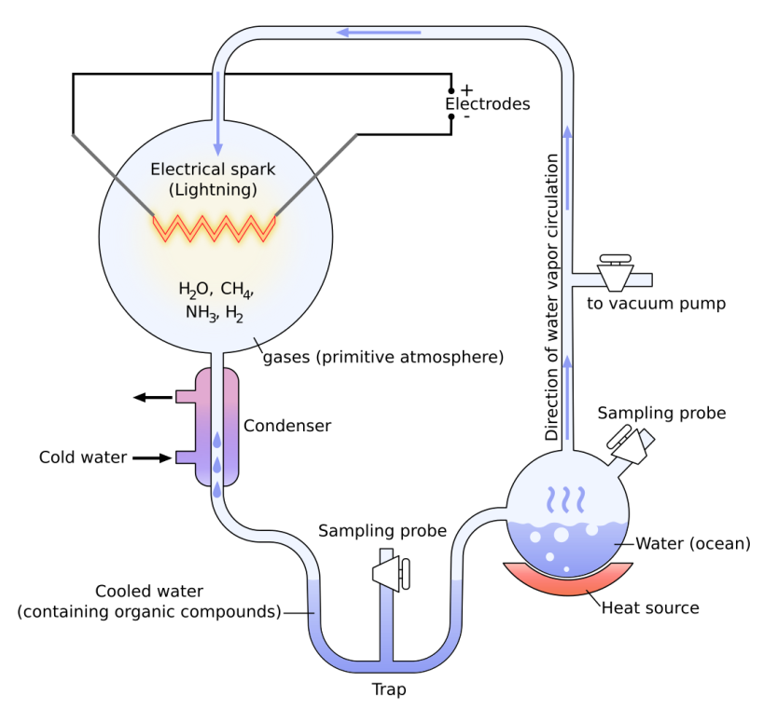
Nice Model | This is the scenario for the dynamical evolution of our solar system
Nonpolar compound | A compound comprised of molecules linked through chemical bonds arranged in such a way that the distribution of charges is symmetrical | google
Palaeozoic | The explosion of multicellular life from the oceans to land and a massive extinction  This is the earliest of the three geologic eras of the Phanerozoic Eon, spanning from roughly 541 to 252.17 million years ago  The Cambrian explosion was theorized to happen at this time which was the huge emergence of multicellular species  You were seeing the first hard shell species  Species like sponges, corals, molluscs, echinoderms, bryozoans, brachiopods and arthropods, these all being soft body organisms  Believed that the hard shell species developed later like the trilobites, archaeocyaths.  The first vertebrate fossils found were these armoured fish that were jawless and covered in scales and had large plate on the top of their head.  Organisms began creeping up on land  (410 to 360 mya) tree life was perfecting the tap root vascular tissue system and big strong forests were sprouting up all over. Two majour cades were moving up on land, the Vertebrate fish and the arthropods  Trees were reaching 100 feet tall and the other weaker plants turned into mosses and low lying vegetation, many of them still using the spore method of reproduction while larger plants developed the seed method of reproduction  This explosion of trees and plants would die and there were no decomposers on the land or very few, so this was a time that high amount of coal was being produced  That atmosphere also had very little oxygen because it was locked in ocean sediments as calcium bicarbonate  At the end of this era came larger and larger vertebrate species in the oceans that began to develop jaws  Permian(286-245)-the largest recorded extinction, extinction of the dinosaurs, 90-95% of marine life disappeared and 70% of terrestrial life was destroyed, the Triassic dinosaurs were soon to follow
Panspermia | The theory that life is everywhere in the universe and that organic compounds are found in asteroids and meteorites.  The idea is large bodies that were developing life are destroyed in space and the chunks fly all over the universe harbouring these extremophile bacteria or prokaryotes and that these have the potential to collide with another planetary body and integrating with the environmental conditions.
Periods | And era is the largest section and the periods are the subsequent intervals that have specific biological and historic characteristics to better understand the events and time.  Ex. There is the Palaeozoic era and its periods were the Cambrian, Ordovician, Silurian, Devonian, Carboniferous and Permian
Phanerozoic eon | Consists of the Palaeozoic era, Mesozoic era and the Cenozoic era  This is the current eon and records the existence of humans  From 542 million years ago to present
Polar compound | A compound that has an uneven distribution of charge  They have a positive and negative side, the most popular being water that due to oxygen’s distribution of electrons one side becomes heavy with electrons and becomes negative, and one side has the hydrogen protons so it becomes positive and creates a 106 degree bend.  Because of this water freezes in a hexagonal pattern and therefore solid water floats on liquid water.
Prebiotic soup | The oceans and concentration of organic material around hydrothermal vents that existed in the Hadean Era.  Coincides with chemical evolution  The term was coined by Alexander Oparin in 1924
Prokaryote | Organism in which the DNA is suspended in the cell interior without separation from other cellular components by a discrete membrane  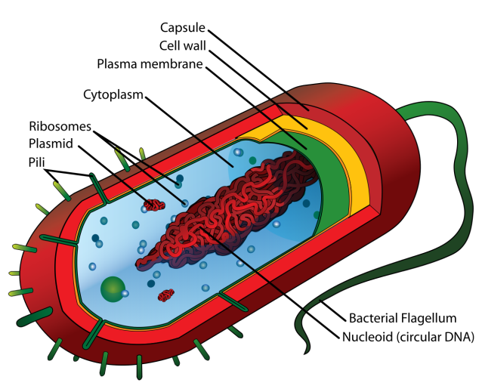 | 29
Proteins first hypothesis | This is the theory that in chemical evolution, it was groups of proteins that actually emerged and created RNA and then later DNA. It’s a theory that believes proteins could communicate in chains and theyre were later bound by these lipid layer cell membrane and this is how the first cell came about
Proterozoic eon | Proterozoic eon (2500 - 543 Ma)  2000 Ma - Oxidation produces "red beds"  1900 Ma - Oxygen levels reach 3%  1800 Ma - Oldest eukaryote fossils  1200 Ma - True algae  1100 Ma - Rodinia supercontinent forms  900 Ma - Soft-bodied animals  800 Ma - Major glaciation period begins  700 Ma - Breakup of Rodinia supercontinent  600 Ma - Protective ozone layer in place  543 Ma - Vendian extinction, Hard-shelled animals
Protobionts | The term given to a group of abiotically produced compounds that are surrounded by a membrane or membrane like structure
Protocells | A protocell is composed of a few things. A fatty acid membrane, a RNA replicase and ribozymes. It is able to reproduce through binary fission and therefore can experience evolution  One of these has not been created artificially yet.
Reducing atmosphere | An atmospheric condition in which oxidation is prevented by removal of oxygen. Instead the atmosphere could be much more thin with gasses such as hydrogen and carbon monoxide.  The early atmosphere on earth was like this
Reverse transcriptase | An enzyme that uses RNA as a template to make a DNA copy of the retrotransposon. Reverse transcriptase is used to make DNA copies of RNA in test tube reactions
Ribozymes | An RNA-based catalyst that is part of the biochemical machinery of all cells
RNA world | RNA: a polymer assembled from repeating nucleotide monomers in which the five-carbon sugar ribose. Cellular RNA’s are mRNA (which is translated to produce a polypeptide), tRNA (which brings an amino acid to the ribosome for assembly into the poly peptide during translation) and rRNA(which is a structural component of ribosomes). The genetic material of some viruses is RNA
Specific heat | The amount of heat required to increase the temperature of a given quantity of water
Spontaneous origins | The idea that life forms could emerge from nothing. Like how it used to be thought that a flea could spontaneously created from dust or that a maggot could spontaneously be generated from the dead body of a fish. We know now that maggots are the larvae of flys that lay their eggs in the fish
Stabilizing phase of the earth
Surface tension | The force that places surface water molecules under tension, making them more resistant to separation than the underlying water molecules
Surfactant | These are compounds that lower the surface tension between two liquids or between a liquid and solid. Surfactants may act as detergents emulsifiers or foaming agents
Vesicles | A small, membrane bound compartment that transfers substances between parts of the endomembrane system
Volcanic outgassing | These are the various gasses that are released into the atmosphere after a volcanic eruption. Chemicals and gasses locked in the magma and bellow earth such as carbon dioxide, h2O, H, N, more h2O
Eons | A majour period of time often divided into eras and then into periods

