Anatomy 1105 – Physiology of Muscle Tissues (Notes)
- Common features of muscle cells
  - Elongated cells = muscle fibers; terminology: “myo-, sarco-“
  - Muscle contraction depends on actin and myosin microfilaments
  - Muscle functions
    - Generate movement
      - Locomotion, manipulation, blood flow and pressure, respiration, propelling of food, urine, etc.
    - Maintain posture
      - Constantly working against gravity
    - Joint stabilization
      - Eg. Shoulders, knees when moving parts of skeleton
    - Generation of heat
      - Maintenance of body temperature
      - Esp. skeletal muscle (at least 40% of body mass)
  - Functional characteristics of Muscle
    - Excitability (irritability): ability to receive and respond to a stimulus
      - Stimulus is usually a chemical (NT, hormone, pH)
      - Response = AP along sarcolemma + muscle contraction
    - Contractility: ability to shorten forcibly when adequately stimulated
    - Extensibility: ability to be stretched or extended
    - Elasticity: ability to resume resting length after being stretched
  - Microscopic anatomy of a skeletal muscle fiber
    - Long, cylindrical cell with many oval nuclei (cell membrane is the sarcolemma)
      - Huge cells (diameter of 10-100 μm & lengths in cm)
    - Sarcoplasm contains lots of glycogen & myoglobin – lots of myofibrils, extensive sarcoplasmic reticulum, T-tubules (enter into the cell to bring action potential deep into the muscle)
    - MYOFIBRILS
      - Each muscle fiber (cell) consists of parallel myofibrils
      - ~80% of cell volume (100s to 1000s per cell)
      - Myofilaments (actin, myosin, etc.) are arranged in a pattern, forming end-to-end sarcomeres
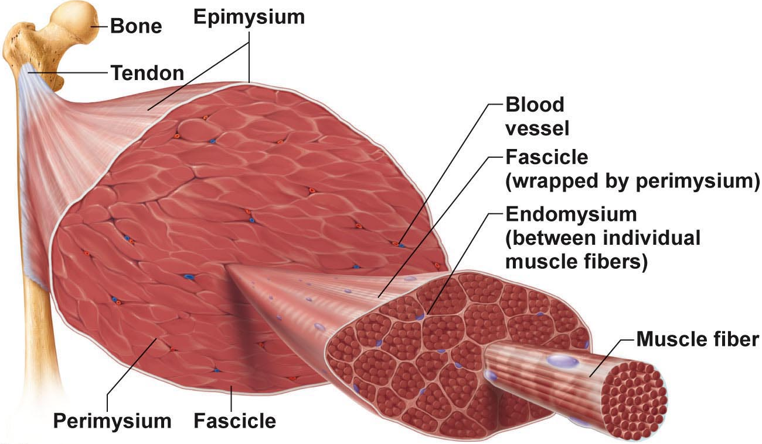
      - Sarcomeres extend from one Z disc to the next; sarcomeres give this muscle type the name “striated muscle”
      - Myofilaments:
        - Actin – thin filaments – across I band and partly into A band
        - Myosin – thick filaments – entire width of A band
      - Zones and lines:
        - Z disc = anchors thin filaments & connects all myofibrils of a cell (nebulin, connectin)
        - H zone = area with NO thin filaments (relaxed muscle)
        - M line = fine strands connecting adjacent thick filaments
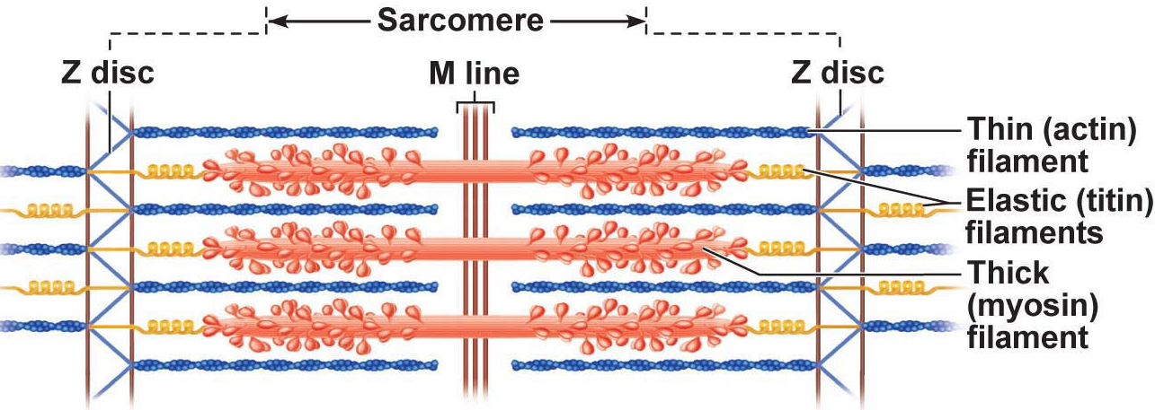
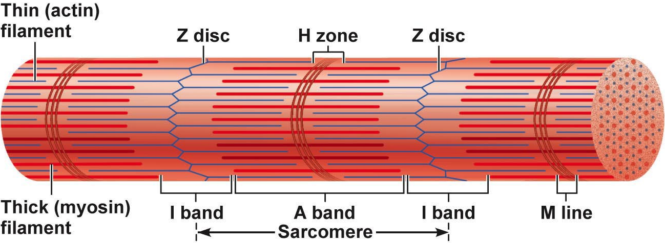

      - Longitudinal section of filaments within one sarcomere of a myofibril
        - In the center of the sarcomere, the thick filaments lack myosin heads. Myosin heads are present only in areas of myosin-actin overlap
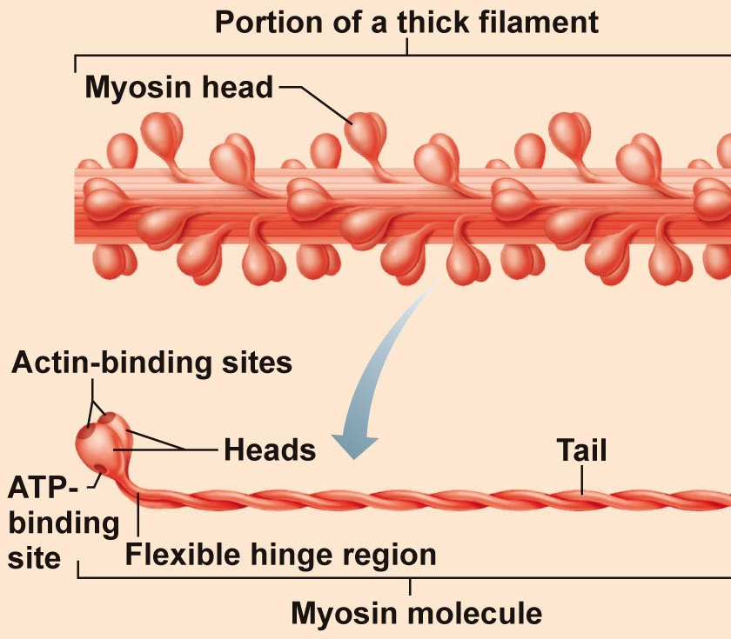

      - Ultrastructure & molecular composition of myofilaments
        - Thick myosin filaments
          - Rod-like tail + 2 globular heads
          - Cross bridges are the business ends of the thick filaments
          - Each thick filament is arranged so central part is smooth and each end is studded with many myosin heads
          - Myosin heads contain ATPase
        - Thin myosin filaments
          - Binding sites for myosin
          - Strands are F-actin; 2 strands would as a helix
          - Additional components:
            - Tropomyosin:
              - Stiffen filament
              - Blocks crossbridge binding
    - Sarcoplasmic reticulum:
      - Elaborate web of ER around each myofibril inside PM
      - Most SR tubules run longitudinally; pairs of cisternae across A-I junctions
      - ROLE: regular intracellular Ca++; storage depot for Ca++ releases it when muscle stimulated to contract
    - T Tubules: at A-I junction sarcolemma prenetrates cytoplasm to form hollow elongated tubes; T-tubule = transverse tubule
      - Triad: group of 3 structures – 2 terminal cisternae + 1 T-tubule
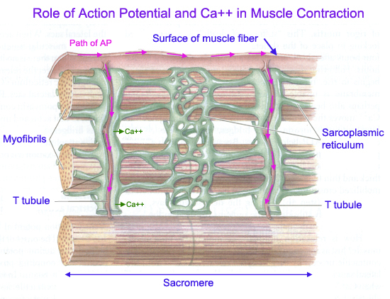

    - Sliding filament mechanism of skeletal muscle
      - Muscle fiber shortens because sarcomeres shorten; filaments remain same length
      - Thin filaments slide over thick filaments
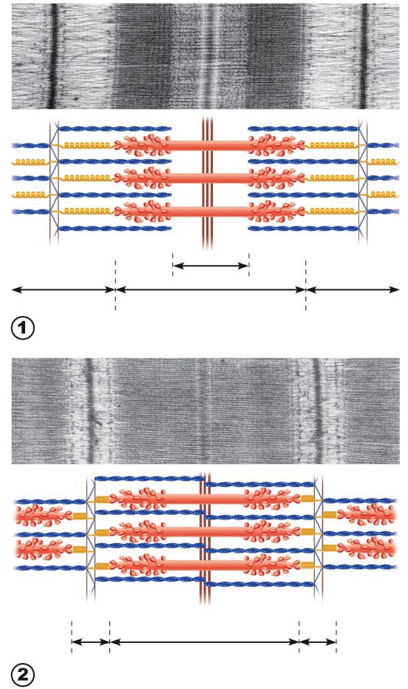
        - Relaxed: only slight overlap of thick and thin filaments
        - Contracted: thin filaments penetrate more deeply into A band – Z discs pulled toward thick filaments
      - Overall:
Relaxed sarcomere
        - Distance between Z discs reduced
        - I bands shorten
        - H zones disappear
        - A bands move closer together, but stay same length
Contracted sarcomere
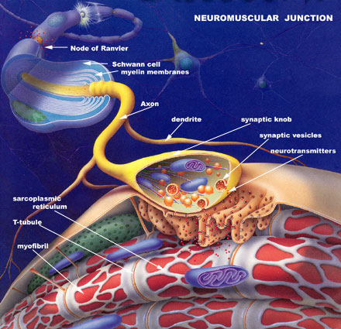

- Neuromuscular junction & nerve stimulus
  - Skeletal muscles stimulated by motor neurons of the somatic nervous system
  - 1 NMJ in ~middle of fiber – synaptic cleft; NT is acetylcholine
  - Events at nerve-muscle synapse identical to those in nerve-nerve synapse
- Generation of an AP across the sarcolemma:
  - Chemically-gated channels: local depolarization AP in all directions
  - Depolarization/repolarization with Na+, then K+ as for axon
  - Na+/K+ pump to restore
  - Once initiated, AP is unstoppable – all or none response of muscle cell
  - AP is brief (1-2 millisecond); contraction can be 100+ milliseconds
- Destruction of acetylcholine
  - Acetylcholinesterase (AChE) = enzyme on the sarcolemma of NMJ (neuromuscular junction)
  - Latent period of excitation-contraction coupling – Ca diffusion
  - If nerve impulses arrive at the NMJ at high frequency fusion, tetanus (super-human strength because the muscle is tense for longer)

- The Motor Unit
  - Motor nerve (at least 1/muscle) hundreds of motor neuron axons each axon to many axonal terminals each axonal terminal to NMJ of a single muscle fiber (cell);
    - Average number of muscle fibers/neuron = 150 (range = 4 to hundreds)
    - When neuron fires, all fibers contract
  - Motor unit = 1 motor neuron + all muscle fibers it supplies
- Graded muscle responses
  - 2 Types of graded responses
    - 1) If there is a change in speed of stimulation
      - Speed of stimulation: wave summation & tetanus
        - Rapid rate of stimuli: each contraction builds on the previous one
        - But AP refractory period is always honoured
        - Tetanus: fused contractions – inter-stimulus interval is too short to allow inter-twitch muscle relaxation – eventually followed by muscle fatigue
        - Primary goal: smooth, continuous contractions
    - 2) If there is a change in number of motor units activated
      - Multiple motor unit summation
        - Threshold stimulus: first observable response
        - Maximal stimulus – strongest stimulus that produces an increase in contractile force (more motor units recruited)
          - Smallest motor units controlled by most excitable neurons
          - More intense stimulation recruits larger motor units
        - All units can be recruited simultaneously, but USU staggered
        - Muscle tone: even relaxed muscle is a bit contracted (tone) due to spinal reflexes activated by stretch receptors (never 0) effect on muscle, joints, posture
- Isotonic & Isometric contractions
  - Isotonic – muscle changes in length and moves load
    - NB: eccentric contractions are 50% more forceful, use less ATP/O2 & fewer muscle fibers but more prone to delayed onset soreness than concentric contractions
  - Isometric – tension increases but muscle remains same length
    - Most body movements are a mix of isotonic and isometric contractions
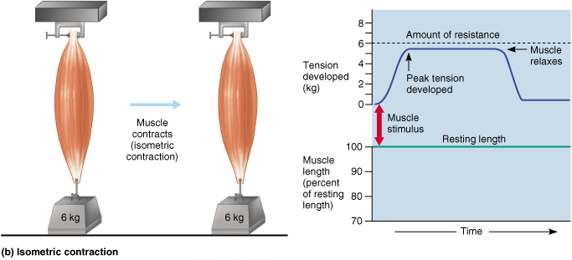
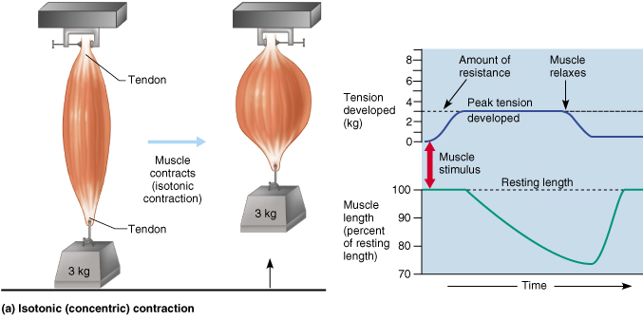
    - Realize that in isotonic contractions, the thing filaments are sliding, but in isometric contractions the cross bridges are generating force, but do not move thin filaments
^Isometric ^Isotonic

- Ideal length-tension relationship when muscle is slightly stretched
  - Supported by attachment to bones
- Velocity & Duration of Contraction depends on:
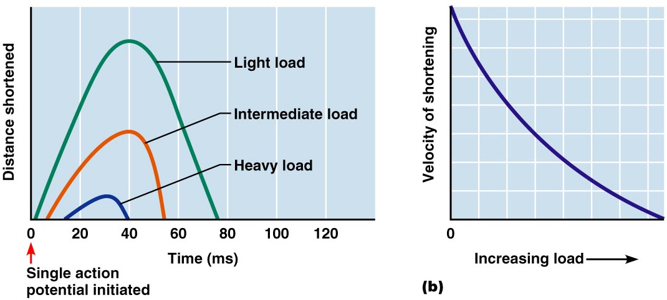
  - Load: greater load = longer latent period = slower contraction = shorter contraction duration

- Sources of energy for muscle contractions
  - Stored ATP
    - ATP for cross bridge movement & detachment; CA2+ pump
    - Only 4-6 seconds of stored ATP; regenerated immediately and continuously (by A2-A4)
  - Direct phosphorylation of ADP by creatine phosphate
    - CP = unique high-energy molecule stored in muscles
      - CP + ADP creatine + ATP
    - Enzyme = creatine kinase; but CP reserves quickly gone (CP & ATP = 15-20 sec; @ maximum muscle power)
  - Aerobic respiration
    - High ATP yield but slower (many steps); requires continuous O2/nutrients
  - Anaerobic glycolysis:
    - Only 2 ATP/glucose but O2 not used and is fast
    - Usually pyrubic acid then enters aerobic pathway; but if ~70% activity for long period, blood vessels compressed by muscles & aerobic respiration too slow
    - Pyruvic acid converted to lactic acid; reconverted back to pyruvic acid once exercise is over; aerobic respiration used to replenish ATP stores
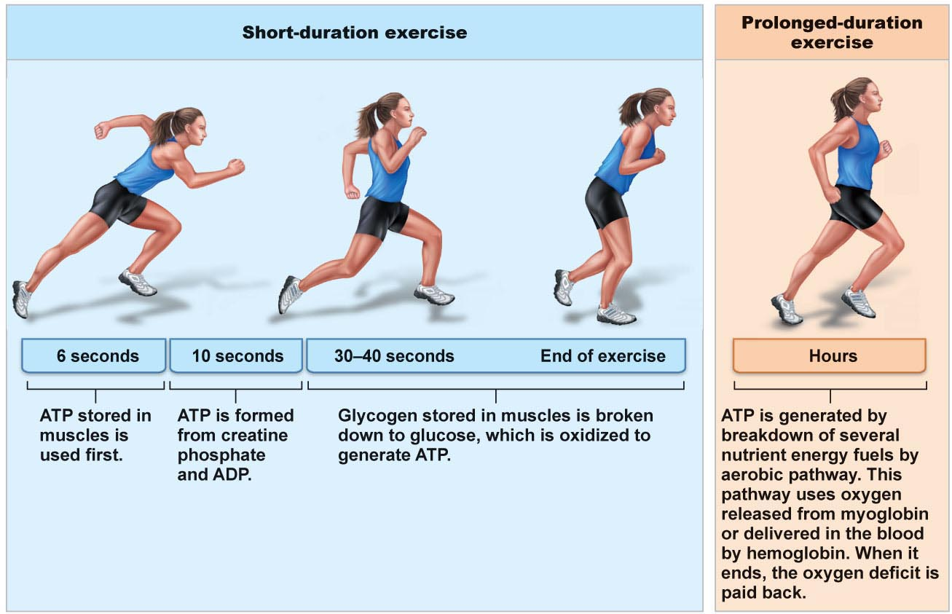
    - Anaerobic pathway produces ~5% ATP of aerobic pathway, but is 2.5x faster >> important during vigorous muscle activity

  - Energy systems used during sports & activities:
    - Weight lifting, diving, sprinting – ATP & CP
    - Tennis, soccer, 100m swim: almost entirely anaerobic
    - Marathon runs, jogging: mainly aerobic, but anaerobic may function until aerobic reaches full efficiency
    - AEROBIC ENDURANCE: length of time a muscle can use aerobic
    - ANAEROBIC THRESHOLD: point at which muscle converts to anaerobic

  - Muscle fatigue:
    - = state of physiological inability to contract; results from a relative deficit of ATP (total absence would cause contractures – eg. ?)
    - Contributors: build-up of lactic acid, ion imbalances (Na+/K+ pump required ATP)
  - Oxygen debt:
    - Post-exercise need to replenish O2 reserves, convert lactic acid to pyruvic acid, replace glycogen stores, restock ATP & CP
    - Liver converts additional lactic acid to glucose/glycogen
    - Oxygen debt: extra amount of oxygen needed to be taken in to accomplish the above (lactic acid indirectly stimulares respiratory center of brain)
    - New term is excess post-exercise oxygen consumption (EPOC)
  - Heat production during muscle activity:
    - ATP-driven muscle contraction 20-25% efficient; dissipated by body’s cooling mechanisms
- Muscle fiber type:
  - Slow oxidative fibers: thin cells with slow-acting myosin ATPases – contract slowly (red = lots of myoglobin); primary energy fuel is fat
    - Lots of mitos, capillaries, aerobic enzymes: oxidative
    - Fatigue resistant, but not powerful (thin)
  - Fast glycolytic fibers: large, pale (white), little myoglobin and diameter 2x that of slow oxidative fibers; fast-acting myosin ATPases & contract quickly
    - Few mitochondria; lots of glycogen reserves: glycolytic
    - Will fatigue, but powerful
  - Fast oxidative fibers: red or pink, intermediate cell size; fast-acting myosin ATPases & contract quickly; high myoglobin content and O2- dependent; fairly fatigue-resistant (eg. Eye muscles)
  - Most body muscles have a mixture of fiber types; genetics can alter distributions and subsequent athletic strengths
- Arrangement of fibers & microscopic structure
  - Small, spindle-shaped cells; one centrally-located nucleus
    - Diameter 2-10 μm; length 100-500 um
  - Cells separated by fine CT; sheets of closely opposed fibers; usually at least 2 sheets with opposite orientations
  - Alternating contractions of opposing layers provide mixing, peristalsis, expelling
  - Varicosities instead of NMJs; bulbous swellings of autonomic ns – release NT into wide synaptic cleft near smooth muscle cells – diffuse junctions

