Introduction to Microeconomics
(Chapter 1)

Definition of Microeconomics
- Microeconomics is the study of individual behavior in the context of insufficiency of amount or supply(shortage).
- Microeconomics seeks to understand and explain how we make choices and how thoe choices affect our behavior in the workplace and society.

Ideas and methods
- The Mission of Economics: Find the best way to use ressources to satisfy the needs that we have in order to be as good as we can.
- Models are frameworks we use to organize how we think about a problem.
- Scientific nature: mathematics, mathematical methods and data/statistical methods to test our policies(one of the most important things).

Challenges for today’s society
- High unemployment rates
- Government debts
- Overpopulation/Climate Change
- Inequality (middle-class is very weak)

Microeconomics and Macroeconomics
- Macroeconomics: we study the system (economy) in itself.
- Microeconomics: individual humans of the system/consumers. *Government is a producer in the economy and affects the economic system by making decisions such as regulate markets, policies that affect firms and people.

Mixed Economy
- Definition: Goods and services are supplied both by private suppliers and government. Hence, the Government makes important decisions for the entire economy, and not only private suppliers.
- Example: Price of food is too high, some people cannot buy enough food. In a free economy, who cares because that is the market price (total free economy). In a mixed economy, government sees the problem, identifies the problem and decides to intervene to lower prices.

Government
- Legal system/structure: Enforces contracts. If we cannot enforce contracts = contracts have no value. Example: United States outstanding legal system which is why it such a developped country. People will want to invest in your country if legal system is strong since the contracts are enforced fast and effectively.
- Governments account for more than one third of all economic activity in the modern mixed economy.

Understand Economics through the Use of Models and Theories
- Model is important because it gives us intuition on how things are working. It should be a reduced version of the phenomenon that is under study, it accords with reality and it makes meaningful predictions.
- A Theory is a logical view of how things work, and is frequently formulated on the basis of observation.
- The Model reduces and simplifies the theory to manageable dimensions.
- Limited ressources but unlimited needs.

The Opportunity Cost: Concept
- Definition: It is what you give up for doing something else.
- The Opportunity Cost can be financial, measured in time or simply the alternative foregone.
- Example: You have the choice of going to class or working at McDonalds for 10$. You choose to go to class. Therefore, your Opportunity cost is the 10$ you did not make from not going to work.

A Model of exchange and specialization
- Example: Two-Person Economy and everybody has 36 hours and two activities. They can produce either fish or vegetables. What can we do to better the production without adding ressources and using more advanced technologies: Amanda takes care of fish and Zoe of vegetables so they can trade and be more efficient.

 | Hours/fish | Hours/vegetable | Fish production | Vegetable production
Amanda | 3 | 2 | 12 | 18
Zoe | 2 | 4 | 18 | 9

- Calculate the Opportunity Cost for Amanda (vegetable) = 12 fish/18 vegetables = 2/3 of a fish per vegetable. If you want to make a vegetable, you have to give up 2/3 of a fish.
- Calculate the Opportunity Cost for Amanda (fish) = 18 vegetables/12 fish =3/2 of a vegetable per fish. If you want to make a fish, you have to give up 3/2 of a fish.
- Calculate the Opportunity Cost for Zoe (vegetable) = 18 fish/9 vegetables = 2. She needs to give up 2 fishes to make 1 vegetable.
- Calculate the Opportunity Cost for Zoe (fish) = If you want to make a vegetable, you have to give up ½ fish. * In the Exam, you need to write: ½ V/F
- Answer: Amanda is more efficient in making vegetables because she sacrifies 0.66 fish for 1 vegetable and Zoe is more efficient in making fish since she sacrifies 0.5 vegetable to make 1 fish.
- 18 (If Amanda makes fish with her 36 hours) and 12(If Amanda makes fish with her 36 hours)
- 9 (If Zoe makes fish with her 36 hours) and 18(If Zoe makes fish with her 36 hours)
- They both use 18 hours for fish and 18 hours in vegetables. Zoe(9; 4.5) and Amanda(6,9)
- PPF= The Production Possibility Frontier defines the combination of goods that can be produced using all of the ressources available.
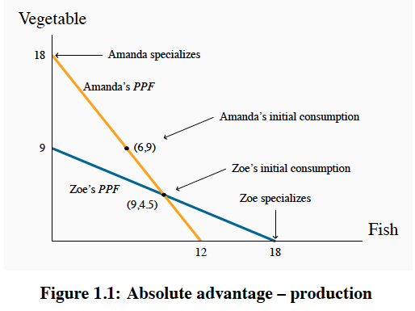
* What is on the line = eliminates ressources and what is outside of the line = cannot be produced.
* On a graph: x=fish and y=vegetable. Production Possibility Frontier
* Amanda’s slope = 1.5

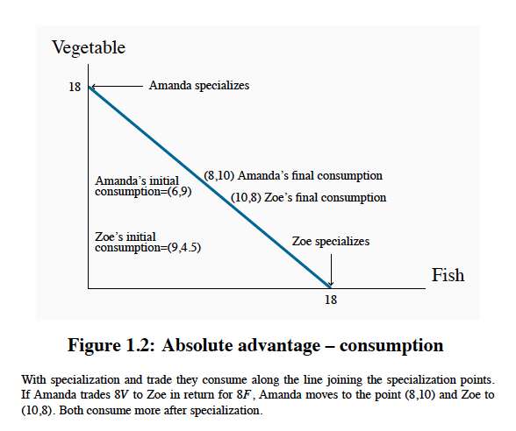
* Consumption Possibilities Frontier: What is possible to be consumed.
- Now per hour, Amanda makes 18 vegetables and Zoe makes 18 fishes. *18V>13.5V and 18F>15F.
- This economic model shows that you can consume more than you can produce.
- The exchange rate must be higher than their own productivity.
- In this problem: ½ V/F <= Terms of exchange Fish <= 1.5 V/F

Economy-wide PPF

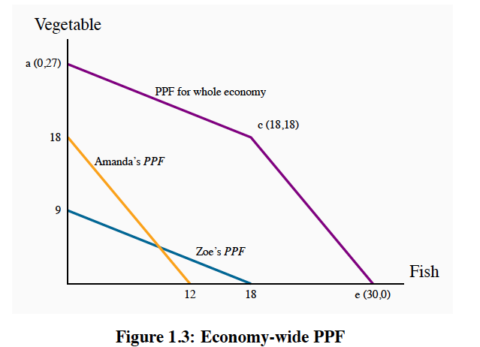
- Definition
- The goods and services combinations that can be produced by the economy when all available productive ressources are in use.

- Point A (0,27): Making only vegetables and no fish. (Addition Vegetable Production for Zoe and Vegetable Production for Amanda)
- Point C (18,18): Zoe gives her 36 hours to only making fish and Amanda gives her 36 hours to only making vegetables.
- Point E (30,0): Making only fish and no vegetables. (Addition Vegetable Production for Zoe and Vegetable Production for Amanda)

A Multi-Person PPF

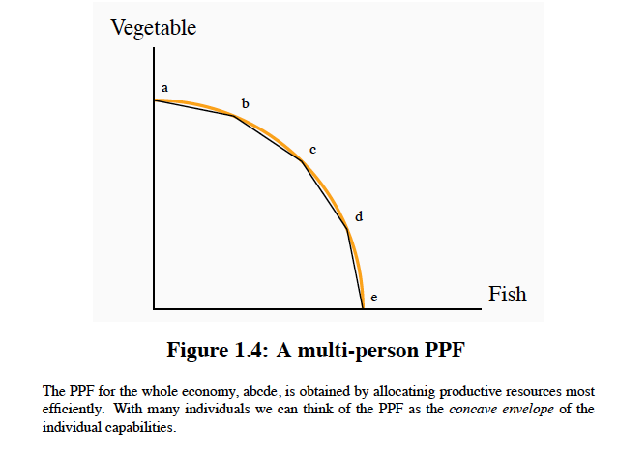
- When we are moving along the frontier of a production possibilities frontier, we are examining the opportunity cost of producing more of one good in terms of the other good.

Productivity of the Economy
- Productivity of Labor is defined as output per worker or per hour and depends on:
- Skill, Knowledge and experience of the labour force
- The Capital Stock
- Current Technology: how we combine labour force and capital stock.
- The Economy’s Output = (Number of Workers Employed) x (Output per Worker)
- Full Employment Output = (Number of Workers at Full Employment) x (Output per Worker)
- Full Capacity Output: Everyone willing to work at current wage rates and normal hours of work is working. My economy is at capacity. It means I am exactly on the frontier.

Economic Growth
- Three Things contribute to growth in the economy:
- The Labour Supply grows as the population expands;
- The Stock of Capital grows as spending by business on new offices, factories, etc;
- Labour-Force Productivity grows as a result of experience.
- Therefore, economies differ in their rates of overall economic growth as a result of different rates of growth in labour force, in capital stock and improvements in the technology.
- When more people are looking for jobs than there are jobs available, it promotes economic growth within a society.

Scarcity Problem
- The scarcity problem states that there are limited ressources.

Recessions and Booms
- Recessions: I operate inside the Production Possibilities Frontier, I’m not using all the ressources that I have.
- Booms: I’m producing outside the Production Possibilities Frontier. Always temporary.

Tutorial 1 : Question 1

- The following are hypothetical production possibilities tables for Japan and the United States.
Japan's Production Possibilities Table |  | The United States' Production Possibilities Table
(Millions of bushels) |  | (Millions of bushels)
   | A | B | C | D
  Bananas | 0 | 40 | 80 | 120
  Oranges | 30 | 20 | 10 | 0
   | A | B | C | D
  Bananas | 0 | 20 | 40 | 60
  Oranges | 30 | 20 | 10 | 0
For each line required, plot any two or more points on the line.
(i) Plot Japan's production possibilities curve by plotting at least 2 points on the curve.
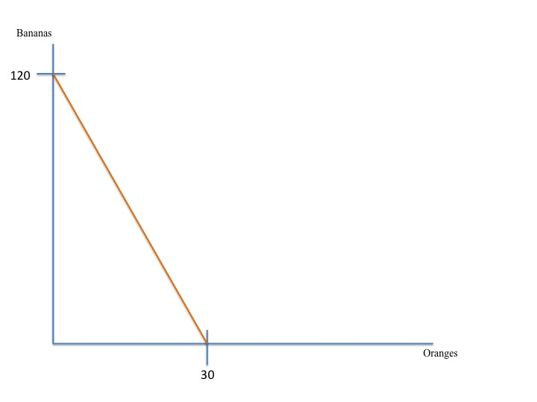
(ii) Plot the United States' production possibilities curve by plotting at least 2 points on the curve on the graph above.
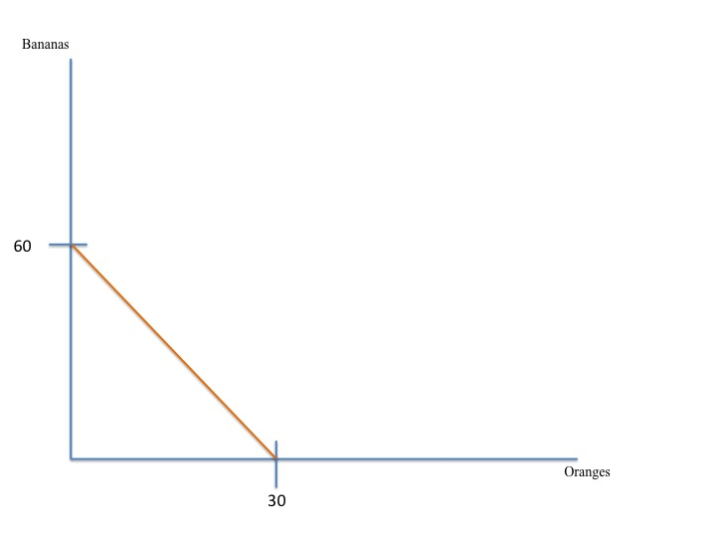
(iii) What is each country's cost ratio of producing Oranges and Bananas?
- Japan
- Opportunity cost of 1 Orange: Loss in Bananas/Gain in Oranges
- Opportunity cost: 40/10 = For each orange, you lose 4 bananas.
- Opportunity cost of 1 Banana: Loss in Oranges/Gain in Bananas
- Opportunity cost: 10/40 = For each banana, you lose 0.25 oranges.
- USA
- Opportunity cost of 1 Orange: 20/10 = For each orange, you lose 2 bananas.
- Opportunity cost of 1 Banana: 10/20 = For each banana, you lose 0.5 oranges.
(iv) Which nation should specialize in which product?
- USA should specialize in oranges because it has the lowest opportunity cost.
- Japan should specialize in bananas because it has the lowest opportunity cost.
(v) Plot Japan's trading possibilities curve (by plotting at least 2 points on the curve) if the actual terms of the trade are 1 orange for 3 bananas.

- Japan
- 30 x 3 = 90 bananas (How many bananas Japan will be getting for selling 30 oranges)
- 120/3 = 40 oranges (How many oranges Japan will be getting for selling 120 bananas)
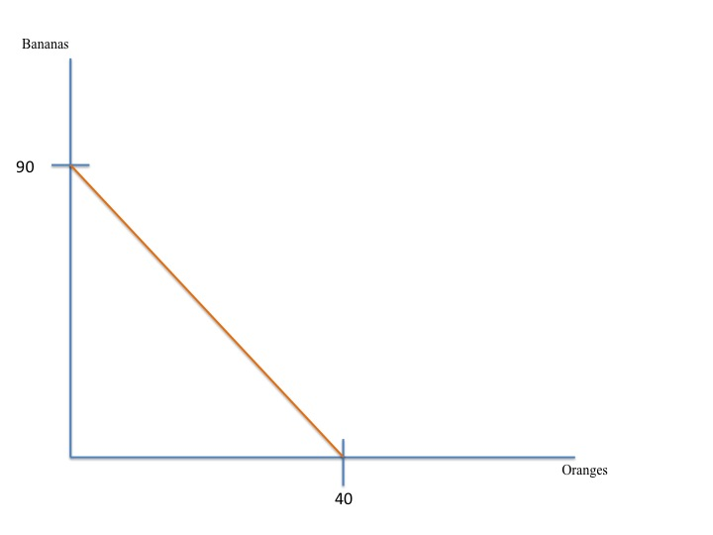
(vi) Plot the United States' trading possibilities curve (by plotting at least 2 points on the curve) if the actual terms of the trade are 1 orange for 3 bananas.
- USA
- 30 x 3 = 90 bananas
- 60/3 = 20 oranges

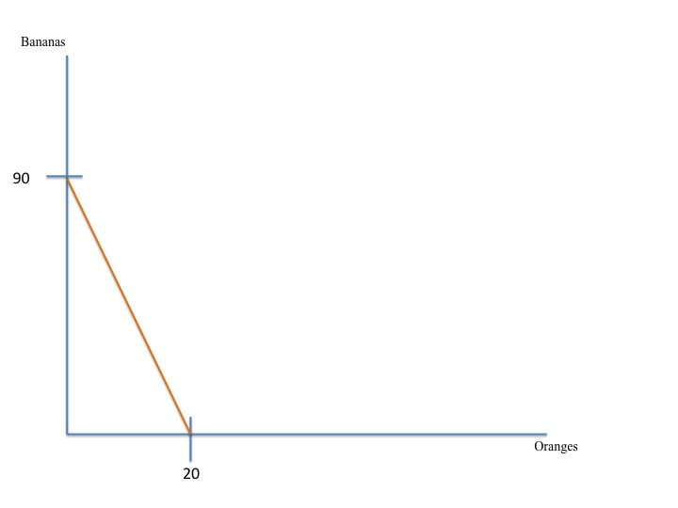
(vii) Suppose that the optimum product mixes before specialization and trade were C in Japan and B in the United States. What are the gains from specialization and trade?
- Before specilization

- Japan produced 80 bananas and 10 oranges.
- USA produced 20 bananas and 20 oranges.
- Total = 100 bananas and 30 oranges.

- After specilization
- Japan produced 120 bananas.
- USA produced 30 oranges.
- Total = 120 bananas and 30 oranges.

- Gains
- Bananas: (120-100) = 20 bananas.
- Oranges: (30-30) = 0 oranges.

2. Consumer Price Index and Real Price Index:
Over a four-year period, the prices of mangoes P_{M} (in dollars) and the Consumer Price Index (CPI) are given below:
Year | CPI | Price of Mangoes (P_{M})
1991 | 94 | 14
1992 | 100 | 15
1993 | 105 | 16
1994 | 115 | 17

- Which year is the base year for CPI? Use this same base year for mangoes.
- 1992 since CPI = 100.

- Calculate the nominal price index for mangoes.
- Nominal Price Index = (Price current year/price base year) x 100
- 1991: (14/15) x 100 = 93.33
- 1992: 100
- 1993: (16/15) x 100 = 106.67
- 1994: (17/15) x 100 = 113.33

- Calculate the real price index for mangoes.
- Real Price Index: (Nominal Price Index/CPI) x 100
- 1991: (93.33/94) X 100 = 99.29
- 1992: 100
- 1993: (106.67/105) X 100 = 101.59
- 1994: (113.33/115) X 100 = 98.55

- Have mangoes been more or less expensive compared to the typical goods consumers buy as measured by the CPI? Explain.

- We need to calculate the percentage change in real prices.
- Percentage Change in Real Price = (Real Price Index in given year – 100)/100 x 100.
- 1991: (99.29-100)/100 x 100 = -0.71%
- 1992: Since it is the base year, mangoes were not any cheaper or more expensive than average goods.
- 1993: (101.59-100)/100 x 100 = 1.59%
- 1994: (98.55-100)/100 x 100 = -1.45%

