Bones of the Head, trunk and Pelvis

Skull

- Skull; a series of bones form its two parts, neurocranium and facial skeleton.
- Neurocranium is formed by 8 bones:
  - A frontal bone
  - Paired parietal bones
  - Paired temporal bones
  - An occipital bone
  - A sphenoid bone
  - An ethmoid bone
- Facial skeleton
- Consists of 14 irregular bones
  - Lacrimal bone (2)
  - Nasal bones (2)
  - Maxillae (2)
  - Zygomatic bones (2)
  - Palatine bones (2)
  - Inferior nasal conchae (2)
  - Mandible (1)
  - Vomer (1)
Lateral aspect of the skull
Main features:
- Temporal fossa
- The opening of the external acoustic meatus
- Mastoid process of temporal bone. Sternocleidomastoid muscle attaches to it.
- Styliid process of temporal bone.
Occipital (posterior) aspect of the skull
- Vertex
- external occipital protuberance
External aspect of the cranial base
- foramen magnum
- two occipital condyles

Verterbral Column
- vertebral column (backbone, spine), extending from skull to apex of the coccyx
- its function includes:
  - forms the skeleton of the neck and back and is the main part of the axial skeleton
  - protects the spinal cord
  - supports the weight of the body
  - provides a partly rigid and flexible axis for the body and a pivot for the head.
  - Plays an important role in posture and locomotion movement from one place to another.
- Consists of 33 vertebrae arranged in five regions , 7 cervical, 12 thoracic, 5 lumbar, 5 sacral and 4 coccygeal.
- 24 of which are movable 5 sacral vertebrae are fused to form sacrum in adults, and 4 coccygeal vertebrae are fused to form coccyx.
- Intervertebral disc (IV disc) approximately one forth of spine is formed by the fibrocartillaginous IV discs, which separate and bind the vertebrae together.

Abnormal curvatures of the vertebral column
- Kyphosis: abnormal increase in the thoracic curvature
- Lordosis: an anterior rotation of the pelvis and can cause low back pain
- Scoliosis: an abnormal lateral curvature that is accompanied by rotation of the vertebrae.

Structure and function of vertebrae

A typical vertebrae consists of
- A vertebral body
  - Gives strength to the vertebral column and supports body weight.
- A vertebral arch
  - Protects spinal cord
- Seven processes
  - A spinous processes for muscle attachement and movement
  - Two transverse processes for muscle attachment and movement
  - Four articular processes two superior and two inferior for restriction movement in certain direction
- Vertebral foramen; is formed by the vertebral arch and the posterior surface of the vertebral body. The succession of vertebral foramen in the articular column forms the vertebral canal (spinal canal)
- The superior and inferior vertebral notches of adjacent vertebrae contribute to the formation of IV foraminia which give a passage spinal nerve roots and accompanying vessels.

Regional characteristics of vertebrae

Cervical vertebrae (C)
- Transverse foramen for passing blood vessels and nerves (small or absent in c7)
- Body is small and wider
- Spinous process is short C3-C5 and bifid C3-C5, C7 has a long spinous process.
- Aticluar processes
  - Superior facets: directed superoposteriorly
  - Inferior facetes: directed inferoanteriorly
Cervical Vertebrae
- C1 and C2 are atypical vertebrae
- C1 the atlas has no spinous process or body, it consists of anterior and posterior arches. The superior articular surfaces of C1 receive the two occipital condyles at the sides of the faramen magnum of the cranial base.
- C2 the Axis is the strongest of the cervical vertebrae
  - Has two large flat bearing surfaces the superior articular facetes on which the atlas roatates.
  - Has the blunt toothlike dens
- Part of the body of C1 is transferred to C2.
Thoracic Vertebrae
- Have the coastal facets for articulation with ribs.
- The spinous processes re long and slopes posteroinferiorly \
- Transverse processes are long, strong and extend posterolaterally
- Articular processes
  - Superior facets directed posteriorly and slightly laterally
  - Inferior facets directed anteriorly and slightly medially.
Lumbar Vertebrae
- Lumbar vertebrae are distinguished by their
  - Absence of coastal facets
  - Massive bodies
  - L5 is the largest of all movable vertebrae.
Sacrum
- Sacrum is usually composed of five fused sacral vertebrae in adults.
- The sacrum forms the posterior part of the bony pelvic
- Articular facets for articulation with L5 and hip bone

Coccyx

- Coccyx is usually formed by four rudimentary vertebrae, but there may be one less or one more
- The 1st coccygeal vertebrae may be separate
- The last three coccygeal vertebrae often fuse together during middle life.

Skeleton of Thoracic Wall

Thoracic cage and wall
- Thoracic cage, is formed by the 12 pairs of ribs, sternum, coastal cartilages, and 12 thoracic vertebrae. Along with the skin and associated fascia and muscles, the thoracic cage forms the thoracic wall.
- the role of the thoracic cage
  - lodges and protects the contents of the thoracic cavity
  - provides attachments for muscles.
  - Supports the pectoral girdle (shoulder girdle)
- The thoracic wall provides mechanical function of breathing

Ribs
- Three types of ribs
- True ribs (first 7) attach directly to the sternum through their own costal cartilages
- False ribs (8th to 10th ribs) their cartillages are joined to that of the rib immediately superior to them. Their connection with sternum is indirect.
- Floating ribs (vertebral free) ribs 11th and 12th. They do not connect to the sternum
Typical ribs have a:
- Head that has two facets for articulation with vertebrae
- Neck
- Tubercle that has one articular area for articulation with vertebra
- Shaft
Atypical ribs are dissimilar; these consists of ribs 1,2,10 and 12.

Sternum
- Consists of three parts, manubrium, body and xiphoid process
- Lies at the level of the bodies of T3 to T10 vertebrae
- Articulates with clavicals and pairs of costal cartilages of 1st to 7th ribs.
- The jugular notch, sternal angle and xiphoid process are palpable and are the important landmarks.

Bones of the Pelvis
Pelvis skeleton
- In the mature adult the pelvic skeleton (bony pelvis) is formed by four bones.
  - Hip bones, two large, irregular shaped bones, each of which develops from the fusion of three bones, ilium,ishchium and pubis.
  - Sacrum, formed by the fusion of five originals separate sacral vertebrae.
  - Coccyx, formed by the fusion of four coccygeal vertebrae
Hip bone (lateral aspect)
- The flattened, fan shaped part of the hip bone
- In children, each hip bone consists of three separate bones, ilium, ischium and pubis, which are united by cartilage at the acetabulum.
Ilium
- The flattened, fan shaped part of the hip bone
Ischium
- The ischium composes the posteroinferior part of the hip bone. It has a body and ramus. The body of ischium helps to form the acetabulum. The ramus of the ischium helps to form the obturator foramen.
- Ischial tuberosity is the place where semitendinosus, semimembranosus and biceps femoris (long head) attach to
Pubis
- The pubis is an angulated bone and composes the anteromedial part of the hip bone.
- The superior ramus of the pubis helps to form the acetabulum, and an inferior ramus helps to form the obturator foramen
- Medialls, the symphyseal surface of the body of the pubis articulates with the corresponding surface of the body of the contralateral pubis by means of the pubic symphysis

Obturator foramen & acetabulum
- Obturator foramen is bounded by the pubis and ischium and their rami, which is a small passageway for the obturator nerve and vessels.
- all three parts (ilium,ischium, pubis) of the hip bone join to form the acetabulum, which articulates with the head of the femur to form the hip joint

Definitions

- Spinous and Transverse process: spinous process is a bony projection off the posterior (back) of each vertebra. The spinous process protrudes where the laminae of the vertebral arch join and provides the point of attachment for muscles and ligaments of the spine. Transverse processes are small bony projections of the right and left side of each vertebrae (not in picure) P.269. they function as the site of attachement for muscle and ligaments of the spine as well as the point of articulation of the ribs (in the thoracic spine)
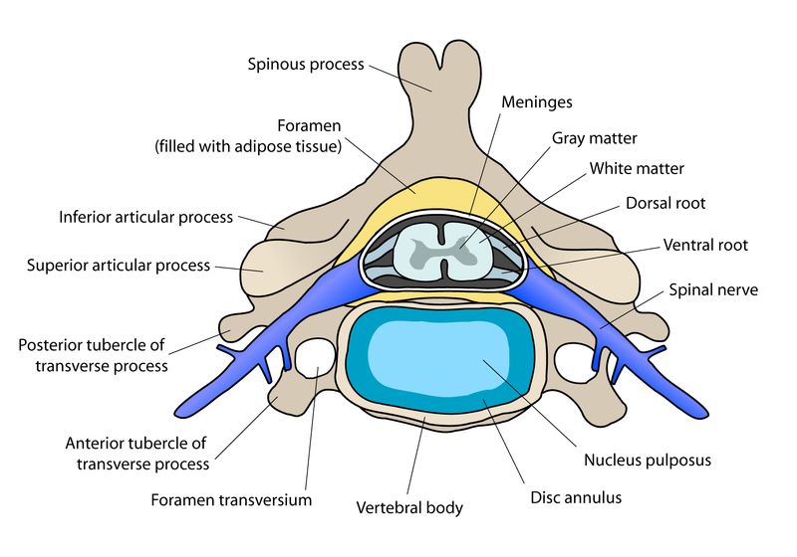

- Articular facetes: the articular surface of the inferior articular processes of vertebrae, combining with the articular facet of the vertebrae above to form a join.
- Articular processes: four of them, two superior and two inferior, each bearing an articular surface (facet). P.269 they serve the purpose of fitting in with another vertebrae. Connect vertebrae’s basically.
- Lamina flat plates od bones forms the roof of the vertebral foramen. Serves to protect the spinal cord.
- Pedicle; pedicles are short, stout processes that join the vertebral arch to the vertebral body.
- Vertebral foramen: the opening formed by a neural arch through which the spinal cord passes.
- Vertebral arch: lies posterior to the vertebral body and is formed by right and left pedicles and laminae. Serves to protect the spinal cord.
- Vertebral body: the larger part of the vertebrae, gives strength to the vertebral column and supports body weight. The size of vertebral bodies especially from T4 inferiorly increases to bar more body weight.
- Vertebral notches: either of two concave constrictions of which one occurs on the inferior surface and one on the superior surface of the pedicle on each side of a vertebra and which are arranged so that the superior notches of one vertebra and the corresponding inferior notches of a contiguous vertebra combine to form an intervertebral foramen on each side. Otherwise known as the IV foramina, which give passage to spinal nerve roots and accompanying vessels and contain spinal ganglia.
- Annular epiphysis: secondary growth centers occurring as rings at the periphery of the superior and inferior surfaces of the vertebral body.
- Process: is a projection or outgrowth of tissue from a larger body.
- Jugular notch: the notch at the top of the sternum that you can feel.
- Clavicular notch: a notch on either side of the jugular notch, still towards the top.
- Sternal angle: the angle between the upper part of the sternum and the boy of the sternum.
- Manubriosternal joint: articulation between manubrium and body of the sternum. Often fuse and become synostisis in older people. Secondary cartilaginous joint.
- Xiphisternal joint: primary cartilaginous joint, articulation between xiphoid process and body of sternum.
- Coastal notches: notches or facets on the lateral edge of the sternum for articulation with a coastal cartilage.
- Xiphoid process: the cartilaginous section at the lower end of the sternum, which is not attached to any ribs and gradually ossifies during adult life.
Pelvis bones:
- Body of first sacral vertebra: in the middle of the base of the sacrum, is connected with the under surface of the body of the last lumbar vertebre.
- Ala: flat bone part of a bone, example the ala of the sacrum.
- Coccys: tail bone, the small bone at the end of the sacrum.

