1.3.2 Four Basic Tissues Types:
- Nerve Tissues
  - control, regulation (Internal communication)
  - Brain, spinal cord, nerves
- Muscle Tissue
  - Contracts to cause movement
  - Skeletal, cardiac, smooth
- Epithelial
  - Forms boundaries between different environments, protects, secretes, absorbs, filters
  - CANCER CELLS!!
- Connective Tissue
  - Supports, protects, binds tissues together
  - Ie bones, tendons

- Epithelial Tissue- a sheet of cells that covers surface or lines a body cavity.
  - Covering and lining epithelium. Creates boundaries. Dips into and lines the open cavities of the urogenital, digestive and respiratory systems and covers the walls and organs of the closed ventral body cavity.
  - Glandular epithelium. Secretion. Fashions the glands of the body
In its role as an interface tissue, epithelium accomplishes many functions including:
- Six functions
  - Protection (mechanical, chemical, infection) ie skin
  - Absorption ie. GI tract
  - Filtration ie kidney
  - Excretion ie kidney
  - Secretion ie glands
  - Sensory reception ie. Taste buds

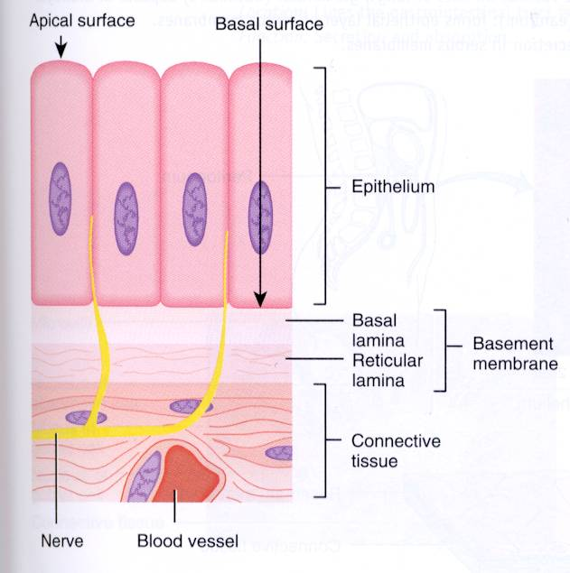
- Apical surface and basal surface
- IMPORTANT: they are adjacent! It is important the epithelial cells know up from down
- Junction: define and stich them together.
- Avascular; no blood supply
- Nerve endings
Seven special structural characteristics of epithelial tissue
- Cellularity
- Specialized contacts: Except for glandular epithelia, epithelial cells fit closely together of form continuous sheets. Lateral contacts, including tight junctions and desmosoes bind adjacent cells together at many points. The tight junctions help keep proteins in the apical region of the plasma membrane from diffusing into the Basal region and thus help to maintain polarity.
- Polarity: apical and basal surfaces; apical surface often specialized such as having microvilli or cilia.
- The two surfaces differ in both function and structure. Therefore, we say epithelial cells exhibit apical-basal polarity
- Apical surface-some appear smooth while others have microvilli and this tremendously increases the exposed surface area. Others may have cilia which have propel substances along their free surface. Ie in the trachea.
- Basal lamina: This non cellular, adhesive sheet consists of largely of glycoproteins secreted by the epithelial cells plus some fine collagen fibers.
      - Acts as a selective filter that determines which molecules diffusing from the underlying connective tissues are allowed to enter the epithelium,
      - Also acts as scaffolding along which epithelial cells can migrate to repair a wound.
- Supported by connective tissue: All epithelial sheets rest upon and are supported by connective tissue. Just deep to the basal lamina is the reticular lamina; a layer of extracellular material containing a fine network of collagen protein fibers.
      - The two laminae form the basement membrane, which reinforces the epithelial sheets, helps it resist stretching and tearing.
- Innervated but avascular: Epithelium is avascular (contains no blood vessels) it is innvervated (supplied by nerve fibers) they are nourished by substances diffusing from blood vessels in the underlying connective tissue.
- Regeneration: high regenerative capacity - Reflects nature of their job – rubbed off, damaged
* An important feature of cancerous epithelial cells is failure to respect the boundary imposed by the basement membrane
Classification of Epithelia
- Each epithelium has two names. The first name indicates the number of cell layers present and the second describes the shapes of its cells.
- Simple epithelia=single layer of cells
- Stratified epithelia=two or more layers of cells. Considerable more durable and protection is their major but not only role!
Shape can change in different. In stratified epithelia, they can be classified by cell shape in apical layer.
Cell Shape
- Squamous cells
  - Flattened and scalelike
  - Nucleus flattened
- Cuboidal cells
  - Boxlike
  - Nucleus round
- Columnar cells
  - Tall; column shaped
  - Nucleus elongated
4 Types Simple Epithelium
View pictures aswell!!
Type | Simple squamous | Simple cuboidal | Simple columnar | Pseudostratified Columnar
Description | Single later of flattened cells with disc-shaped central nuceli and sparse cytoplasm. | Single layer of cubelike cells with large, spherical central nuclei. | Single layer of tall cells with round to oval nuceli. Some cells; cilia or mucus secreting cells. | Single layer of cells differing heights, some not reaching the free surface; cilia and mucus
Function | Allows materials to pass by diffusion and filtration in sites where protection is not important. | Secretion and absorption. | Absorption; secretion of mucus, enzymes and other substances. | Secrete substances, particularly mucus, propulsion of mucus by ciliary action.
Location | Air sacs in lungs, lining in heart, blood vessels, etc. | Kidney tubules; ducts of small glands. | Nonciliated types lie in GI tract, rectum, ducts and etc | Noncilliated; sperm and ducts in large glands. Trachea

Types of Stratified Epithelia
Type | Stratified squamous | Transitional
Description | Thick membrane composed of several cell layers; basal cells are cuboidal or columnar and metabolically active. Surface cells are flattened and are full of keratin and are dead. Basal cells are active in mitosis and produce cells of the more superficial layer. | Resembles both stratified squamous and stratified cuboidal; basal cells cuboidal or columnar; surface cells dome shaped.
Function | Protects underlying tissues in areas subjected to abrasion | Stretched readily, permits stored urine to descend to urinary organ.
Location | Nonkeratinized type forms the moist linings of esophagus, vagina and mouth. Kerantized forms the epidermis of skin. | Lines the ureters, bladder and part of the urethra.

1.3.8 Glandular Epithelia
- Gland: consists of one or more cells that make and secrete a particular product. This product is called a secretion; is an aqueous fluid that usually contains proteins, but there is some variation.
- Secretion is an active process. Glandular cells obtain needed substances from the blood and transform them chemically into a product that is then discharged from the cell.
- Glands are classified according to two sets of traits:
  - Site of product release: endocrine (internally secreting) or exocrine (externally secreting)
  - Relative cell number glands may be unicellular or multicellular
- Endocrine gland: Produce hormones, messenger chemicals that they secret by exocytosis directly into the extracellular space. Because endocrine glands eventually lose their ducts, they are often called ductless glands.
  - Each hormone produced prompts its target organ(s) to respond in some characteristic way.
  - Endocrine glands are structurally diverse, therefore one description does not fit all.
  - Most are compact multicellular organs, but some individual hormone-producing cells are scattered in the digestive tract lining (mucosa) and in the brain.
- Exocrine Glands: secrete their products onto body surfaces (sin) or into body cavities. They release by ducts.
  - Ie. Sweat, mucus, oil/salivary glands, liver (bile), pancreas and etc
  - Two important types of exocrine glands:
    - Unicellular: secrete by exocytosis. Unicellular glands are sprinkled in the epithelial lining if the intestinal and respiratory tracts.
      - Ie. Mucin and goblet cells
View text
    - Multicellular: More structurally complex. 2 major parts: an epithelium-derived duct and a secretory unit consisting of secretory cells.
      - Surrounded by supportive connective tissue which supplies it with blood vessels and nerves fibers, and forms a fibrous capsule that extends into the gland and divides it into lobes.

Classification of Multicellular Glands
- Structural
  - Simple: unbranched ducts
  - Compound: branched duct
- Type of Secretion
  - Merocrine
    - Most common, secrete products by exocytosis. “Merely secrete” Ie. Pancreas, most sweat glands and salivary glands
  - Holocrine
    - Accumulate their products within them until they rupture. “die for their cause”
  - Aprocrine
    - Accumulates products within the apex and pinches off
    - Controversy
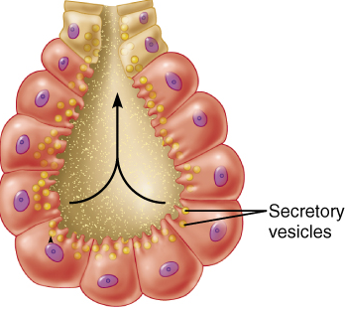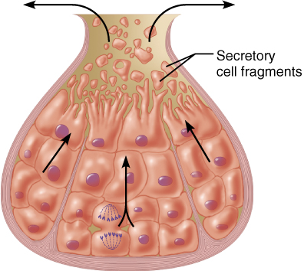

1.3.9 Connective Tissues
5 Major Types: Main Functions:
- Mesenchyme 1) Binding or support
- CT Proper 2) Protection
- Cartilage 3) Insulation
- Bone 4) Transportation
- Blood
- Connective tissue is the most abundant and widely distributed of the primary tissues, but its amount in particular organs varies.
- Three main elements:
  - Ground Substance
    - Unstructured material that fills the space between the cells and contains the fibers. It is composed of interstitial (tissue) fluid, cell adhesion proteins.
    - Consists of large amounts of fluid and functions as a molecule sieve through which nutrients and other dissolved substances can diffuse between the blood capillaries and the cells.
    - Fibronectin, laminin help cells attach to matrix elements
    - Proteoglycans consist of a protein core to which glycosaminoglycans (GAGs) are attached. The strand like GAGs are large, negatively charged polysaccharides that stick out from the core protein like fibers on a bottle brush. Both of these intertwine and trap water forming a substance that varies from a fluid to a vicious gel.
  - Fibers
    - Collagen: high tensile strength
      - Protein called collagen, fibrils cross-link causing these fibers to be super strong.
    - Elastic fibers: protein elastin has a coiled structure to allow for stretch and recoil. Found in skin, lungs and blood vessel walls.
    - Cells: immature (blast aka forming) vs. mature (cyte)
      - “blasts” are actively dividing/synthesizing cells during growth & repair
      - “cytes” primarily provide a level of maintenance
      - Others – fat cells, immune cells (WBC, mast cells, macrophages)
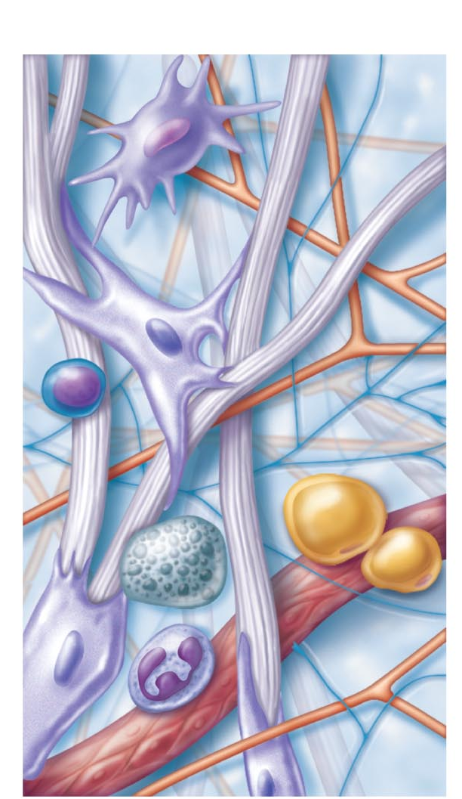 Label: Macrophage, Fibroblast, Lymphocyte, Fat Cell, Mast Cell, Neutrophil, Capillary, Ground Substance Fibers, Collagen, Elastic and Reticular Fibers.

1.3.11 Three Types of Loose Connective Tissue
Type | Areolar | Adipose | Reticular
Description | Gel-like matrix with all three fiber types: cells, fibroblasts, macrophages, mast cells and some WBC. | Matrix as in areolar but very sparse. Closely packaged adipocytes or fat cells, have nucleus pushed to the side by large fat droplets. | Network of reticular fibers in a typical loose ground substance reticular cells life on the network.
Function | Wraps and cushions organs; its macrophages phagocytize bacteria; plays an important role in inflammation and holds conveys tissue fluid. | Provides reserve food fuel and insulates against heat loss. Supports and protects organs. | Fibers form a soft internal skeleton (stroma) that supports other cell types including WBC, mast cells and macrophages.
Location | Widely distributed under epithelia of body; ie. Surrounds capillaries | Around kidneys and eyeballs, within abdomen and in breasts. | Lymphoid organs ie lymph nodes, bone marrow, spleen

1.3.12 Three Types of Dense Connective Tissue
Type | Dense Regular | Dense Irregular | Elastic
Description | Primary parallel collagen fibers; a few elastic fibers; major cell type is the fibroblast. | Primarily irregularly arranged collagen fibers; some elastic fibers; fibroblast is the major cell type. | Dense regular connective tissue containing a high proportion of elastic fibers.
Function | Attaches muscle to bones or to muscles; attaches bones to bones; withstands great stress when pulling force is applied in one direction. | Withstands tension exerted in many directions, provides structural strength | Allows tissue to recoil after stretching; maintains pulsatile flow of blood through arteries; aids passive recoil of lungs.
Location | Tendons, most ligaments | Fibrous capsules or organs and joints; dermis of skin and submucosa of digestive tract. | Walls of large arteries, certain ligaments and walls of bronchial tubes.

Cartilage
- Because cartilage is avascular and aging cartilage cells lose their ability to divide, injured cartilage heals slowly.
- Three varieties of cartilage: hyaline, elastic and fibrocartilage.

Type | Hyaline | Elastic | Fibrocartilage
Description | Collagen fibers form a network. Form a firm matrix | Similar to hyaline but more elastic fibers in matrix | Matrix similar but less firm than that in hyaline cartilage; thick collagen fiber predominate.
Function | Supports and reinforces serves as resilient cushion; resists compressive stress. | Maintains the shape of a structure while allowing great flexibility. | Tensile strength allows it to absorb shock
Location | Forms most of embryonic skeletons; covers the ends of long bones; forms costal cartilage. | Supports external ear. | Intervertebral discs, pubic symphysis and discs of knee joint.

Bone ** dealt with more later
- Calcium salts give hardness & strength for support/protection of softer tissues; cavities for fat storage & synthesis of blood cells.
- Osteoblasts: bone producing cell, mature into osteocytes
- Osteocytes: mature bone cell, reside in lacunae (spaces in bone matrix)
- Osteoclasts: “bone-breakers”
Blood
- Although it does not connect things or give mechanical supports it is classified as a connective tissue because it develops from mesenchyme and consists of blood cells, surrounded by nonliving fluid matrix called blood plasma.
- Function: transports respiratory gases, nutrients, wastes and etc.
- Contained within blood vessels.

REVIEW CHARTS BELOW!


