- 1.1

BUSINESS
  - all profit seeking activities and enterprises that provide goods and services necessary to an economic system

PROFIT
  - reward business owners make (revenue – expense)
- 1.2
- FACTORS OF PRODUCTION
  - Natural resources
  - Capital resources
  - Human resources
  - Entrepreneurship

- 1.3
- PRIVATE ENTERPRISE SYSTEM
  - An economic system that rewards firms for their ability to identify and serve the needs and demands of customers

- CAPITALISM
  - An economic system that rewards firms for their ability to perceive and serve the needs and demands of consumers; also called private enterprise system

- COMPETITION
  - The battle among businesses for consumer acceptance

- COMPETITVE DIFFERENTIATION
  - The unique advantage that sets the company apart

BASIC RIGHTS IN THE PRIVATE ENTERPRISE SYSTEM

- 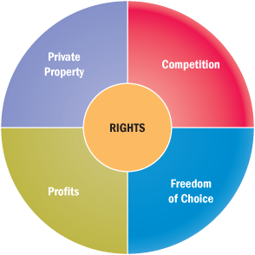

- PRIVATE PROPERTY
  - The right to sell, use, own, buy and hand down land, buildings, machinery, equipment, patents, individual possessions, and various intangible kinds of property
  - The most basic freedom under the private enterprise system

- ENTREPRENEUR
  - A person who seeks profitable opportunity and takes necessary risk to set up and operate a business

- 1.4
- SIX ERAS IN THE HISTORY OF BUSINESS
- 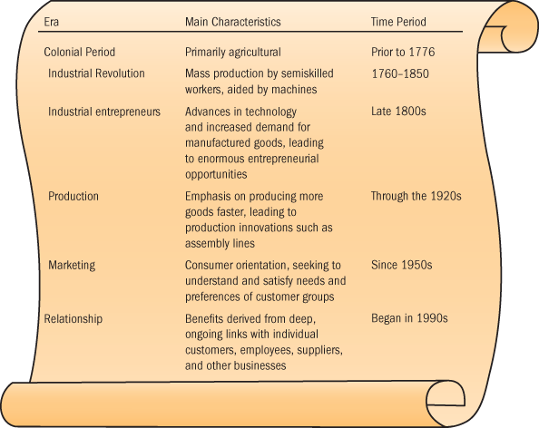

- TRANSACTION MANAGEMENT
  - Building and promoting products in hopes that enough customers buy to cover costs and make profit

- RELATIONSHIP MANAGMENT

Increasing, business focus on relationship management
  - The collection of activities that build and maintain ongoing mutually beneficial activities ties with customers and others

- Strategic Alliances
  - A partnership formed to create a competitive advantage for the business involved; in international business, the business strategy of one company partnering with another company in the country where they want to do business

- GREEN ADVANTAGE
  - A way to make profit is to address issues that customers may care about
    - Coffee companies try to make their product recyclable

- 1.5
- TODAYS BUSINESS WORKFORCE
  - A skilled and knowledgeable workforce is essential resource for keeping pace with the rapid rate of change in today’s business world

- CHANGES IN WORKFORCE
  - Aging population
  - Shrinking labour pool
  - Growing diversity of workforce
  - The changing nature of work
  - Need for flexibility and mobility
  - Need to work with others to innovate

- NEARSHORING
  - The outsourcing of production or services to locations near a firm’s home
- 1.6
- THE 21ST CENTURY MANAGER
  - 21ST Century managers must apply critical thinking skills and creativity to business challenges and lead changes.

Vision
  - the ability to perceive marketplace needs and what an organization must do to satisfy them
- CRITICAL THINKING
  - The ability to analyze and assess information to pinpoint problems and opportunities

- CREATIVITY
- The capacity to develop novel solutions to perceived organizational problems

- 1.7
- WHAT MAKES A COMPANY ADMIRED?
  - Solid profit
  - Stable growth
  - Safe and challenging Work environment
  - High quality of goods and services
  - Business ethics and social responsibility

