CP102 Midterm 1
Chapter 1
Section A
- Digital Revolution- ongoing process of social political and economic change brought on by digital tech.
- Digitalization- converting text, numbers, sounds, photos and video into data that can be processed by digital devices (conversion)
- Today’s society demands constant tech. improvements The desired medium for consumers continues to change ( ex. Cloud computing over network computing)
- Phase 1=Mainframe computing was the origin of computers used by most large companies for payroll etc.
- Data processing based around info being input, then processed by the comp, and then output
- Phase 2=Personal Computing- Small standalone computers
  - Original personal comps. Very limited capabilities, and expensive
- Phase 3= Network computing A group of computers linked together to share data. Developed when comps. Gained network ability and the internet was opened to the public
- Origin of the Internet
  - A collection of networks connecting billions of computers globally
  - Developed during the cold war by the US
    - Established secure form of communication
    - Generic way for all computers to connect
- Internet= all services provided on it, World Wide Wed= unique web pages on INT.
- The Web- Collection of linked docs, graphics and sounds that can be accessed over the INT
- Cloud Computing- access to info, applications, and communication stored over the internet
- Digital technology is an important factor in global and national economies, in addition to affecting the economic status of individuals
- Globalization can be defined as the worldwide economic interdependence of countries that occurs as cross-border commerce increases and as money flows more freely among countries
Section B
- Comp. Basics- a multipurpose device that accepts input processes data, stores data and produces output based on a series of instructions
- Input- Whatever is typed, submitted or transmitted to a comp. system
  - Output- result produced by comp
  - Computers manipulate data processes
- Memory- temporarily holds data waiting to be processed stored or output
  - Storage is permanent, when it is not needed for processing save on hard drive
  - RAM stores processing in short term
- The series of instructions that tells a computer how to carry out processing tasks is referred to as a computer program
  - Software
- A stored program: a series of instructions for a computing task can be loaded into a computer’s memory
- Application software is a set of computer programs that helps a person carry out a task
  - Sometimes referred to as apps
- System software is what allows the comp. system to monitor itself in order to function efficiently
  - Operating System
  - Process = access app, OS processes request, tells hardware how to act
- Computer types
  - Mainframe
  - Super Computer
  - Personal computer
- Microcontrollers
  - a special-purpose microprocessor that is built into the machine it controls
Section C
- Data representation: the form data is stored in, processed, and transmitted.
- Digital data- text, numbers, graphics, sound, and video that has been converted into discrete digits such as 0s and 1s known as BINARY (how the comp. understands the data)
- Analog data is represented using an infinite scale of values (digital 0 or 1)
- Bits and Bytes:
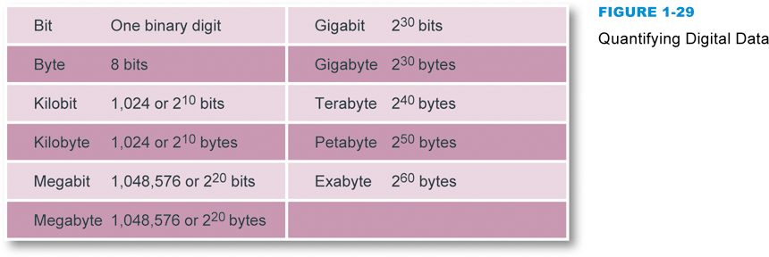
- Circuits and Chips
  - Integrated circuits are super thin semiconducting material packed with microscopic elements
  - Components are mounted on circuit board (mother board)
Section D
- Computers all work with digital data under the control of a comp. prgm
- Programmers create prgms that control digital devices
- Source code is the human readable version of complex coded programs
- Instruction set- a language understood by a microprocessor
- OP code- specifies the instruction ex. Add, compare or jump
- AlU- arithmaic logic unit= part of a CPU that performs arithmetic operations
- Control Unit- fetches each instruction of your program in order to execute it
- How processors work:
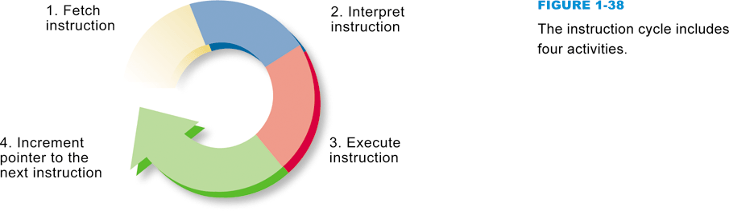
- Processor goes from RAM to the Control Unit and then to the ALU
Section E
- Authentication protocol: any method that confirms a person’s identity using something the person knows, something the person possesses, or something the person is
  - Passwords- series of characters that verify a user’s ID
  - Identification through physical features is also common ex. Fingerprint
- Password Hack- unauthorized access to your personal data illegally
  - Through dictionary attacks- use of common passwords
  - Or Brute force attacks- password cracking software
- Phishing- posing as a legitimate representative of an organization to persuade you to disclose highly secure info
- Keylogger- program that records keystrokes of a user and send them to a hacker
  - Usually in the form of a Trojan
  - Embedded in files, downloads, emails etc.
  - Trojans act as fake programs

Chapter 2
Section A
- Desktop computer- a computer system that houses a processor, memory, display circuitry and sound.
Section B
- A microprocessor is an integrated circuit designed to process instructions
- Your CPU- most expensive portion of the computer
- Measured in gigahertz
- Multicore Processor- example- i7 chips have 4 core processors, i5 only has 2
  - The more cores, the faster the processor
- Front Side bus- circuitry that transports data to and from the microprocessor
- CPU Cache
  - Special high speed memory that allows a microprocessor to access data more rapidly
- Bit Processor- ex. 64 bit processor processes and registers 64 bits at a time.
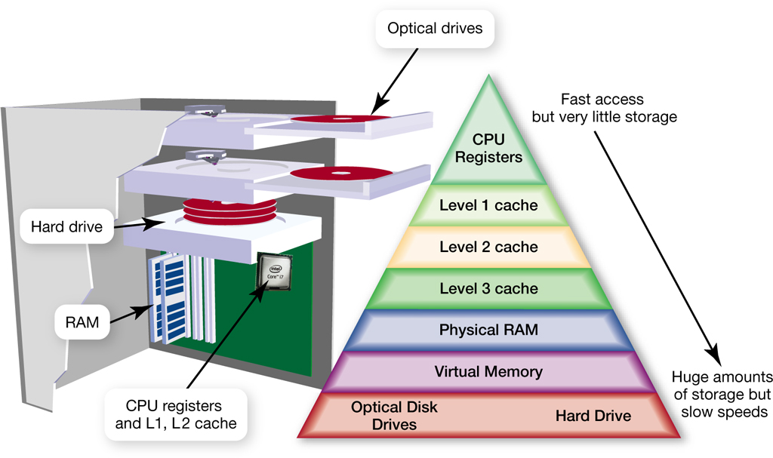
- CISC- Complex Instruction Set Computer= microprocessors with complex instructions
- RISC- Reduced Instruction Set Computer= microprocessor with limited instructions
- Serial Processing- processor completes instructions one at a time, must finish one before moving to another
- Pipelining- processor that can execute another instruction without finishing the first
- Parallel Processing- one step up from pipelining, can process multiple @ same time
- Bench Marks- tests of microprocessor speed
- RAM- temporary holding area for data= where programs reside while running
  - Volatile- erased after shutdown
  - Capacity expressed in gigabytes

- ROM vs. EEPROM
  - ROM- type of memory circuit that is housed in a single integrated circuit, permanent (non-modifiable) and non-volatile. Small set of instructions- like BIOS, how to load RAM.
  - EEEPROM- Non- Volatile and user modifiable
Section C
- Storage Medium contains data
- Data gets copied from a storage device into RAM, where it waits to be processed
- Processed data is held temporarily in RAM before it is copied to a storage medium
- Magnetic storage stores data by magnetizing microscopic particles on the disk or tape surface
- Hard disk technology is the preferred type of main storage for most personal computers
- Not as durable as many other storage technologies
  - Only part of computer requiring a moving part
  - Prone to problems
  - But provides a larger storage capacity
- Optical storage technology- stores data as microscopic light and dark spots on a disk surface
  - CD, DVD, Blu-Ray
  - 3 types- ROM, Recordable, rewriteable
- Solid State Storage- stores data in a erasable rewriteable circuitry
  - Non-volatile, card readers are usually the hardware that read the disk
  - SSD- Solid State Drive= package of flash memory that can be used as a hard drive substitute
Section D
- Basic input devices- keyboard, mouse, track pad, touchscreen
- Display Devices- Filter light through liquid crystal cells
  - Graphics circuitry generates the signals for displaying an image on the screen
- Graphics Cards
  - Graphics processing unit (GPU)- stores screen images as they are processed, but before displayed
  - Graphics Memory (RAM)- Stored in RAM
- Installing Peripheral Devices- When you connect or disconnect a peripheral device while the computer is operating, you are hot-plugging, a practice that’s allowed with USB and FireWire devices
Section E
- Basic Computer Maintenance
  - Keep the keyboard clean
  - Clean your computer screen on a regular basis
  - Make sure fans are free of dust

Chapter 3
Section A
- Software is categorized in two main categories
  - System Software- designed for computer tasks
  - Application Software- Designed to help people accomplish real-world tasks
- Software can be broken into: Graphics, Video, Music, and image software
- CAD- computer aided design
  - Most things made via CAD before actual construction
- Business software- developed to specialize in tasks for a business
  - Vertical- specialized
    - Unique to a business
  - Horizontal- generic
    - Accounting, payroll etc.
  - Number Crunching software- statistical, mathematic modelling software
- Device Drivers- Software that helps peripheral devices establish communication with computer
  - Ex. Printer driver- connects comp. to printer
Section B
- Office Suite- a collection of programs
  - Includes word processing, spreadsheet, presentations etc.
- Word Processing
  - Word wrap- how text flows from line to line, by moving words down to the next line
  - Search and Replace- used to track constant mistakes, or bad habits to change or correct
  - Grammar Checker- reads through doc, and points out grammatical errors
  - Readability Formula- used to find if writing matches your target audience
- Document Formatting
  - Page Layout- physical position of each element on a page
  - Paragraph style- includes the alignment of text within the margins and space between text
  - Font- set of letters that are unified by their design
- Spreadsheets- use rows and columns to create models or representations for data
  - Individual cells can execute formulas for reference, math, recalculations, functions.
- Databases- a collection of data
  - Helps find and organize info stored In a database
- Presentations
  - Supplies tool for combining, text, photos, graphs, animation etc. into a series of slides that can be presented from a computer screen or projector
Section C
- Wed Apps- Software installation process that places a program into a comp. so it can be run
  - Software is accessed through a web browser- example of cloud computing, all on web
- Mobile Apps- designed for handheld devices like smartphones
  - Can be purchased through app retail stores
- Local Apps- apps that contain a setup program and is installed onto device to be accessed through the OS
- Portable software- runs from a removable source like a usb
- Software updates- a replacement of software, were small amounts of code are edited to change or improve appearance or function
- Uninstalling software- process of deleting the files from the various folder on your computer
Section D
- Most operating systems include a handful of small applications and a variety of useful utility software
- Software Copyrights- a form of legal protection that grants the author exclusive rights
- Licenses- agreements allowing you to use a computer program
  - Types:
    - Public domain- not protected due to expiry
    - Proprietary- copyright has restrictions
    - Commercial software- sold in stores or online
    - Demoware- often preinstalled
    - Shareware- try before you buy
    - Open source- free software
    - BSD- Berkley software distribution
    - GPL- General public license
Section E
- Security software is designed to protect computers from various forms of destructive software and unauthorized intrusions
- Malicious software and malware refer to any computer program designed to surreptitiously enter a computer, gain unauthorized access to data, or disrupt normal processing operations
- Computer Virus- set of computer instructions attached to a file
- Computer worm- self-replicating program designed to carry out unauthorized activity
- Trojan Horse- (RAT) built in code that opens a back door to allow hackers access to computer info
- Bot- Any software that can automate a task or autonomously execute a commanded task
- Spyware- things that spy on your internet usage to spy on you. Ex. Ads for products you like are because you have been tracked
- Rootkit refers to software tools used to conceal malware and backdoors that have been installed on a victim’s computer
- Security Suites- integrates several security modules to protect against the most common types of malware, unauthorized access, and spam
  - Includes anti-virus software such as MacAfee
  - They are a series of instructions that identify known malicious programs etc.
  - Very Highly Recommended

Chapter 4
Section A
- Operating System- software that acts as the master controller for all activities that take place within a computer system.
- Tasks: 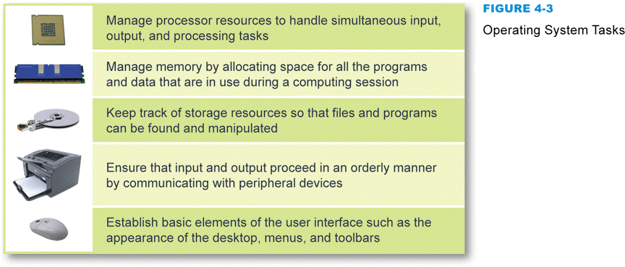
- Anything with hardware is allocated and dealt with by the OS
- Process: Application Software Operating System Hardware
- Multitasking – two or more programs running simultaneously
- Multithreading- allows multiple parts, or threads, of a single program to run simultaneously
- Multiprocessing- the capability supports a division of labor among all the processing units
- Memory leak- when an application requests memory but never releases it
- Programs move in and out of the OS very quickly. SO quickly we refer to it as “simultaneous”
- The Boot Process- OS kernel from ROM tells Hard disk to load OS, kernel then goes to RAM and into the processor
  - Computer’s small bootstrap program (BIOS) is built into special ROM circuitry housed in the computer’s system unit
- User Interface- combination of hardware and software that helps people & comp. communicate with each other
- Graphical User Interface (GUI)- provides a way to select menu options and manipulate graphical objects
Section B
- Windows- most popular, wide variety of programs unmatched by any other system, has large user community
- Mac OS- easy to use, reliable, security (fewer viruses), dual boot options
- Dual boot- use one computer to simulate the hardware and software of another
- Linux- Open source- distributed through GPL, developed in 1991

Section C
- File Names and Extensions – provide clues to the file contents ( what kind of file etc.)
  - Unique to each OS- Ex. .docx is a word processing document
- File Directories- designate a files location and where it is stored in memory
- 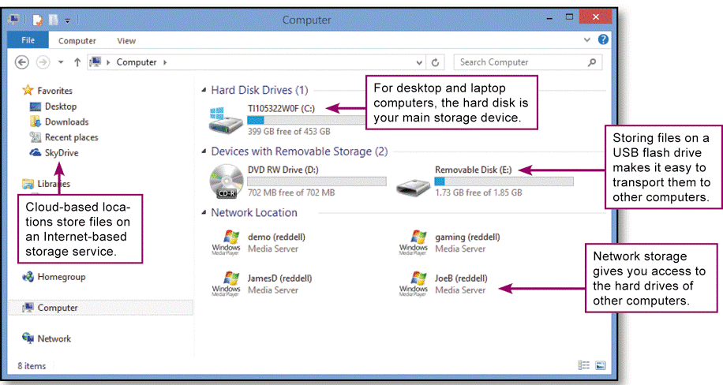
- Every storage device has a directory containing a list of its files
  - Root directory
  - Subdirectory
    - Depicted as folders
- Example:
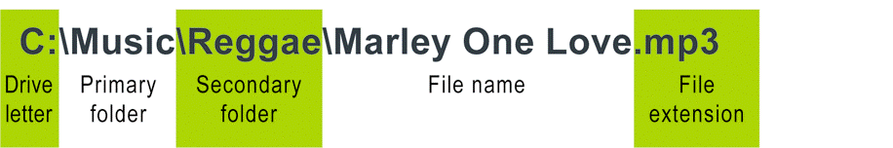

- File Format- the organization and layout of data that is stored in a file
Section D
- File Explorer- helps you manipulate files and folders
  - Rename
  - Copy
  - Move
  - Delete
- Library- used to group similar types of files together
- Physical file storage- what actually happens on the disks and in the cuircuts
  - Files are usually stored bit by bit in different sections of a disk
  - Uses a file system to track names and locations of file companies
  - Defragmenting your disk can increase efficiency through better grouping (contiguous clusters)
Section E
- Back up- stores files needed to recover data in case of failures. Allows you to recover these files
- File Copies- replications of documents usually done as part of a back up
- Synchronization- compares content on two devices and makes them the same
- Backup Software- set of utility programs designed to back up and restore computer files
  - Disk image- exact bit-by-bit copy of the data from all sectors of a disk
Chapter 5
Section A
- Network classifications-
  - PAN (personal area network)- interconnection of personal digital devices
  - LAN (local area network)- connects computers in a small geographic area (dorm room)
    - Advantages
      - Enables people to work together
      - Reduces cost
      - Shared data can increase productivity, and is more convenient
    - Disadvantages
      - Malfunctions leave resources unavailable
      - Vulnerable to malicious code and unauthorized access
  - MAN (metropolitan area network)- public network, with large range (50 miles)
  - WAN (wide area network)- overs very large area, consisting of several smaller networks
- Network Devices-
  - Node- connection point on a network
  - NIC- network interface card= needed to connect to LAN
  - Network peripheral- a device that contains network circuitry to connect directly to a network
  - NAS- network attached storage- storage device that connects directly to a network
  - Network device- any electronic device that broadcasts network data, boosts signals, or routes data to its destination ex router
- Network Links-
  - A physical path or frequency for signal transmission
  - Bandwidth- transmission capacity of a communication channel
  - Wired networks use cables to connect to nodes
    - Tv cables, phone, internet (fiber optic)
  - Fiber optic cables- fiber-optic cable is composed of a glass fiber through which the data is transmitted. Signals converted into light pulses, making them immune to interference
- Communication Protocols-
  - Rules for efficiency transmitting data from one network node to another:
    - Divide messages into packets
    - Affix addresses to packets
    - Initiate transmission
    - Regulate flow of data
    - Check for transmission errors
    - Acknowledge receipt of transmitted data

  - Packet- a parcel of data that is sent across a computer network
    - Contains address of recipient- Internet Protocol (IP)address- series of numbers used to identify a network device
      - composed of 4 octets – 4 groups of 8 bits- represent a # between 0-255
      - example- http://216.249.58.87/
    - Circuit switching- is a direct single line. Used for making phone calls. This is inefficient for computers
    - Packet switching, sends info in little packages, allowing many people to use the lines at once
    - MAC address- a unique number assigned to a network interface card upon manufacturing, used for security
  - Example – email is broken down into packets, sent through many lines and reassembled at desired IP address

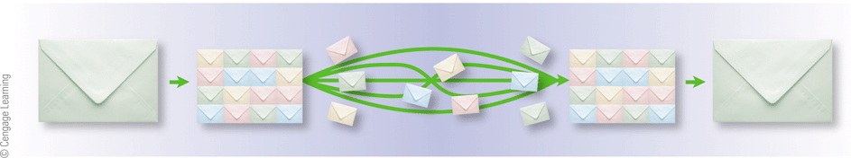
Section B
- Wired Networks-
  - A wired network uses cables to connect network devices
  - Wired networks are fast, secure, and simple to configure
  - Less mobility
  - Ethernet- wired network that broadcasts data packets to a network device
- Wireless-
  - Transports data from one device to another wirelessly using Radio Frequency signals
  - More convenient, less secure ex. Router, or Bluetooth
Section C
- Router installation-
  - Before using your network, you should adjust the router’s configuration settings to make sure your network is secure
  - Stored in router’s EEPROM
  - You must connect a computer to the router
  - You can use your computer’s browser to access the router configuration utility
  - SSID- name of wireless network
  - Wireless encryption (passcode) scrambles the data transmitted between wireless devices and then unscrambles the data only on devices that have a valid encryption key
    - WEP
    - WPA
  - Modem- comes from internet provider to transfer data to and from the Internet
    - Usually connected to a router
Section D
- File Sharing- allows file with any form of data to be accessed from computers other than the one on which they are stored
- Network discovery- a setting that affects whether your computer can see other computers on a network, and whether your computer can be seen by others

