External Analysis & Critical Success Factors
Why is each CSF important?
- Achieving financial performance
  - A successful business is one that’s profitable
  - Ex: Coca-Cola is so successful because they are a cash cow
- Meeting customer needs
  - Understanding what your customer is looking for
  - Ex: Apple introduced the iPad without knowing for sure that consumers would want to buy a tablet but the demand has now increased significantly
- Building quality products and services
  - Staying on top of the environment and trends
  - No quality = No profits
  - Ex: Apple’s iPhone is changing its design each year to keep up with consumer preferences in smartphones
- Encouraging innovation and creativity
  - Vital to delivering a good and unique product or services
  - Ex: When Apple introduced the iPad, it was unique and people wanted it
- Gaining employee commitment
  - Vital to gaining employee commitment because they are the front line of your work force
  - Ex: Google has such dedicated employees because they are treated with respect; working conditions are superb
- Creating distinctive competitive advantage
  - Set yourself apart from the rest
  - How you can beat the competition
  - Ex: Apple has gained a competitive advantage in the market because they are innovative and constantly provide new and unique products; they are at the top of the game in many industries

Questions to think about regarding Critical Success Factors (CSF):
- Why is each CSF important?
- How are they interconnected?
- Why must you pursue them all?

Diamond-E: Strategy, Management Preference, Organization, Resources, and Environment – SMORE
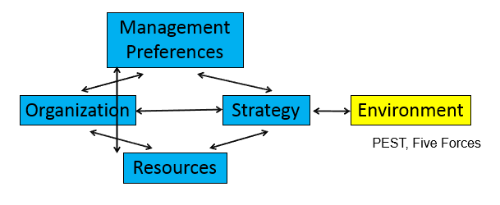

- Determines if certain components in your business are consistent and match up with the business environment
- Strategy: A plan chosen to bring about one’s desired future
- Environment:
  - Strategy – Must be consistent with customer demande
    - Ex: Blackberry’s share of the cellphone market plummeted because their strategy didn’t keep up with trends in the environment
- Resources:
  - Strategy – Must take current resources into account (must be attainable)
Ex: PG’s strategy is to create many brands for their products; they have enough resources to do so and now many of their products can be found in the common household
- Organization:
  - Strategy – Strategy may stress demand on an organization
Ex: Apple produces a new product every year because their customers expect that from
  - Management – You could be really good at what you do but it may not apply to the organization’s structure
Ex: Steve Job’s was fired from Apple because he has conflicting opinions with past Apple CEO, John Sculley, regarding Apple’s direction
  - Resources – The formation of the structure depends on your resources
Ex: Ford’s introduction of the innovative assembly line could only be possible if Henry Ford had the start-up capital

- Management Preferences:
  - Strategy – Management has the ultimate say in strategy
Ex: Apple’s strategy to release a product every year was implemented by Steve Job’s
  - Organization – A manager’s personality has effect on an organization’s structure
Ex: Apple’s success is based off of innovation, this is because Steve job’s structured apple to allow his employees to think freely and innovatively
Importance of Diamond-E:
- Consistency internally leads to performance only if there not a disconnect between strategy and the environment (e.g. CD manufacturers strategies doesn’t keep up with the environment; nobody buys that shit anymore)
- Two way relationship exists where if a company doesn’t have the resources – If you want to execute a well-developed strategy that is aligned in the environment, it will not be feasible

External Analysis: Process of scanning and evaluating the external environment to determine opportunities and threats that exist in the market
- Environments can be classifies as general environment (all businesses) or specific environment (businesses in that specific market)
- Benefits:
  - Makes managers proactive
  - Provides information used in planning
  - Helps you organize to get the needed resources
  - Helps organization cope with uncertainty
  - Improves consistency
- Challenges:
  - Forecasts and trend analyses are not perfect
  - Rapidly changing environment hard to keep up with
  - Time consuming
- External analysis is based upon trends in the environment

PEST – Political, Economic, Social, and Technological
- Analyzes different factors used in environment-scanning and strategy-planning
- Political
  - Laws
  - Taxes
  - Trade agreements
  - Political system/stability
  - Effects:
    - Can create incentives for business
    - Ex: A business may not want to invest its business in Syria due to its current civil war
- Economic:
  - Balance of trade
  - Exchange rates
  - Productivity
  - Inflation/Deflation
  - Interest rates
  - Employment rates
  - Effects:
    - Affects financial performance
    - Ex: Bread was a formidable commodity until the Great Depression hit in 1930s, inflating the price of bread to the point where it became unaffordable

- Social
  - Custom/Values
  - Attitudes
  - Demographics
  - Trends
  - Effects:
    - Influences customer preferences, attitudes, and lifestyles
    - Ex: Silly Bandz were a large trend during one Summer but eventually, the fad died out and no one cared for them anymore

- Technological
  - E-Commerce (Internet)
  - Information technologies
  - Innovation Cycle
  - Effects:
    - Results in firms needing to constantly scan the environment
    - Ex: Amazon is a huge online retailer that sells a huge variety of products; this changed the conventional way of distribution of real life shops

Questions to answer from PEST:
  - Are there opportunities provided by government? (e.g. grants)
  - Do the economic conditions affect my business or industry (e.g. Canada-US exchange rates)
  - What demographic and trends affect my business? How?
  - What technological factors affect me now or in the future? Do they assist or constrain?

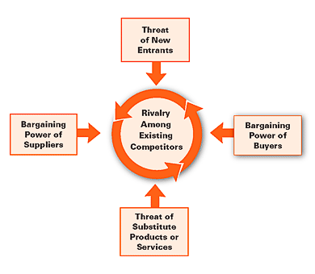
Porter’s Five Forces: Determines what factors predict industry profitability and how I can manage them

*Bargaining Power: Ability of a parties in a situation to exert influence over each other

- Rivalry (Middle):
  - High rivalry results in price competition, shrink profits
  - Most powerful force
Influenced by:
    - Industry growth rate – As your industry grows, businesses in your industry grow and competition shrinks
    - Product differences – If consumers can differentiate you product from the competitors, then you have an edge
    - Brand Identity – Risk of competition becomes lower when consumers think of your brand first in the industry
    - Switching costs – The cheaper it is for a consumer to switch from one supply to another, the stronger the competition is
  - Ex: Coke vs. Pepsi:
    - Suppliers – Not many suppliers of cola drinks, making the market an oligopoly (Consumers don’t have many choices of brands)
    - Potential Entrants – Since It’s an oligopoly, there’s large barriers for potential entrants to drive competition
    - Substitutes – Coke and Pepsi have good brand loyalty, locking in consumers from going to another market, such as Powerade
    - Buyers – Cola is a huge market, so prices for each are as low as possible to stay competitive
- Suppliers:
  - Factors that lead to increased bargaining power:
    - Few suppliers – The fewer the suppliers, the more control they have over the market prices
    - High switching costs – Higher switching costs means less businesses will change suppliers
    - Low attractiveness of substitutes
  - Bargaining power increases costs of inputs; less suppliers to turn to for cheaper costs
  - Solution:
    - Strategic alliance of internal supply – Allows for greater market share and ability to shift prices; less competition
  - Ex: Exxon’s merger with Mobil increased their bargaining power in the oil and gas industry, allowing them to drive their prices higher up
- Potential Entrants:
  - Have ability to disrupt industry and drive intense competition (unless market is monopolistic)
  - Solution:
    - Create barriers (i.e. Patent on good prevents potential entrants from using your ideas for profits)
  - Ex: Lego has a patent on interlocking toy bricks, making it difficult for toy companies to enter the “building toys” market
- Substitutes:
  - Products that provide similar use but are still different
  - Many substitutes = Greater competition (e.g. soft drink industry)
  - Solution:
    - Lock in your buyers with brand loyalty – Consumers will come back to your brand instead of a customers if you have solid reputation and are keeping up with the environment
  - Ex: Powerade is a substitute to Coke – Similar products but in different markets (soft drinks vs. sports drinks)
- Buyers:
  - Consumers
  - Factors that lead to increased bargaining power:
    - Buyer group is concentrated – If buyers change suppliers, the profit decrease immensely
    - Undifferentiated products – Easy for buyers to change suppliers if your product isn’t unique
    - Low switching cost – Easy for buyers to find a new supplier
  - More buyers drive down the price of the product – Prices need to stay competitive with other brands by being the most affordable
  - Solution:
    - Form alliances with firms – less sellers to turn to for cheaper prices
- Ex: The PS4 and Xbox are in the same industry with many buyers but the PS4 stays competitive because it is $100 more affordable

Questions to answer from Porter’s:
  - Is the industry a realistic place for a new venture?
  - Can we do a better job than the competition at avoiding factors that suppress profitability?

Entrepreneurship
New Venture:
- Recently formed commercial organization that sells goods or services

Entrepreneurship:
- identifying opportunity and assessing resources to capitalize on
- Entrepreneur: Someone whose willing to seek opportunity

Small business:
- Managed by owner
- Not dominant in market
- <100 employees
- 98.1% of business in Canada
- Contributes to 30% of Canada’s GDP
- Gross Domestic Product: Sum of a total country’s production

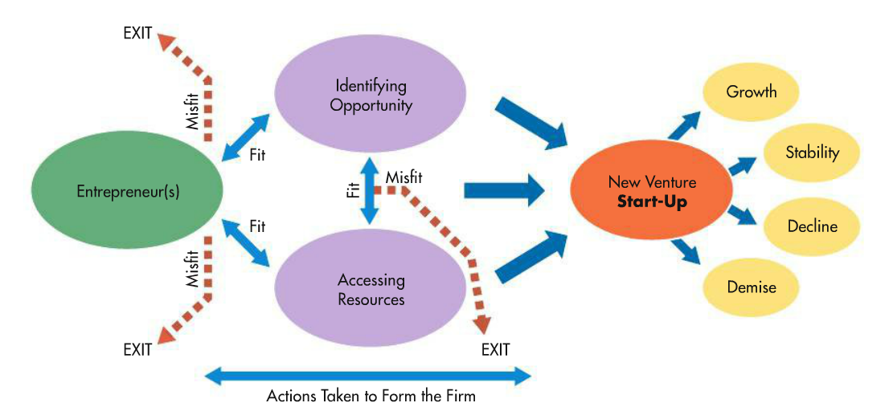
Entrepreneurial process:

- Identify Opportunity – Seek and opportunity using external analysis
- Access Resources – Having access to the necessary resources to make business a reality

You know you have a good idea when…
- Creates value for customers – Solves problems, customers willing to pay for it
- Sustainable competitive advantage – Product is unique and can be protected with patents
- Idea is marketable – Ensuring a quantity of long-term customers, growing market

Developing the Opportunity:
- Business concept often change from original due to changing environment
- Once concept is finalized, time for business plan

Accessing Resources:
- Bootstrapping: Making due with as few resources as possible
- Debt Financing: Loans w/ interest
- Equity Financing: Venture capitalists (e.g. Shark Tank)

Social Entrepreneurship:
- Organizational structure may vary importance of attaining social value is consistent
- Accountability to community stakeholder rather than investors and shareholders
- Importance of self-sustainability

Traditional Entrepreneurship | Social Entrepreneurship
Value defined economically – high net profit (return to investors) is primary | Social Value: Proposition – social benefit is primary
Social benefit may be created as by-product of economic value | Economic wealth created as by-product and allows for self-sustainability
Serving Markets that can afford the new product or service | Target underserved populations; cannot afford (financially or politically) to achieve the benefit on their own
Social involvement in the form of “CSR” initiatives (stay tuned!) | Social motives at the core of the business (not limited to CSR)
Traditional Vs. Social Entrepreneurship:
Economic Factors
Four pillars:
- #1: Chartered banks
  - Provides loans to individuals, businesses
  - Expands money supply through deposit expansion
  - Ex: 'The Big 5’ – RBC, CIBC, BMO, Scotia Bank, and TD
- #2: Alternate Banks:
  - Provide loans, but in specialized way (receive loan as member of bank)
  - Ex: Trust companies, Credit Unions
- #3: Specialized Intermediaries
  - Provides loans as a subset of their original business
  - Ex: Insurance companies, venture capitalist firms
- #4: Investment Dealers:
  - Facilitates buying/selling of stocks
  - Primary market: Companies
  - Secondary Market: Investors

Deposit expansion at Chartered Banks:
- Process:
- You deposit $100 into a bank
- The bank has $100 in cash and the liability to repay you $100
- Bank only keeps portion of cash on hand in case of repayment (e.g $10)
- They loan out in remaining cash ($90) to someone else
- Money supply = Your investment + Other’s loan

Types of Shareholders:
- Common Stock: Ordinary shareholders with no special privileges
- Preferred Stock: Favourited shareholders who take priority over common shareholders (i.e. dividends are paid earlier than common stock)

Bank of Canada and Money Supply
- Canada’s National bank
- Provides loan to chartered banks
- Sets interest rates
- Money Supply:
  - The amount of cash available in country
  - Affects inflation rates, exchange rates
- Buying government bonds changes interest rates to increa/decrease money supply
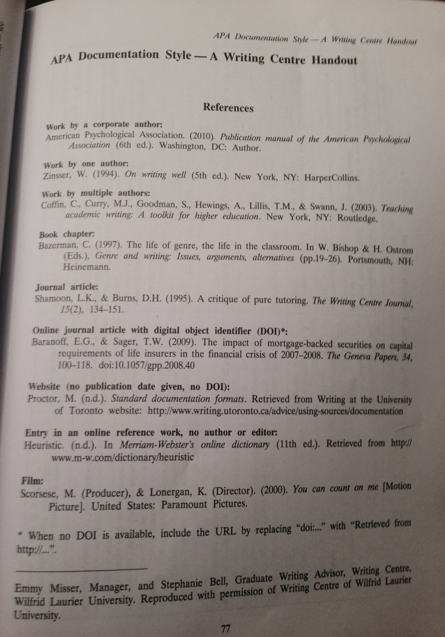
- Buy bonds:
  - Public receives cash for the bonds they own, increases money supply
- Sell bonds:
  - Public pays for bonds, lowers money supply

APA Formatting
Name of Author
Brackets
Date
Title
Italicized title
Place of Publication
Publisher

Example of a novel cited in APA: Grenfell, W. T. (1919). A Labrador doctor: The autobiography of Wilfred Thomason Grenfell. Boston, MA: Houghton, Mifflin Company

