1. a)

Alternatives | Expected Rate of Return | Potential % per $
Stock A | $2 | 30%
Stock B | $1.5 | 20%

How much should I invest in each of the stocks?

Maximize Profit:
Let x₁ represent the amount of $ invested in Stock A
Let x₂ represent the amount of $ invested in Stock B

2x₁ + 1.5x₂

Subjected to the following constraints:
x₁ + x₂ <= 10 dollars
0 + x₂ = 10 x₁ + 0 = 10
(0,10) (10,0)

0.3x₁ + 0.2x₂<= 2.5 dollars
0.3(0) + 0.2x₂ = 2.5 0.3x₁ + 0.2(0) = 2.5
x₂ = 12.5 x₁ = 8.3
(0,12.5) (8.3,0)

x₁ >= 0
x₂ >= 0

b)
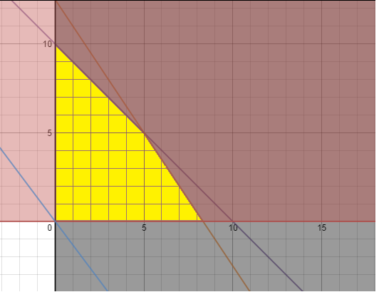

The feasible region has been highlighted in yellow and the objective function is in blue.

c)
Intersection points:

3/10x₁ + 2/10x₂ <= 2.5
3/10x₁ + 2/10(0) = 2.5
3/10x₁ = 5/2
6x₁/6 = 50/6
x₁ = 25/3
x₁ = 8.3
(8.3,0)

3/10(0) + 2/10x₂ =2.5
2/10x₂ = 5/2
4x₂/4 = 50/4
x₂ = 50/4
x₂ = 12.5
(0,12.5)

x₁ - 10 = - x₂
10 - x₁ = x₂

.3x₁ - 2.5 = -.2x₂
2.5/.2 - .3/.2 x₁ = x₂
set them equal to each other
2.5/.2 - .3/.2x₁ = 10 - x₁
-.3/.2x₁ + x₁ = 10 - 2.5/.2
- 0.5x₁ = -2.5
x₁ = 5
sub into equation
10 - (5) = x₂
5 = x₂
(5,5)

Optimal solution:
(8.3,0): 2(8.3) +2.5 (0)
= 16.6
(0,10): 2(0) + 1.5 (10)
= 15
inadmissible since 12.5 is > 10 dollars
(5,5) : 2(5) + 1.5(5)
= 17.5

Therefore, there is only one optimal solution and the optimal value is $17.50 with an optimal solution of (5,5). This also satisfies the risk factor 3/10(5) + 2/10(5) <=2.5.
The investor should invest $5 dollars in stock A and $5 dollars in stock B.

2. a) Maximize 3x + y subjected to the following constraints:
2x - y <= 4
2x - 0 = 4 2(0) - 4 = 4
x = 2 y = -4
(2,0) (0,-4)

2x + 3y <= 12
2x + 3(0) = 12 2(0) + 3y = 12
2x = 12 3y = 12
x=6 y = 4
(6,0) (0,4)

x >= 1

y <= 2.5

x + y >= 1.5
x + (0) = 1.5 (0) + y = 1.5
(1.5,0) (0,1.5)

y - x <= 1
y - x = 1 y - (0) = 1
(0) - x = 1 y = 1
x = -1 (0,1)
(-1,0)

x >= 0

y >= 0

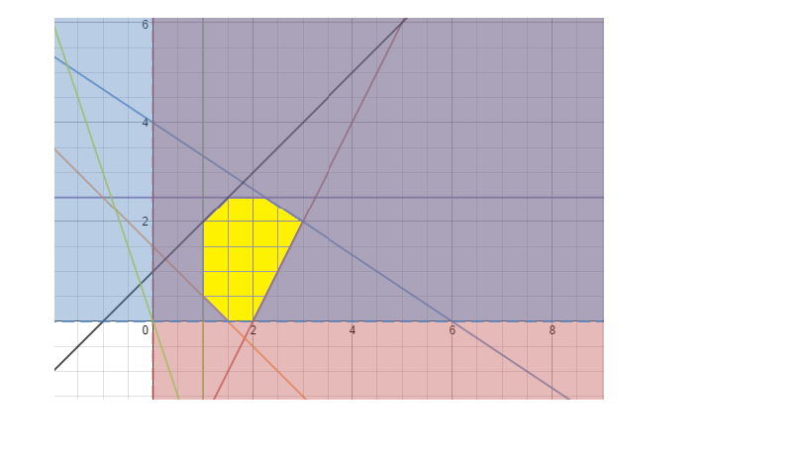
The objective function is drawn in green while the feasible area is highlighted in yellow.

Intersection points:
2x + 3y <= 12
2x + 3 (x+1) = 12
2x + 3x + 3 = 12
5x/5 = 9/5
x = 9/5
sub into equation
y-x <= 1
y = x+ 1
y = 9/5 + 1
y = 14/5
(9/5 , 14/5)

2x + 3y <= 12
2x + 3(5/2) = 12
x = 9/4
x = 2/23
sub into equation
y <= 2.5
y = 5/2
(9/4, 5/2)

Optimal Solution:
(9/5, 14/5): = 3(9/5) + (14/5)
= 27/5 + 14/5
= 8.2
(9/4, 5/2) = 3(9/4) + (5/2)
= 27/4 + 5/2
= 37/ 4
= 9.25
(3,2) : = 3(3) + 2
= 9 + 2
= 11
Therefore, (3,2) is the optimal solution because when plugged into the objective function, it produces the highest output value while still following the constraints.

b) The objective function does not change.
y2-y1/x2-x1 objective function
pt (1.5,0) 3x + y
(1, 0.5) y = -3x
= .5 - 0/ 1- 1.5 slope = -3/3 = /1
=.5/ - .5
= - 1
The optimal solution that minimizes the objective function is the following (1,0.5) it makes the objective value 3(1) + (0.5) = 3.5. This makes sense because it has the same slope as proven above. It also gives the lowest value while still following the constraints.

3. a) Maximize the objective function 4x + y, subjected to the following constraints:
2x - y <= 4
2(0) - y = 4 2x - (0) = 4
-y = 4 x = 2
y = -4 (2,0)
(0,-4)

x + 10y <=100
x + 10(0) = 100 (0) +10y = 100
x = 100 y = 10
(100,0) (0,10)

10y = 100 - x
y = 10 - x/10
sub in 10 for x
y = 10 - (10)/10
y = 9
(10,9)

x + y <=14
y = 14 - x
sub in x = 3 sub in x = 5
y = 14 - (3) y = 14 - (5)
y = 11 y = 9
(3,11) (5,9)

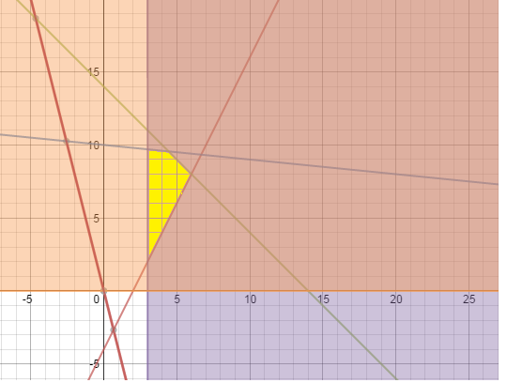
Intersections between constraints
- y = 4 - 2x
y = 2x - 4 y = 14 - x
set equations equal to each other
2x - 4 = 14 - x
3x = 18
x = 6
sub in
y = 14 - (6)
y = 8
(6,8)

y = 14 - x y = 20 - x/10
set equations equal to each other
14 - x = 10 - x/10
4 = -x/10 + x
4 = -x/10 +10x/10
4 = 9x/10
40 = 9x
40/9 = x
sub in
y = 14 - 40/9
= 86/9
(40/9,86/9)
y = 2x - 4
sub in x = 3
y = 2(3) - 4
y = 2
(3,2)

x + 10y = 100
sub in x = 3
3 + 10y = 100
10y = 97
y = 9.7
(3,9.7)

Plug all corner points into the objective function 4x + y
(6,8) : 4(6) + 8 = 32

(40/9,86/9) : 4(40/9) + 86/9 = 27.33

(3,2) : 4(3) + 2 = 14

(3, 9.7) : 4(3) + 9.7 = 21.7
Therefore, the optimal solution is (6,8) with an optimal value of 32. It's the optimal solution because it gives the highest value while still satisfying all of the constraints.

b) After adding the constraint x + y <= 0 there is no feasible region that satisfies all of the total constraints. Therefore there is no optimal solution.

4. a) Minimize the objective function 4x +2y, subjected to the following constraints:
2x + y >=3
2(0) + y = 3 2x + (0) = 3
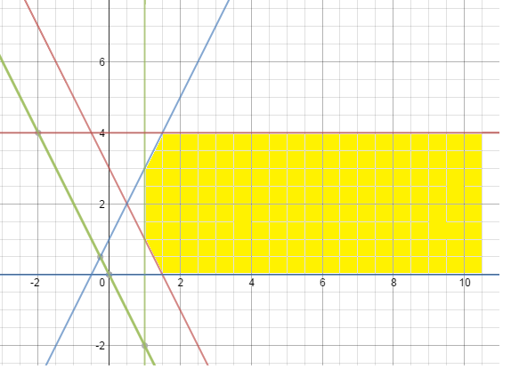
y = 3 x = 3/2
(0,3) (3/2,0)

y - 2x <= 1
y - 2(0) = 1 (0) - 2x = 1
y = 1 x = -1/2
(0,1) (-1/2, 0 )

x>=1

y<=4

y>=0

The objective function is bolded in green and the feasible region has been highlighted in yellow.

Intersections between constraints:
y = 1 + 2x
sub in x = 1
y = 1 + 2(1)
y = 3
(1,3)

y = 3 - 2x
sub in x = 1
y = 3 - 2(1)
y = 1
(1,1)

y = 1+ 2x
sub in y = 4
4 = 1 + 2x
3 = 2x
3/2 = x
(3/2,4)

y = 3 - 2x
sub in y = 0
0 = 3 - 2x
3/2 = x
(3/2, 0)

Plug all intersections into objective function 4x + 2y
(1,3) : 4x + 2y
= 4 (1) + 2(3)
= 4 + 6
= 10
(1,1) : 4 (1) + 2(1)
= 6
(3/2,4) : 4x + 2y
= 4(3/2) + 2(4)
= 14
(3/2,0) : 4(3/2) + 2(0)
= 6

Therefore the optimal solution is (1,1) and (3/2,0) and any point on the line situated between these two points. They all give the same optimal value of 6 since the slope of that line is the same as the slope of the objective function (4x + 2y = 0 y = -2x) (4x +2y=0 y = -2/1x).
b) When changing the objective function to "maximize 4x+ 2y" it becomes an unbounded solution since there are no constraints preventing the solution from becoming infinitely large. The objective function can keep moving and hitting every point of y <=4.

5. a) The optimal solution for the problem of maximizing the function 3x-y, subjected to the following constraints:
x-y>=0
2-y=0 3-y=0
y=2 y=3
(2,2) (3,3)

x+4y<=10
2+4y=10 6+4y=10
4y=8 4y=4
y=2 y=1
(2,2) (6,1)
x-2y<=6
8-2y=6 10-2y=6
-2y=-2 -2y=-4
y=1 y=2
(8,1) (10,2)
x+3y<=9
0+3y=9 6+3y=9
3y=9 3y=3
y=3 y=1
(0,3) (6,1)
x+5y<=12
2+5y=12 7+5y=12
5y=10 5y=5
y=2 y=1
(2,2) (7,1)

x>=0 and y>=0

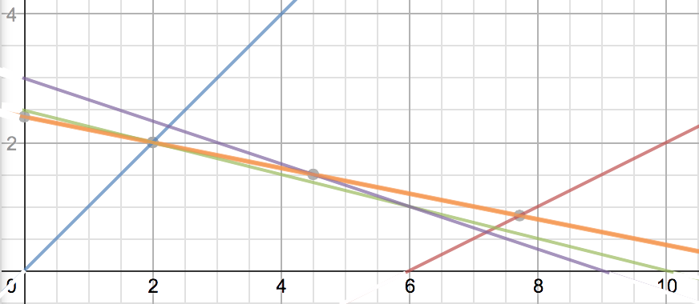

Without drawing the objective function, it is possible to find the optimal solution by drawing the constraints (and therefore finding the feasible area). After finding the feasible area, there are three intersection points (corner points). The coordinates of the three corner points [in this case they are (2,2), (7.2,0.6) and (6,0)] can be inputted into the objective function where the coordinates that give the highest value will be the optimal solution (since we are trying to maximize the function).

Objective Function = Maximize 3x-y
= 3(2)-2
= 4

Objective Function = Maximize 3x-y
= 3(7.2)-0.6
= 21

Objective Function = Maximize 3x-y
= 3(6)-0
= 18

The optimal solution is (7.2,0.6) and the optimal value is 21.

b) There are several redundant constraints in this problem. Redundant constraints are constraints that, if removed from the problem, would not change the feasible area. The only constraints that contribute to the outlines of the feasible area are x-y>=0, x+4y<=10 and x-2y<=6, therefore the redundant constraints in this problem are the remaining two constraints, x>=0, x+5y<=12.

c) All of the constraints listed in part b) as redundant constraints could be removed and the optimal solution found in part a) would still be found. This is because there are only three constraints (x-y>=0, x+4y<=10 and x-2y<=6) that form the feasible area. Therefore removing all the other ones will not have an affect on the possible set of solutions to the problem.

6.a) The red line on the graph indicates the feasible area. The following are the constraints of the linear programming model:
x-y>=2
2-y=2 4-y=2
-y=0 -y=-2
y=0 y=2
(2,0) (4,2)
x-3y<=2
5-3y=2 8-3y=2
-3y=-3 -3y=-6
y=1 y=2
(5,1) (8,2)

5x+4y=15
5(3)+4y=15 5(2)+4y=15
15+4y=15 10+4y=15
4y=0 4y=5
y=0 y=1.25
(3,0) (2,1.25)

x>=0 and y>=0

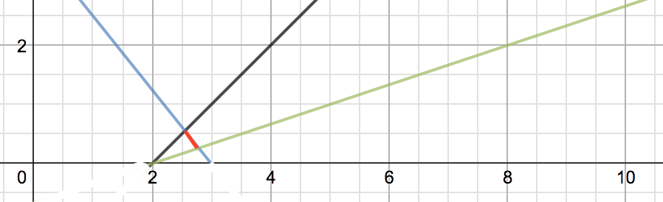

b) Without graphing the objective function, we can find the optimal solution(s) first by graphing the constraints and finding the feasible area. The feasible area can be found by inputting values that aren’t on the constraint lines into the constraint functions. If the inequalities are satisfied, then the feasible area lies on the same side of the line as the point you put in. If the inequalities are not satisfied, the feasible area lies on the opposite side of the line.
Once the feasible area has been determined, the optimal solution is found by inputting the values for the intersection points of the feasible area [in this case the points are (2.556, 0.556) and (2.789, 0.263)]. Since we are trying to maximize the function, the point that results in the biggest value is the optimal solution.

Objective Function (2.556, 0.556) = 2x+6y
= 2(2.556)+6(0.556)
= 8.448

Objective Function (2.789, 0.263) = 2x+6y
= 2(2.789)+6(0.263)
= 7.156

Since the objective function is “maximize 2x+6y”, we want to find the largest possible number. Therefore the optimal solution is (2.556, 0.556) and the optimal value is 8.448.

c) If the objective function is changed to “minimize 2x+6y” the optimal solution will be the point that gave the smallest value when inputted into the objective function. Therefore the optimal solution is (2.789, 0.263) and the optimal value is 7.156.

